70477
Considering Otto Wiener's experiment in monochromatic light of wavelength 550nm, if the film plane is angle at 1 degree to the reflecting surface, determine the number of bright bands per centimeter that will appear on it.

Answer:

In this experiment the light sensitive film is formed before the mercury polish, forming the mirror. If the film is making angle θ with the mirror then a wedge shaped air film is formed between the mirror and the film. The thickness of this air film is changing with the distance from the wedge angle. The lower surface of the film reflects a part of the light incident on it and the rest is reflected from the reflecting surface (mirror) and in that way we get two beams of light
- The light reflected from the lower surface of the film, and refracted back, and
- The light reflected from the mirror and then refracted from the film.
These two beams interfere and the resulting fringe pattern is observed in the region above the system.
θ

x
Now the thickness of the air film is a function of x and as θ is very small (in radiuns), given by

t = θ x

The path difference between the two beams at x is given by
δ = 2 t + λ/2
= 2 θ x + λ/2

Here λ/2 is the additional path difference, because at mirror light is reflecting from denser medium.

For the maximum intensity (bright line) of resulting wave at x this path difference should be an integer multiple of λ or

2 θ x + λ/2 = nλ.

and for the next maximum

2 θ (x +Δx) + λ/2 = (n + 1) λ.

Subtracting the two equations we get the distance between two consecutive maximum, or the fringe width β as

2 θ Δx = 2 θ β = λ.

Or β = λ / (2θ) = 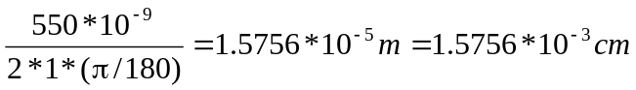.

Hence the number of fringes in 1 cm is given by

N = 1/(1.5756*10⁻³) = 634.67.

