

**Diagrams for supporting Dissertation Thesis**

ITC Security Systems Engineering, Design and DevOps

Student:

Mareș Robert-Dorian

Table of contents

1. Use case Diagram 3

2. Activity Diagram 4

2.1. Examiner adds item to Item Pool 4

2.2. Examinee takes test 5

3. Class Diagram 6

4. Interaction Diagram 7

# Use case Diagram

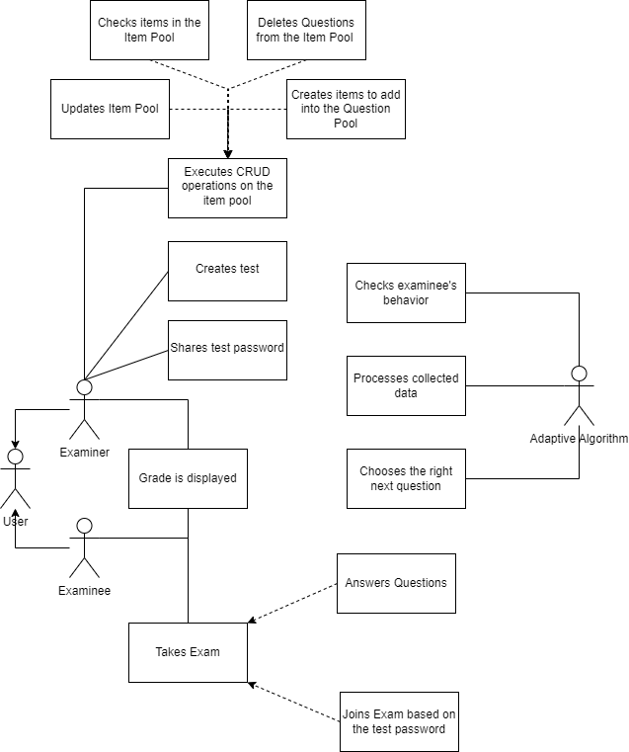

**AS A USER** I may take the role of an examiner or an examinee.

**AS A USER WITH EXAMINER AUTHORITY** I may check the grade of my **EXAMINEES.**

**AS A USER WITH EXAMINER AUTHORITY** I may share to the **EXAMINEES** the test password.

**AS A USER WITH EXAMINER AUTHORITY** I may perform CRUD operations on a question and add it to the Item Pool.

**AS A USER WITH EXAMINER AUTHORITY** I may bundle together multiple questions into an **EXAM.**

**AS A USER WITH EXAMINEE PRIVILEGES** I may check my grades.

**AS A USER WITH EXAMINEE PRIVILEGES** I may take an exam.

# Activity Diagram

## 2.1. Examiner adds item to Item Pool

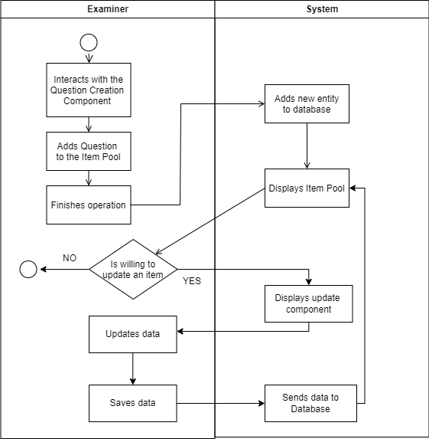

**AS AN EXAMINER** I may add questions to the question pool. **THE SYSTEM** is going to add the new entity to the database, then will display the whole ITEM POOL to me, the examiner.

**AS AN EXAMINER** I may choose to update a question. If I choose not to update a question, the process is finished. If I choose to update a question, **THEN** **THE SYSTEM** is going to display to me a component designed to update questions. After updating the data, and saving the question, **THE SYSTEM** will send the data to the database, while displaying the new ITEM POOL to me. **THEN** I may choose to update an item again.

## 2.2. Examinee takes test

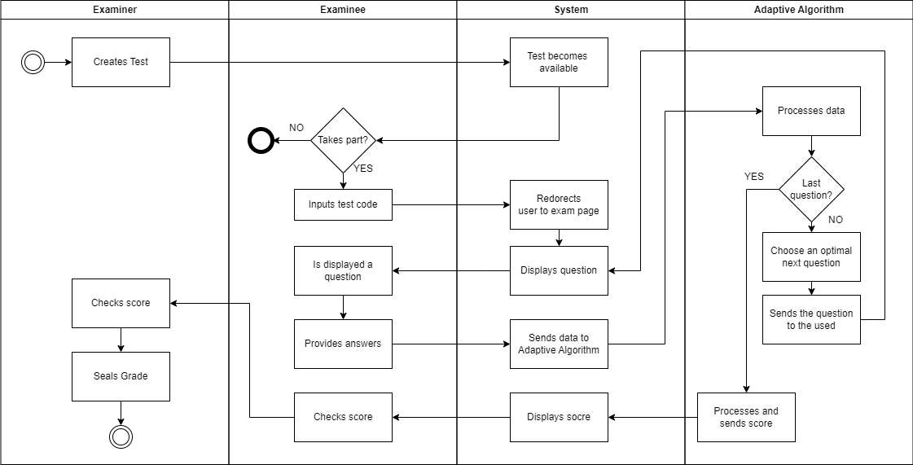

# Class Diagram

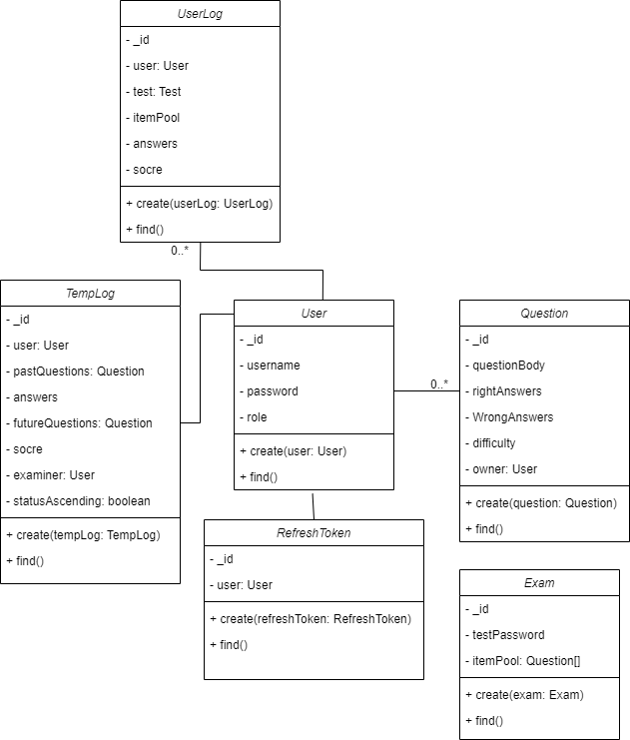

# Interaction Diagram

