Bucharest Academy of Economic Studies

Faculty of Cybernetics, Statistics, and Economic Informatics

IT&C Security Master

Security of a Computerized Adaptive Testing Solution

Dissertation Thesis

**Dissertation Advisor:**

Assoc. PhD. Toma Cristian Valeriu

**Graduate:**

Mareș D.S. Robert-Dorian

Bucharest 2023

Declaration of Originality

I hereby declare that the results presented in this paper are entirely of my own creation unless reference is made to the results of other authors. I confirm that any material used from other sources (journals, books, articles, and Internet websites) is clearly referenced in the paper and is indicated in the list of references.

Contents

Table of Figures 5

Abstract 6

1. Introduction 7

1.1. History of Education and Evaluation 7

1.2. Multiple-choice Examinations 7

1.3. Education in Post-Covid Conditions 8

2. Computerized Adaptive Testing with Security Related Aspects 10

2.1. Introduction to C.A.T. 10

2.2. Structure of a C.A.T. 10

2.3. Process of a C.A.T. 11

2.4. Correlation with Item Response Theory 11

2.5. Advantages and Disadvantages of C.A.T. based on Results. 12

3. Technology Stack and Architecture 14

3.1. Base of Development 14

3.2. Development Technologies and Architecture 14

3.3. Security Techniques and Architectural Choices 17

3.4. Implemented Architectural Standards 19

4. Implementation 22

4.1. Use case Diagram. 22

4.2. Activity Diagram 24

4.2.1. Adding an Item to the Item Pool 24

4.2.2. Taking a Computerized Adaptive Test 25

4.3. Class Diagram 26

4.4. Interaction Diagram 27

5. Conclusions 28

Bibliography 29

# Table of Figures

Figure 1: Solution Technology Architecture 15

Figure 2: Adaptive Algorithm Process 16

Figure 3: JSON Web Token Architecture 17

# Abstract

Such solution is needed because of the way in which education is evolving today. As you may already know, post-covid-19 pandemic education has taken a turn for the better adopting a mostly digital approach, in the way that humanity managed to realize that someone with internet access may have all the possibilities to become a great mind in this world, thus, any form of digitization of this concept is a big step towards the great minds of tomorrow.

It is understood why it is important to have computerized examinations, but a step forward is introducing the concept of adaptability. Adaptability is needed because of the nature of standardized testing, a concept that may lead to many academic fails for most students for ages now. Out of all standardized test methods, one kept constantly rising in popularity due to its simplicity, that being the multiple-choice question.

Multiple choice-based examinations give the least possible room for the student’s creativity, as well as being most prone to academic dishonesty. Their simple form makes good easy work of the evaluation by the teacher, yet circling the right answer on a paper, without having a word to say, may sometimes succumb to the factor known as luck, rather than knowledge. The adaptability part of computer-based adaptive examinations is trying to make exams more interactive and knowledge solicitating for the examinee.

Finally, the matter of security is an essential factor in every concept linked to computers. For as many features a machine has, a bigger number of security issues may be exploited in an attacker’s favour. Taking a digital test is just the same, we keep asking ourselves the question “How may I alleviate academic dishonesty?”. Fortunately, computers may help with this task, only if the security norms are respected.

# Introduction

## History of Education and Evaluation

From the beginning of time and until now, learning and education have paved the way for the society we live in today. Without this figurative hunger for knowledge that the human being has shown in its all so evolving and fast-adapting behavior, society would have not progressed thus far, to the point of its members being able to reflect on it and themselves. The act of learning led to the creation of a concept known today as education, which was common ground for the great evolution society has seen in recent history. Education, being this pillar of society, gave birth to an institution whose sole aspiration is to educate the population. This institution is best known as “school”, and it is such an important aspect for humans, that today it is part of every living human, regardless of their nationality, beliefs, or race.

Education, as a process, has many relevant aspects, yet this study aims to underline the one that exposes the results, namely, evaluation. The English Dictionary defines the word, evaluation, as the action of determining or fix the value of something, thus, in the context of education, evaluation follows the exact same principle, specifically, it is the action to determine the level of knowledge of the person being educated, commonly known as “the student”. It is common sense for the process of education to conclude with evaluation, thus, this step is necessary, so that they can bring their newly gathered knowledge into society. It is fairly known that each human being has different needs and wishes, no two people may want to receive the same treatment or cure, in this case no evaluation should be the same for every two individuals.

According to censuses conducted by the world governments, it is stated that population growth rate upsurged in the last century, the educational system, which was put in place by each country’s government for its population as a public service, grew accordingly to provide paths of performance for each citizen.

Considering the growing population, as well as each student’s needs regarding evaluation, standardized testing was adapted as the main procedure for evaluation. Standardized testing takes many forms, ranging from multiple-choice questions to interviews held face to face with an examiner, but the main aspect of it is that it applies the same set of questions and tasks for each examinee, without their specific needs and unique behavior being taken into consideration.

## Multiple-choice Examinations

With standardized testing being the status quo for most educational facilities, the multiple-choice based tests proved to become the most popular among examinators, due to their distinguished aspects, among which we mention low effort on behalf of the examiner, since they are only required to validate a corresponding answer in the answer sheet, thus becoming a comfortable way of evaluating a large volume of students. On the other hand, for the examinee, a multiple-choice test drastically limits creativity and adaptability while providing an answer. By limiting one’s field of action, the results strain the truth even further.

Through the years, fundamental disadvantages of multiple-choice based tests were discovered, yet the academic system preferred the advantages and managed to find workarounds for what was missing. Naming these fundamental disadvantages goes as follows:

* Limiting one’s ability to express, a multiple-choice test drastically limits creativity and adaptability while providing an answer. By limiting one’s field of action, the results strain the truth even further.
* Academic dishonesty has been and still is to this day the main issue in all forms of evaluation. It is not specific to the multiple-choice question-based evaluation, but it is easier to perform in the case of these types of tests. The answers have a simple form, e.g.: 1.A, 2.B, 3.C and so on, thus examinees may very well discreetly communicate this information among each other through various communication channels, and the smaller the payload, the easier it would be to transmit to other examinees.
* Random choices exist as part of every human being. Unlike computers, which have a hard time creating something truly random, humans have this ability at their fingertips. For the examinee, to choose one of the answers to the multiple-choice question, and that answer being the right one there is a very high possibility, depending on the number of available answers to choose from. Even if the odds are not that high, they are still much higher than a random choice in another form of evaluation, for example written text. It is clear to say that if an examinee answered correctly to a question by using the random factor, that does not validate their abilities in the process of education.

## Education in Post-Covid Conditions

With the passing of time these problems persisted and even escalated with the evolution of technology, and the ease of transmitting messages through various channels. In the post-covid context, many educational institutions were forced to perform evaluations in an digitalized manner through the internet, thus giving the examinees enough room to commit academic dishonesty. [1]

To survive and not leave the students in a limbo state, educational facilities had to succumb to creating online environments for courses and laboratories to take place. Entering online teaching students were facing accommodation with many new tools that may be used for either sustaining a video conference between teacher and student, or for sharing resource and examinations. [2]

This study’s focus is aiming towards aiding the first two presented disadvantages. The stiffness of multiple-choice questions can be torn down by an adaptive component, meaning that the logic behind the test builds a model of the examinees capabilities and models the process according to their current performance. The academic dishonesty factor could never be deemed as fully eradicated, yet it could be threatened by implementing security solutions to the support platform.

All aspects for creating a better experience out of the multiple-choice exam are to be interlaced with each other into a single application designed specifically for sustaining such an exam.

# Computerized Adaptive Testing with Security Related Aspects

## Introduction to C.A.T.

Unlike the basic multiple-choice based test, an adaptive multiple-choice test is going to give better results, while using less items. From a technical point of view, computerized adaptive testing aims towards the successive selection of the next item out of the item pool. This selection is going to be based on the previous performance as the specific process indicates. [3]

The adaptive testing factor may be hidden from the user, letting the hardware process the examinee’s profile, yet the results will be present. If the examiner demands, the process of adaptability could be visible to the examinee, yet this kind of exam would be more appropriate for research studies, since seeing the process and the performance may bias the user and change their natural behavior.

## Structure of a C.A.T.

As stated in [4] and explored furtherly in [5], to make sure the computerized adaptive test is properly providing the results required, there are multiple components required.

* The item pool: It should be as vast as possible, while still maintaining the quality of the item since low quality items may only drive the algorithm in an uncalibrated state. As it is the saying in all popular machine learning solutions, garbage in, will only result in garbage out.
* The response model: It refers to the psychometric model that the algorithm will compute in each iteration to retrieve the optimal question for the examinee.
* The test entry procedure: It requires an item of average difficulty to leave equal room for the algorithm to evolve in both directions, ascending or descending.
* The item selection procedure: Goes as instructed by the adaptive algorithm design.
* The scoring procedure: Grading is based on the evolutive stagnation and crystallization of the psychometric model since the lack of modification is the true form of the examinee’s capabilities.
* The test termination procedure: May be based on multiple criterions such as running out of time or the previously explained evolutive stagnation. Another one could be the R.O.O.T exams (run out of time), in which, in a given amount of time, the adaptive test is going to take place and the examinee is required to pass a specific threshold in order for the test to be marked as PASSED. [6]

Other components may be considered as optional, used to provide a better experience for the user, but the ones named above are utterly essential for the process. Many examination solutions provide quality-of-life features in the digital view of the exam, such as a timer, the progression or even multimedia features to construct a more appealing item for the examinee to tackle on.

## Process of a C.A.T.

As stated in [7] and reflected on the same idea in [5], process of adaptive evaluation may very well divide the into four elementary steps, that state the base for an efficient testing process following the means of adaptability to the examinee’s capabilities and behavior.

* The first step requires selecting the optimal element from the item pool. The quality of the item is going to be deduced based on estimations from previous iterations. Even as a principal selection criterion, the difficulty of the previous item may not serve as the only one, other criteria, like the category in which the item is placed, will provide valuable information for the adaptive algorithm.
* Secondly, the optimal item should be presented to the examinee, following the user input, regardless of the results, the digital model will be updated with the gathered information during the previous iteration.
* Thirdly, the digital model of the examinee which embodies the user’s abilities is going to be rebuilt and serve as the new train model for the algorithm.
* Finally, steps 1 to 3 get repeated until the exit criterion is triggered. The exit criterion may vary based on the examiner’s demands, usually it is based on a stagnation in the change of the digital model. When iterations become more similar from one to another, the algorithm may stop. [8]

## Correlation with Item Response Theory

For the first iteration the algorithm may not have a proper model to build on, thus the items with an average difficulty will be presented, to have a better approximation during the next iterations. Each time the building of the digital model is going to be different since the human behavior is never the same on two individuals. [9]

Item response theory is yet another component present in an adaptive algorithm created for computerized evaluation. Presented in [10], inside adaptive testing, IRT makes the difference between a low and a high difficulty item. Based on this methodology, the psychometric model will be able to mirror the examinee’s capabilities [11], as well as making a clear comparison between the item’s difficulty and category compared to the examinee and his status. IRT compares under the same metric all these aspects to provide optimal calibrated results. [12]

As stated in [13], from a mathematical standpoint we can refer to the psychometric model as *θ*. In the context of IRT, the probability of obtaining the exact answer could be calculated through iterative functions of *θ*. Based on the item score vector, certain decisions must be made regarding the probabilities obtained by computing *θ*. The probability may pe specified using 1 to 3 parameter logistic models [14]. A model example for three parameter logistic models was provided in [13], as it follows:

$$P_{g}\left(θ\right)=c_{g}+\frac{\left(1-c_{g}\right)e^{[a_{g}(θ-b_{g})]}}{1+e^{[a_{g}(θ-b_{g})]}}$$

ag – item discrimination parameter (based on category)

bg – item difficulty

cg – the probability of a correct response for every low *θ* examinees

## Advantages and Disadvantages of C.A.T. based on Results.

Some observed advantages of computerized adaptive testing are as follows:

* Compared to static testing, adaptive testing offers better precision of results [7], while static tests tend to give better results only for medium trained. As a result, the outliers would face a bad examination in the case of static tests.
* In a computerized adaptive test, the difficulty of a question wears the specific weight, thus a more difficult item would give more score to an examinee, unlike static tests where usually all questions have the same value.
* Since an adaptive test may end based on a finish criterion, they tend to take 50% less time [3]. A static test always has a predefined time length since an examinee must iterate through all items to finish the test.
* Overall gives the user a better experience, since it avoids stressful situations where an examinee may be faced with consecutive difficult questions. The adaptive factor manages to help the user to correct their mistakes and improve their final score.
* Adaptive tests may find their way not only in academic environments, but also in the recruitment sector. Recruiters may setup recruitment tests in an adaptive manner to make sure they find what they are really looking for in a candidate. [15]
* All the security measures that can be applied on traditional multiple-choice test can find their way in computerized adaptive test, per se:
  + Scrambling the order of the answers to decrease the easiness of performing academic dishonesty by transmitting only one indicator. If each examinee has a different answer order, they may not be able to just express the position of the answer in the answer list, they are going to have to express the whole answer, which drastically complicates the process of academic dishonesty.
  + Presenting different starting questions, and progressive questions, if there are enough items in the item pool to choose from.
  + Encapsulating the test in a secure application that is built specifically to work against cheating by limiting the application that can run on the computer.

On the other hand, some disadvantages have been observed as it follows:

* The first few iterations of the process are used by the adaptive algorithm to calibrate the item pool. Such algorithm, in the case that it is not optimized, requires a larger item bank, thus more iterations spent in the calibration process. [3]
* In the case of multiple examinees showing identical behaviour in the interaction with the algorithm, these users may commit academic dishonesty by experiencing a similar exam and being able to consult each other during the evaluation process. [16]
* Processing of the psychological model requires hardware resources, thus the algorithm should either be optimized properly to run smoothly or be hosted by powerful hardware that can process the model fast enough.

# Technology Stack and Architecture

## Base of Development

To conduct proper research on this topic and assure that the studies before are indeed still relevant in the context of post-covid education, we may construct an informatic solution, designed to englobe both computerized adaptability for item selection, as well as security aspects to mitigate academic dishonesty.

In the sense of security, such solutions may only be constructed using new technologies that benefit from long-term support from the developers. Open-source technology developers choose to adopt a certain method of security, by revealing the whole source code to the community, they build an entire environment around it, thus every contributor may come with an opinion regarding security and useful features. By gathering many contributors and reviewers, the open-source framework benefits from multiple diverse opinions. There are multiple frameworks currently developed and continuing to receive long-term support, each of them taking a different part of the market share, thus at the end of the day, it comes to generic preference when choosing a framework to develop a solution.

## Development Technologies and Architecture

JavaScript, or more commonly known as JS, is a object based programming language popularized in the early 2000s as a tool for creating interactive web pages. Along with HTML and CSS they became the backbone of web applications. Being an open-source technology, it benefits from a large environment built by the JavaScript enjoyers. In this environment we find not only web page creation tools, but also server-side technologies as Node.js or Deno.js; tools for creating a Restful API as Express.js; Typescript, which is an entirely JavaScript superset, used for enabling datatypes and a more controlled programming manner.

In the scope of the research conducted in this thesis, a solution was built using the microservice architecture of Node.js development framework. The main component of this solution is a central service meant to connect the others through HTTP. This server would be responsible for transiting most of the data and forwarding it to other microservices that may process or aggregate data. The microservice architecture, even being more complex and requiring more resources, is superior to the monolith architecture, since a more distributed and scalable solution has better adaptability in case of any hazard, being it hardware or software, may occur. For instance, triggering an uncovered exception is going to cease the activity of the monolith solution, since the sole server was stopped, on the other hand this case in a microservice architecture is going to stop just one of the microservices, not affecting the other and leaving them to run properly in their own sandbox.

Express.js is responsible for building and maintaining the Restful API. Developed in 2010 as a library for the Node.js superior framework, Express.js enables the user to create a simple, or complex, Restful API and configure it to their likings.

To be used, a solution requires an attractive user interface to facilitate interaction and user experience. In this scope, Angular v16 was used alongside its many features to facilitate an easy-to-use user interface that manages to establish communication with the main server. This interface may provide the examiner with the ability to create question items that may be assembled into a test, the test itself may later be activated and become accessible by the examinees. On the other hand, the examinee may use the solution to take a computerized adaptive test. They would first access the test by a unique identifier, afterwards the user is going to take the test, items will be displayed to them through the Angular user interface, after providing an answer, the current gathered information, information like the correctness of the answer provided, question category, answer time, is going to be processed by one, or multiple microservices in order to provide an accurate next question. This is an iterative process that is going to end when a finish criterion has been achieved.

Being a data intensive application, in the sense that the psychometric model of each user must be stored, updated, and interrogated multiple time for the adaptive aspect to be present, the solution requires a strong and high scalable database provider. As it was stated before, the psychometric model of the examinee is a complex entity that stores a dynamic amount of data, a cloud and document-based database fits the role in this type of application. MongoDB is a popular document-based NoSQL database which provides cloud features to its users.

The cloud aspect is mandatory when building a horizontally scaling application. A solution providing C.A.T. experience is required to be scalable because of the big processing power that is required for each examinee during an examination, since the adaptive algorithm itself is going to require real-time processing and is expected to provide fast and accurate results. Another strong point in using MongoDB to provide the adaptive examination experience is that it works very efficiently alongside the Node.js server framework, in the sense that around these technologies a large community has been formed to provide a strong and reliable secure open-source development environment.

Figure 1: Solution Technology Architecture

The center of data processing and aggregation of the solution is the microservice which hosts the adaptive algorithm. This function dictates the entire flow of the application in the form that it is responsible for analyzing the psychological model of the user, so that it can apply custom filtering on the item bank, to retrieve the optimal item to be presented to the examinee. Custom filtering is going to be made based on the difficulty of the items, as well as the examinee’s status, which may be on an ascending or a descending trend. A secondary filtering is going to take place to not present items like the ones before that the examinee didn’t manage to provide the correct answer. This iterative workflow would be stopped by a finish criterion. Such criterion may constitute the stagnation of the psychological model in the last couple of iterations, thus deeming the evolution of the psychological model as finished. After the end of the exam, the results may be displayed to both the examiner and the examinee.

As it was formerly described, the adaptive algorithm is the most convoluted agent in the process of conducting a C.A.T., thus any safe measure must be put in practice so the algorithm may operate smoothly and unbothered. By using highly scalable technologies, such as Node.js and MongoDB, the component wrapping the adaptive algorithm is designed to be a suite of multiple microservices, all of them connecting to the main backbone. This horizontal scaling of the adaptive agent must take place to ensure that the high processing algorithm is not overflowing with requests, thus interfering with the calculation of the psychometric model.

Figure 2: Adaptive Algorithm Process

## Security Techniques and Architectural Choices

For an application that works with data as sensitive as official examination, security has to be precise and cover all the possibilities of fraudulent actions, such application has to ensure confidentiality, integrity, and availability to the user, while also providing a smooth experience of the intended service.

The aspect of “Confidentiality” requires data to be confident to all user, except the indented receiver and the sender. In a Single Page Application, which is communicating to a Restful API, even if it is transmitted through a secure channel, like HTTPS, data is still considered to be exposed, since an attacker will always have access tot the communication channel, thus a supplementary measure becomes the status quo, respectively encrypting a payload of data before being sent and after being received by both parts. With end-to-end encryption, the attacker which will intercept the payload half-way, will come into the possession of an encrypted message which will be deemed as useless. The best practice for end-to-end encryption is to encrypt data using an asymmetric encryption algorithm in order to further complicate the attacker’s malicious activity.

In the context of “Integrity”, such solution must use access and refresh token architecture so it can manage the secure authorization and avoid possible scripting attacks such as Cross-Site Scripting or Cross-Site Request Forgery. The token architecture is provided by the JSON Web Token Library which manages the in-code implementation. It assures data integrity and confidentiality by the contents of the token. The token has multiple layers to it in the way that it contains all data needed for the API to know the sender is indeed the authenticated user. The token contains the encrypted user data, as well as the time the token was issued, the lifespan of it, the role of the user, and a checksum, so that the contents may not be tempered with.

Another integrity provider is meticulous input sanitization and validation. Inputs will always receive any data they are given, so it is the job of the developer to ensure data sanitization. The lack of it may result in a series of possible attacks, by which we can name SQL injection or Cross-Site Scripting.

Thirdly, the “Availability” will be ensured by the Restful API, which is always running, intercepting request through the endpoints and processes them in the order they are received, so that any user requesting for data, will be granted a response, if they are meeting the security clearance for it.

Figure 3: JSON Web Token Architecture

The problem faced by the JWT architecture is storing the access token in a proper manner so that it is not accessible by JavaScript prebuilt scripts. The act of loading a script in an input so that it tempers with the web application’s source code is known as Cross Site Scripting. Thus, a Cross Site Script will try to access the stored token and use it to create a malicious request in the name of victim. A common approach for developers is to store the token in either cookies or the local storage of the browser, both being dangerous location for storing sensitive data, as it is easy to iterate through all the items in those collections by using vanilla JavaScript.

As a solution to this topic, the only feasible approach is to issue a new token each time a component is initialized, and have it given a low lifespan. By fetching the token whenever the component is created and having it stored in a local variable inside the component source code, the variable name will be hidden while using a code obfuscator, as well as it would be impossible to find the exact variable as you may not iterate through all the variables as it is possible to iterate through all cookies or through all items inside local or session storage.

The issuing of numerous access tokens does not constitute a problem as the architecture imposes the user to own only one token at a time, while also providing a short lifetime of it. If the user’s token expires before they finish the intended action, they may refresh the web page to get issue of a new token.

Another security aspect is the integration with the open-source chromium-based software named Safe Exam Browser, which drastically limits the examinees’ available actions. Safe Exam Browser is, as the name suggests, a configurable browser which creates a perfect examination environment. Integration with any online application is easy to do, through the SEB configuration file. Being a chromium-based browser, it also benefits from all the features other popular browsers use.

Yet another security feature for authentication is the implementation of a two-factor authentication system provided using a simple mobile application developed in parallel. On the action of user login, the mobile application is going push a notification that requires specific user sensitive data, needed for assuring the person that initiated the login is indeed the owner of the account. The user specific data may be either of biometric origin, or password based, each technique having its advantages and disadvantages. Modern smartphones excel in the category of gathering biometric data, thus making the development of such feature, very convenient and facile.

Lastly, to persist the identity of the user and avoid impersonation, in parallel with the test running, video feed of the examinee is always gathered and forwarded to the examiner in the scope of surveillance. [17]

Fortunately, modern browsers support peer-to-peer connection through the web-socket in order emit and receive video feed from one source to another. The webRTC open-source project is built especially for this type of secure real-time communication, while also benefiting from great support and integration in the JavaScript development environment, making it a great candidate to facilitate examination monitoring during a C.A.T. exam.

## Implemented Architectural Standards

The proper implementation of the system described previously would certainly be best created using an informatic system. Considering informatic architecture, such a solution would require specific architectural modules to offer enhanced user experience. The architectural standards identified in [18], [19], [20] and [21], are prime tools in building a sustainable and safe environment to facilitate computerized adaptive tests.

* The “State” design pattern is used in this type of solution to provide specific experience for the user, depending on their status, as an examiner or examinee, they may be presented with different guided user interfaces. The place of the “State” design pattern in a C.A.T. providing application, is in the authorization component display. Being a multiple role application, presumably examiner and examinee, based on specific processing using the authorization token, the UI framework is going to initialize a specific state for each type of user. For an examiner, the UI is going to present multiple components used for item creation, on the other hand, the examinee is supposed to be greeted only by the exam interface.
* The “Memento” design pattern serves as a core module in both storage of the user’s psychometric model in a digital form, as well as providing fail-safe techniques to restore the session in case of various hardware malfunctions. Being a web solution, a C.A.T. providing platform would be prone to multiple malfunctions, in this case the “Memento” will “remember” previous states of the exam and will be able to instantiate them after reconnecting.
* All these aspects come together under the rules of the Clean Code, by which the source code can be easily altered and updated depending on the owner’s demand.
* The “rfc7231” enables proper usage of the HTTP and its functionalities. This protocol allows remote connections through browsers and mass aggregation of data on one server.

Restful API or Application Programming Interface is a method in which two entities may communicate through the request/response mechanism. A user may access an API through a request to the IP Address of the API in clause. The request must contain the following elements:

* Specific headers to provide authorization to API data and processing, considerably, the Authorization header provided by the JSON Web Token architecture which is the main point to demonstrate the authenticity of the request sender.
* The body of the request in which lays the data which is going to be processed by the API. The body of the request, also referred to as the payload, should always be encrypted while being transmitted between each service.
* Parameters are part of a request header and are included in the link as a volatile value that may alternate. The parameters are intended to provide swift and short volume data to facilitate faster processing of the data.
* Cookies are part of the browser and are sent as a header during a request in the form of request options. Cookies may benefit from powerful flags such as “HTTP ONLY” or “SECURE” which limit cookie access from browser console.
* The HTTP verb. They are conventions established to match the intention of a specific request, as well as to differentiate between endpoints that may have the same address. The most common HTTP verbs are:
  + GET – A GET request may be used only for retrieving data and not processing. This specific type of request is supposed to only be sent with an empty payload, as data interrogation does not require payload processing. All data filters should be transmitted to the API as parameters in the request headers. Many programming languages and frameworks are built to forbid adding a payload to a GET request. A response containing data is expected to be received and the data processed.
  + POST – On the other hand, the POST request is meant to be used in processing data and storing it into a database. The post request is designed to be sent to the API with a payload containing data to be processed. A response containing data from the database should not be received, yet a response containing the status of the processing is expected.
  + PUT – Thirdly, the PUT is meant to update data from a database. It is supposed to have a payload containing the changes, as well as a parameter in the request header to identify the entity meant to be updated.
  + DELETE – Working in a similar manner as the GET request, the DELETE is meant to delete items from the database by a specific parameter in the request header. The DELETE request should not contain a payload, and is supposed to receive a response indicating only the status of the delete procedure. [21]

# Implementation

The sum of all workflows in an informatic solution may be represented to individuals in the form of various types of diagrams. It is recommended to have a graphical representation of the application, so that non-technical staff, as well as newcomers starting work on the project, will be provided with a quick and concise summary of the solution’s purpose and workflows. Another perk of implementation diagrams is the ability to swiftly identify problematic or overcomplicated workflows, in the sense that it highlights redundant steps, as well as it comes as a great tool in the debugging process.

All those resources assembled represent the documentation of the software solution. Respecting the Agile Methodology, these resources are required to be first and foremost optimized and regulated, and then shared across the teammates to ensure working efficiency.

## Use case Diagram.

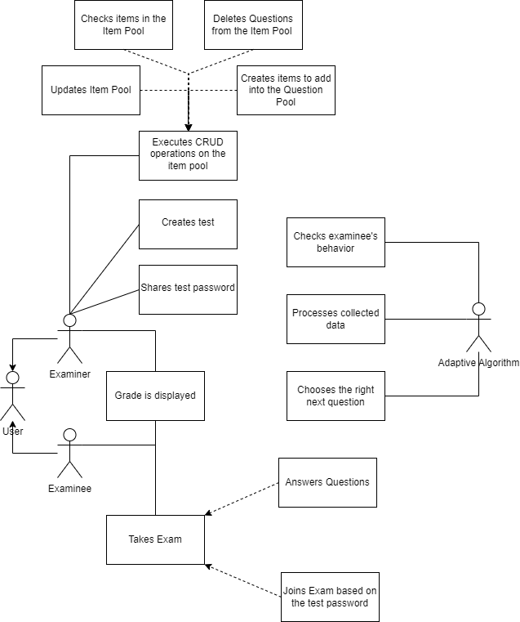

The Use Case Diagram englobes all workflows linked to the users of the software application and displays them as they are connected to eachother. Each workflow is vaguely presented as the more detalied approach is touched in other forms of diagrams built specifically for each component. Regarding the Agile Methodology, every single diagram may be explained using Agile specific sentences. For a C.A.T. providing application, the Agile explanation would go as follows:

* **AS A USER,** I may take the role of an examiner or an examinee.
* **AS A USER WITH EXAMINER AUTHORITY,** I may check the grade of my EXAMINEES.
* **AS A USER WITH EXAMINER AUTHORITY,** I may share to the EXAMINEES the test password.
* **AS A USER WITH EXAMINER AUTHORITY**, I may perform CRUD operations on a question and add it to the Item Pool.
* **AS A USER WITH EXAMINER AUTHORITY,** I may bundle together multiple questions into an EXAM.
* **AS A USER WITH EXAMINEE PRIVILEGES,** I may check my grades.
* **AS A USER WITH EXAMINEE PRIVILEGES,** I may take an exam.

## Activity Diagram

### Adding an Item to the Item Pool

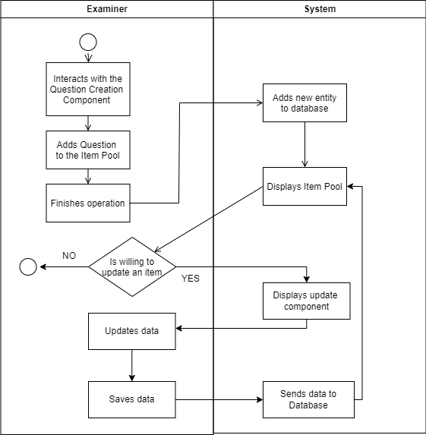

The Activity Diagram is a representation of a single specific workflow of the solution, presented in great detail and in a specific manner. One or many users may take part in the described process, which starts from only ONE initial point, and succumb to only one ending point. Multiple ending points may exist, yet they will mutually exclude each other. Any iterative process will be displayed as a loop of events until a conditional block may diverge the process.

In an Agile working environment, a specific workflow may be introduced as a feature by a developer. It is important to describe the actions in great detail while setting up the acrhitecture, so that the developer may implement the feature properly and spend the least amount of work force on the specific topic.

* **AS AN EXAMINER** I may add questions to the question pool. **THE SYSTEM** is going to add a new entity to the database, then will display the whole ITEM POOL to me, the examiner.
* **AS AN EXAMINER,** I may choose to update a question. If I choose not to update a question, the process is finished. If I choose to update a question, **THEN** **THE SYSTEM** is going to display to me a component designed to update questions. After updating the data, and saving the question, **THE SYSTEM** will send the data to the database, while displaying the new ITEM POOL to me. **THEN,** I may choose to update an item again.

### Taking a Computerized Adaptive Test

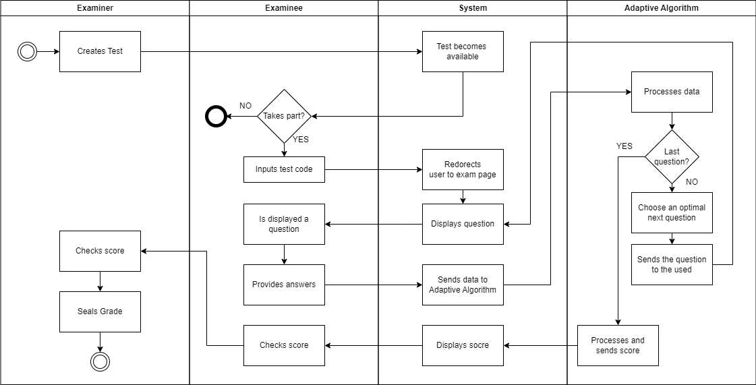

* **AS AN EXAMINER** I may choose some questions and create a **TEST**, **THEN** the **SYSTEM** is going to make the test available.
* **AS AN EXAMINER** I may check the examinee’s score, **THEN** seal their grade.
* **AS AN EXAMINEE** I may join a test by inputting the test code, **THEN** the **SYSTEM** will navigate me to the test page.
* **AS AN EXAMINEE** I may answer displayed questions, **THEN** the **SYSTEM** is going to call the **ADAPTIVE ALGORITHM** and it will provide the **SYSTEM** with an optimal question.
* **AS AN EXAMINEE** I may check my grades.

## Class Diagram

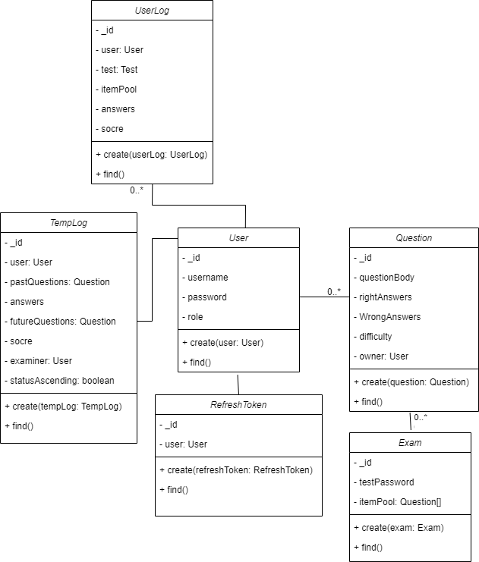

* As **User** may only have one **REFRESHTOKEN**, only one **TEMPLOG**, multiple **QUESTIONS** and multiple **USERLOGS**.
* An **EXAM** may be composed of multiple **QUESTIONS**.
* Only one **REFRESHTOKEN** may exist for each **user**.
* Only one **TEMPLOG** may exist for each **user**.

## Interaction Diagram

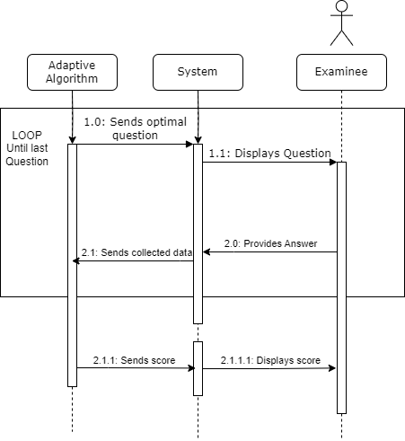

The Activity Diagram is meant to represent a specific workflow with the accent falling over the interaction between the user and the system, rather then the processes themselves. It follows a column structure and iterative processes are indicated by specific markings.

* The flow may be started by the **ADAPTIVE ALGORITHM** which sends the optimal question according to the situation the **EXAMINEE** is in, the **SYSTEM** will display the question and the **EXAMINEE** may provide an answer. The process loops until the **ADAPTIVE ALGORITHM** concludes the scoring.
* Afterwards the **SYSTEM** may display the score to the **EXAMINEE**.

# Conclusions

To conclude what has been stated, such web solution is conceived with the scope of facilitating computerized adaptive tests in a secure manner, while benefiting from multiple quality-of-life features present to enhance user experience. The two main interfaces of the application, the examiner and examinee user interfaces, tend to achieve a comfortable and user-friendly experience.

During the development process, the technology stack proved to be the right choice for this type of application since the framework provided enough built-in features to make the process fast and reliable.

While being in a functional state, the adaptive testing application is not running optimally, such application would require a prolonged period and a committed development team to sit in an optimal state, yet as a proof of concept, it fits the role in the current state.

Unlike other online testing platforms, the solution brings the adaptive factor to the table as well as the security aspects used for academic dishonesty mitigation.

# Bibliography

|  |  |
| --- | --- |
| [1] | T. Gonzalez, M. A. de la Rubia, K. P. Hincz, M. Comas-Lopez, L. Subirats and S. Fort, “Influence of COVID-19 confinement on students’ performance in higher education,” *PLoS ONE,* vol. 15, no. 10, 2020. |
| [2] | K. Gamage, D. Wijesuriya, S. Ekanayake, A. Rennie, C. Lambert and N. Gunawardhana, “Online Delivery of Teaching and Laboratory Practices: Continuity of University Programmes during COVID-19 Pandemic,” *Education Sciences,* vol. 10, no. 10, p. 5, 2020. |
| [3] | D. J. Weiss and G. G. Kingsbury, “Application of computerized adaptive testing to educational problems,” in *Journal of Educational Measurement*, Philadelphia, NCME National Council for Measurement in Education, 1984, pp. 361-375. |
| [4] | G. G. Kingsbury and A. R. Zara, “Procedures for Selecting Items for Computerized Adaptive Tests,” *Applied Measurement in Education,* vol. 2, no. 4, pp. 359-375, 1989. |
| [5] | N. A. Thompson and D. A. Weiss, “A Framework for the Development of Computerized Adaptive Tests,” *Practical Assessment, Research and Evaluation,* vol. 16, no. 1, 2011. |
| [6] | “Computerized Adaptive Testing,” NCSBN Leading Regulatory Excellence, [Online]. Available: https://www.nclex.com/computerized-adaptive-testing.page. [Accessed 3 June 2023]. |
| [7] | H. Wainer, D. Thissen and R. Mislevy, “Testing Algorithms,” in *Computerized Adaptive Testing: A Primer, Second Edition*, New York City, Routledge Taylor & Francis Group, 2014, pp. 101-134. |
| [8] | C.-J. Lin and J. Spray, “Effects of Item-Selection Criteria on Classification Testing with the Sequential Probability Ratio Test,” ACT Inc., Iowa City, 2000. |
| [9] | H. Wainer and B. Green, “System design and operation,” in *Computerized Adaptive Testing: A Primer*, 2nd ed., New York City, Routledge Taylor & Francis Group, 2014, pp. 23-36. |
| [10] | H. Wainer and R. Mislevy, “Item response theory, Item Calibration, and Proficiency Estimation,” in *Computerized Adaptive Testing: A Primer*, 2nd ed., New York City, Routledge Taylor & Francis Group, 2014, pp. 61-100. |
| [11] | E. FitzGerald, N. Kucirkova, A. Jones, S. Cross, R. Ferguson, C. Herodotou, G. Hillaire and E. Scanlon, “Dimensions of personalisation in technology-enhanced learning: A framework and implications for design,” *British Journal of Educational Technology,* vol. 49, no. 1, pp. 165-181, 2018. |
| [12] | B. F. Green, R. D. Bock, L. G. Humphreys, R. L. Linn and M. D. Reckase, “Technical Guidlines for Assessing Computerized Adaptive Tests,” *Journal of Educational Measurement,* vol. 21, no. 4, pp. 347-360, 1984. |
| [13] | R. R. Meijer and M. L. Nering, “Computerized Adaptive Testing: Overview and Introduction,” *Applied Psychological Measurement,* vol. 23, no. 3, pp. 187-192, 1999. |
| [14] | H. Chang and Y. Z., “A Global Information Approach to Computerized Adaptive Testing,” *Applied Psychological Measurement,* vol. 20, no. 3, pp. 213-229, 1996. |
| [15] | D. O. Segall, “Computerized Adaptive Testing,” in *Encyclopedia of Social Measurement*, Arlington, Academic Press, 2005. |
| [16] | S. Dendir and M. R. Stockton, “Cheating in online courses: Evidence from online proctoring,” *Computers in Human Behavior Reports,* vol. 2, 2020. |
| [17] | Y. Atoum, L. Chen, A. X. Liu, S. D. H. Hsu and X. Liu, “Automated Online Exam Proctoring,” *IEEE Transactions on Multimedia,* vol. 19, no. 7, 2018. |
| [18] | E. Gamma, R. Helm, R. Johnson and J. Vlissides, “State,” in *Design Patterns Elements of Reusable Object-Oriented Software*, Portland, Addison-Wesley, 1994, pp. 338-348. |
| [19] | E. Gamma, R. Helm, R. Johnson and J. Vlissides, “Memento,” in *Design Patterns: Elements of Reusable Object-Oriented Software*, Portland, Addison-Wesley, 1994, pp. 316-326. |
| [20] | R. C. Martin, “Chapter 2: Meaningful Names,” in *Clean Code A Handbook of Agile*, Boston, Pearson Education Inc., 2009, pp. 17-30. |
| [21] | R. Fielding, “rfc7231 Section#4,” IETF (Internet Engineering Task Force), June 2014. [Online]. Available: https://datatracker.ietf.org/doc/html/rfc7231#section-4. [Accessed 26 March 2023]. |