*Розовый цвет появляется при наведении курсора*

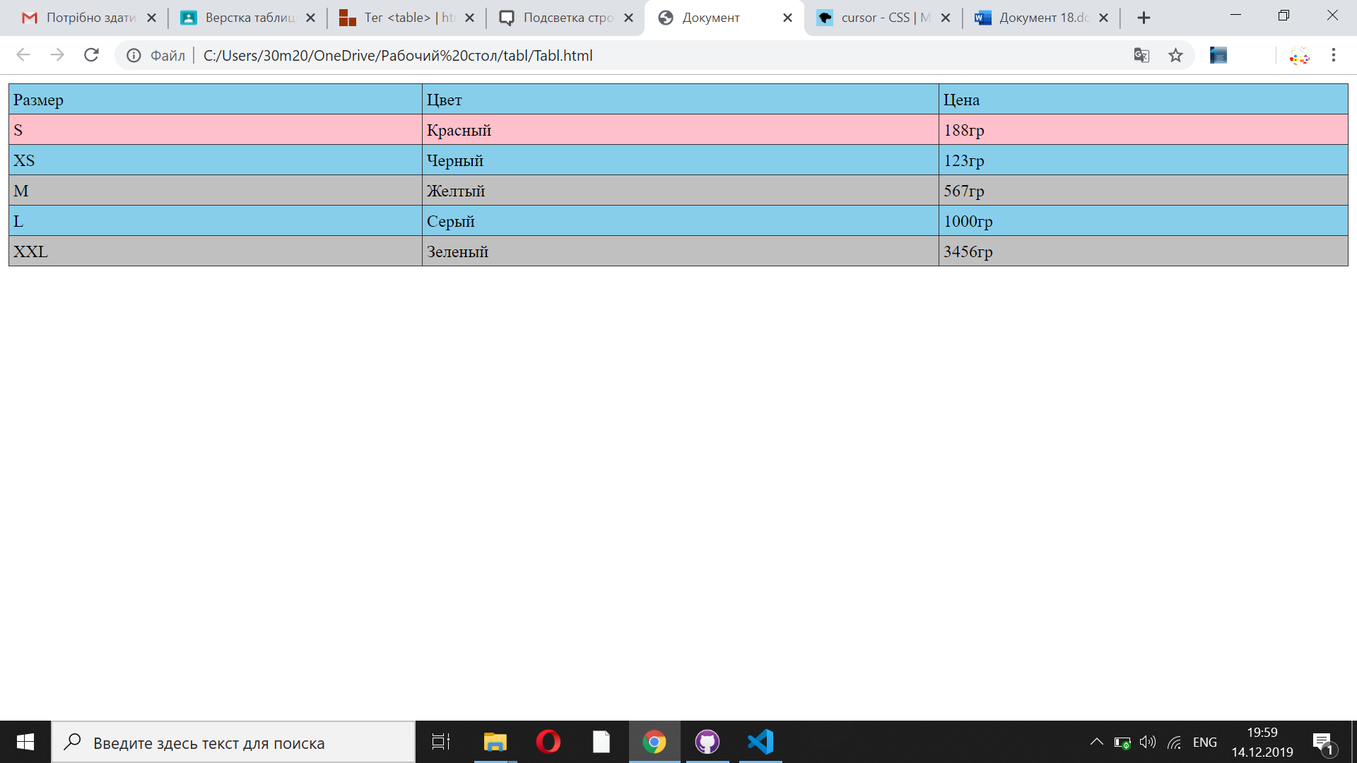

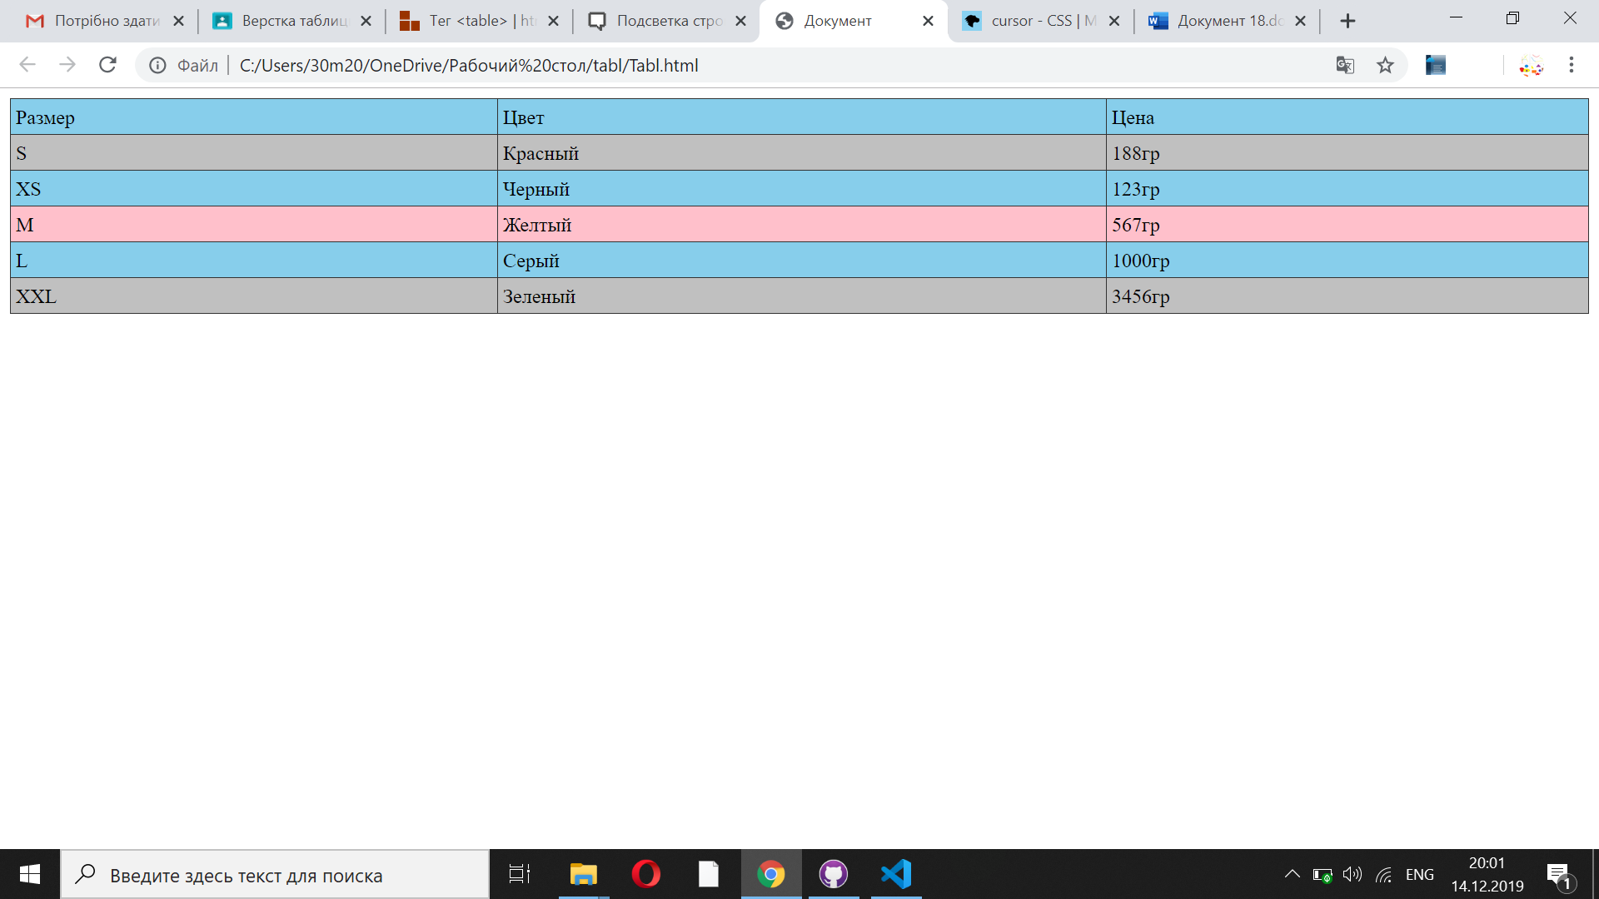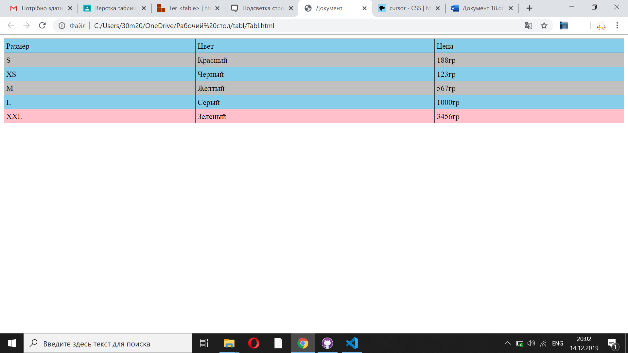**Код**

**HTML**

<!DOCTYPE html>

<html lang="en">

<head>

<meta charset="UTF-8">

<meta name="viewport" content="width=device-width, initial-scale=1.0">

<meta http-equiv="X-UA-Compatible" content="ie=edge">

<title>Document</title>

<link rel="stylesheet" href="K.css">

</head>

<body>

<table>

<tr class="first" ><td>Размер</td><td>Цвет</td><td>Цена</td></tr>

<tr class="second" ><td>S</td><td>Красный</td><td>188гр</td></tr>

<tr class="first" ><td>XS</td><td>Черный</td><td>123гр</td></tr>

<tr class="second" ><td>M</td><td>Желтый</td><td>567гр</td></tr>

<tr class="first" ><td>L</td><td>Серый</td><td>1000гр</td></tr>

<tr class="second" ><td>XXL</td><td>Зеленый</td><td>3456гр</td></tr>

</table>

</body>

**CSS**

table {

width: 100%;

border-collapse: collapse;

}

td {

border: 1px solid #333;

padding: 4px;

}

tr:hover {

background: pink;

}

.first{

background: skyblue;

cursor: pointer;

}

.second{

background: silver;

cursor: pointer;

}