Cloud Computing Technology in UAE

With the advancement of technology, UAE has been
strongly focussing in implementation of cloud computing in Information Communication Technology
(ICT) industry.
For any industry, data are of high priority. Data need to
be accessed safely with proper security and the
data need to be saved for fututre reference. So here,
cloud computing play an important role. There are many companies providing cloud computing service in UAE such as CloudzMe FZE, eHosting DataFort, Burhani Managed IT Services and many more.
Cloud computing services are mainly offered in three service models, Software-as-a-Service, Platform-as-a-Service and Infrastructure-as-a-Service on public, private or hybrid deployment model.

IaaS Paas SaaS
lets you control almost lets you develop your lets you carry out
everything from ground up own web application certain functions
such as load balancing and deploy it to their without having to
e.g AWS servers. Code it up yourself
e.g Heroku e.g Twitter

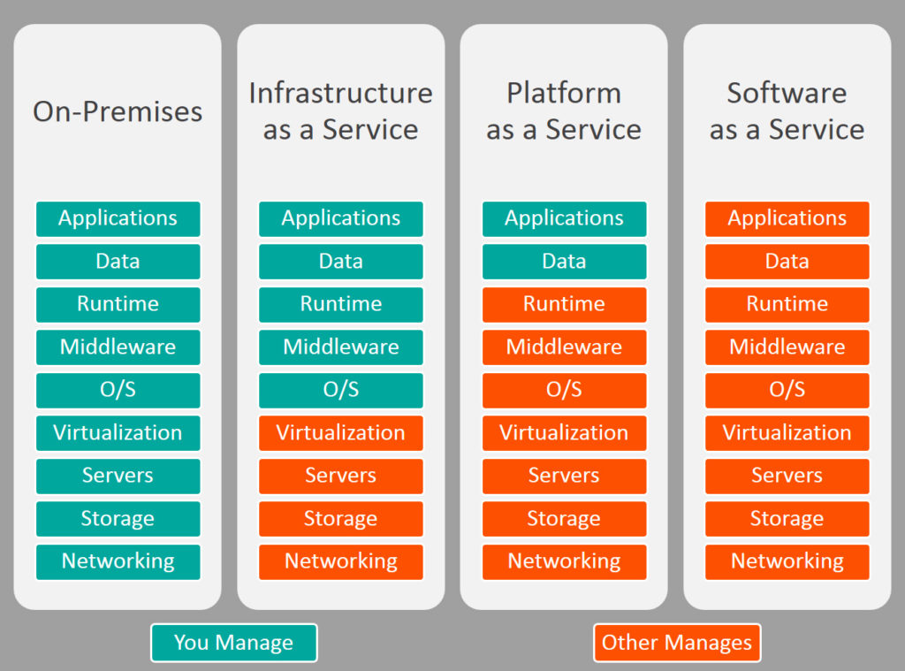

As per a survey conducted by Dun & Bradstreet in collab with EMC, 95 percent of prganiztions have already implemented or plan to implement a cloud computing model.
The study showed that 49 per cent of enterprises stated to have currently implemented a private cloud model while 35 per cent consider their environment to be a public cloud.
Public cloud services are run over the internet and are accessible to the general public like Gmail, Office365 and Dropbox while private cloud is payable and is run from within a corporate firewall, driven by concerns around security and compliance.
The study clarifies that private cloud adopters cited a clear focus on security and control when making a decision about a cloud computing model.
46 per cent of organisations cited the maximised control and security as being a primary factor for selecting private cloud while 31 per cent said that they selected the private cloud for the universal network access with seamless connectivity to public cloud resources and 12 per cent cited the ability to meet local hosting regulations as a primary reason.
As cited on study, public cloud services such as infrastructure as a service (IaaS) and software as a service (SaaS) will begin to tear apart and disrupt traditional software and service base as competition intensifies.IaaS is a model in which an organisation outsources the equipment needed to support operations while paying on a per-use basis. SaaS is a model that allows organisations to gain access to software and it is hosted remotely while paying on a per-use basis.
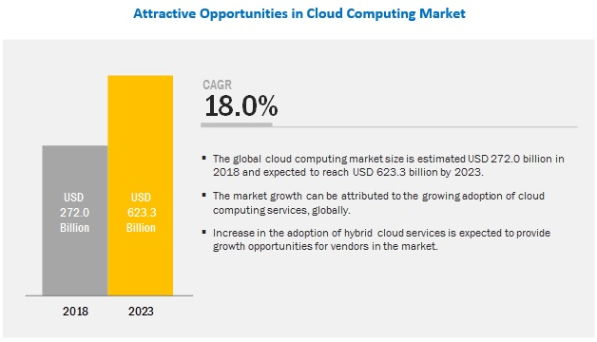

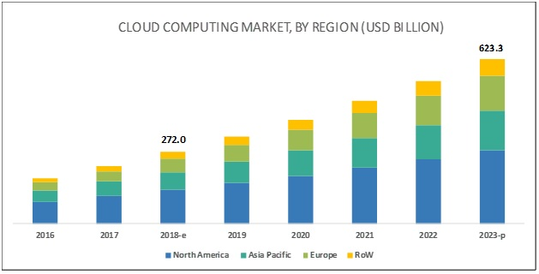



Cloud Computing in future:
From an alternative to necessity, there is no doubt that Cloud Computing will rule the future. There are infinite potentials citing what can be achieved with the help of cloud computing.
Cloud computing is estimated to grow at a compound annual growth (CAGR) of 19% and is expected to reach $162 billion in 2020 from $67 billion in 2015.
Gartner has also predicted that worldwide public cloud services will grow to $247 billion in 2017 from $210 billion in 2016.
The revenue of Amazon Web Services (AWS) will reach $43 billion by 2022, which will be around 9% of all cloud spending in the world.
By 2022, the global spending on IT-as-a-service will reach $547 billion.

So why cloud computing will rule?
- From security point of view, It is more secure. Big cloud operators have more security and capacity for data. And their own employees even dont have the access to server.
- It is economical for big data.
- Developers are safe from software piracy.
- Energy will be efficient as cloud computing datacenters use less resources.
- Everything will be digitized and hardware will be on extinction.

Cloud computing initially emerged in the United States. Since 2015, the U.S. has been the leader in cloud adoption and still it ranks first. In fact, by 2022, cloud adoption for all other countries will lag behind the U.S. by one to seven or more years. Also in 2022 in the U.S., 14% of total IT spending will be on cloud services.
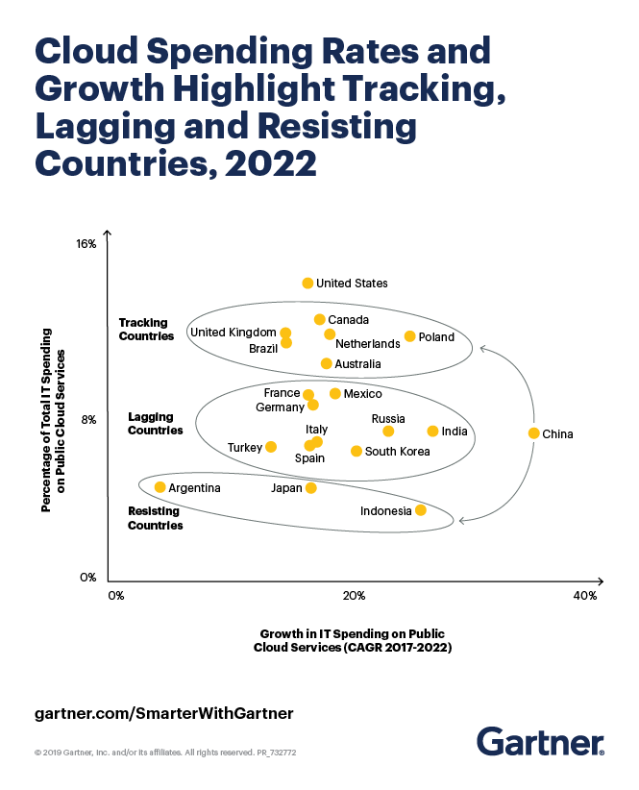
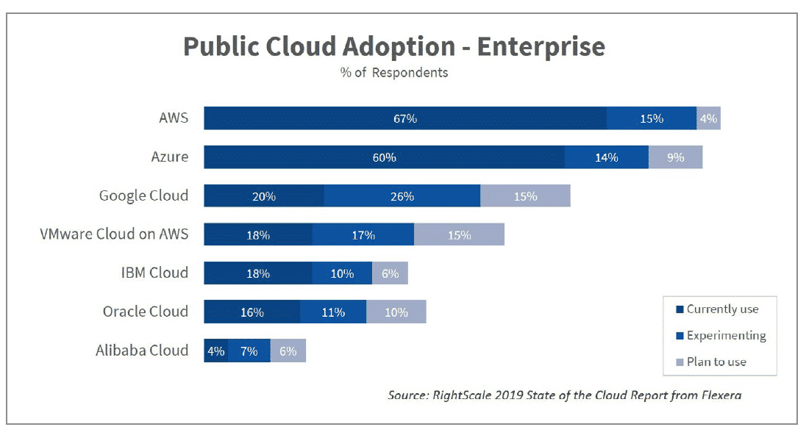

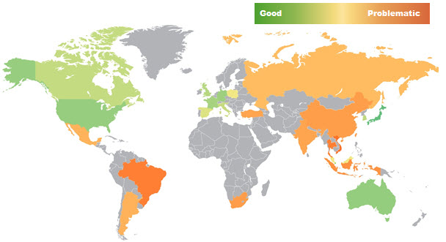

Virtual environments¶

Linux Systems¶

sudo ansible-pull -U https://github.com/stmcginnis/cinder-dev-setup
If that does not work for your system, continue on with the manual steps below.
Install the prerequisite packages.
On Ubuntu16.04-64:
sudo apt-get install python-dev libssl-dev python-pip git-core libmysqlclient-dev libpq-dev libffi-dev libxslt-dev
To get a full python3 development environment, the two python3 packages need to be added to the list above:
python3-dev python3-pip
On Red Hat-based distributions e.g., Fedora/RHEL/CentOS/Scientific Linux (tested on CentOS 6.5 and CentOS 7.3):
sudo yum install python-virtualenv openssl-devel python-pip git gcc libffi-devel libxslt-devel mysql-devel postgresql-devel
On openSUSE-based distributions (SLES 12, openSUSE 13.1, Factory or Tumbleweed):
sudo zypper install gcc git libmysqlclient-devel libopenssl-devel postgresql-devel python-devel python-pip

macOS Systems¶
Install virtualenv:
sudo pip install virtualenv
Check the version of OpenSSL you have installed:
openssl version
If you have installed OpenSSL 1.0.0a, which can happen when installing a MacPorts package for OpenSSL, you will see an error when running cinder.tests.auth_unittest.AuthTestCase.test_209_can_generate_x509.
The stock version of OpenSSL that ships with Mac OS X 10.6 (OpenSSL 0.9.8l) or later should work fine with cinder.

Getting the code¶
Grab the code:
git clone https://opendev.org/openstack/cinder.git
cd cinder

Running unit tests¶
The preferred way to run the unit tests is using tox. It executes tests in isolated environment, by creating separate virtualenv and installing dependencies from the requirements.txt and test-requirements.txt files, so the only package you install is tox itself:
sudo pip install tox
Run the unit tests by doing:
tox -e py35
tox -e py27

Manually installing and using the virtualenv¶
You can also manually install the virtual environment:
tox -e py27 --notest
or:
tox -e py35 --notest
This will install all of the Python packages listed in the requirements.txt file into your virtualenv.
To activate the Cinder virtualenv you can run:
$ source .tox/py27/bin/activate
or:
$ source .tox/py35/bin/activate
To exit your virtualenv, just type:
$ deactivate
Or, if you prefer, you can run commands in the virtualenv on a case by case basis by running:
$ tox -e venv -- <your command>

References:
https://gulfnews.com/technology/cloud-computing-gains-traction-in-uae-1.1443530

