**MINI PROJECT (COMP 8157-1R-2021S)**

**Professor Name : Dr Kalyani Selvarajah**



**Assignment 4**

**Student id: 110026527**

**Student Name :Margaret Arulmalar Rebeka Nesaraj**

**Uwin Mail:nesarajm@uwindsor.ca**

**Submitted date: 01.08.2021**

Contents

**Introduction:** 3

**Dataset:** 3

**Data pre-processing:** 3

**LOL Environment:** 4

**Approach 1 :Data Exploration:** 4

Winning count and density 5

Correlation between the Kills and First Tower Capture 5

Correlation between the Dragon Kills and First Dragon capture 5

Correlation between the Kills and First inhibitor capture 6

Missing data: 7

**Approach 2: Data Visualisation** 7

Composition Plots: 8

**Recommendation for Coach /Players** 9

**Conclusion** 9

**References:** 10

# **Introduction:**

In this digital era most of the games are played online connecting the players across the globe. The League of Legends (LOL) is one such multiplayer e-game that has become the King of Games having over a 100 million users. LOL Tournaments and other events are being conducted frequently, thereby attracting a lot of players. LOL has a huge repository of Gaming data that can be utilized for data analytics and data visualisation to predict the Game plan for winning strategies. It is fascinating to work with the raw dataset of such a popular game and to infer salient features and strategies contributing to the winning solution that would help Coaches and Players. I have taken the data of over 600+ LOL ranked games for the visualisation project with R-Studio. This project is implemented on R-Studio Version 1.4.1717 and plotly library is being used to plot the data. Data Exploration and Data Analysis techniques are used to extract the information from raw data.

# **Dataset:**

The League of Legends dataset contains the 2016-2018 Tournament data from the North America Server. It is a collection of 600+ ranked games containing data of the different game parameters like dragons, towers, blood, barons, environments etc.. for two different teams. A team generally consists of 5 players whose collaborative approach is vital for the success of the team. It is challenging yet rewarding to work with a complex dataset and to make inferences on the deciding factors for game wins which helps to improve the game-play.

# **Data pre-processing:**

Data pre-processing was done by cleaning the data after analysing the summary. Some columns were dropped based on the prior gaming experience. In addition, misspelt column names were corrected.

*Fig 1 : High level overview of LOL dataset (after data pre-processing)*

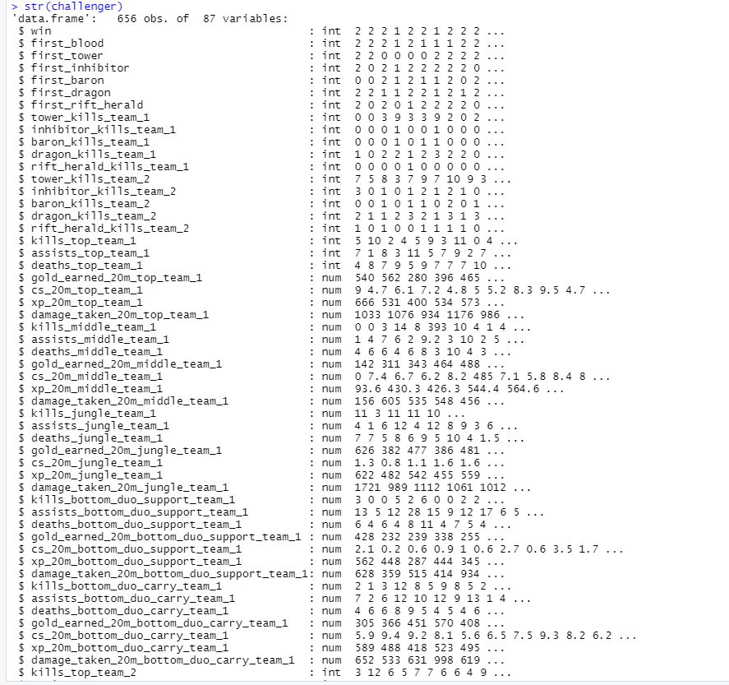

*Fig 2 : Summary of LOL dataset (after data pre-processing)*

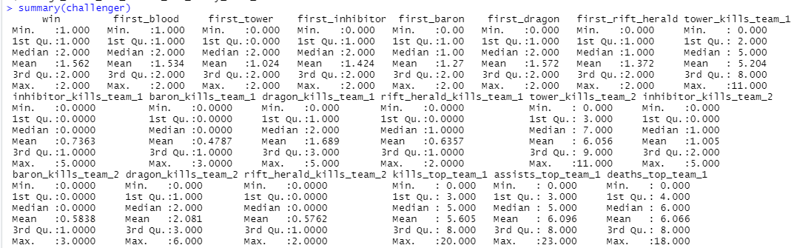

# **LOL Environment:**

The Game Environment has different lanes like Jungle, Top lane, Mid lane and Bottom lane with Turrets, Inhibitors and Nexus for each team.

*Fig 4: LOL Environment*

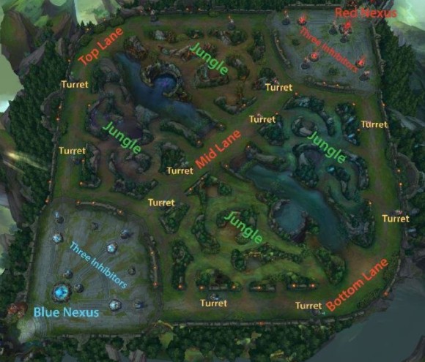

# **Approach 1 : Data Exploration:**

An overview of the data structure and patterns were extracted using different plots and bar diagrams. Correlation analysis was done on Towers, Dragon and Inhibitors for the capture of Firsts. This helps in identifying the key attributes of the dataset and locates the outliers. For better understanding, the dataset has been summarised using the below formula in R

**Formula: str(challenger), summary(challenger)**

**Visual Analysis:** The statistical summary of the dataset is viewed using a visual aid to find the relationships and characteristics between the variables.

## Winning count and density

The winning count and density distribution were analysed before moving in depth to the data visualisation. It is observed that, overall the Team 2 has more number of wins nearly 400 while the Team 1 has less than 300 wins. It is significant to note that the Team 2 has more Wins/Density

*Fig 5: Winning count of LOL Teams Fig 6: Team-wise Win Distribution of LOL*

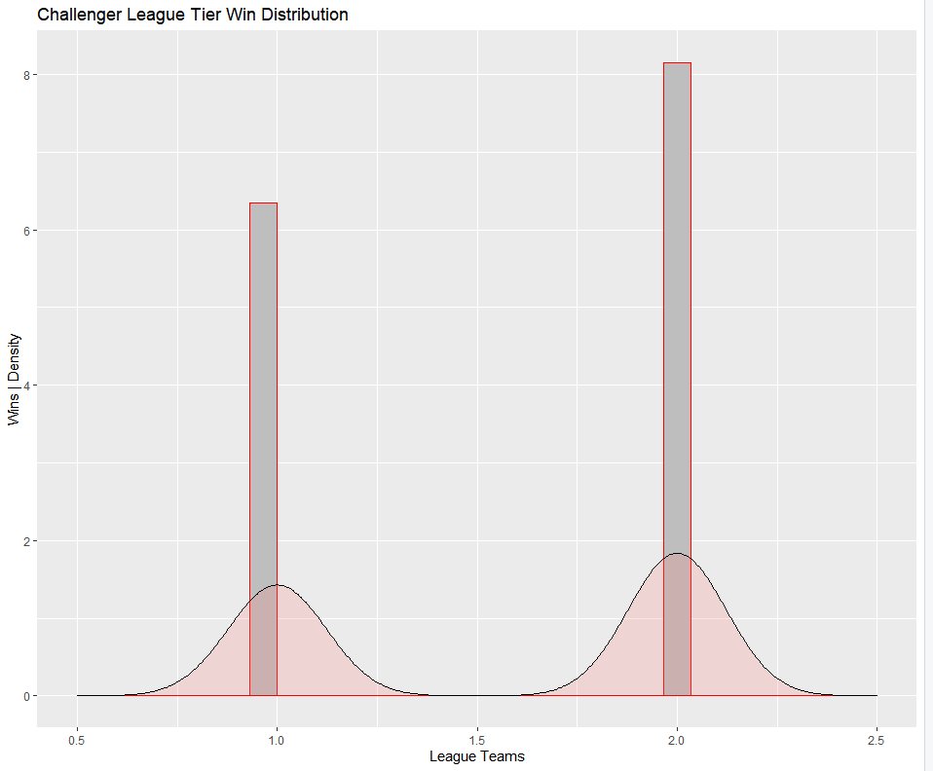 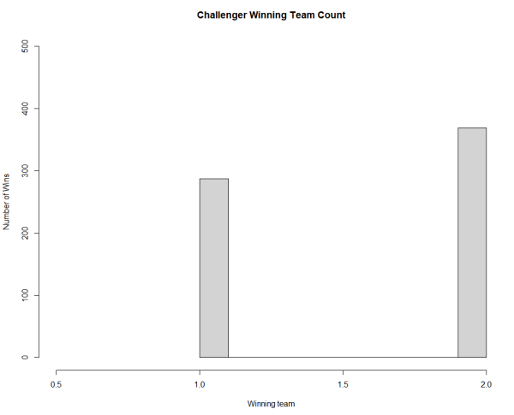

## Correlation between the Kills and First Tower Capture

The capture of the first tower plays a vital role in LOL as it accumulates the bonus points. Correlation between the number of Tower kills and the capture of the first Tower for Team 1 and Team 2 were plotted using a point plot. **It is observed that the number of Tower Kills does not necessarily lead to the capture of the first tower** .In other words the pattern implies that the higher kill count did not lead to the capture of the significant first tower. There is no strong correlation pattern observed between First Tower capture and number of kills for both the teams.

*Fig* *7: Tower Kills Vs First Tower Capture*

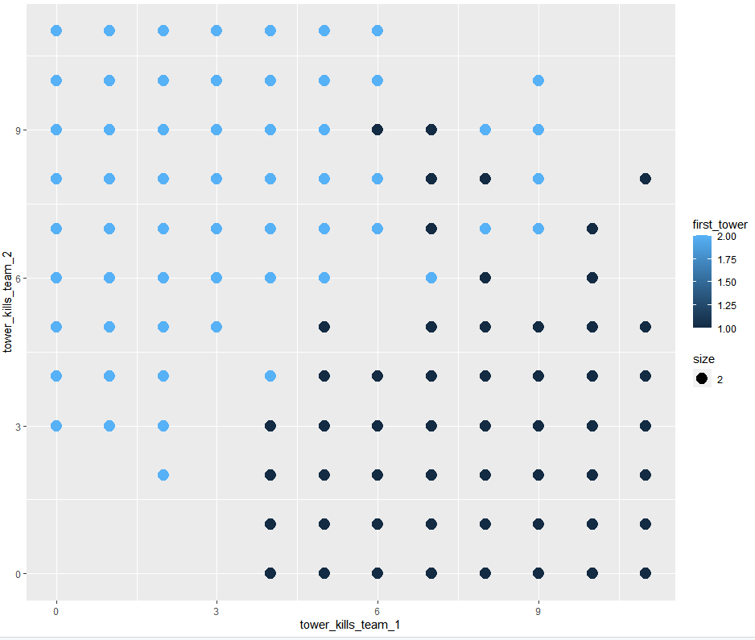

## Correlation between the Dragon Kills and First Dragon capture

Point plots were drawn to visualise the relationship between the number of Dragons killed and its significance in capturing the First Dragon for Team 1 and Team 2. From the below graph at (0,0) it is clear that despite the Dragons not being killed (0 Dragons died ) , the Teams were still able to capture the First Dragon. **The number of Dragons killed does not considerably contribute to conquer The First Dragon.**

*Fig 8: First Kill Vs Tower Capture*

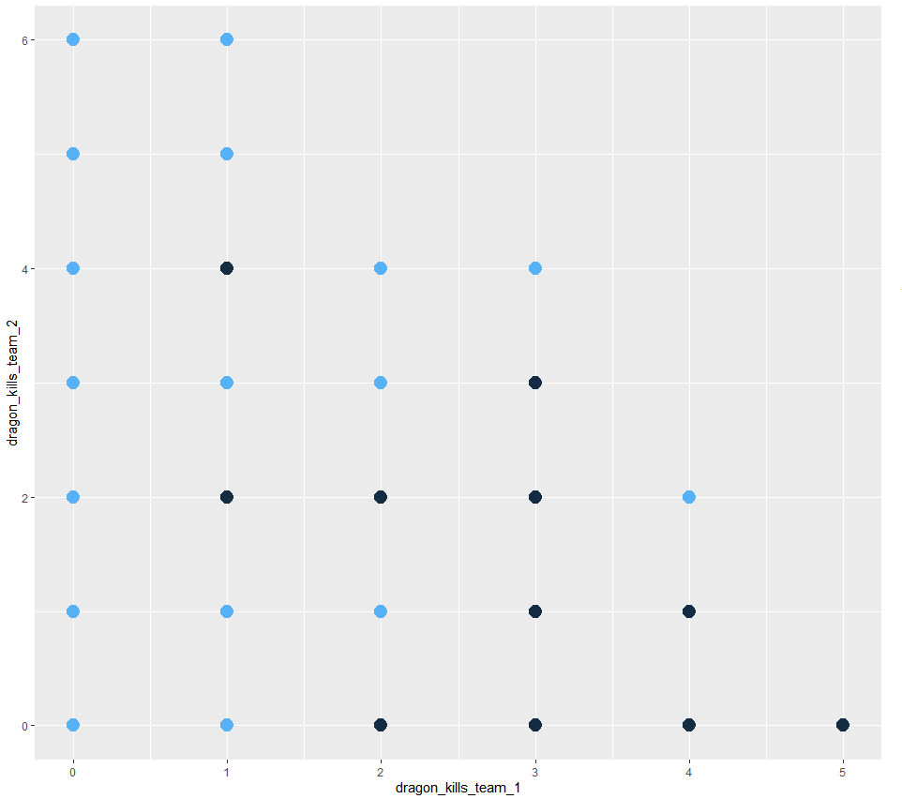

## Correlation between the Kills and First inhibitor capture

Point plots were drawn to visualise the relationship between the number of inhibitors killed and its significance in capturing the First inhibitors for Team 1 and Team 2. At the coordinate (0,0) it is evident that despite the inhibitors not being killed (0 Inhibitor died ) , the Teams were still able to capture the First Inhibitor. **The number of Inhibitors killed didn’t contribute to a greater extent in capturing the First Inhibitor.**

*Fig* 9: First Kill Vs Inhibitor Capture

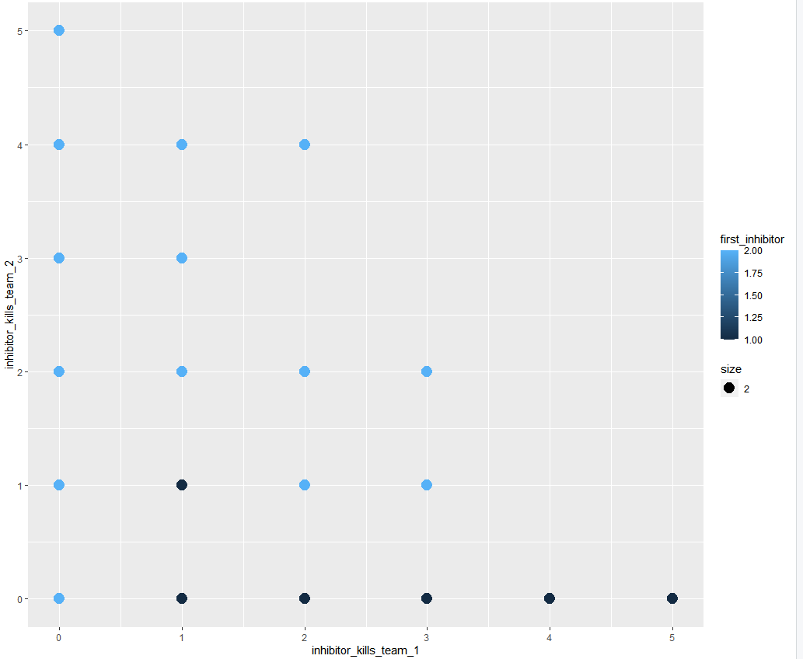

## Missing data:

Analysing missing values is vital in determining the data quality and helps to avoid bias to further prepare data for reliable prediction and collect information on the factors contributing to the best Game-play. No missing values are deducted here.

**Formula used : md.pattern(“Challenger”)**

*Fig 3: Observing missing data*

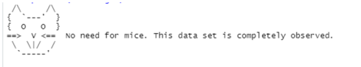

# **Approach 2: Data Visualisation**

As Joe Sacco rightly said, “It is a visual world and people respond better to Visuals than words”. Visualization helps us to tell a compelling story with the inference made from the data using varied visual representations like chart, graph, plots, etc to visually discriminate the composition of data and variables, data distribution and relationship between the variables

The dataset was queried focusing the features First Tower, First Inhibitors and First Dragon. This query is then used with datafrane to populate the graphs .If the First Dragon/Inhibitor/Tower is 1 then it is represented by Team 1 Red, if it is 2 then it is Team 2 Blue and 0 represents none of the team won or a tie.

Fig 8 :Query to manipulate the First’s data

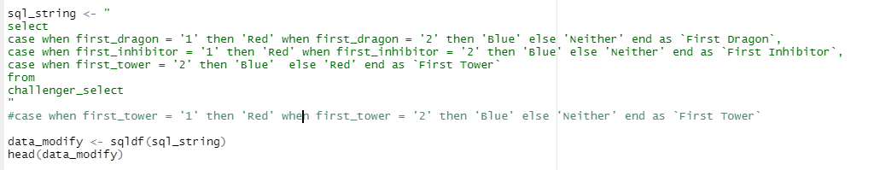

From the below image it is observed that the **Team 1 defeated the majority of the First Dragon and Inhibitor with counts ranging above 300**. The neutral defeats for First Inhibitor are a little over 50 while in the case of First Dragon it’s negligible. Although the **First tower was almost equally secured by both the teams, team 2 shows a slight edge.**

*Fig 9: Firsts acquired general vs win count plot*

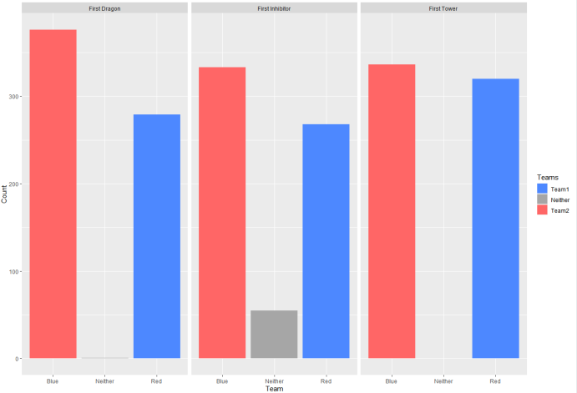

## Composition Plots:

The composition of Creep Score, Experience, Gold Earned and Damage across the different lanes was taken an analysed. It is worthy to point out that **acquiring more Gold in the first 20 minutes and gaining more Experience favours the Team’s win**. On the other hand, killing the minions had less significant impact on game points unless they were in large numbers. Keeping the damage level less is found to be favourable in all areas exception Jungle. It is **advisable to position low-health players in Jungle to avoid dealing with major damages** which could have a key impact. The highest point scored for minions killed (Team 1) and experienced gained (Team 2) is from the Mid-lane.

*Fig 10 : Location of Team Vs Points scored(minions) Fig 11 :Location of Team Vs Points scored(experience)*

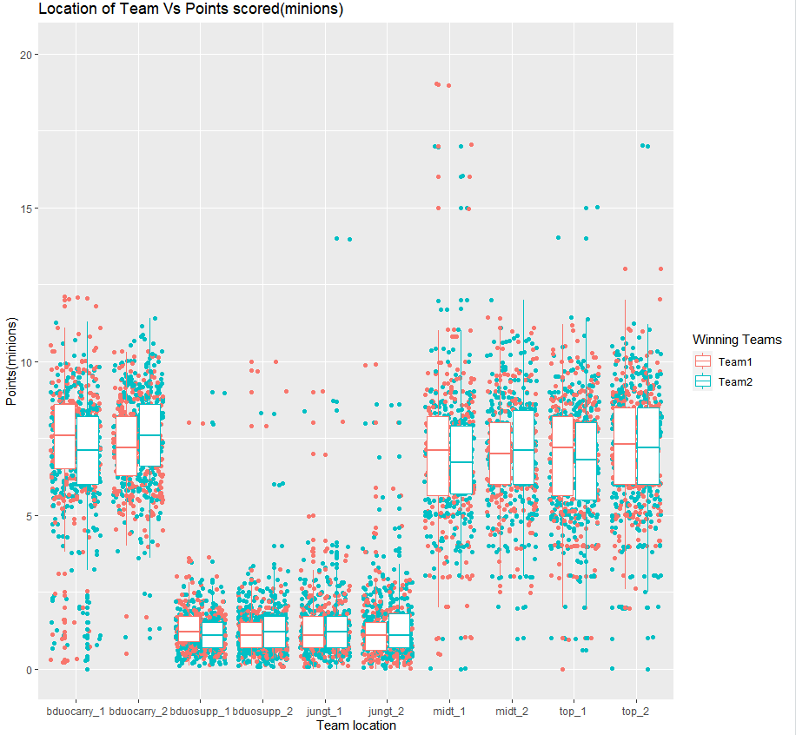 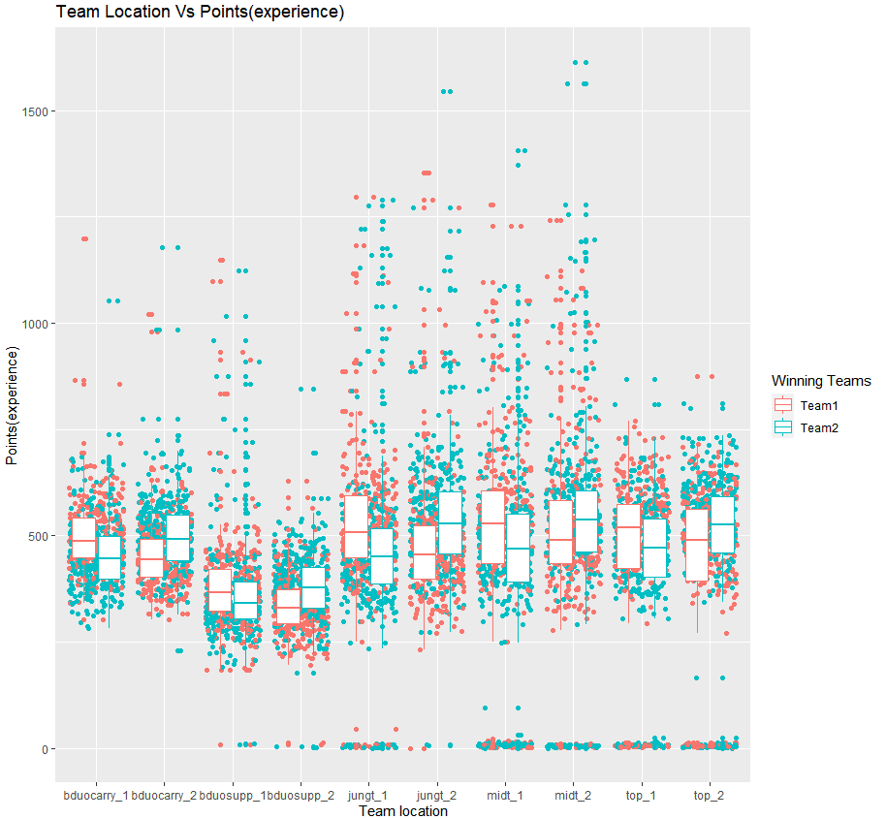

*Fig 12 :Location of Team Vs Points scored(gold) Fig 13 :Location of Team Vs Points scored(damage)*

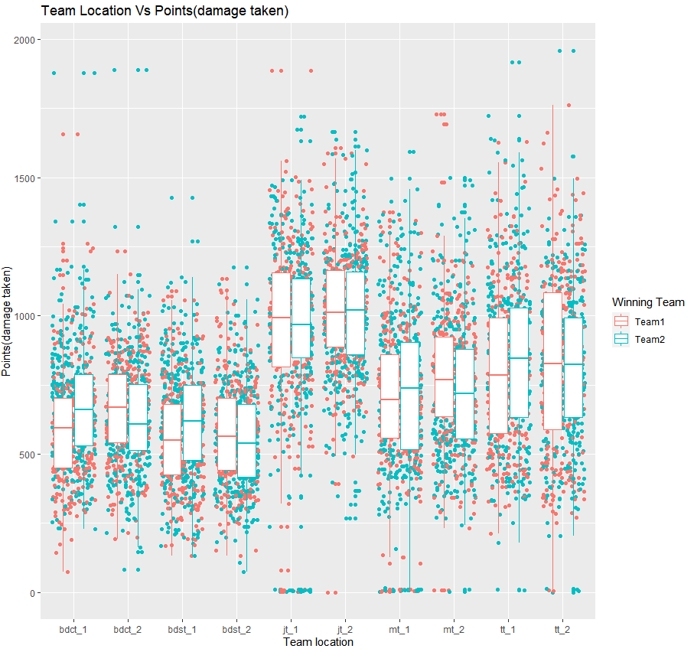

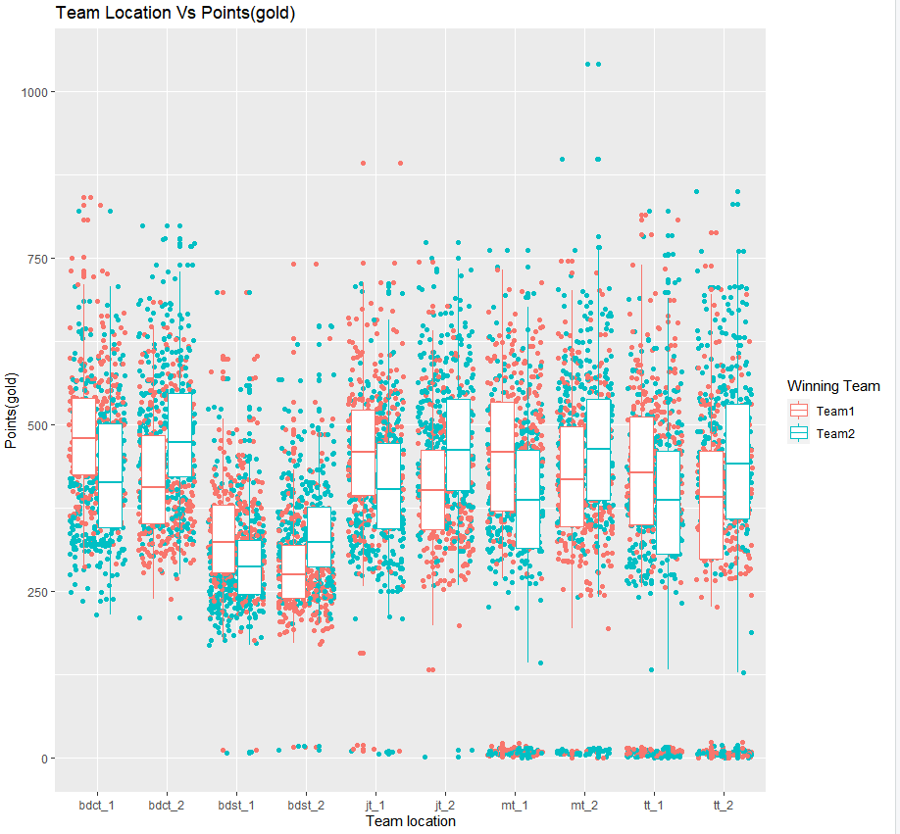

**From the below charts its inferred that the team that captures first tower and first inhibitor has the most chance of game win**

*Fig* 14 : Comparison of Wins Vs Loss for First Tower Fig 15 : Comparison of Wins Vs Loss for First Inhibitor

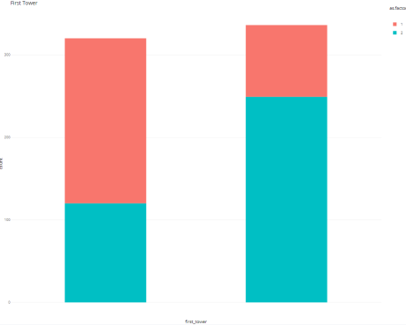 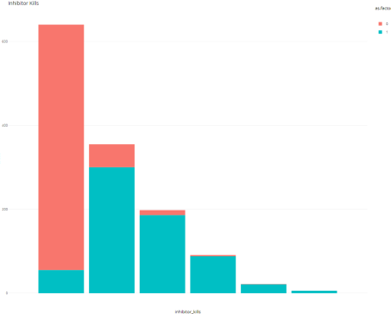

**Viewing the below chart, the Dragon kills is not** **essential for winning the game. (**Red indicates game lost and Blue indicates game won**)**

Fig 16 :Dragon Kill count Win Vs Loss

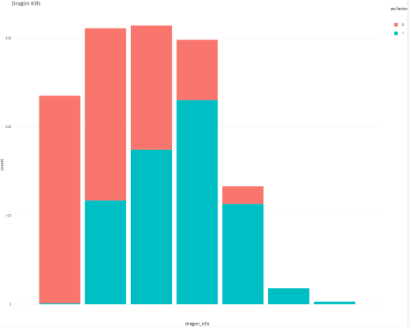

# **Recommendation for Coach /Players**

Based on analysis of Gold, Tower, Dragon and Inhibitors

1. The team must collect substantial amount of gold to increase strength and destroying the enemy’s Nexus to Win the match. Analysis shows that gold acquired is correlated with winning. Each lane of the map requires its own strategy in acquiring the most gold in the first 20 minutes of the game.
2. The team should aim at acquiring the first tower, first inhibitor and first dragon to improve the winning chances

# **Conclusion**

Different techniques were used to draw insight from the underlying data for the League of Legends game which will help the team in their goal of achieving the championship. The trainer and trainee players can make use of these strategies to achieve their Championship Goal.

# **References:**

<https://www.kaggle.com/gabisato/league-of-legends-ranked-games/code>

<https://expertgamereviews.com/how-to-get-better-at-warding-league-of-legends/>

<https://en.wikipedia.org/wiki/League_of_Legends>