3. What country generated the highest profit in 2019

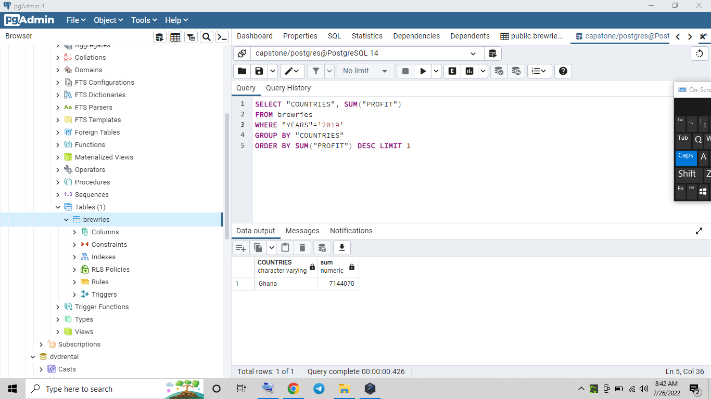

4. Help him find the year with the highest profit.

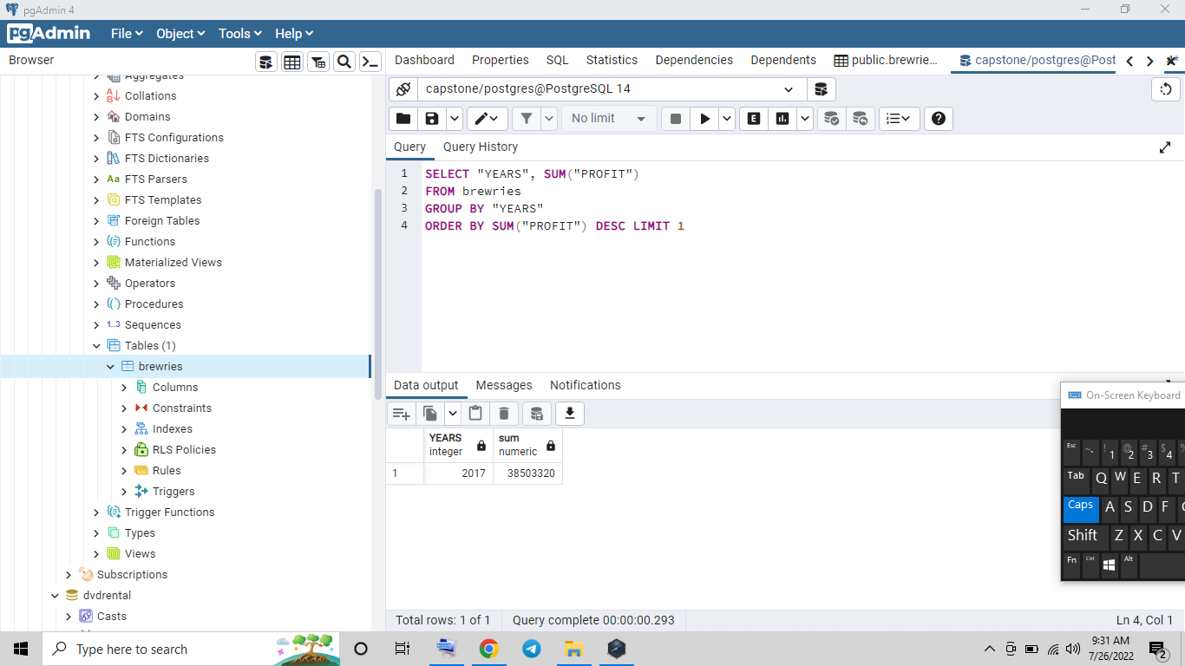

5. Which month in the three years was the least profit generated?

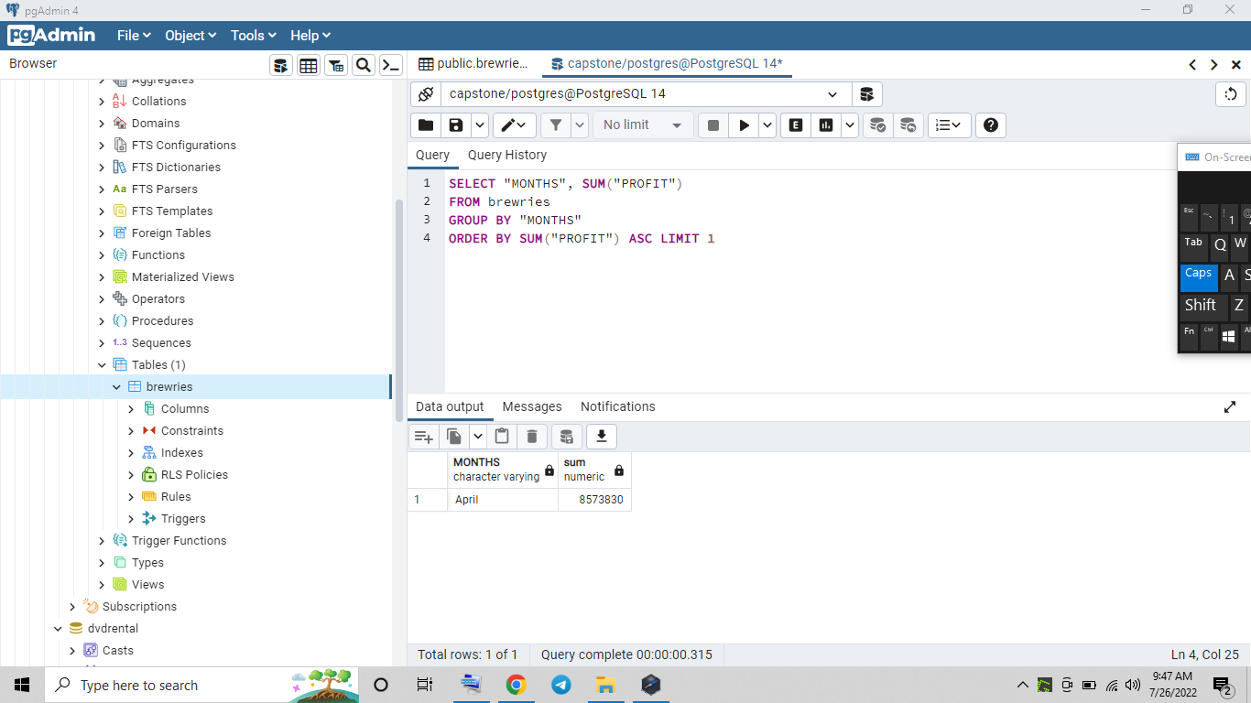

6. What was the minimum profit in the month of December 2018?

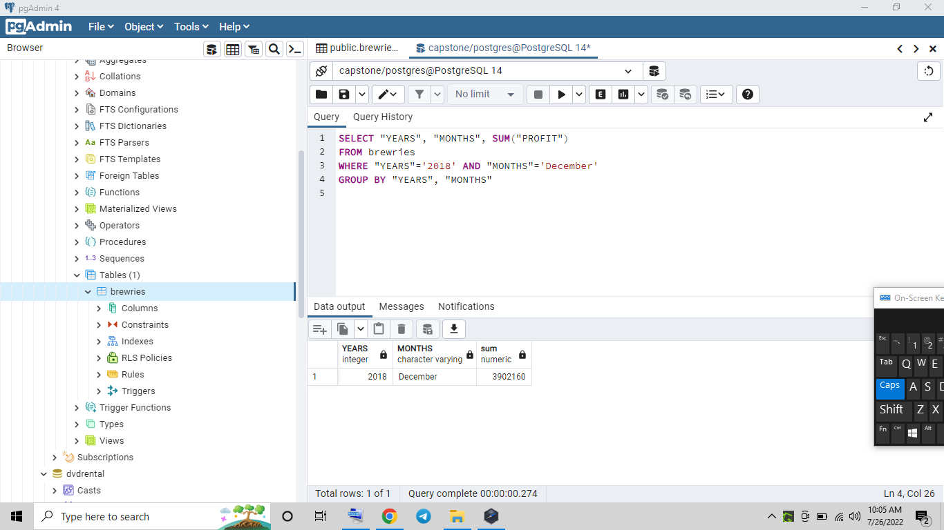

7. Compare the profit for each of the months in 2019

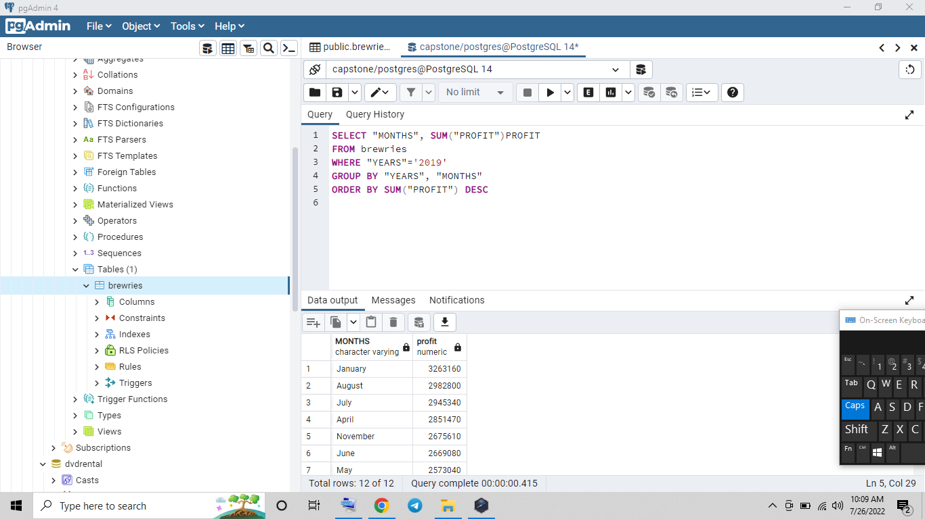

8. Which particular brand generated the highest profit in Senegal?

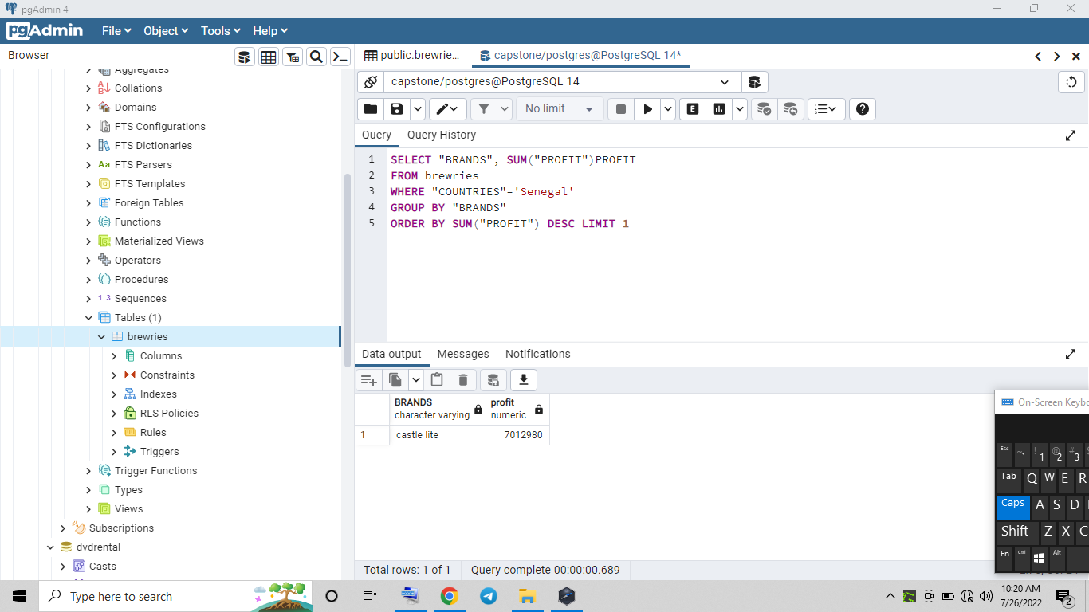

**Session B**

**BRAND ANALYSIS**

1. Within the last two years, the brand manager wants to know the top three brands consumed in the francophone countries

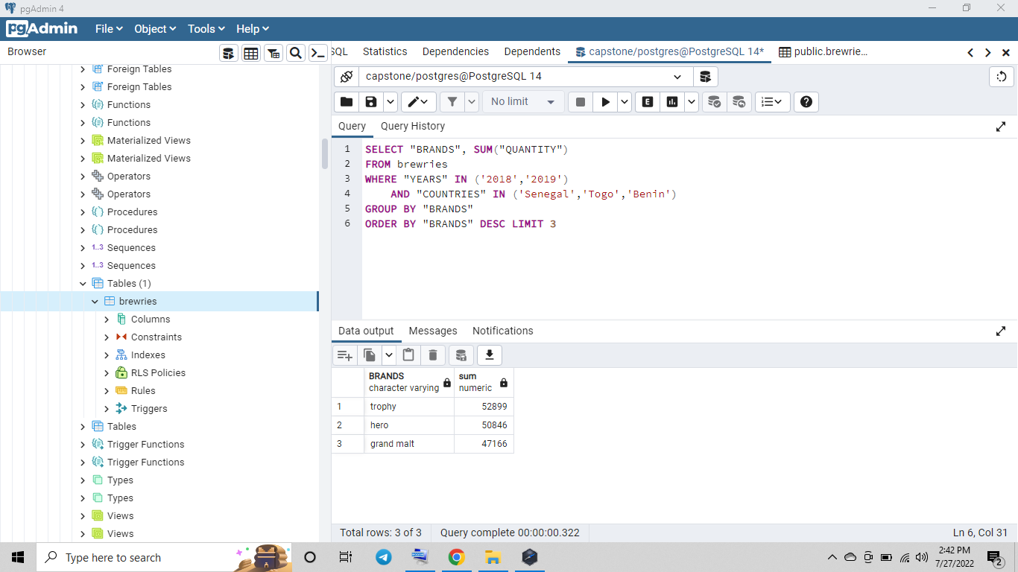

2. Find out the top two choice of consumer brands in Ghana

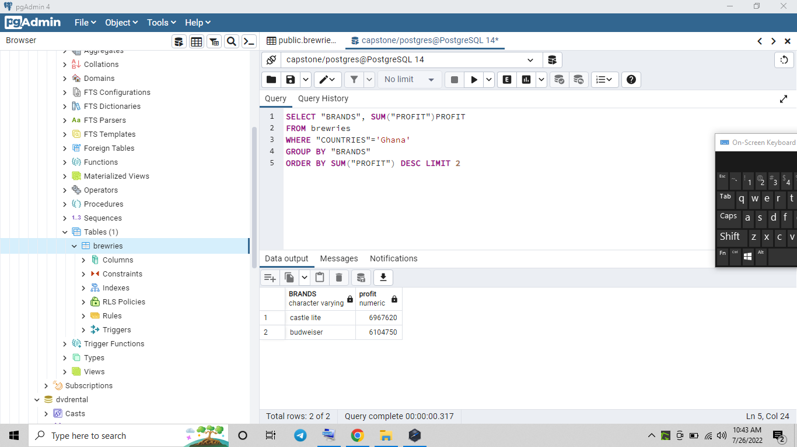

3. Find out the details of beers consumed in the past three years in the most oil reached country in West Africa.

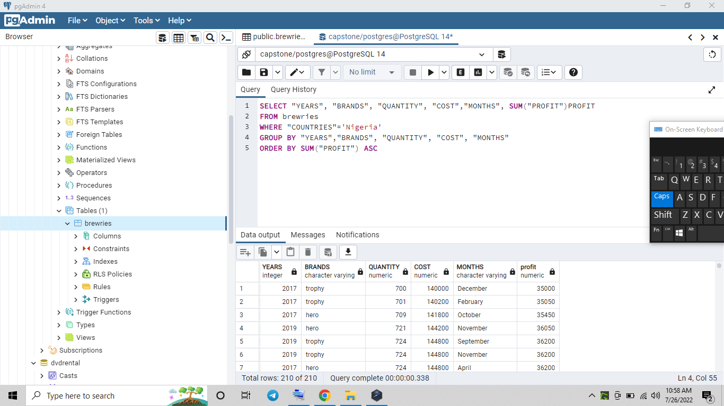

4. Favorites malt brand in Anglophone region between 2018 and 2019

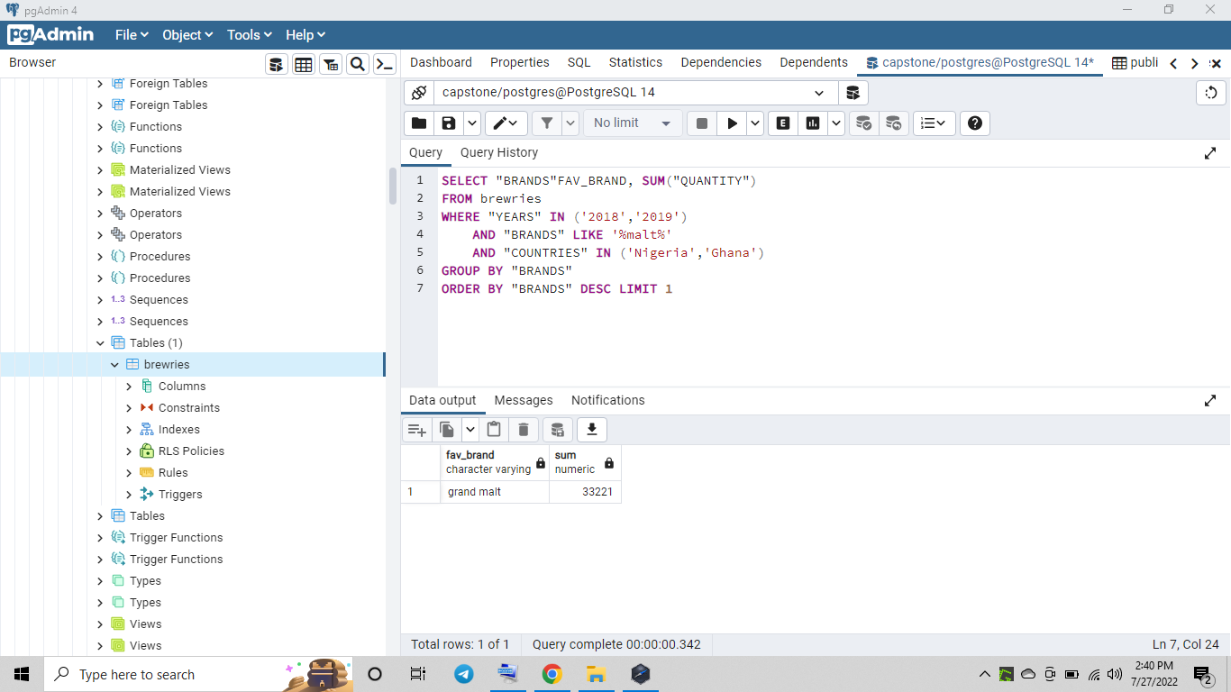

5. Which brands sold the highest in 2019 in Nigeria?

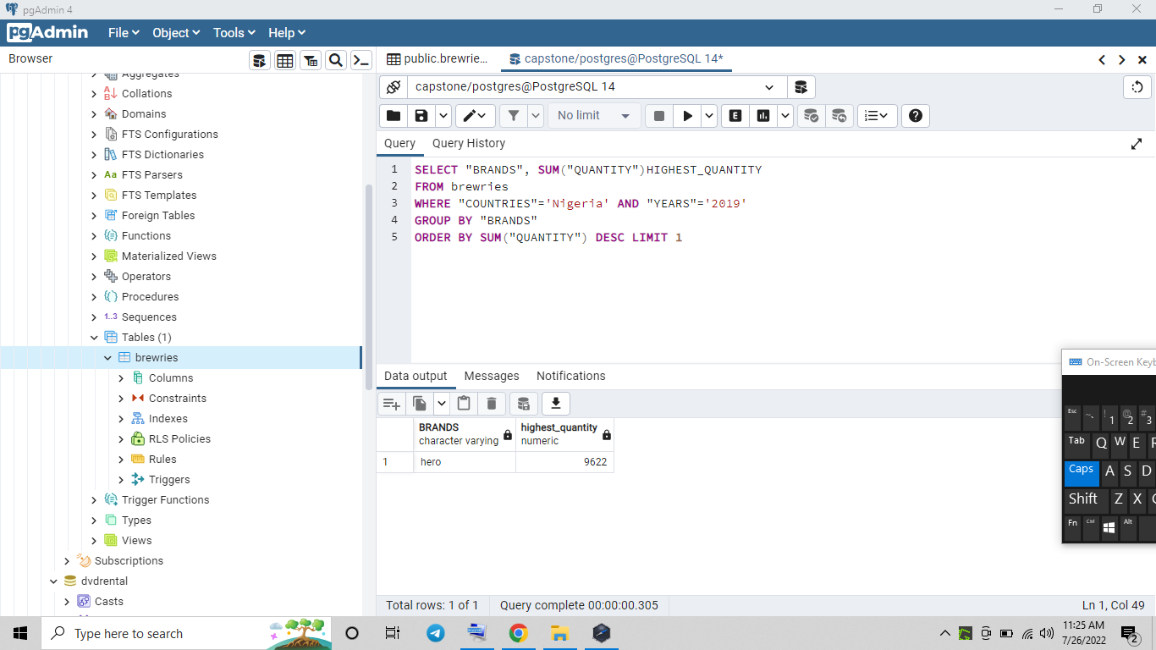

6. Favorites brand in South_South region in Nigeria

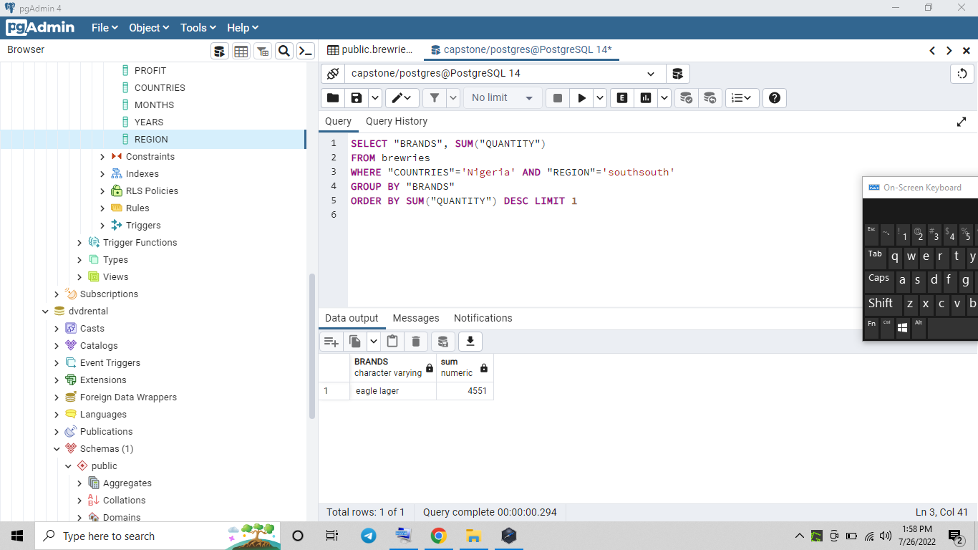

7. Bear consumption in Nigeria

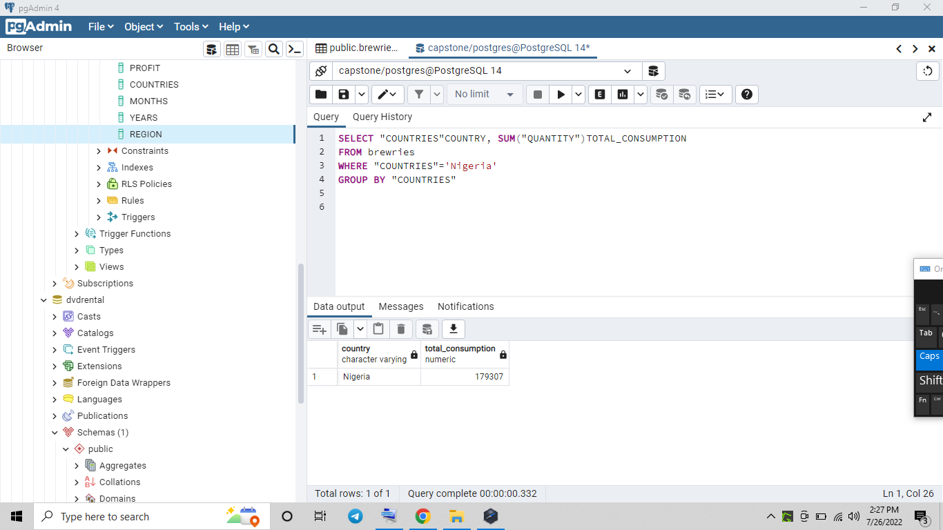

8. Level of consumption of Budweiser in the regions in Nigeria

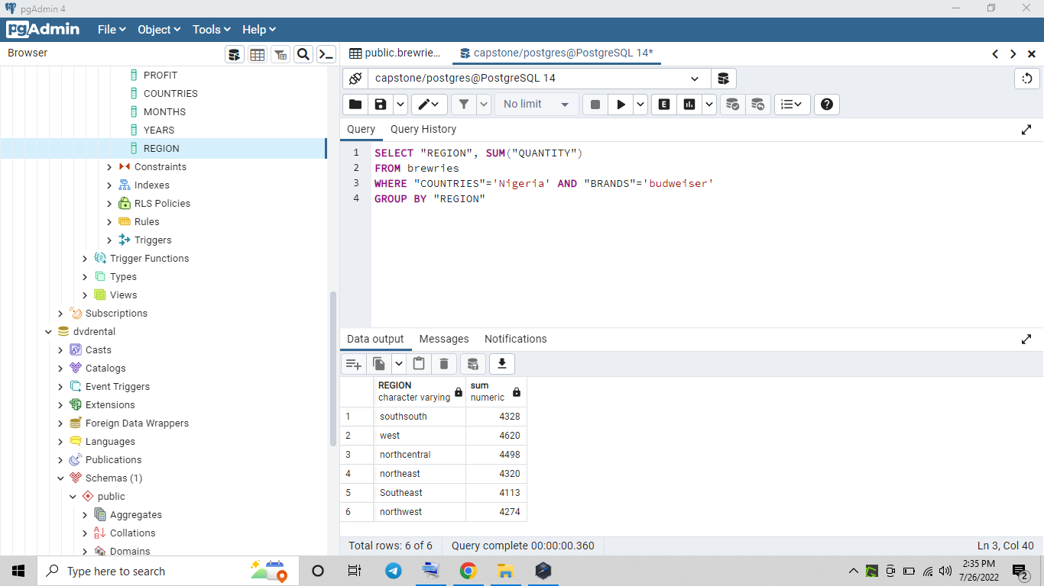

9. Level of consumption of Budweiser in the regions in Nigeria in 2019 (Decision on Promo)

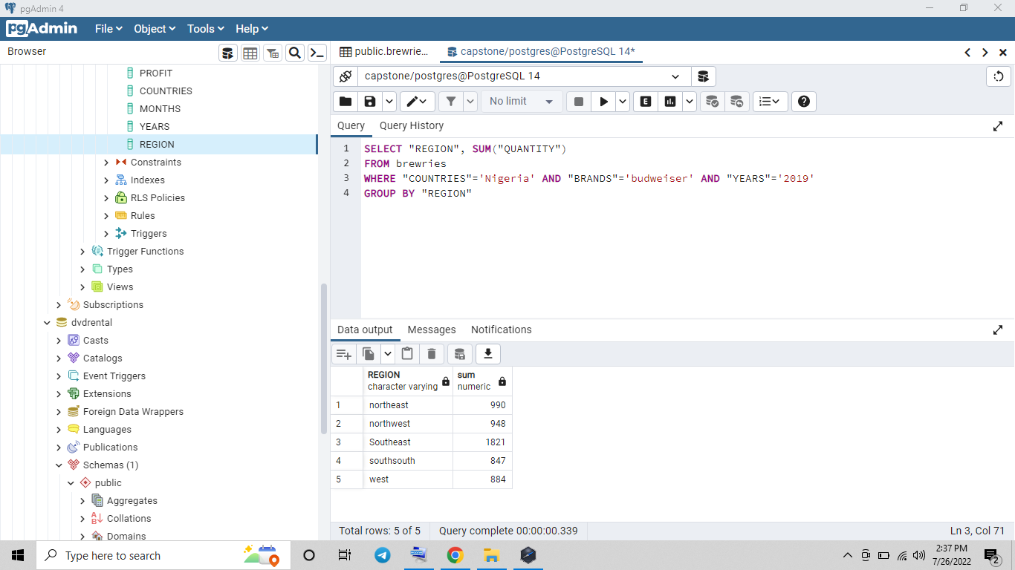

**Session C**

**COUNTRIES ANALYSIS**

1. Country with the highest consumption of beer.

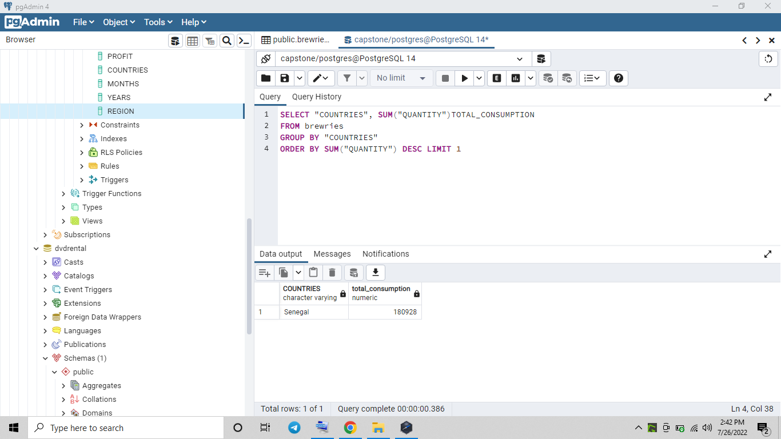

2. Highest sales personnel of Budweiser in Senegal

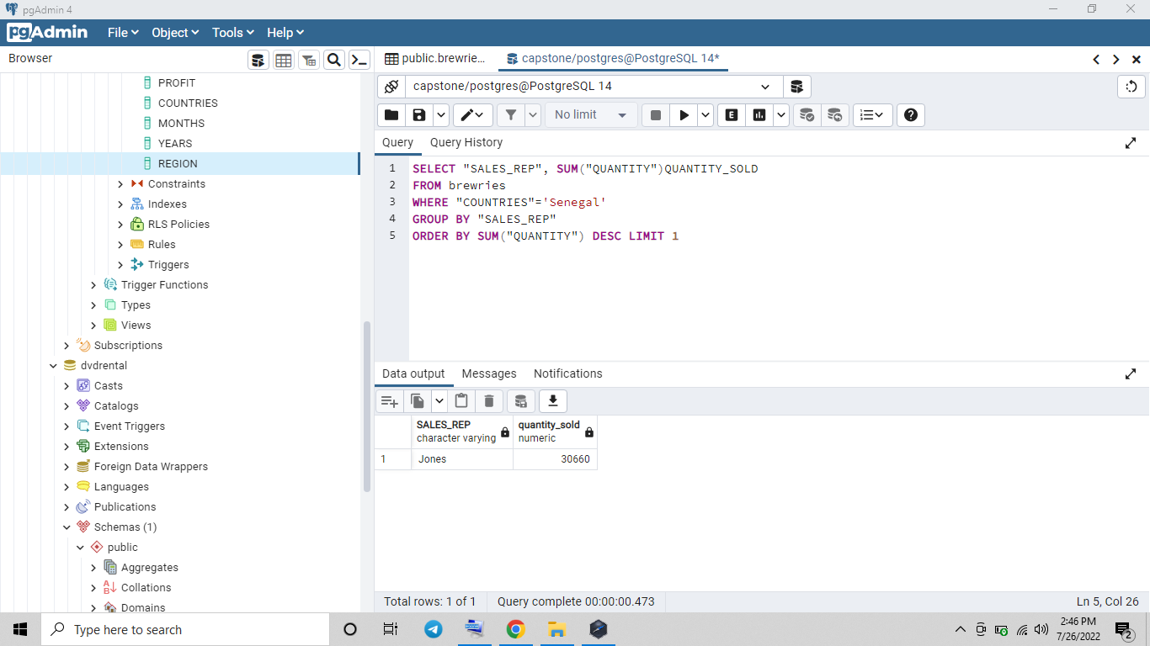

3. Country with the highest profit of the fourth quarter in 2019

