BoothFlow Application

About This Guide
This user guide provides step-by-step instructions for using the BoothFlow application. It covers all three user portals — Booth Representative, Manager, and Admin — and is intended to help users navigate the system effectively during Dell Technologies Forum Singapore.

Who Is This Guide For?
- Booth Representatives — scanning QR codes and capturing leads
- Managers — monitoring team performance and managing follow-ups
- Administrators — managing users, teams, and system settings

How to Use This Guide
Each section follows a consistent format:
- Overview — what the feature does
- Steps — how to perform the action
- Expected Result — what you should see after completing the steps

Table of Contents
1 Introduction & System Requirements 3
2 Booth Representative Portal 3
3.1 Welcome Screen 3
3.2 Login 4
3.3 Dashboard 5
3.4 Camera Permission 6
3.5 Scan QR Code 7
3.6 Retrieve Lead Information 8
3.7 Submit Lead Information 9
3.8 AI Follow-Up Recommendations 10
3.9 Manage Leads 12
3.10 View Lead Details 13
3.11 Update Lead Details 15
3.12 Activity Analytics 17
3 Manager Portal 18
4.1 Login 18
4.2 Dashboard 19
4.3 View Performance Charts 20
4.4 View Team Leads 21
4.5 Update Follow-Up Status 22
4.6 View Lead Details 23
4.7 Activity Logs 25
4.8 Email Follow-Ups 26
4.9 Reset Follow-Up 27
4.10 Resend Follow-Up Email 28
4.11 Export Leads 29
4.12 Download Excel Report 30
4.13 Upload Report to Google Drive 31
4.14 View Uploaded Report 32
4.15 View Exported Excel Report 33
4 Admin Portal 34
5.1 Login 34
5.2 Dashboard 35
5.3 View User Accounts 36
5.4 Create User 38
5.5 Edit User 39
5.6 View User Details 40
5.7 View All Leads 42
5.8 Manage Teams 43
5.9 Edit Team 44
5.10 Create Team 45
5.11 Change Appearance 47
5.12 Export Lead Report 48
5.13 Logout 49
5 Troubleshooting 50
6 Frequently Asked Questions (FAQ) 51

1. Introduction and System Requirements
BoothFlow is a lead management application designed to help booth representatives capture, qualify, manage, and route customer leads during events and exhibitions. The system improves lead tracking and follow-up efficiency by enabling users to collect customer information, identify customer interests, and assign leads to the appropriate teams.
User Roles:
- Booth Representative
- Manager
- Admin

System Requirements
- Android Phone ( Download the APK file)
- Stable internet connection
- Device camera access for QR code scanning
- Valid BoothFlow user account

Booth Representative Portal

2.1 Welcome Screen

Overview
The Welcome Screen is the first page displayed when the BoothFlow application is launched. It provides users with access to the login page.

Steps
- Launch the BoothFlow application.
- Review the welcome screen.
- Tap the Arrow button to continue.

Expected Result
The Login page is displayed.
Figure 2.1: Welcome Screen
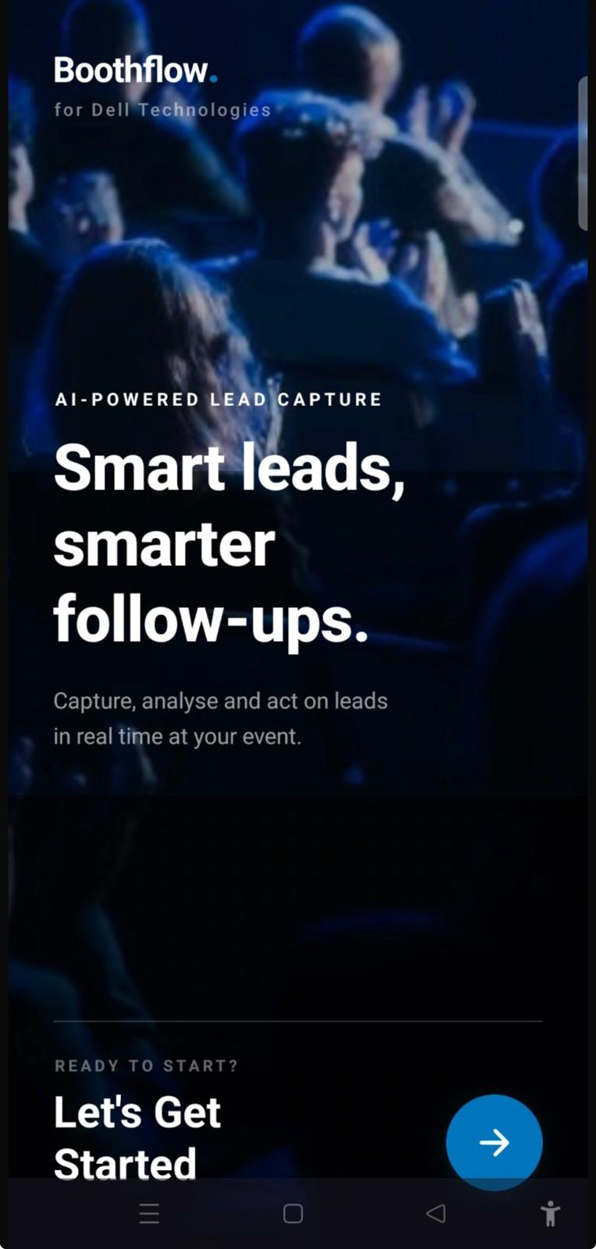

2.2 Login

Overview
The Login page allows Booth Representatives to securely access the BoothFlow application using their registered account credentials.

Steps
- Enter your registered Email Address.
- Enter your Password.
- Tap Login.

Expected Result
The user is successfully authenticated and redirected to the Dashboard.
Figure 2.2: Login Page
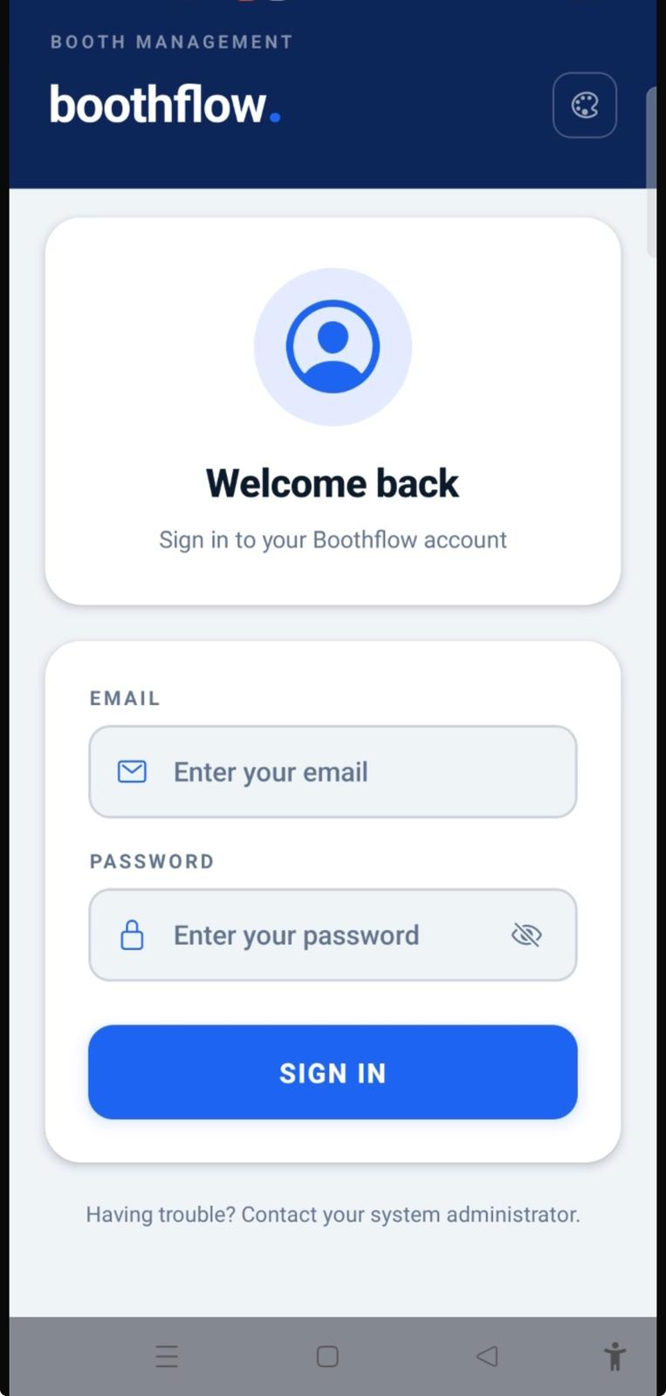

2.3 Dashboard

Overview
The Dashboard provides Booth Representatives with an overview of their lead collection activities and quick access to the QR Code Scanner.
The Dashboard displays:
- QR Code Scanner
- Total Leads Captured
- Lead Summary

Steps
- Log in to the application.
- Review the dashboard summary.
- Tap QR Code Scanner to begin capturing a visitor's information.

Expected Result
The Dashboard displays the latest lead statistics and allows the user to access the QR Code Scanner.
Figure 2.3: Dashboard

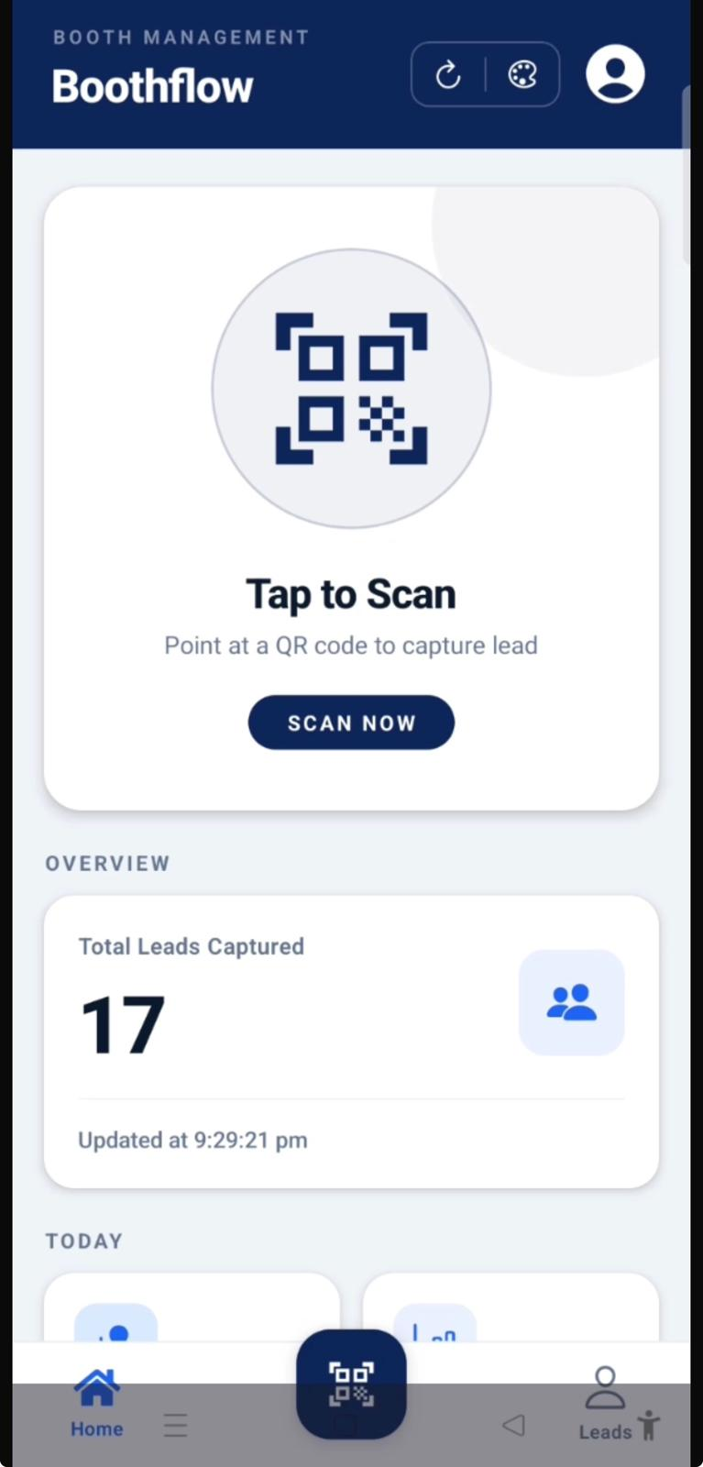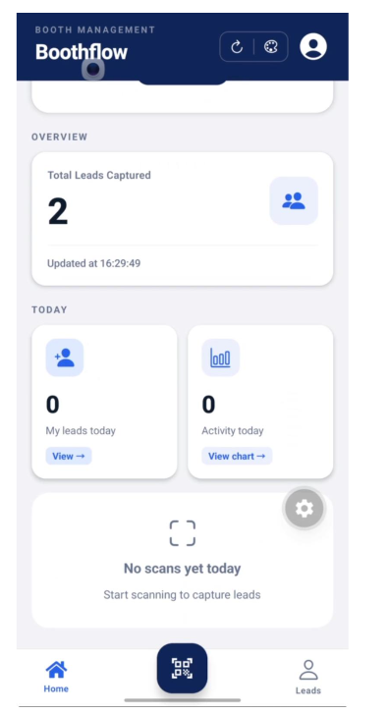

2.4 Camera Permission

Overview
The Camera Permission screen requests access to the device's camera, which is required to scan visitor QR codes.

Steps
- Tap QR Code Scanner.
- When prompted, select Allow.
- The message "Allow BoothFlow to take pictures and record videos?" will appear.
- Tap Allow to grant camera access.

Expected Result
Camera permission is granted, and the QR Code Scanner opens.
Figure 2.4: Camera Permission
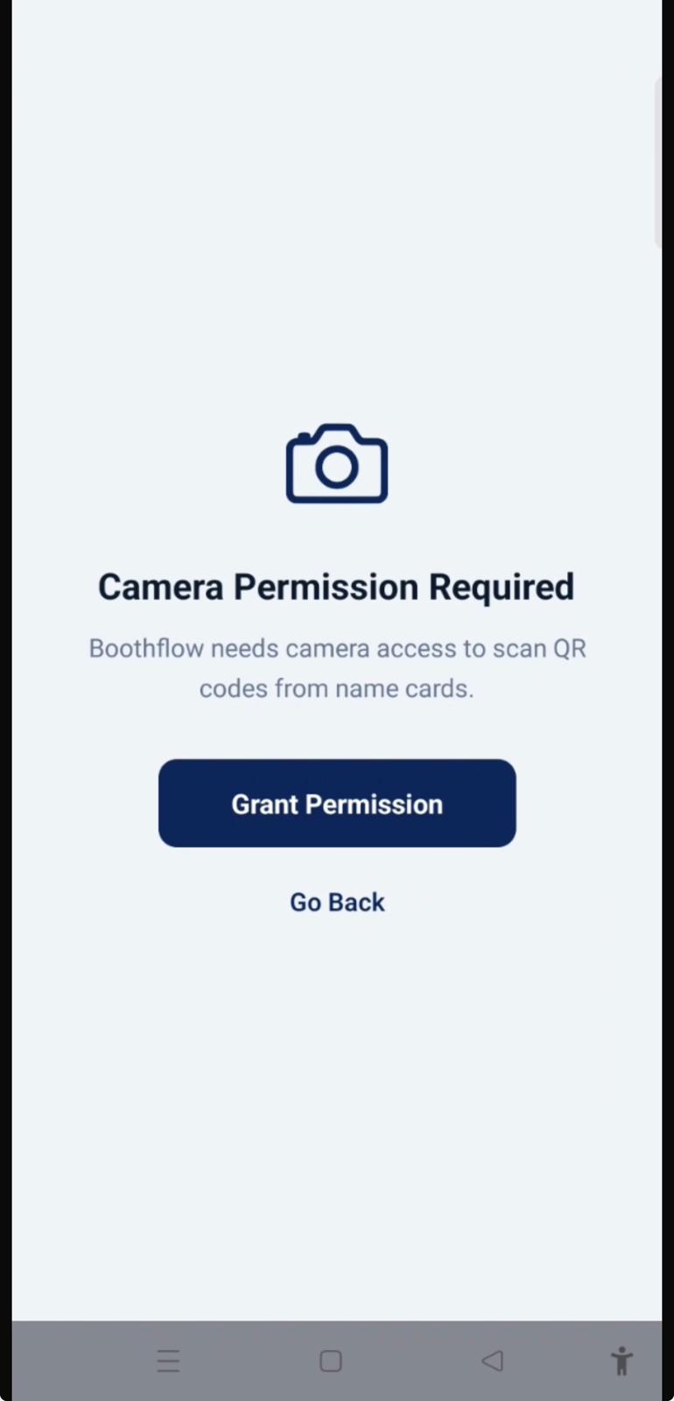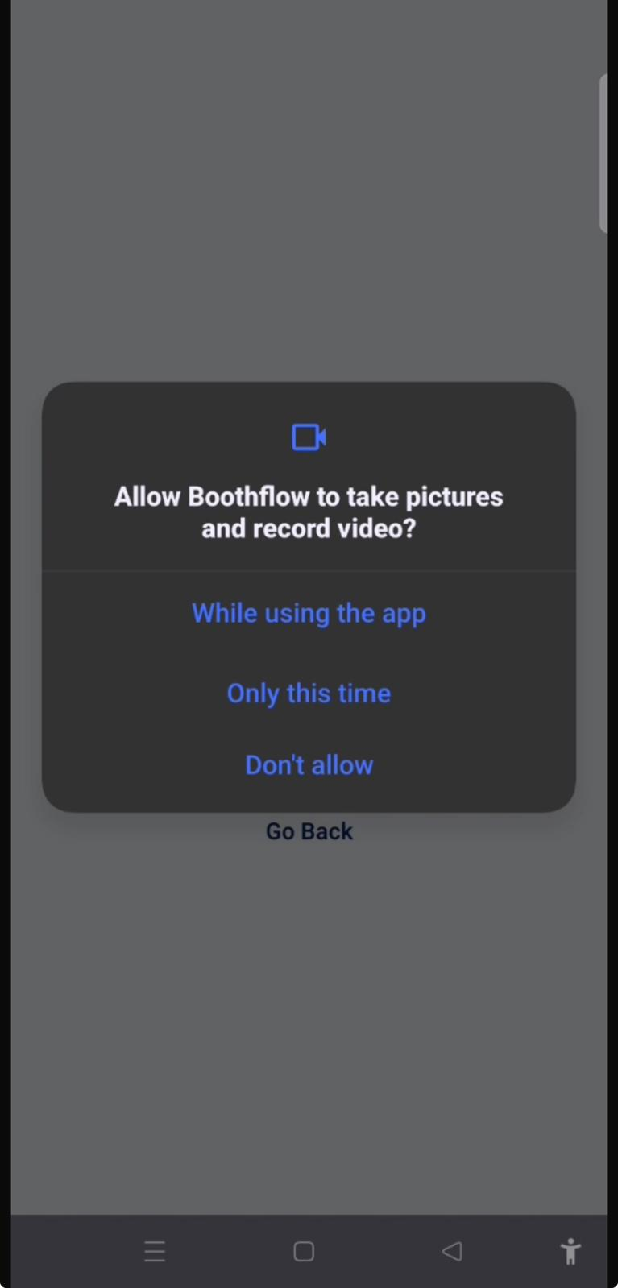

2.5 Scan QR Code

Overview
The QR Code Scanner captures visitor information by scanning the QR code provided during the event.

Steps
- Position the camera over the visitor's QR code.
- Wait for the QR code to be detected automatically.
- The system processes scanned information.

Expected Result
The visitor's QR code is successfully scanned, and the application proceeds to retrieve the visitor's information.
Figure 2.5: QR Code Scanner
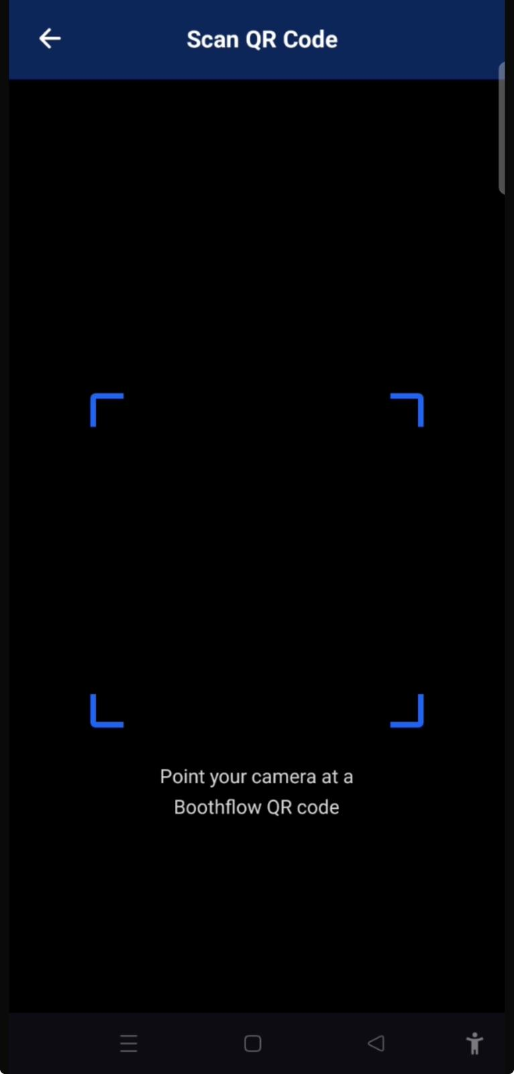

2.6 Retrieve Lead Information

Overview
After scanning the QR code, BoothFlow automatically retrieves the visitor's information. The Booth Representative can review the details before submitting the lead.
The retrieved information includes:
- Full Name
- Company
- Job Title
- Email Address
- Phone Number
- Primary Interest
The representative may also:
- Select additional interests
- Choose the customer's intent
- Add notes if required

Steps
- Review the retrieved visitor information.
- Verify that all details are correct.
- Update the customer's interests or intent if necessary.
- Add any additional notes.
- Proceed to submit the lead.

Expected Result
The visitor's information is displayed correctly and is ready for submission.
Figure 2.6: Retrieve Lead Information

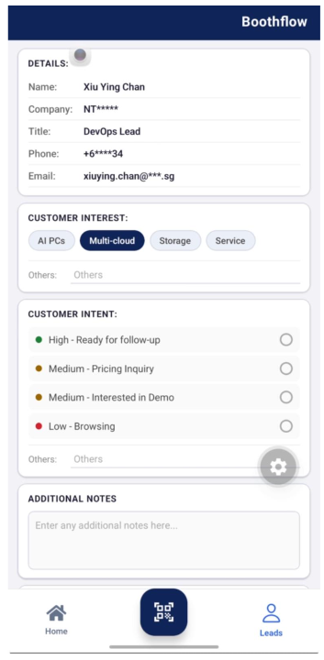

2.7 Submit Lead Information

Overview
The Submit function saves the visitor's information and routes the lead to the appropriate sales team for follow-up.

Steps
- Review all lead information.
- Confirm that the visitor has provided consent.
- Tap Submit.

Expected Result
The lead is successfully saved, and the system assigns it to the appropriate team.
Figure 2.7: Submit Lead Information
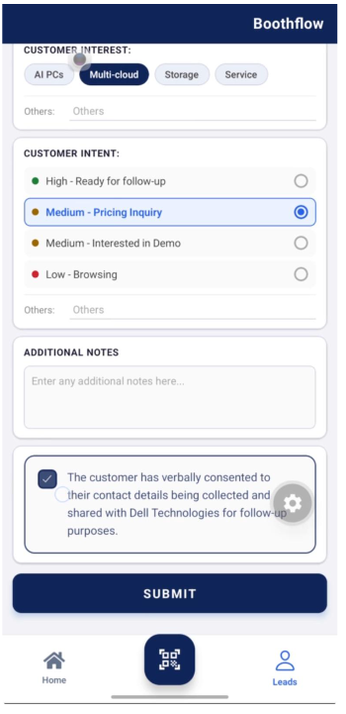

2.8 AI Follow-Up Recommendations

Overview
After the lead has been submitted, BoothFlow generates AI-powered recommendations to assist with customer follow-up.
The page displays:
- Assigned Team
- Customer Intent
- Customer Interests
- AI Follow-Up Recommendation
- Suggested Next Actions

Steps
- Review the AI-generated recommendations.
- Confirm the assigned team.
- Read the suggested follow-up actions.
- Return to the Dashboard or continue managing leads.

Expected Result
The Booth Representative receives AI-generated recommendations to support effective customer follow-up.
Figure 2.8: AI Follow-Up Recommendations

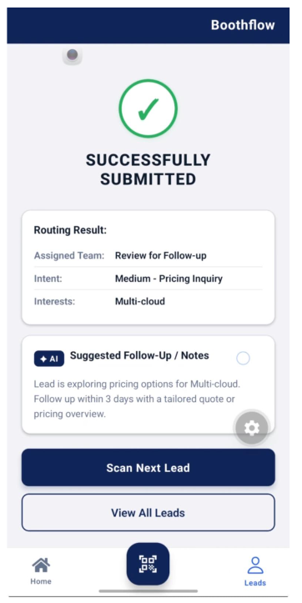

2.9 Manage Leads

Overview
The Manage Leads page allows Booth Representatives to search, view, and manage all submitted leads.
Available functions include:
- Search Leads
- View Lead Details
- Update Lead Information
- Filter Leads

Steps
- Open Manage Leads from the navigation menu.
- Browse the list of submitted leads.
- Use the search bar or filters to locate a specific lead.
- Select a lead to view or update its details.

Expected Result
The selected lead information is displayed and can be managed successfully.
Figure 2.9: Manage Leads

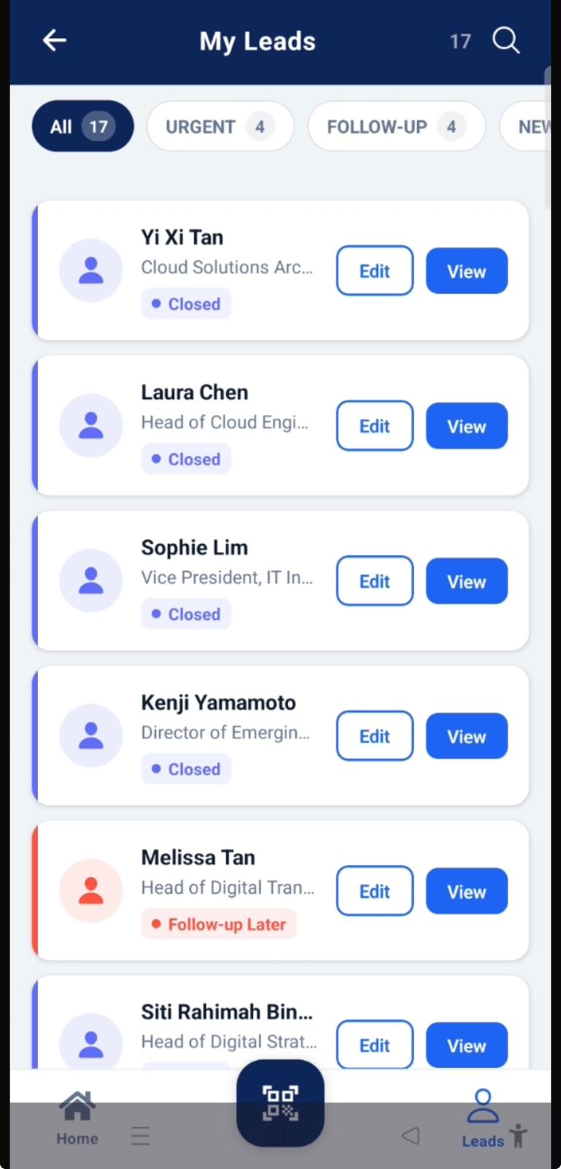

2.10 View Lead Details

Overview
The View Lead Details page allows Booth Representatives to review the complete information of a selected lead after it has been submitted. This helps users verify customer information, review lead qualifications, and access AI-generated follow-up recommendations.
The page displays:
- Customer Name
- Company
- Job Title
- Email Address
- Phone Number
- Primary Interest and Additional Interests
- Customer Intent
- Ai confidence
- Assigned Team
- AI Follow-Up Recommendations

Steps
- Navigate to the Manage Leads page.
- Browse or search for the desired lead.
- Select the lead.
- Tap View to display the lead details.

Expected Result
The complete lead information is displayed, allowing the Booth Representative to review the customer's details and follow-up recommendations.
Figure 2.10: View Lead Details
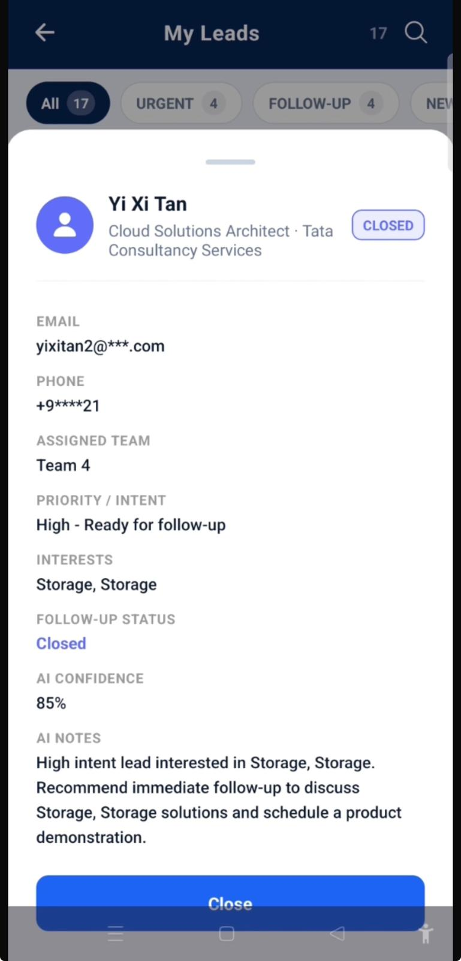

2.11 Update Lead Details

Overview
The Update Lead Details page allows Booth Representatives to modify lead qualification information after a lead has been submitted. This ensures that customer interactions remain up to date while protecting important personal information.
The following fields can be updated:
- Customer Intent
- Additional Notes
- Lead Status (if applicable)
The following fields cannot be modified:
- Customer Name
- Company
- Email Address
- Phone Number

Steps
- Navigate to the Manage Leads page.
- Locate the lead to be updated.
- Tap Edit .
- Modify the required lead qualification details.
- Tap Save to confirm the changes.

Expected Result
The updated lead information is successfully saved, and the latest changes are reflected in the lead record.
Figure 2.11: Update Lead Details
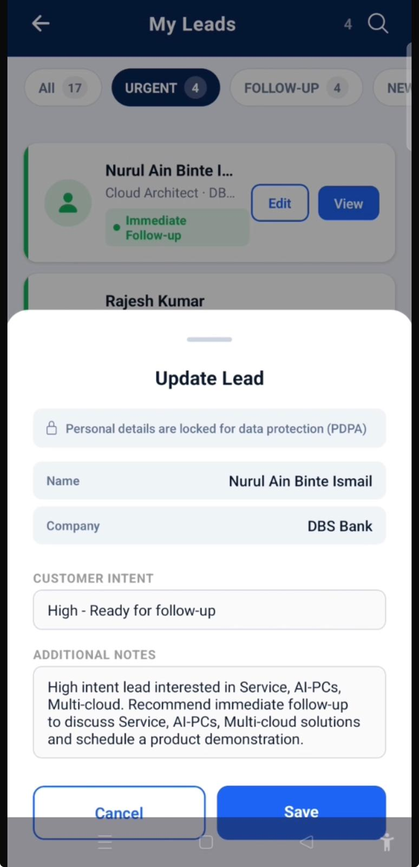

2.12 Activity Analytics

Overview
The Activity Analytics page provides Booth Representatives with a visual summary of their lead collection performance throughout the event.
The dashboard includes:
- Total Leads Captured
- Lead Summary
- Line graph showing lead collection trends
- Number of leads collected during each two-hour time slot

Steps
- Navigate to Activity Analytics.
- Review the dashboard statistics.
- Analyse the line graph to identify lead collection trends.
- Monitor the number of leads captured during each two-hour time slot.

Expected Result
The Activity Analytics page displays performance metrics that help Booth Representatives monitor lead collection trends and identify peak activity periods.
Figure 2.12: Activity Analytics Dashboard
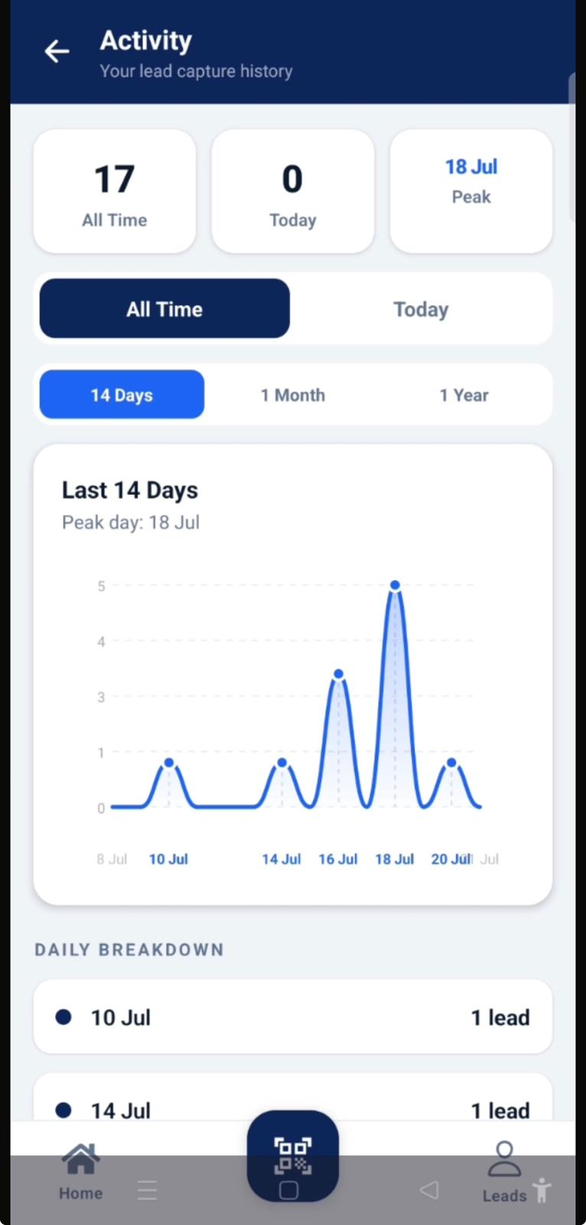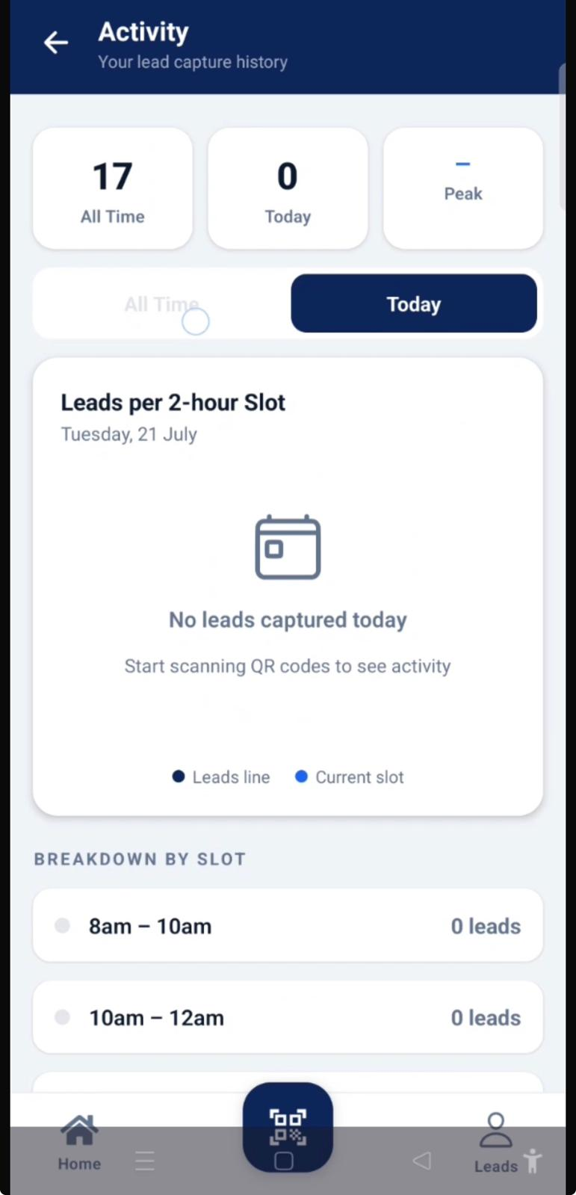

3. Manager Portal

3.1 Login

Overview
The Login page allows Managers to securely access the BoothFlow Manager Portal using their registered account credentials.

Steps
- Enter your registered Email Address.
- Enter your Password.
- Tap Login.

Expected Result
The Manager is successfully authenticated and redirected to the Dashboard.
Figure 3.1: Login Page
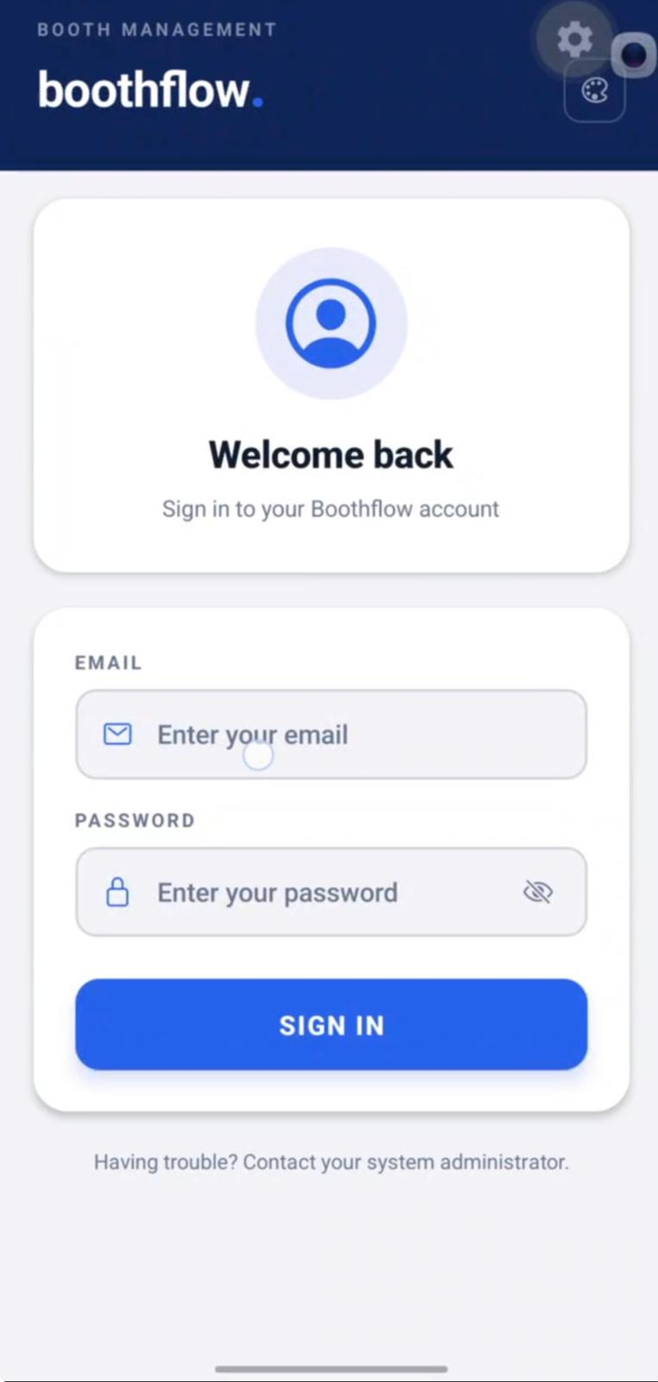

3.2 Dashboard

Overview
The Dashboard is the default landing page displayed after a Manager successfully logs in. It provides a real-time overview of the team's lead performance and offers quick access to key management features.
The Dashboard displays:
- Total Team Leads
- Performance Chart (Bar, Line and Pie Chart views)
- Lead Status Summary
- Lead Breakdown by Status
- Quick Access shortcuts to Leads, Activity, Emails and Export

Steps
- Log in to the BoothFlow Manager Panel.
- Review the Total Team Leads displayed at the top of the Dashboard.
- Swipe left or right on the Performance Chart to switch between the Bar Chart, Line Chart and Pie Chart views.
- Review the Lead Status cards to monitor the number of New, Follow-Up and Urgent leads.
- View the Breakdown section for a detailed summary of each lead category.
- Tap the Quick Access icons or use the bottom navigation bar to access the Leads, Activity, Emails or Export modules.

Expected Result
The Dashboard displays the latest team lead statistics, performance charts and lead status information, allowing Managers to quickly monitor team performance and navigate to other management features.
Figure 3.2: Manager Dashboard
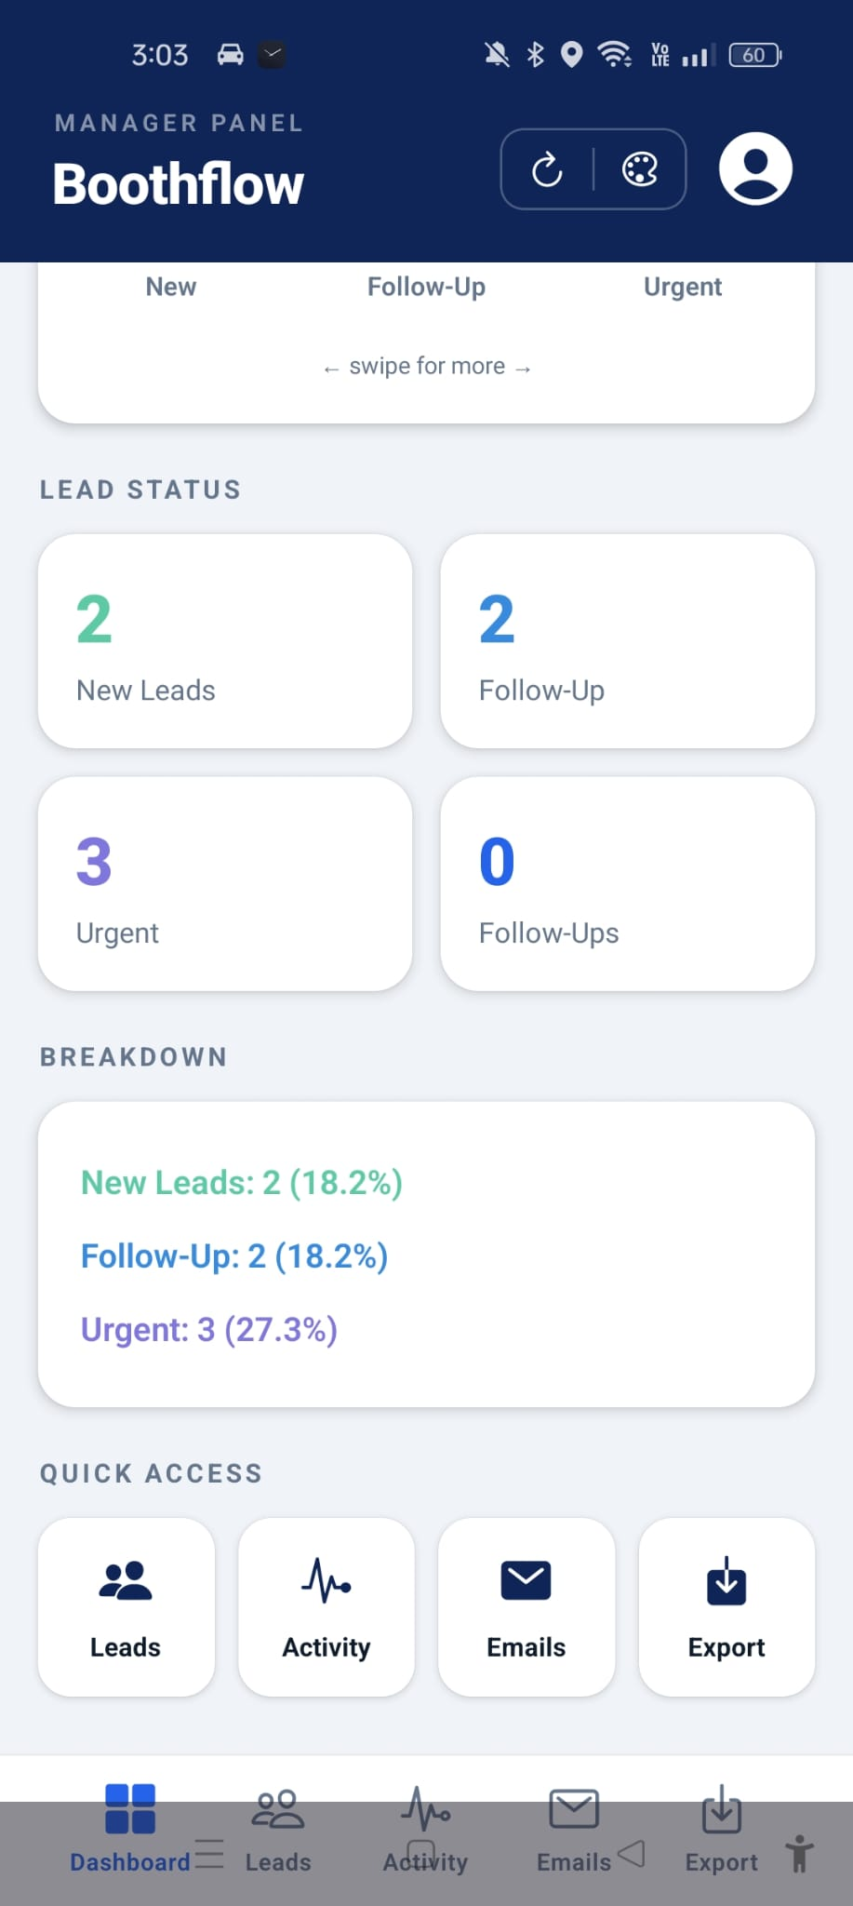

3.3 View Performance Charts

Overview
Managers can analyse team performance using different chart visualisations available on the Dashboard.
Available chart types include:
- Bar Chart (Leads Overview)
- Line Chart (Leads Trend)
- Pie Chart (Leads Distribution)

Steps
- Navigate to the Dashboard.
- Swipe left or right across the Performance Chart.
- View the selected chart.

Expected Result
The selected chart is displayed, allowing Managers to analyse lead performance from different perspectives.
Figure 3.3: Performance Charts

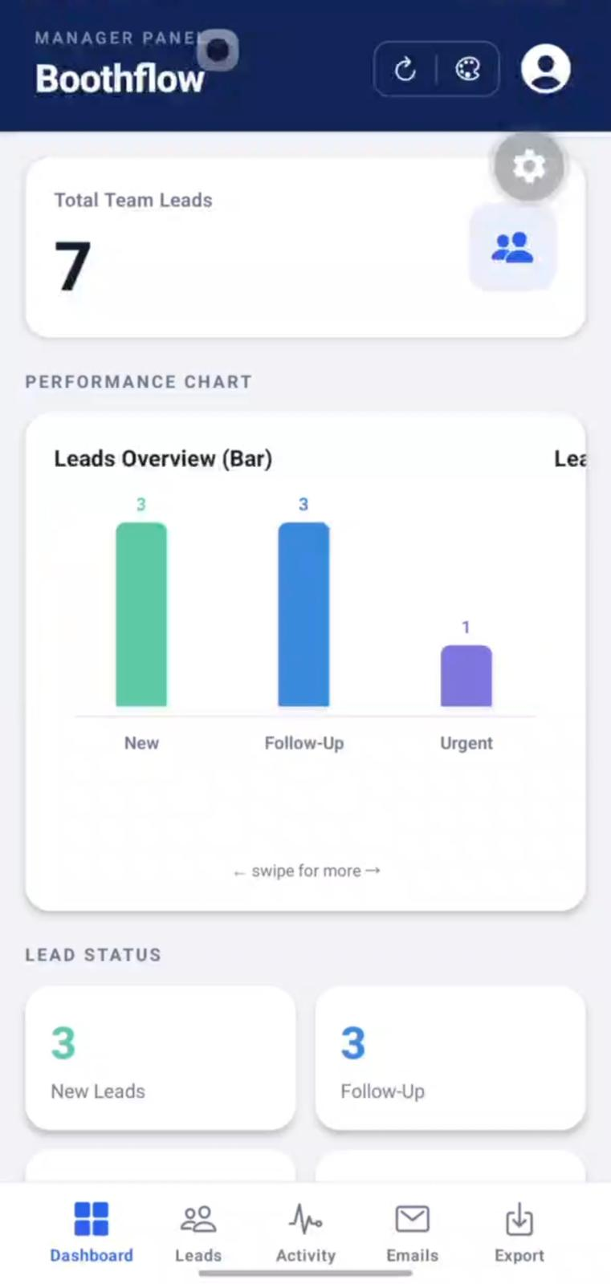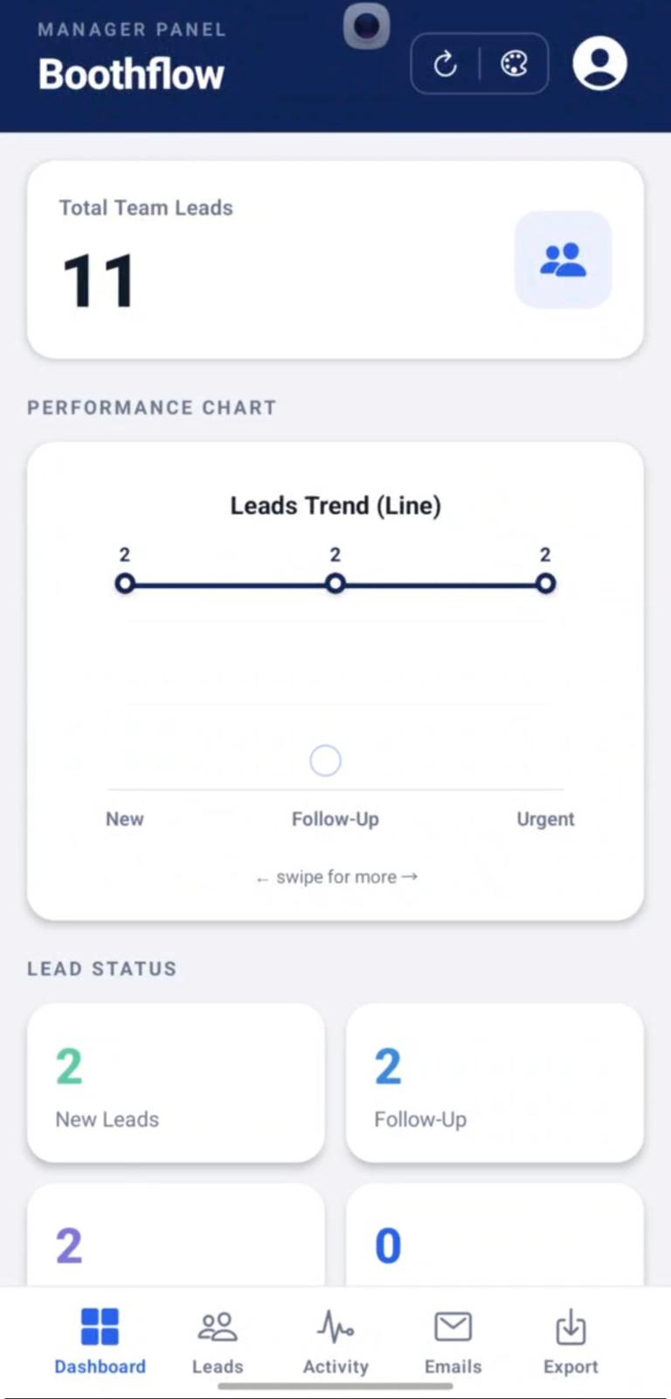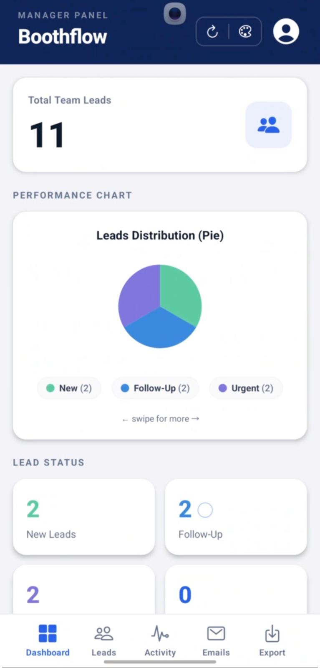

3.4 View Team Leads

Overview
The Team Leads page displays all leads captured by the team. Managers can search, filter and review lead information.
Available functions include:
- Search Leads
- Filter Leads by Status
- Edit Follow-Up Status
- View Lead Details

Steps
- Tap Leads from the bottom navigation bar.
- Browse the list of captured leads.
- Use the search bar or status filters to locate a specific lead.

Expected Result
The selected lead is displayed and available for further management.
Figure 3.4: Team Leads
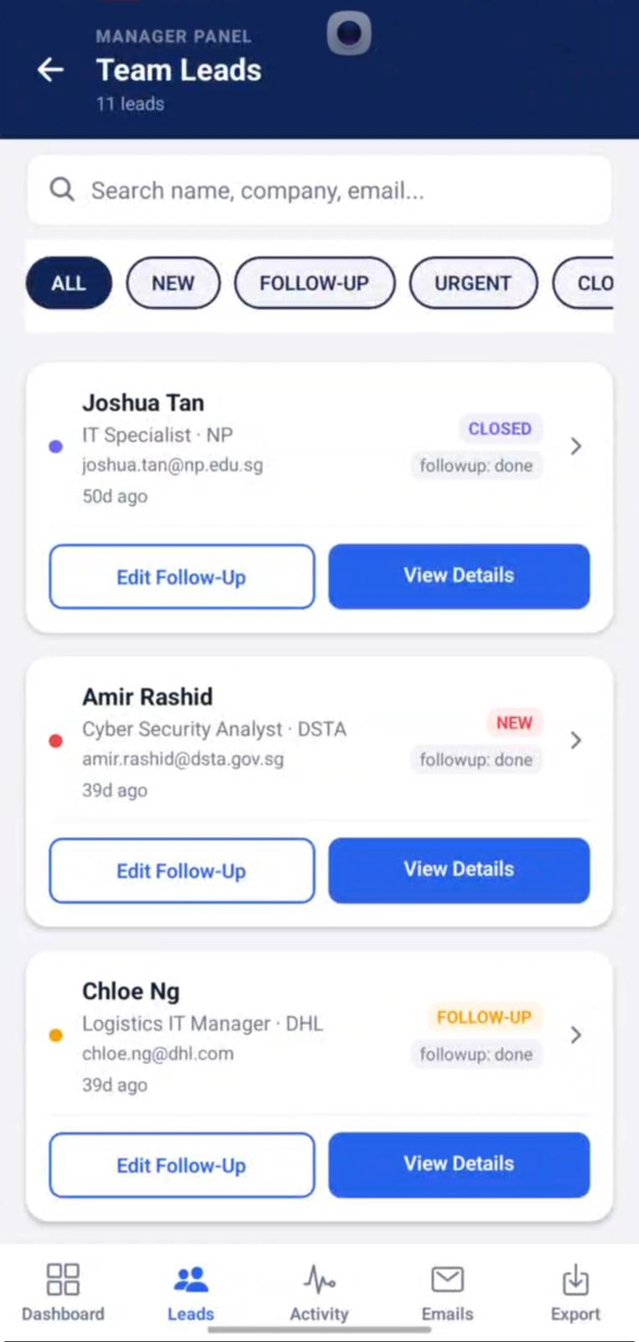

3.5 Update Follow-Up Status

Overview
Managers can update the follow-up progress of a lead to reflect its current status.
Available options include:
- Pending
- Done
- Cancelled

Steps
- Select Edit Follow-Up for the desired lead.
- Choose the appropriate follow-up status.
- Tap Done to confirm the update.

Expected Result
The selected follow-up status is successfully updated.
Figure 3.5: Update Follow-Up Status
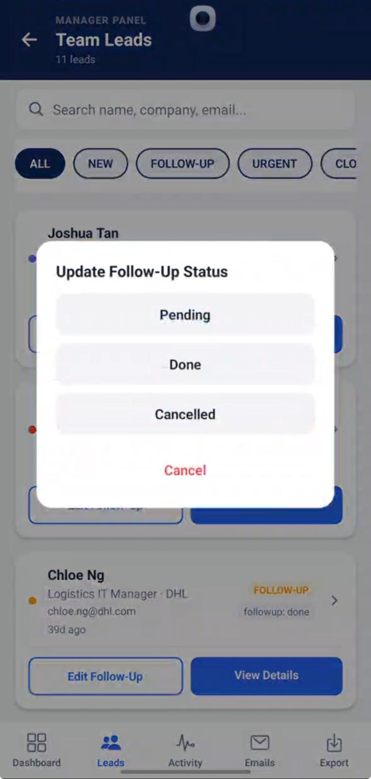

3.6 View Lead Details

Overview
The View Details page displays complete information about a selected lead.
The information includes:
- Email Address
- Phone Number
- Customer Intent
- Follow-Up Progress
- AI Confidence
- AI Notes
- Scanned By
- Captured Date and Time

Steps
- Tap View Details on the selected lead.
- Review the lead information.
- Tap Close to return to the Team Leads page.

Expected Result
The complete lead profile is displayed successfully.
Figure 3.6: View Lead Details
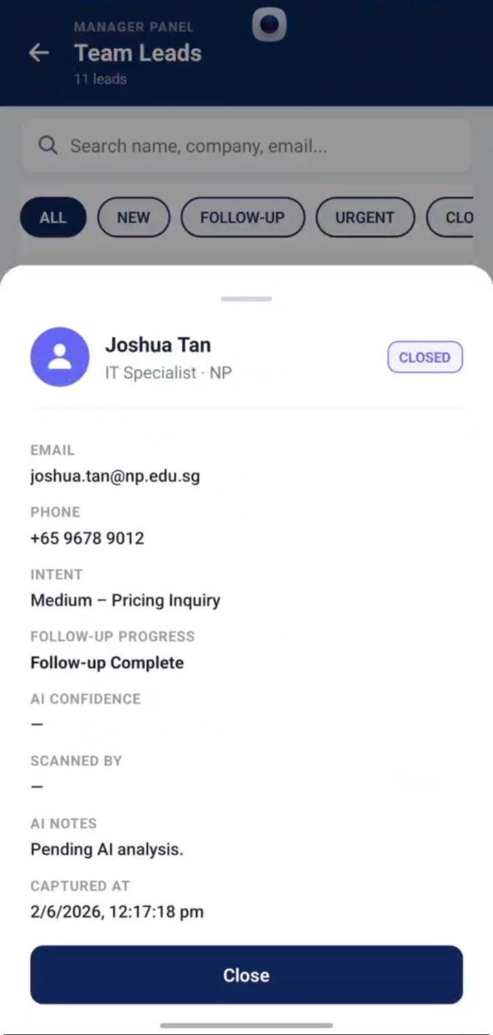

3.7 Activity Logs

Overview
The Activity Logs page records all follow-up activities and communications performed for team leads.
Managers can review:
- Follow-up Emails
- Activity History
- Communication Records
- Event Invitations

Steps
- Tap Activity from the navigation bar.
- Browse the activity records.
- Review the selected activity.

Expected Result
The complete activity history is displayed.
Figure 3.7: Activity Logs
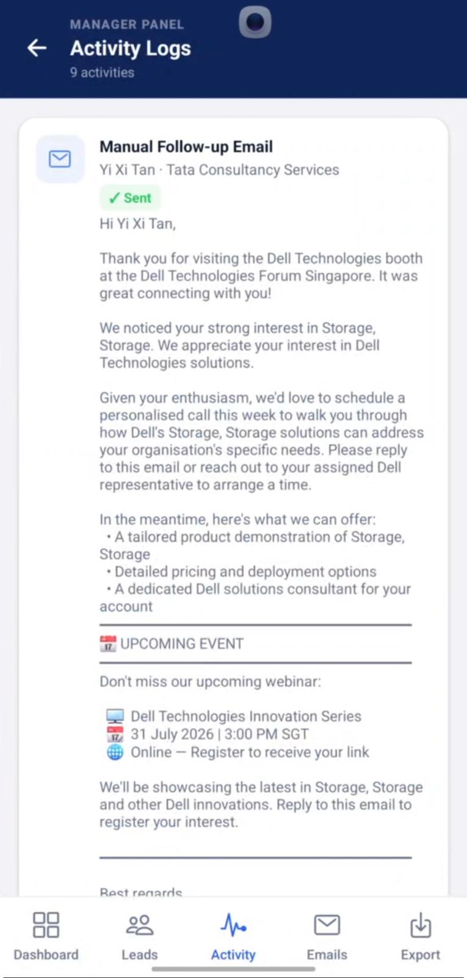

3.8 Email Follow-Ups

Overview
The Email Follow-Ups page allows Managers to schedule and manage follow-up emails for leads.
The page displays:
- Total Emails Sent
- Emails Sent This Week
- Overdue Follow-Ups
- Selected Lead Information

Steps
- Tap Emails from the navigation bar.
- Select a lead.
- Choose the follow-up date and time.
- Tap Schedule Follow-Up.

Expected Result
The follow-up email is successfully scheduled.
Figure 3.8: Email Follow-Ups
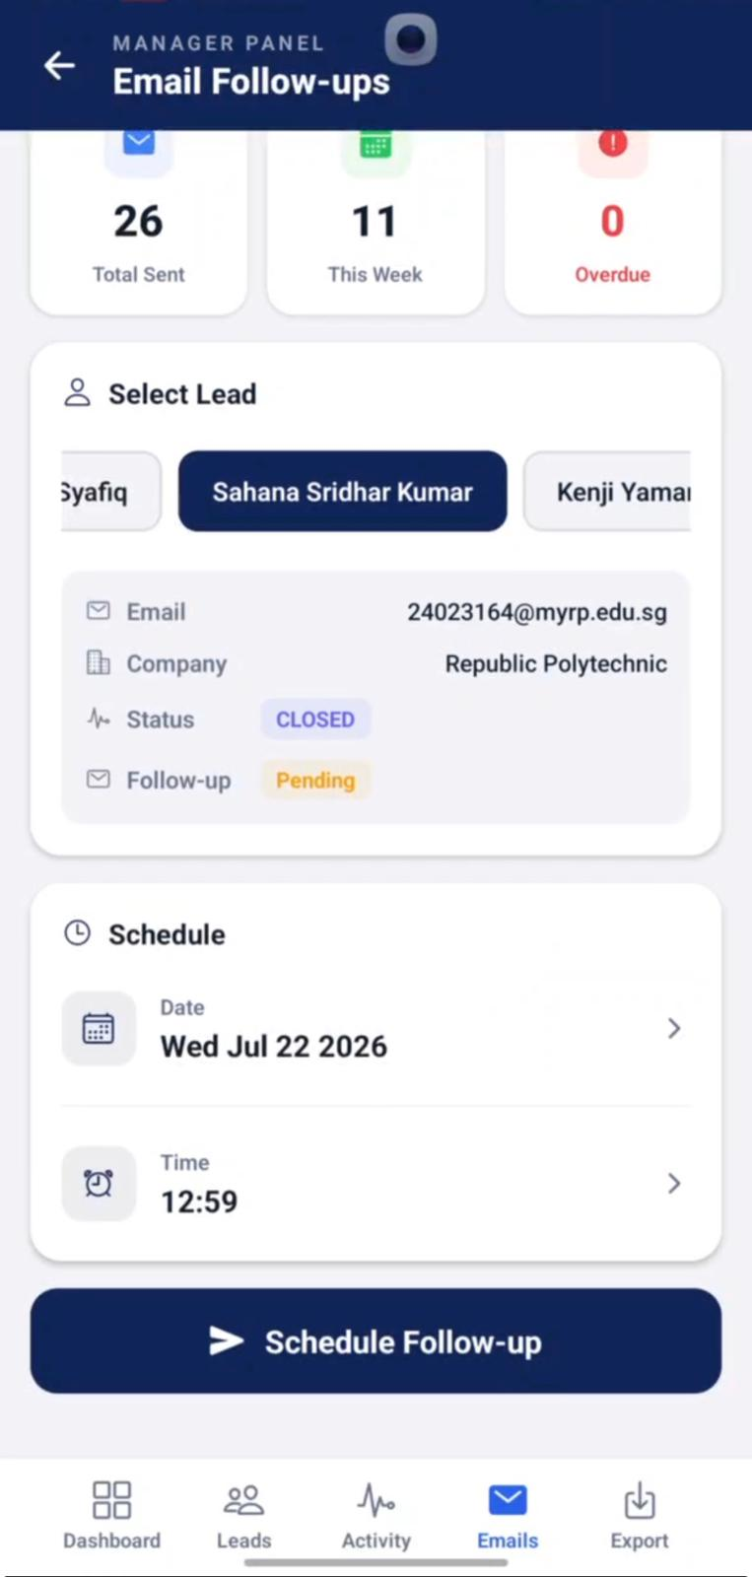

3.9 Reset Follow-Up

Overview
Managers can reset a completed follow-up, allowing a new follow-up email to be sent to the selected lead.

Steps
- Select a lead whose follow-up has already been completed.
- Tap Reset.
- Confirm the action by selecting Reset in the confirmation dialog.

Expected Result
The follow-up status is reset to Pending, allowing another email to be scheduled.
Figure 3.9: Reset Follow-Up
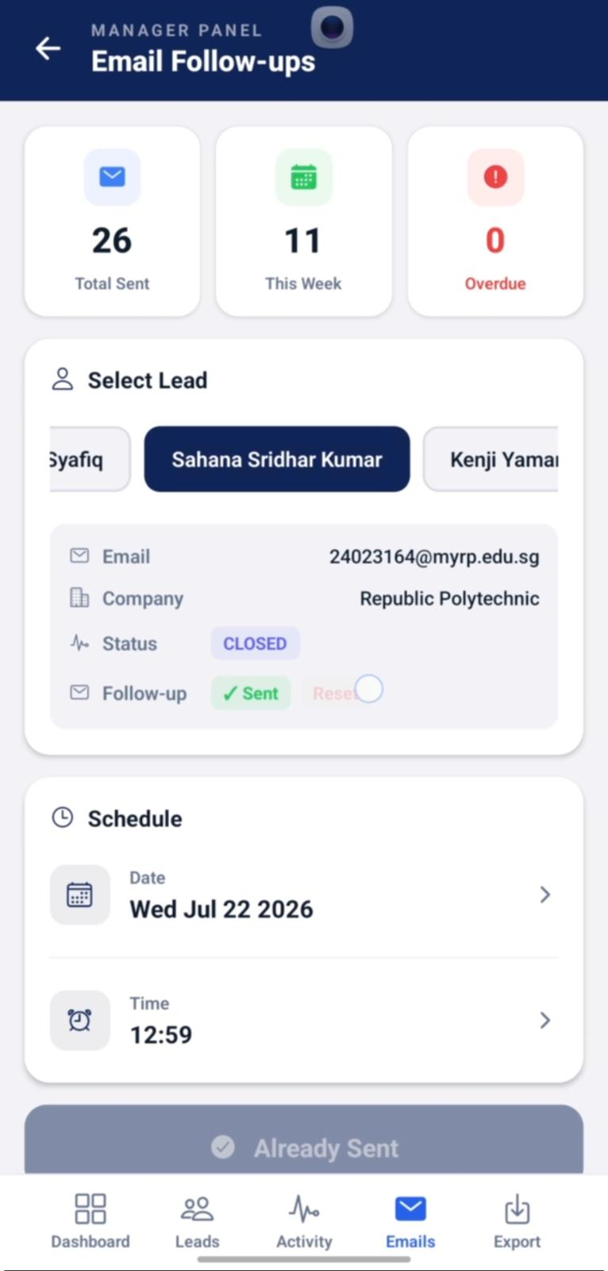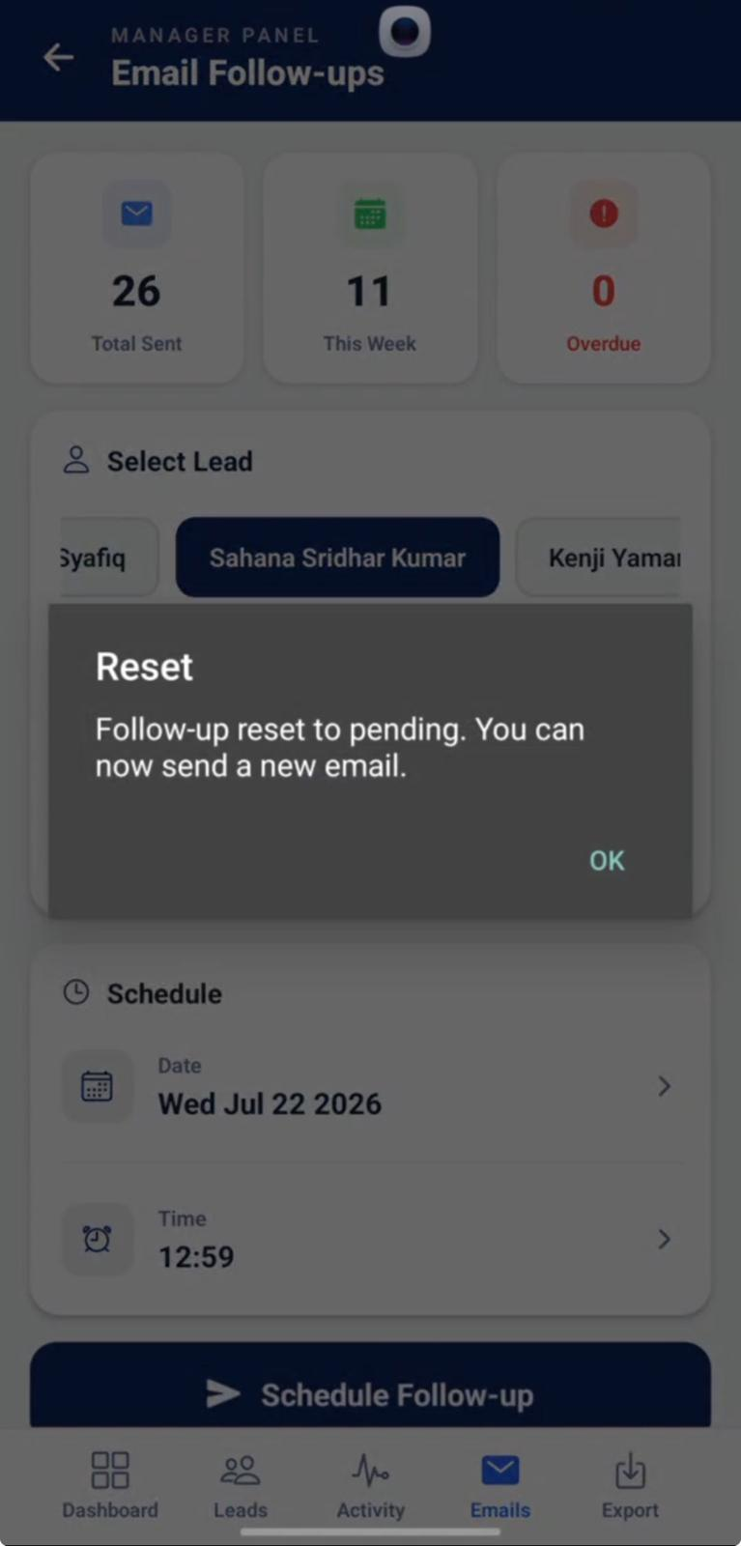

3.10 Resend Follow-Up Email

Overview
After resetting a follow-up, Managers can resend the follow-up email to the selected lead.

Steps
- Schedule the new follow-up.
- Tap Schedule Follow-Up.
- Wait for the confirmation message.

Expected Result
The system confirms that the follow-up email has been resent successfully.
Figure 3.10: Resend Follow-Up Email
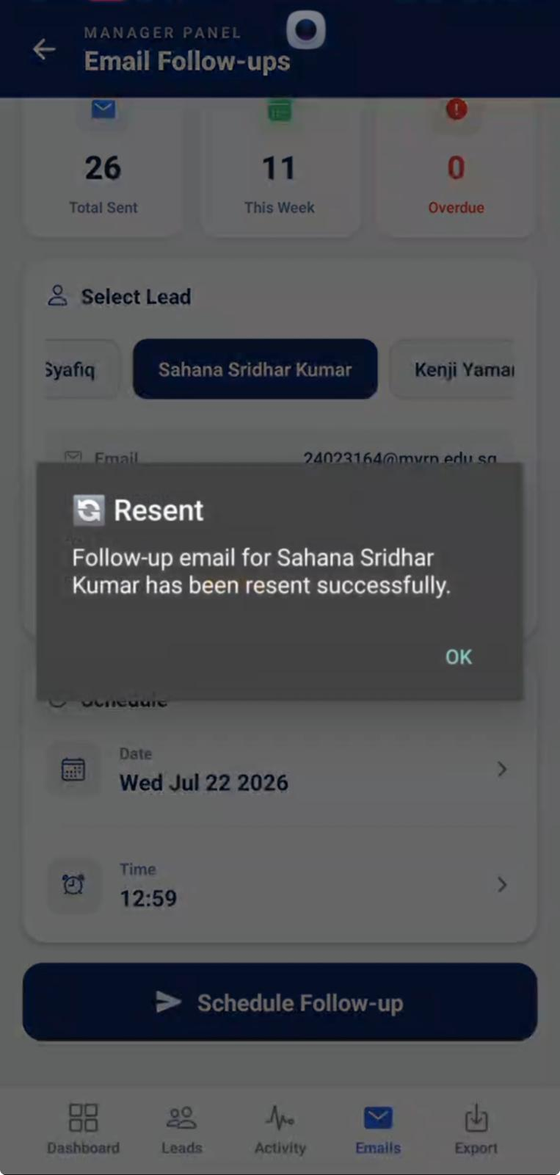

3.11 Export Leads

Overview
The Export Leads page allows Managers to export all captured team leads for reporting purposes.
Available options include:
- Preview JSON
- Download Excel

Steps
- Tap Export.
- Select Preview JSON to preview lead data or Download Excel to export the report.

Expected Result
The selected export option is completed successfully.
Figure 3.11: Export Leads
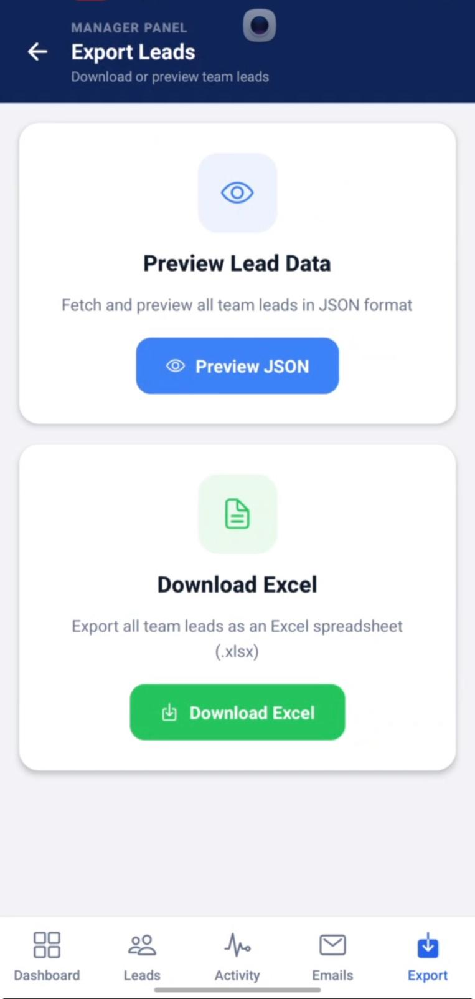

3.12 Download Excel Report

Overview
Managers can download all team leads as a Microsoft Excel spreadsheet for reporting and analysis.

Steps
- Tap Download Excel.
- Wait for the report to be generated.
- Select the generated Excel file.

Expected Result
The Excel report is successfully generated and downloaded.
Figure 3.12: Download Excel Report
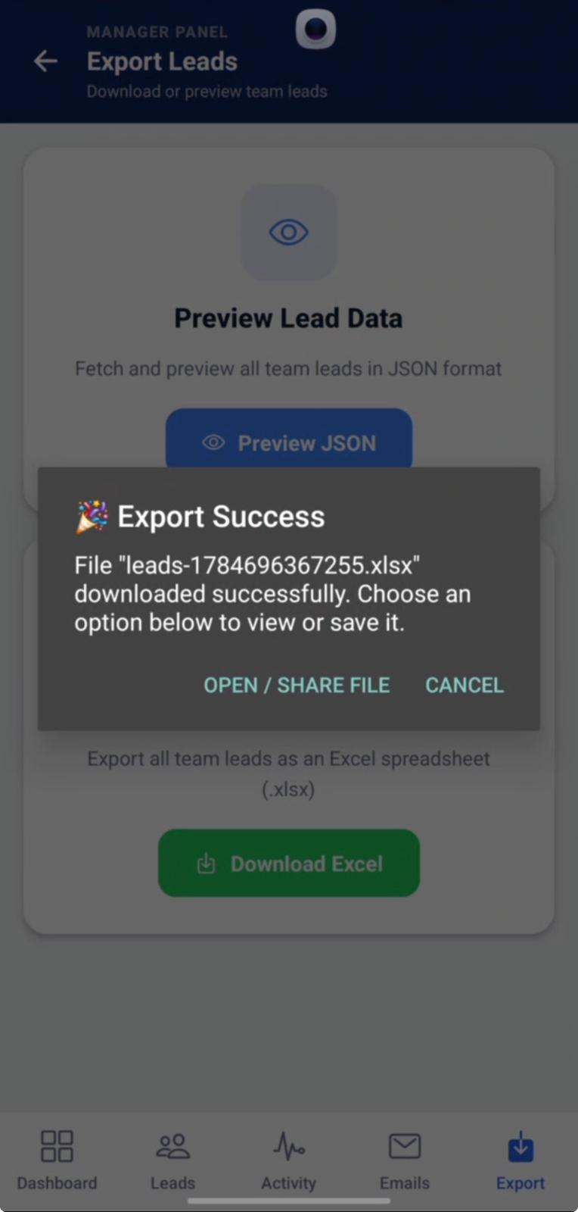

3.13 Upload Report to Google Drive

Overview
Managers can upload the exported Excel report directly to Google Drive for backup or sharing.

Steps
- Select the exported Excel file.
- Choose Upload to Drive.
- Select the destination folder.
- Tap Upload.

Expected Result
The Excel report is successfully uploaded to the selected Google Drive location.
Figure 3.13: Upload Report to Google Drive
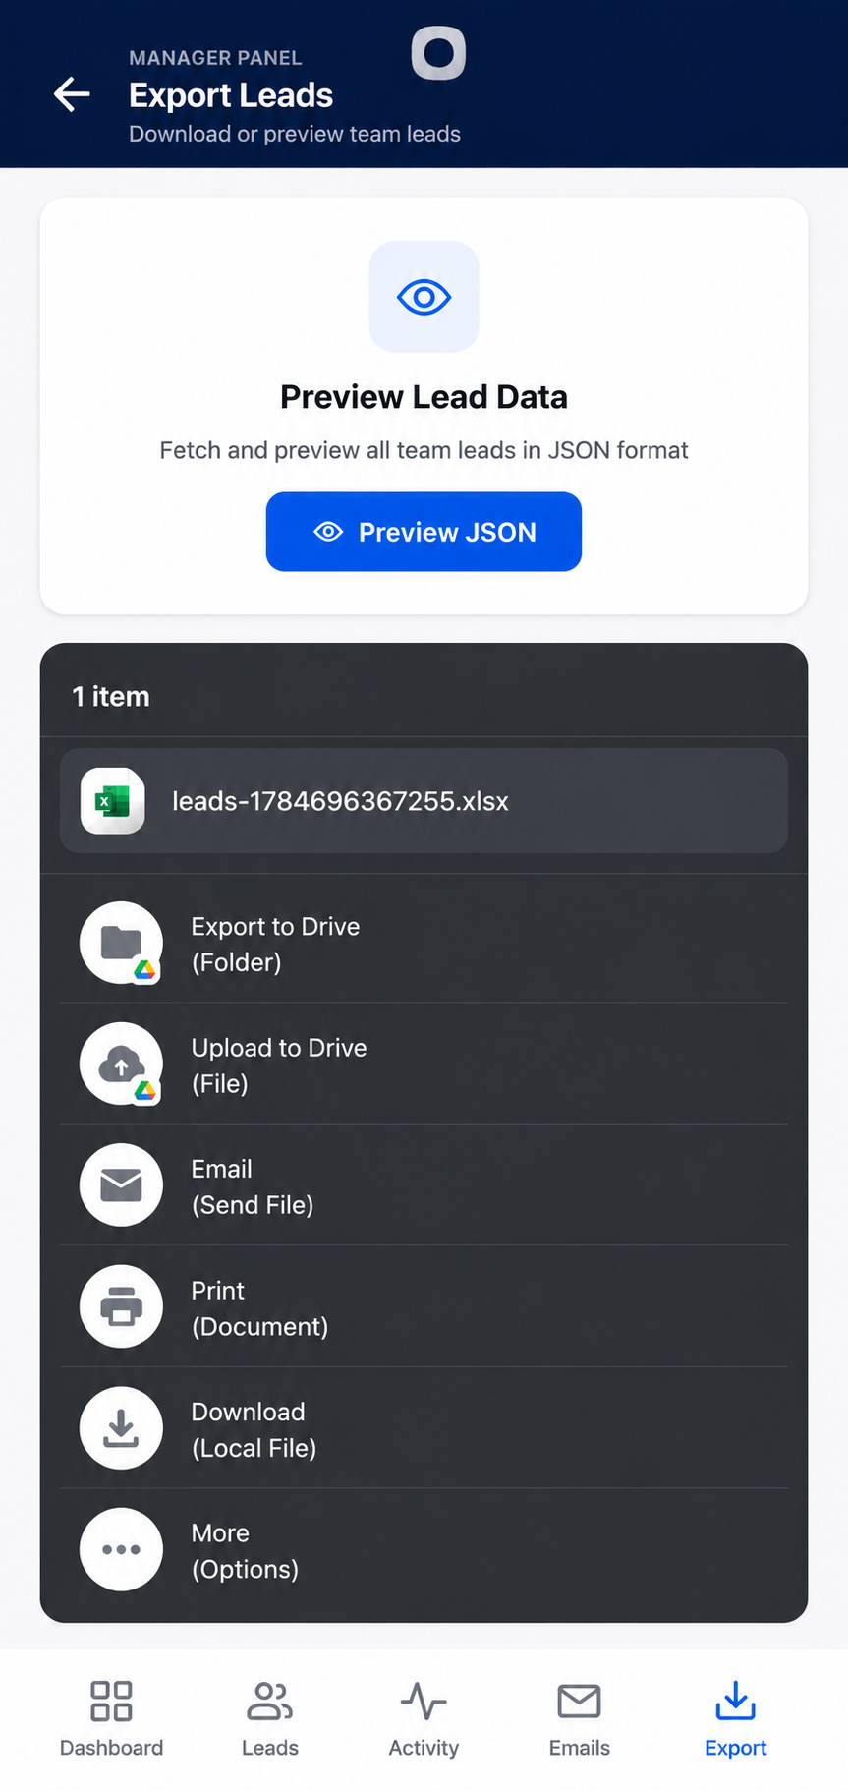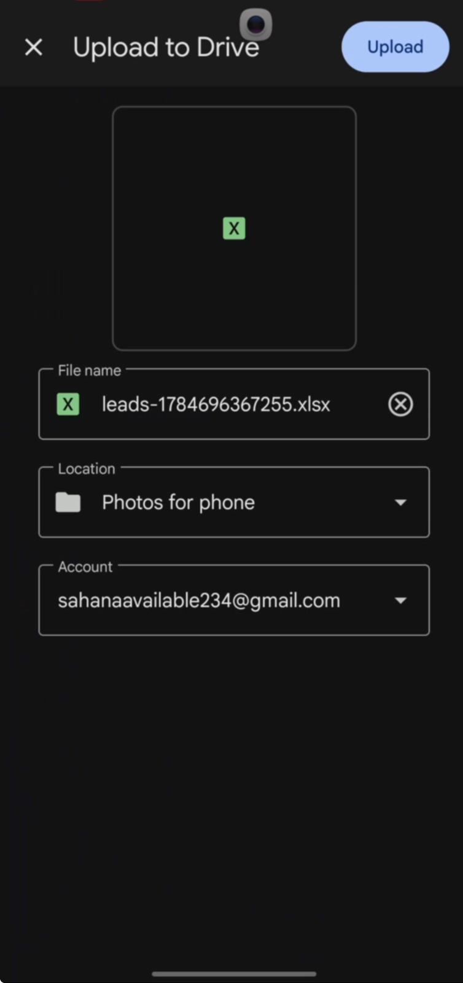

3.14 View Uploaded Report

Overview
After the upload is complete, Managers can verify that the exported report is available in Google Drive.

Steps
- Open Google Drive.
- Navigate to the selected folder.
- Locate the uploaded Excel report.

Expected Result
The exported report is successfully stored in Google Drive and is available for viewing or sharing.
Figure 3.14: Uploaded Excel Report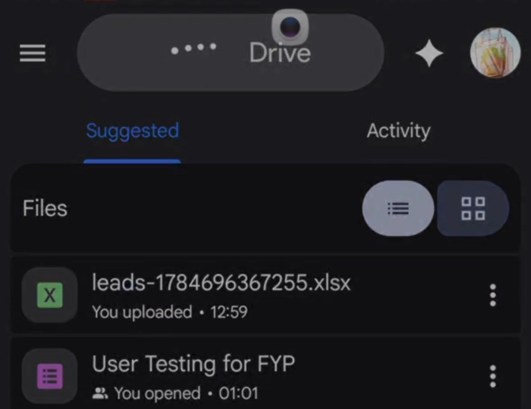

3.15 View Exported Excel Report

Overview
The exported Excel report contains all captured lead information and can be used for reporting, analysis, and record keeping.
The report may include:
- Lead ID
- Name
- Company
- Job Title
- Email Address
- Lead Status

Steps
- Open the exported Excel file.
- Review the lead information.
- Use the report for analysis or sharing.

Expected Result
The Excel report displays all exported lead information successfully.
Figure 3.15: Exported Excel Report
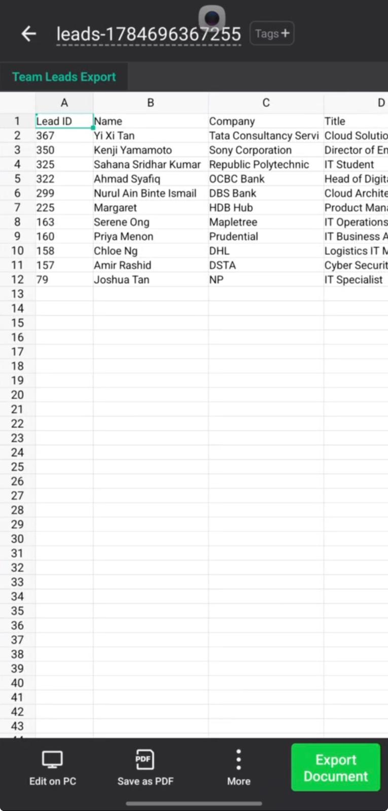

4. Admin Portal

4.1 Login

Overview
The Login page allows Administrators to securely access the BoothFlow Admin Portal using their registered account credentials.

Steps
- Enter your registered Email Address.
- Enter your Password.
- Tap Login.

Expected Result
The Administrator is successfully authenticated and redirected to the Admin Dashboard.
Figure 4.1: Login Page


4.2 Dashboard

Overview
The Dashboard provides Administrators with a system-wide overview of BoothFlow and quick access to administrative functions.
The Dashboard displays:
- Total Leads
- Qualified Leads
- Contacted Leads
- New Leads
- User Accounts
- Teams

Steps
- Log in to the Admin Portal.
- Review the system overview.
- Select the required management module.

Expected Result
The Dashboard displays the latest system statistics and administrative options.
Figure 4.2: Admin Dashboard
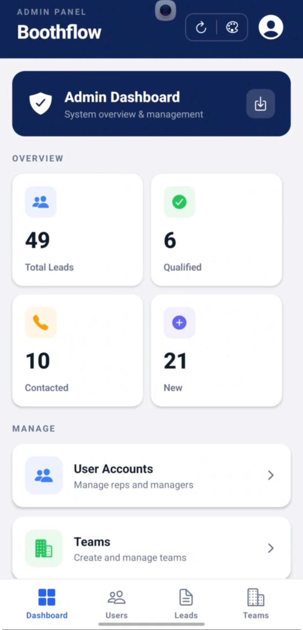

4.3 View User Accounts

Overview
The User Accounts page allows Administrators to view and manage all registered users within the BoothFlow system.
The page displays:
- Full Name
- Email Address
- User Role
- Assigned Team
- Account Status

Steps
- Select Users from the navigation bar.
- Browse the list of registered users.
- Search for a specific user if required.

Expected Result
The list of user accounts is displayed successfully.
Figure 4.3: User Accounts
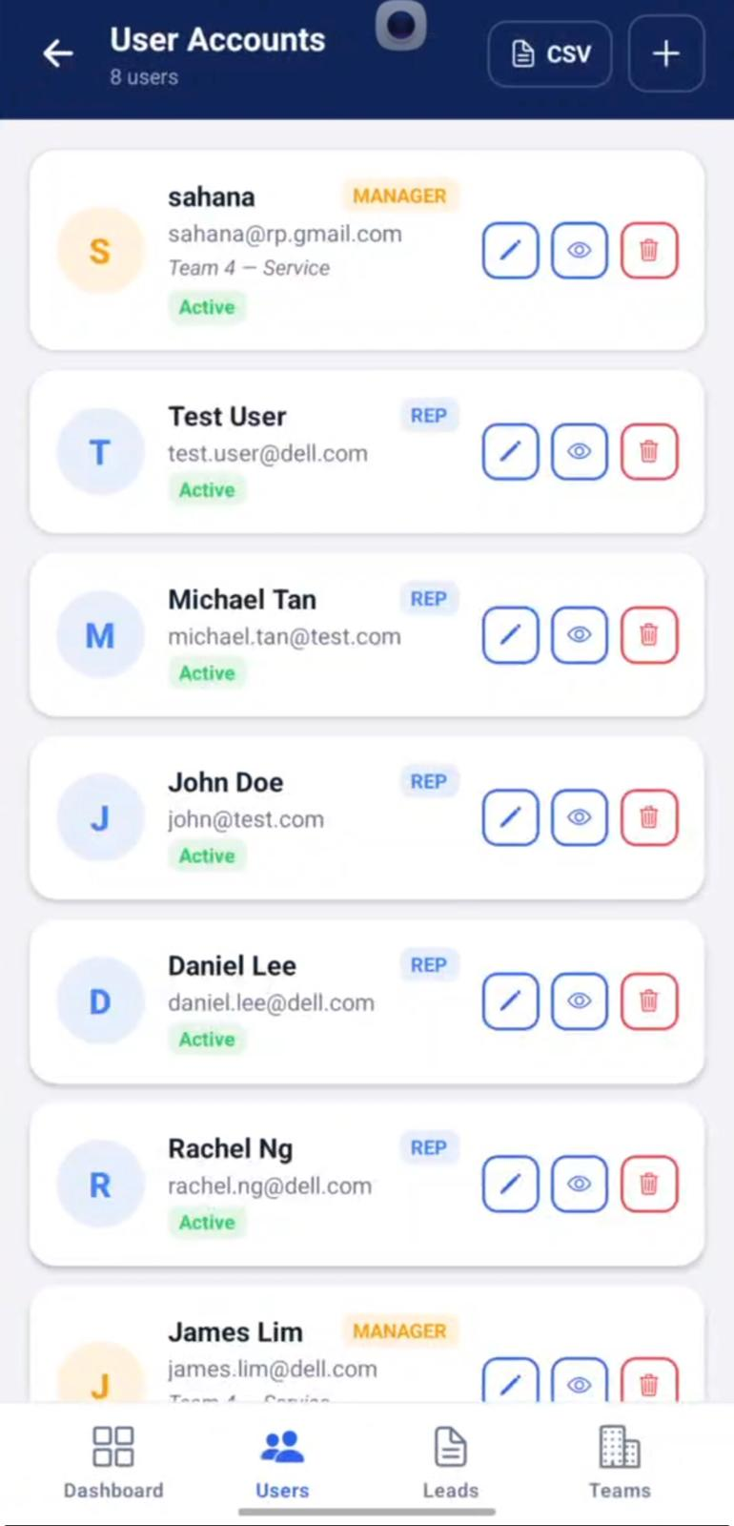

4.4 Create User

Overview
Administrators can create new user accounts for Booth Representatives, Managers, or Administrators.

Steps
- Tap the + button.
- Enter the user's details.
- Select the appropriate Role.
- Assign the user to a team.
- Tap Create.

Expected Result
The new user account is successfully created.
Figure 4.4: Create User
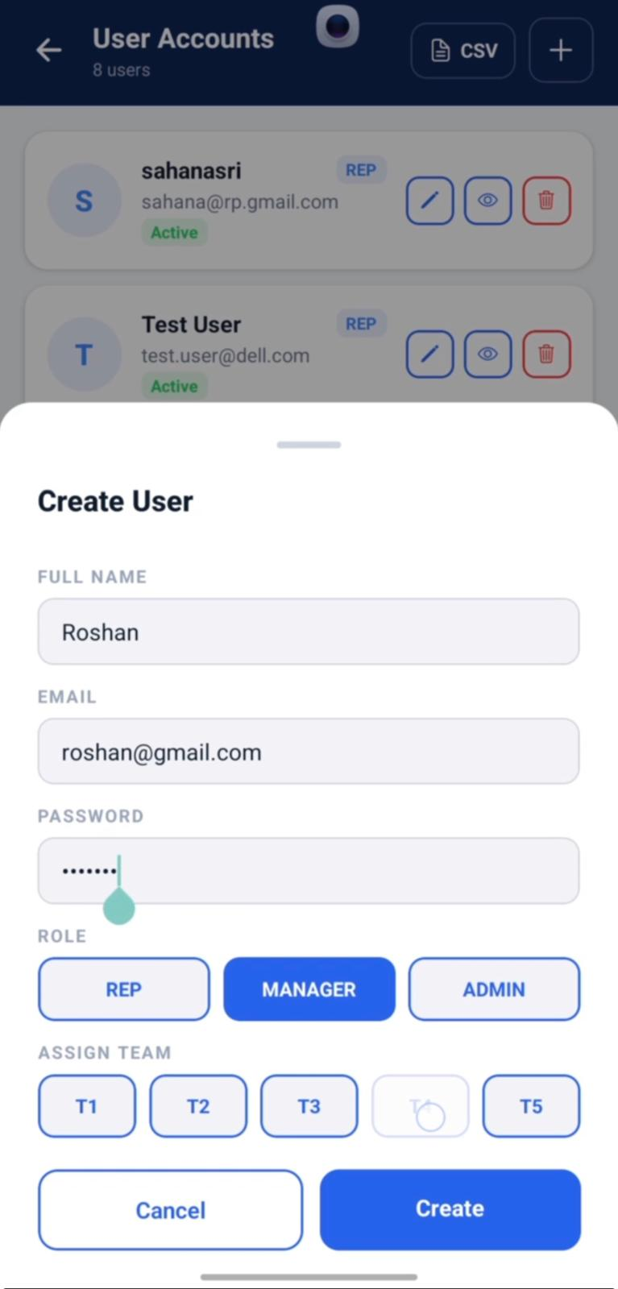

4.5 Edit User

Overview
The Edit User page allows Administrators to update an existing user's information.
Editable information includes:
- Full Name
- Email Address
- Password
- Account Status
- User Role
- Assigned Team

Steps
- Select the desired user.
- Tap Edit.
- Update the required information.
- Tap Save.

Expected Result
The selected user's information is updated successfully.
Figure 4.5: Edit User
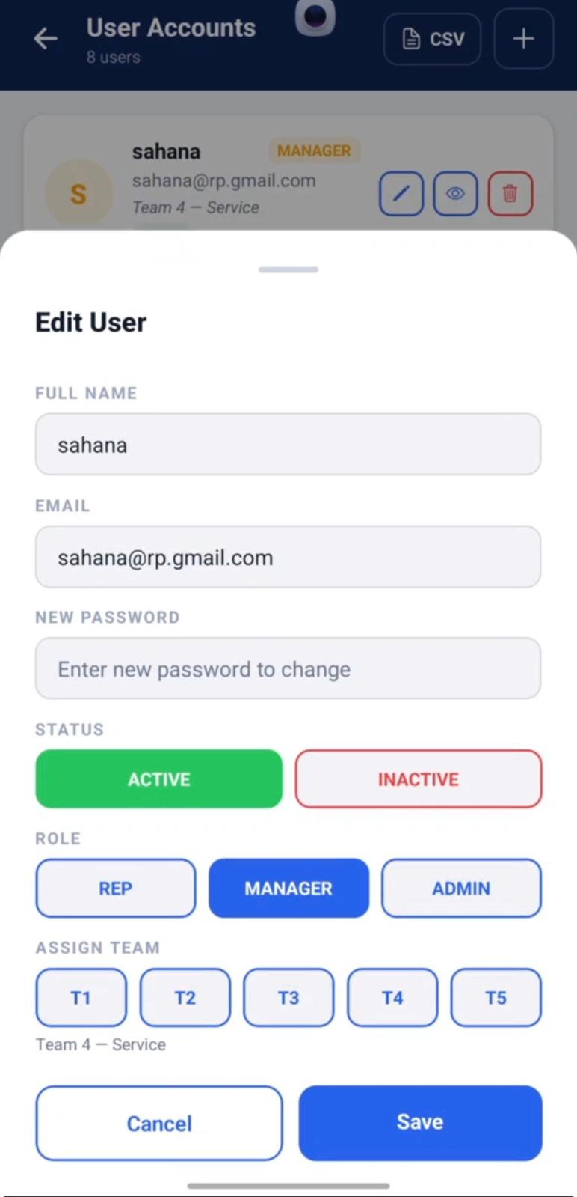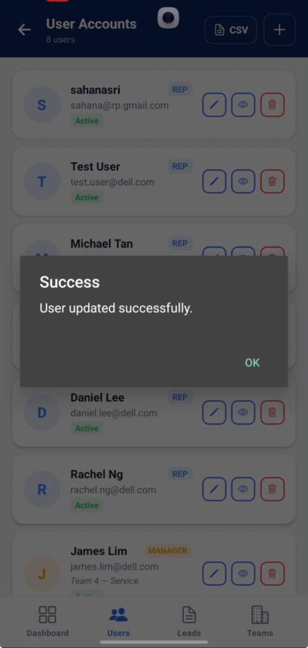

4.6 View User Details

Overview
The User Details page displays complete information about the selected user.
The information includes:
- Full Name
- Email Address
- User Role
- Account Status
- User ID

Steps
- Select View on a user account.
- Review the displayed information.

Expected Result
The selected user's details are displayed successfully.
Figure 4.6: View User Details
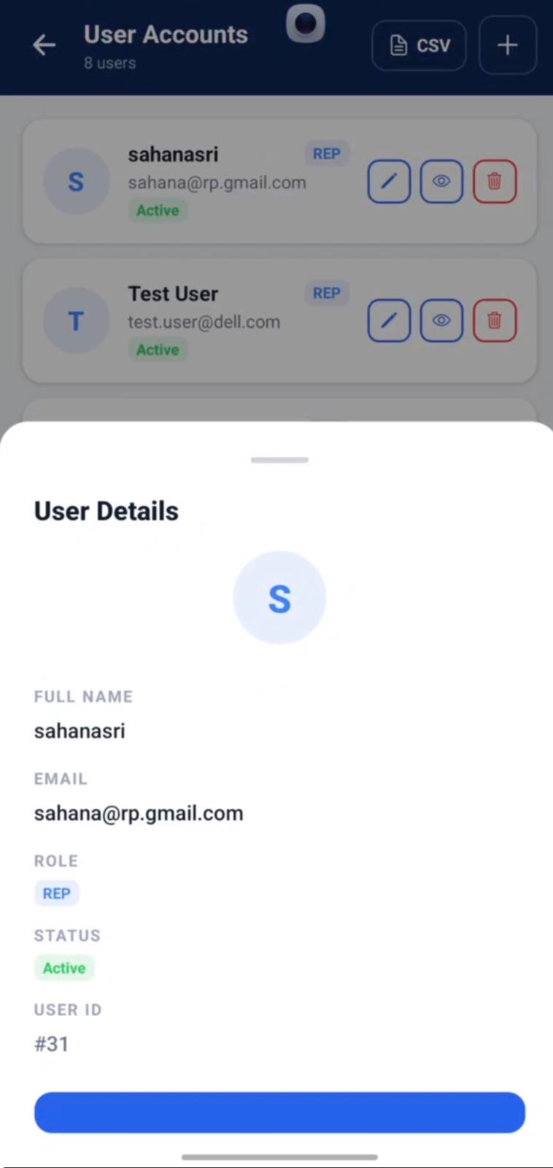

4.7 View All Leads

Overview
The All Leads page allows Administrators to view and manage every lead captured across all teams within the BoothFlow system. Leads are organised by their assigned teams, making it easier to monitor and manage team-specific lead information.
The page displays:
- Total Number of Leads
- Team Name
- Number of Leads Assigned to Each Team
- Customer Name
- Job Title
- Company
- Lead Status
- Edit and View options

Steps
- Select Leads from the bottom navigation bar.
- Browse the list of teams and their assigned leads.
- Select a team to view its captured leads.
- Tap View to review the lead details or Edit to update the lead information.

Expected Result
The selected team's leads are displayed successfully, allowing the Administrator to view and manage lead information.
Figure 4.7: All Leads


4.8 Edit Lead

Overview
The Edit Lead page allows Administrators to update an existing lead's information. This feature ensures that lead details remain accurate and up to date throughout the lead management process.
Administrators can update the following information:
- Name
- Company
- Email Address
- Lead Status
- Customer Intent
- Primary Interest
- Additional Interests
- AI Notes (Override)

Steps
- Navigate to the All Leads page.
- Locate the lead you wish to update.
- Tap the Edit button.
- Modify the required information.
- Tap Save to apply the changes, or tap Cancel to discard the changes.

Expected Result
The selected lead information is successfully updated, and the latest details are reflected in the All Leads list.
Figure 4.8: Edit Lead
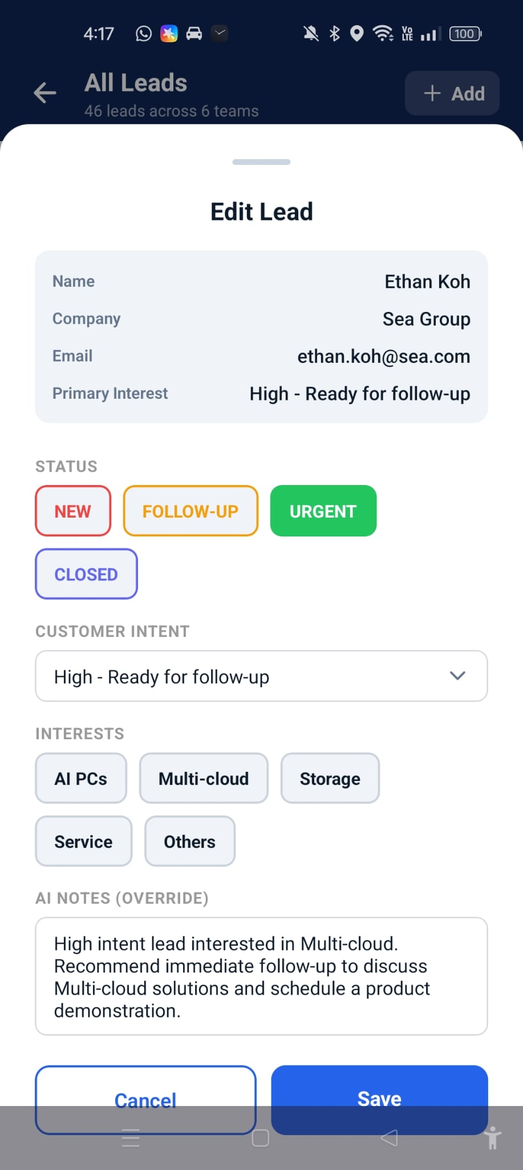

4.9 Add New Lead

Overview
The Add New Lead page allows Administrators to manually create a new lead within the BoothFlow system. This feature is useful when lead information is collected outside the QR code scanning process or needs to be entered manually.
The following information can be entered:
- Full Name
- Email Address
- Company
- Job Title
- Phone Number
- Customer Intent
- Customer Interests

Steps
- Navigate to the Leads page.
- Tap the + Add button.
- Enter the lead's Full Name.
- Enter the Email Address.
- Enter the Company name.
- Enter the Job Title.
- Enter the Phone Number.
- Select the Customer Intent from the available options.
- Select one or more Customer Interests.
- Tap Add Lead to save the new lead, or tap Cancel to discard the changes.

Expected Result
The new lead is successfully created and added to the All Leads list, where it can be viewed, edited, or managed.
Figure 4.9: Add New Lead
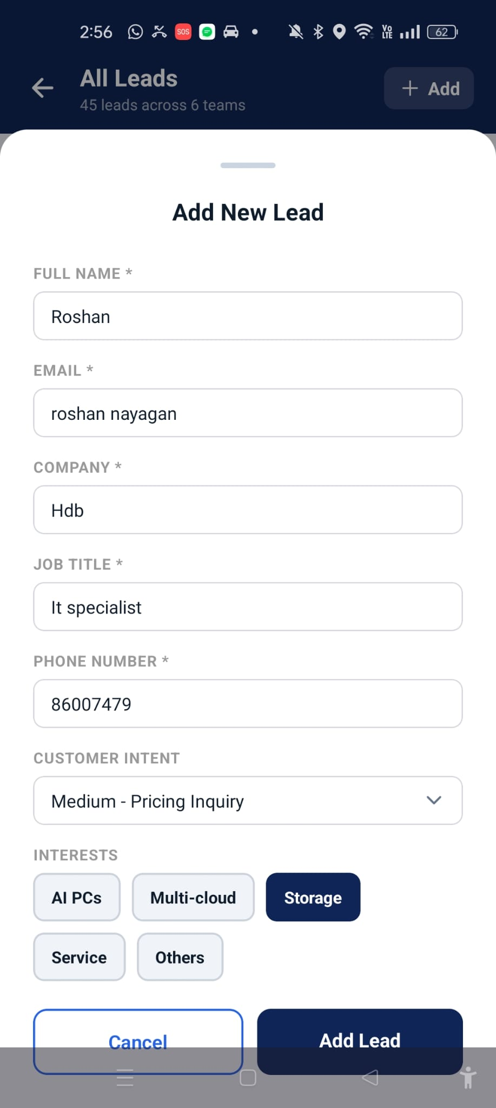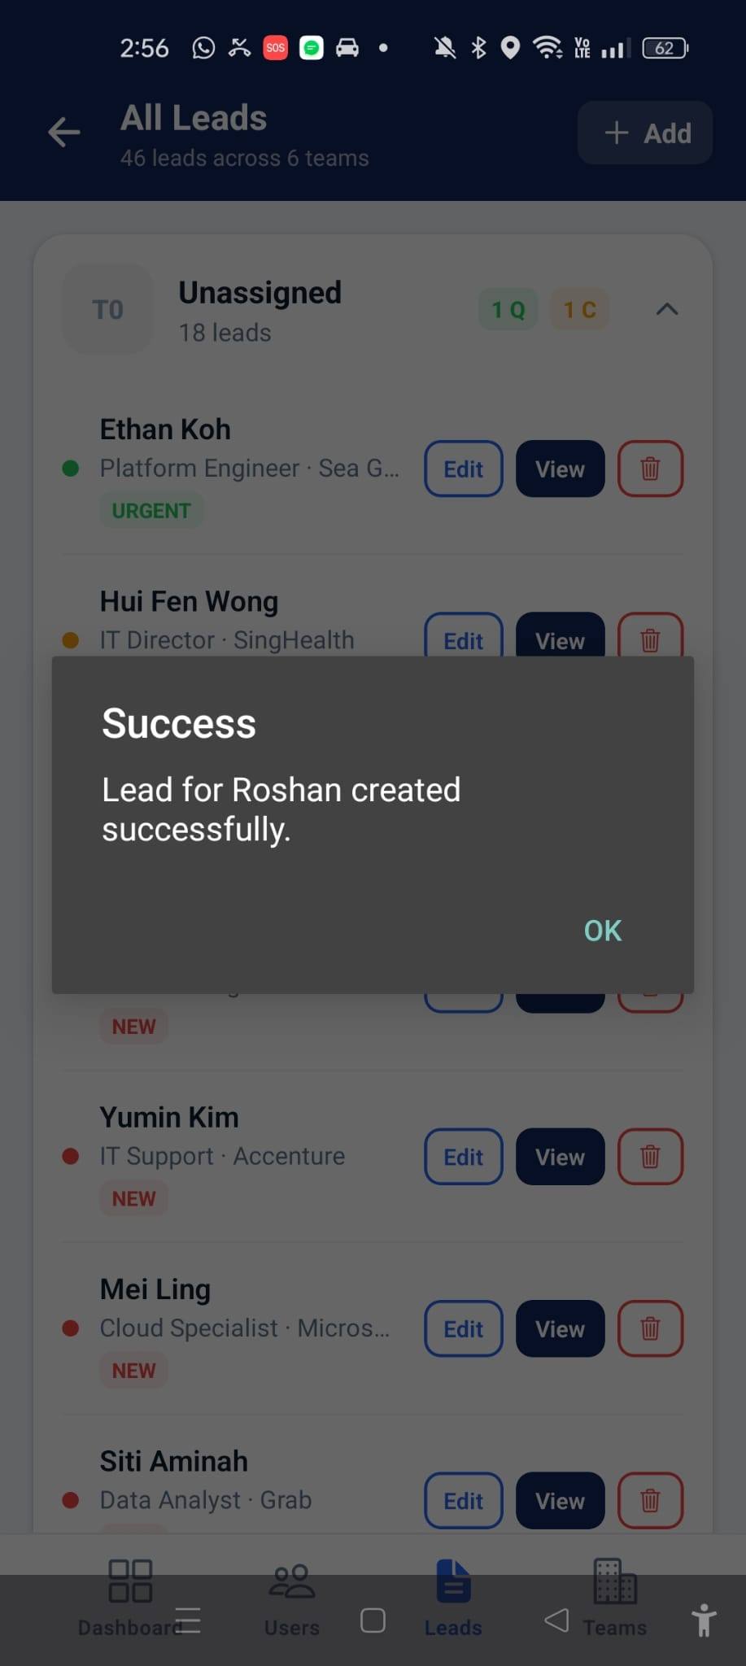

4.10 Delete Lead

Overview
The Delete Lead function allows Administrators to permanently remove a lead from the BoothFlow system. Before the lead is deleted, the system displays a confirmation dialog to prevent accidental deletion.
Note: Deleting a lead is permanent and cannot be undone.

Steps
- Navigate to the All Leads page.
- Locate the lead you wish to remove.
- Tap the Delete button.
- Review the confirmation message.
- Tap Delete to permanently remove the lead, or tap Cancel to return without making any changes.

Expected Result
The selected lead is permanently deleted from the system and is no longer displayed in the All Leads list.
Figure 4.10: Delete Lead
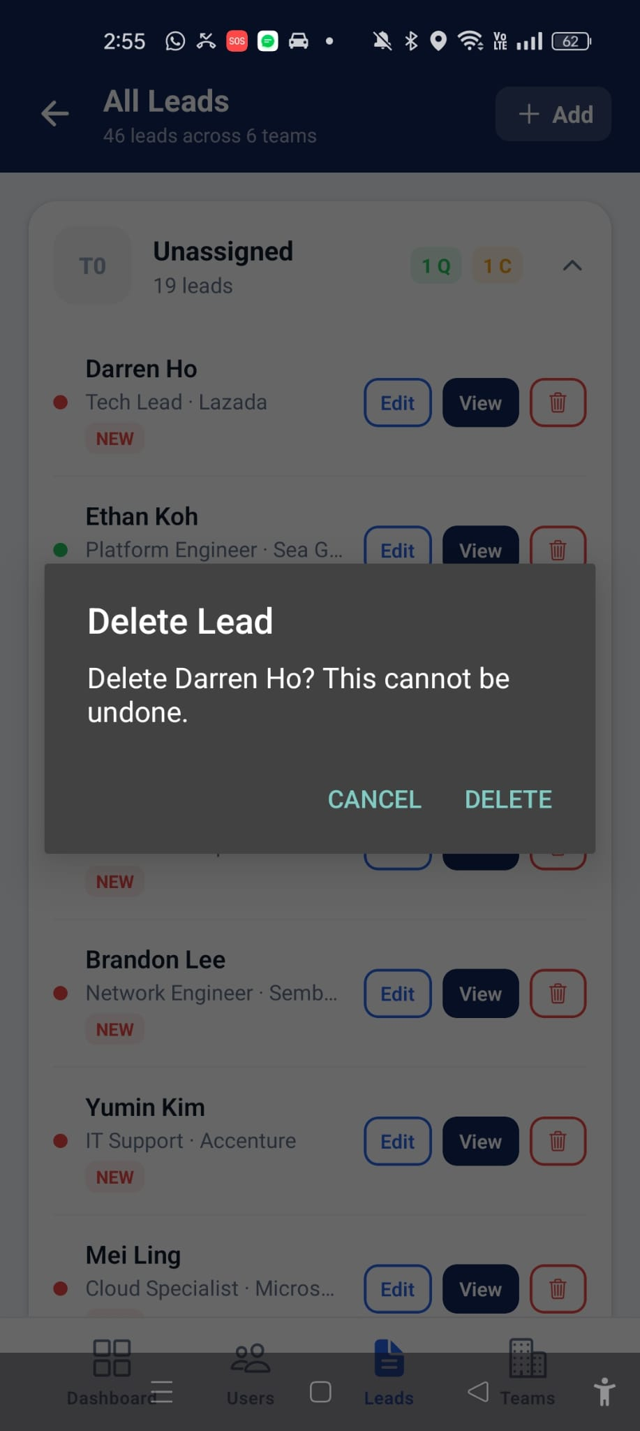

4.11 Manage Teams

Overview
The Teams page allows Administrators to view all existing teams within the BoothFlow system.
The page displays:
- Team Name
- Territory
- Team Description

Steps
- Select Teams.
- Browse the list of available teams.

Expected Result
The complete list of teams is displayed.
Figure 4.11: Teams
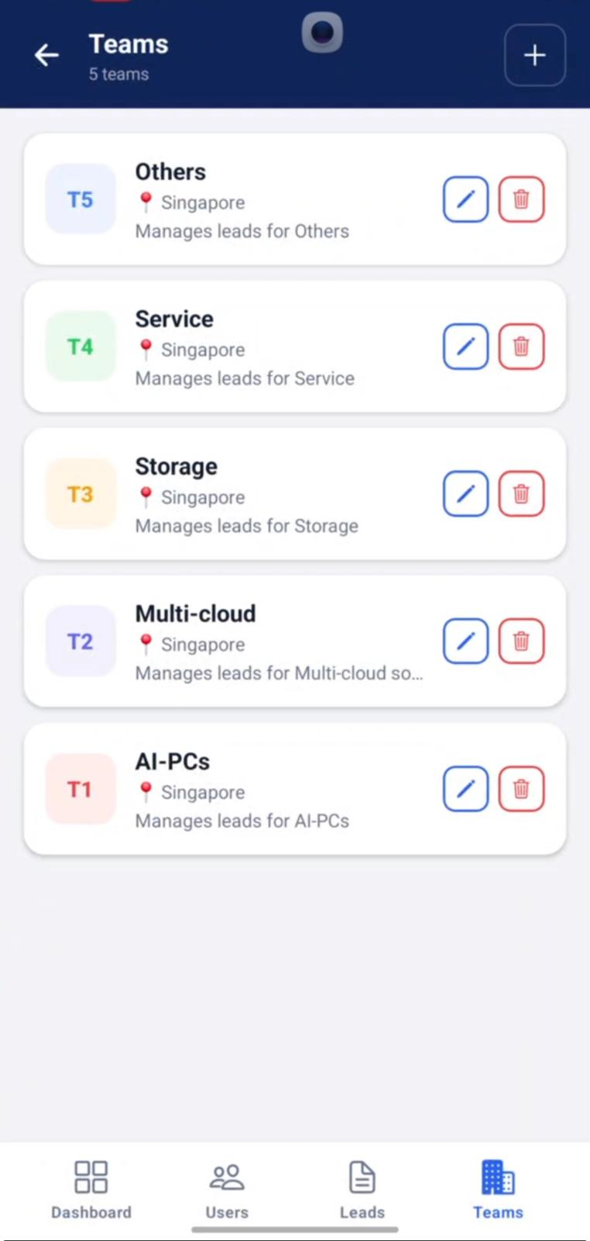

4.12 Edit Team

Overview
Administrators can modify existing team information.
Editable information includes:
- Team Name
- Territory
- Description

Steps
- Select a team.
- Tap Edit Team.
- Update the required information.
- Tap Save.

Expected Result
The team's information is updated successfully.
Figure 4.12: Edit Team
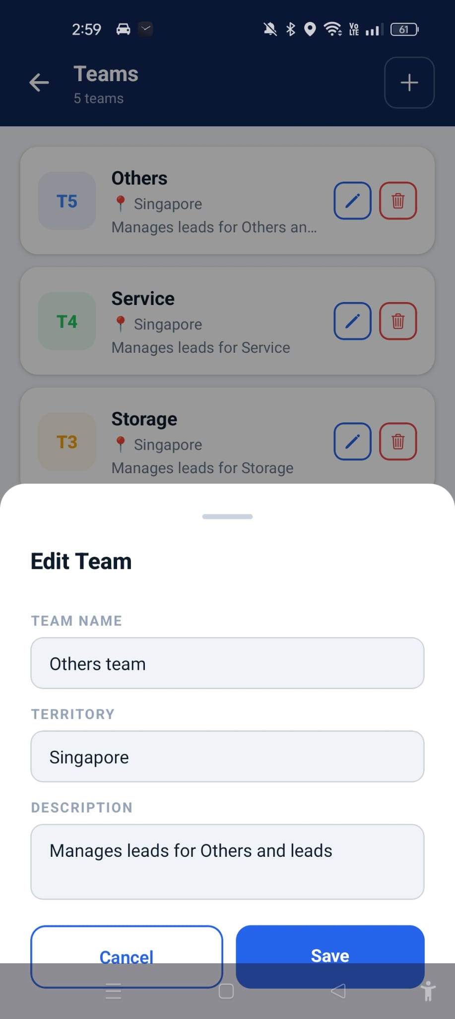

4.13 Delete Team

Overview
The Delete Team page allows Administrators to permanently remove a team that is no longer required. Before the team is deleted, the system displays a confirmation message to prevent accidental deletion.

Steps
- Navigate to the Teams page.
- Select the team you wish to remove.
- Tap the Delete button.
- Review the confirmation message.
- Tap Delete to permanently remove the team, or tap Cancel to return without making any changes.

Expected Result
The selected team is successfully deleted and removed from the Teams list.
Figure 4.13: Delete Team
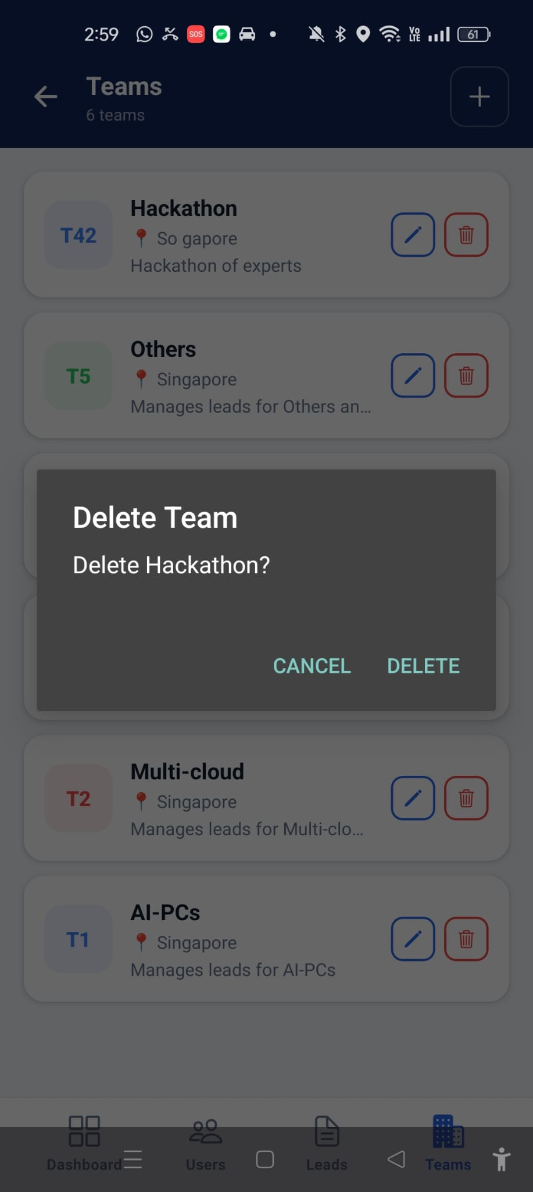

4.14 Create Team

Overview
The Create Team page allows Administrators to create a new team within the BoothFlow system. Each team can be assigned a name, territory, and description to help organise Booth Representatives and Managers according to their business function or region.
The following information is required:
- Team Name
- Territory
- Team Description

Steps
- Navigate to the Teams page.
- Tap the + button.
- Enter the Team Name.
- Select the Territory.
- Enter a brief Description for the team.
- Tap Create to save the new team.

Expected Result
The new team is successfully created and added to the Teams list.
Figure 4.14: Create Team
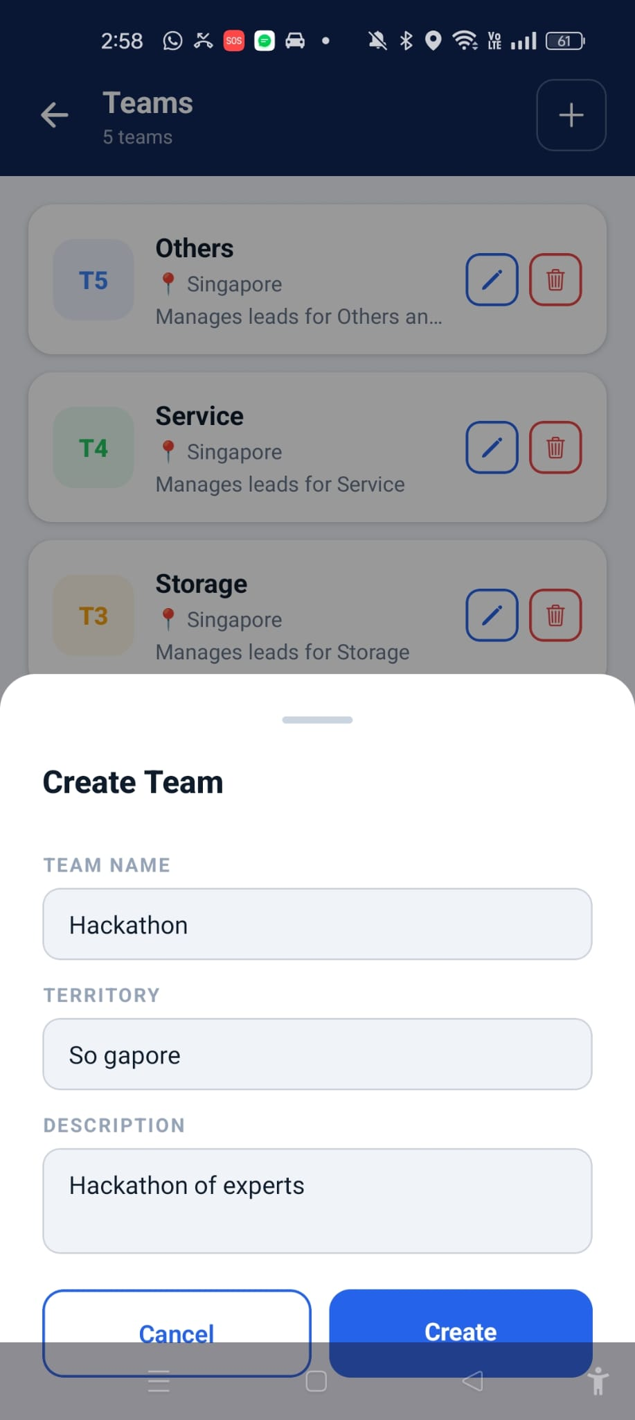

4.15 Change Appearance

Overview
The Appearance page allows Administrators to personalise the application's colour theme.
Available themes include:
- Navy
- Matcha
- Dark
- Aurora

Steps
- Open the Appearance settings.
- Select the preferred theme.
- The application automatically applies the selected colour theme.

Expected Result
The application's interface is updated with the selected appearance theme.
Figure 4.15: Change Appearance
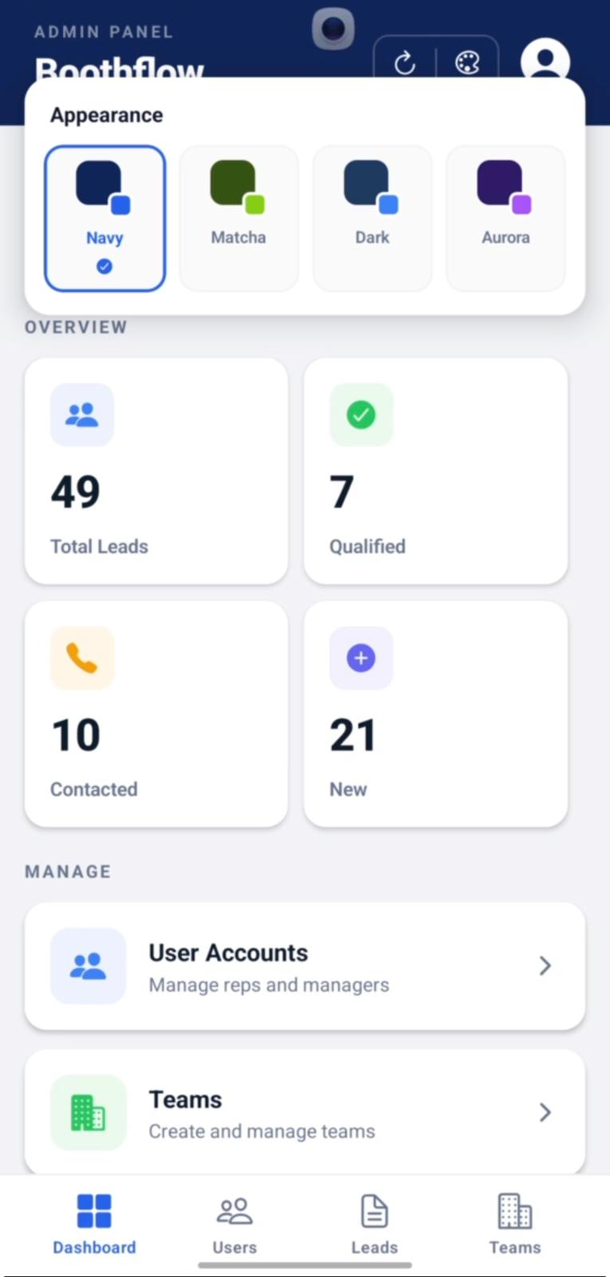

4.16 Export Lead Report

Overview
Administrators can export the complete lead database for reporting and record-keeping purposes.

Steps
- Navigate to the Dashboard.
- Select Export.
- Wait for the report to be generated.

Expected Result
The lead report is successfully downloaded.
Figure 4.16: Export Lead Report
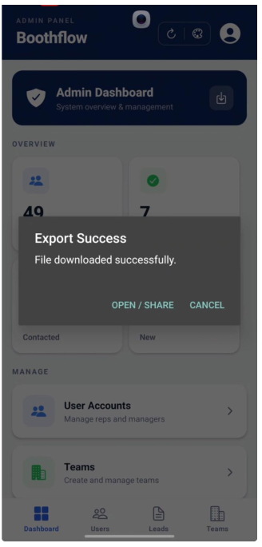

4.17 Logout

Overview
The Logout function allows Administrators to securely end their current session and return to the Login page.

Steps
- Tap the Logout option.
- Confirm the logout action if prompted.

Expected Result
The Administrator is logged out successfully and redirected to the Login page.
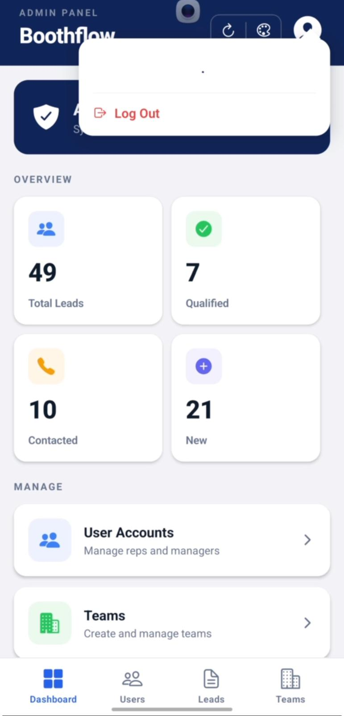
Figure 4.17: Logout

6. Troubleshooting

Issue | Possible Cause | Solution
Unable to log in | Incorrect email or password | Verify your login credentials and try again. Contact an administrator if the issue persists.
QR Code Scanner does not open | Camera permission denied | Go to your device's Settings → Apps → BoothFlow → Permissions and enable Camera access.
QR Code cannot be scanned | Poor lighting, damaged QR code, or camera not focused | Ensure the QR code is fully visible, improve lighting, and hold the camera steady.
Visitor information is not displayed after scanning | Network connection issue or invalid QR code | Check your internet connection and scan a valid QR code again.
Unable to submit a lead | Required information is missing or network interruption | Complete all mandatory fields, verify customer consent, and ensure you have an active internet connection before submitting.
AI Follow-Up Recommendation does not appear | AI service is still processing or internet issue | Wait a few seconds and refresh the page. If the problem continues, return to the Dashboard and try again.
Changes to lead information are not saved | Save button not selected or network error | Review your updates and tap Save again after confirming a stable internet connection.
Email follow-up cannot be scheduled | Follow-up status already completed or invalid date selected | Reset the follow-up status first, then select a valid future date and schedule the email again.
Excel report cannot be downloaded | Network interruption or insufficient storage | Check your internet connection and ensure there is enough storage space on your device.
Google Drive upload fails | Google account not signed in or internet connection unavailable | Sign in to your Google account, reconnect to the internet, and try uploading again.
Unable to create a new user or team | Required fields are incomplete | Ensure all mandatory fields are completed before selecting Create.
Application becomes slow | unstable internet connection | Refresh the application, reconnect to a stable network, or restart the application.

7. Frequently Asked Questions (FAQ)

Q1. What is BoothFlow?
BoothFlow is a lead management application that enables Booth Representatives to capture visitor information, qualify leads, and route them to the appropriate sales teams during events and exhibitions.

Q2. Who can use BoothFlow?
BoothFlow supports three user roles:
- Booth Representative
- Manager
- Administrator
Each role has different permissions and features.

Q3. Why does BoothFlow request camera permission?
Camera access is required to scan visitor QR codes for automatic lead capture. Without camera permission, the QR Code Scanner cannot function.

Q4. Can I edit a submitted lead?
Yes. Booth Representatives can update customer intent, additional notes, and lead status where applicable. However, customer details such as name, company, email address, and phone number cannot be modified.

Q5. How are leads assigned?
After a lead is submitted, BoothFlow automatically assigns it to the appropriate team based on the customer's information and generates AI-powered follow-up recommendations.

Q6. Can Managers export lead reports?
Yes. Managers can export captured leads by previewing the data in JSON format or downloading it as an Excel report.

Q7. Can exported reports be uploaded to Google Drive?
Yes. Managers can upload exported Excel reports directly to Google Drive for backup or sharing.

Q8. Can Administrators create new users?
Yes. Administrators can create Booth Representative, Manager, and Administrator accounts, assign roles, and allocate users to teams.

Q9. What should I do if I forget my password?
Contact your system administrator to reset your password. For security reasons, passwords cannot be recovered directly through the application.

Q10. What are the minimum system requirements?
BoothFlow requires:
- An Android device with the BoothFlow APK installed
- A stable internet connection
- Camera permission enabled
- A valid BoothFlow user account

