This is a test of the cross-refs in this doc. Here is the first figure cross-reference (Figure ).

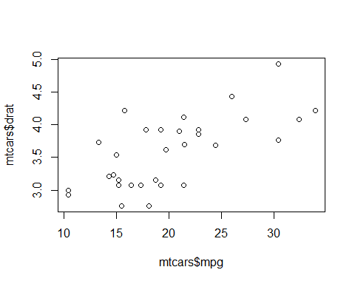

**Figure** **:** Figure caption for first figure.