# Parameterized report for cars with 4 cylinders

Here are some results that repeat for each of several species. Here I will cross-reference to the first figure in this “chapter” (Figure ), and here I will cross reference to the second figure in this chapter (Figure ). You will notice that if you’re reading the second parameterized chapter in the doc, these references will be Figure and Figure . The index doesn’t advance the same way the figure numbers in the captions do!

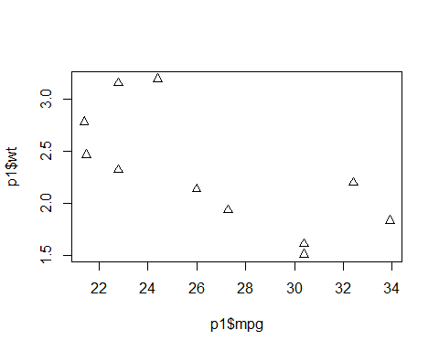

**Figure** **:** First figure in parameterized document – the figure number is 2 the first time it shows up, and 4 the second time it shows up.

Here’s some more text, followed by a second figure. For each parameterized report thing, there will be two graphs.

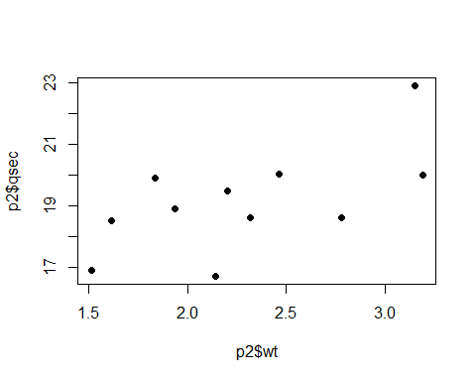

**Figure** **:** Second figure in parameterized document – the figure number is 3 the first time it shows up, and 5 the second time it shows up.