Eastern Bering Sea – Jellyfishes

Contributed by Thaddaeus Buser and Sean Rohan

Resource Assessment and Conservation Engineering Division, Alaska Fisheries Science Center National Marine Fisheries Service, NOAA

**Contact**: [thaddaeus.buser@noaa.gov](mailto:thaddaeus.buser@noaa.gov)

**Last updated**: September 2024

**Description of Indicator**: The index of abundance time series for jellyfishes (Scyphozoa, but primarily *Chrysaora melanaster*) was updated for 2024 from the eastern Bering Sea shelf survey (Figures JELLY1 and JELLY2).

Since 1982, the RACE Groundfish Assessment Program (GAP) and Shellfish Assessment Program (SAP) have conducted annual fishery-independent summer bottom trawl surveys on the EBS shelf using standardized trawl gear and methods. Biomass index trends from the survey are likely to reflect changes in the abundance of species and life history stages that are available to the survey, especially if trends are sustained over time.

Regional and stratum indices of abundance (biomass in kilotons) and confidence intervals were estimated for jellyfish by fitting a multivariate random effects model (REM) to stratum-level design-based abundance index time series calculated from GAP summer bottom trawl survey catch and effort data. The index was calculated for the entire standardized survey time series (1982 to 2024). The design-based index of abundance were calculated using the *gapindex* R package (Oyafuso, 2024) and REM were fitted to survey time series using the *rema* R package (Sullivan and Balstad, 2022). Code and methods to calculate these indicators are provided in the *esrindex* R package and repository (Rohan, 2024).

**Methodological Changes**: Methods for producing this indicator have been updated this year to account for process error in survey abundance estimates, facilitate interpretation of indicator trends, utilize consistent statistical methods across ESR regions, and ensure consistent species group composition across regions. Previously, time series for this indicator were calculated as the average bottom trawl survey catch-per-unit effort for the full survey area (CPUE, kg ha-1) that were scaled proportionally to the maximum CPUE in the bottom trawl survey time series.

This year, stratum biomass estimates were calculated using the gapindex R package (Oyafuso, 2024), which uses the Wakabayashi et al. (1985) method to estimate design-based abundance index means and coefficients of variation (CVs) from catch (kg) and effort data (area swept; ha) collected during EBS summer bottom trawl surveys. Abundance index time series means and confidence intervals were estimated by fitting a multivariate random effects model (REM) to stratum biomass estimates and CVs using the R package *rema* (Sullivan et al., 2022; Sullivan and Balstad, 2022) to account for process error in indicator time series. The code and methods to calculate abundance indices and fit REM to time series are implemented in the R package *esrindex* (Rohan, 2024).

In this update, we also provide figures showing REM estimates of abundance, by stratum, to improve the characterization of spatial abundance patterns and trends, similar to subarea trends that have been presented in the AI and GOA ESRs.

**Status and Trends**:

*Eastern Bering Sea:*

The abundance of jellyfishes in the eastern Bering Sea in 2024 was near the time series average and similar to estimates from 2022 and 2023 (Figure JELLY1). There is an apparent pattern of cyclical rise and fall in jellyfish abundance throughout the time series. The relatively low abundance estimated from 1982 to 1988 was followed by a period of increasing biomass throughout the 1990s. A second period of relatively low biomass from 2001 to 2008 was followed by a period with relatively high abundance from 2009 to 2015. Jellyfish occur throughout the survey area, but their biomass is highest in Strata 10 (southern inner shelf at bottom depth < 50 m), 30 (southern middle shelf at 50-100 m), 40 (northern middle shelf at 50-100 m), and 60 (northern outer shelf at 100-200 m; Figure JELLY2).

**Factors influencing observed trends**: Cyclic fluctuations in jellyfish abundance in the EBS are associated with jellyfish biomass during the preceding year and environmental and climatological factors, including the timing of sea ice retreat, sea surface temperature, wind mixing, and currents (Brodeur et al., 2008; Decker et al., 2023).

**Implications**: Jellyfishes are pelagic consumers of zooplankton, larval and juvenile fishes, and small forage fishes. At high levels of abundance, jellyfishes can limit fish productivity through competition for prey and predation on larval fish (Purcell and Arai, 2001). ECOTRAN model suggests that the predominant jellyfish species in the EBS, Chrysaora melanaster, utilized 1% of consumer production over the middle shelf (51–100 m) during a period of high abundance (2009–2014; Ruzicka et al. (2020)). This level of consumption corresponds with roughly a quarter of production required to support predominant forage fish in the EBS (age-0 walleye pollock, age-0 Pacific cod, Pacific herring, capelin; Ruzicka et al. (2020)).

**Research priorities**: The bottom trawl survey uses standardized survey protocols aimed at ensuring consistent sampling efficiency. However, additional research is needed to better characterize the catchability and selectivity of jellyfish by the bottom trawl survey.

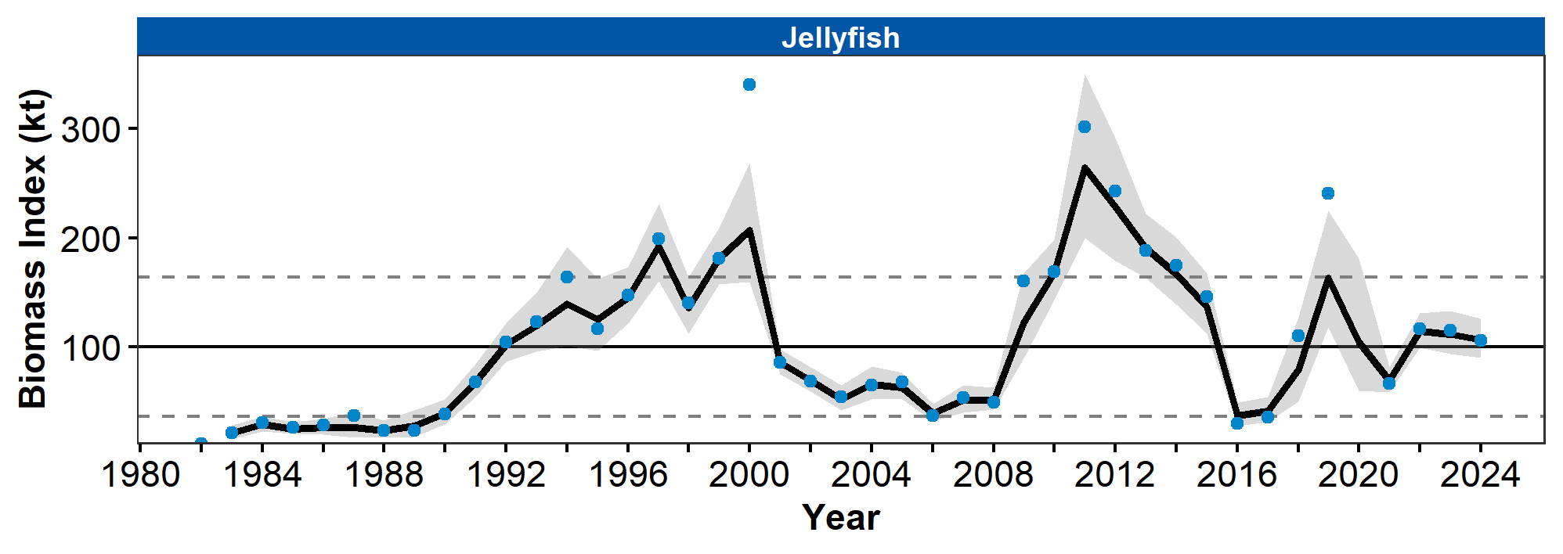

Figure 1. Biomass index of jellyfish from AFSC/RACE summer bottom trawl surveys of the eastern Bering Sea continental shelf from 1982 to 2024 showing the observed survey biomass index mean (blue points), random effects model fitted mean (solid black line), 95% confidence interval (gray shading), overall time series mean (solid gray line), and horizontal dashed gray lines representing one standard deviation from the mean.

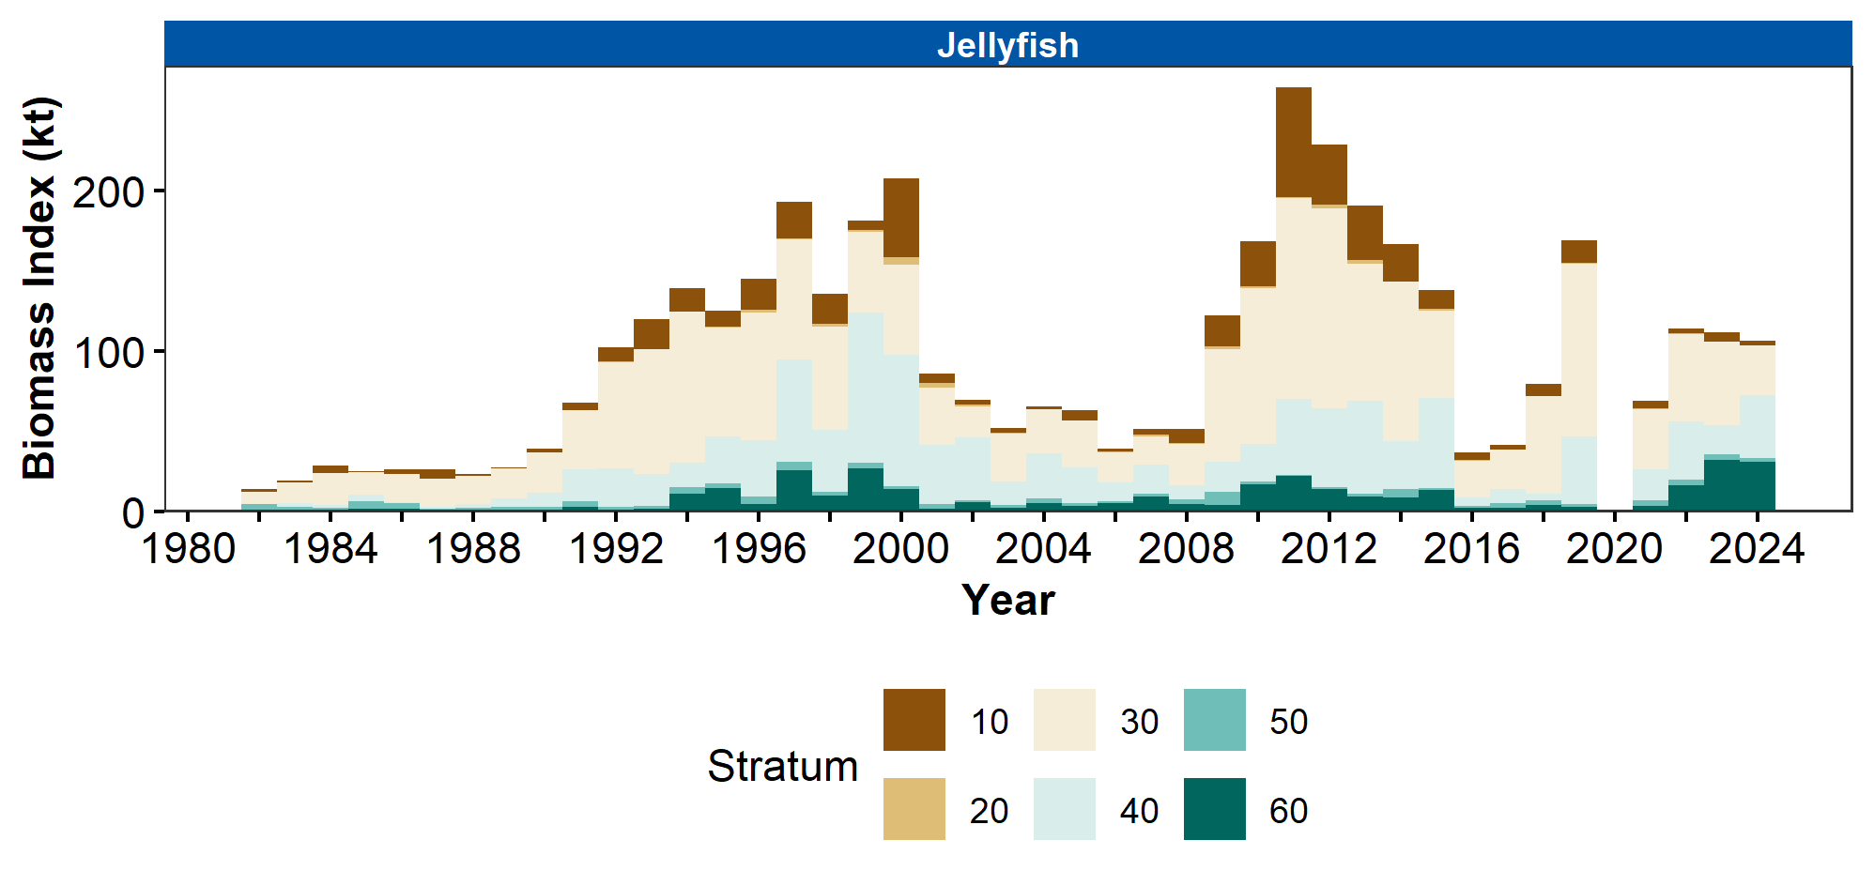

Figure 2. Biomass index of jellyfish in eastern Bering Sea survey strata 10-60 estimated from RACE Groundfish Assessment Program and Shellfish Assessment Program summer bottom trawl survey data from 1982 to 2024

## References

Brodeur, R. D., Decker, M. B., Ciannelli, L., Purcell, J. E., Bond, N. A., Stabeno, P. J., Acuna, E., and Hunt, G. L. (2008). Rise and fall of jellyfish in the eastern Bering Sea in relation to climate regime shifts. *Progress in Oceanography*, *77*(2-3), 103–111. <https://doi.org/10.1016/j.pocean.2008.03.017>

Decker, M. B., Brodeur, R. D., Ciannelli, L., Britt, L. L., Bond, N. A., DiFiore, B. P., and Hunt, G. L. (2023). Cyclic variability of eastern Bering Sea jellyfish relates to regional physical conditions. *Progress in Oceanography*, *210*(June 2022), 102923. <https://doi.org/10.1016/j.pocean.2022.102923>

Oyafuso, Z. (2024). *gapindex: Standard AFSC GAP Product Calculations. R package version 3.0.0*. <https://github.com/afsc-gap-products/gapindex>

Purcell, J. E., and Arai, M. N. (2001). Interactions of pelagic cnidarians and ctenophores with fish: A review. *Hydrobiologia*, *451*, 27–44. <https://doi.org/10.1023/A:1011883905394>

Rohan, S. (2024). *esrindex: Abundance index products for Alaska ESRs. R package version 0.1.0*. <https://github.com/afsc-gap-products/esrindex>

Ruzicka, J., Brodeur, R. D., Cieciel, K., and Decker, M. B. (2020). Examining the ecological role of jellyfish in the Eastern Bering Sea. *ICES Journal of Marine Science*, *77*(2), 791–802. <https://doi.org/10.1093/icesjms/fsz244>

Sullivan, J., and Balstad, L. (2022). *rema: A generalized framework to fit the random effects (RE) model, a state-space random walk model developed at the Alaska Fisheries Science Center (AFSC) for apportionment and biomass estimation of groundfish and crab stocks. R package version 1.2.0*. <https://github.com/afsc-assessments/rema>

Sullivan, J., Monnahan, C., Hulson, P., Ianelli, J., Thorson, J., and Havron, A. (2022). *REMA: A consensus version of the random effects model for ABC apportionment and tier 4/5 assessments. Plan Team Report, Joint Groundfish Plan Teams, North Pacific Fishery Management Council. 605 W 4th Ave, Suite 306 Anchorage, AK 99501*. <https://meetings.npfmc.org/CommentReview/DownloadFile?p=eaa760cf-8a4e-4c05-aa98-82615da1982a.pdf&fileName=Tier%204_5%20Random%20Effects.pdf>

Wakabayashi, K. R., Bakkala, G., and Alton, M. S. (1985). Results of cooperative U.S.-Japan groundfish investigations in the Bering Sea during May-August 1979. In R. G. Bakkala and K. Wakabayashi (Eds.), *International North Pacific Fisheries Commission Bulletin* (Vol. 44, pp. 7–29). International North Pacific Fisheries Commission.