Eastern Bering Sea – Miscellaneous benthic fauna

Contributed by Thaddaeus Buser and Sean Rohan

Resource Assessment and Conservation Engineering Division, Alaska Fisheries Science Center National Marine Fisheries Service, NOAA

**Contact**: [thaddaeus.buser@noaa.gov](mailto:thaddaeus.buser@noaa.gov)

**Last updated**: September 2024

**Description of Indicator**: ‘Miscellaneous’ species fall into three groups: eelpouts (fishes of the Family Zoarcidae), poachers (fishes of the Family Agonidae), and sea stars (Class Asteroidea). The three species comprising the bulk of the eelpout group are the wattled eelpout (*Lycodes palearis*) and shortfin eelpout (*L. brevipes*) and to a lesser extent the marbled eelpout (*L. raridens*). The biomass of poachers is dominated by the sturgeon poacher (*Podothecus accipenserinus*) and to a lesser extent the sawback poacher (*Leptagonus frenatus*). The composition of sea stars is dominated by the purple-orange sea star (*Asterias amurensis*), found primarily in the inner/middle shelf (Strata 10–40), and the common mud star (*Ctenodiscus crispatus*), primarily in the outer shelf (Strata 50 and 60).

Since 1982, the RACE Groundfish Assessment Program (GAP) and Shellfish Assessment Program (SAP) have conducted annual fishery-independent summer bottom trawl surveys on the EBS shelf using standardized trawl gear and methods. Biomass index trends from the survey are likely to reflect changes in the abundance of species and life history stages that are available to the survey, especially if trends are sustained over time.

Regional and stratum indices of abundance (biomass in kilotons) and confidence intervals were estimated for each taxonomic group by fitting a multivariate random effects model (REM) to stratum-level design-based abundance index time series calculated from AFSC summer bottom trawl survey catch and effort data. Indices were calculated for the entire standardized survey time series (1982 to 2024). Design-based indices of abundance were calculated using the *gapindex* R package (Oyafuso, 2024) and REM were fitted to survey time series using the *rema* R package (Sullivan and Balstad, 2022). Code and data used to produce these indicators are provided in the *esrindex* R package and repository (Rohan, 2024).

**Methodological Changes**: Methods for producing this indicator have been updated this year to account for process error in survey abundance estimates, facilitate interpretation of indicator trends, utilize consistent statistical methods across ESR regions, and ensure consistent species group composition across regions. Previously, time series for this indicator were calculated as the average bottom trawl survey catch-per-unit effort for the full survey area (CPUE, kg ha-1) that were scaled proportionally to the maximum CPUE in the bottom trawl survey time series.

This year, stratum biomass estimates were calculated using the gapindex R package (Oyafuso, 2024), which uses the Wakabayashi et al. (1985) method to estimate design-based abundance index means and coefficients of variation (CVs) from catch (kg) and effort data (area swept; ha) collected during EBS summer bottom trawl surveys. Abundance index time series means and confidence intervals were estimated by fitting a multivariate random effects model (REM) to stratum biomass estimates and CVs using the R package *rema* (Sullivan et al., 2022; Sullivan and Balstad, 2022) to account for process error in indicator time series. The code and methods to calculate abundance indices and fit REM to time series are implemented in the R package *esrindex* (Rohan, 2024).

In this update, we also provide figures showing REM estimates of abundance, by stratum, to improve the characterization of spatial abundance patterns and trends, similar to subarea trends that have been presented in the AI and GOA ESRs.

**Status and Trends**:

*Eastern Bering Sea:*

The 2024 biomass estimate for eelpouts increased from 2023, continuing an increasing trend that began in 2021 (Figure MBF1). The 2024 estimate is >1 standard deviation above the time series average and represents the largest biomass estimate since 1983. Eelpout biomass is concentrated on the outer shelf in Strata 50 and 60 (100-200 m bottom depth) and southern middle shelf in Stratum 30 (50-100 m bottom depth; Figure MBF2).

Poacher biomass increased from 2023 and is near the time series average (Figure MBF1). Poacher biomass is concentrated in inner (< 50 m) and middle (50-100 m) shelf strata (10-40), although lower abundances of deeper species are encountered in strata 50 and 60 (Figure MBF2).

The biomass for sea stars in 2024 was similar to 2023, which marked the apparent end of a multi-year period of above average biomass from 2017 to 2022. The 2023 and 2024 sea star biomass estimates are near the time series average and are a return to levels last seen in 2016 (Figure MBF1). Sea stars are observed in all survey strata, although their biomass in Stratum 50 is much lower than in other strata.

**Factors influencing observed trends**: It is difficult to identify trends. Determining whether, for example, the low abundance after 2018 in poachers represent changes in abundance, demographic structure, distributional changes, or selectivity will require more specific research on survey trawl gear selectivity relative to interannual differences in bottom temperatures and on the life history characteristics of these epibenthic species.

**Implications**: Eelpouts, poachers, and sea stars have important roles in the energy flow within benthic communities. For example, eelpouts are a common prey item of arrowtooth flounder (*Atheresthes stomias*). However, it is not known at present whether these changes in CPUE are related to changes in energy flow.

**Research priorities**: The bottom trawl survey uses standardized survey protocols aimed at ensuring consistent sampling efficiency. However, additional research is needed to better characterize the catchability and selectivity of structural epifauna groups by the bottom trawl survey.

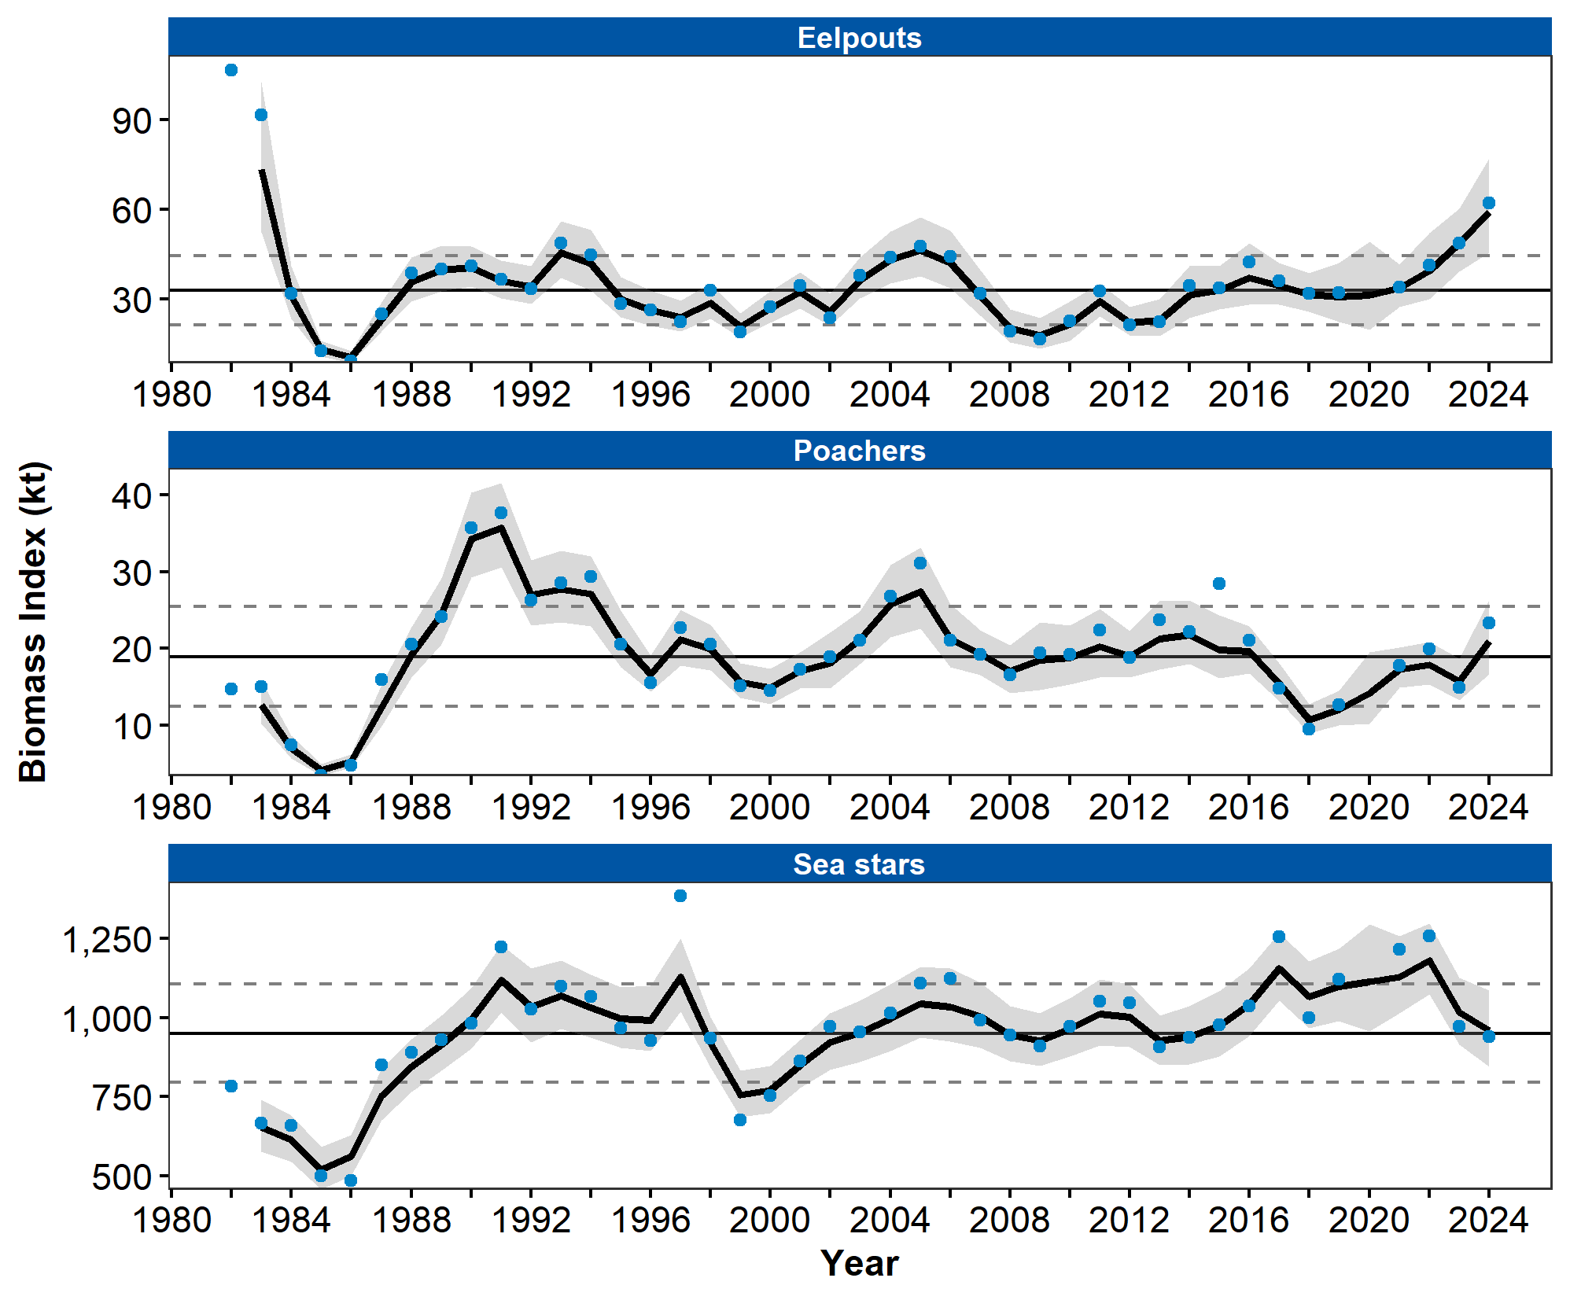

Figure 1. Biomass index of Miscellaneous Benthic Fauna (eelpouts, poachers, sea stars) from AFSC/RACE summer bottom trawl surveys of the eastern Bering Sea continental shelf from 1982 to 2024. Panels show the observed survey biomass index mean (blue points), random effects model fitted mean (solid black line), 95% confidence interval (gray shading), overall time series mean (solid gray line), and horizontal dashed gray lines representing one standard deviation from the mean.

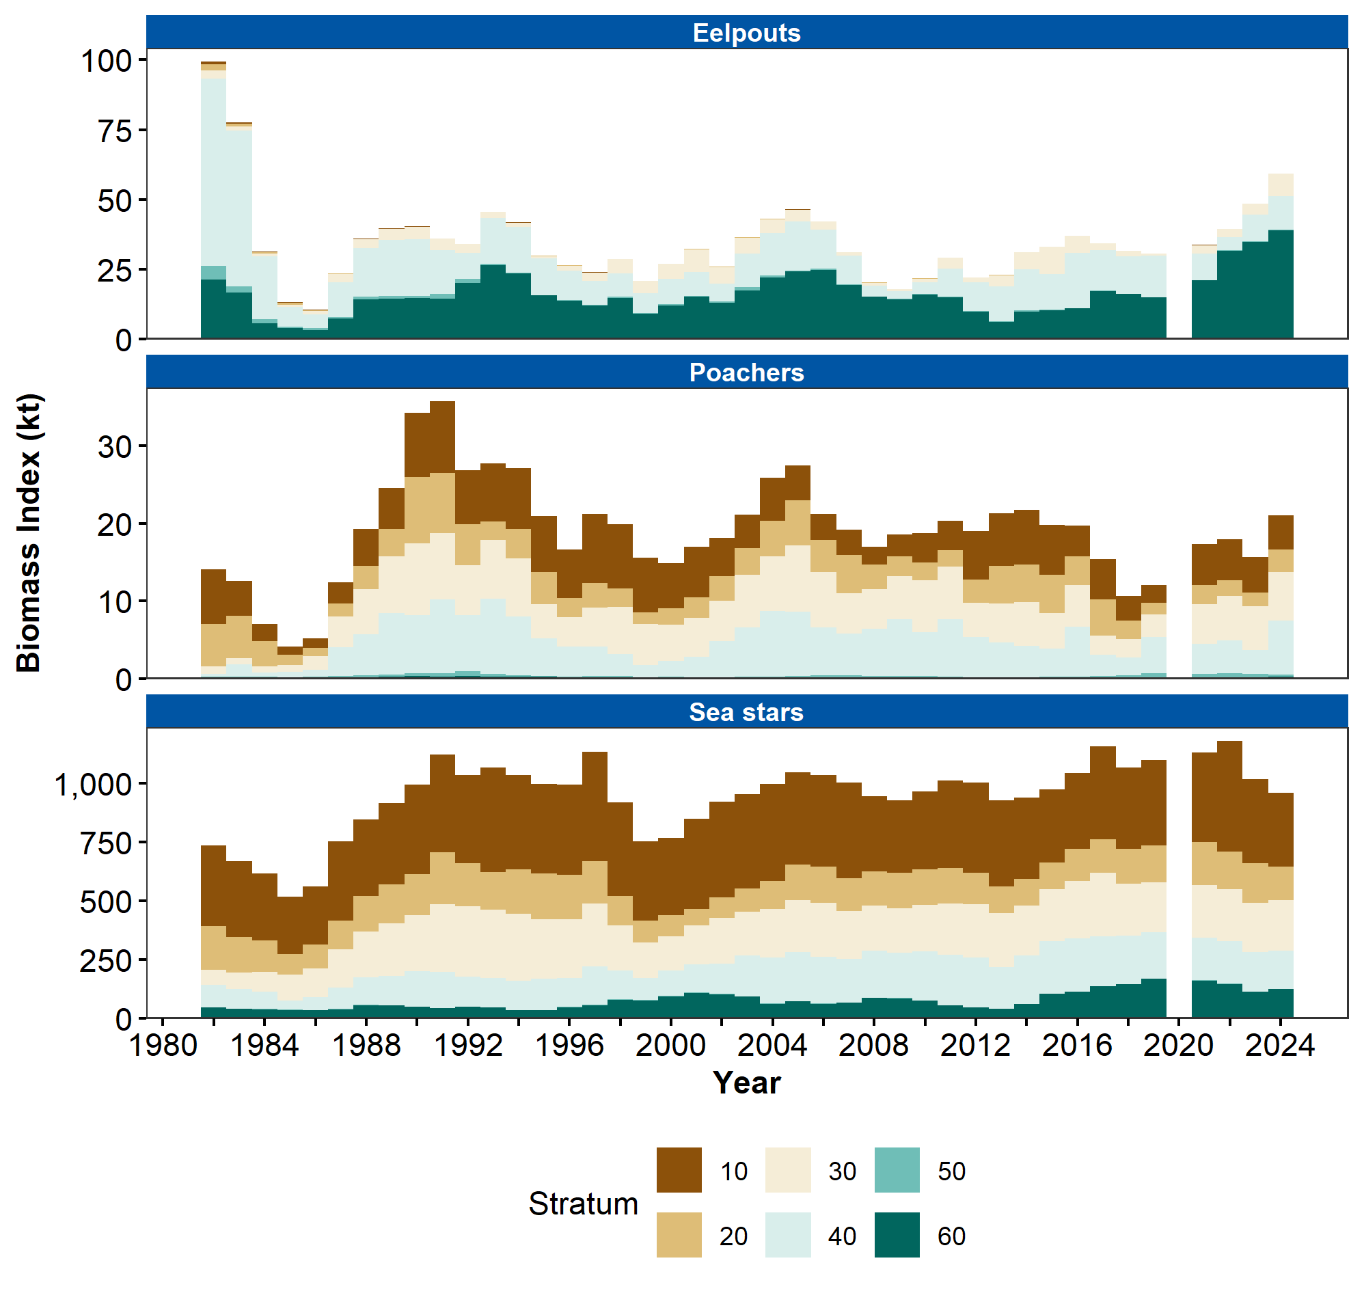

Figure 2. Biomass index of Miscellaneous Species (eelpouts, poachers, sea stars) in eastern Bering Sea continental shelf survey strata 10-60 estimated from RACE Groundfish Assessment Program and Shellfish Assessment Program summer bottom trawl survey data from 1982 to 2024.

## References

Oyafuso, Z. (2024). *gapindex: Standard AFSC GAP Product Calculations. R package version 3.0.0*. <https://github.com/afsc-gap-products/gapindex>

Rohan, S. (2024). *esrindex: Abundance index products for Alaska ESRs. R package version 0.1.0*. <https://github.com/afsc-gap-products/esrindex>

Sullivan, J., and Balstad, L. (2022). *rema: A generalized framework to fit the random effects (RE) model, a state-space random walk model developed at the Alaska Fisheries Science Center (AFSC) for apportionment and biomass estimation of groundfish and crab stocks. R package version 1.2.0*. <https://github.com/afsc-assessments/rema>

Sullivan, J., Monnahan, C., Hulson, P., Ianelli, J., Thorson, J., and Havron, A. (2022). *REMA: A consensus version of the random effects model for ABC apportionment and tier 4/5 assessments. Plan Team Report, Joint Groundfish Plan Teams, North Pacific Fishery Management Council. 605 W 4th Ave, Suite 306 Anchorage, AK 99501*. <https://meetings.npfmc.org/CommentReview/DownloadFile?p=eaa760cf-8a4e-4c05-aa98-82615da1982a.pdf&fileName=Tier%204_5%20Random%20Effects.pdf>

Wakabayashi, K. R., Bakkala, G., and Alton, M. S. (1985). Results of cooperative U.S.-Japan groundfish investigations in the Bering Sea during May-August 1979. In R. G. Bakkala and K. Wakabayashi (Eds.), *International North Pacific Fisheries Commission Bulletin* (Vol. 44, pp. 7–29). International North Pacific Fisheries Commission.