Eastern and Northern Bering Sea – Structural Epifauna

Contributed by Thaddaeus Buser and Sean Rohan

Resource Assessment and Conservation Engineering Division, Alaska Fisheries Science Center National Marine Fisheries Service, NOAA

**Contact**: [thaddaeus.buser@noaa.gov](mailto:thaddaeus.buser@noaa.gov)

**Last updated**: September 2024

**Description of Indicator**: Groups considered to be structural epifauna include: sea pens, corals, anemones, and sponges. Corals are rarely encountered in the eastern Bering Sea so they were not included here. For each group, biomass indices were updated for 2024 from the eastern Bering Sea shelf survey.

Since 1982, the RACE Groundfish Assessment Program (GAP) and Shellfish Assessment Program (SAP) have conducted annual fishery-independent summer bottom trawl surveys on the EBS shelf using standardized trawl gear and methods. Biomass index trends from the survey are likely to reflect changes in the abundance of species and life history stages that are available to the survey, especially if trends are sustained over time.

Regional and stratum indices of abundance (biomass in kilotons) and confidence intervals were estimated for jellyfish by fitting a multivariate random effects model (REM) to stratum-level design-based abundance index time series calculated from GAP summer bottom trawl survey catch and effort data. The index was calculated for the entire standardized survey time series (1982 to 2024). The design-based index of abundance were calculated using the *gapindex* R package (Oyafuso, 2024) and REM were fitted to survey time series using the *rema* R package (Sullivan and Balstad, 2022). Code and methods to calculate these indicators are provided in the *esrindex* R package and repository (Rohan, 2024).

**Methodological Changes**: Methods for producing this indicator have been updated this year to account for process error in survey abundance estimates, facilitate interpretation of indicator trends, utilize consistent statistical methods across ESR regions, and ensure consistent species group composition across regions. Previously, time series for this indicator were calculated as the average bottom trawl survey catch-per-unit effort for the full survey area (CPUE, kg ha-1) that were scaled proportionally to the maximum CPUE in the bottom trawl survey time series.

This year, stratum biomass estimates were calculated using the *gapindex* R package (Oyafuso, 2024), which uses the Wakabayashi et al. (1985) method to estimate design-based abundance index means and coefficients of variation (CVs) from catch (kg) and effort data (area swept; ha) collected during EBS and NBS summer bottom trawl surveys. Then, abundance index time series means and confidence intervals were estimated by fitting a multivariate random effects model (REM) to stratum biomass estimates and CVs using the R package *rema* (Sullivan et al., 2022; Sullivan and Balstad, 2022) to account for process error in indicator time series. The code and methods to calculate abundance indices and fit REM to time series are implemented in the R package *esrindex* (Rohan, 2024).

In this update, we also provide figures showing REM estimates of abundance, by stratum, to improve the characterization of spatial abundance patterns and trends, similar to subarea trends that have been presented in the AI and GOA ESRs.

Switching to REM addresses an issue raised during the November 2023 BSAI Groundfish Plan Team meeting pertaining to statistical methods to estimate Structural Epifauna abundance in the EBS:

*“The Team had a conversation about utilizing random effects models to deal with process error in the indicator and standardizing the index for variables such as bottom contact time.”*

We note that bottom contact time is already accounted for in bottom trawl survey effort data because effort is only calculated for the time the net is on bottom based on bottom contact sensor data.

**Status and Trends**:

*Eastern Bering Sea:*

Sponges have undergone cyclical variability in abundance throughout the time series (Figure STEP1). The biomass of sponges (Porifera) in 2024 remains >1 standard deviation below the time series average, which is a continuation of the extremely low biomass level observed since 2021. Similarly low biomass was also observed intermittently early in the time series, 1984–1992. Sponges have primarily been observed in Stratum 30, the southern middle shelf, at 50–100 m bottom depth (Figure STEP2).

The biomass of sea anemones (Actiniaria) has been above average from 2022-2024, similar to 2010–2015. The recent period of above-average biomass contrasts with the period of near-average biomass observed from 2016–2021. Sea anemones are regularly encountered in all EBS survey strata, except Stratum 20, the inner shelf (< 50 m) north-northwest of Kuskokwim Bay, near Nunivak Island. Sea pen (Pennatulacea) biomass has increased since 2019 and has remained above the time series average since 2019. Sea pens are most abundant on the outer shelf (100-200 m bottom depth) in Strata 50 and 60.

**Factors influencing observed trends**: Further research in several areas would facilitate the interpretation of structural epifauna trends including systematics and taxonomy of Bering Sea shelf invertebrates, better characterization of survey gear efficiency, and the life history characteristics of the epibenthic organisms captured by the survey trawl.

**Implications**: Structural epifauna are utilized as habitat by commercial groundfish species in Alaska (Rooper et al., 2019), although associations on the Bering Sea shelf are not well understood. Sponges can be extremely long-lived and have slow recovery times from disturbance, meaning they may be vulnerable to impacts from fishing gear (Malecha and Heifetz, 2017; Montero-Serra et al., 2018). However, very little is known about the longevity and growth rates of most sponge taxa in Alaska. Generally, sponge longevity increases with depth (Stone et al., 2019). Understanding the trends as well as the distribution patterns of structural epifauna is important for modeling habitat to develop spatial management plans for protecting habitat, understanding fishing gear impacts, and predicting responses to future climate change (Rooper et al., 2016). More research on the eastern Bering Sea shelf will be needed to determine if there are definitive links.

**Research priorities**: The bottom trawl survey uses standardized survey protocols aimed at ensuring consistent sampling efficiency. However, additional research is needed to better characterize the catchability and selectivity of structural epifauna groups by the bottom trawl survey.

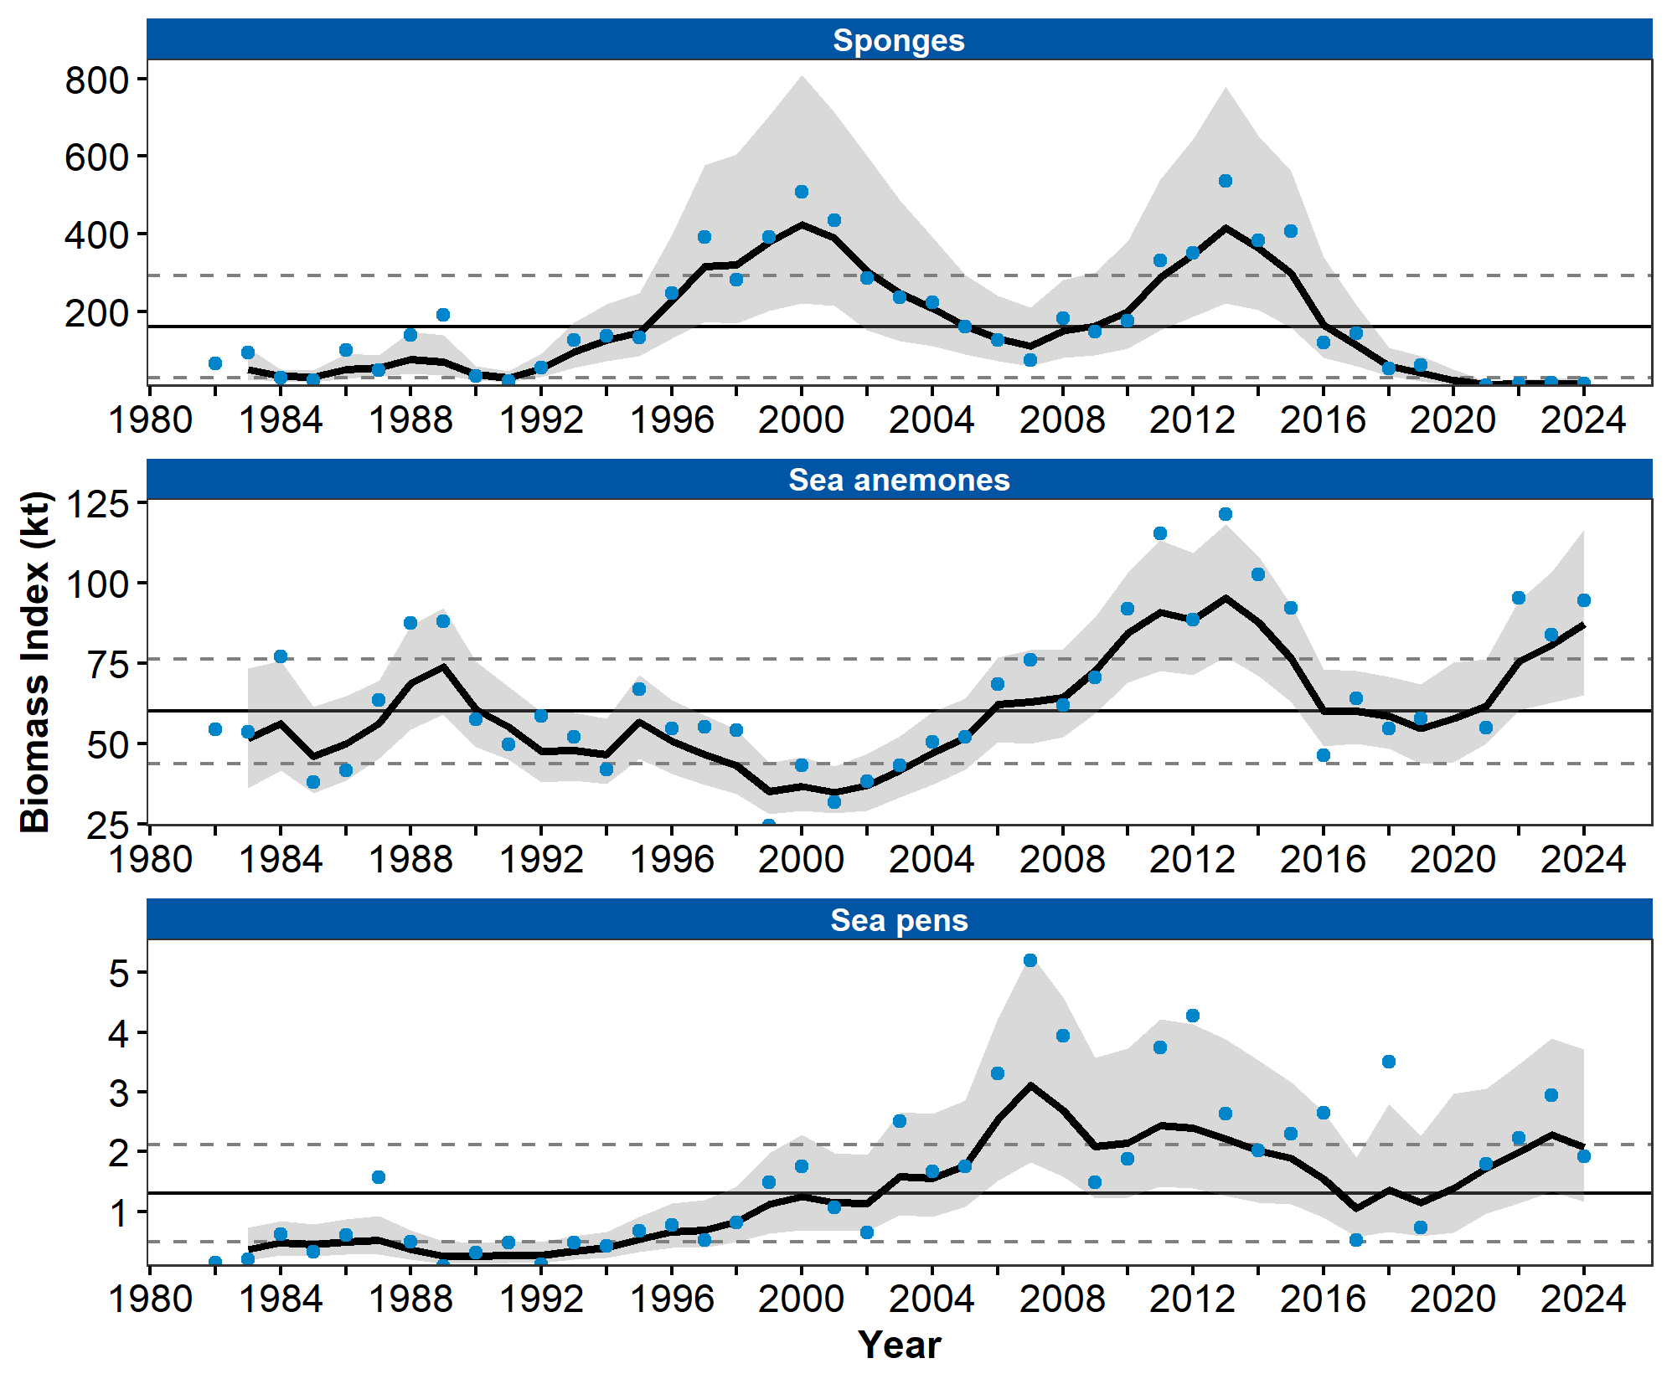

Figure 1. Biomass index of Structural Epifauna (sponges, sea anemones, and sea pens) from AFSC/RACE summer bottom trawl surveys of the eastern Bering Sea continental shelf from 1982 to 2024. Panels show the observed survey biomass index mean (blue points), random effects model fitted mean (solid black line), 95% confidence interval (gray shading), overall time series mean (solid gray line), and horizontal dashed gray lines representing one standard deviation from the mean.

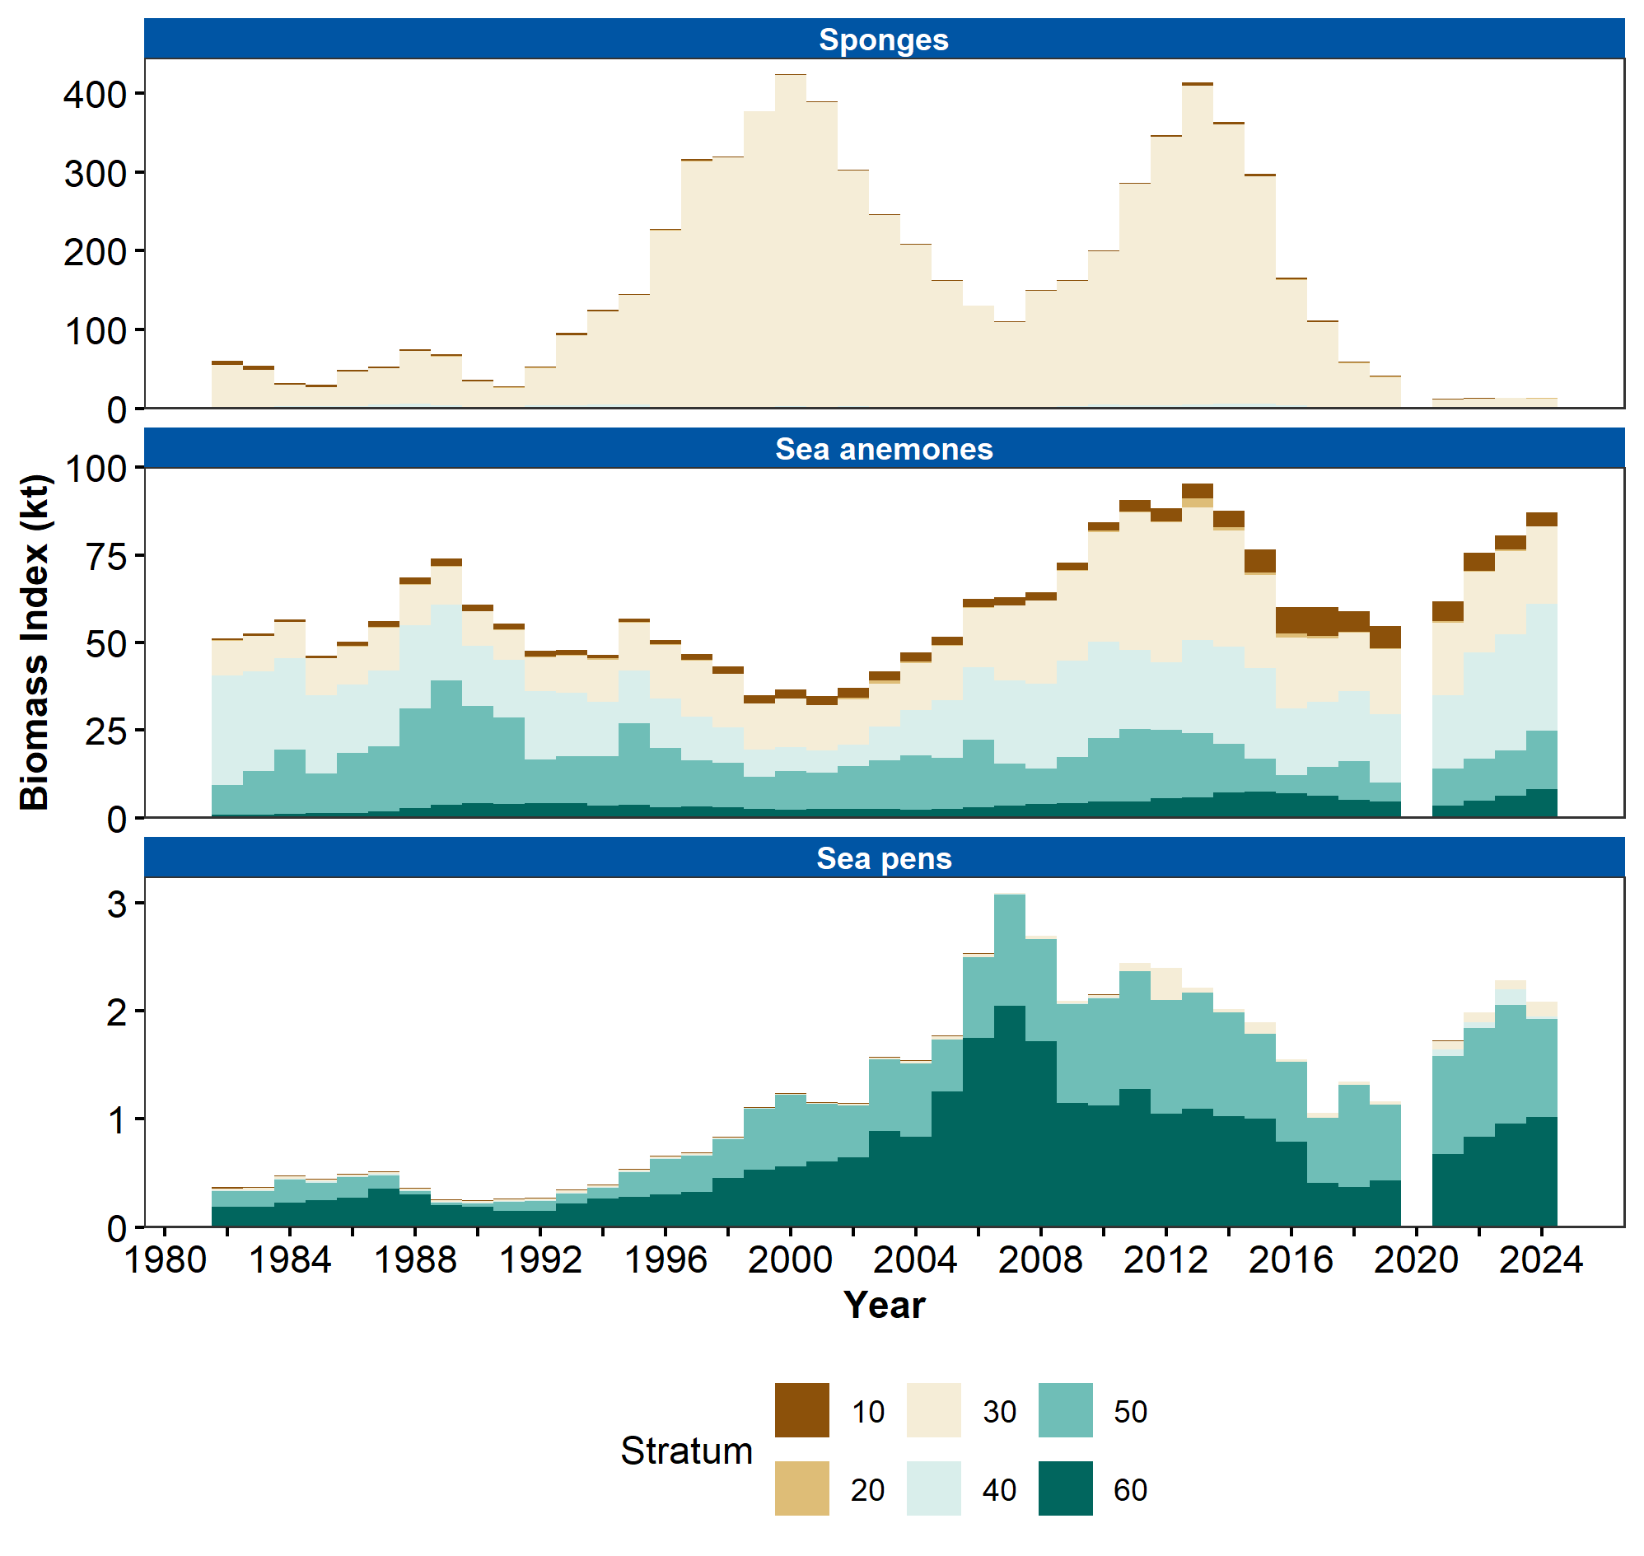

Figure 2. Biomass index of Structural Epifauna (sponges, sea anemones, and sea pens) in eastern Bering Sea continental shelf survey strata 10-60 estimated from RACE Groundfish Assessment Program and Shellfish Assessment Program summer bottom trawl survey data from 1982 to 2024.

## References

Malecha, P., and Heifetz, J. (2017). Long-term effects of bottom trawling on large sponges in the Gulf of Alaska. *Continental Shelf Research*, *150*(September), 18–26. <https://doi.org/10.1016/j.csr.2017.09.003>

Montero-Serra, I., Linares, C., Doak, D. F., Ledoux, J. B., and Garrabou, J. (2018). Strong linkages between depth, longevity and demographic stability across marine sessile species. *Proceedings of the Royal Society B: Biological Sciences*, *285*(1873). <https://doi.org/10.1098/rspb.2017.2688>

Oyafuso, Z. (2024). *gapindex: Standard AFSC GAP Product Calculations. R package version 3.0.0*. <https://github.com/afsc-gap-products/gapindex>

Rohan, S. (2024). *esrindex: Abundance index products for Alaska ESRs. R package version 0.1.0*. <https://github.com/afsc-gap-products/esrindex>

Rooper, C. N., Goddard, P., and Wilborn, R. (2019). Are fish associations with corals and sponges more than an affinity to structure? Evidence across two widely divergent ecosystems. *Canadian Journal of Fisheries and Aquatic Sciences*, *76*(12), 2184–2198. <https://doi.org/10.1139/cjfas-2018-0264>

Rooper, C. N., Sigler, M. F., Goddard, P., Malecha, P., Towler, R., Williams, K., Wilborn, R., and Zimmermann, M. (2016). Validation and improvement of species distribution models for structure-forming invertebrates in the eastern Bering Sea with an independent survey. *Marine Ecology Progress Series*, *551*, 117–130. <https://doi.org/10.3354/meps11703>

Stone, R. P., Lehnert, H., and Hoff, G. R. (2019). Inventory of the eastern Bering Sea sponge fauna, geographic range extensions and description of Antho ridgwayi sp. nov. *Zootaxa*, *4567*(2), 236–250. <https://doi.org/10.11646/zootaxa.4567.2.2>

Sullivan, J., and Balstad, L. (2022). *rema: A generalized framework to fit the random effects (RE) model, a state-space random walk model developed at the Alaska Fisheries Science Center (AFSC) for apportionment and biomass estimation of groundfish and crab stocks. R package version 1.2.0*. <https://github.com/afsc-assessments/rema>

Sullivan, J., Monnahan, C., Hulson, P., Ianelli, J., Thorson, J., and Havron, A. (2022). *REMA: A consensus version of the random effects model for ABC apportionment and tier 4/5 assessments. Plan Team Report, Joint Groundfish Plan Teams, North Pacific Fishery Management Council. 605 W 4th Ave, Suite 306 Anchorage, AK 99501*. <https://meetings.npfmc.org/CommentReview/DownloadFile?p=eaa760cf-8a4e-4c05-aa98-82615da1982a.pdf&fileName=Tier%204_5%20Random%20Effects.pdf>

Wakabayashi, K. R., Bakkala, G., and Alton, M. S. (1985). Results of cooperative U.S.-Japan groundfish investigations in the Bering Sea during May-August 1979. In R. G. Bakkala and K. Wakabayashi (Eds.), *International North Pacific Fisheries Commission Bulletin* (Vol. 44, pp. 7–29). International North Pacific Fisheries Commission.