AI data reports - quarto version
This is a test of the cross-refs in this doc (Table 1). And here is a test for figure cross-referencing. This is a test of the citations (Rugolo et al. 2020).
Table 1: Stations allocated and sampled this year.
INFPC area | Depth range | Allocated | Attempted | Succeeded | Total area | Stations per 1,000 km^2
Central Aleutians | 1 - 100 m | 30 | 29 | 29 | 960.0 | 30.21
Central Aleutians | 1 - 100 m | 30 | 29 | 29 | 2105.6 | 13.77
Central Aleutians | 1 - 100 m | 30 | 29 | 29 | 1617.7 | 17.93
Central Aleutians | 1 - 100 m | 30 | 29 | 29 | 1164.0 | 24.91
Central Aleutians | 101 - 200 m | 47 | 49 | 47 | 1735.5 | 27.08
Central Aleutians | 101 - 200 m | 47 | 49 | 47 | 1066.0 | 44.09
Central Aleutians | 101 - 200 m | 47 | 49 | 47 | 1052.3 | 44.66
Central Aleutians | 101 - 200 m | 47 | 49 | 47 | 751.8 | 62.52
Central Aleutians | 201 - 300 m | 28 | 29 | 27 | 766.4 | 35.23
Central Aleutians | 201 - 300 m | 28 | 29 | 27 | 439.0 | 61.50
Central Aleutians | 201 - 300 m | 28 | 29 | 27 | 426.0 | 63.38
Central Aleutians | 201 - 300 m | 28 | 29 | 27 | 477.4 | 56.56
Central Aleutians | 301 - 500 m | 10 | 10 | 9 | 1237.5 | 7.27
Central Aleutians | 301 - 500 m | 10 | 10 | 9 | 1239.7 | 7.26
Central Aleutians | 301 - 500 m | 10 | 10 | 9 | 789.2 | 11.40
Central Aleutians | 301 - 500 m | 10 | 10 | 9 | 714.3 | 12.60
Eastern Aleutians | 1 - 100 m | 14 | 14 | 14 | 1932.5 | 7.24
Eastern Aleutians | 1 - 100 m | 14 | 14 | 14 | 1268.1 | 11.04
Eastern Aleutians | 1 - 100 m | 14 | 14 | 14 | 1906.8 | 7.34
Eastern Aleutians | 1 - 100 m | 14 | 14 | 14 | 1740.6 | 8.04
Eastern Aleutians | 101 - 200 m | 62 | 64 | 61 | 1594.3 | 38.26
Eastern Aleutians | 101 - 200 m | 62 | 64 | 61 | 2012.6 | 30.31
Eastern Aleutians | 101 - 200 m | 62 | 64 | 61 | 2261.0 | 26.98
Eastern Aleutians | 101 - 200 m | 62 | 64 | 61 | 1900.2 | 32.10
Eastern Aleutians | 201 - 300 m | 50 | 52 | 49 | 155.9 | 314.25
Eastern Aleutians | 201 - 300 m | 50 | 52 | 49 | 1968.6 | 24.89
Eastern Aleutians | 201 - 300 m | 50 | 52 | 49 | 716.4 | 68.40
Eastern Aleutians | 201 - 300 m | 50 | 52 | 49 | 2060.6 | 23.78
Eastern Aleutians | 301 - 500 m | 9 | 9 | 7 | 2670.0 | 2.62
Eastern Aleutians | 301 - 500 m | 9 | 9 | 7 | 438.2 | 15.97
Eastern Aleutians | 301 - 500 m | 9 | 9 | 7 | 2574.7 | 2.72
Southern Bering Sea | 1 - 100 m | 19 | 23 | 20 | 1585.6 | 12.61
Southern Bering Sea | 1 - 100 m | 19 | 23 | 20 | 2440.3 | 8.20
Southern Bering Sea | 101 - 200 m | 16 | 17 | 15 | 669.5 | 22.40
Southern Bering Sea | 101 - 200 m | 16 | 17 | 15 | 1179.1 | 12.72
Southern Bering Sea | 201 - 300 m | 8 | 9 | 8 | 563.9 | 14.19
Southern Bering Sea | 301 - 500 m | 4 | 6 | 4 | 1043.2 | 3.83
Western Aleutians | 1 - 100 m | 23 | 20 | 20 | 3693.3 | 5.42
Western Aleutians | 1 - 100 m | 23 | 20 | 20 | 1183.3 | 16.90
Western Aleutians | 101 - 200 m | 65 | 57 | 56 | 4065.2 | 13.78
Western Aleutians | 101 - 200 m | 65 | 57 | 56 | 1252.5 | 44.71
Western Aleutians | 201 - 300 m | 26 | 24 | 24 | 940.2 | 25.53
Western Aleutians | 201 - 300 m | 26 | 24 | 24 | 783.4 | 30.64
Western Aleutians | 301 - 500 m | 9 | 8 | 8 | 1711.1 | 4.68
Western Aleutians | 301 - 500 m | 9 | 8 | 8 | 1561.4 | 5.12

Table 2: Target numbers of length samples for each managed species.
Species.or.species.group | Target.sample.size
Walleye pollock | 100
Pacific cod | 100
Arrowtooth flounder (ATF) | 150
All rockfish species | 100
Sablefish | 100
Atka mackerel | 100
All species of flatfish (except ATF) | 100
Skates and Sharks (total length) | 50
Grenadiers (tip of snout to insertion of first anal ray) | 50
Prowfish | All
Lingcod | All
Salmon | All
Yellow Irish lord (*Hemilepidotus jordani*) | All
Bigmouth sculpin (*Hemilepidotus bolini*) | All
Great sculpin (*Myoxocephalus polyacnthocephalus*) | All
Plain sculpin (*Myoxocephalus jaok*) | All
Warty sculpin (*Myoxocephalus verrucosus*) | All
Forage fish (herring, eulachon, capelin, sand lance) | All
Commander squid (*Berryteuthis magister*) | All
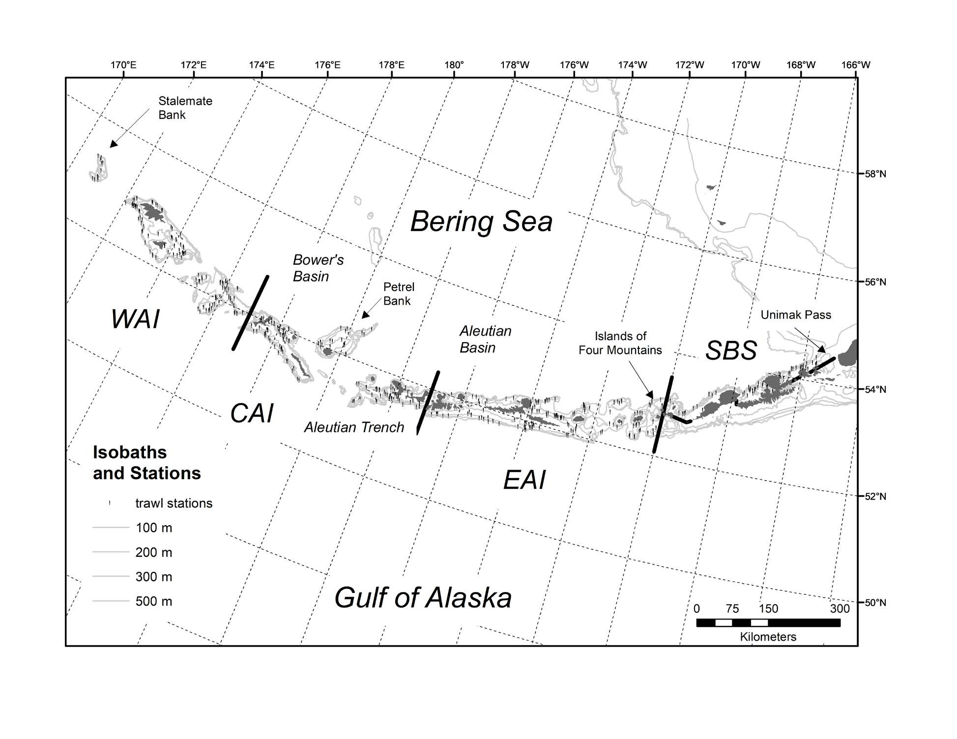
Map of the Aleutian Islands 2018 bottom trawl survey area indicating survey districts (WAI = Western Aleutian Islands, CAI = Central Aleutian Islands, EAI = Eastern Aleutian Islands, and SBS = Southern Bering Sea), isobaths from 100–500 m and stations sampled (black dots).
Rugolo LJ, Turnock BJ, Von Szalay PG. 2020. Examination of the Statistical Performance of the Mean Basket Weight Protocol in Survey Catch Processing.

