# Marine Economy - National Overview

## Seafood Sales and Processing

The economic contributions or impacts of recreational fishing activities in the United States is based on spending by recreational anglers.[1] Total annual trip expenditures were estimated at the state level by multiplying mean trip expenditures by the estimated number of adult trips in each trip mode (for-hire, private boat, and shore) and adjusting by the CPI (consumer price index) to the current year. Total annual durable expenditures were estimated by multiplying mean durable expenditures by the estimated annual number of adult participants in the United States and adjusting by the CPI (consumer price index) to the current year.[2]

Four different measures are commonly used to show how angler expenditures affect the economy in a region (state or nationwide): sales, income, value-added, and employment. The term sales refers to the gross value of all sales by regional businesses affected by an activity, such as recreational fishing. It includes both the direct sales made by the angler and sales made between businesses and households resulting from that original sale by the angler. Income includes personal income (wages and salaries) and proprietors’ income (income from self-employment). Value-added is the contribution made to the gross domestic product in a region. Employment is specified on the basis of full-time and part-time jobs supported directly or indirectly by the purchases made by anglers. The first three measures are calculated in terms of dollars, whereas employment impacts are measured in numbers of jobs. Note that these categories are not additive.

* **Drum (Atlantic croaker and spot) (Atlantic regions)**
* **Drum (seatrouts) (Atlantic regions)**: sand seatrout, seatrout genus, silver seatrout, spotted seatrout, and weakfish
* **Pacific halibut (North Pacific)**

## United States | Commercial Fisheries

#### Harvest (H) & Release (R) of Key Species/Species Groups (thousands of fish)[3] , [4]

|  |  |  |  |  |
| --- | --- | --- | --- | --- |
| Fishing Mode | #Jobs | Sales | Income | Value Added |
| For-Hire | 1,097 | 121,965 | 41,158 | 73,447 |
| Private Boat | 1,876 | 254,812 | 79,074 | 154,631 |
| Shore | NA | NA | NA | NA |
| Total Durable Expenditures | 10,610 | 1,343,395 | 522,431 | 851,616 |
| Total State Economic Impacts | 13,583 | 1,720,172 | 642,663 | 1,079,694 |

I may be using the wrong trips value?

Nichol, D. G. 1995. “Spawning and Maturation of Female Yellowfin Sole in the Eastern Bering Sea.” Journal Article. In Proceedings of the International Flatfish Symposium; October 1994, Anchorage, Alaska, 35–50.

———. 1997. “Effects of Geography and Bathymetry on Growth and Maturity of Yellowfin Sole, Pleuronectes Asper, in the Eastern Bering Sea.” Journal Article. Oceanographic Literature Review 12 (44): 1548. <https://spo.nmfs.noaa.gov/sites/default/files/pdf-content/1997/953/nichol.pdf>.

———. 1998. “Annual and Between-Sex Variability of Yellowfin Sole, Pleuronectes Asper.” Journal Article. Fishery Bulletin 96: 547–61. <https://spo.nmfs.noaa.gov/content/annual-and-between-sex-variability-yellowfin-sole-pleuronectes-aspe-spring-summer>.

Nichol, D. G., S. Kotwicki, T. K. Wilderbuer, R. R. Lauth, and J. N. Ianelli. 2019. “Availability of Yellowfin Sole Limanda Aspera to the Eastern Bering Sea Trawl Survey and Its Effect on Estimates of Survey Biomass.” Journal Article. Fisheries Research 211: 319–30. <https://doi.org/10.1016/j.fishres.2018.11.017>.

Wilderbuer, T. K., D. G. Nichol, and J. Ianelli. 2018. “Chapter 4: Yellowfin Sole.” Book Section. In Stock Assessment and Fishery Evaluation Report for the Groundfish Resources of the Bering Sea/Aleutian Islands Regions. 605 W. 4th Ave., Anchorage, AK 99501: North Pacific Fishery Management Council.

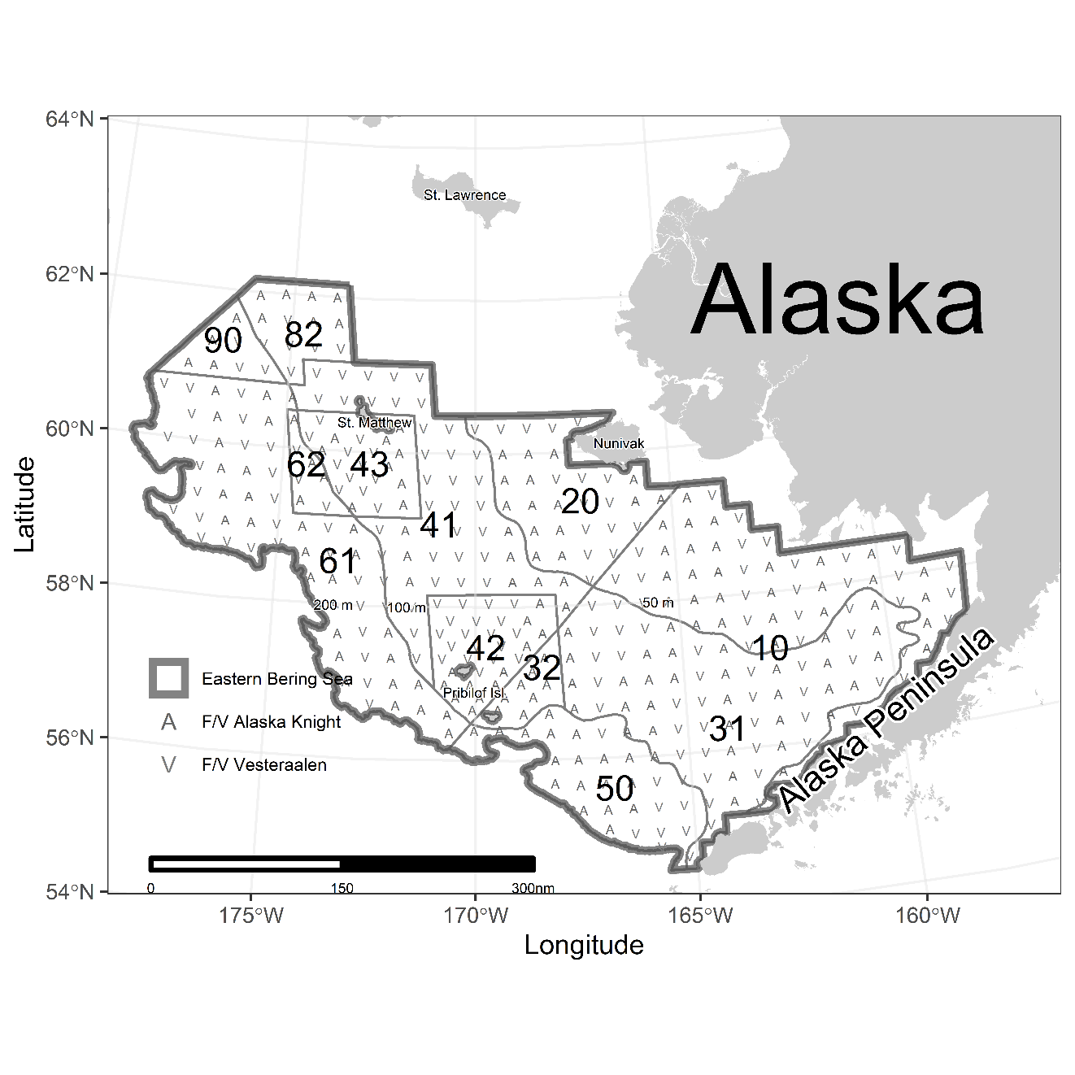

Figure . blah

1. Trip expenditure estimates were generated from the 2016/2017 National Marine Recreational Fishing Expenditure Survey. Durable goods expenditures were generated from the 2014 National Marine Recreational Fishing Expenditure Survey [Available at <http://www.st.nmfs.noaa.gov/economics/fisheries/recreational/Marine-Angler-Durable-Expenditures/2014-durable-expenditures-survey>].
2. Summary data is available online in the FEUS webtool [Available at <https://www.st.nmfs.noaa.gov/data-and-tools/FEUS/explore-the-data>].
3. Data on the number of fish released in Texas are not collected by the Texas Parks and Wildlife Department (TPWD) and therefore not reported in this table.
4. ‘NA’ = not available.