# Information Visualization

# CHECKPOINT III: Visualization Sketch

**G15 - A**

1. **Overview**

To visualize the impact that reading habit have in the demographics of a given country in EU we combine 5 different visualizations idioms. The represent the reading habits of a given country in EU, we use map where each country in associated with a color (in a color scale) which represents the country average reading. To correlate the reading habit with level of education/income in EU, we use 3 heatmaps. Each heatmap represents one of the 3 levels of education. In the heatmap each column represents a year and each row represents the evolution of the average income in country given a level of education. The average income is encoded in color scale. To complement the information showed in the heatmap we use a histogram plot that’s allows to visualize, given a year and a level of education the average income in all countries. To impact of reading habit can also been analyzed in others perspective such as the education dropout, participation in education after living the traditional education and the percentage of expenditure per household reading material. To visualize the education dropout and adult participation in learning activities we use two lines plots, one of each, where is possible to analyze they evolution along the last decade. For the expenditure in reading materials we use parallel coordinates plot to represent the percentage of the household income is invested in in EU countries. In our visualization all the changes made in one of the five mediums that we use in the visualization will affect, dynamically, the other four.

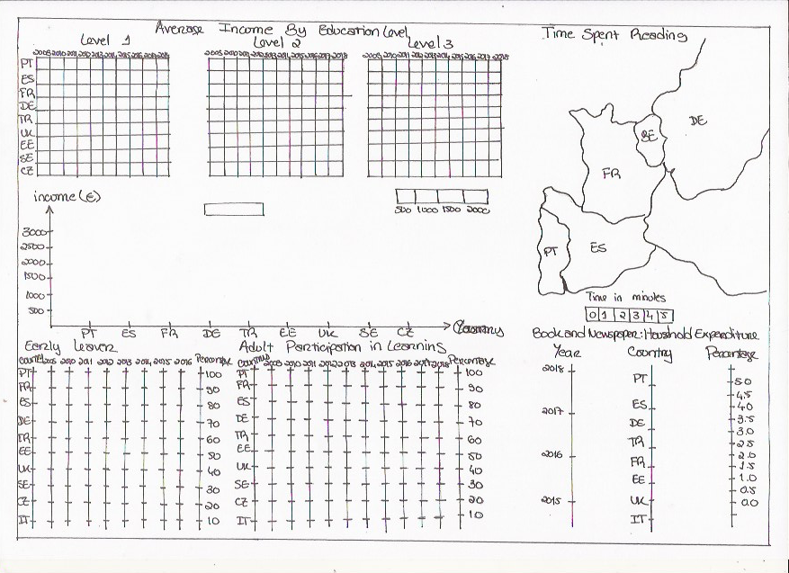

1. **Visual Encoding**

**Heatmap** – represents the average incoming by educational level, each of the level have different values.

**Column** – each label represents one year, from 2009 to 2018

**Row** – each label represents a country.

**Colour** – represents the value of incoming in euros

**Cell** – represents the country and respective year.

**Map** – represents each of the countries

**Numbers** - each number represents the time spent reading a book in minutes from 0 to 5.

**Colour** – represents differentiate country that read most than other.

**Parallel coordinates plot** – represents books and newspaper household expenditure by year, country, and percentage. Each variable is given its own axis and all axes are placed in parallel to each other.

**Values** – are plotted as series of lines that connect across all axes.

**Line chart**? 1 – represents early leaver by year, country, and percentage.

**Axes** – represents variables year, country and percentage

**Line** – represents the growth or decrease of a country over the years.

**Line chart?2** – represents the adult participation in learning, by year, country, and percentage

**Axes** - represents variables year, country and percentage

**Line** - represents the growth or decrease of a country over the years.

1. **Storyboard: “What is the average income for level 2 of education in Portugal, give the country’s reading habits?”**

To answer this question, the user can perform the following tasks:

1. Select Portugal in the Map

1. Look at the Heatmap on the left of the dashboard, the selected country is in the first row of the heatmap.

1. From right to left, the columns show the evolution of the average income by level of education in this country.
2. Below the heatmap, there is a multiple bar chart, where you can also see the difference of average income per level of education in Portugal.

1. You can also select multiple countries on the map, or on the heatmap, clicking the row correspondent to that country, and that way comparing the information on the selected countries.