# Information Visualization

# CHECKPOINT III: Visualization Sketch

G15 - A

1. **Overview**

Our visualization is based on an interactive map, where the user will be able to choose one or more countries from the EU, being able to explore information on those countries and making comparisons between them. This information will be obtained from idioms such as scatter plot, heatmap chart and parallel coordinates plot.

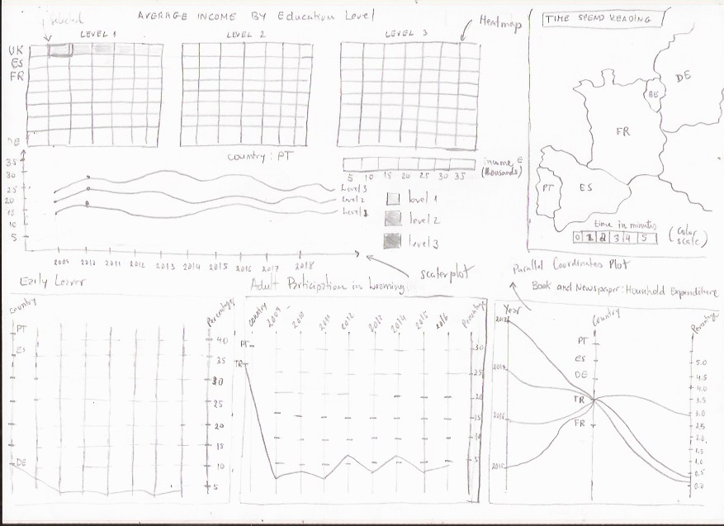

**2. Visual Encoding**

|  |  |  |
| --- | --- | --- |
| **Variable** | **Data Type** | **Visual Encoding** |
| **“avg_year_income”** | Quantitative | Heatmap, scatter plot, colour scale |
| **“percentage_total_expend”** | Quantitative | Parallel Coordinates Plot, vertical |
| **“avg_reading_minutes”** | Quantitative | Map, colour scale |
| **“percentage_pop”** | Quantitative | Colour scale, line |
| **“Year”** | Quantitative | Shape, area, line |
| **“Country”** | Nominal | Map, tag |

1. **Answering the questions**

|  |  |
| --- | --- |
| **Questions** | **Encoding** |
| **How many hours in average do the countries in Eu spend in reading** | Countries: Map with EU countries  Average time: colour scale (for each country) |
| **Average income for education for level** | Education level: Heatmap + scatter plot  Average Income: colour scale |
| **Country reading habit and dropout rate** | Parallel Coordinates plot |
| **Education participation** | Parallel Coordinates plot |
| **Household expenditure in books** | Parallel Coordinates plot |

**Story board: Average income for education level?**

In the top left of visualization, you can find the 3 heatmap corresponding to values associated with the income level from 2009 to 2018, from each country. The income level is encoded in colour scale. By clicking on a given country, in any of the 3 heatmap, we can visualize in the scatter plot bellow, the heatmap’s, the country income level evolution in each of the 3 level of education.

