# Information Visualization

# CHECKPOINT IV: First Prototype

G15 - A

**1. Layout**

For this checkpoint we defined the layout for our visualization which is shown in figure 1.

|  |  |  |
| --- | --- | --- |
| **Location** | **Idiom** | **Representation** |
| Top Left | Country Income by Education Level | Stacked Bar Chart |
| Bottom Left | Early Leavers in Education | Line Chart |
| Top Right | Reading Habits per Country | Choropleth Map |
| Bottom Right | Household Expenditure in Reading Material | Heatmap |

Our initial idea of the layout (Figure 2), had a total of six idioms, we reduced it to four. Some of the idioms were redundant, they were showing the same information as others, and it was also causing clutter in the visualization. For these two reasons we removed the heatmap for the “Average Income by Education Level” and changed the multiple bar chart to a stacked bar chart, giving the user the possibility to compare the information between countries and education level. We also removed the “Adult Participation in Learning” idiom. The “Books and Newspapers: Household Expenditure” is now a heatmap.

Fig 1 – Current Layout of the Interface (Updated)

Fig 2 – Initial Layout of the interface

**2. Implemented Idioms**

We have three of the four idioms where the base structure is fully implemented, which are “Average Income by Education Level” (Figure 3), “Early Leavers in Education” (Figure 5) and “Books and Newspapers: Household Expenditures” (Figure 6).

The choropleth map, our idiom correspondent to the “Average Time Spent Reading” (Figure 4) already has a basic part implemented, we have the map only containing EU countries and when the user clicks a country the colour of the border changes. We are missing the implementation of the title, the label explaining the hue of the map, the label that will appear when the user hovers with the mouse over a country, and finally the implementation of the interactivity between the map and the rest of the idioms, when a user selects a country in the map, a filter is created on the rest of the idioms.

For now, only the “Average Income by Education Level” idiom has interactivity, the user can select the year it wants to visualize in a dropdown. And the stacked bar chart will have a transition and show the user the data correspondent to that year.

Since the interactivity between the views is not completed, and we are still missing the key idiom for interactivity (Choropleth map), we are not considering as fully implemented.

Fig 3 – Idiom “Average Income by Education Level”

Fig 4 – Idiom “Average Time Spent Reading”

Fig 5 – Idiom “Early Leavers in Education”

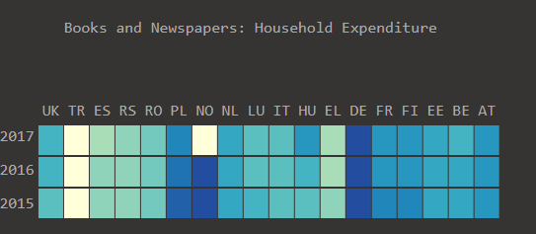

Fig 6 – Idiom “Books and Newspapers: Household Expenditure”

**3. Implementation of Linking Mechanism**

The connection between the different views will mainly work through the selection of the countries which the user wants to compare, then the views are filtered according to that selection. The user will be able to select the countries through the map and the heatmap, selecting a column corresponds to selecting a country.

When the visualization is initialized, it will be selected 6 random countries, and the rest of the views will be filtered according to these, the user can then select the countries he/she wants.

All the views will have a transition when the country selection is made:

* **Choropleth Map** – Countries selected get a border with a different colour.
* **Stacked Bar Chart** – The countries being shown change.
* **Line Chart** – Only the lines of the countries selected are shown.
* **Heatmap** – The columns of the selected countries get a box surrounding the column elements.