**Project #1 CS 550**

**Draw Something Cool in 3D!**

**Rainbow Road**

**Margaux Masson**

[massonm@oregonstate.edu](mailto:massonm@oregonstate.edu)

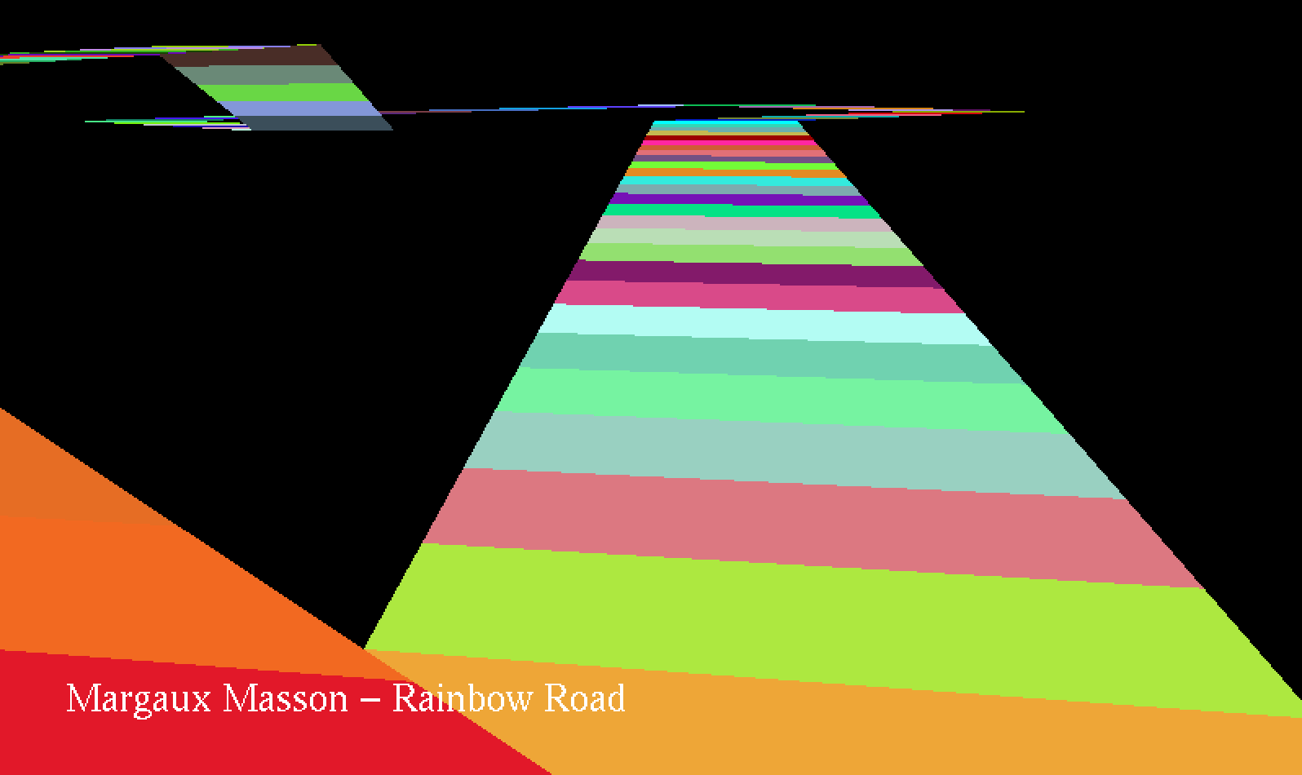

Race view like in Mario Kart

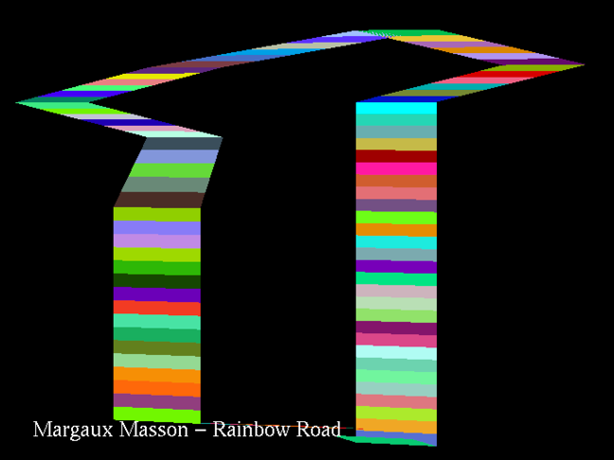

Circuit’s overview