1.Connect to the postgres Database and create new one named “test_db”.

2. Run query, investigate result:

select d.oid, d.datname, d.datistemplate, d.datallowconn, t.spcname from pg_database d join pg_tablespace t on t.oid = d.dattablespace

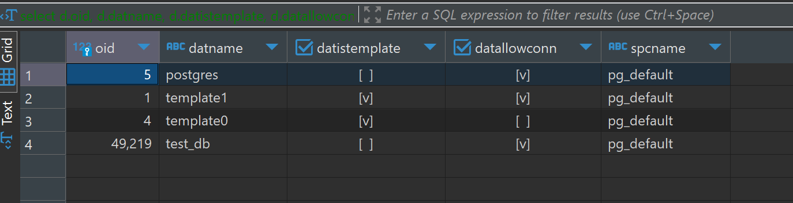

postgres is the default administrative connection database.

template1 is the default template database that is used to create new databases.

template0 is a pristine template that can be used if template1 becomes corrupted or modified.

test_db is a user-created database just now.

Oid is unique identifier.

Datname is name of the database.

datistemplateindicates whether the database is a template and template databases are used as the basis for creating new databases.

datallowconn indicates whether connections to the database are allowed

spcnameIndicates the tablespace associated with the database. pg_default is the default tablespace.

2.

**select** *

**from** ***pg_tablespace***

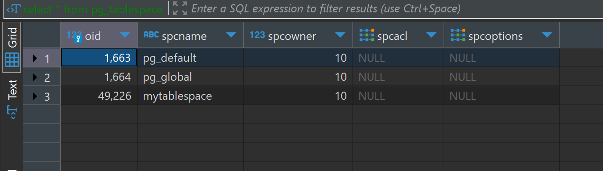

It tells names of spcnames.

ALTER DATABASE test_db SET TABLESPACE mytablespace

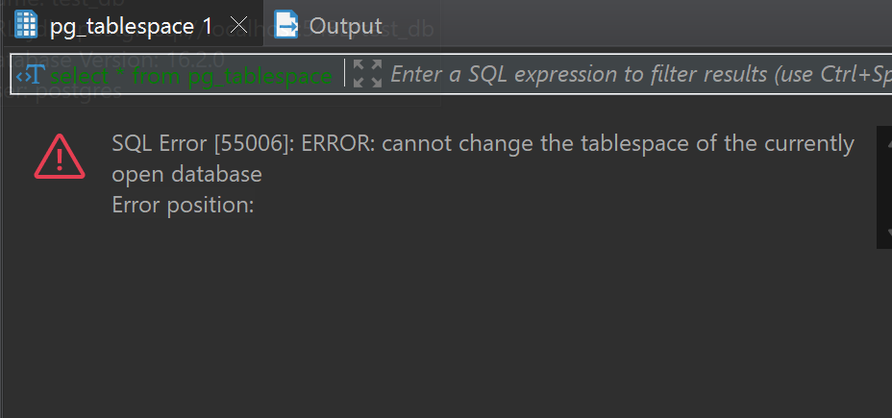

Location: 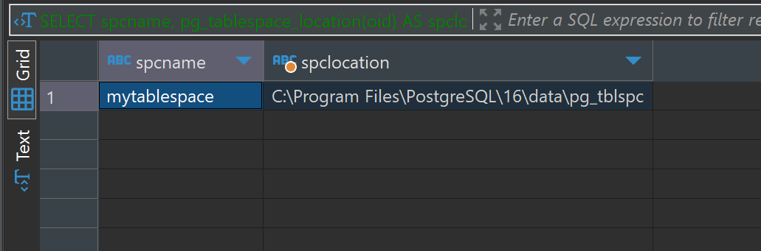

2.3 TASK 3 CREATE NEW SCHEMA

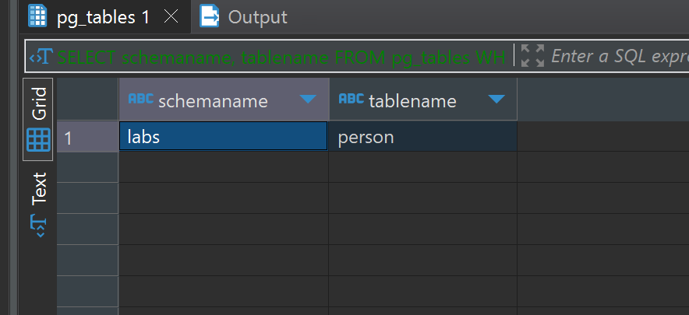

3. 0

I inserted from below to up

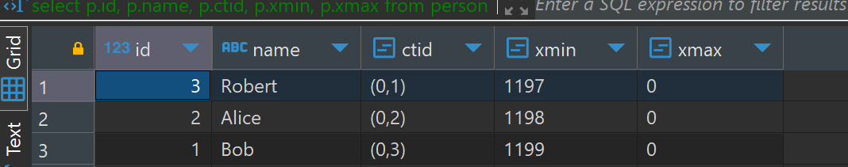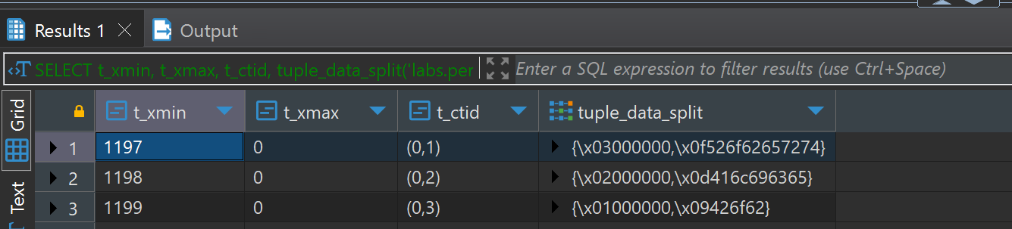

After this:

**INSERT** **INTO** ***person*** **VALUES**(4, **'John'**);

**UPDATE** ***person*** **set** **name** = **'Alex'** **where** ***id*** = 2;

**DELETE** **FROM** ***person*** **WHERE** ***id*** = 3;

**INSERT** **INTO** ***person*** **VALUES**(999, **'Test'**);

**DELETE** **FROM** ***person*** **WHERE** ***id*** = 999;

**SELECT** ***t_xmin***, ***t_xmax***, ***t_ctid***,

tuple_data_split(**'labs.person'**::**regclass**, ***t_data***, ***t_infomask***,

***t_infomask2***, ***t_bits***)

**FROM** heap_page_items(get_raw_page(**'labs.person'**, 0));

I accidentally inserted twice I think.

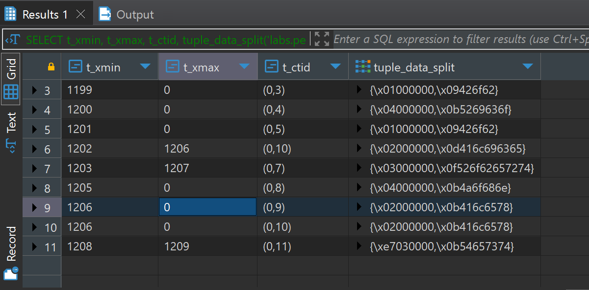

A t_xmax of zero means the tuple is currently not marked for deletion or update

3.2

Aftger vacuum 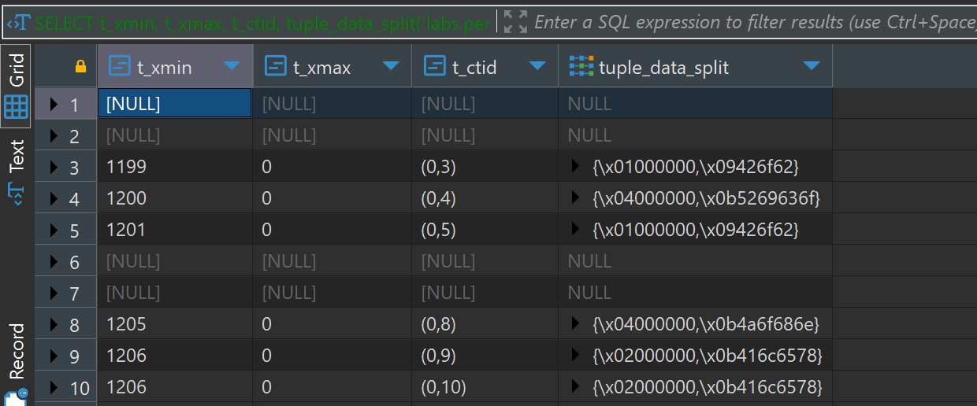

Inserting ‘sarah’ made t_xmin to 1200

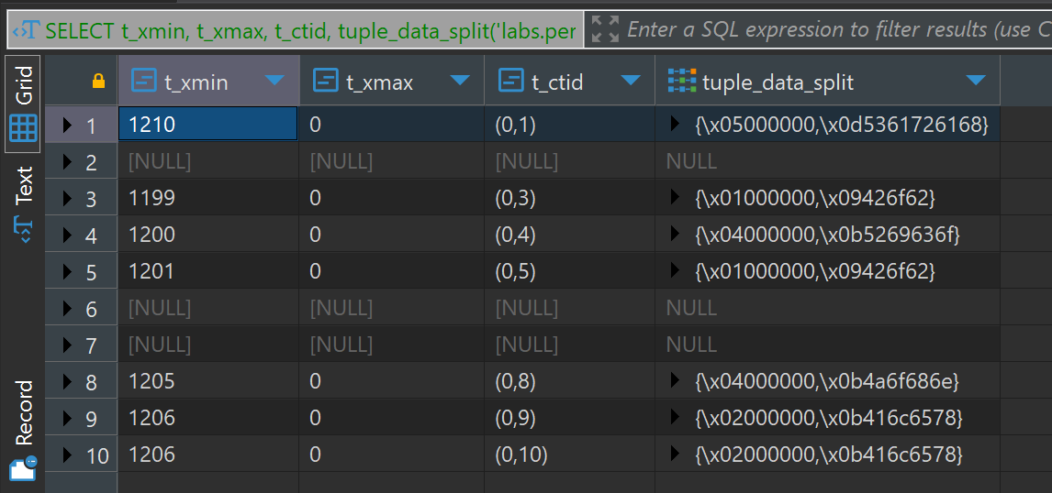

After vacuum full the result is:

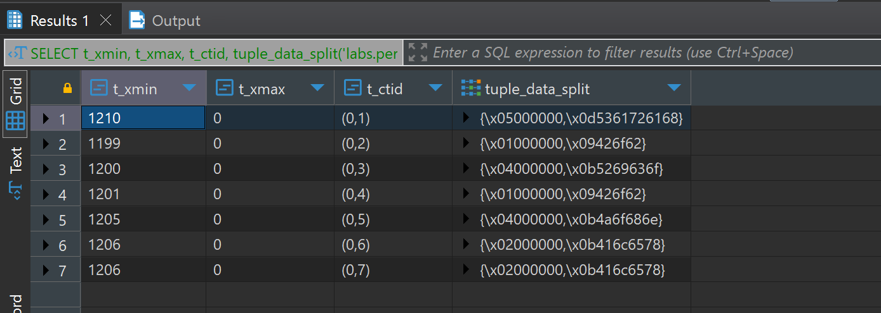

Vacuum full deleted nulls.