1. It shows T a detailed execution plan of a query, helping to understand how the database process it, things like scans, joins, and the estimated costs.

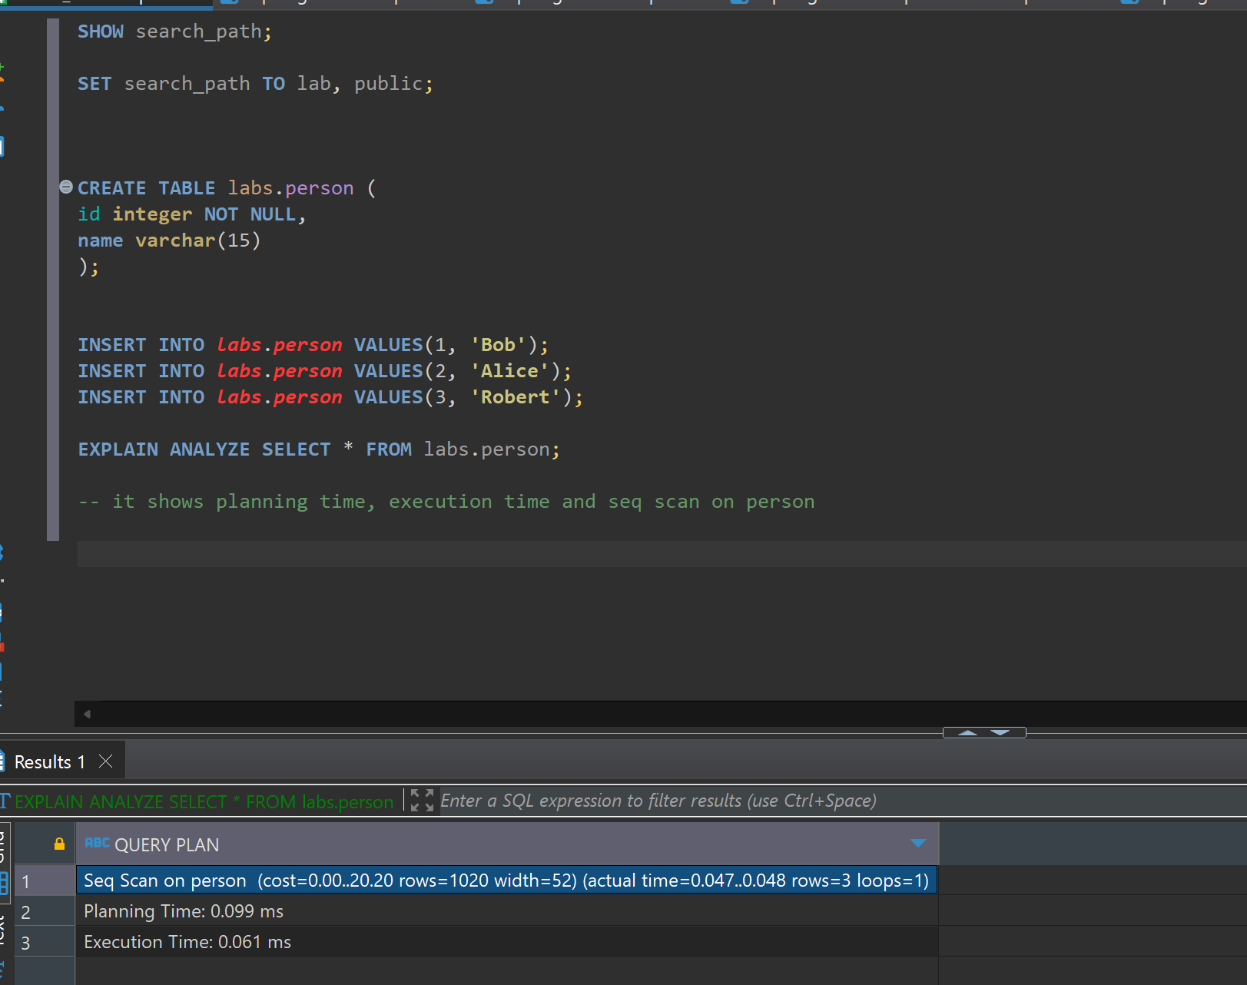

2.

Time on inserting first.

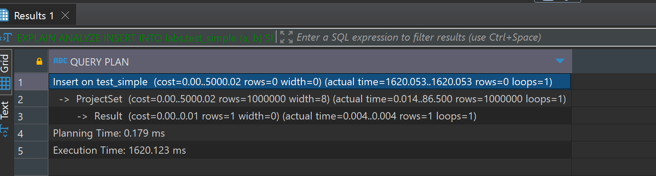

Second execution time was much more, like 5 or 6 seconds more than first one.

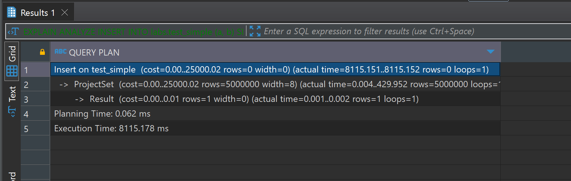

With unlogged table it took much less inserting 1000000

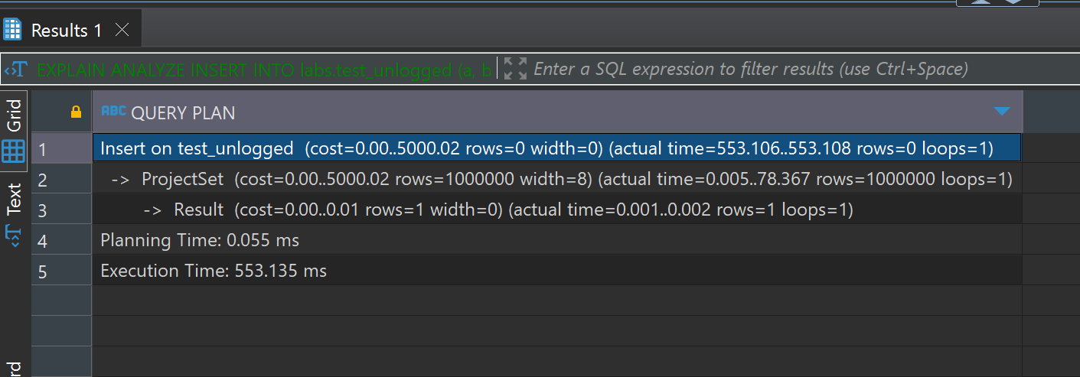

It also took much less for the 5000000 rows

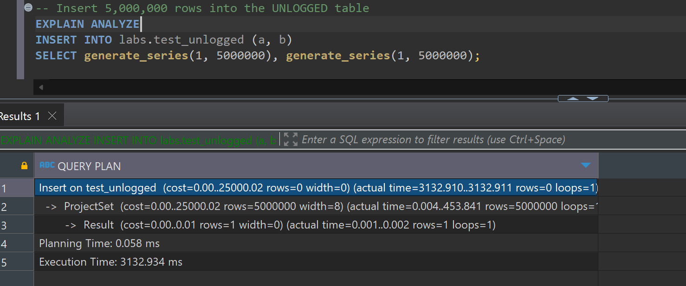

2.2

Select lab person only shows originally inserted member, with only keyword with it

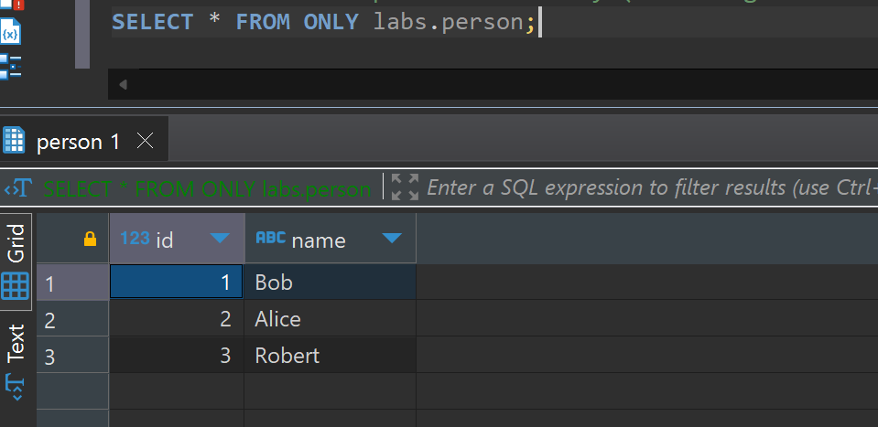

Without only keyword, it only shows the all members ids, the ones who also where inserted in users, because user inherits persons table.

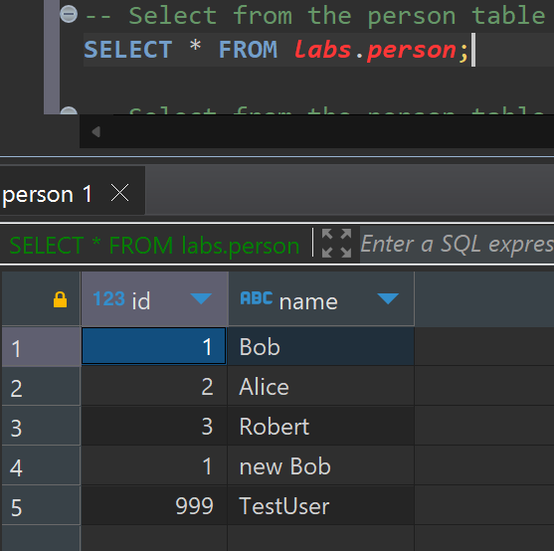

Selecting from users shows inserted members into users table, nothing more nothing less, just the table and its rows.

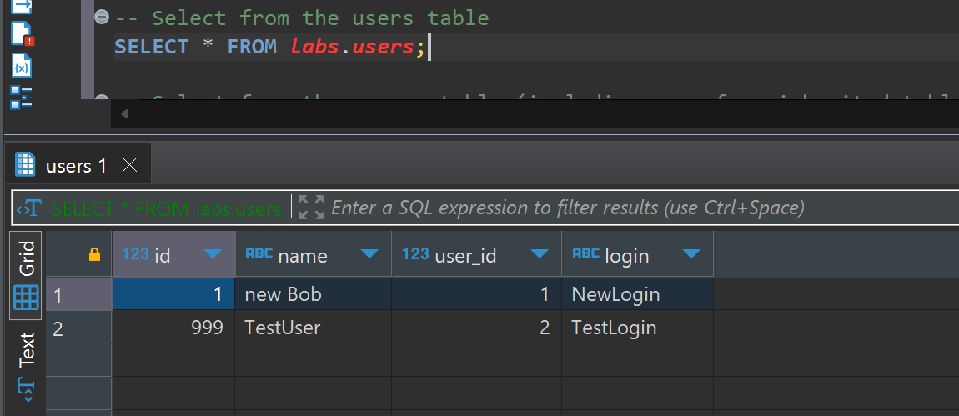

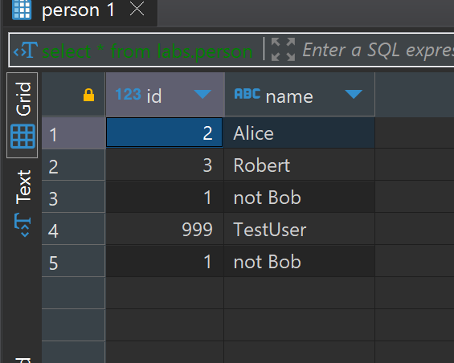

In order to change update only for the person table only we update it like this:

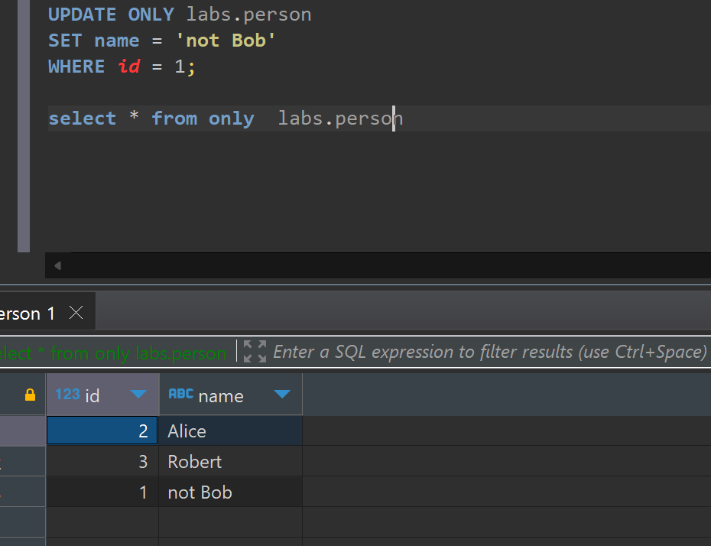

Person columns

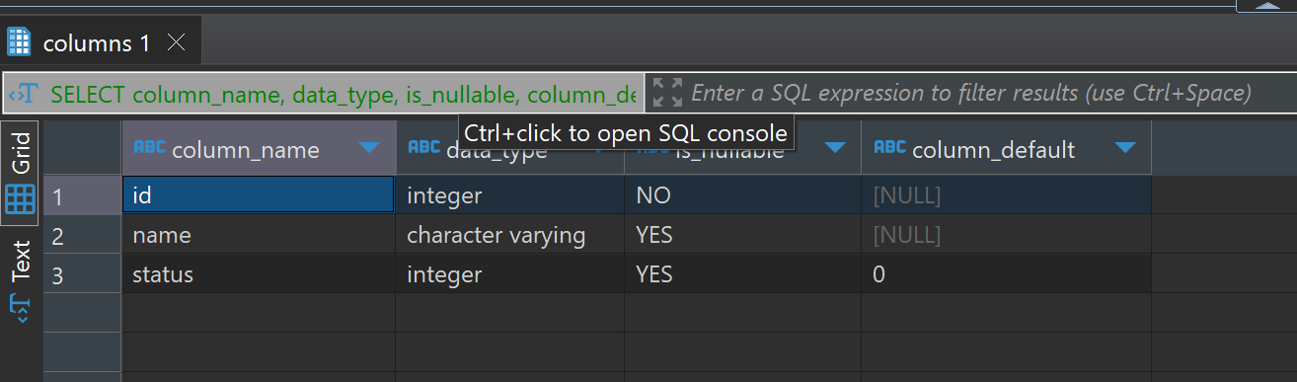

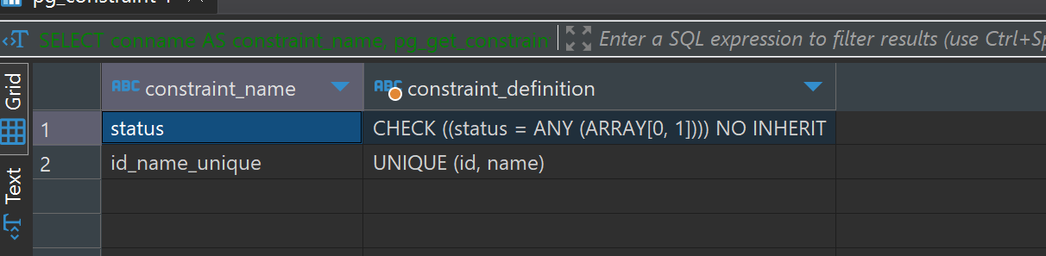

Constraints for person table, like id and name should be unique and status should be checked

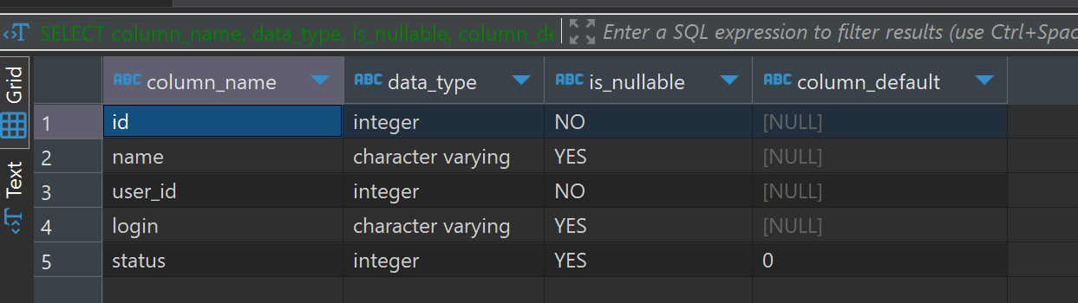

Users added status after altering operations, it added attributes from person and constraint has not been added to the user though. Seems like contrain can be only done to the table and does not affect child

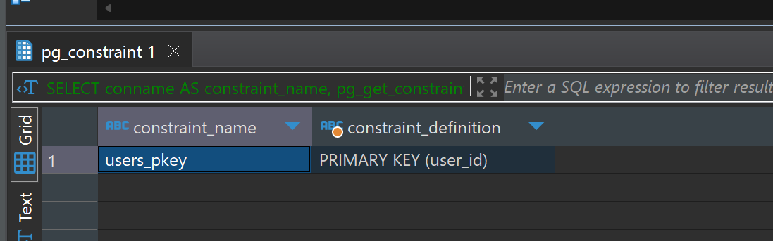

3.1

Checking the table size:

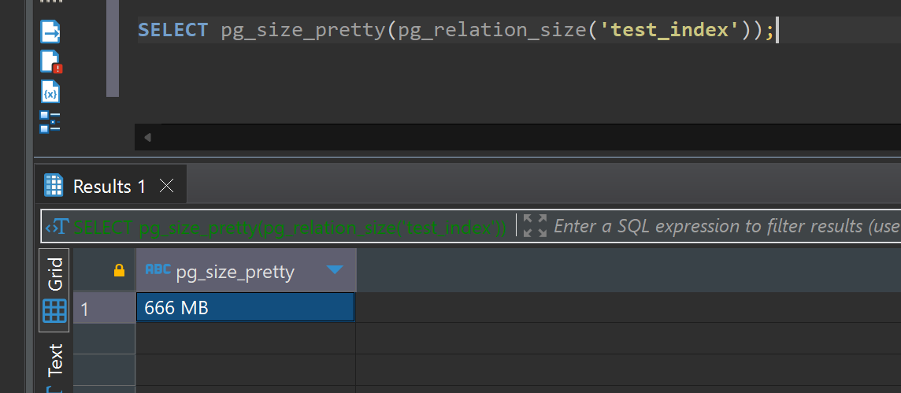

it is how much time it took to run select

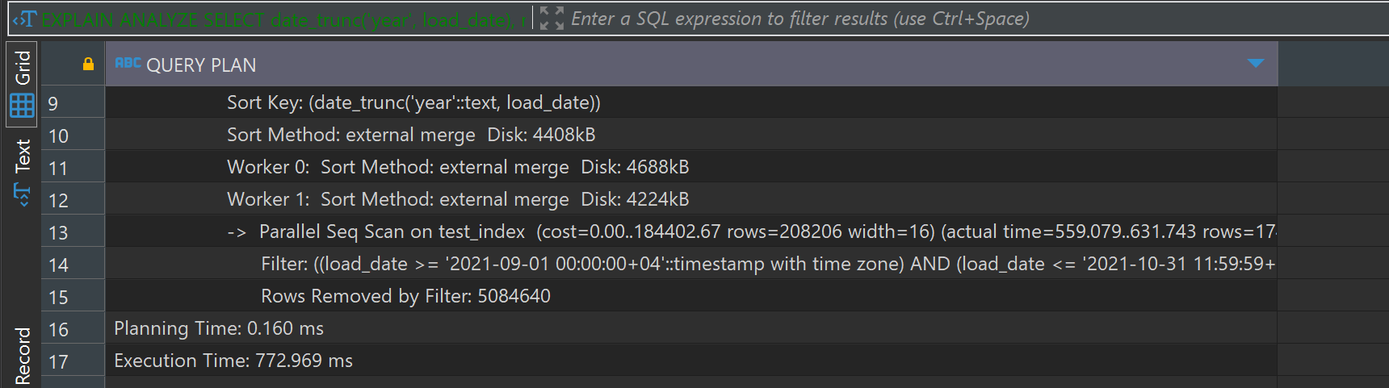

It took twice less time using btree index.

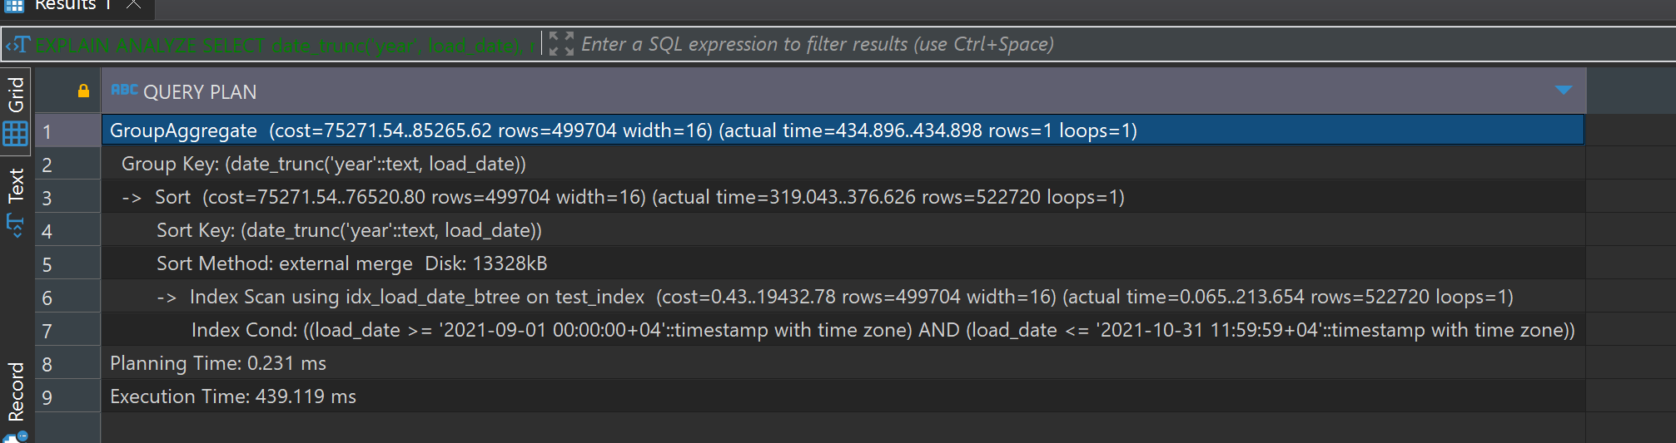

This is the size of the btree

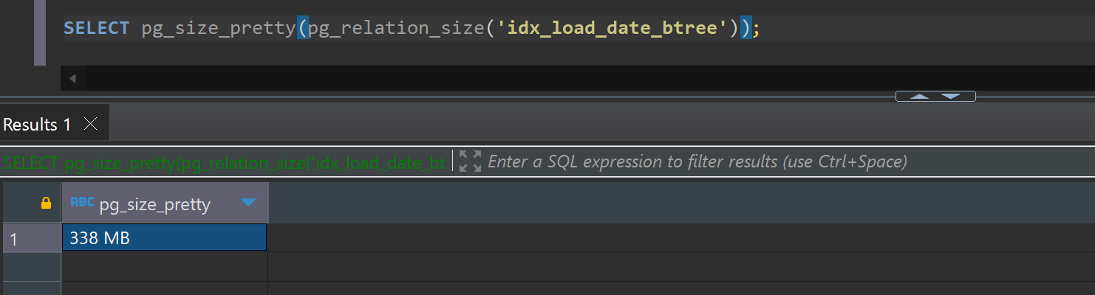

How much time it takes for brin index. Much less, twice less

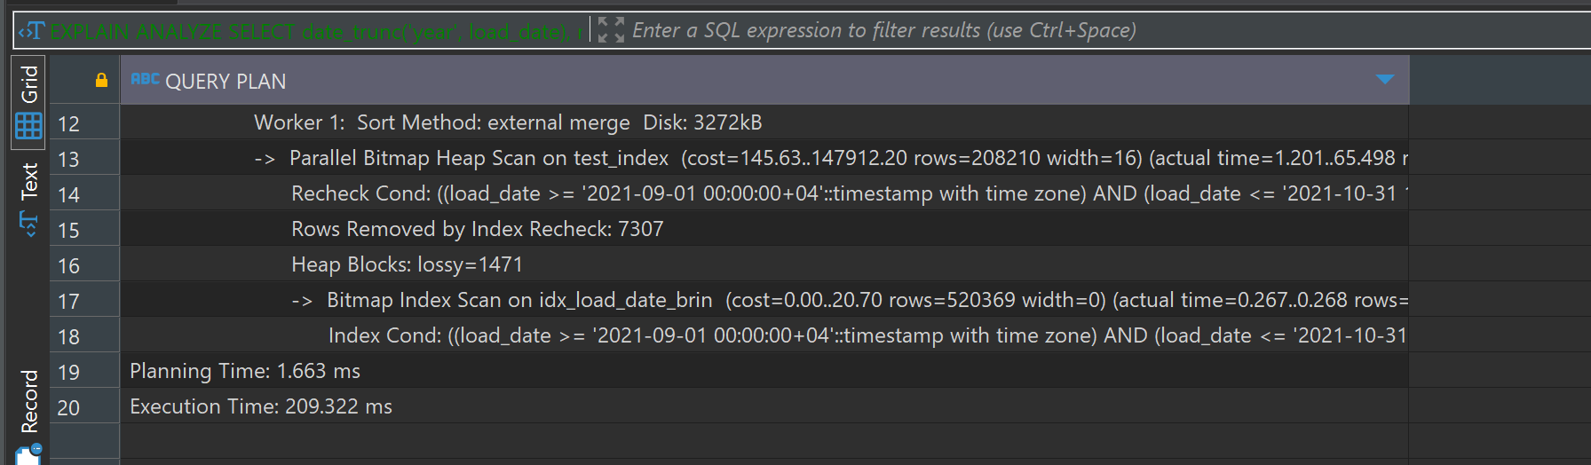

Its very small

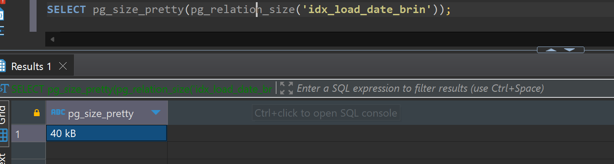

3.2

Size of the table

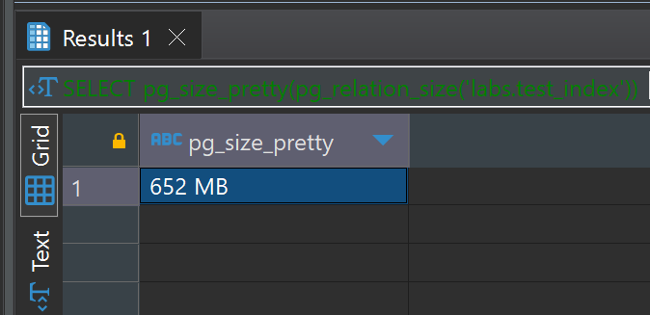

How much time it takes

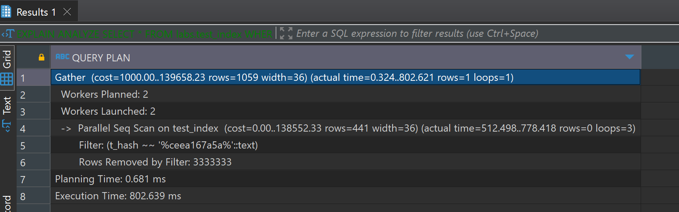

It took 5 minutes for gist index

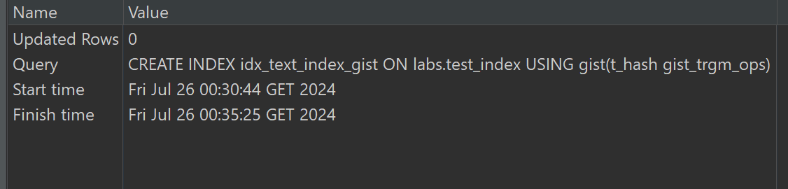

It is this size

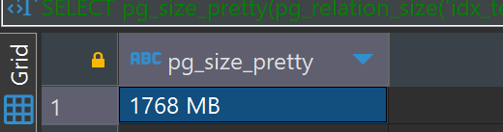

Took 2 minutes

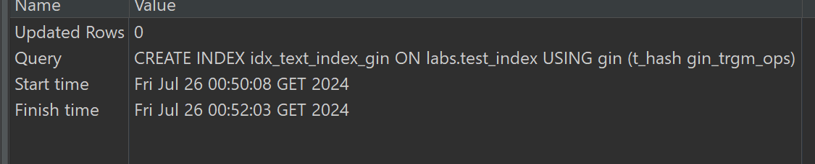

It is smaller than gist



4.0

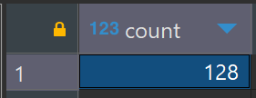

After deleting some rows, materialized view still shows that it has 128 rows, while in the original file it is 118 row

And after refreshing mview shows that it has 118 row.