1.1

Created table, filled the table and then running select

With Explain it provides a basic plan without execution

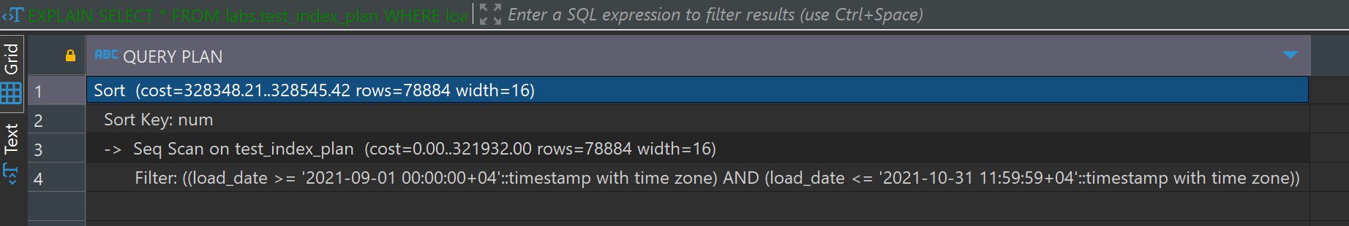

With Explain analyze, provides execution details with actual timings.

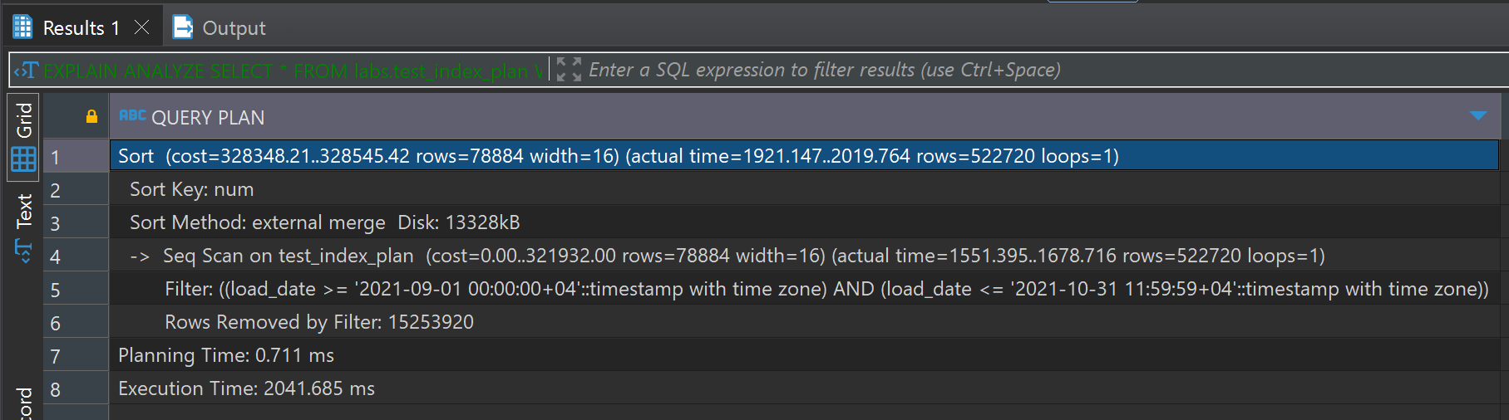

With EXPLAIN (ANALYZE, BUFFERS), includes buffer usage details, offering insights into I/O performance.

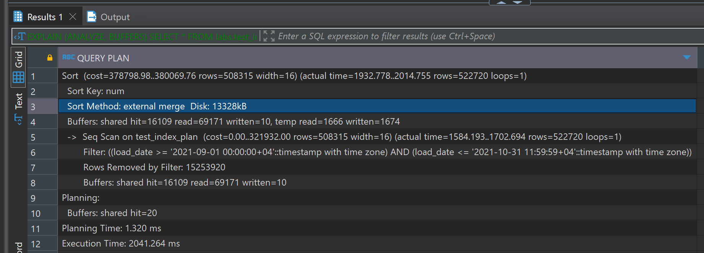

1.2

Btree index

With explain:

The planner predicts that using the index will significantly reduce the number of rows scanned compared to a sequential scan, The overall cost is reduced, indicating a more efficient plan due to the index.

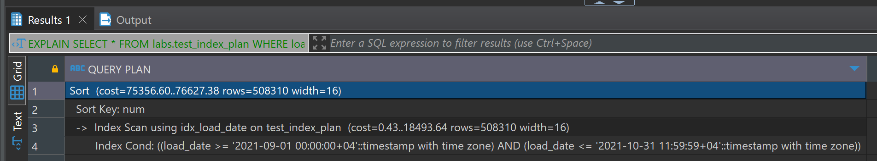

With explain analyze, the index scan is much faster than a sequential scan, with actual times showing significant improvement, total execution time confirms the efficiency of using the index.

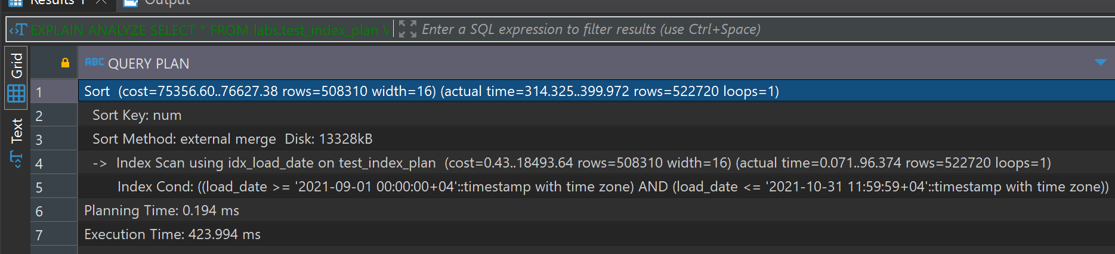

Explain analyze, buffers. the majority of the pages were found in shared buffers, indicating efficient caching and use of temporary space for sorting is highlighted by the temp read and written values.

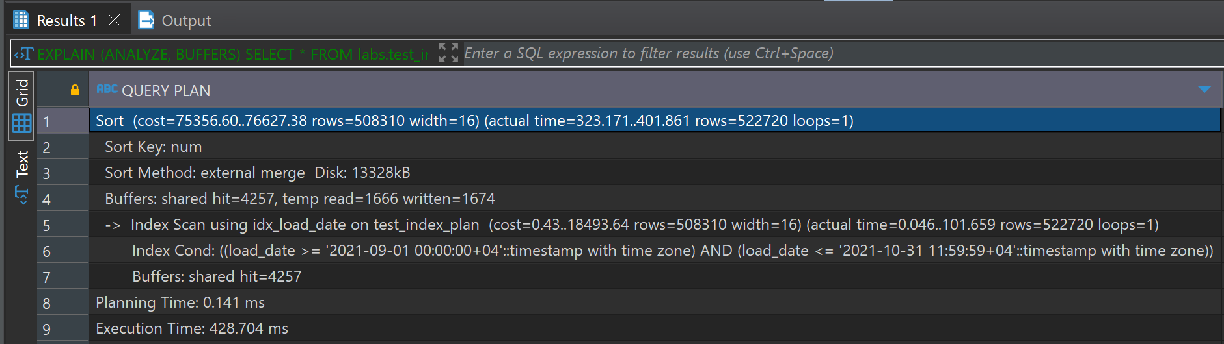

Brin index:

With explain

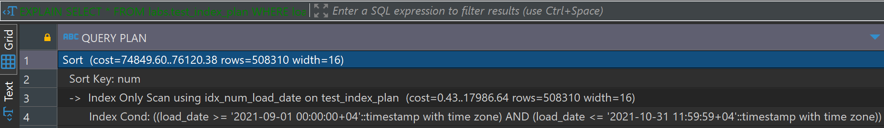

With explain analyze

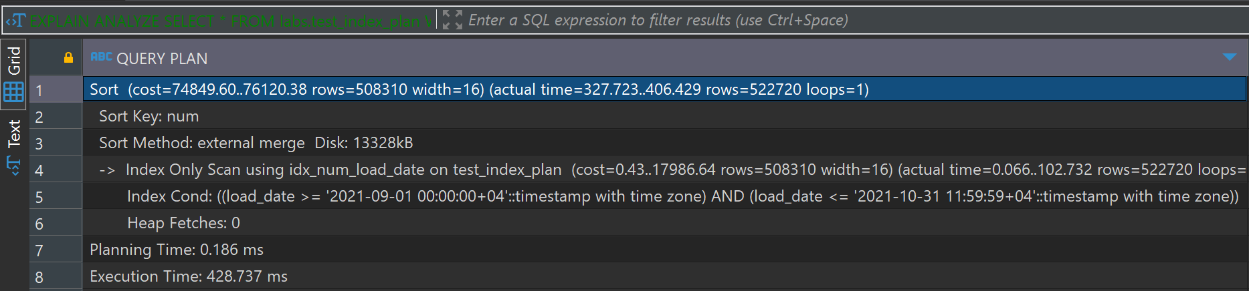

With explain analyze, buffer

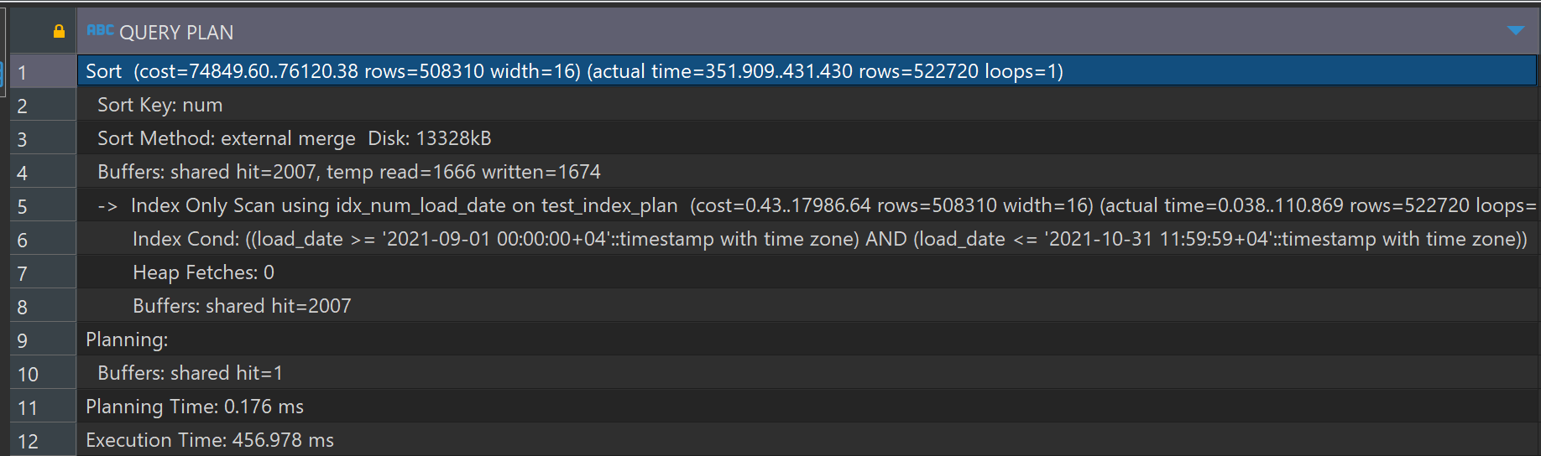

BRIN is more space it also allows for an Index Scan, which still requires accessing the table (heap) to retrieve the actual rows. Non-zero heap fetches indicate additional I/O operations, which can slow down performance compared to B-Tree. More buffer reads and writes compared to B-Tree, indicating more disk I/O operations. Slightly lower performance compared to B-Tree, but generally it is very effective for large datasets with wide ranges.

2.1

Optimized query:

INSERT INTO emp (empno, ename, job, mgr, hiredate) VALUES

(1, 'SMITH', 'CLERK', 13, '17-DEC-80'),

(2, 'ALLEN', 'SALESMAN', 6, '20-FEB-81'),

(3, 'WARD', 'SALESMAN', 6, '22-FEB-81'),

(4, 'JONES', 'MANAGER', 9, '02-APR-81'),

(5, 'MARTIN', 'SALESMAN', 6, '28-SEP-81'),

(6, 'BLAKE', 'MANAGER', 9, '01-MAY-81'),

(7, 'CLARK', 'MANAGER', 9, '09-JUN-81'),

(8, 'SCOTT', 'ANALYST', 4, '19-APR-87'),

(9, 'KING', 'PRESIDENT', NULL, '17-NOV-81'),

(10, 'TURNER', 'SALESMAN', 6, '08-SEP-81'),

(11, 'ADAMS', 'CLERK', 8, '23-MAY-87'),

(12, 'JAMES', 'CLERK', 6, '03-DEC-81'),

(13, 'FORD', 'ANALYST', 4, '03-DEC-81'),

(14, 'MILLER', 'CLERK', 7, '23-JAN-82');

2.2

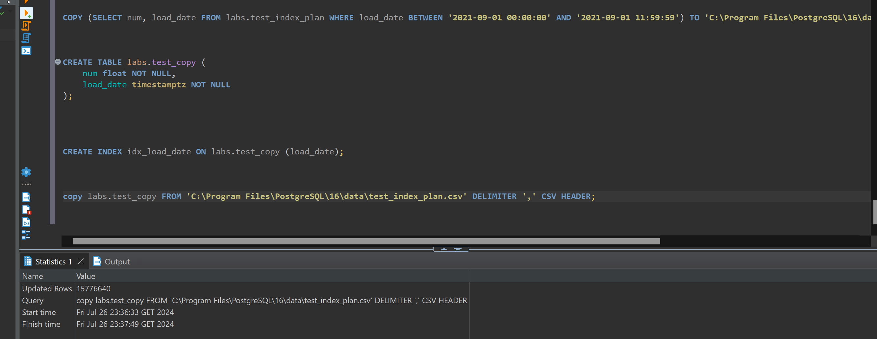

2.3

With this code it is making sure that emp table is updated correctly without duplicating rows, which helps to maintain data integrity and consistency.

