Here I write the process for loading data into a 3NF schema using PL/pgSQL functions. The idea is to ensure data integrity and track procedure executions using a logging mechanism.

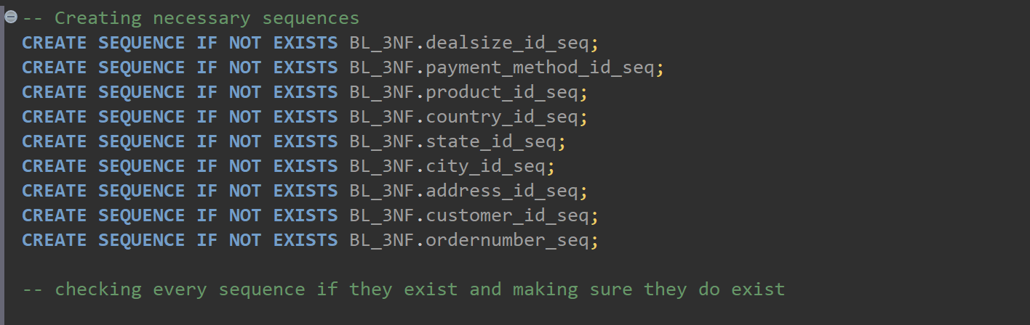

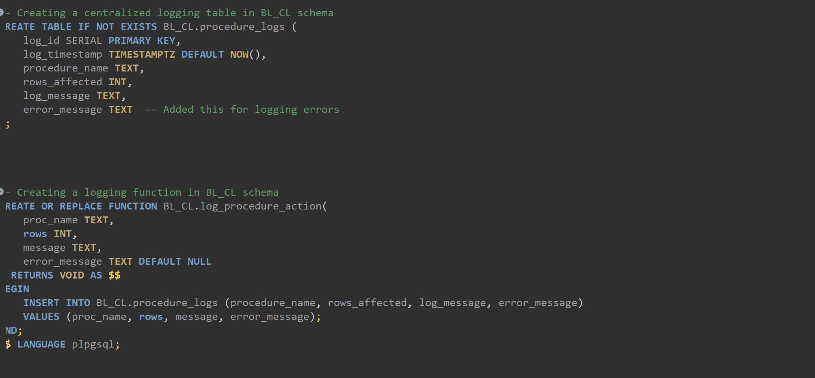

**Creating Logging Table**

A logging table is created to keep track of the execution of data loading procedures. This table stores information about the procedure name, rows affected, log message, and timestamp.

This table is used to store log entries for each data loading procedure.

log_id: This is like the entry number in our journal. It’s a unique number that automatically increases with each new log entry.

procedure_name: This tells the name of the procedure that is ran, so it known what operation the log entry is about.

rows_affected: This shows how many rows of data were processed by the procedure. It's like noting down how many tasks were completed.

log_message: This is a short description of what happened. It could be something like "Dealsizes loaded successfully"

log_timestamp: This records the exact time when the log entry was made. It helps know when each procedure was run.

And then next function writing entries into it. We call this function at the end of each data loading procedure to record what happened.

proc_name is name of the procedure where I am logging. Rows is number of rows the procedure affected. Message is describing what the procedure did.

Data Loading Functions:

This function loads data into the CE_DEALSIZES table. It selects distinct deal sizes from the source tables and inserts them into the target table, handling duplicates appropriately. And basically all the tables are basically same.

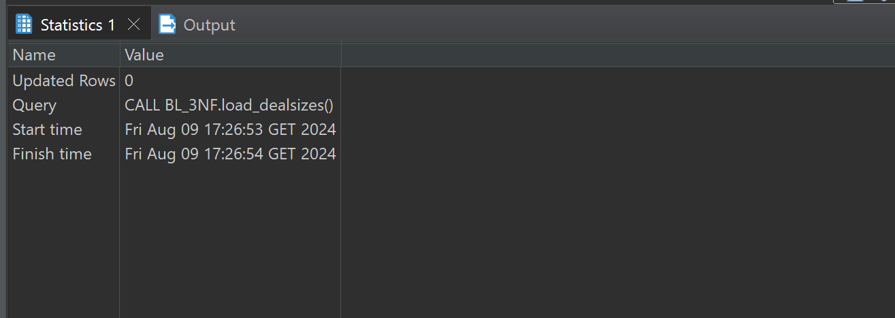

Payments:

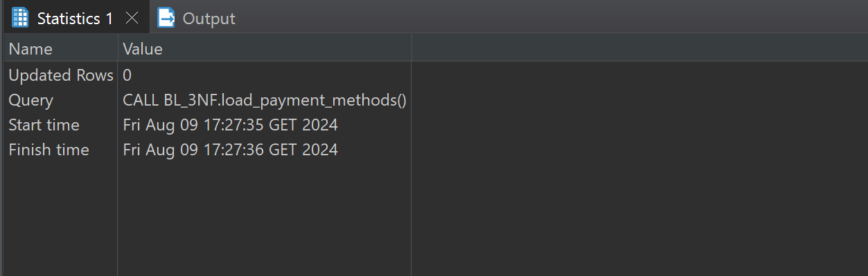

Products:

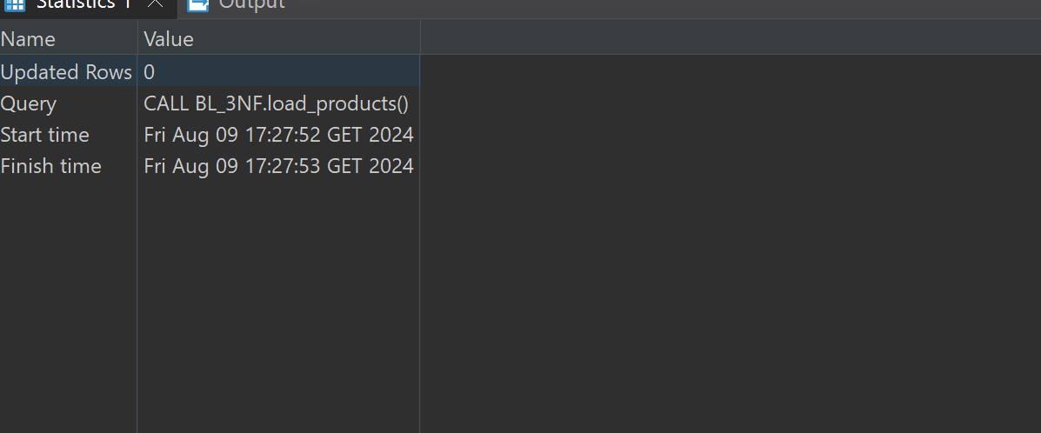

Countries:

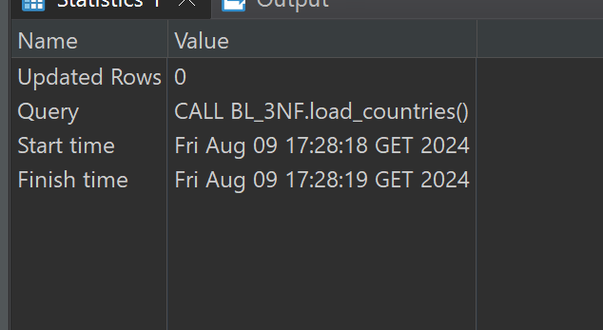

States:

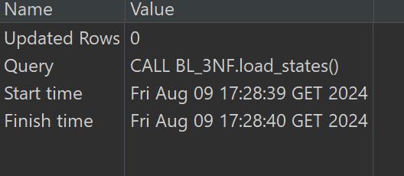

Cities:

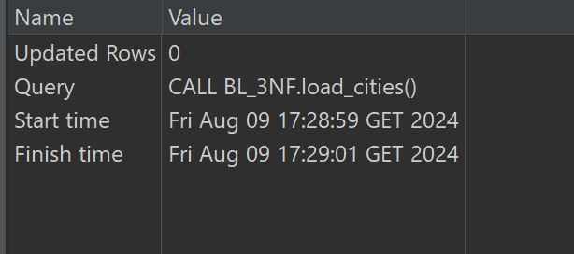

Address :

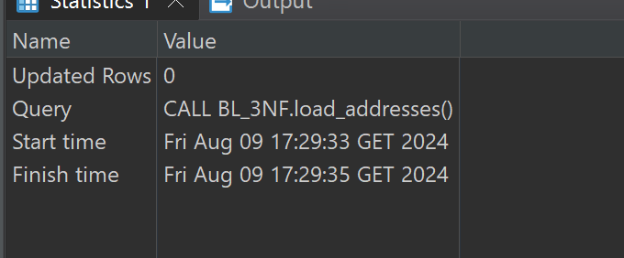

* Orders
* 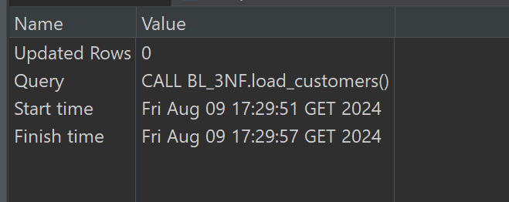

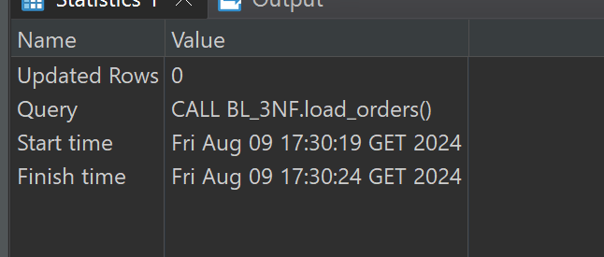

Calling procedures and selecting

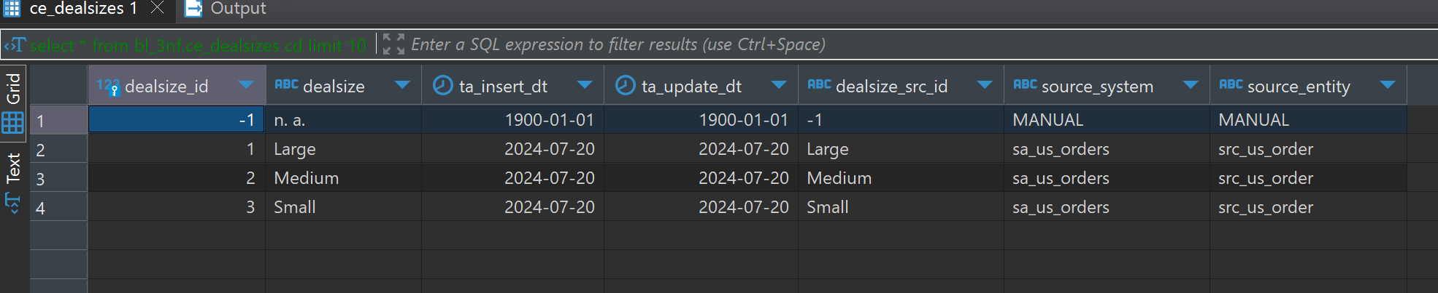

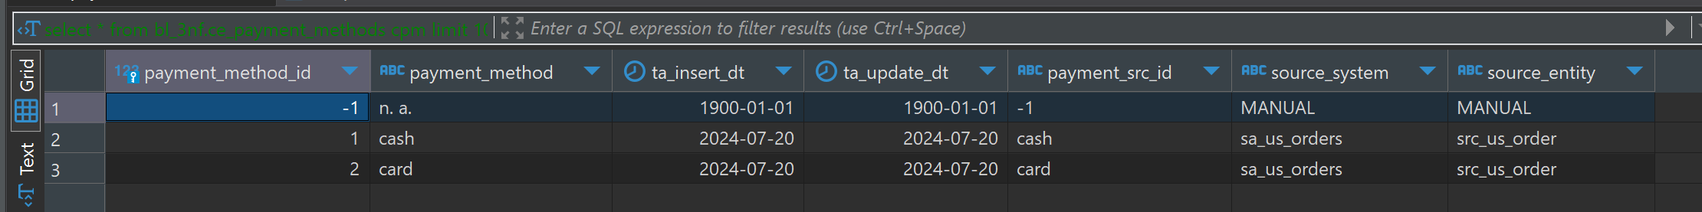

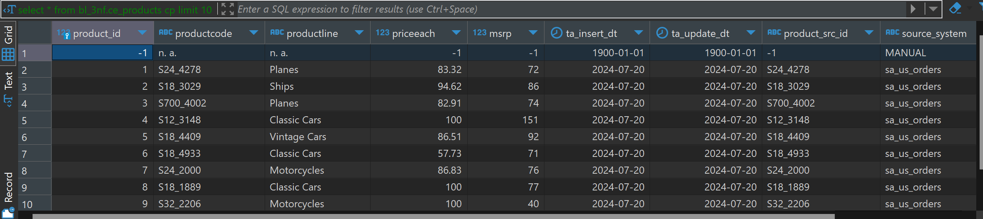

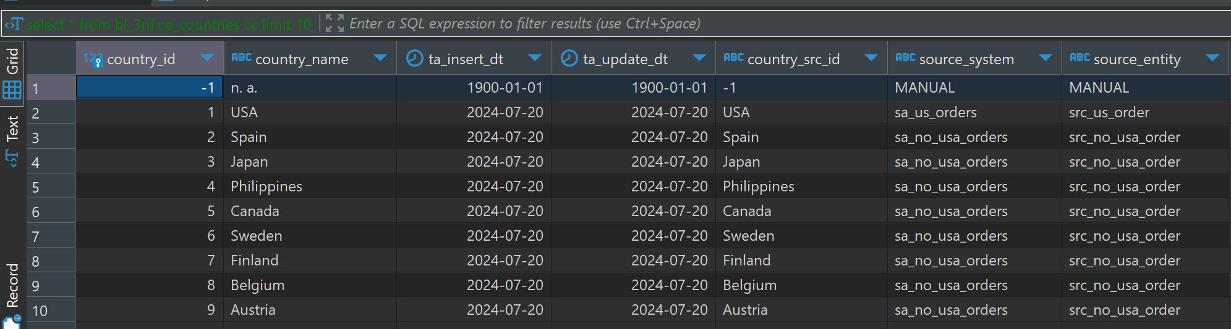

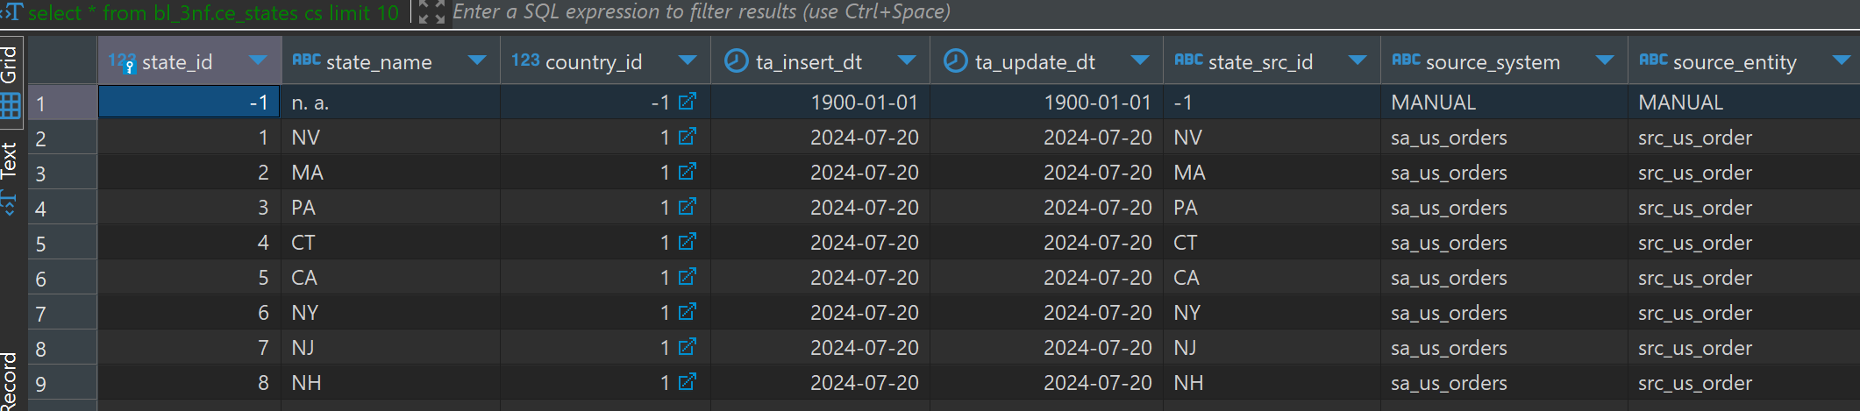

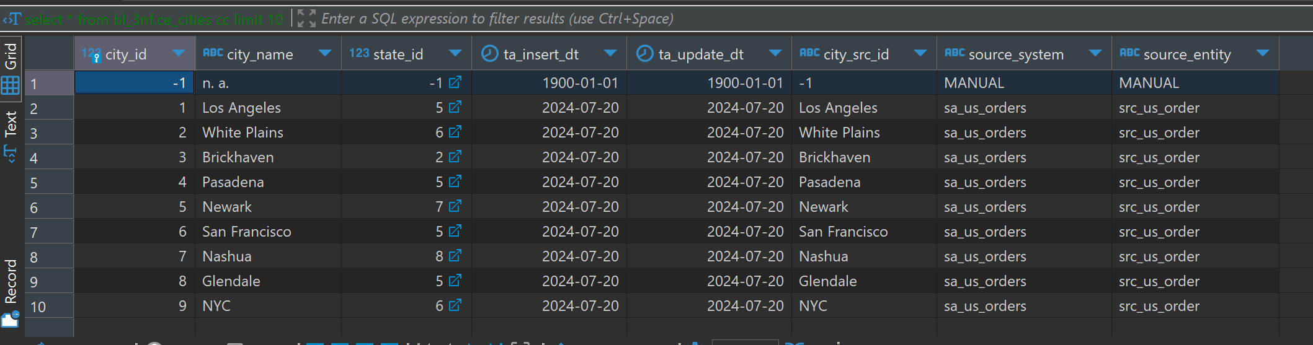

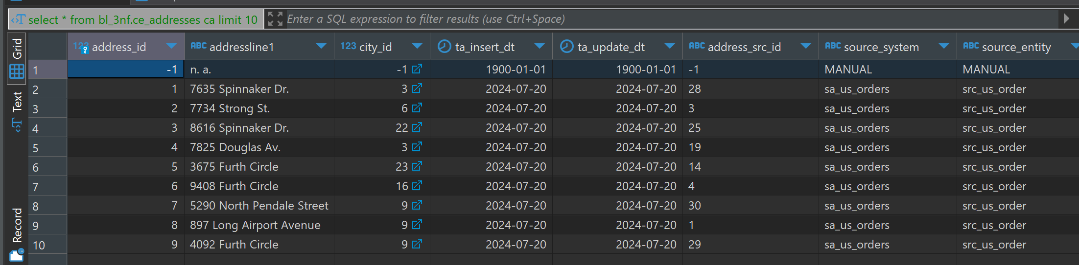

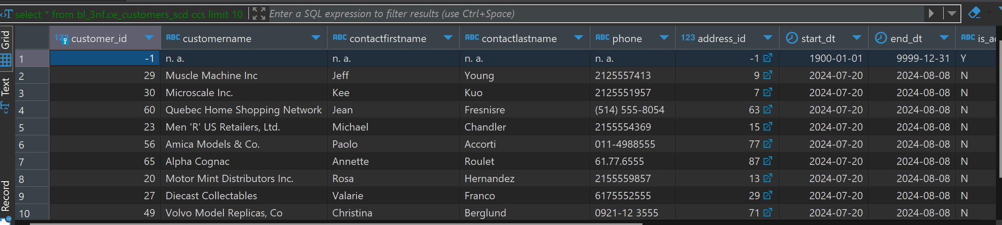

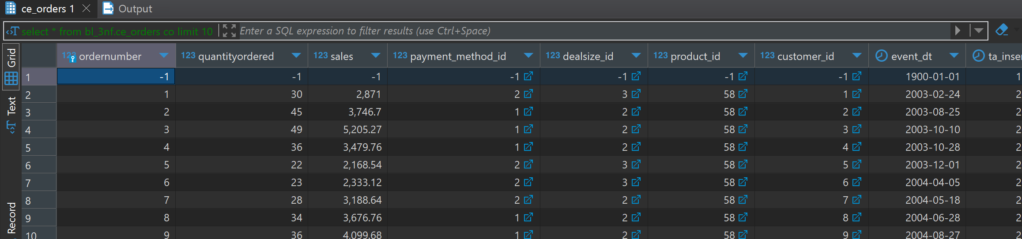

Checking log tables: 