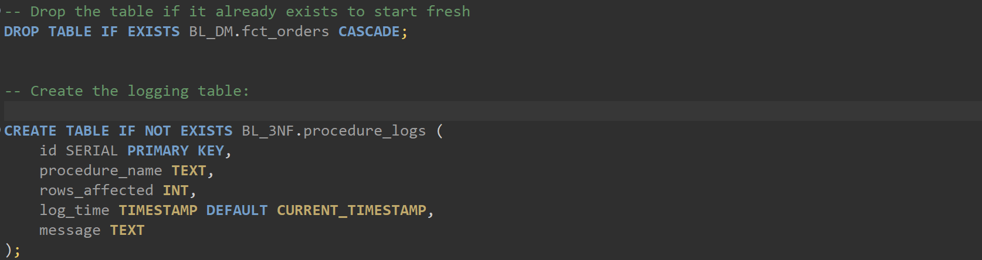

Create table again with partitioning

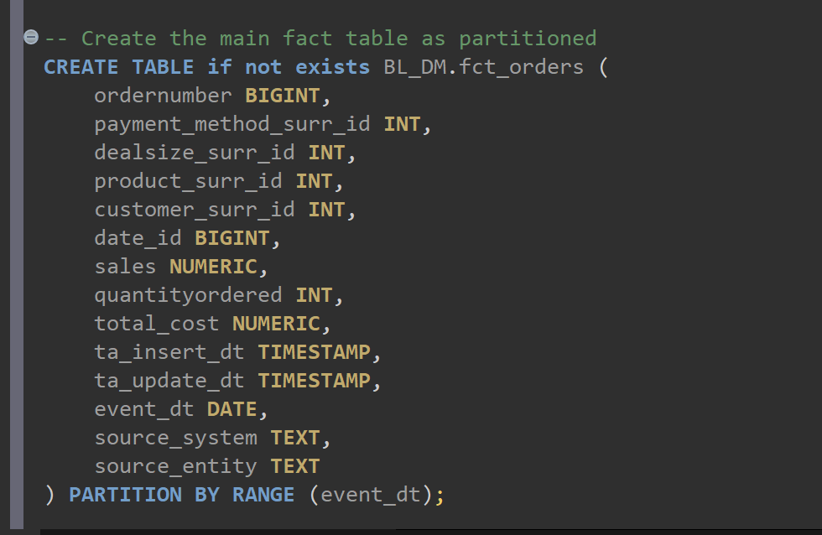

Partitioning

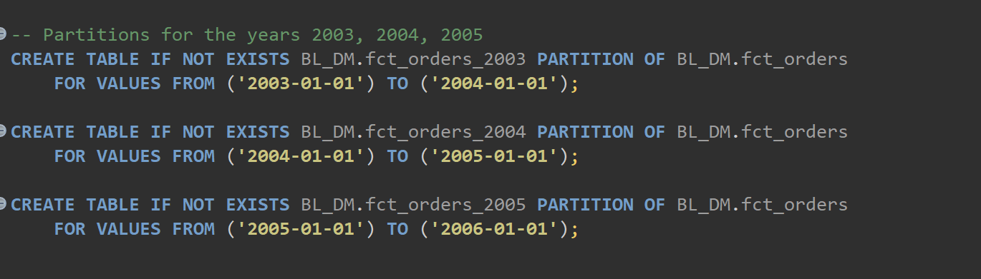

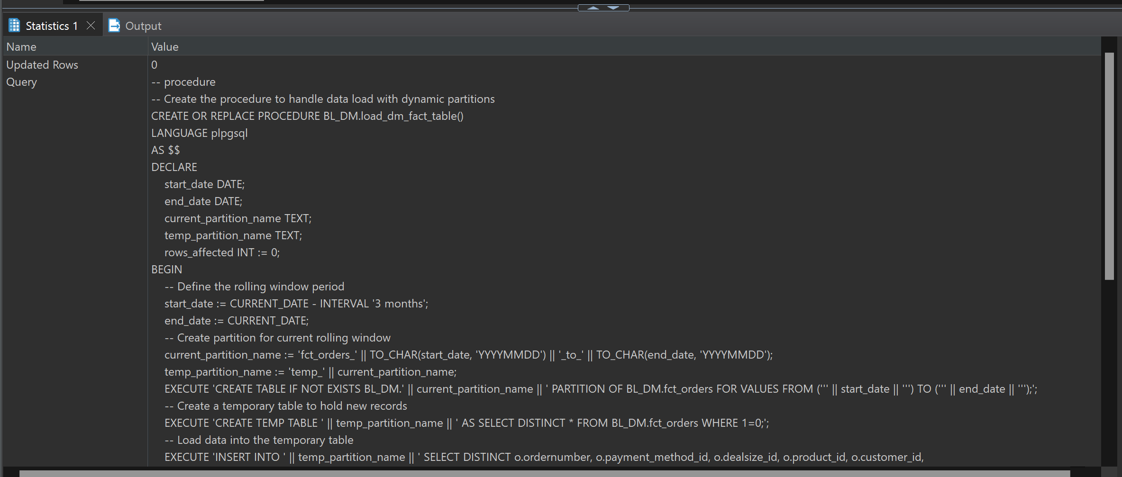

Calling the procedure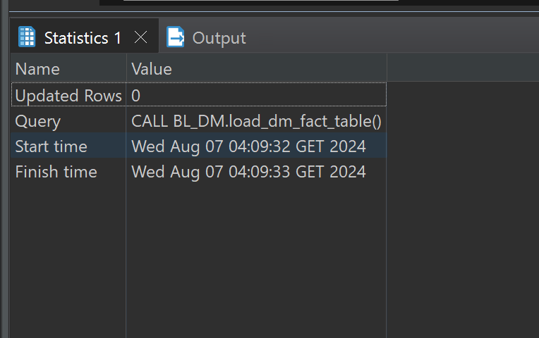

Selecting from fact table:

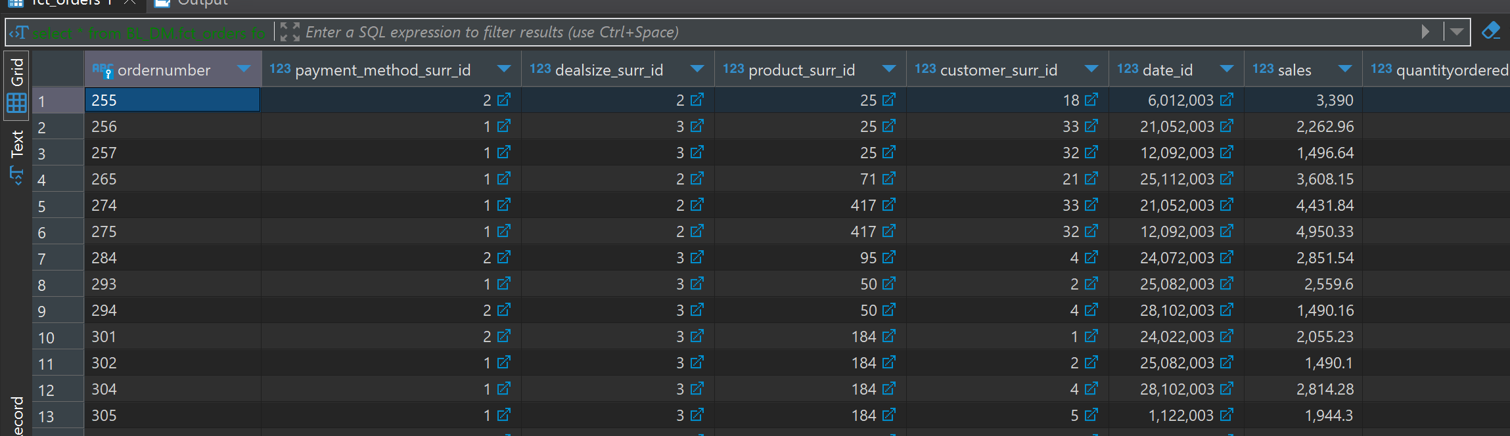

**SELECT** * **FROM** BL_3NF.procedure_logs **WHERE** procedure_name = **'load_dm_fact_table'** **ORDER** **BY** ***log_time*** **DESC**;

