1. First problem noticed:

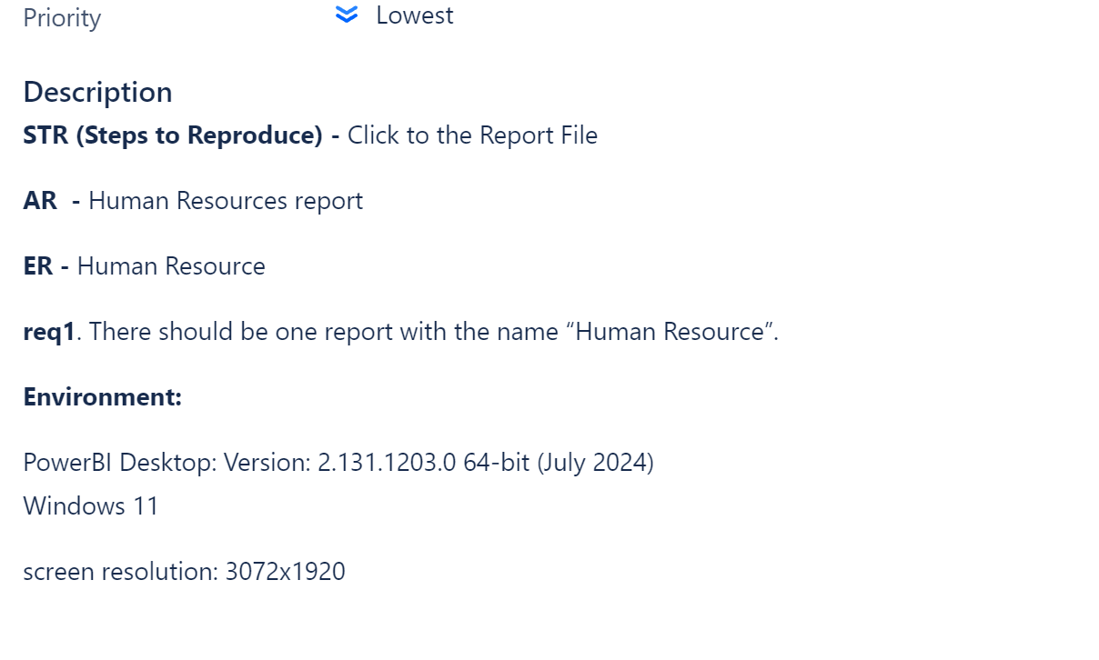

1. Second one :

One page were missing

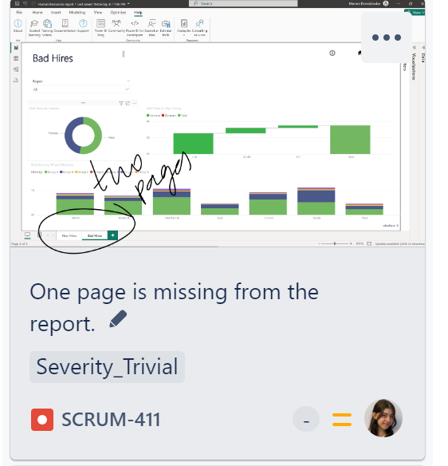

1. And next one is that missing page obviously did not have any text in it

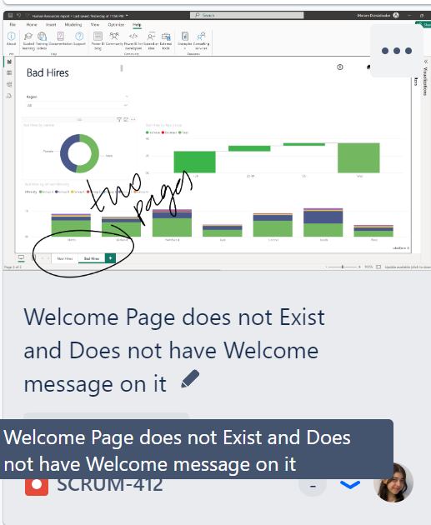

1. Next issue is that there is not name for the barchart in the New Hires page

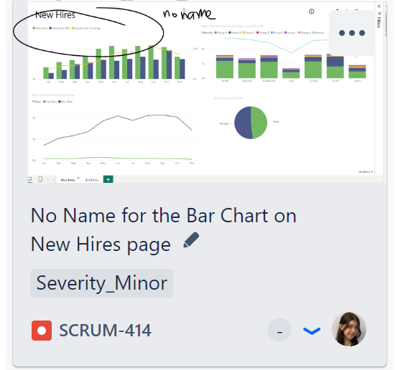

1. Next problem is that there is additional information on second chart.

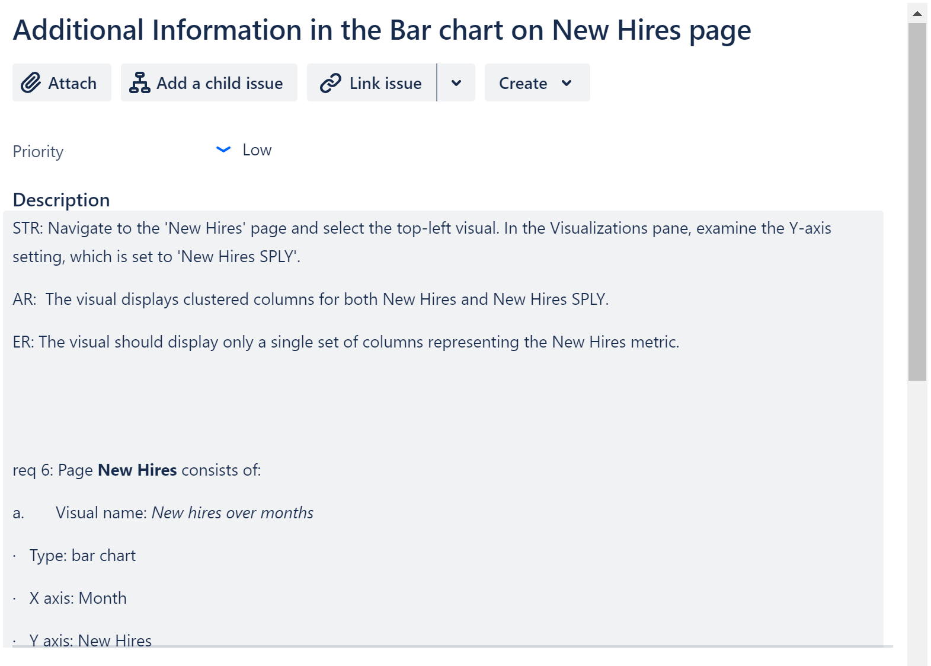

1. It should be no new Hires SPLY, it is not in requirements.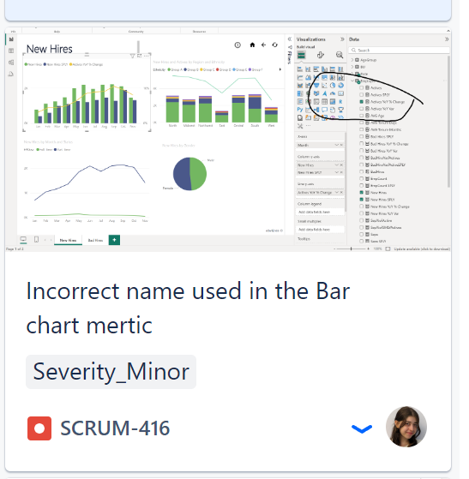
2. Next issue that I find out is that there is incorrect name in the char,

The label in the legend of the top-left visual on the New Hires page should be "Active YoY % Change".

1. Next problem I faced is that in the report there is incorrect trend line

The trend line label in the 'New Hires and Actives by Region, and Ethnicity' visual is displayed as 'Actives'.  
The label should be 'Activities per Region'

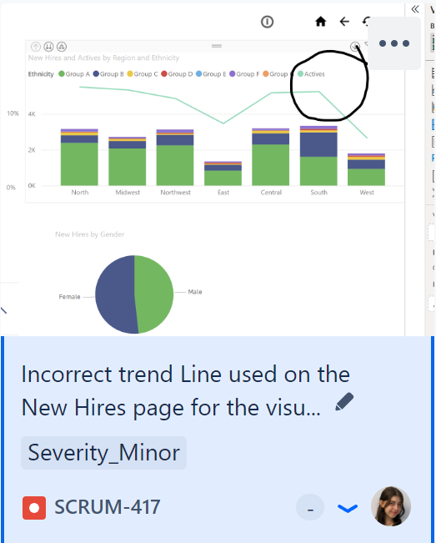

1. there is additional trend line for the visual when press drill down button.

there should not be additional trend line for the visual when drill down

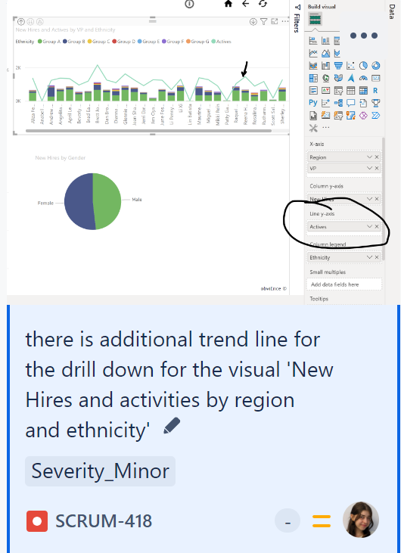

1. the title of the visual is 'New Hires by Month and Status' and the title should be '*New Hires by Month and FPDesc*'

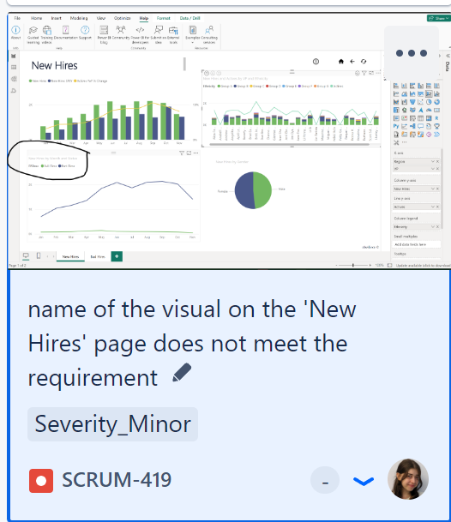

1. there is no visual ‘Bad Hires KPI’ on the ‘Bad Hires’ page

there should be visual named ‘Bad Hires KPI’

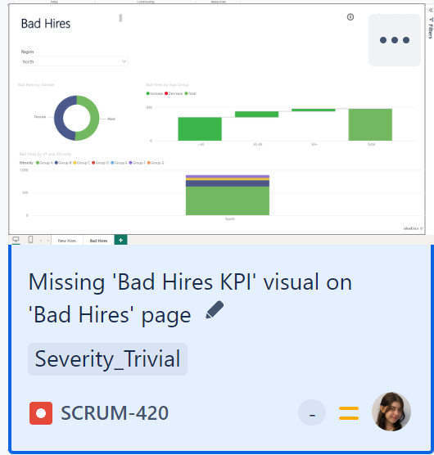

1. there is bad hires SPLY for y axis for the visual

there should have been X axis > Age Category and Y axis> BedHires%of Activities a

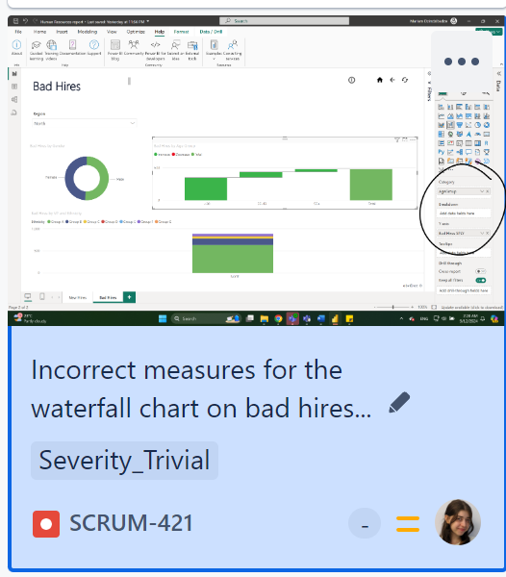

1. 'i' button is not working on 'New Hires' and on 'Bad Hires' page

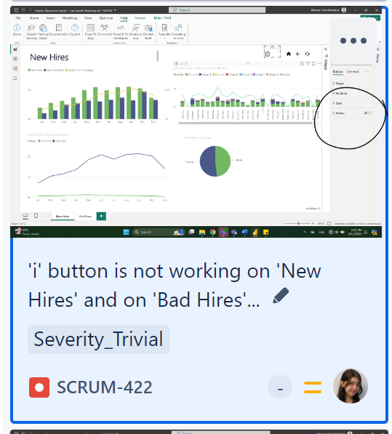

1. Background, It should be pink, and not white

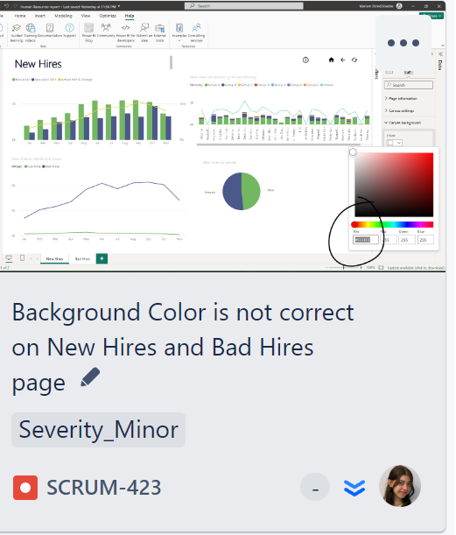

1. 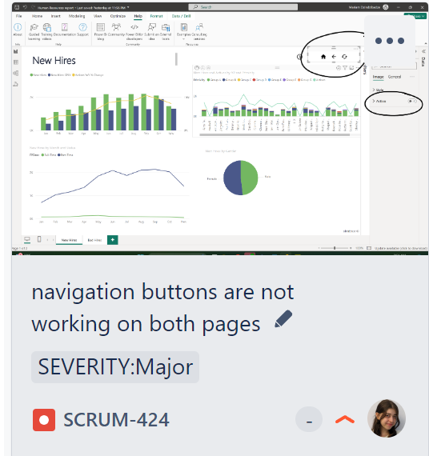

Navigation buttons not working as well

1. Font size for visuals’ names: 9.

Font size for visuals’ Legend: 8.

Font size for visuals’ axes: 8.

Font Size for pages’ names: 28.

Font name: Tahoma.

Font colonr: Black - #000000, RGB: (0,0,0)

None of those requirements are met

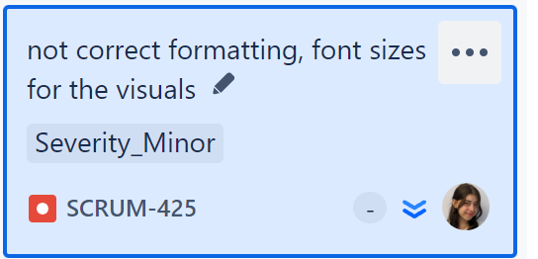

1. 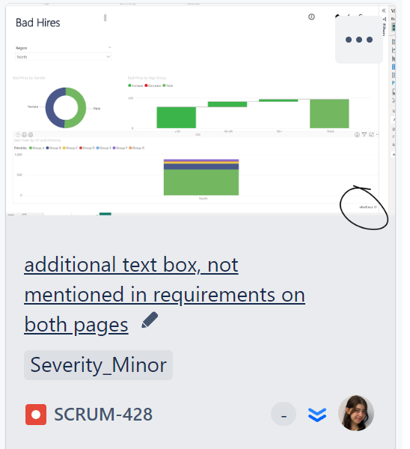

There is additional text box, not mentioned in the requirements

obviEnce ©

1. No epam logo

