

**GlobalGear Analysis**

**Field of Activity:**  
GlobalGear Analytics specializes in advanced data analytics for international retail businesses. The company leverages sales data from various regions to provide actionable insights that drive business growth, optimize supply chains, and enhance customer experience.

**Business Process to Expose and Analyze**

GlobalGear Analytics aims to expose and analyze the **global sales distribution process**. The focus will be on comparing sales performance between the USA and other regions. By understanding regional sales trends, the company can better allocate resources, adjust marketing strategies, and optimize inventory management.

**Purpose of the Report**

The purpose of the report is to provide a comprehensive analysis of the sales performance across different regions, focusing on the USA versus non-USA markets. This analysis will help the company identify key growth opportunities, understand market dynamics, and improve overall sales strategy.

**End User of the Report**

The primary end users of this report are the management team. The report will also be valuable to the marketing and supply chain departments, providing them with the insights needed to adjust their strategies.

**Business Questions and Problems Addressed**

the analysis will be mostly about sales, revenue, total cost and profit

which country was the most benefitial for the company?

Which dealsize were sold the most?

Which year was most profitable?

Which product made max and min of sales?

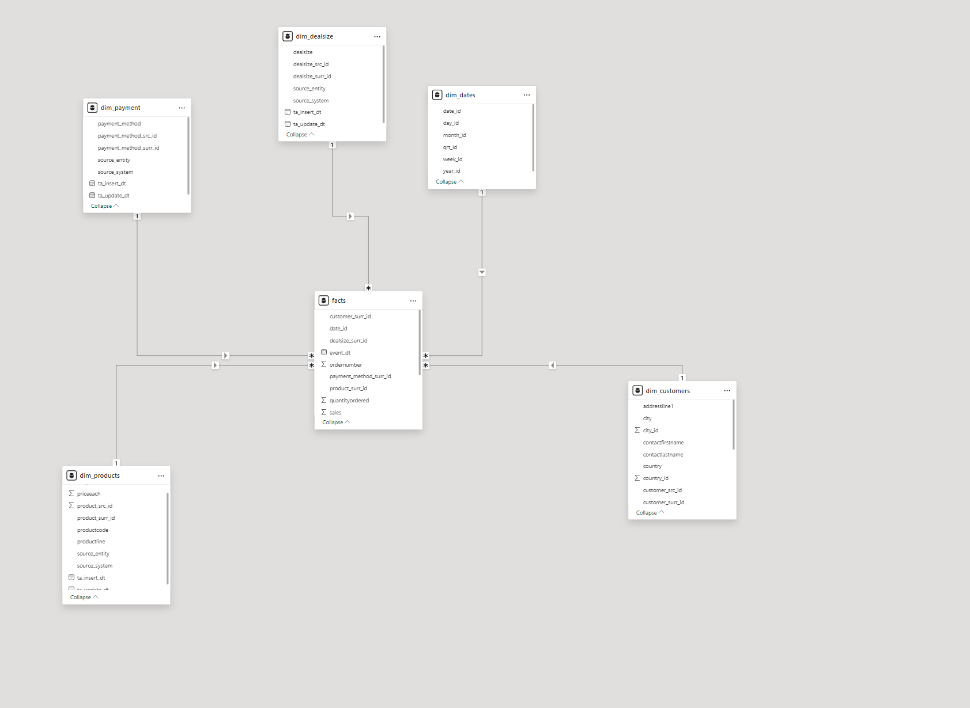

I deleted Default values from tables.

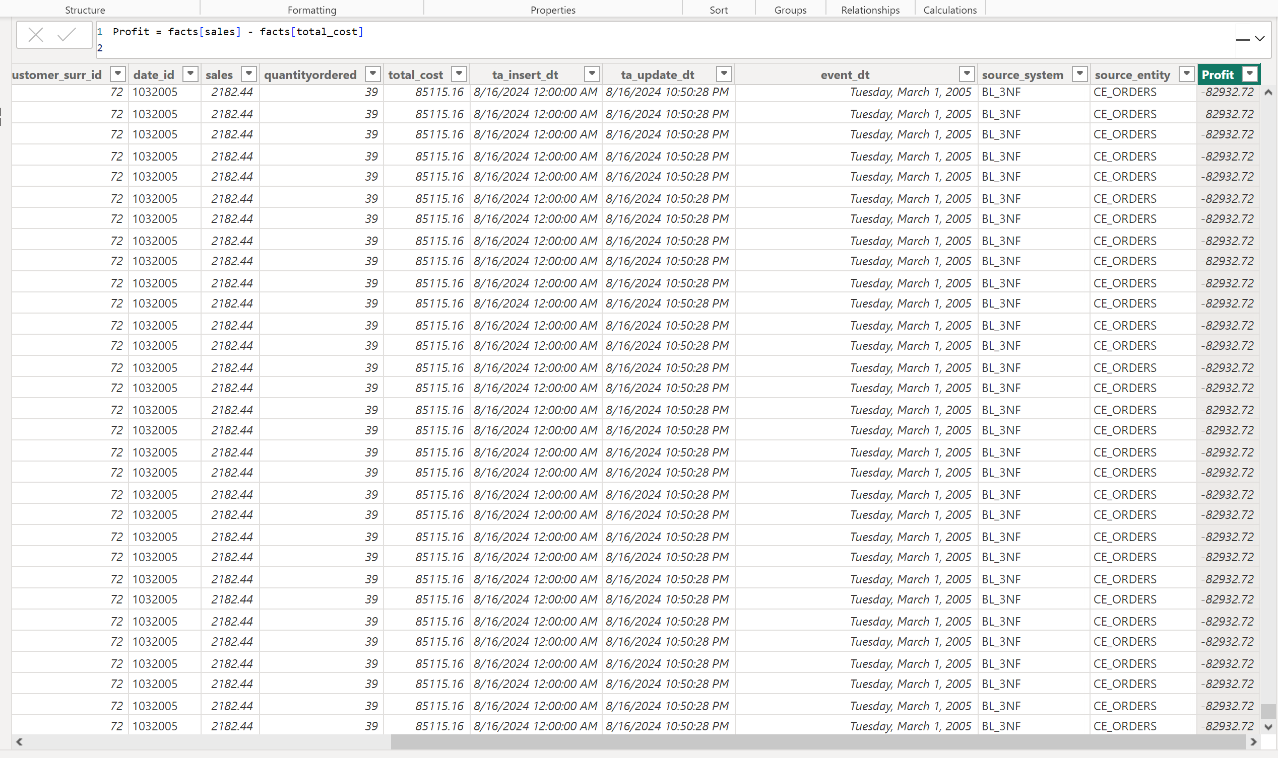 add profit as calculated column

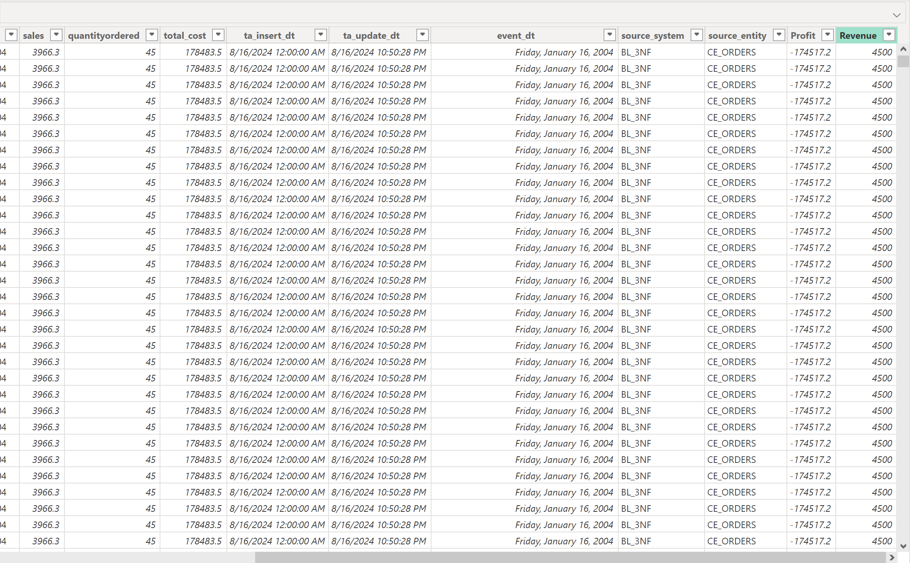

I added revenue as price * quantity ordered

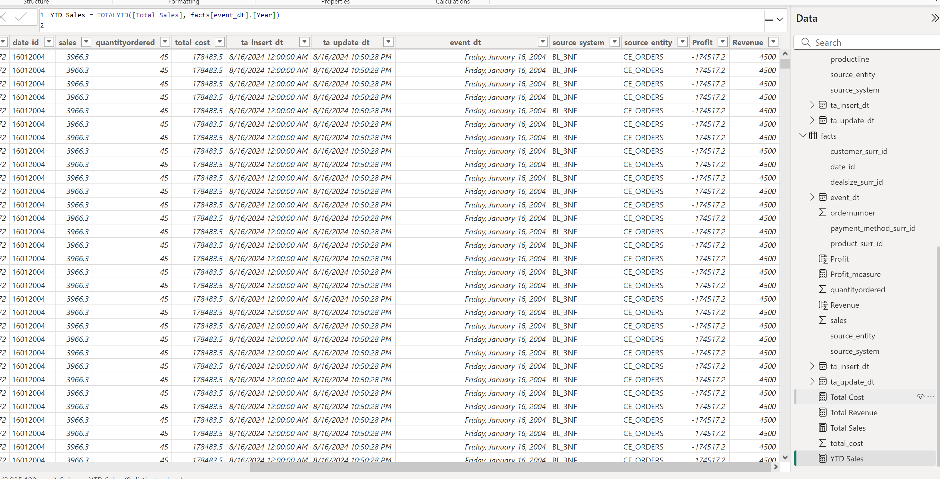 creating several measures, like total cost, total revenue, total sales and ytd sales

Added bookmarks and make It interactive

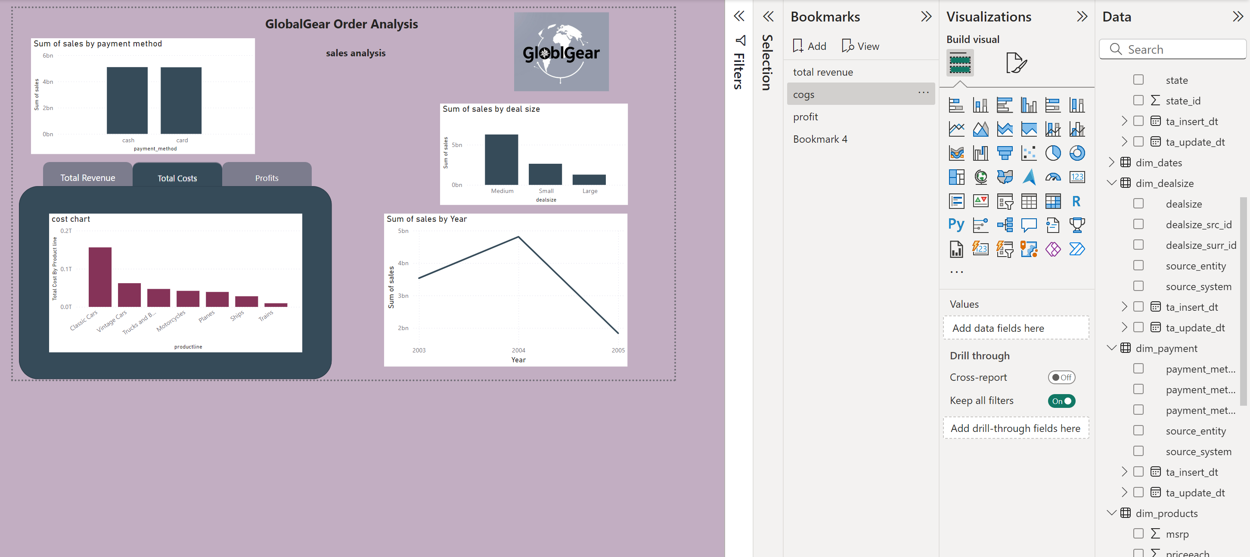

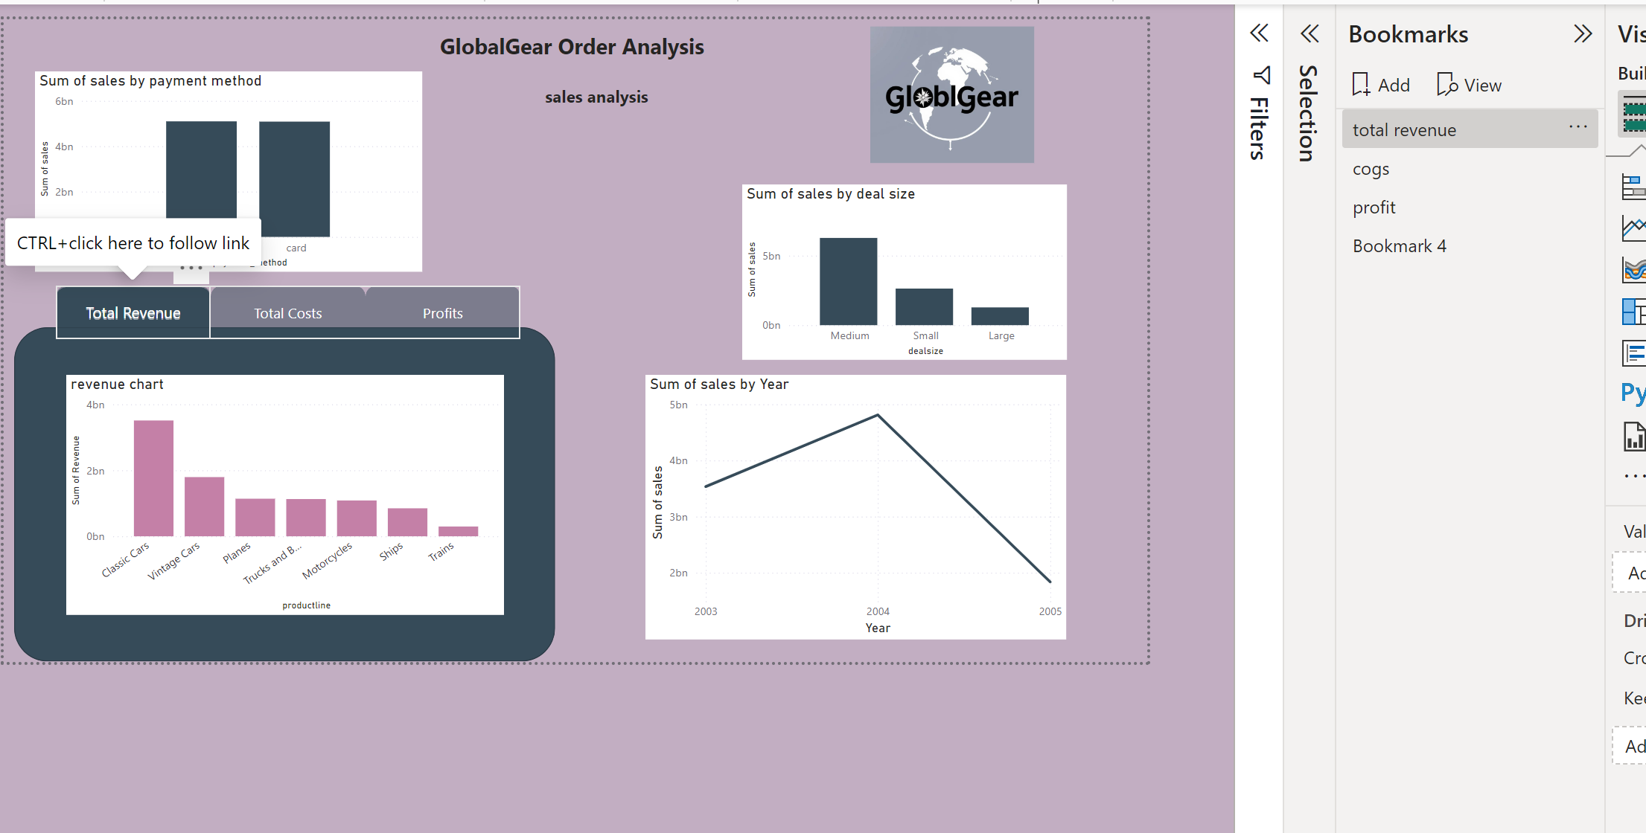

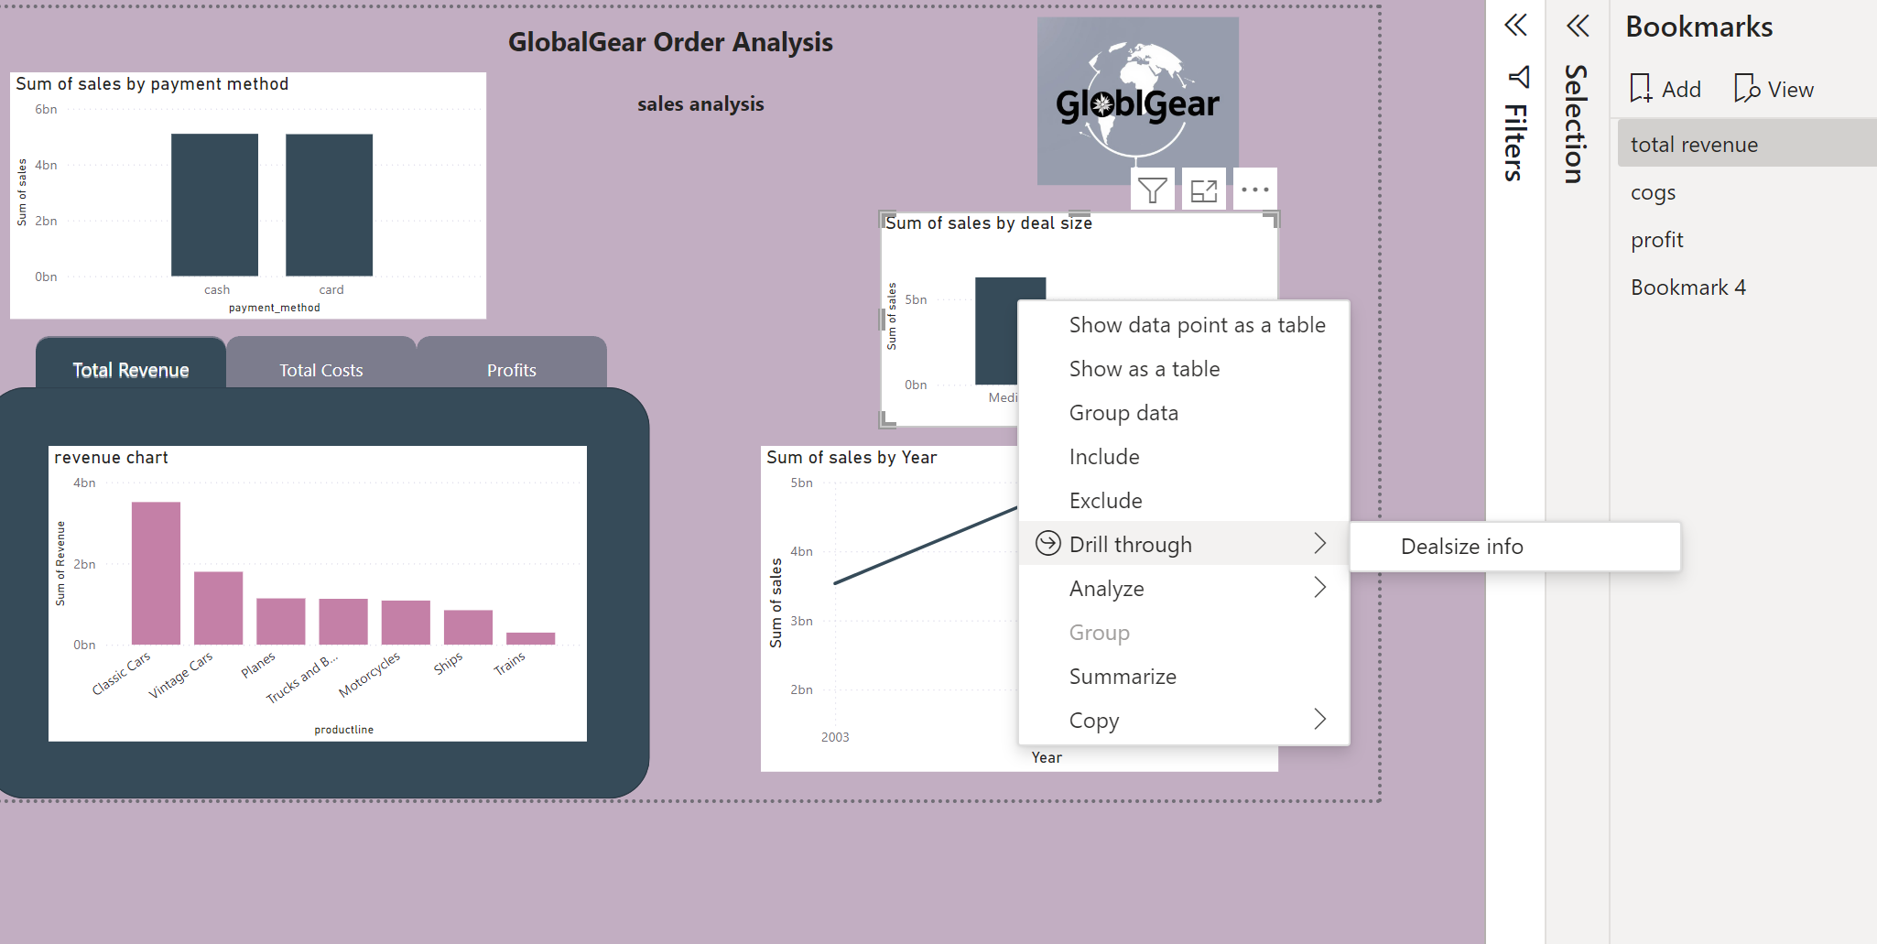

Added drilltrhough to the dealsize barchart



I hided dealsize info

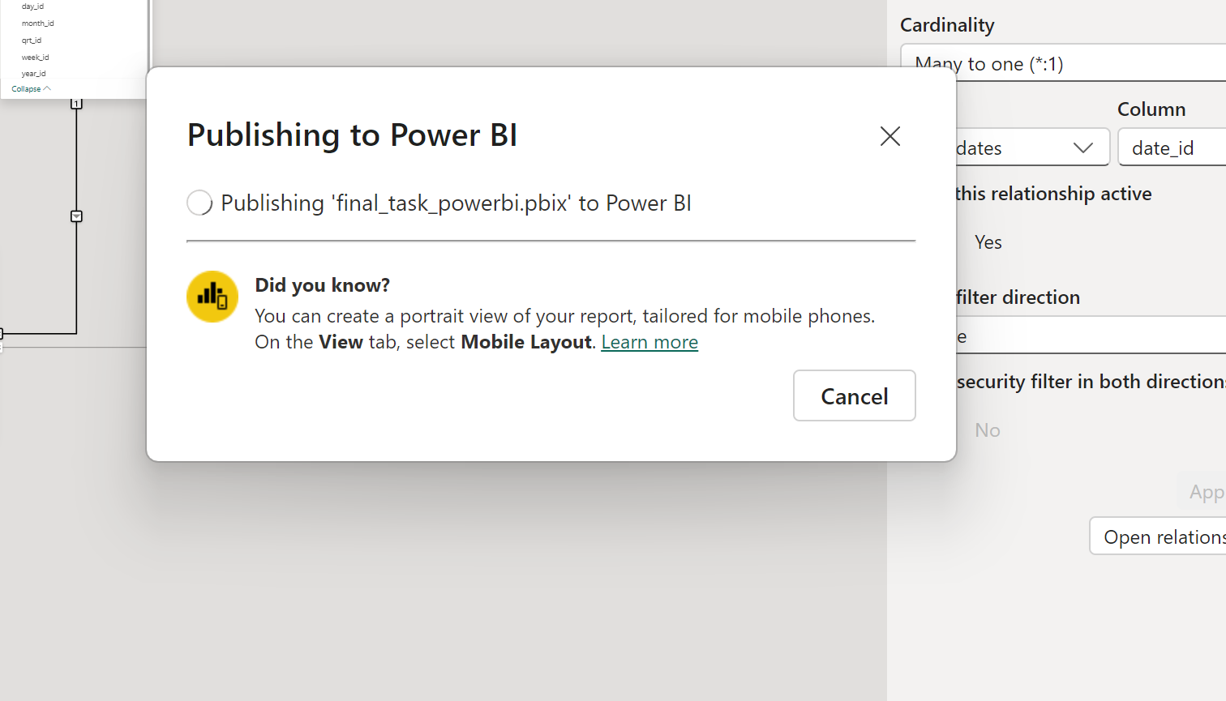

Published to power bi service