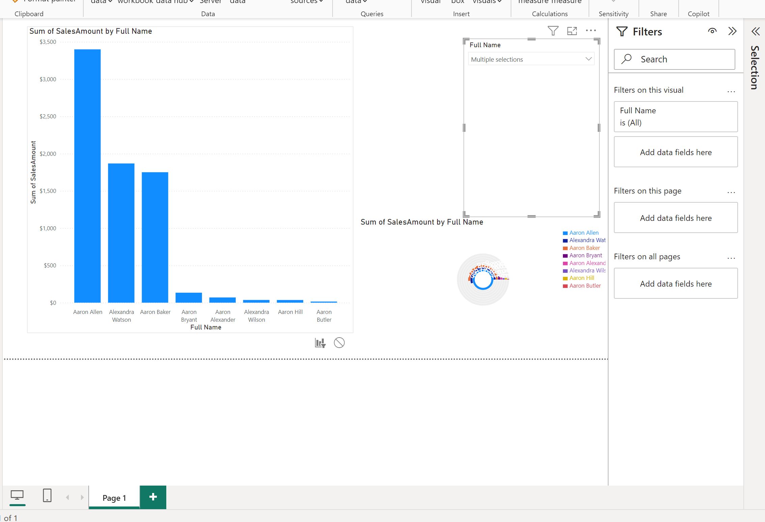

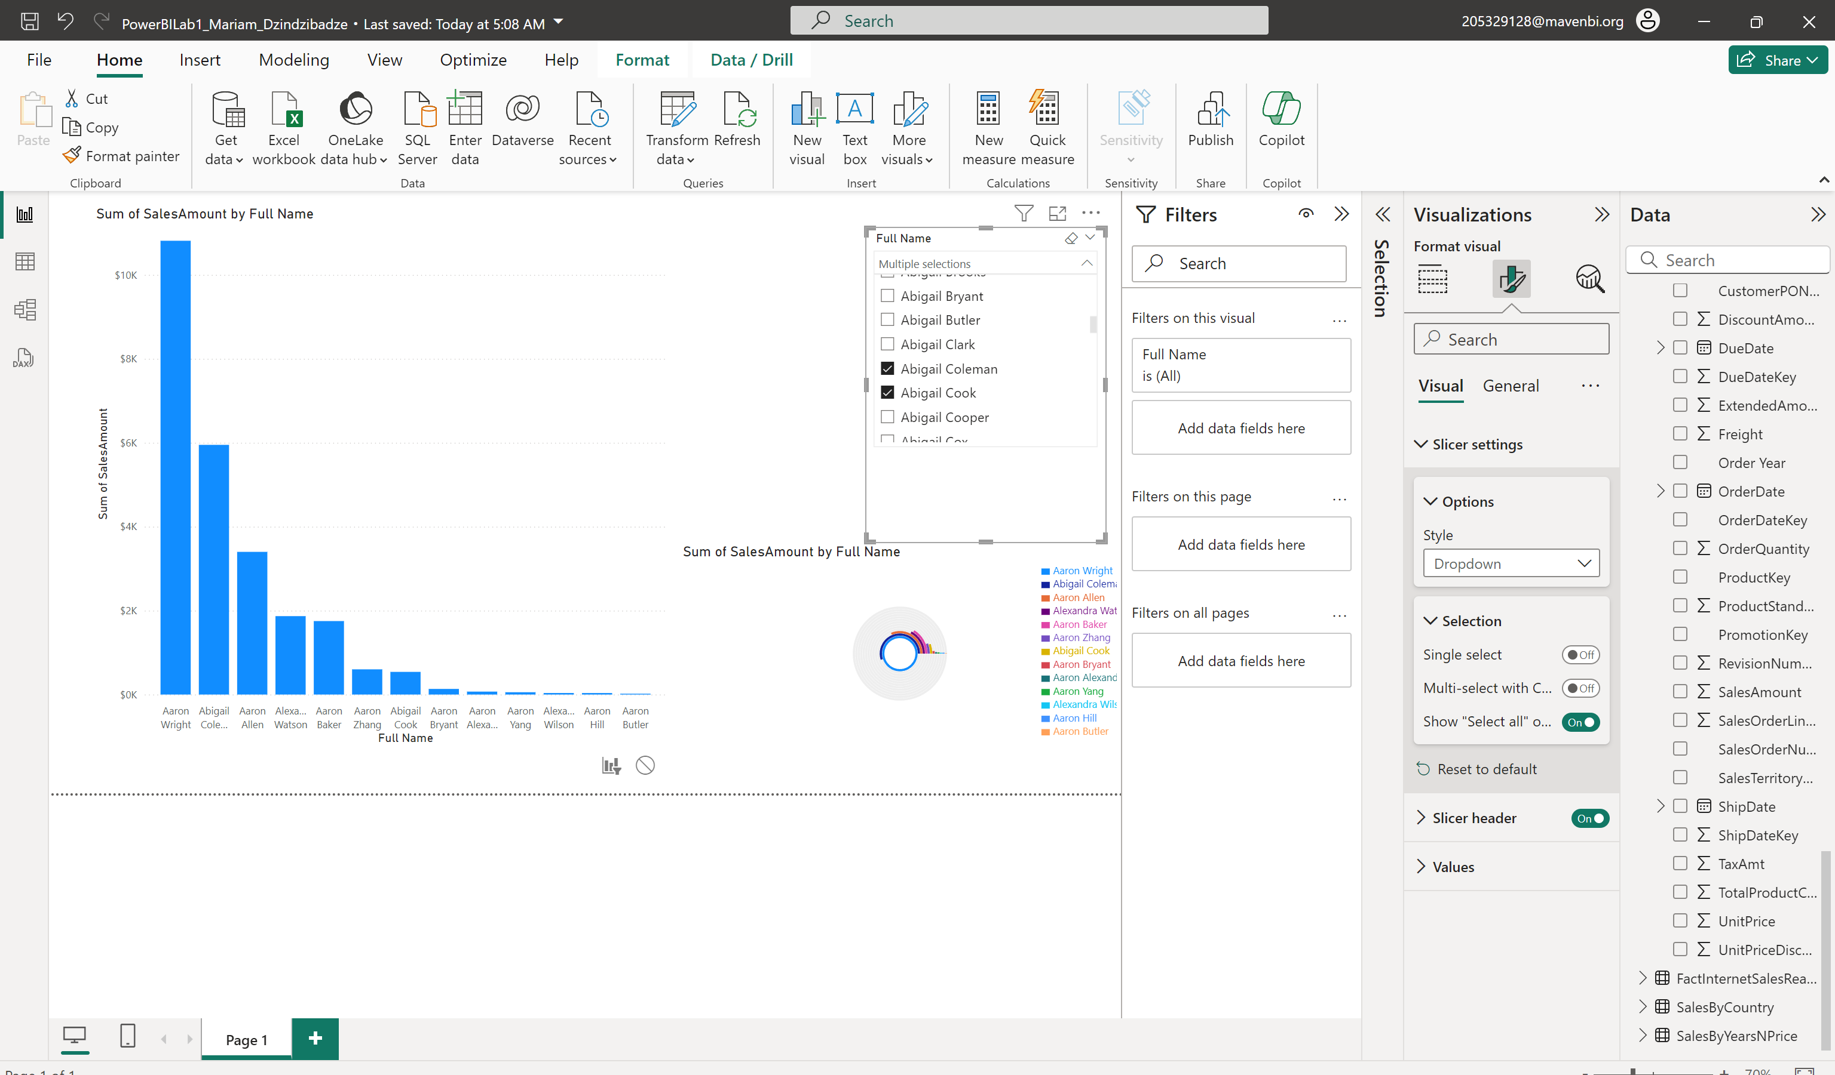

I have multiselection for slicer and I can choose as many customers, as I want to see sales amount for them and then I added simple radialchart for the visualizing same data.

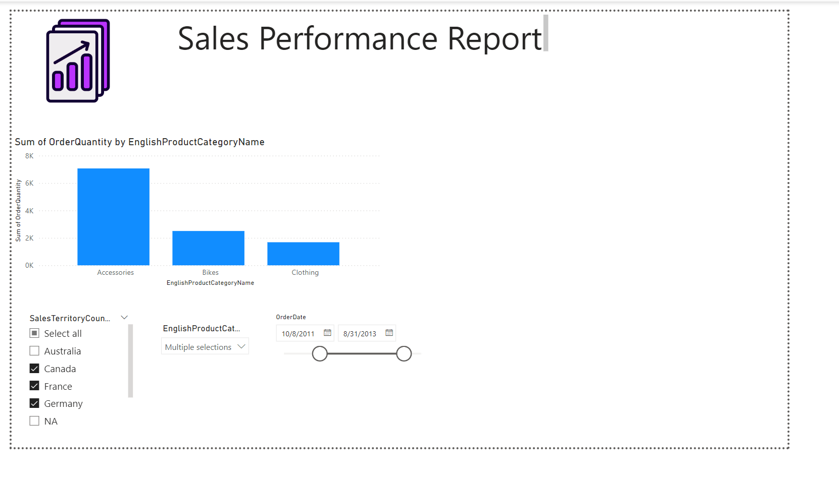

2.1-2 I did English product category with 3 slicers. One date, one category and one country.

2.3 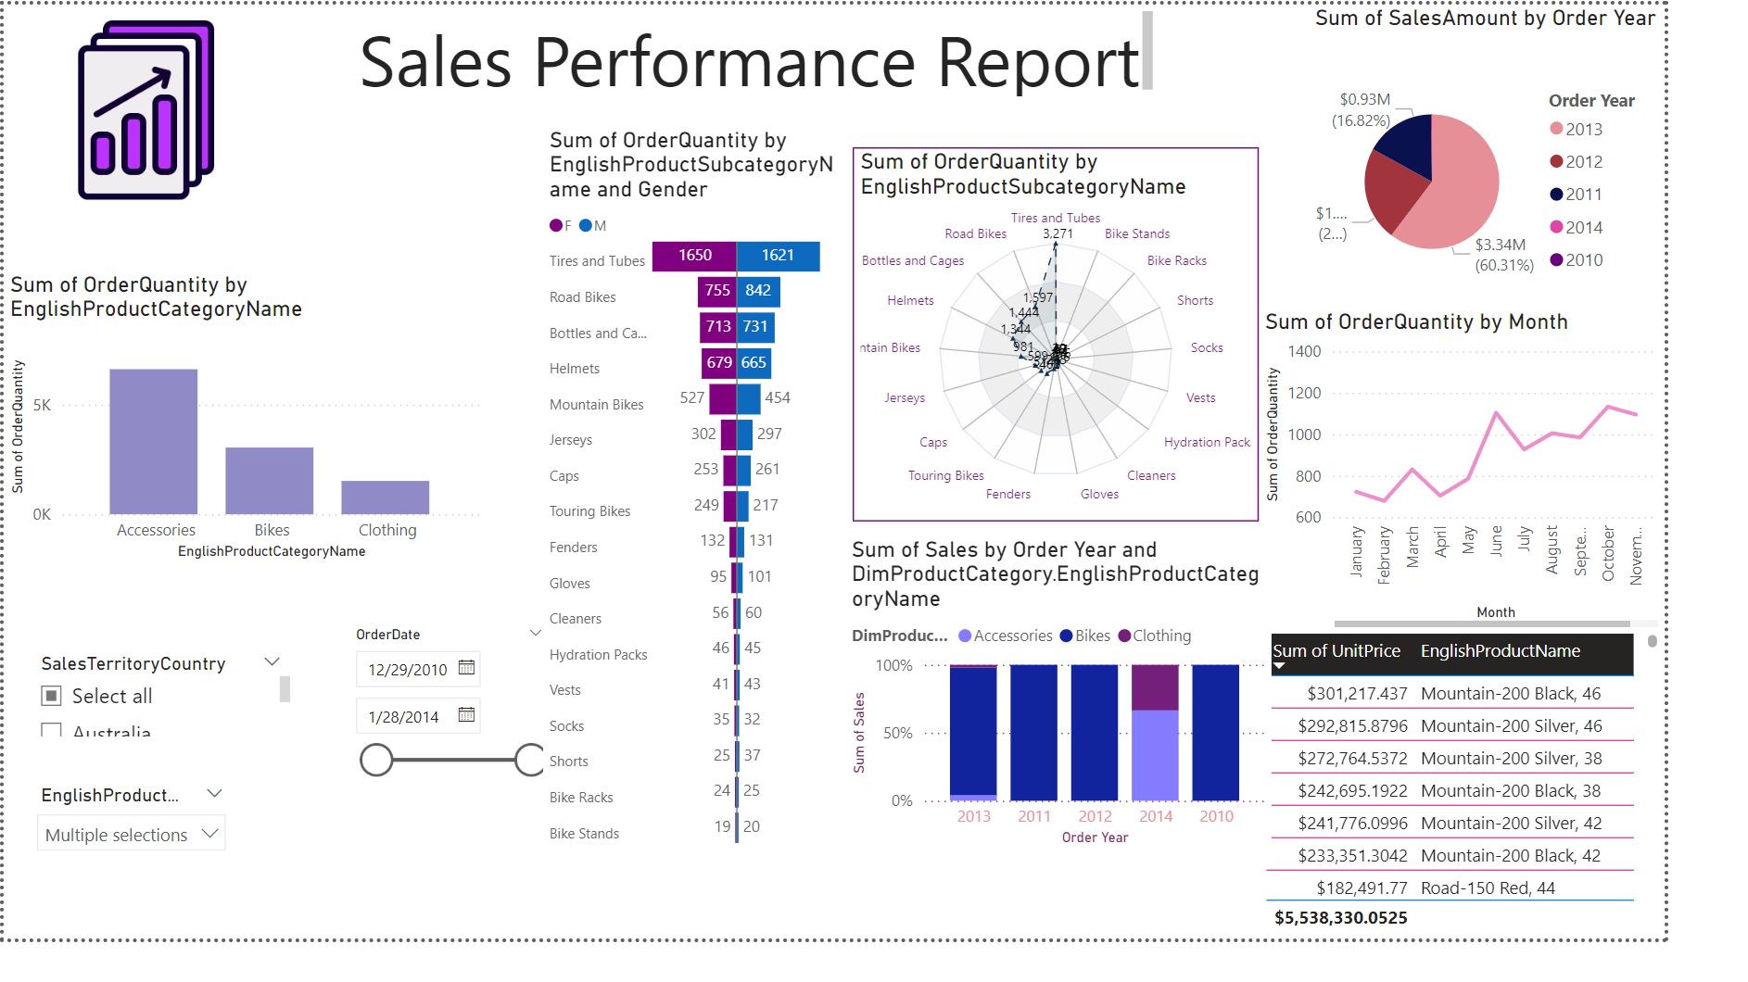

5 visualisation and 2 custom visuals for the data.

1 I have bar char for product category names. The barplot shows how many orders were made in each category.

2 custom visual chart shows for each gender and how many product subcategory quantity was sold

3 spider web shows generally the quantity for each subcategory.

Barplot below that shows in 4 years, each category sales and percentage for them.

Then I have table shows unit prices for the subcategory and

Line chart shows which month is most active for the sales and lastly I have pie chart showing which country distribution for sales



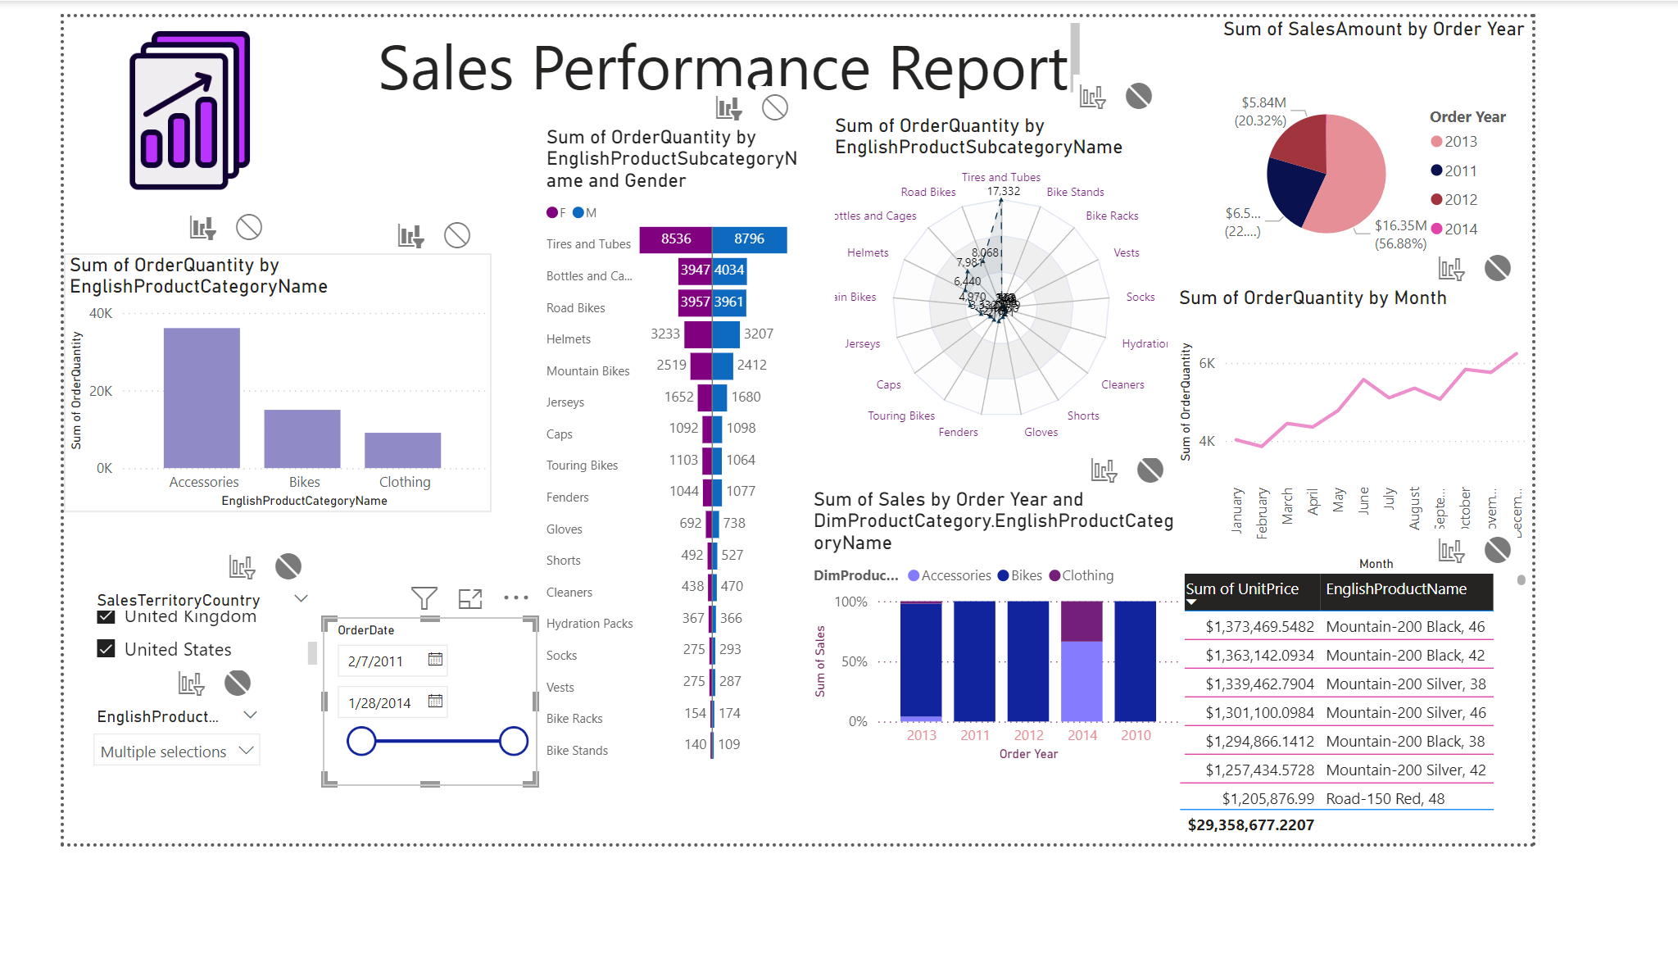 I disabled some slicer and some visuals, so they will not get affected when slider changes.

I chose color palate of purple, blue and pink

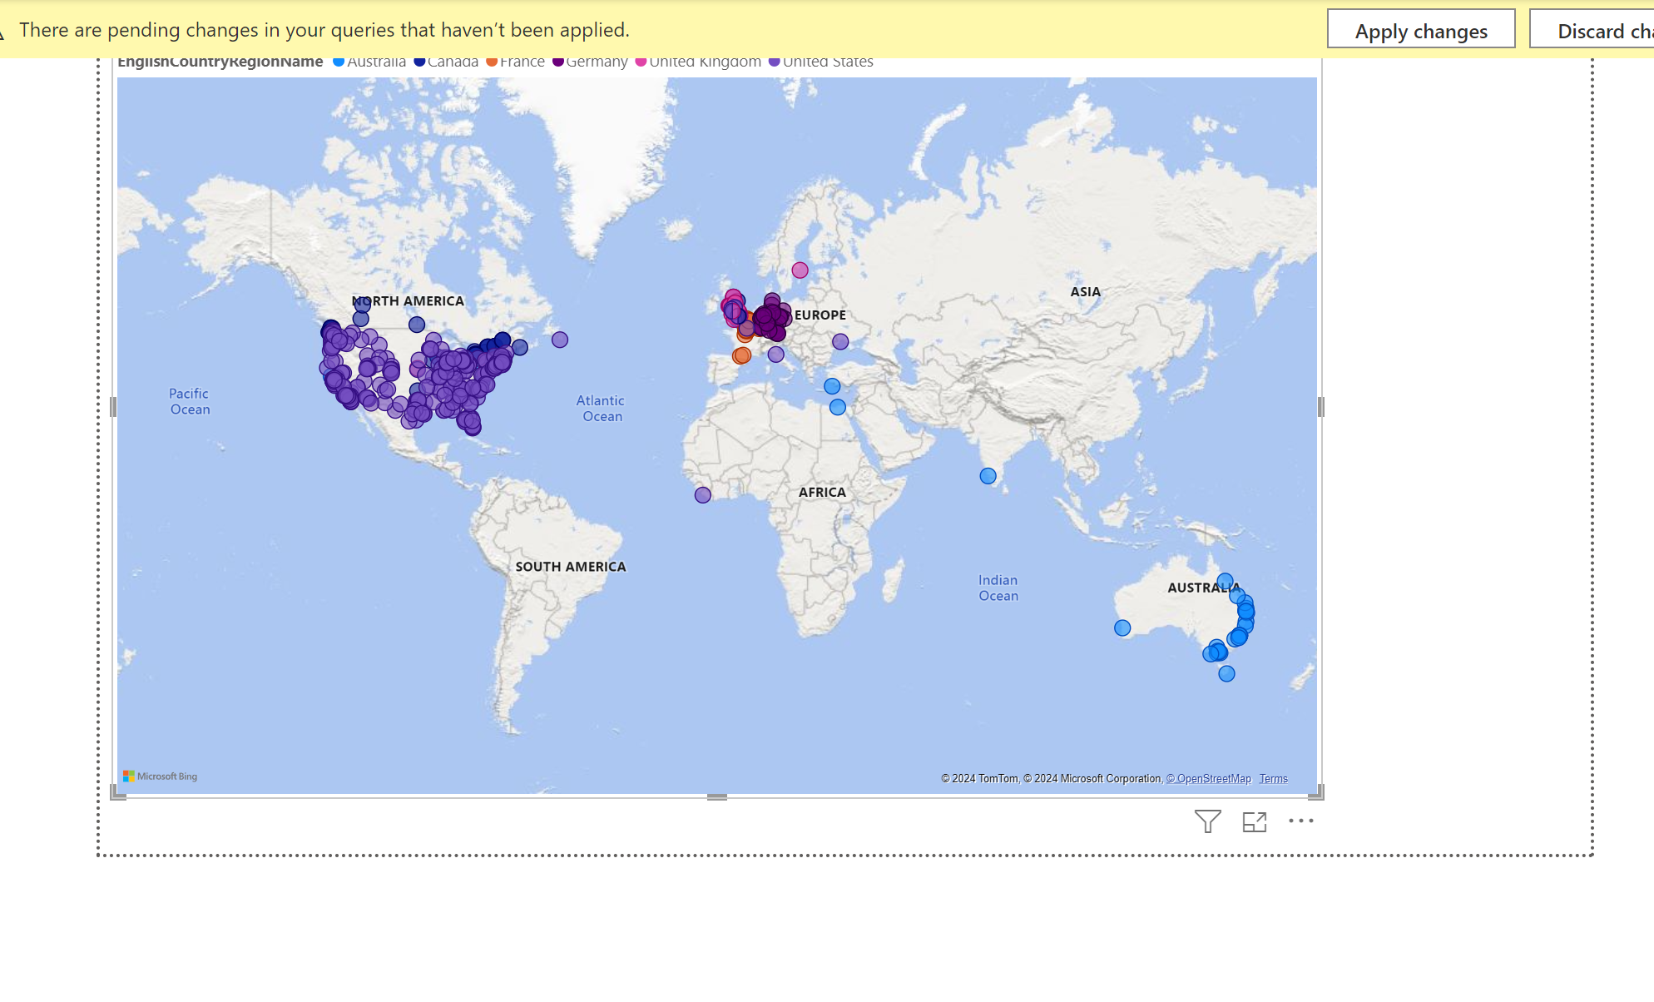map

Report in powerBI service

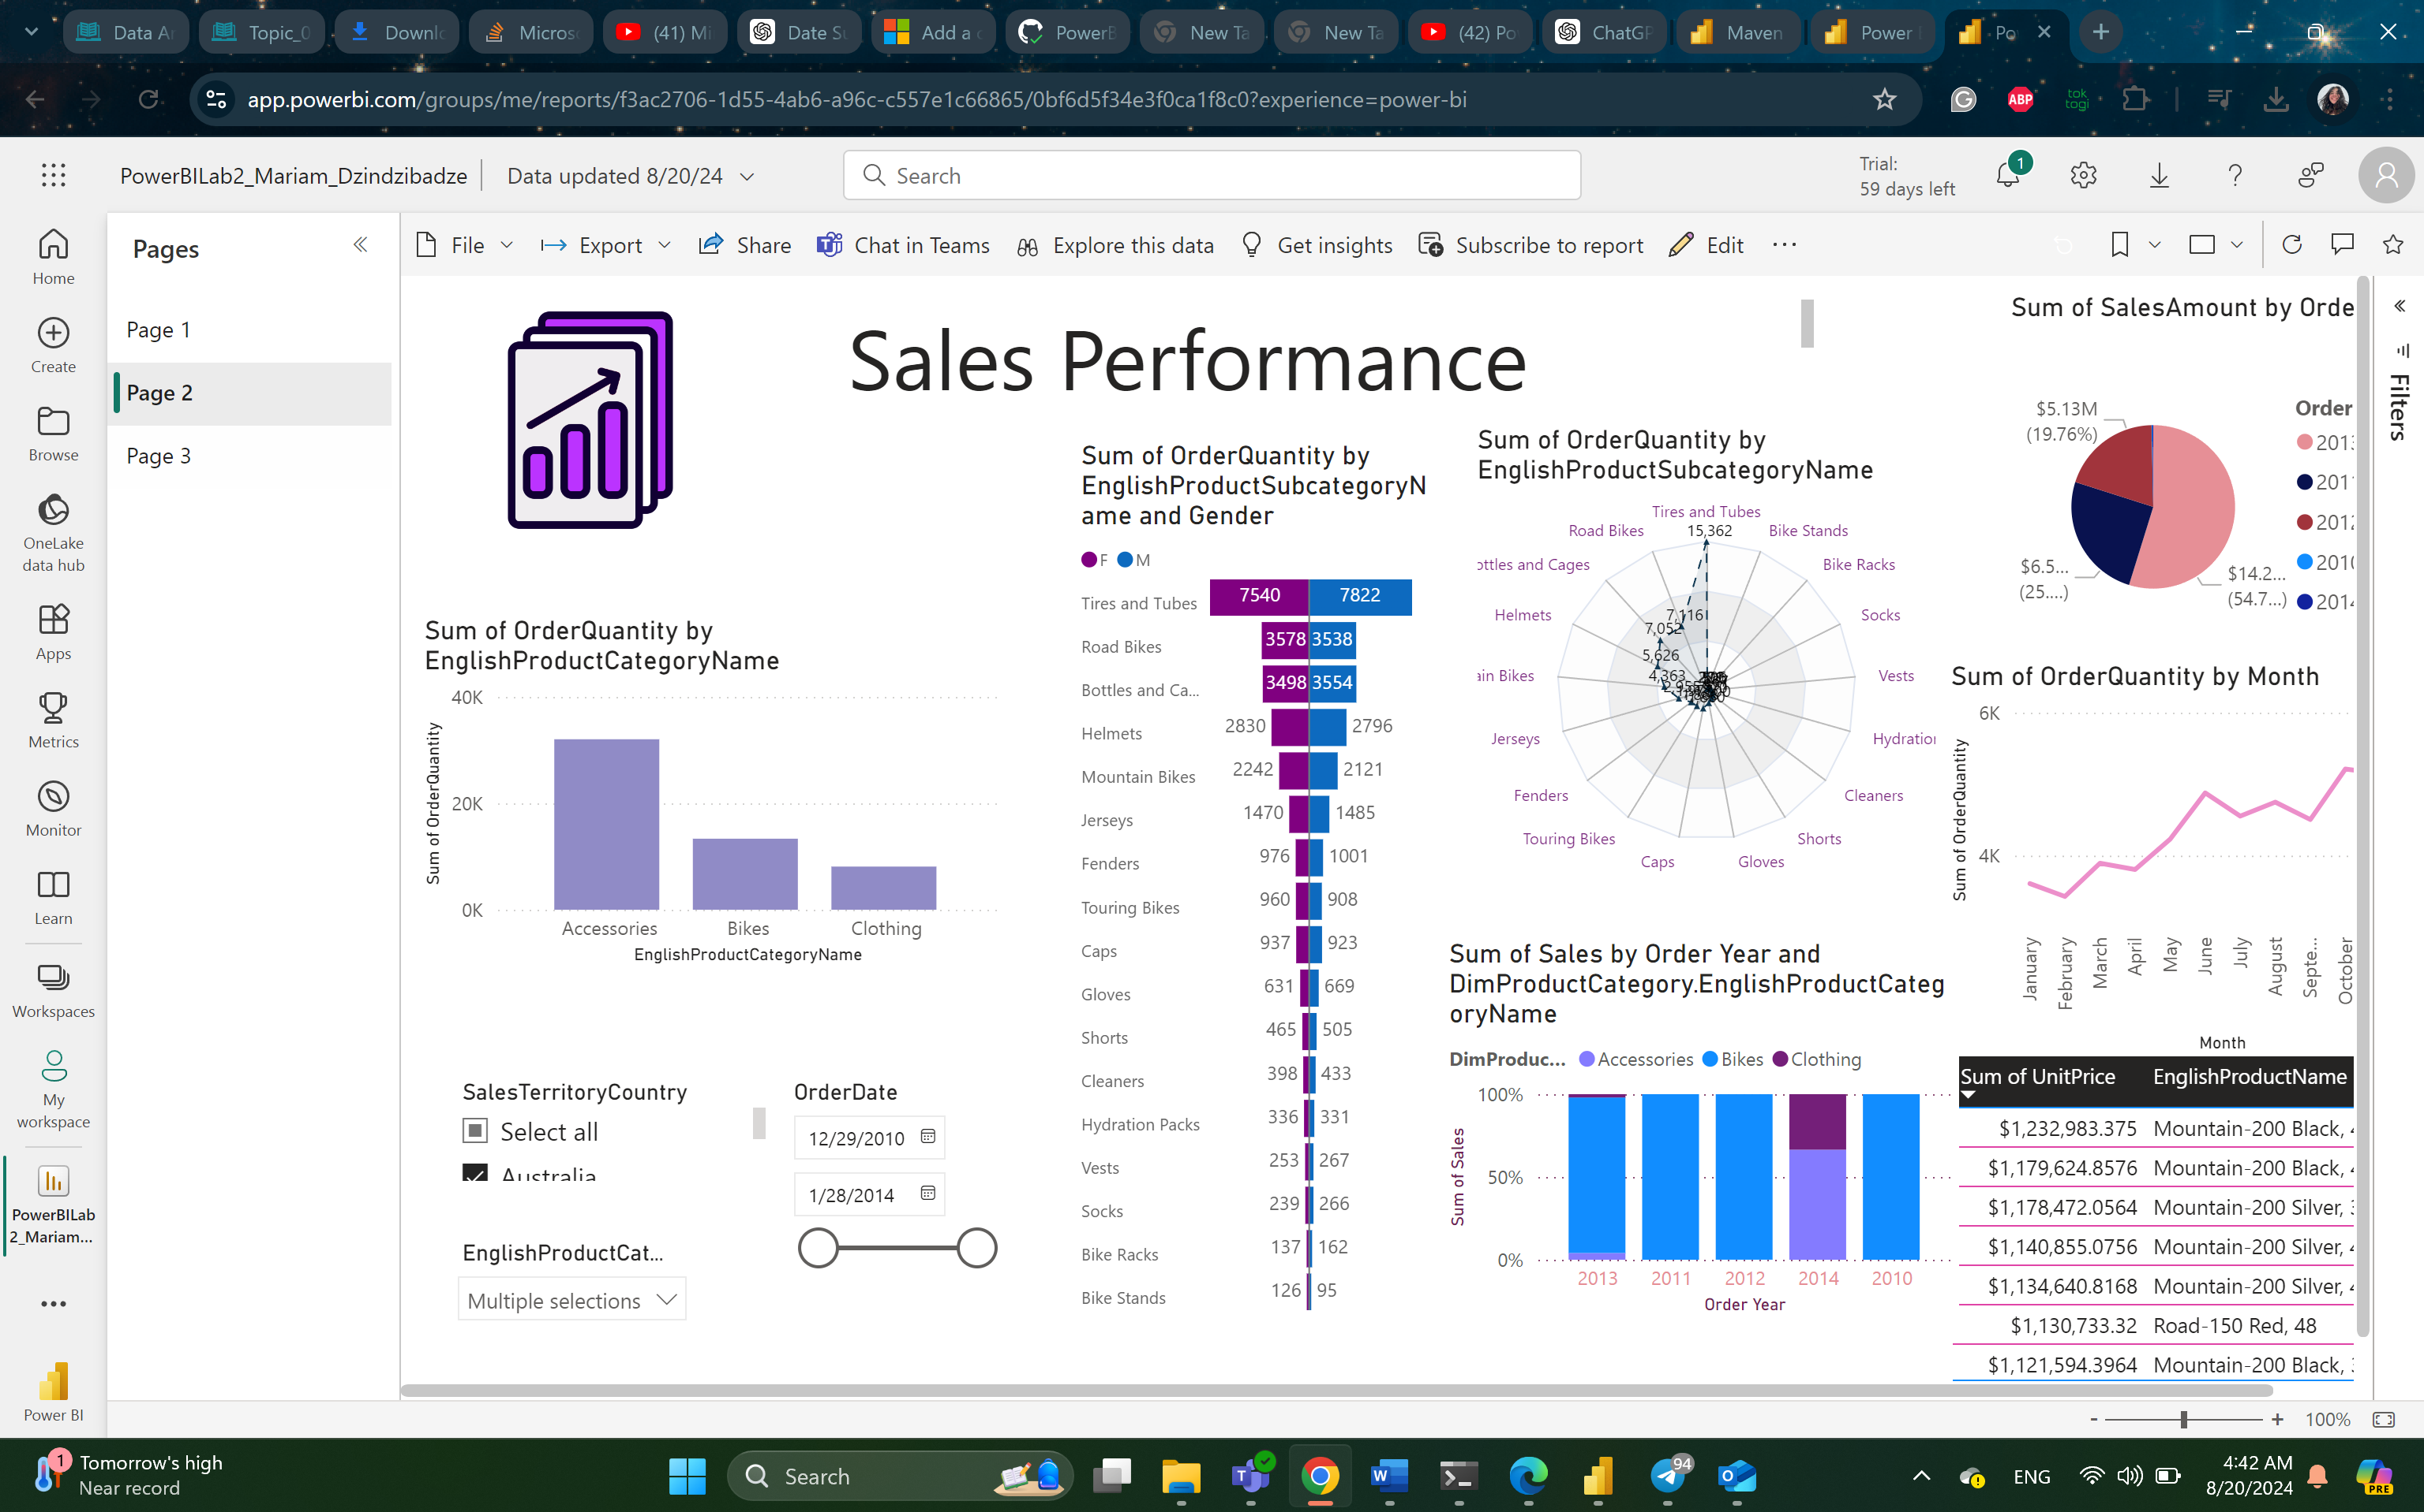

I could not do daily updates, I don’t know why but I was not able to connect the gateway correctly.

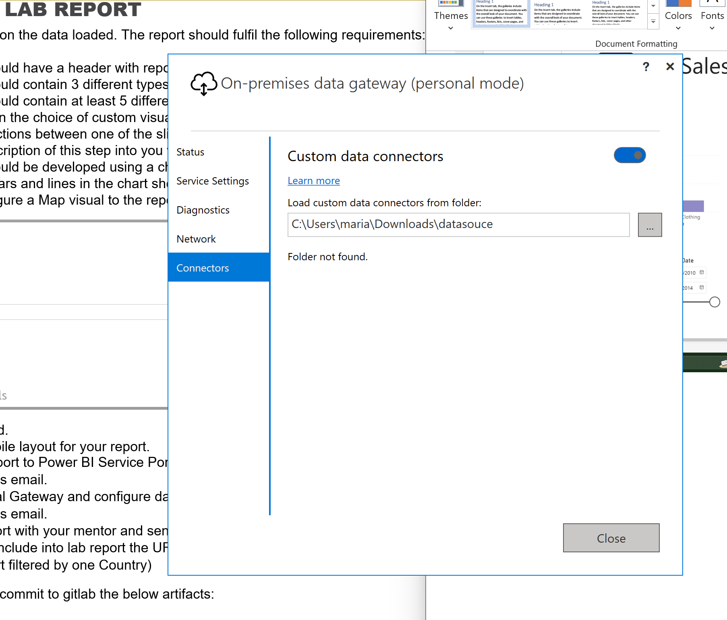

Could not Send you mail )

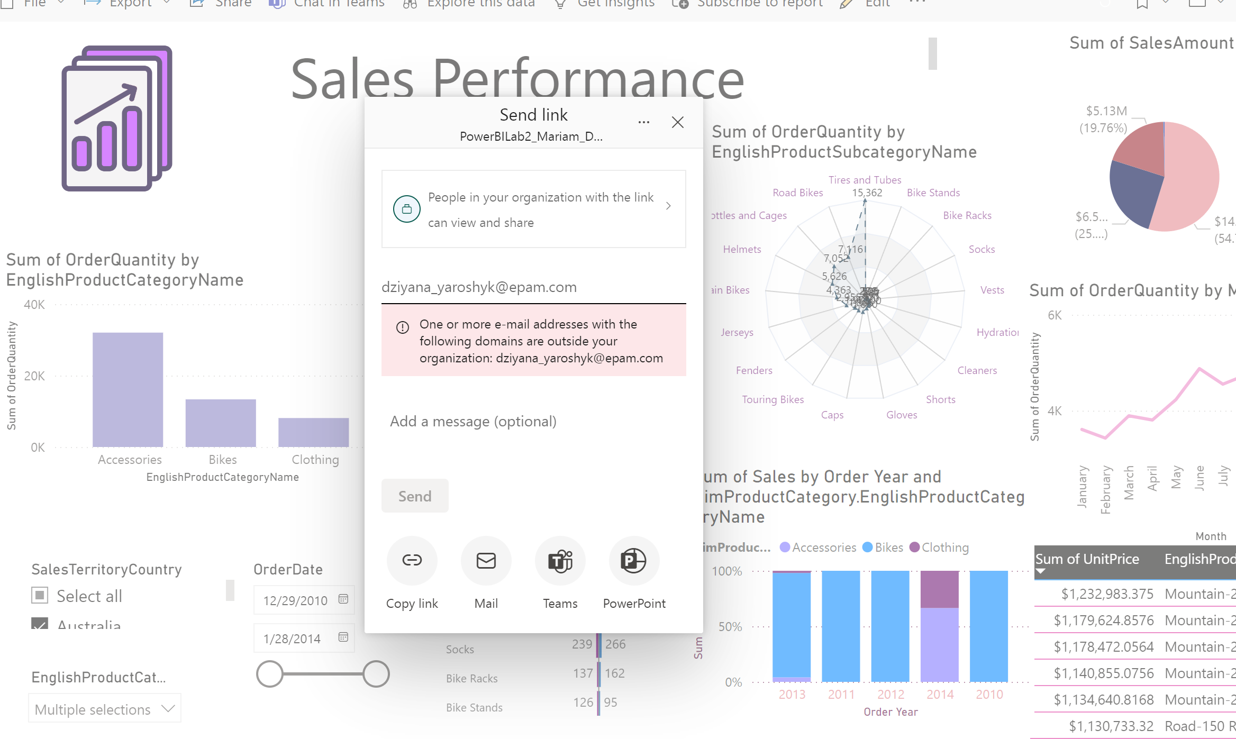

I changed pie on the last minute to the pie where percentage for sales is shown for all countries, I did that for the link creation

<https://app.powerbi.com/links/j5qgc2TwE8?ctid=25ce0261-bbd6-49cd-a1e2-54260886d159&pbi_source=linkShare&bookmarkGuid=2ae87d7f-c403-4b46-a85e-d413a51cf8a5>