1.1.2

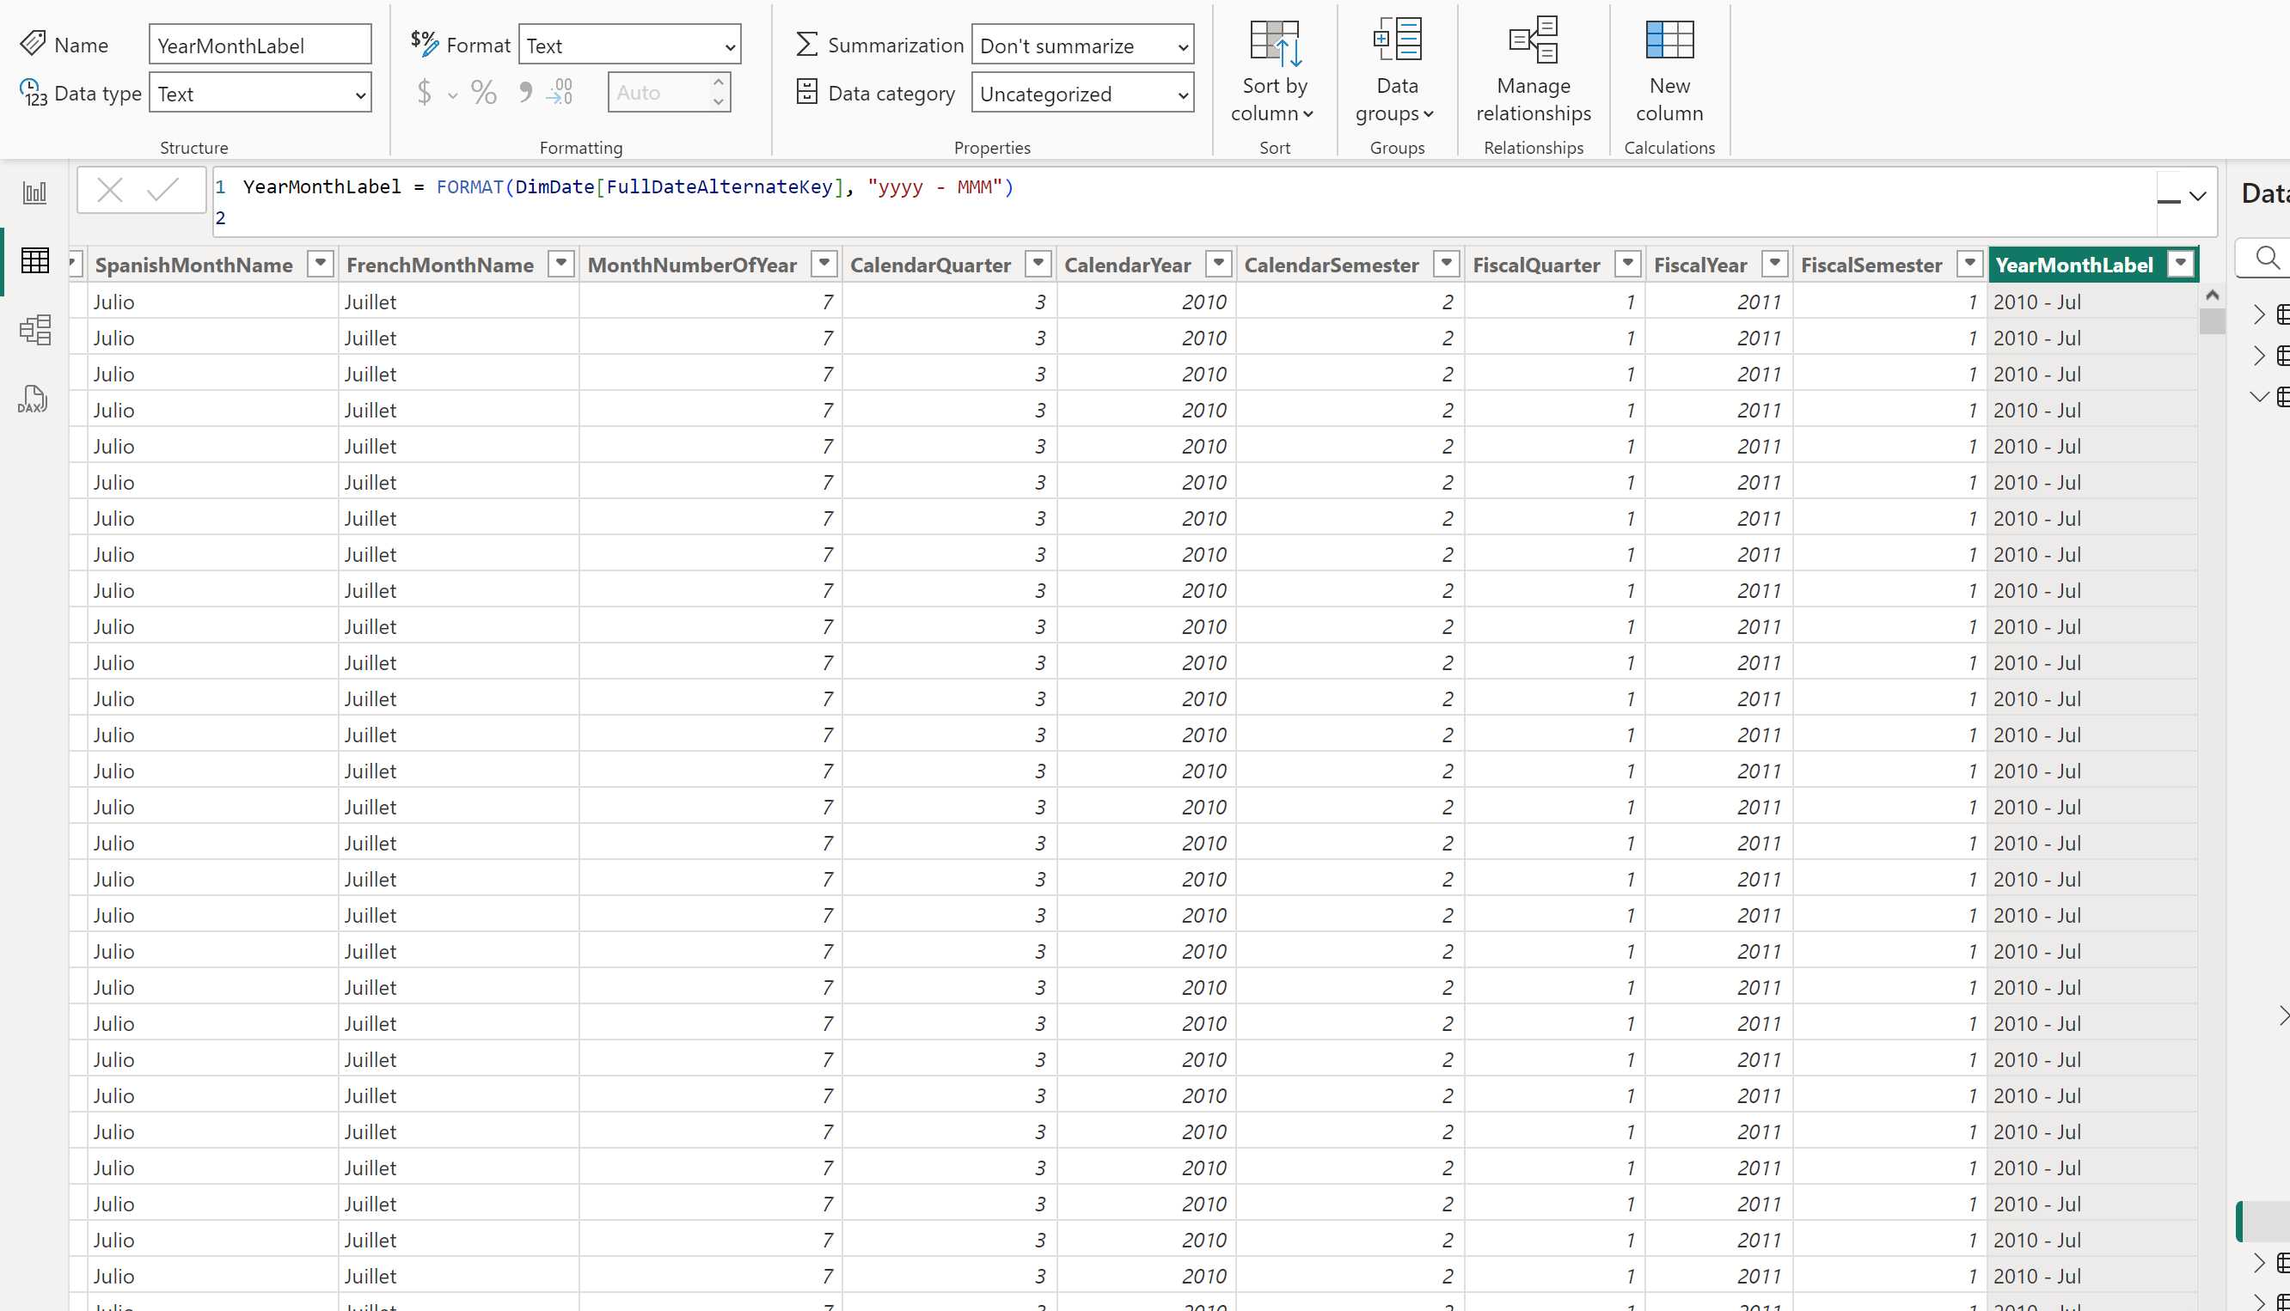

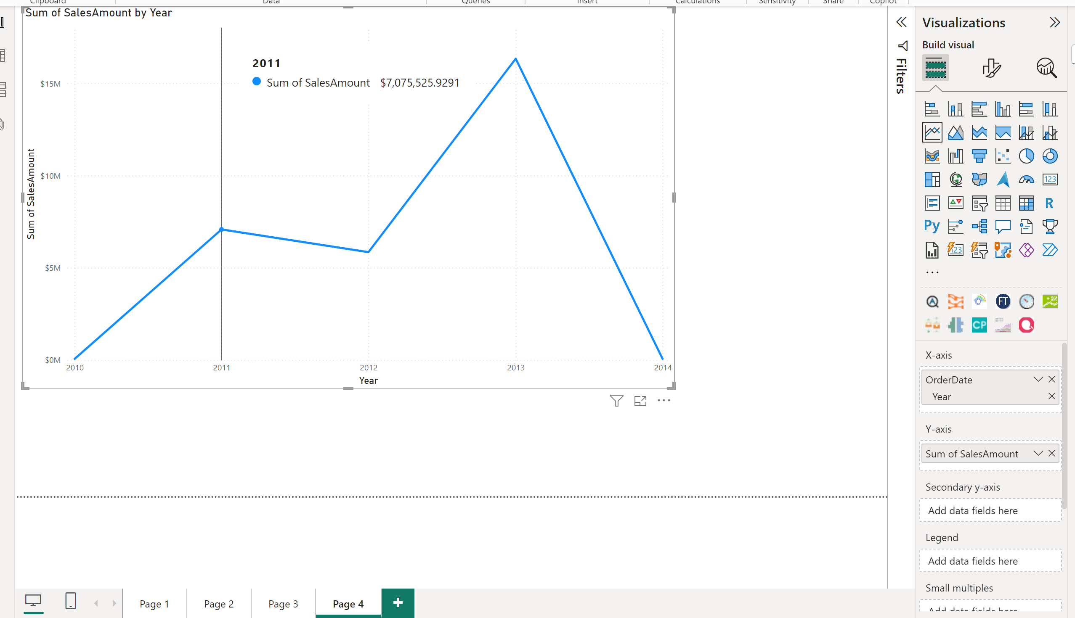

**3.this is when using orderdate from fact table and only showing year**

**4.** 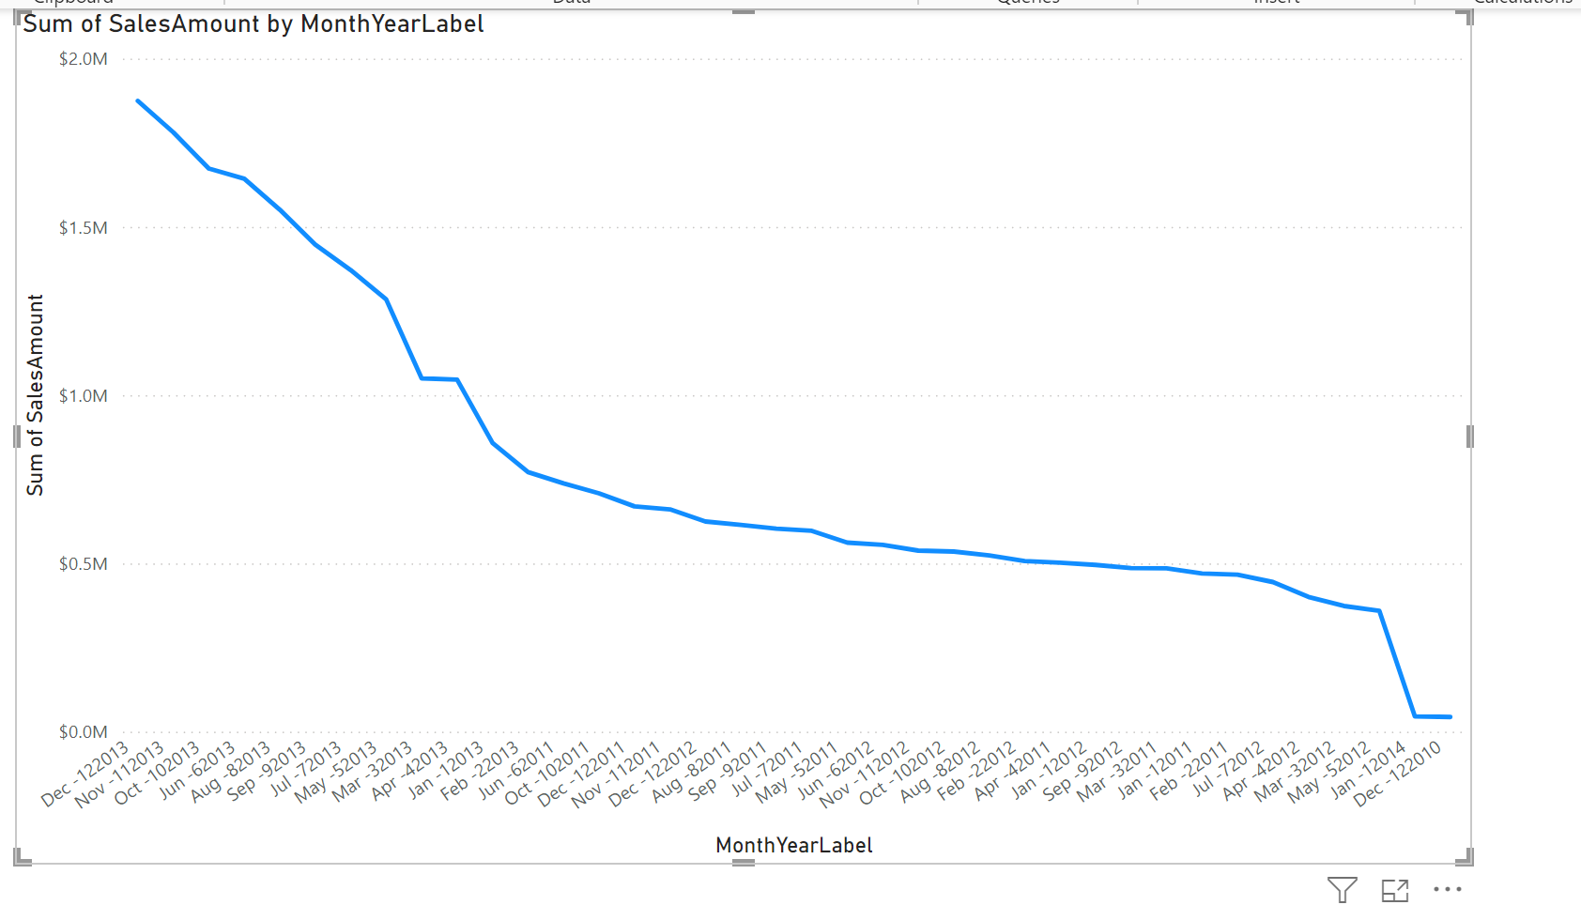

**Using monthyearlabel to show sales. I created new column with month and then year.**

**5.** 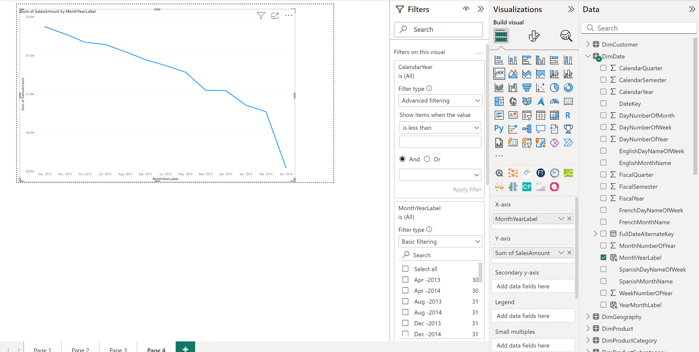

**Using filter to see years 2013-2014**

**6.** 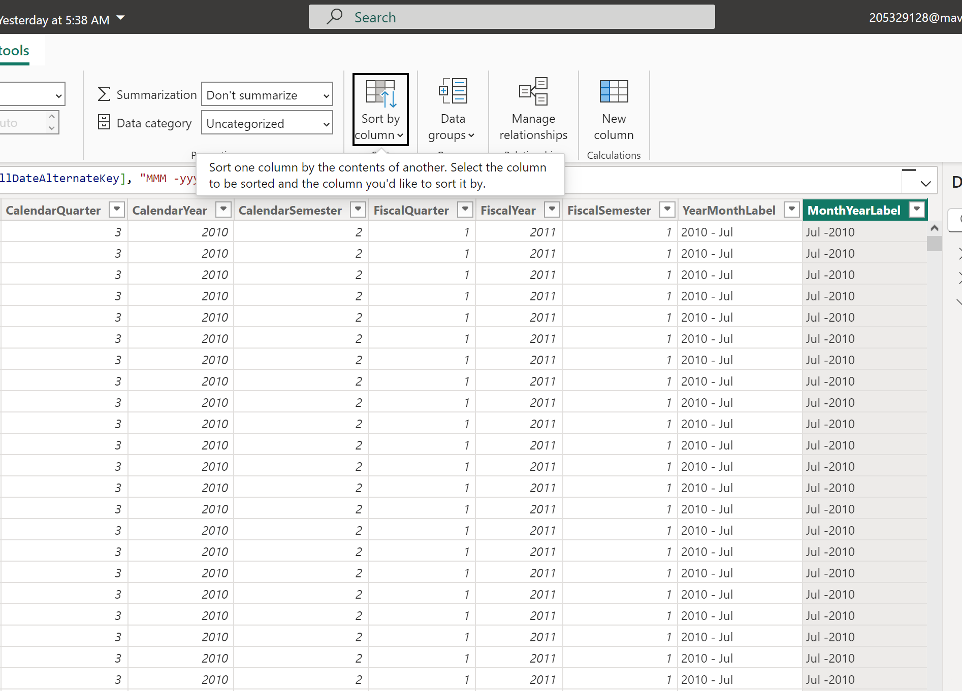

**I sorted the column on itself**

**And then this is the result**

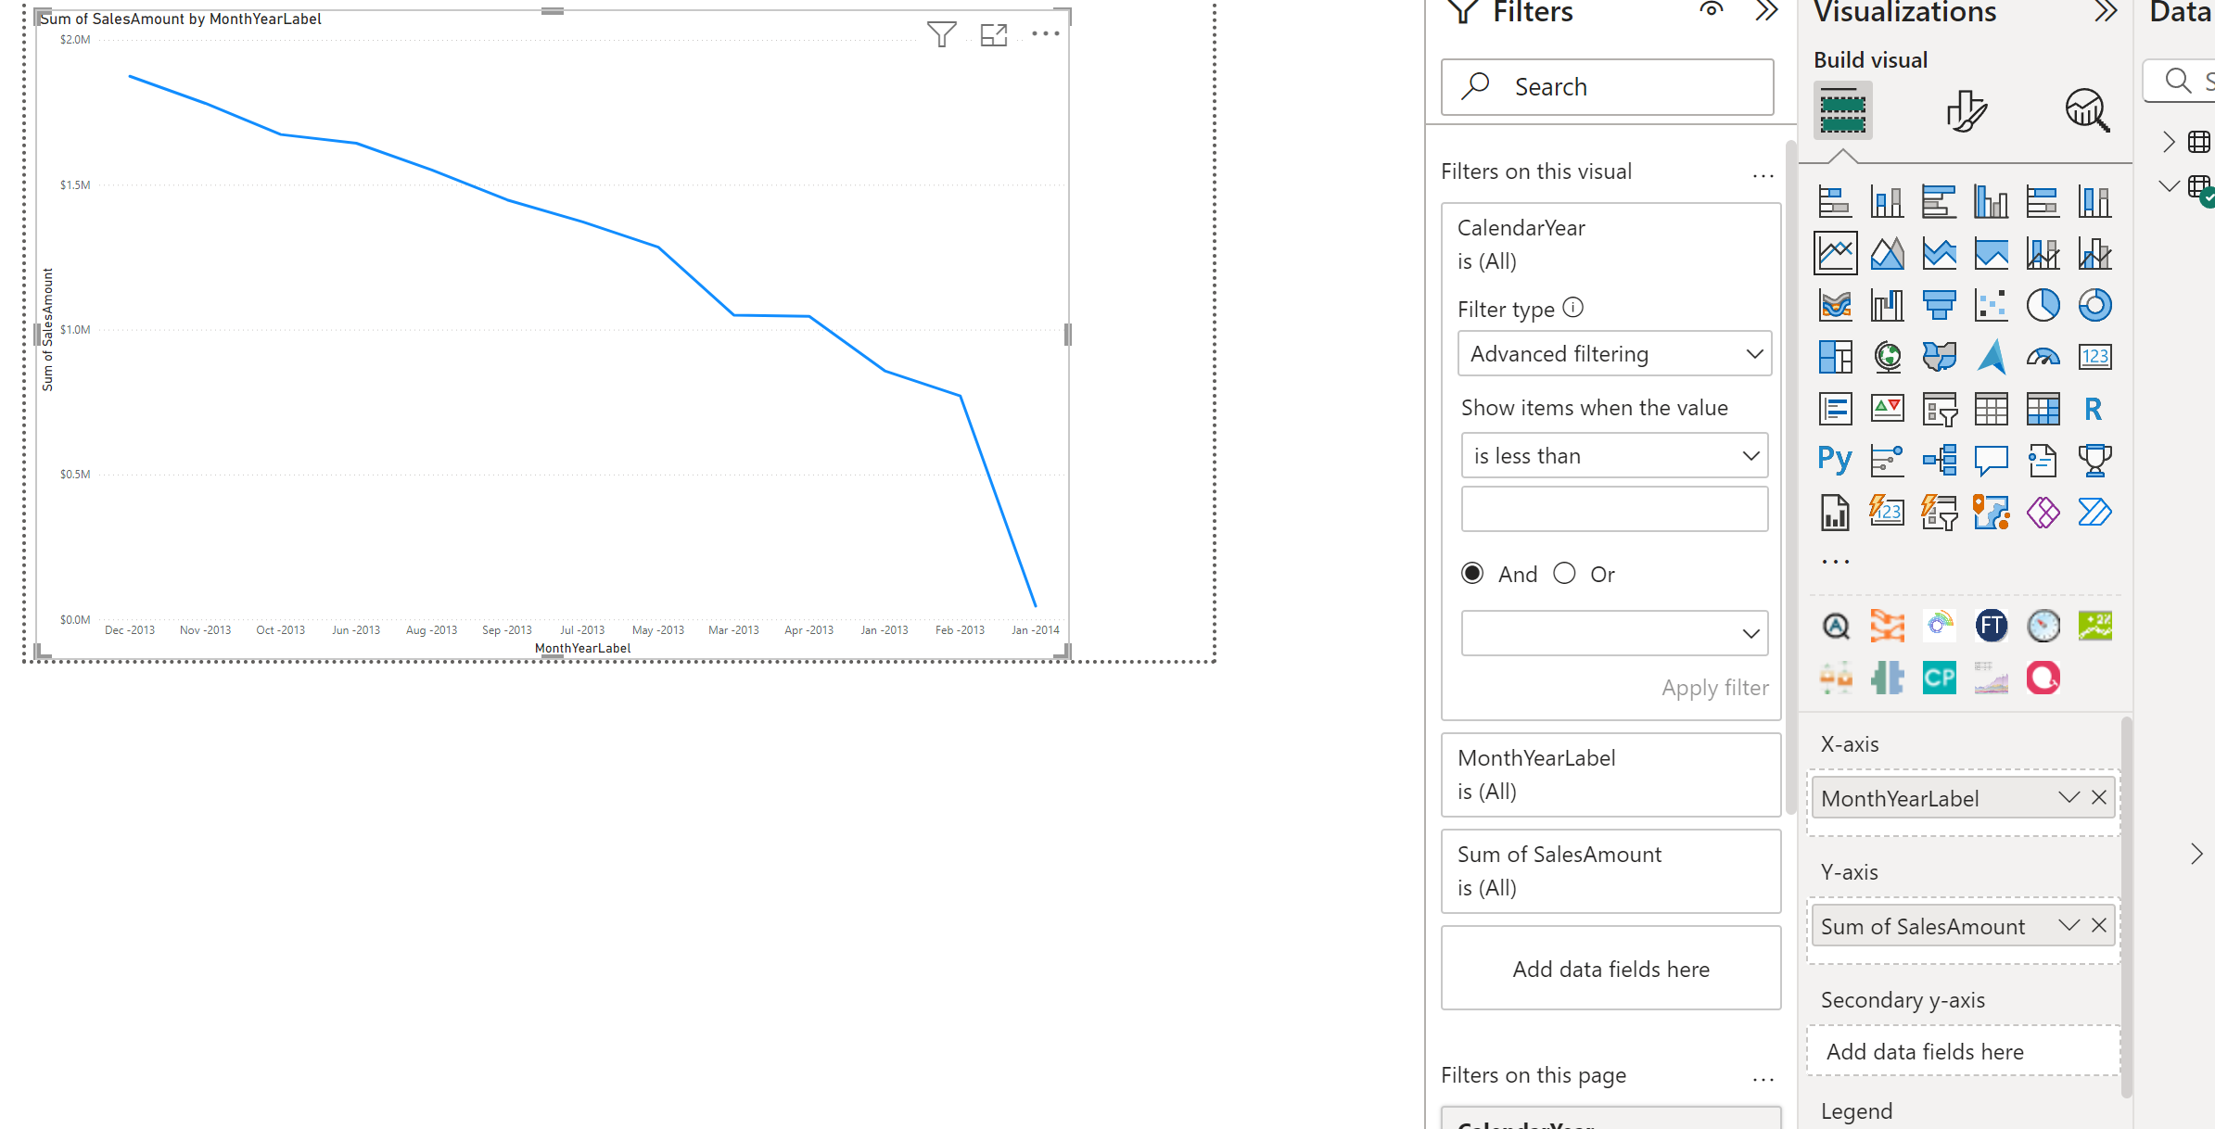

**1.2**

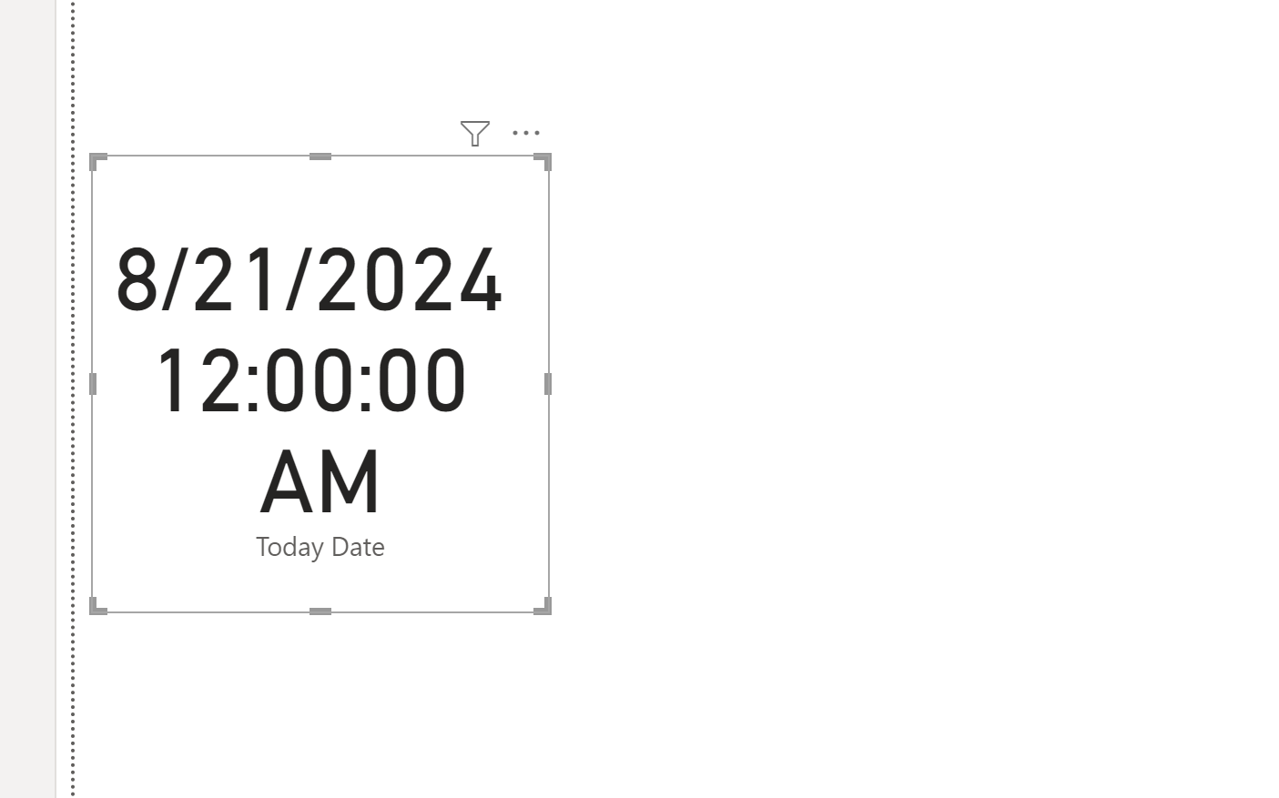

**1-3. Creating measure today and presenting it in card visualization.**

**4.** 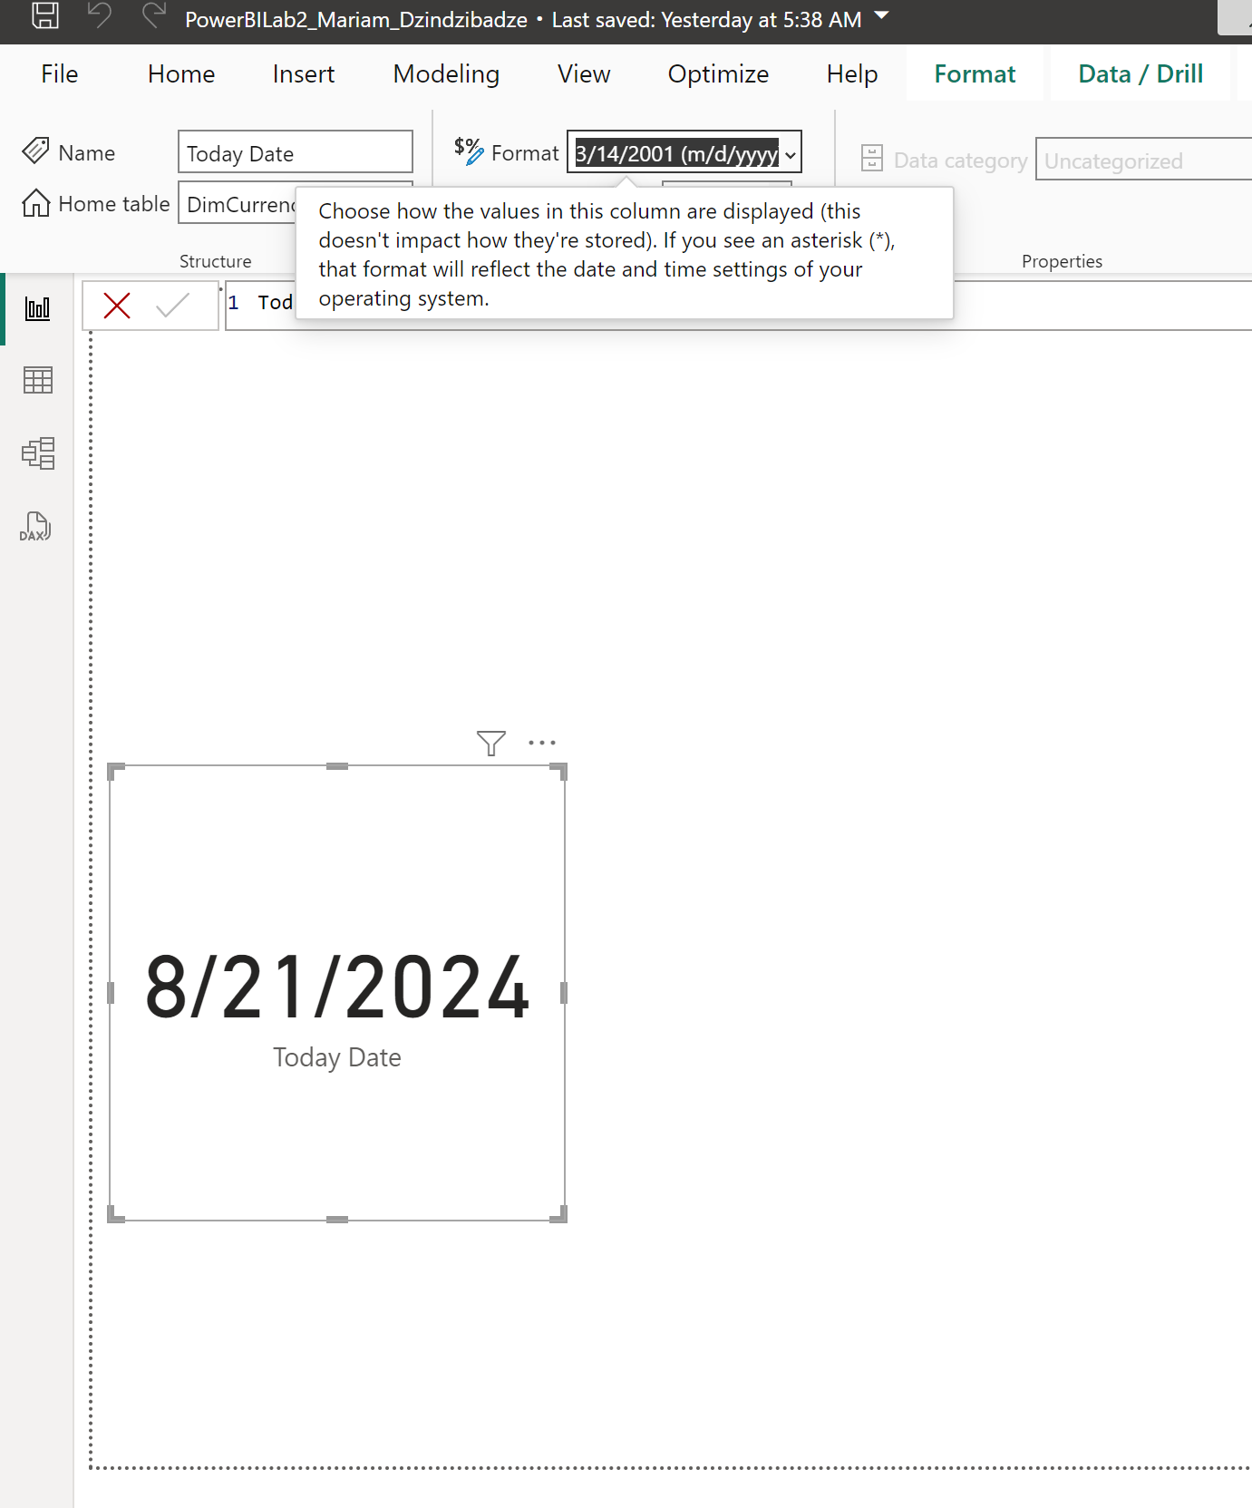

**Formatting into shorter version**

**5.** 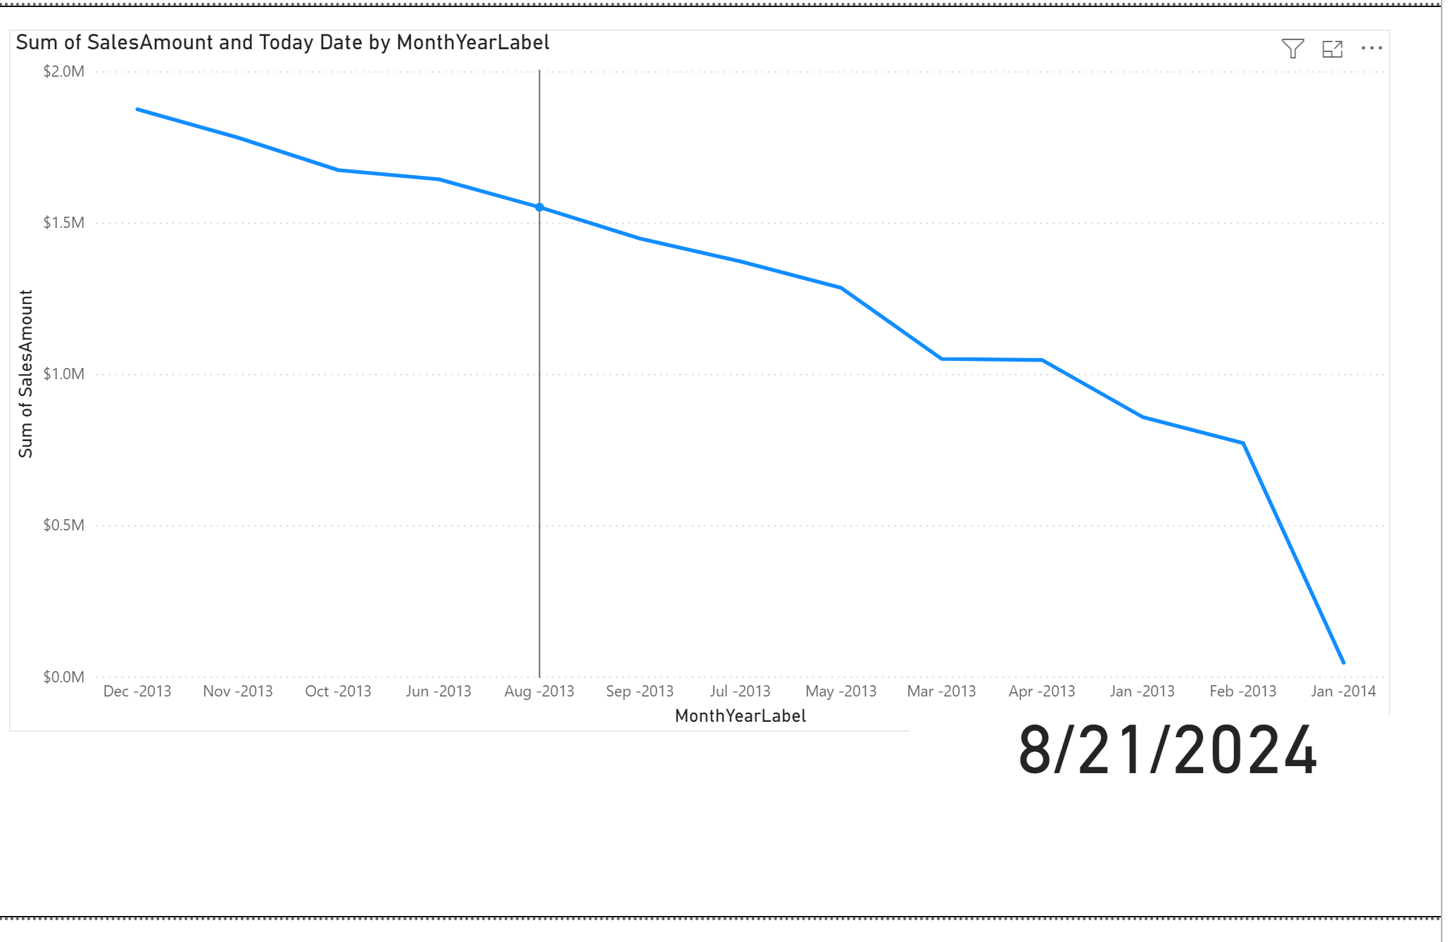

**Adding card to the bottom of the line chart.**

**6-7.** 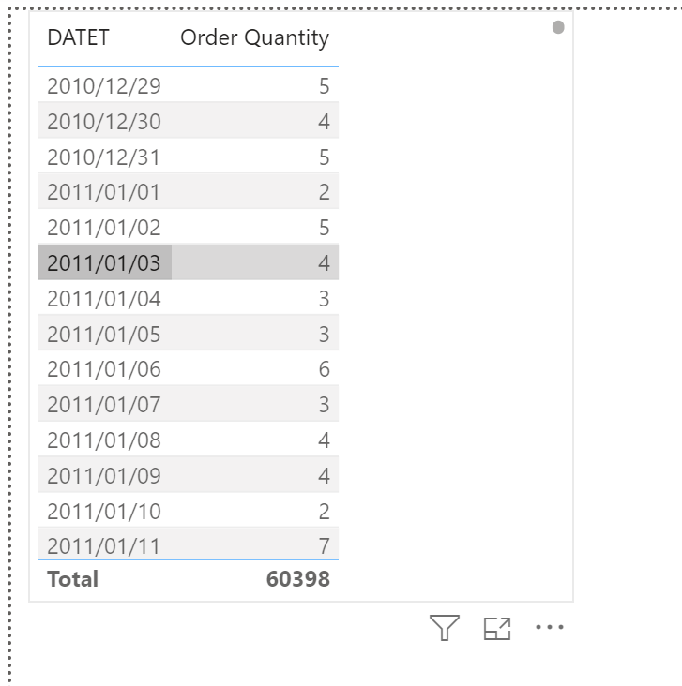

I cerated new datet column with only numerical date and add it with measure of quantity

**8-9.**

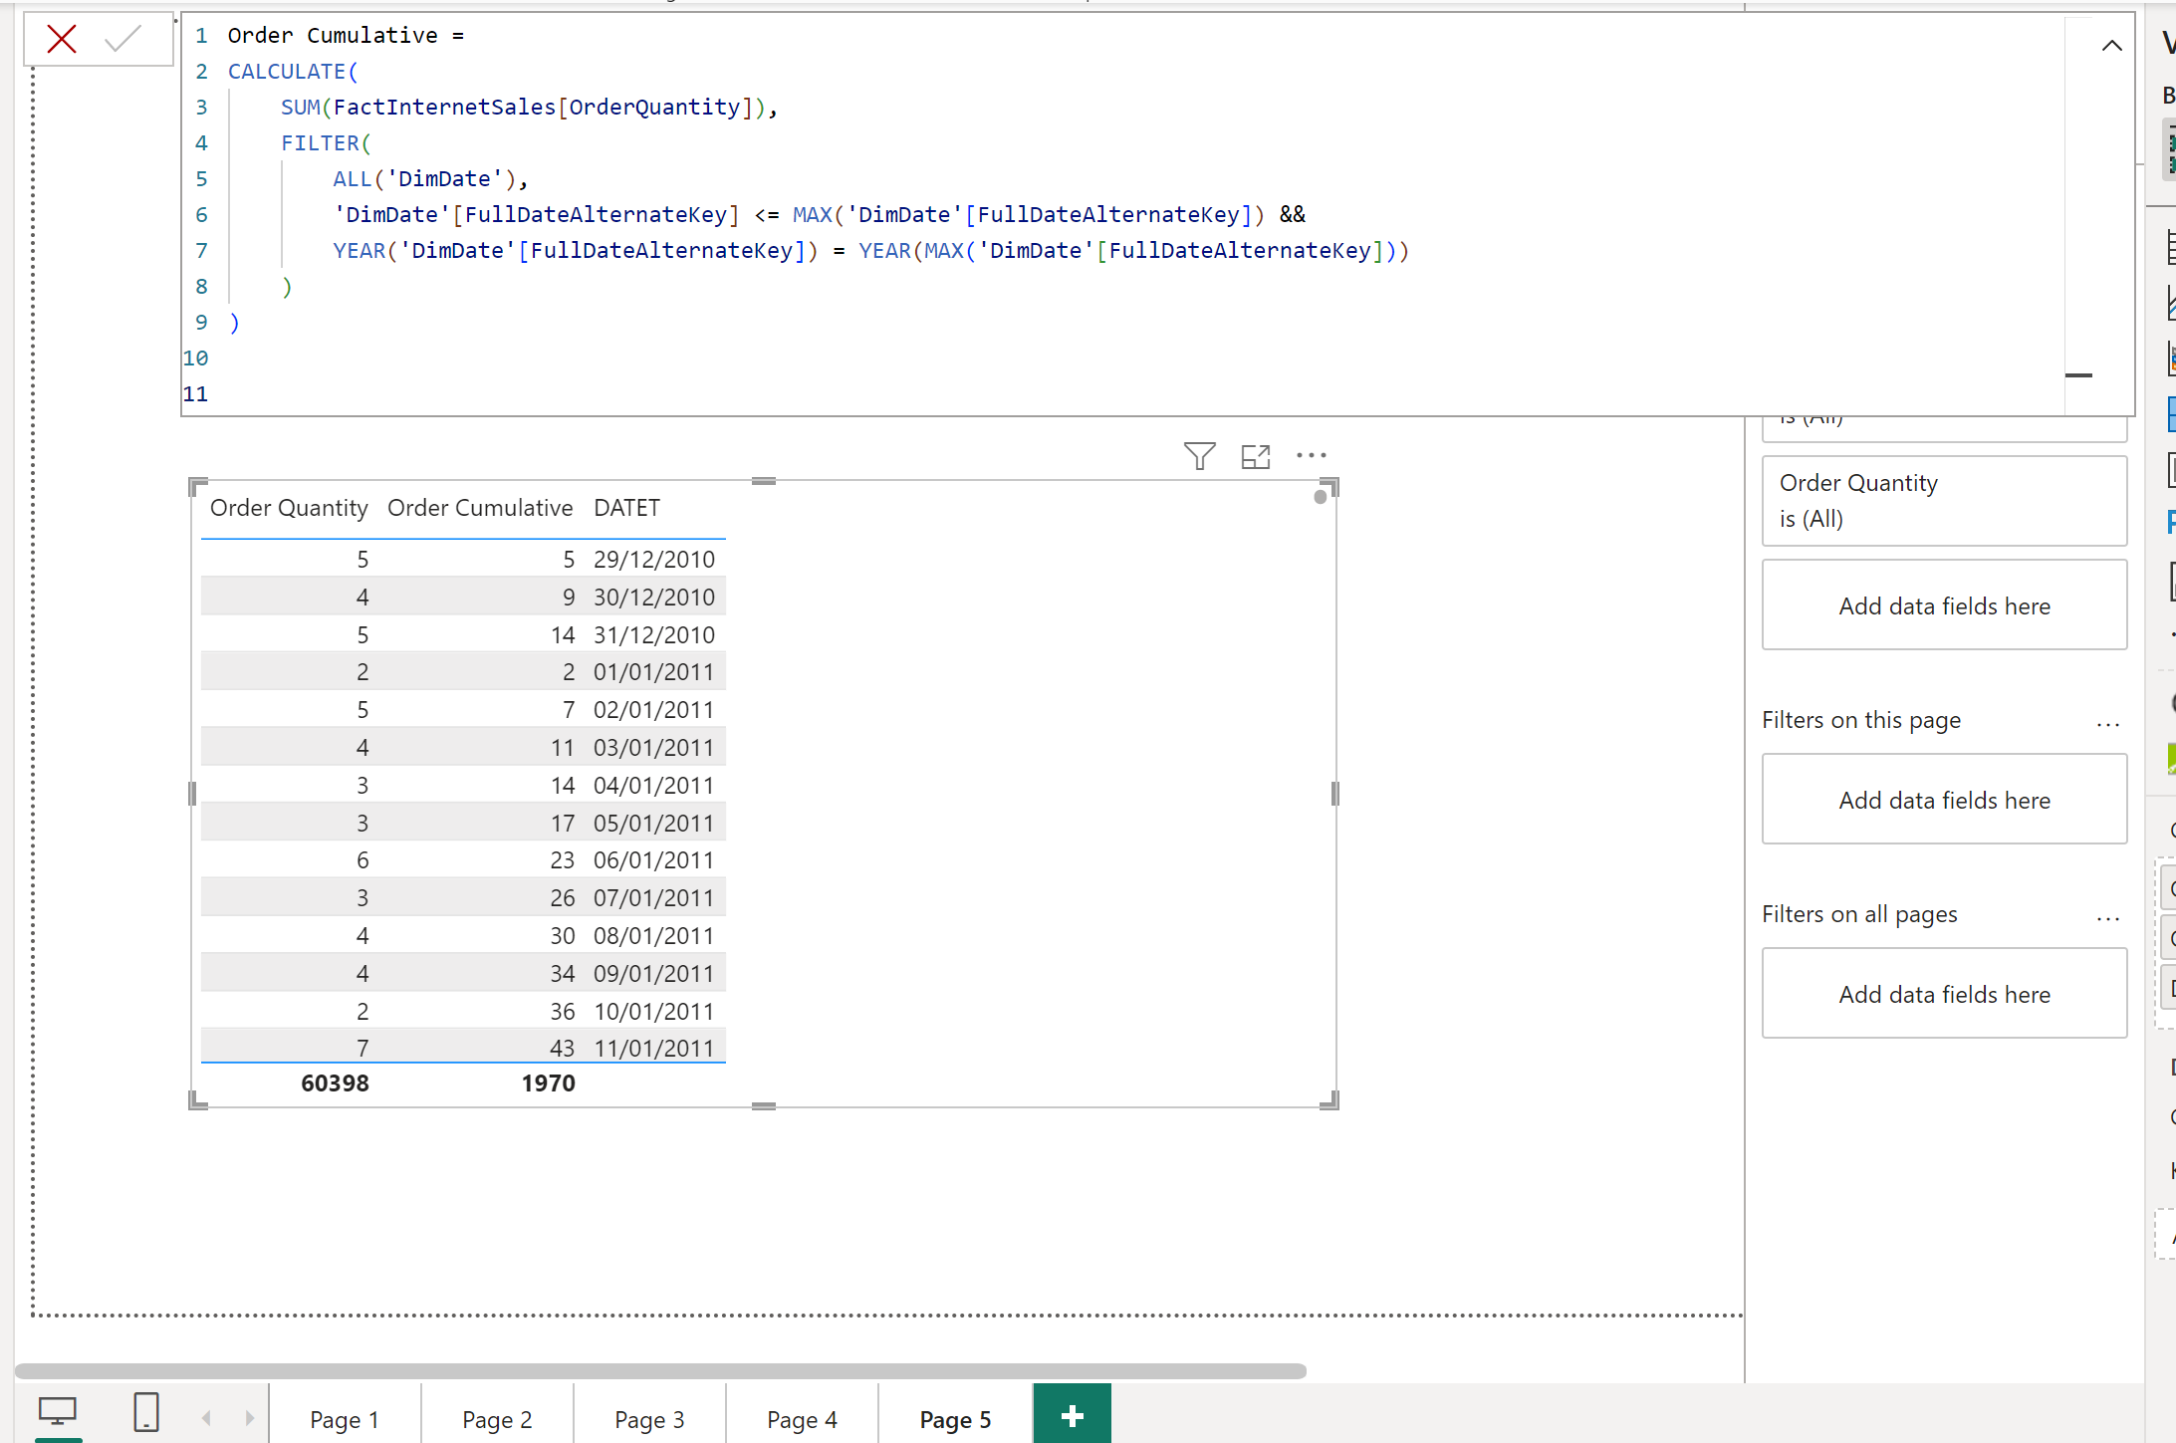

**Created order cumulative to see cumulative orders by years. But datesytd was not working**

**2. 1**

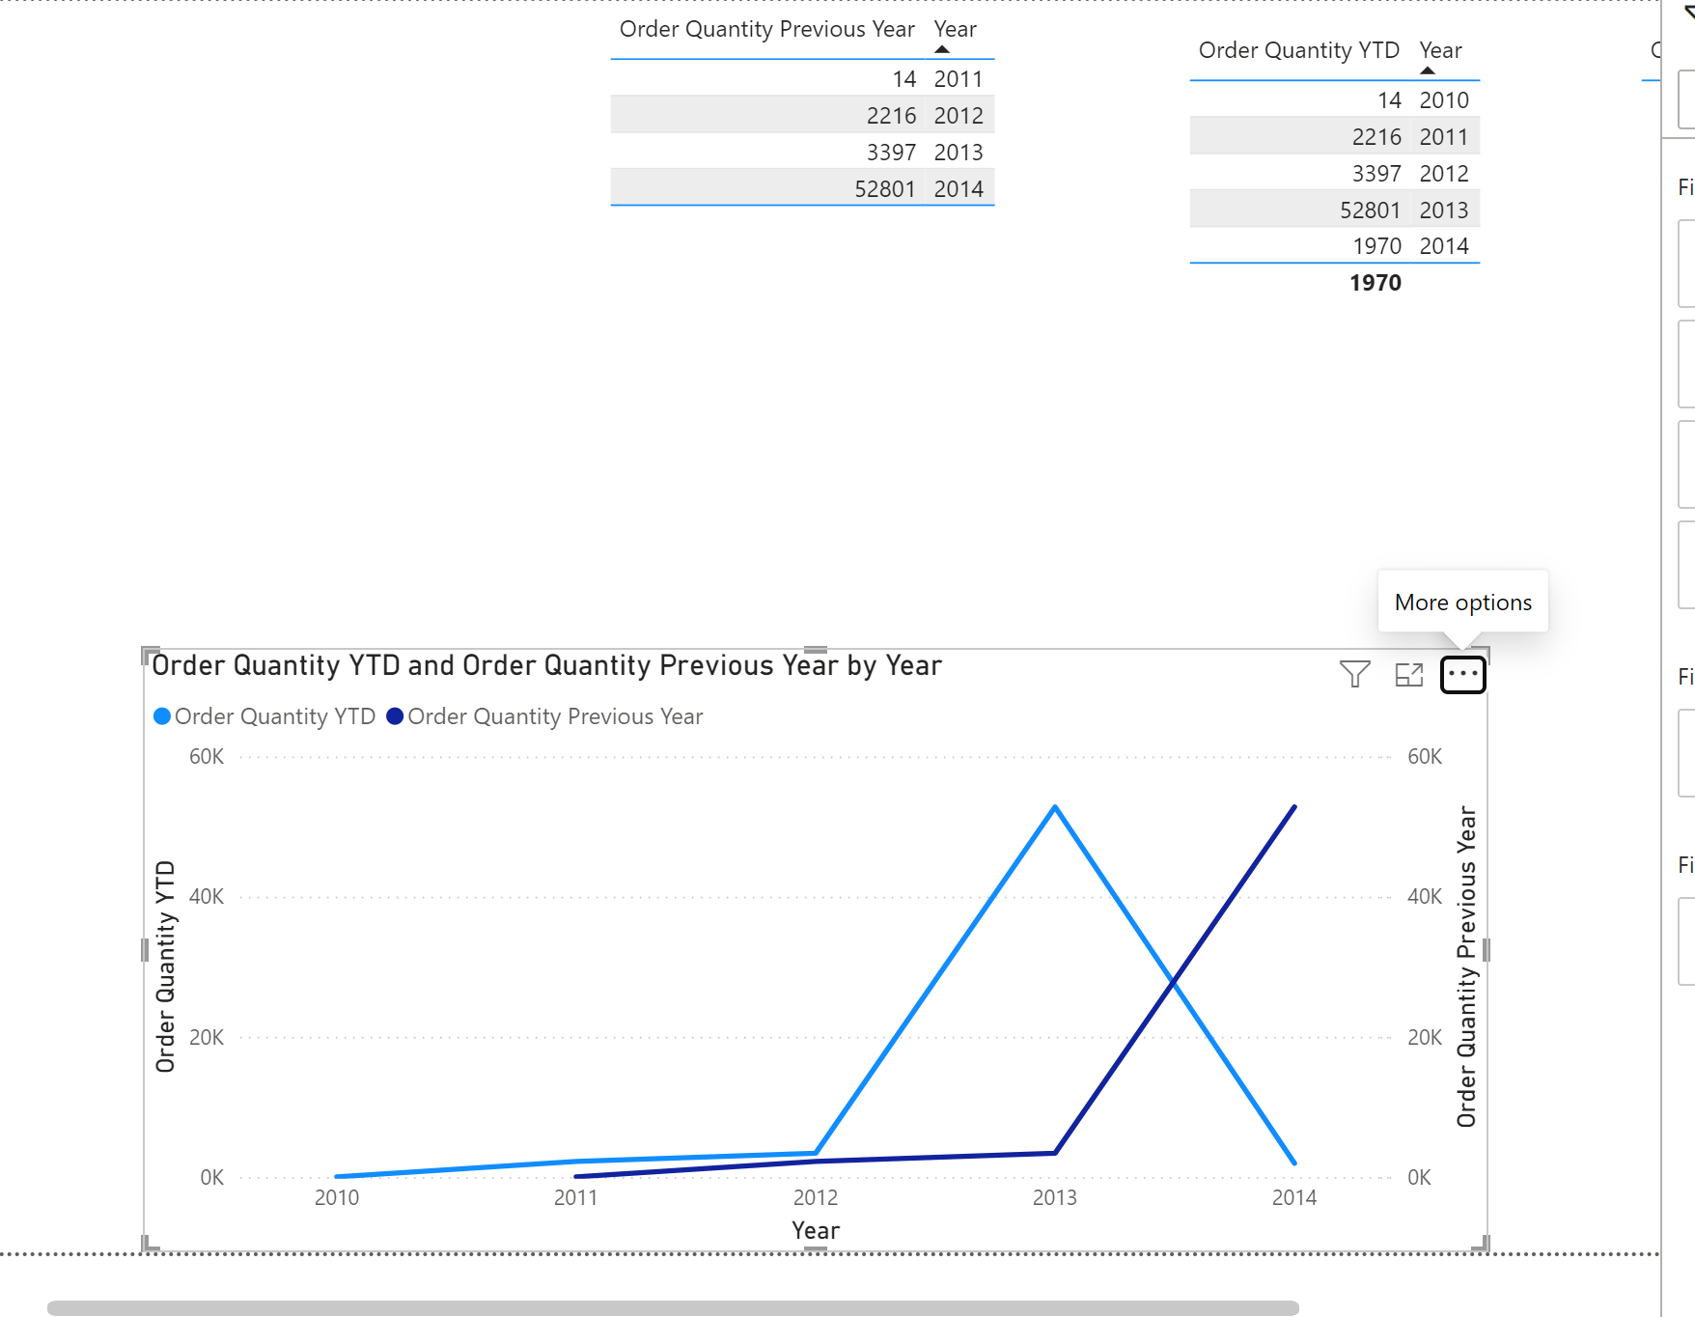

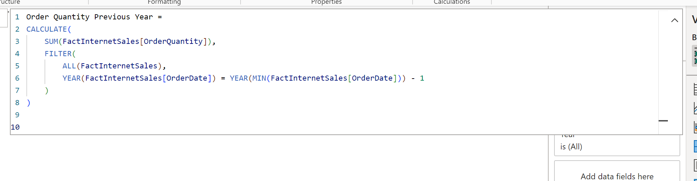

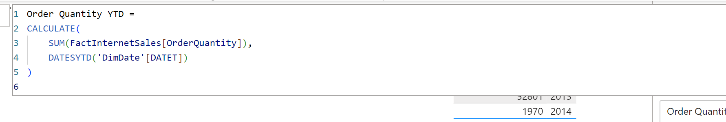

**2.** 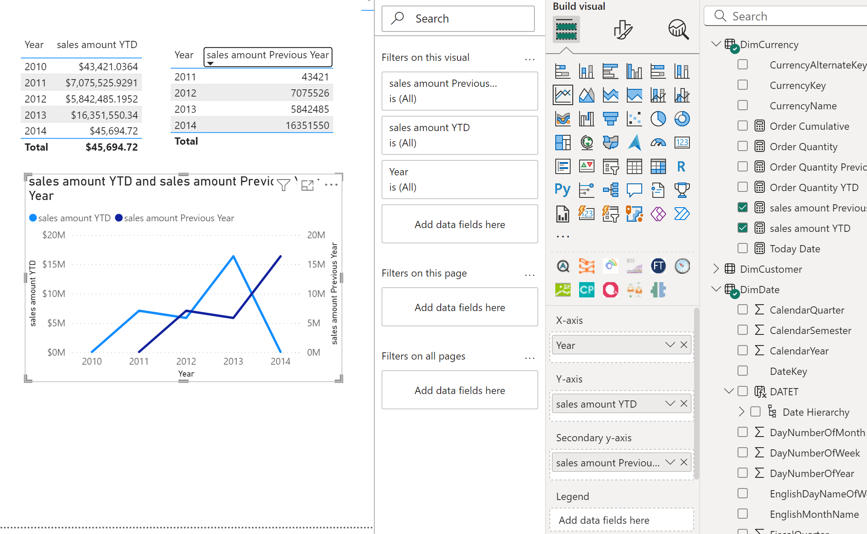

**Same for sales**

**3.**

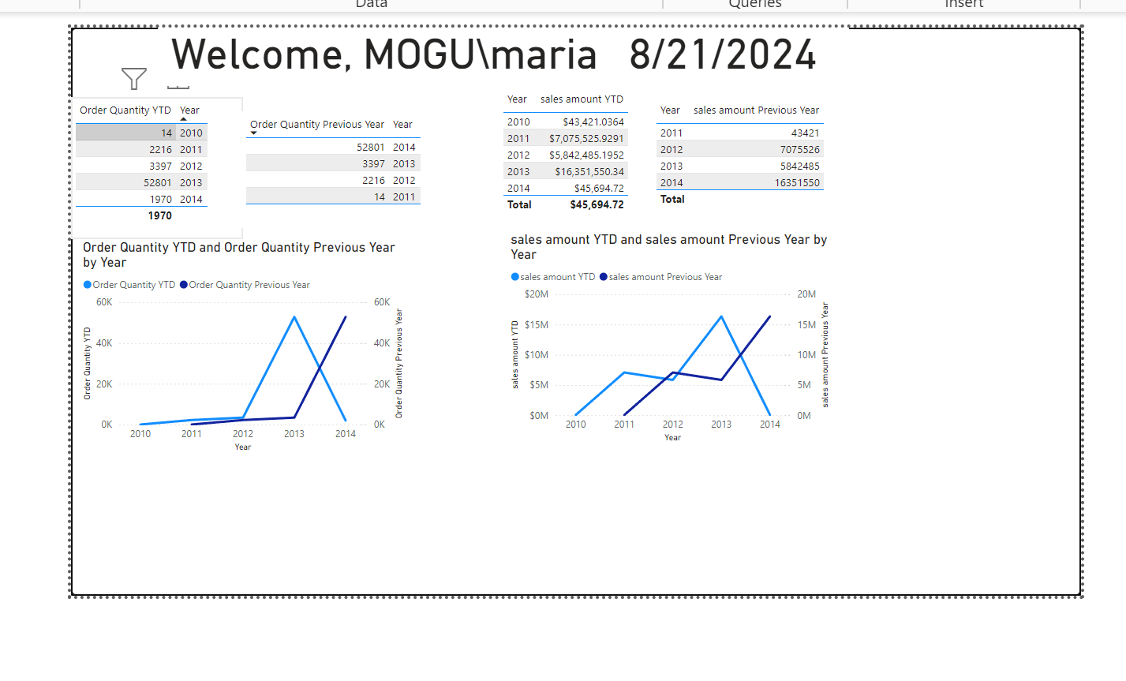

**4.**

**Calculating percent**

**5.** 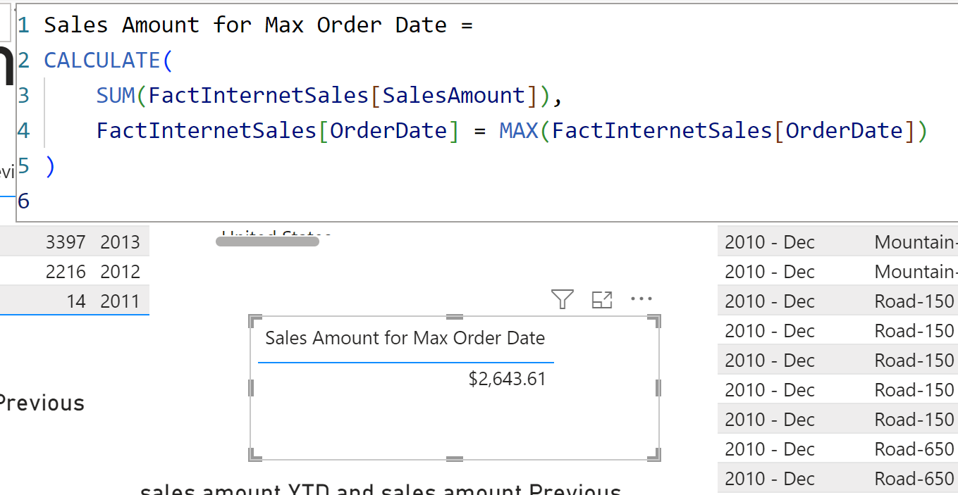

**I chose this method because CALCULATE allows me to adjust the filter context by applying a specific condition. In this case, it filters the data to only include rows where the OrderDate equals the maximum OrderDate in the dataset.**

**6.** 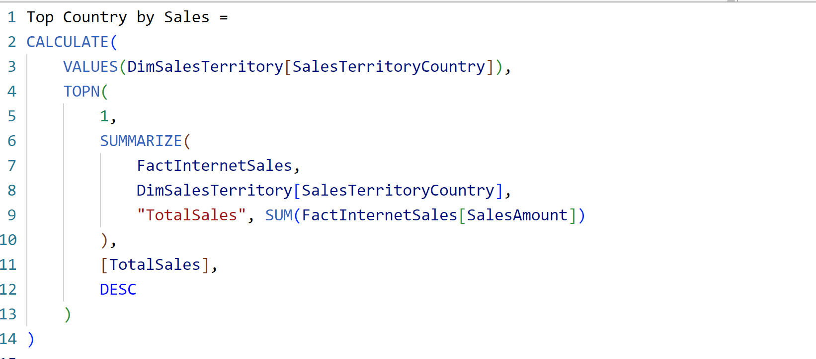

Shows us

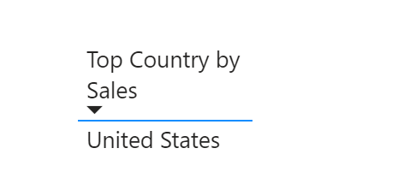

**This method uses TOPN combined with SUMMARIZE to rank the countries by their total sales. TOPN is used to select the top country by sales amount, and CALCULATE changes the context to return the value for that country.**

**7.** 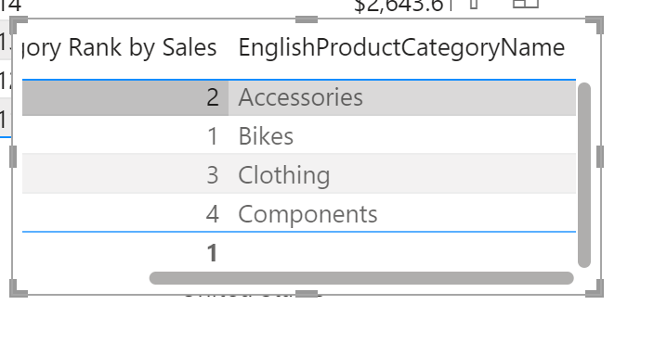

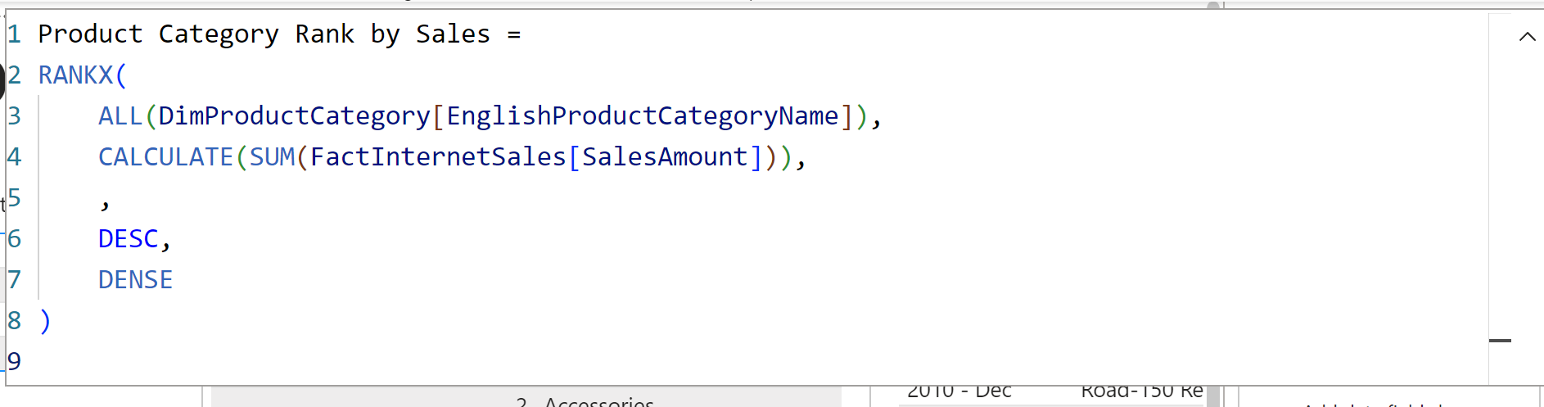

**RANKX is used to rank each product category by its total sales amount. The ALL(DimProductCategory) function removes any filters from the DimProductCategory table so that all product categories are considered when calculating the rank.** **The DENSE option is used for ranking to ensure that categories with the same sales amount receive the same rank, without skipping numbers in the rank order.**