American University of Armenia
CS 108 Statistics, Fall 2026
Project 1: Descriptive Statistics and Exploratory Data Analysis
Confirmed Exoplanets in the NASA Exoplanet Archive
Group members: [names]
Submission deadline: October 10, 2026

1. Dataset
Source. The data come from the NASA Exoplanet Archive, Planetary Systems (PS) table (https://exoplanetarchive.ipac.caltech.edu/), which collects published parameters of confirmed planets outside the Solar System.
Observation and population. One row of the raw table is one published parameter set for one planet; the same planet can appear in many rows when different papers report different values. After keeping only the default parameter set of each planet (Section 2), one observation is one confirmed exoplanet. The data therefore describe the population of discovered planets, which is shaped by what current instruments can detect.
Size. The raw file has 40,155 rows and 92 columns; the analysis uses 6,366 planets. The variables used are listed below.
Table 1. Variables used in the analysis
Variable | Meaning (unit) | Type
pl_rade | Planet radius (Earth radii) | Numerical
pl_bmasse | Planet mass or minimum mass (Earth masses) | Numerical
pl_orbper | Orbital period (days) | Numerical
pl_orbsmax | Semi-major axis, distance from the star (AU) | Numerical
pl_eqt | Equilibrium temperature (K) | Numerical
st_mass | Host-star mass (solar masses) | Numerical
discoverymethod | Detection technique (11 categories) | Categorical
sy_snum | Number of stars in the system (grouped: single, binary, 3+) | Categorical
disc_year | Discovery year (grouped in four periods) | Categorical
ttv_flag | Transit timing variations detected (Yes/No) | Categorical

2. Data Preparation
The data were imported in R with the structure checked by str(). Numerical variables were stored as numbers; discovery method and multiplicity were read as text or integers and converted to factors. Missing values differ strongly by variable: radius 31.1%, orbital period 8.5%, semi-major axis 44.2%, and planet mass 81.1% (mass is rarely available for transit planets). Every analysis therefore uses the available cases for the variables involved, and the sample size is reported each time. No zero or negative values occur in any physical variable.
Modifications (none were silent).
- Duplicates removed: only rows with default_flag = 1 were kept (40,155 to 6,366 rows), so each planet counts once. Keeping all rows would give planets with many papers a larger weight.
- Categories combined: the four most frequent discovery methods are kept and the remaining seven are merged into "Other" (72 planets). "Other" mixes several techniques and is not one method. Systems with three or more stars were merged because they are rare (75 planets).
- New variables: discovery year was cut into four periods (before 2010, 2010-2014, 2015-2019, 2020 onward); ttv_flag was labelled No/Yes. No outlier was removed.

3. Categorical Variables
The distribution of discovery method is very unbalanced: Transit finds 73.96% of the planets, Radial Velocity 18.85%, Microlensing 4.54% and Imaging 1.52%; the other seven methods together contribute 1.13% (six of them have fewer than 30 planets each), so their summaries would be unstable. Most planets orbit single stars (90.94%; binary 7.89%, three or more stars 1.18%). Discoveries are concentrated in recent years: 93.64% were made after 2010 (2010-2014: 21.65%, 2015-2019: 36.33%, 2020 onward: 35.66%). Only 7.76% of planets show transit timing variations.
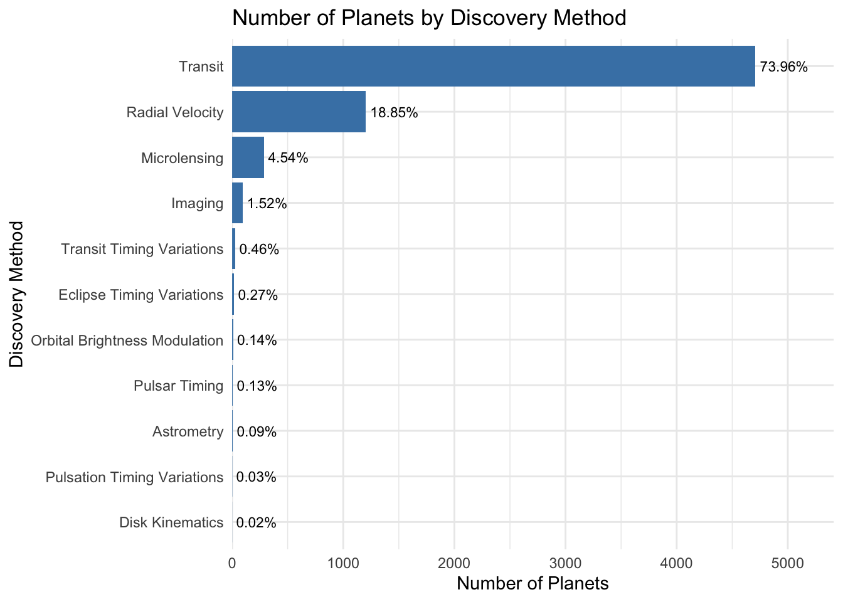 | 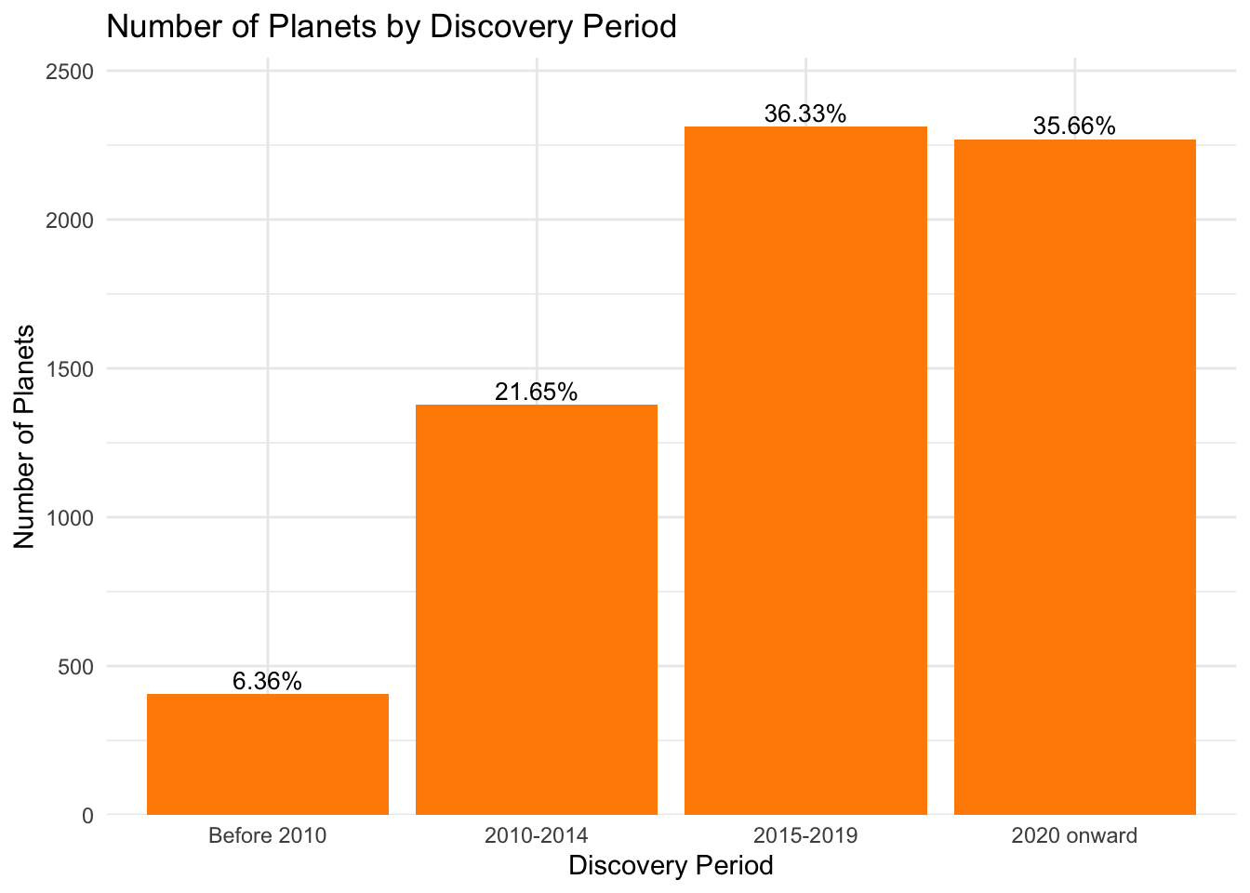
Figure 1. Planets by discovery method (left) and by discovery period (right).

3.1 Association between categorical variables
Discovery method and stellar multiplicity. Single-star hosts dominate every method, but the share of binary hosts differs: 3.8% for Microlensing, 6.3% for Transit, 13.2% for Radial Velocity, 16.5% for Imaging and 27.8% for "Other". The distribution of multiplicity therefore depends on the method. This is probably due to how surveys select their targets, not an effect of one variable on the other.
Discovery method and discovery period. The method mix changed strongly over time. Before 2010 Radial Velocity found 77.0% of the planets and Transit 14.8%; in 2010-2014 Transit rose to 80.5% and in 2015-2019 to 85.1% (the Kepler era). From 2020 onward Transit falls to 69.2% while Microlensing grows to 8.8%. So the distribution of one variable clearly changes with the categories of the other.
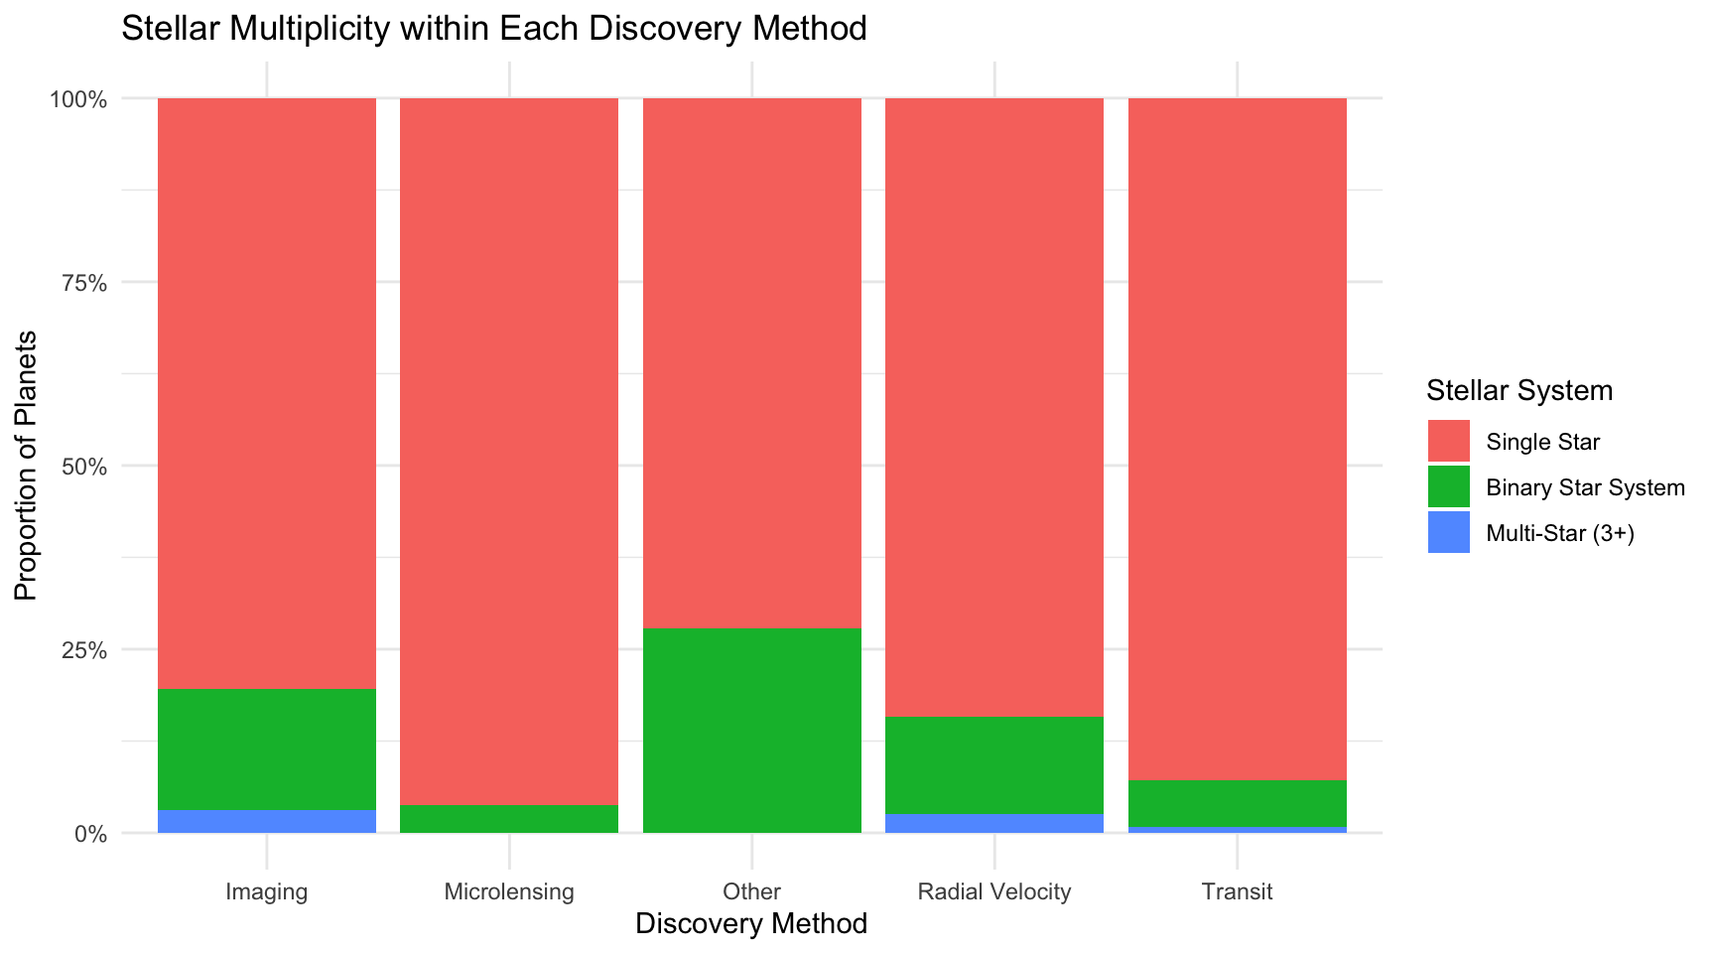 | 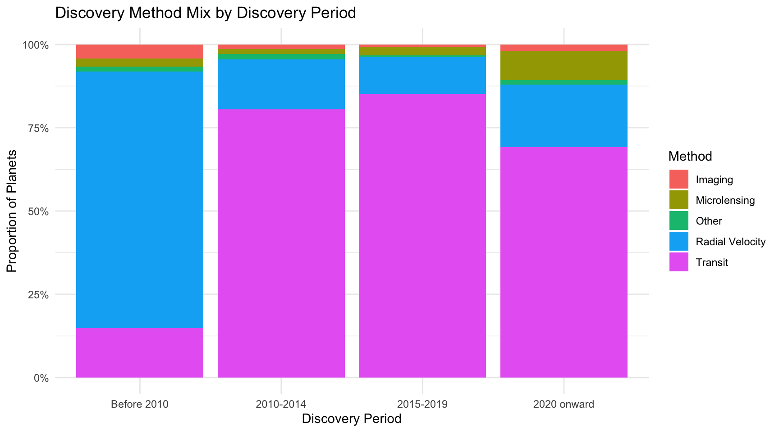
Figure 2. Stellar multiplicity within each method (left); method mix within each discovery period (right).

4. Numerical Variables
Table 2. Descriptive statistics of the key numerical variables (outliers: boxplot rule)
Variable | n | Mean | Median | IQR | SD | Max | Outliers
Radius (R_Earth) | 4,741 | 4.50 | 2.47 | 2.55 | 4.94 | 87.2 | 906 (19.1%)
Mass (M_Earth) | 3,158 | 766.4 | 171.2 | 683.9 | 1,495 | 9,535 | 422 (13.4%)
Period (days) | 5,994 | 4,337.6 | 10.78 | 34.23 | 160,700 | 8,040,000 | 1,041 (17.4%)
Semi-major axis (AU) | 3,926 | 20.11 | 0.12 | 0.78 | 405.0 | 19,000 | 606 (15.4%)
Equil. temp. (K) | 1,753 | 1,001 | 900 | 800 | 540 | 3,921 | 12 (0.7%)

Radius, mass, period and semi-major axis are strongly right-skewed: the mean is far above the median (for the period it is about 400 times larger), so the median and IQR describe a typical planet better than the mean and SD. A typical planet is small (2.5 Earth radii), close to its star (0.12 AU, closer than Mercury) and orbits in about 11 days. These variables span several orders of magnitude, so log scales were used. On the log scale radius and mass are bimodal: radius has peaks near 2-3 and 12 Earth radii, mass near 8 and 300 Earth masses, which suggests two populations (small planets and gas giants). The coefficient of variation is very high (above 1 for all variables except temperature, 0.54), confirming the large variability. Equilibrium temperature is the exception: it has a single peak, a mild right skew (skewness 0.82) and moderate spread.
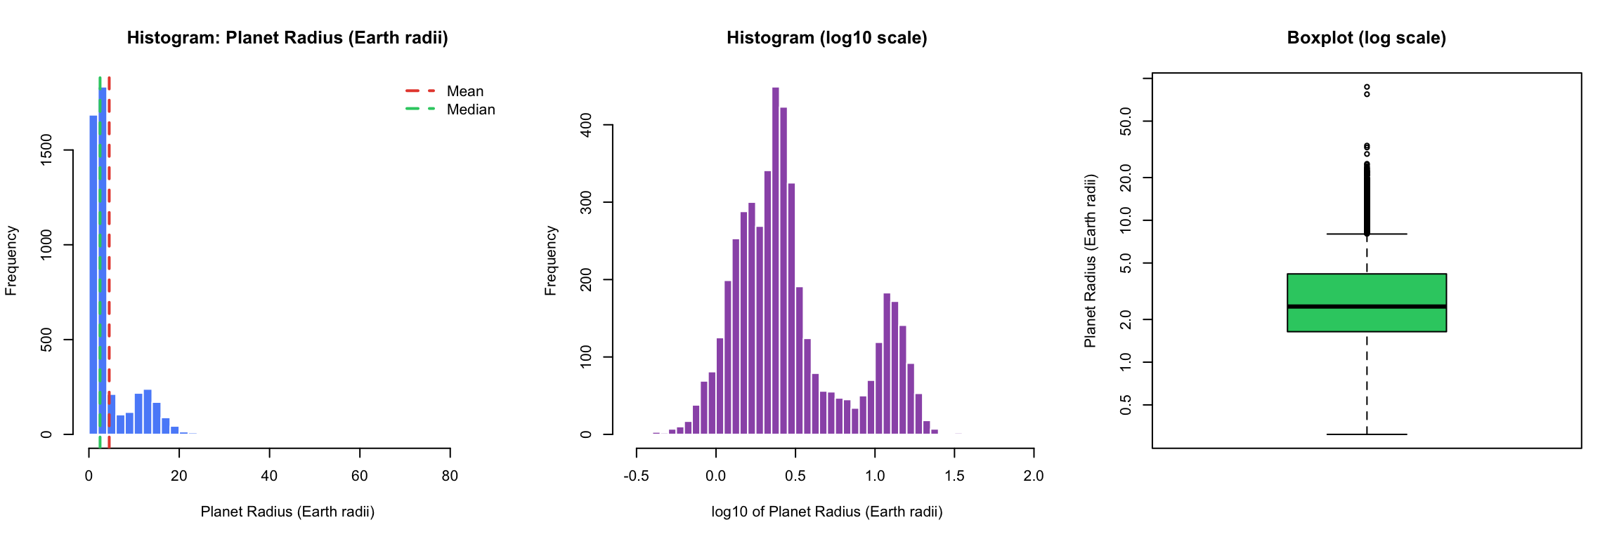
Figure 3. Planet radius: raw histogram (mean in red, median in green), log10 histogram and log-scale boxplot.

5. Numerical Variables by Categories
Planet radius by discovery method. The median radius is 2.45 Earth radii for Transit (n = 4,675), 2.59 for Radial Velocity (n = 30), 15.2 for Imaging (n = 30) and 6.31 for "Other" (n = 6). Imaging detects large, young, wide-orbit planets, so its median is about six times higher and its spread is larger (SD 17.5 against 4.6 for Transit). Transit has many small planets and a long upper tail with many boxplot outliers. The Radial Velocity and "Other" groups are very small, so the differences involving them are tentative.
Orbital period by stellar multiplicity. Medians are close (10.6 days for single stars, 12.8 for binary, 13.7 for 3+), but the spread differs a lot: IQR is 30.8 days for single stars, 213 for binary and 252 for 3+ systems. Planets in multi-star systems are therefore more spread toward long periods. All groups are strongly right-skewed (the means are much larger than the medians, for example 16,857 against 12.8 days for binary systems), and the median is the proper measure of location.
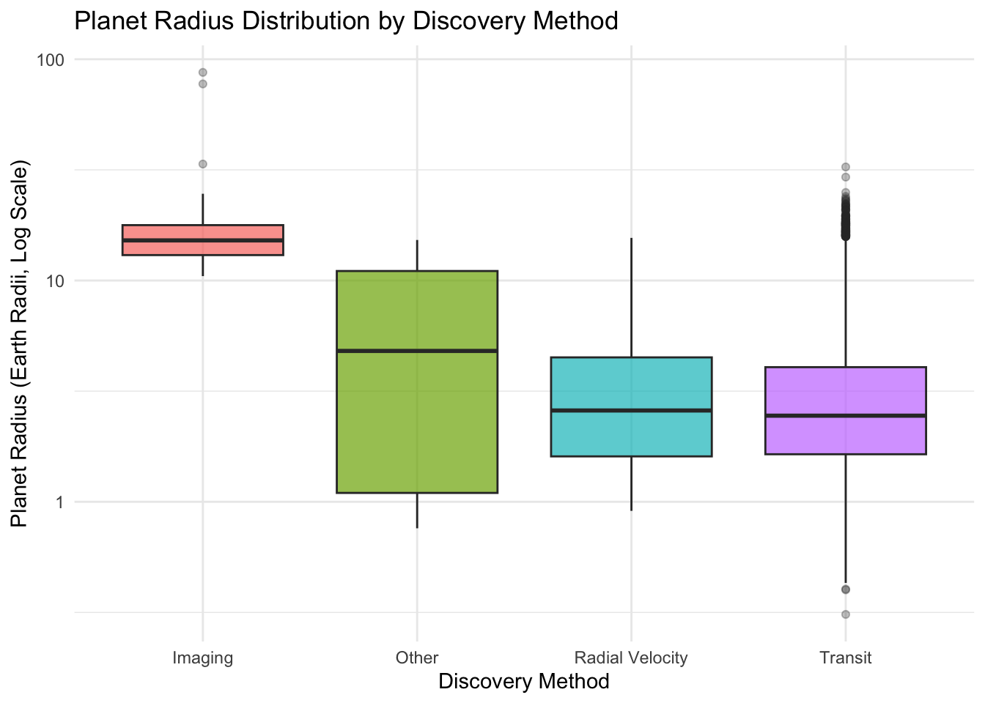 | 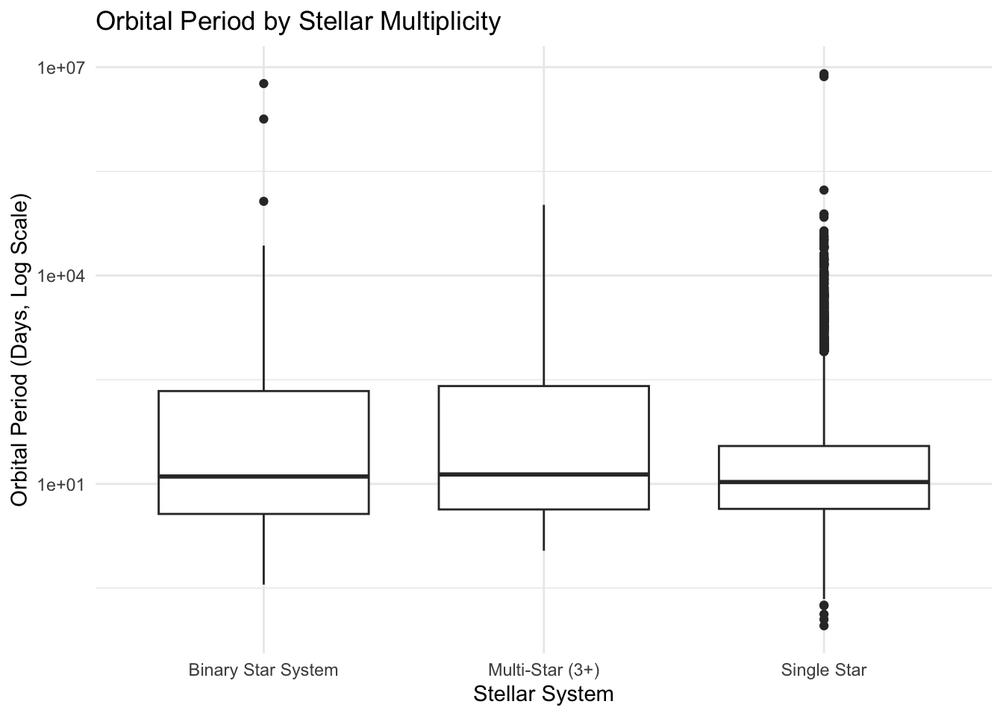
Figure 4. Radius by discovery method (left) and orbital period by stellar multiplicity (right), log scales.

6. Relationships Between Numerical Variables
Semi-major axis and orbital period. The relationship is positive and, on log-log scales, almost perfectly linear (a power law, as expected from Kepler's third law). On the raw scale the Pearson correlation is only 0.69, because a few planets with huge orbits dominate the calculation; this shows how strongly extreme values can distort the correlation.
Mass and radius. The relationship is positive but weaker (raw correlation 0.36) and not linear on the log-log scale: the spread changes along the range, and small and giant planets follow different patterns. Splitting by discovery method, the positive trend stays visible, but the methods occupy different areas of the plot (Radial Velocity mostly at high masses, Transit at smaller planets), and the fitted lines differ. The method is associated with the observed relationship, but this is an effect of selection and not a causal effect.
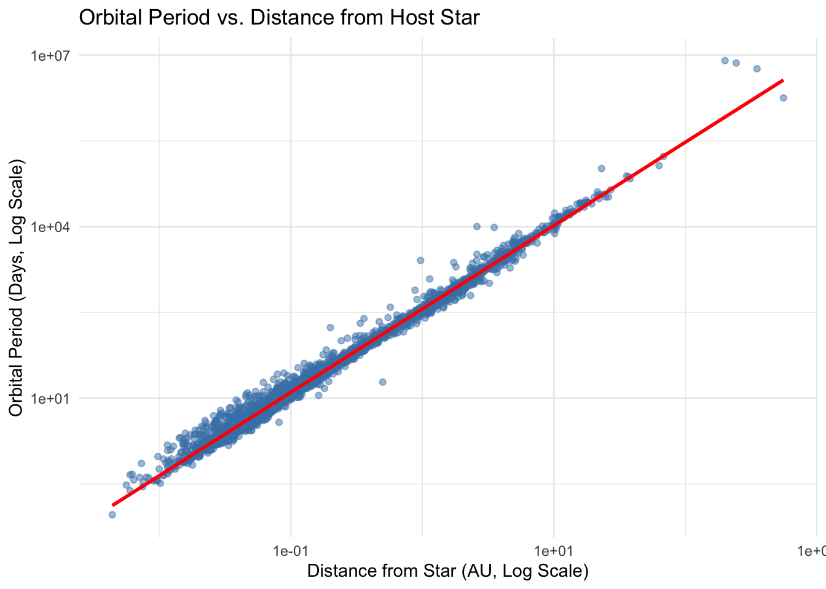 | 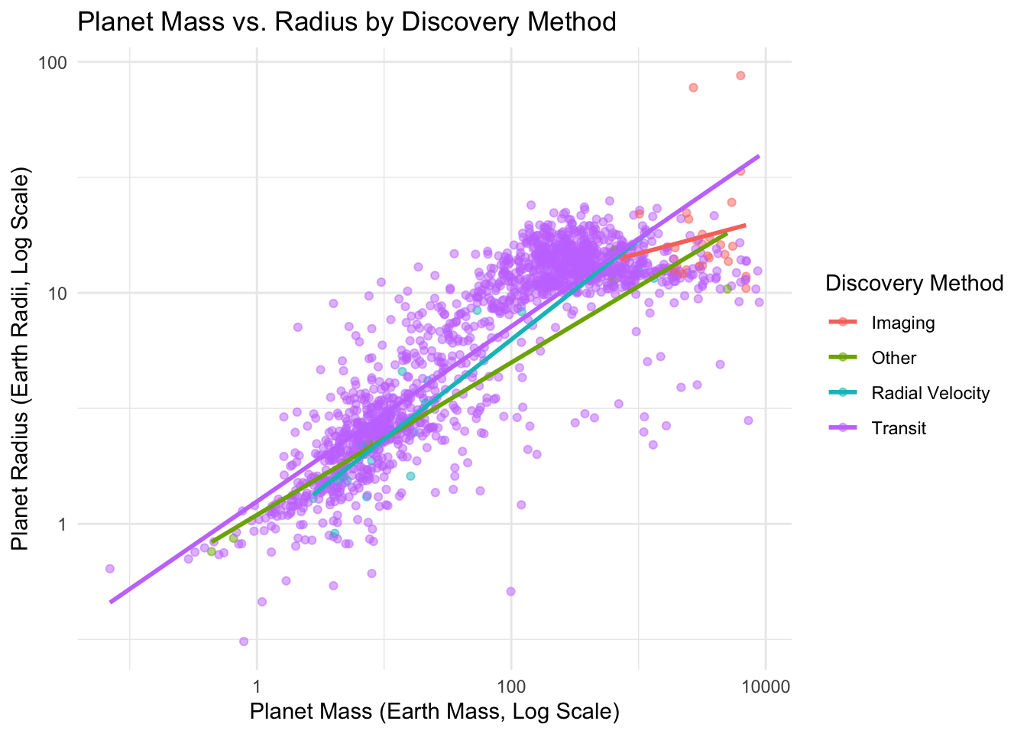
Figure 5. Period vs. semi-major axis (left); mass vs. radius by discovery method (right), log-log scales.

7. Distributional Analysis and QQ Plots
We study the equilibrium temperature (n = 1,753) because it is the least skewed variable and the Normal distribution is a natural candidate. The mean (1,001 K) is above the median (900 K), and the histogram has a long upper tail. In the Normal QQ plot the points follow the line in the middle but leave it systematically in the tails, mainly in the upper one. The Normal distribution is therefore only a rough approximation in the center, and not a reasonable model overall. The extreme hot planets are physically plausible (ultra-hot planets) and are not treated as errors.
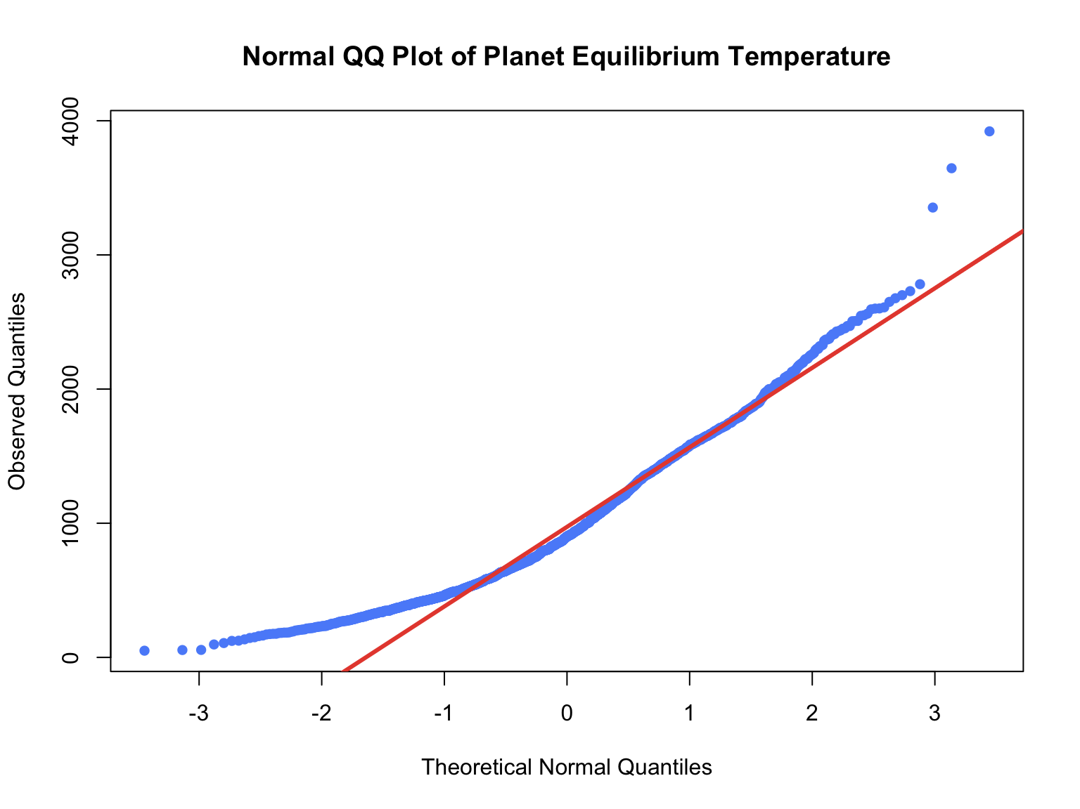 | 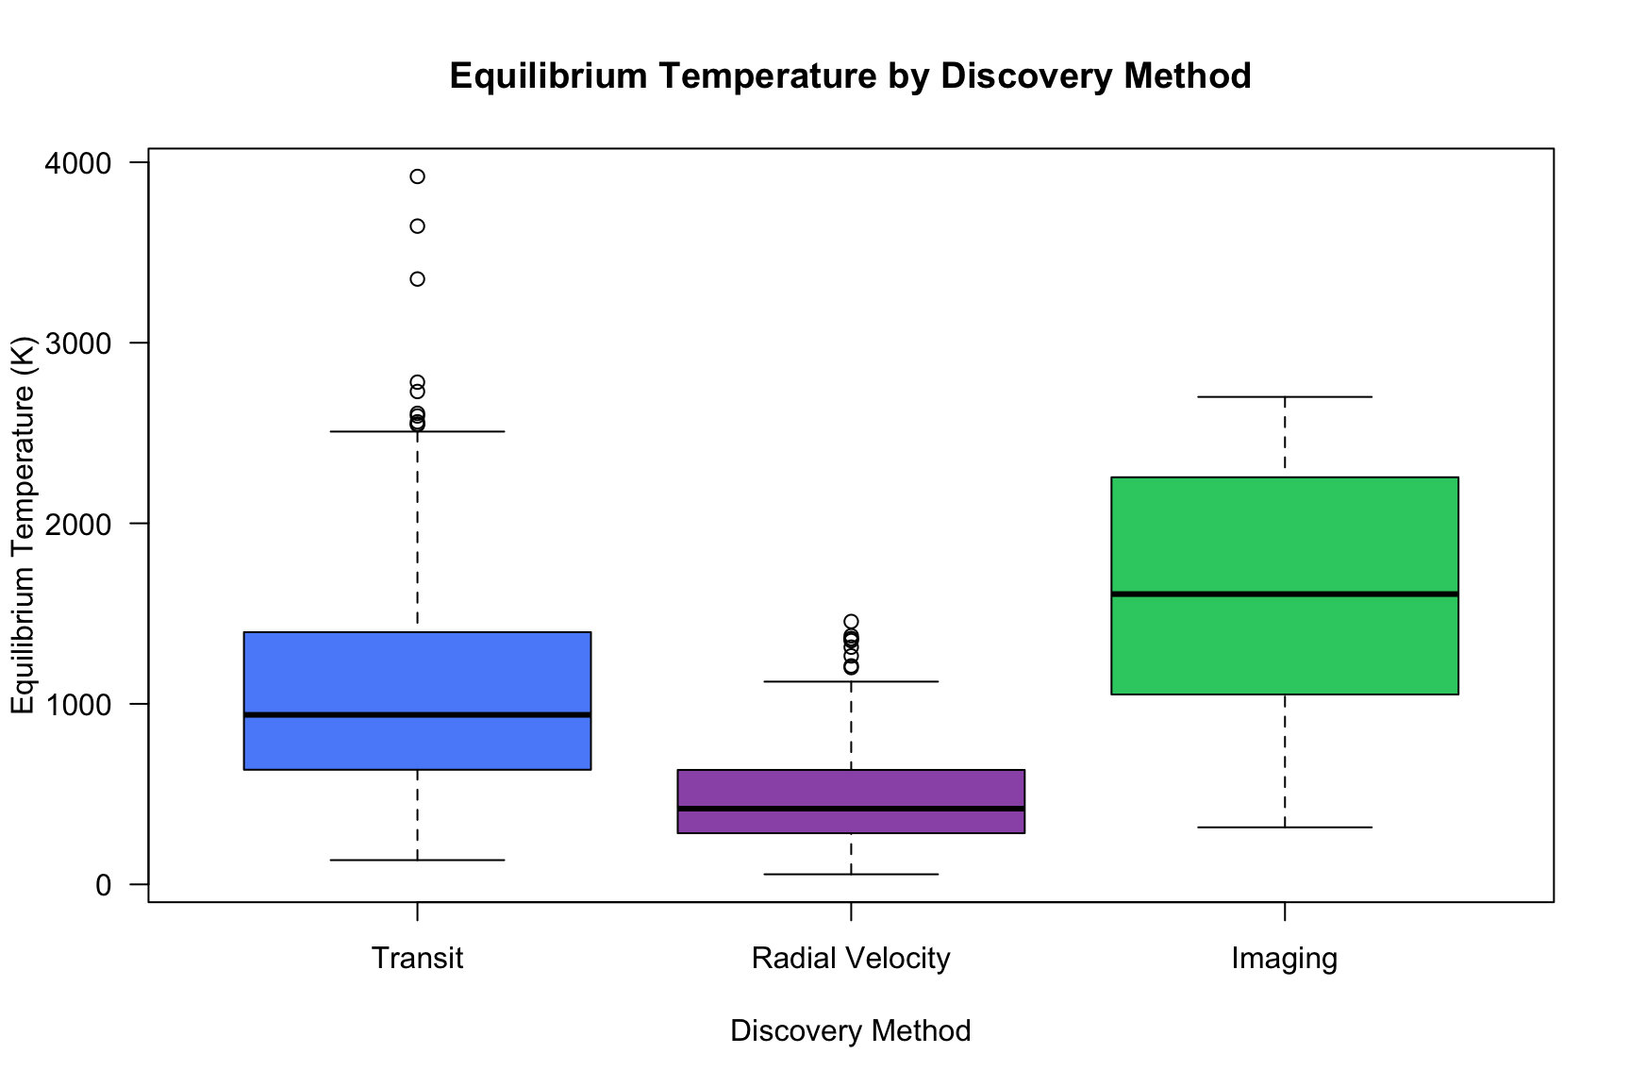
Figure 6. Normal QQ plot of equilibrium temperature (left); temperature by discovery method (right).
Changes across discovery methods. The distribution is not the same for the three main methods (Transit n = 1,536; Radial Velocity n = 152; Imaging n = 52). The median is 939 K for Transit, 420 K for Radial Velocity and 1,608 K for Imaging; the IQR is 762, 347 and 1,195 K. Imaging has the highest location and the largest spread and is nearly symmetric (its QQ plot is close to linear in the center), while Transit and Radial Velocity are right-skewed with longer upper tails; Transit has the heaviest tail. The differences in location and spread are substantial, not minor. Imaging (small n) should be read with caution, and the results show association only.
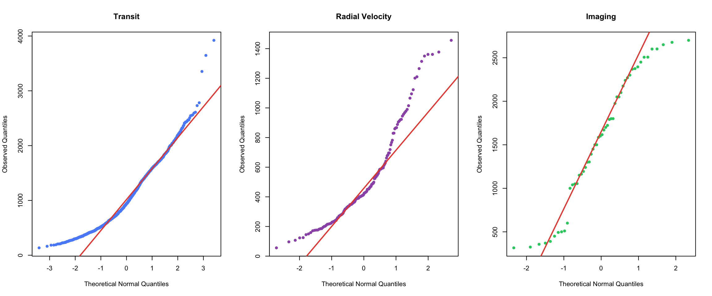
Figure 7. Normal QQ plots of equilibrium temperature for Transit, Radial Velocity and Imaging.

8. Integrated Exploratory Data Analysis
Three questions arising from the previous sections were investigated using several variables simultaneously (code in the R Markdown file, Sections 8.1-8.3).
Question 1. Has the kind of planet discovered changed over time, and does this depend on the method? Variables: orbital period, discovery period and method (and radius for Transit planets). Method: median and IQR of the period for every period-by-method group (only groups with at least 10 planets are plotted), line plot of medians and faceted boxplots on a log scale. Result: [insert medians by period and method from the output, and the Transit radius medians by period]. Interpretation: because the method mix changes with time (Section 3.1), a change in the "typical discovered planet" mixes a change within each method with a change in which method dominates; comparing within methods separates the two. What it does not tell: these samples are detection-biased, so the trends reflect instruments and missions, not how common each type of planet is.
Question 2. Is the period-distance relationship explained by the host-star mass, and does it differ by stellar multiplicity? Variables: period, semi-major axis, stellar mass, stellar multiplicity. Method: log-log scatterplot coloured by stellar mass, slope and correlation by multiplicity group, and the log-ratio of the observed period to the period predicted by Kepler's third law, P = 365.25 sqrt(a^3 / M) days. A slope near 1.5 and a log-ratio near 0 mean agreement with the law. Result: [insert pooled slope, slopes by group, share of planets within a factor of 1.3]. What it does not tell: points far from 0 may be errors or inconsistent parameters, the 3+ group is small, and some semi-major axes are computed from the period, which makes the agreement partly circular.
Question 3. Does the equilibrium temperature fall with distance in the same way for small (< 4 R_Earth), intermediate (4-10) and giant (> 10) planets? Physically temperature depends on the star and the distance, not on the planet size, so we expect similar behaviour (log-log slope about -0.5). Method: scatterplot by size class with fitted lines, slope and correlation per class. Result: [insert slopes and correlations by size class, and host-star temperatures by class]. What it does not tell: equilibrium temperature is a calculated quantity, so part of the relationship is built into its definition, and only planets with both radius and temperature are included, which are mostly close-in transit planets.

9. Outliers and Unusual Observations
Outliers were identified with the boxplot rule (below Q1 - 1.5 IQR or above Q3 + 1.5 IQR). On the raw scale the rule flags 19.1% of the radii (above about 8 REarth), 13.4% of the masses (above about 1,700 MEarth), 17.4% of the periods (above about 90 days) and 15.4% of the semi-major axes (above about 2 AU), always on the upper side, but only 0.7% of the temperatures. These shares are high because the distributions are skewed: the rule expects a roughly symmetric shape and treats the long right tail as outliers, although much of it is a real population (the gas giants).
Are they errors? We checked extreme values against physical limits. The largest radius (87.2 Earth radii, about 7.8 Jupiter radii) and the largest mass (9,535 Earth masses, about 30 Jupiter masses, near the planet/brown-dwarf boundary) are unusual but possible for directly imaged or very massive objects, and many masses are only lower limits (M sin i). The period maximum (8,040,000 days, about 22,000 years) and the semi-major axis maximum (19,000 AU) come from wide-orbit planets for which the orbit is poorly constrained, so they are legitimate but highly uncertain. [insert the counts from the R output: planets above 13 Jupiter masses, with period above 10^5 days, with semi-major axis above 1,000 AU, and records inconsistent with Kepler's law by more than a factor of 2].
Influence. The extreme values have a very large influence on the mean, SD and Pearson correlation (for example, the raw period-distance correlation is 0.69, while the relationship is nearly perfect on the log scale), but very little on the median, IQR and rank correlation. [insert the with/without comparison table].
Table 3. Decision on unusual observations
Group of unusual observations | Error? | Decision
Gas giants flagged on the raw scale | No, a real second population | Retain
Mass above 13 Jupiter masses, radius above 2 Jupiter radii | Possible for a few (lower limits, brown dwarfs) | Retain and flag
Very long periods, orbits above 1,000 AU | Uncertain values, but legitimate | Retain and flag; use median, IQR, log scale
Records inconsistent with Kepler's law | Most likely | Retain and flag

Nothing was deleted. None of the observations is physically impossible, and removing them would delete the gas giants and wide-orbit planets and bias every comparison. The influence of outliers is controlled instead by using medians, IQRs, Spearman correlation and log scales.

10. Conclusions
- Dataset. 6,366 confirmed planets, dominated by Transit discoveries (74%), single-star hosts (91%) and recent years (94% after 2010). Missing data are substantial (mass 81%).
- Associations. Method is associated with stellar multiplicity (binary hosts from 4% to 28% depending on the method) and with discovery period (Radial Velocity 77% before 2010, Transit 80-85% in 2010-2019, Microlensing growing after 2020).
- Group differences. Imaging planets are much larger (median radius 15.2 against 2.5 for Transit) and hotter (1,608 K against 939 K); planets in multi-star systems have a much wider spread of orbital periods (IQR 213-252 days against 31).
- Relationships. Period and distance follow a power law (r = 0.69 raw, nearly linear on log scales); mass and radius are positively but non-linearly related (raw r = 0.36) and the pattern differs between methods.
- Distributions. Radius and mass are bimodal (small planets and giants); most variables are strongly right-skewed. Equilibrium temperature is only roughly Normal in the center, with a heavy upper tail, and its distribution changes substantially between methods.
- Surprises. About 15-19% of observations are boxplot outliers, but most belong to real populations, not errors; the raw correlation is very sensitive to a handful of extreme orbits.
- Limitations. The sample describes discovered planets and is shaped by detection bias; many variables are missing, so each analysis uses a different subset; some groups are very small (Imaging, Radial Velocity and "Other" for radius); some masses are lower limits. All findings are associations and do not establish causation.

References
NASA Exoplanet Archive, Planetary Systems table. NASA Exoplanet Science Institute, Caltech/IPAC. https://exoplanetarchive.ipac.caltech.edu/ (accessed 2026).
R Core Team. R: A Language and Environment for Statistical Computing. R Foundation for Statistical Computing. https://www.R-project.org/
Wickham, H. ggplot2: Elegant Graphics for Data Analysis. Springer, 2016.

