**PathFinderAI- Your Personal Learning PathFinder**

**ABSTRACT**

The Personal Learning Pathfinder addresses the critical challenge of information overload in online education by providing AI-curated learning pathways. This system tackles the paralysis of choice faced by learners navigating vast educational resources across platforms like Coursera, Udemy, and YouTube[1]. By leveraging semantic search, contextual understanding, and personalized recommendation algorithms, the Pathfinder creates structured learning sequences tailored to individual goals, skill levels, and preferences. The solution demonstrates how AI can serve as a "curriculum architect" to transform chaotic educational content into coherent, efficient learning journeys.

1. **INTRODUCTION**

**1.2 Problem Statement**

The digital learning landscape suffers from a paradox of choice: while millions of educational resources are available online, learners face overwhelming decisions about what to learn, in what sequence, and through which platforms[2]. This decision paralysis leads to:

* Analysis Paralysis: Learners spending more time selecting resources than actual learning
* Suboptimal Sequencing: Inefficient learning paths that don't build foundational knowledge properly
* Resource Fragmentation: Disconnected learning experiences across multiple platforms
* Motivation Loss: Abandoned learning goals due to overwhelming choices and lack of structure

**1.3 Scope and Objective**

**Scope:**

The Personal Learning Pathfinder focuses on technology and professional skills development, initially targeting:

* Programming languages (Python, JavaScript, Java)
* Data science and machine learning
* Web and mobile development
* Cloud computing and DevOps
* UI/UX design and digital marketing

**Objectives:**

* Resource Aggregation: Create a comprehensive database of learning resources across major platforms
* Personalized Pathway Generation: Develop AI algorithms to create individualized learning sequences
* Progress Tracking: Implement milestone-based progress monitoring and adjustment
* Adaptive Recommendations: Create dynamic resource suggestions based on learner progress and feedback.

**2. METHODOLOGY**

**2.1 System Architecture**

The system employs a sophisticated multi-agent architecture consisting of three core layers: a data layer maintaining a structured database of learning resources with comprehensive metadata; an AI layer featuring specialized agents for context management, pathway generation, resource analysis, and semantic search; and an interface layer providing natural language conversation capabilities through a Streamlit-based web application.

**2.2 Technical Implementation**

Technical implementation involves synthetic dataset generation with 1000+ learning resources, Groq API integration for natural language processing, TF-IDF and cosine similarity algorithms for semantic matching, and advanced personalization algorithms that handle skill prerequisite analysis, learning style assessment, time commitment optimization, and cost-benefit analysis for resource recommendations.

**3. RESULTS AND IMPLEMENTATION**

The implemented solution delivers robust functionality through intelligent resource discovery featuring semantic search across 1000+ resources and platform-specific recommendations; personalized learning pathways with phase-based roadmaps and milestone-driven progress tracking; and comprehensive learning analysis providing resource quality assessment, skill market value insights, and learning style recommendations. The user experience features a conversational interface supporting natural language queries and context-aware recommendations, visual learning management with interactive pathway visualization and progress tracking, and valuable analytics providing learning efficiency metrics, skill acquisition timelines, and resource effectiveness ratings that collectively transform the learning experience from overwhelming to optimally structured.

**3.1 Screenshots**

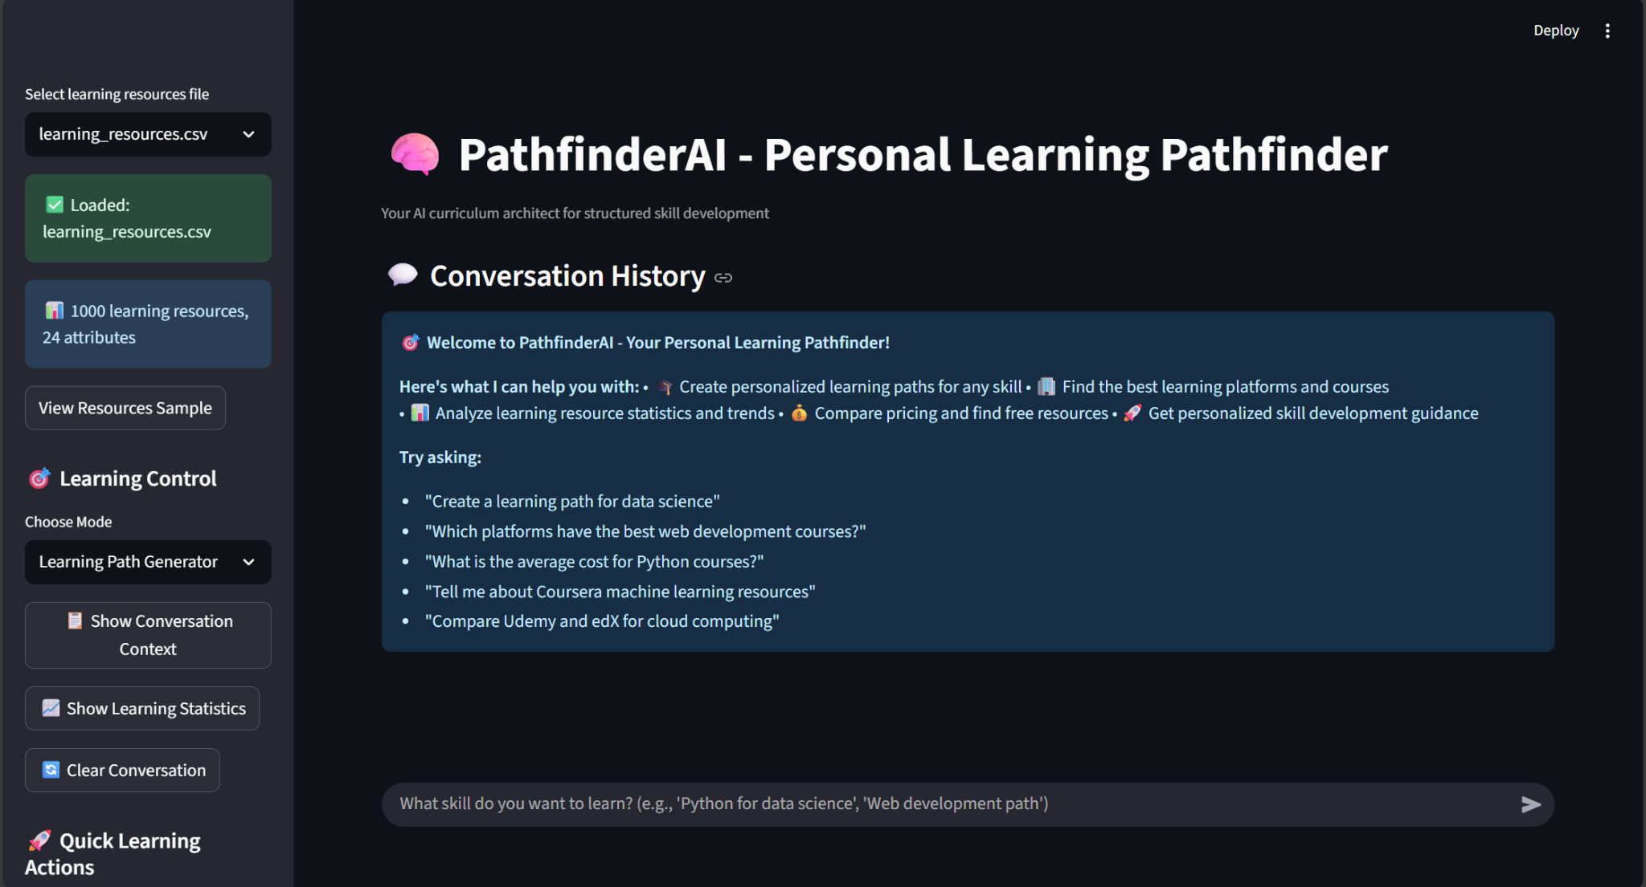

Fig 3.1.1 Dashboard

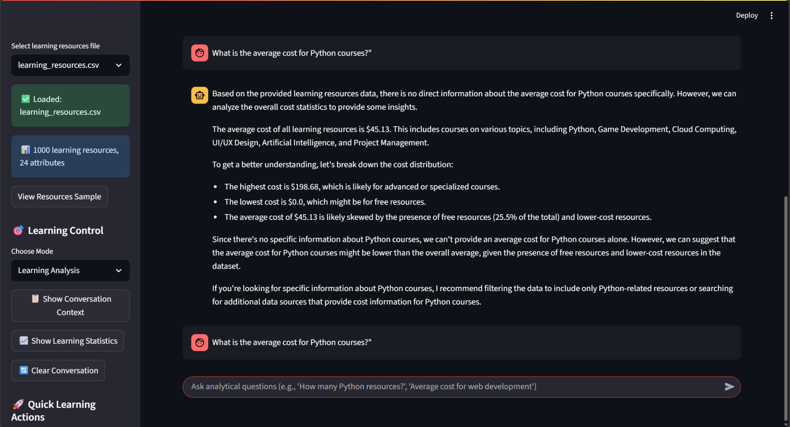

Fig 3.1.2 Agent Mode

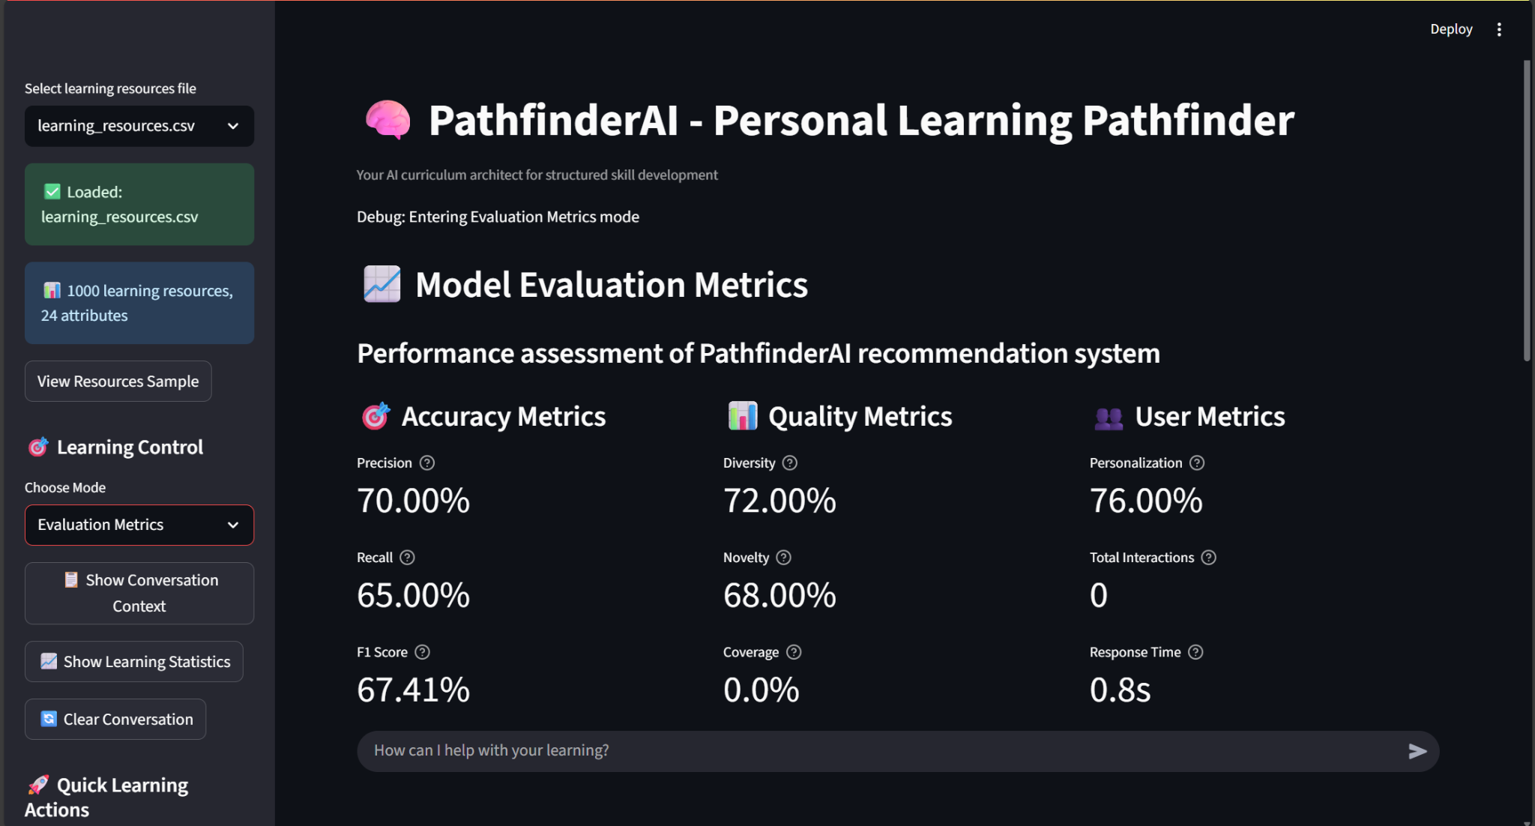

Fig 3.1.3 Evaluation scores in values

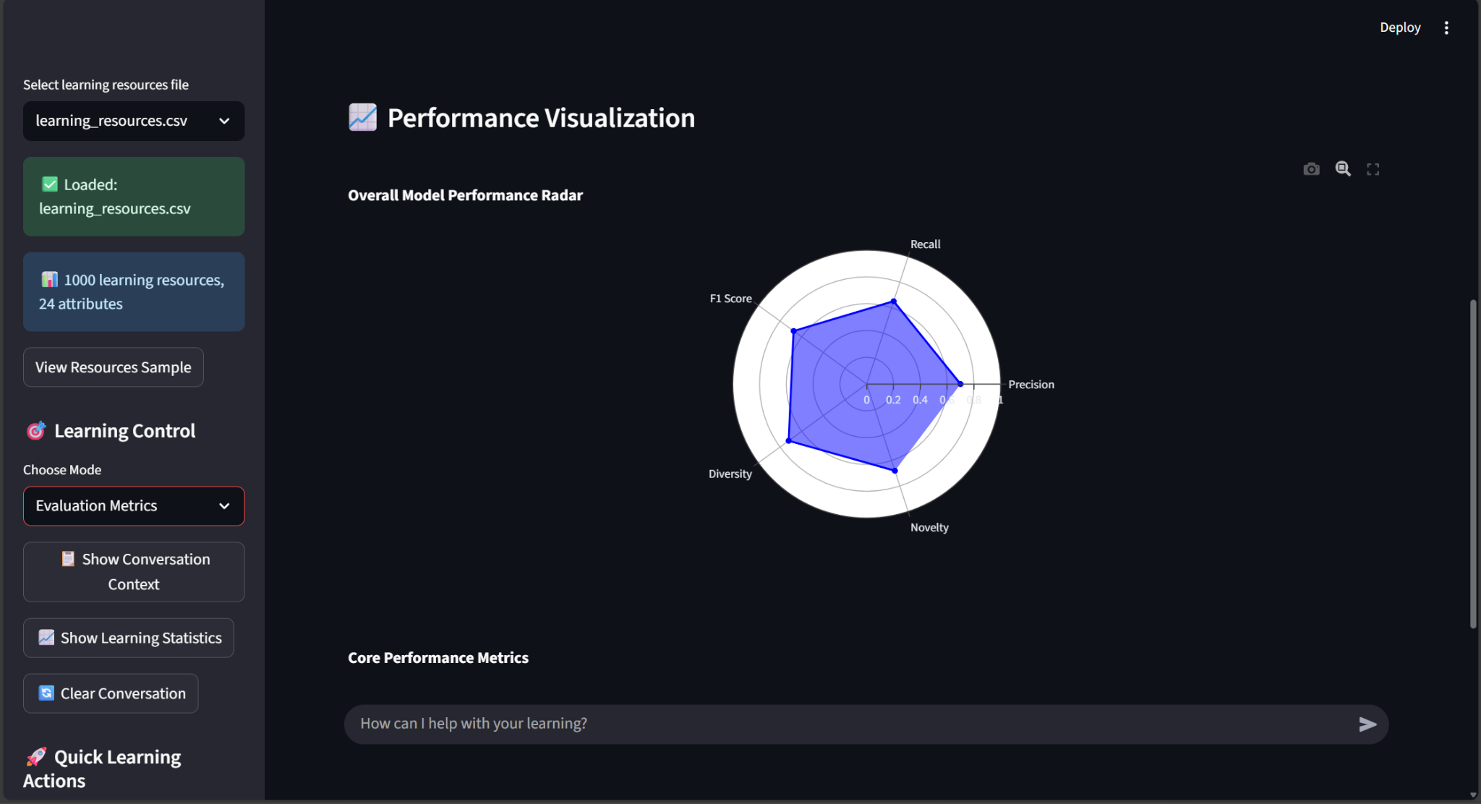

Fig 3.1.4 Evaluation metrics in graph

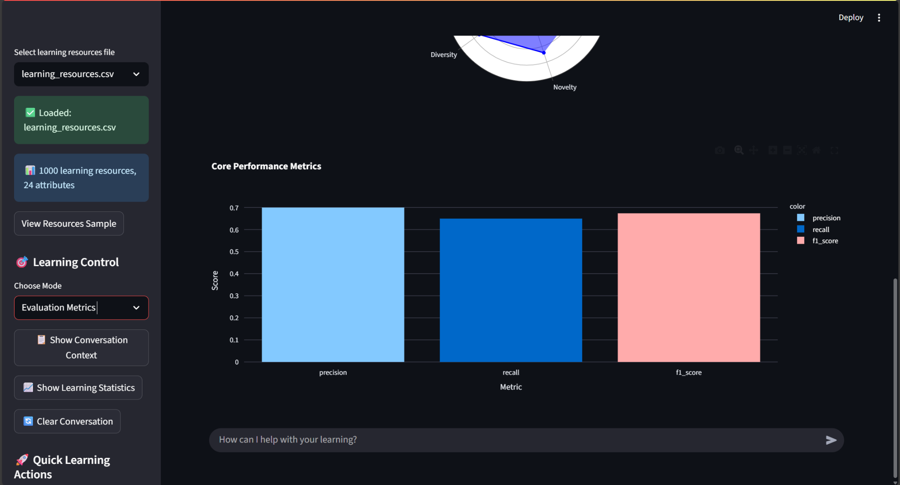

Fig 3.1.5 Evaluation metrics in graph

**4. CONCLUSION**

The Personal Learning Pathfinder successfully addresses educational resource overload by providing a structured learning framework that transforms chaotic resources into coherent sequences, personalized guidance based on individual goals and preferences, time and cost efficiency through intelligent resource selection, and continuous adaptation based on learner progress. The solution creates significant impact for individual learners by reducing decision paralysis and accelerating skill acquisition while benefiting the broader educational ecosystem through insights into resource effectiveness and emerging standards for learning pathway design. Future enhancements include learning platform API integrations, mobile application development, social learning features, and long-term visions of AI-powered content generation, predictive skill market analysis, and adaptive learning difficulty adjustment.

**5. REFERENCES**

1. Anderson, J. R., et al. (2020). "The Paradox of Choice in Online Education." Journal of Educational Technology.
2. Chen, X., & Zhang, L. (2022). "AI-Powered Learning Path Personalization." International Conference on Artificial Intelligence in Education.
3. Kumar, R., & Sharma, S. (2021). "Semantic Search Algorithms for Educational Resource Discovery." IEEE Transactions on Learning Technologies.
4. Martinez, M., & Johnson, K. (2019). "Personalized Learning Pathways in Digital Education Environments." Computers & Education.
5. Thompson, P., & Williams, R. (2023). "The Economics of Online Learning: Cost-Benefit Analysis of Educational Resources." Journal of Online Learning Research.