Software Requirements Specification (SRS)

PESTI – Project
Academic Year 2025/2026
2nd Semester

Skin Lesion Detection and Gamification Web Platform

Prepared by:
Gonçalo Vale
Francisco Silva
Ricardo Torres
Maria Rocha

Project Supervisor:
Patricia Alves

Porto, 25 February 2026

Table of Contents

1. Introduction 3
1.1. Purpose of the Document 3
1.2. Scope of the Product 3
1.3. Definitions, Acronyms and Abbreviations 4
1.4. References 5
2. Overall Description 5
2.1. Product Functions 5
2.2. Actors 5
3. Requirements Specifications 6
3.1. Non-Functional Requirements 6
3.1.1. Module SEC (Security and Data Privacy) 6
3.1.2. Module PERF (Performance and Efficiency) 8
3.1.3. Module USAB (Usability and Accessibility) 10
3.1.4. Module PORT (Portability and Compatibility) 11
3.2. Functional Requirements 12
3.2.1. USERM Module (User Management) 12
3.3. Diagramas de Casos de Uso 16
3.3.1. Visão Geral 16
3.3.2. Módulo X (<<Abreviatura para o nome do módulo>>) 16
4. Protótipo da interface do utilizador 17
4.1. <<Nome da funcionalidade>> (<<MM-UI-X.Y>>) 17

- Introduction

Purpose of the Document

The purpose of this document is to formally specify the functional and non-functional requirements for the development of the Web Platform for Early Skin Lesion Detection and Gamified User Engagement.
This Software Requirements Specification (SRS) defines the system’s expected behaviour, operational constraints, performance criteria, and interaction mechanisms, as identified through initial project discussions with the academic supervisor. It establishes a formal baseline for system development and serves as a reference for the development team, the academic supervisor, and other relevant stakeholders throughout the project lifecycle. The document provides a structured foundation for implementation, validation, testing, and acceptance of the proposed system. It ensures that all requirements are clearly defined, traceable, and aligned with the project objectives.

To ensure clarity, traceability, and alignment with Agile Software Development practices, the project follows the Scrum framework. Requirements are therefore structured using User Stories, organised hierarchically as follows:
- User Story (US) – A concise description of a system requirement written from the end-user’s perspective. Each User Story represents a deliverable increment to be implemented within a Sprint.
- Epic (E) – A high-level requirement that groups multiple related User Stories under a broader functional objective.
- Module – A logical system component that aggregates one or more Epics related to a specific area of functionality.

This structure enables incremental development, facilitates prioritisation, and ensures continuous alignment between technical implementation and user-centred objectives.

Scope of the Product

The proposed product consists of a web-based platform designed to support the early detection of skin lesions through image analysis and the integration of gamification strategies aimed at promoting regular self-examination. The platform will enable users to capture or upload images of skin lesions, which will be processed using an artificial intelligence algorithm developed within the scope of the project, providing a preliminary risk assessment accompanied by clear and accessible explanatory information.
In addition to the analytical component, the system will incorporate gamification mechanisms intended to encourage consistent use and preventive health behaviour, such as progress tracking, consistency indicators, and motivational feedback designed to reinforce regular self-monitoring practices.

The application is intended to operate on mobile devices through a web browser, ensuring accessibility and cross-platform compatibility. Subject to technical feasibility, the system should support offline functionality to enhance user privacy and reduce dependency on continuous internet connectivity.
The platform is designed for use by the public, particularly individuals seeking to monitor skin changes in a preventive and self-assessment context. It is important to emphasise that the system does not provide a medical diagnosis and does not replace professional healthcare consultation. Instead, it functions as a supportive tool intended to raise awareness and encourage timely medical evaluation when necessary.
Where applicable, the system may allow the storage of historical records to enable users to track changes over time. The product is developed within an academic context and may serve as a foundation for future research developments or potential integration with broader healthcare or research initiatives.

Definitions, Acronyms and Abbreviations

AI (Artificial Intelligence) – Computational techniques that enable systems to perform tasks typically requiring human intelligence, such as image analysis and pattern recognition.
SRS (Software Requirements Specification) – A formal document that defines the functional and non-functional requirements of a software system.
US (User Story) – A short description of a system requirement written from the end-user’s perspective.
Epic – A high-level requirement that groups multiple related User Stories under a broader functional objective.
Module – A logical system component that aggregates one or more related Epics.
PWA (Progressive Web Application) – A web application that provides enhanced capabilities such as offline functionality and improved performance on mobile devices.
Skin Lesion – An abnormal growth or appearance on the skin that may require medical evaluation.
Offline Mode – System capability to operate without an active internet connection.
Gamification – The application of game design elements in non-game contexts to increase user engagement and motivation.

References

- Overall Description

Product Functions

The proposed platform serves as a supportive digital tool for skin health monitoring. It enables users to capture or upload images of skin lesions and obtain a preliminary risk assessment generated by an integrated artificial intelligence algorithm.
At a high level, the system provides the following core functions:
- Image Acquisition and Analysis: Allow users to capture or upload images of skin lesions for automated analysis and preliminary risk classification.
- Offline Processing Capability: Support local image processing, where technically feasible, to enhance privacy and reduce reliance on continuous internet connectivity.
- Result Presentation: Display analysis outcomes in a clear, structured, and user-friendly format, including explanatory information to aid interpretation.
- Historical Monitoring: Maintain records of previous images and assessments to support longitudinal tracking of skin changes over time.
- Gamification Mechanisms: Incorporate engagement features such as progress tracking and consistency indicators to encourage regular self-examination behaviour.

Actors

The system requires user authentication to access its functionalities. All actors must be registered and authenticated before interacting with the platform.
The application supports two distinct user roles: System Administrator and User, each with different levels of access privileges and responsibilities within the system. Access rights are granted according to the assigned role, ensuring controlled access to system functionalities and administrative operations.
User | Description
System Administrator | Has administrative privileges over the platform, including user management, system configuration, monitoring of system operations, and maintenance of administrative settings.
User | Individuals from the public who use the platform to monitor their skin. They can capture images, run AI assessments, view their history, and interact with gamification features.

  - Operating Environment and Technology Stack

The platform will be implemented as a Progressive Web Application (PWA), primarily designed for mobile devices and accessible through modern web browsers.
The main technologies expected to be used are:
- React for the user interface;
- TypeScript for typed frontend development;
- PWA and Service Workers and browser caching mechanisms to support offline execution;
- IndexedDB for local storage of images, scan history, and user progress;
- TensorFlow.js or ONNX Runtime Web for client-side AI inference (model training);
- Git-based version control repository, coupled with its board for planning and team management.
The system shall support offline-first operation, meaning that core functionalities such as image capture, local storage, and, where technically achievable, AI-based analysis, remain available without an active internet connection.
The user interface will be developed using React and TypeScript, enabling a strongly typed frontend architecture and improved maintainability.
The application will be delivered as a Progressive Web Application (PWA), allowing users to access it through a browser while benefiting from app-like capabilities such as installation, offline access, and local resource caching.
Offline support will be enabled through a Service Worker, which will cache the core application assets, including frontend resources and static files, so that the platform remains accessible even without an internet connection.
User-generated data, such as captured images, scan history, and gamification progress, will be stored locally using IndexedDB. This approach supports an offline-first and privacy-oriented architecture.
Technology Justification and Rejected Alternatives:
The selection of a Progressive Web App (PWA) utilizing React and TypeScript was a strategic decision to ensure cross-platform compatibility. Native development languages such as Java or Kotlin (for Android) and Swift (for iOS) were considered but ultimately discarded, as they would require maintaining two separate codebases, significantly increasing the development effort and time.
Regarding the Artificial Intelligence component, the diagnostic algorithm is being developed externally as part of a separate Master's research project. Typically, integrating external AI models requires setting up a centralized backend server with an API to process user images. However, this server-side approach was explicitly rejected to comply with strict data privacy requirements (SEC-RN-1) and offline capabilities. Instead, technologies like TensorFlow.js (or ONNX Runtime Web) were selected to import and execute the pre-trained model entirely client-side. This ensures sensitive medical images are processed locally and never leave the user's device.
Finally, for data persistence, traditional server-side databases (such as SQL/PostgreSQL) were avoided. IndexedDB was chosen to guarantee that all patient history remains exclusively local to the device, maintaining absolute decentralization of health records.

- Requirements Specifications

The following section presents the system’s non-functional and functional requirements, expressed in the form of User Stories grouped by Epic and Module.
For each User Story, the following elements are defined:
- Description – A brief description of the user story written from the end-user’s perspective.
- Acceptance Criteria – Acceptance tests that confirm the system satisfies the requirements addressed in the user story.
- Effort – An estimation expressed in story points, using the Fibonacci scale, representing the implementation effort required.
- Priority – A MoSCoW classification, where each uppercase letter indicates the implementation priority of the user story, according to the legend provided below.
- UI Link – Reference to the corresponding User Interface (UI) mock-up.
- Issue – The corresponding YouTrack issue representing the User Story.

Utilizador | Detalhes
M (Must) | Critical for the success of the project and must be included within the estimated delivery timeline of the application (red).
S (Should) | Important for the success of the project, but not critical for the initial delivery. Its exclusion should not compromise the core functionality of the application (yellow).
C (Could) | Less critical and often considered as a “nice to have” feature (green).
W (Won’t) | Lower priority and limited return, or not appropriate to be implemented at this stage (grey).

Non-Functional Requirements

This section specifies the non-functional requirements of the Skin Lesion Detection and Gamified Web Platform.
The requirements are grouped by Module and expressed as Epics and User Stories, following the Scrum structure defined in this document.

    - Module SEC (Security and Data Privacy)
The SEC module concerns data protection, user privacy and legal compliance regarding private health information.
Only the non-functional requirements are presented here.

Business Rules
ID | Description
SEC-RN-1 | All medical-related data and scan history must be stored strictly locally. If a user logs into the same account on a different device, their medical history will not be carried over, ensuring absolute decentralization of sensitive health records.
SEC-RN-2 | The system shall clearly state that it does not provide medical diagnosis or replace professional medical advice.
SEC-RN-3 | User sessions must expire after a defined period of inactivity.
SEC-RN-4 | The system shall enforce access control based on user roles and permissions.
SEC-RN-5 | The system shall ensure user consent is obtained before collecting and storing health-related data.
SEC-RN-6 | The system shall protect locally stored health-related data against unauthorised access.

SEC-E-1 Data Protection and Privacy
Description | As a user, I want the system to ensure the protection of my health-related data and privacy so that I can use the platform with confidence.
Effort | N/A
Issue | To be defined

SEC-US-1.1 Local Data Storage
Description | As a user, I want my health-related data to be stored locally by default so that my personal information remains under my control.
Acceptance Criteria | AC1: Health-related data shall not be transmitted to external servers without explicit user consent.  AC2: Images and assessment results shall be stored locally on the user’s device
Priority | Must
Effort | To be defined
Link UI | To be defined
Issue | To be defined

SEC-US-1.2 Session Timeout
Description | As a user, I want my session to automatically expire after a period of inactivity so that unauthorised access is prevented.
Acceptance Criteria | To be defined
Priority | To be defined
Effort | To be defined
Link UI | To be defined
Issue | To be defined

SEC-US-1.3 Medical Disclaimer
Description | As a user, I want to be clearly informed that the application does not replace professional medical advice so that I understand its limitations.
Acceptance Criteria | To be defined
Priority | To be defined
Effort | To be defined
Link UI | To be defined
Issue | To be defined

SEC-US-1.4 Role-Based Access Control
Description | As a user, I want access to system functionalities to be restricted according to my assigned role so that sensitive operations are protected from unauthorised access.
Acceptance Criteria | To be defined
Priority | To be defined
Effort | To be defined
Link UI | To be defined
Issue | To be defined

SEC-US-1.5 Explicit Data Consent
Description | As a user, I want to provide explicit consent before my health-related data is collected or stored so that I am aware of how my information is handled.
Acceptance Criteria | To be defined
Priority | To be defined
Effort | To be defined
Link UI | To be defined
Issue | To be defined

    - Module PERF (Performance and Efficiency)
This module defines constraints related to system responsiveness and computational efficiency.
Business Rules
ID | Description
PERF-RN-1 | Image processing time must not exceed 5 seconds on standard mobile devices.
PERF-RN-2 | The system must load the main interface within 3 seconds.
PERF-RN-3 | The system shall manage computational and memory resources efficiently to prevent application crashes on supported mobile devices.

PERF-E-1 – System Performance
Description | As a user, I want the system to respond within an acceptable time frame so that my interaction with the platform is smooth and efficient.
Effort | N/A
Issue | To be defined

PERF-US-1.1 Application Load Time
Description | As a user, I want the application to load quickly so that I can access its features without delay.
Acceptance Criteria | To be defined
Priority | To be defined
Effort | To be defined
Link UI | To be defined
Issue | To be defined

PERF-US-1.2 Image Processing Time
Description | As a user, I want the image analysis process to complete within a short time so that I can receive assessment results without unnecessary waiting.
Acceptance Criteria | To be defined
Priority | To be defined
Effort | To be defined
Link UI | To be defined
Issue | To be defined

PERF-US-1.3 Efficient Resource Usage
Description | As a user, I want the application to use device resources efficiently so that it runs smoothly without crashing or freezing.
Acceptance Criteria | To be defined
Priority | To be defined
Effort | To be defined
Link UI | To be defined
Issue | To be defined

    - Module USAB (Usability and Accessibility)
This module ensures the system is intuitive, accessible, and understandable to non-technical users.
Business Rules
ID | Description
USAB-RN-1 | The interface must use non-technical language.
USAB-RN-2 | The interface must follow accessibility guidelines (Web Content Accessibility Guidelines basic compliance).
USAB-RN-3 | The system shall maintain a consistent layout and navigation structure across all screens.
USAB-RN-4 | The system shall provide clear and immediate feedback for user actions.

USAB-E-1 User Experience and Accessibility
Description | As a user, I want the system to provide a clear, intuitive, and accessible interface so that I can use it confidently without prior technical knowledge.
Effort | N/A
Issue | To be defined

USAB-US-1.1 Clear Language
Description | As a user, I want the information in the application to be presented in clear and non-technical language so that I can easily understand instructions and assessment results.
Acceptance Criteria | To be defined
Priority | To be defined
Effort | To be defined
Link UI | To be defined
Issue | To be defined

USAB-US-1.2 Accessibility Compliance
Description | As a user with accessibility needs, I want the interface to support readable fonts and adequate contrast so that I can use the application effectively.
Acceptance Criteria | To be defined
Priority | To be defined
Effort | To be defined
Link UI | To be defined
Issue | To be defined

USAB-US-1.3 Consistent Interface Design
Description | As a user, I want the interface layout and navigation structure to remain consistent across all screens so that I can use the application intuitively.
Acceptance Criteria | To be defined
Priority | To be defined
Effort | To be defined
Link UI | To be defined
Issue | To be defined

USAB-US-1.4 Clear User Feedback
Description | As a user, I want the system to provide clear and immediate feedback after my actions so that I understand what is happening at each step.
Acceptance Criteria | To be defined
Priority | To be defined
Effort | To be defined
Link UI | To be defined
Issue | To be defined

    - Module PORT (Portability and Compatibility)
This module ensures that the system will provide an application that is compatible with different modern devices and web browsers.
Business Rules
ID | Description
PORT-RN-1 | The system must operate on modern mobile browsers.
PORT-RN-2 | The interface shall adapt to different screen sizes and resolutions.

PORT-E-1 Cross-Platform Compatibility
Description | As a user, I want the application to be accessible and functional across different devices and web browsers so that I can use it regardless of my platform
Effort | N/A
Issue | To be defined

PORT-US-1.1 Browser Compatibility
Description | As a user, I want the application to function correctly on modern mobile web browsers so that I can use it without compatibility issues.
Acceptance Criteria | To be defined
Priority | To be defined
Effort | To be defined
Link UI | To be defined
Issue | To be defined

PORT-US-1.2 Responsive Interface
Description | As a user, I want the interface to adapt to different screen sizes and resolutions so that the application remains usable on various mobile devices.
Acceptance Criteria | To be defined
Priority | To be defined
Effort | To be defined
Link UI | To be defined
Issue | To be defined

Functional Requirements
This section specifies the functional requirements of the application, grouped by modules. For each model it will be described its Business Rules, Epics and respective User Stories.
    - USERM Module (User Management)
This module handles user authentication and profile management to ensure secure access to personal records.

Business Rules
ID | Description
USERM-RN-1 | Users must be authenticated to access the application’s functionalities
USERM-RN-2 | Passwords must meet minimum security complexity standards

USERM-E-1 Account and Profile Management
Description | As a Patient, I want to be able to manage my account and profile so that my data is secure and personalized.
Effort | To be defined
Issue | To be defined

USERM-US-1.1 User Registration
Description | As a new Patient, I want to create an account by providing my email, password, and birth year, so that the application can calculate age-related risk factors and grant me access the system.
Acceptance  Criteria | 1. The system provides a registration form requiring email, password, and birth year.  2. Users must be 18 years or older to register.  3. After logging in, the application must validate the credentials, and if they’re correct, should log in the user and display the application's homepage.
Priority | M
Effort | To be defined
Link UI | Link para a UI contida neste relatório (mockup)
Issue | To be defined

USERM-US-1.2 Profile Customization
Description | As a Patient, I want to be able to customize my profile.
Acceptance  Criteria | 1. The system must allow the user to edit his/her display name (or nickname).  2. The system must allow the user to choose an avatar or profile picture.  3. The system must allow the user to send friend invites to other users.
Priority | To be defined
Effort | To be defined
Link UI | To be defined
Issue | To be defined

    - ADMIN Module (Administration and Management)
Business Rules
ID | Description
ADMIN-RN-1 | The Administrator must authenticate via a secure role-based loginn to access the backoffice.
ADMIN-RN-2 | The Administrator shall not access to any user-uploaded medical images or specific diagnostic results, ensuring strict data pricacy

ADMIN-E-1 Content and System Management
Description | As an Administrator, I want to manage the platform’s educational content and monitor user accounts so that the system remains safe, updated, and engaging.
Effort | To be defined
Issue | To be defined

ADMIN-US-1.1 Manage Educational Quizzes
Description | As an Administrator, I want to create and manage mini-challenges (quizzes) so that users haze new educational content regularly without needing app updates.
Acceptance  Criteria | 1. The admin panel must include a “Quizzes” section with an option to create new question  2. The Administrator can input the question text, multiple-choice options, select the correct answer and assign XP value.  3. Saved quizzes must be immediately available in users “Learn” section.
Priority | S
Effort | To be defined
Link UI | To be defined
Issue | To be defined

ADMIN-US-1.2 List and Suspend Users
Description | As an Administrator, I want to view a list of registered users and suspend accounts if necessary, to intervene in case of platform misuse.
Acceptance  Criteria | 1. The system displays a table with User Email, Registration Date and Account Status (Active/Suspended).  2. The Administrator can toggle the account status to prevent a suspended user from logging in.  3. No medical images or personal health history are visible in this view.
Priority | M
Effort | To be defined
Link UI | To be defined
Issue | To be defined

ADMIN-US-1.3 View Global Statistics
Description | As an Administrator, I want to view global platform statistics so that I can understand the app’s reach and user demographics.
Acceptance  Criteria | 1. The admin dashboard displays the total number of registered accounts.  2. The dashboard calculates and displays the average age of the users based on their registered birth year.  3. All data must be presented anonymously
Priority | C
Effort | To be defined
Link UI | To be defined
Issue | To be defined

ADMIN-US-1.4 Manage Badges and Achievements
Description | As an Administrator, I want to manage the gamification rewards (trophies and badges), so that I can create new milestones to keep users engaged
Acceptance  Criteria | 1. The admin panel includes an "Achievements" section.  2. The Administrator can create a new badge by uploading an icon, defining its name, and setting the unlock condition (e.g., "Complete 5 scans").  3. The Administrator can edit or archive existing badges.
Priority | S
Effort | To be defined
Link UI | To be defined
Issue | To be defined

ADMIN-US-1. 5 Configure Scan Frequencies
Description | As an Administrator, I want to configure the recommended scan intervals for different age groups, so that the system’s consistency tracking always aligns with updated medical guidelines.
Acceptance  Criteria | 1. The admin panel includes a "Scan Frequencies" settings page.  2. The Administrator can define age brackets (e.g., 18-40, 41-60) and assign a required scan interval (in weeks or days) to each bracket.  3. Changes saved in this panel automatically update the streak deadlines for all active users.
Priority | S
Effort | To be defined
Link UI | To be defined
Issue | To be defined
    - ANLS Module (Analysis and Detection)
This module is the core of the application, allowing users to submit images of skin lesions for evaluation by the AI algorithm and receiving preliminary risk assessments.

Business Rules
ID | Description
ANLS-RN-1 | The application must accept images from the device’s camera or the local gallery.
ANLS-RN-2 | The AI evaluation must explicitly categorize the algorithm's probability output into a 3-Tier Risk Stratification Scale (Low Risk, Medium Risk, High Risk), mapped to a traffic light visual system (Green, Yellow, Red). This ensures the user receives understandable triage feedback instead of raw probabilities or complex medical jargon.
ANLS-RN-3 | Any result must be accompanied by recommendation to consult a healthcare professional.
ANLS-RN-4 | The application must remain fully functional for image capture and AI analysis regardless of internet connectivity.

ANLS-E-1 Image Submission and AI Diagnosis
Description | As a Patient, I want to be able to submit photos of my skin lesions and receive a preliminary AI analysis, so that I can decide if I need to see a doctor
Effort | To be defined
Issue | To be defined

ANLS-US-1.1 Capture Image via Camera
Description | As a Patient, I want to take a picture of a skin lesion directly within the web application, so that I can quickly submit it for analysis.
Acceptance  Criteria | 1. The web application must request permission to access the device’s camera.  2. A live preview must be displayed with a visual guide (e.g. a circle or outline) to help center the lesion.  3. After capturing, the user must be able to confirm the image or retake it before submission.
Priority | M
Effort | To be defined
Link UI | Link para a UI contida neste relatório (mockup)
Issue | To be defined

ANLS-US-1.2 Upload Image from Gallery
Description | As a Patient, I want to upload an existing photo of a skin lesion from my device’s gallery, so that I can analyse a picture I took previously.
Acceptance  Criteria | 1. The application must provide an “Upload” button that opens the native file picker of the mobile device.  2. The system must accept standard image formats (e.g. JPEG, PNG).  3. An error message must be shown if the file type is unsupported.
Priority | M
Effort | To be defined
Link UI | Link para a UI contida neste relatório (mockup)
Issue | To be defined

ANLS-US-1.3 Display AI Assessment Results
Description | As a Patient, I want to see the results of the AI analysis presented clearly and empathetically, so that I understand my risk level and know exactly who to contact for help.
Acceptance  Criteria | 1. Upon processing the image, the interface must display a clear risk indicator using colour codes.  2. If the result is Moderate or High risk, the system must prominently display an action button to "Call a Dermatologist" or "Call Saúde 24" (SNS 24).  3. The screen must show a summary of the analysis alongside the submitted photo.
Priority | To be defined
Effort | To be defined
Link UI | Link para a UI contida neste relatório (mockup)
Issue | To be defined

ANLS-US-1.4 Offline AI Assessment
Description | As a Patient, I want to perform a skin lesion analysis even when I have no internet connection, so that I can get immediate feedback in any location.
Acceptance  Criteria | The system must detect the lack of internet and trigger the local AI model.  The AI assessment is generated and displayed using only local device resources.
Priority | To be defined
Effort | To be defined
Link UI | Link para a UI contida neste relatório (mockup)
Issue | To be defined

    - GAMF Module (Gamification and Engagement)
This module integrates game-design elements and principles into the platform to motivate users to perform regular skin self-examinations and learn about skin cancer prevention.

Business Rules
ID | Description
GAMF-RN-1 | Users must be rewarded with virtual points or achievements for completing positive actions (e.g. analysing a lesion, completing an educational module).
GAMF-RN-2 | The system must track the frequency of user interactions to calculate consistency metrics (streaks).

GAMF-E-1 Gamified User Engagement
Description | As a Patient, I want to be motivated through rewards and challenges for consistent app usage, so that I remember to check my skin regularly and stay engaged with my health.
Effort | To be defined
Issue | To be defined

GAMF-US-1.1 Age-Adaptive Consistency Tracking
Description | As a User, I want my self-examination goals and streak intervals to be personalized based on my age, so that I maintain a monitoring routine that fits my specific risk profile.
Acceptance  Criteria | 1. The system calculates a recommended scan interval and goal based on the user's registered birth year.  2. The dashboard displays a "Streak Counter" that tracks adherence to this personalized routine.  3. Reminders and notifications to maintain the streak are adjusted according to the age-based frequency.
Priority | M
Effort | To be defined
Link UI | Link para a UI contida neste relatório (mockup)
Issue | To be defined

GAMF-US-1.2 Achievement Badges
Description | As a User, I want to unlock digital badges for reaching milestones, so that I feel a sense of accomplishment for taking care of my skin.
Acceptance  Criteria | 1. The system must grant specific badges for predefined milestones (e.g. “First Scan”, “3-Month Streak”, etc)  2. A dedicated “Achievements” section must exist in the user profile displaying unlocked and locked badges (greyed out).  3. Unlocking a badge must trigger a celebratory visual notification on the screen.
Priority | S
Effort | To be defined
Link UI | Link para a UI contida neste relatório (mockup)
Issue | To be defined

GAMF-US-1.3 Educational Mini-Challenges
Description | As a Patient, I want to complete short, interactive educational challenges about skin health, so that I can earn points while learning how to spot dangerous lesions.
Acceptance  Criteria | 1. The platform must include a “Learn” section with bite-sized informational cards or short quizzes.  2. Upon completing reading a card or passing a quiz, the user’s total score/points  3. Completed challenges must be marked visually to prevent farming points on the same challenge
Priority | To be defined
Effort | To be defined
Link UI | Link para a UI contida neste relatório (mockup)
Issue | To be defined

GAMF-US-1.4 Daily Sun Protection Missions
Description | As a Patient, I want to receive daily sun protection missions based on my local UV index, so that I can build proactive sun safety habits and earn points.
Acceptance  Criteria | 1. The system must integrate with a weather API (e.g., IPMA) to fetch the user’s local UV index.  2. On days with moderate or high UV index, the dashboard must display a daily mission (e.g. “Apply sunscreen today”).  3. Checking off the daily mission must reward the user with virtual points or XP.
Priority | C
Effort | To be defined
Link UI | Link para a UI contida neste relatório (mockup)
Issue | To be defined

GAMF-US-1.5 “Doctor Visit” Verification Badge
Description | As a User, I want to be able to confirm that I consulted a doctor after receiving an AI assessment, so that the app rewards me with special “Active Prevention” badge.
Acceptance  Criteria | 1. If a scan results in a moderate or high-risk alert, the scan details page must display a “I Visited a Doctor” button.  2. Clicking this button grants the user a unique, high-tier “Active Prevention” badge.  3. The action must be recorded in the scan history, marking that specific lesion as “Medically Evaluated”.
Priority | S
Effort | To be defined
Link UI | Link para a UI contida neste relatório (mockup)
Issue | To be defined
    - HIST Module (History and Tracking)
This module allows users to maintain a visual log of their skin lesions over time, which is crucial for early detection of changes that might indicate melanoma or KSC (Keratinocyte Skin Cancer).

Business Rules
ID | Description
HIST-RN-1 | All historical images and analysis results must be timestamped automatically by the system.
HIST-RN-2 | The history must be organized chronologically, from the most recent to oldest scan.

HIST-E-1 Lesion Evolution Tracking
Description | As a User, I want to access a history of my previous scans and images, so that I can monitor any physical changes in my skin lesions over time
Effort | To be defined
Issue | To be defined

HIST-US-1.1 View Scan History Gallery
Description | As a User, I want to view a gallery of all my past skin lesion photos, so that I can find and review previous AI assessments
Acceptance  Criteria | 1. The application must have a “History” tab displaying a list or grid of past scans  2. Each entry must show a thumbnail of image, the date it was taken, and a small indicator of the risk level assessed at the time  3. Tapping an entry must open the full details of that specific scan
Priority
Effort | To be defined
Link UI | Link para a UI contida neste relatório (mockup)
Issue | To be defined

HIST-US-1.2 Side-by-Side Comparison
Description | As a User, I want to be able to compare a new photo of a lesion with an older photo of the same lesion, so that I can easily spot if it has grown, shape, or altered its colour.
Acceptance  Criteria | 1. The interface must allow the user to select two images from their history to view simultaneously.  2. The images must be displayed side-by-side or top-and-bottom, scaled to fit the mobile screen.  3. The dates of both images must be clearly visible above or below each picture
Priority
Effort | To be defined
Link UI | Link para a UI contida neste relatório (mockup)
Issue | To be defined
HIST-US-1.3 Export History
Description | As a user, I want to export my history as a report to share with my doctor during a consultation.
Acceptance  Criteria | 1. The ‘History’ page of the user must have an “Export” button that generates a PDF of the report.  2. The PDF includes the images, each with the respective AI results.  3. The timeframe of the images included in the report can be selected by the User.
Priority
Effort | To be defined
Link UI | Link para a UI contida neste relatório (mockup)
Issue | To be defined

    - Module SYNC (Data Synchronization)

This module ensures that user data is securely stored locally on the device and can be safely transferred between user devices without relying on centralized servers.

The system must guarantee data ownership, privacy, and portability, ensuring that all medical data always remains under the user’s control.

Business Rules
ID | Description
SYNC-RN-1 | All user data must be stored exclusively in a local database on the device.
SYNC-RN-2 | The system must not store or transmit patient data to centralized servers.
SYNC-RN-3 | The system must allow users to export and import their data securely between devices.
SYNC-RN-4 | The user must have full control over when and how data is shared between devices.
SYNC-RN-5 | The system must ensure data integrity during transfer between devices.

SYNC-E-1 Data Portability
Description | As a user, I want to securely transfer my scan history between my devices so that I can access my data anywhere while maintaining full privacy.
Effort | To be defined
Issue | To be defined

SYNC-US-1.1 Secure Data Transfer Between Devices
Description | As a user, I want to transfer my data from one device to another without using cloud services, so that my medical data remains private and under my control.
Acceptance  Criteria | 1. The system allows the user to export all local records into a secure file.  2. The exported file must be encrypted and protected by a user-defined password.  3. The system allows importing the file on a new device, validating file integrity and the decryption key before merging data.  4. No data is transmitted to external servers during this process.
Priority | M (Must)
Effort | 5
Link UI | To be defined
Issue | To be defined

Use Case Diagram
This section specifies the functionalities of the platform from the perspective of its actors, illustrated through use of case diagrams. For each use case, the actors and their interactions with the application’s features are identified. The system includes two primary actors: the User and the System Administrator.
The following diagram shows the primary actors involved and their high-level relationship with the system:
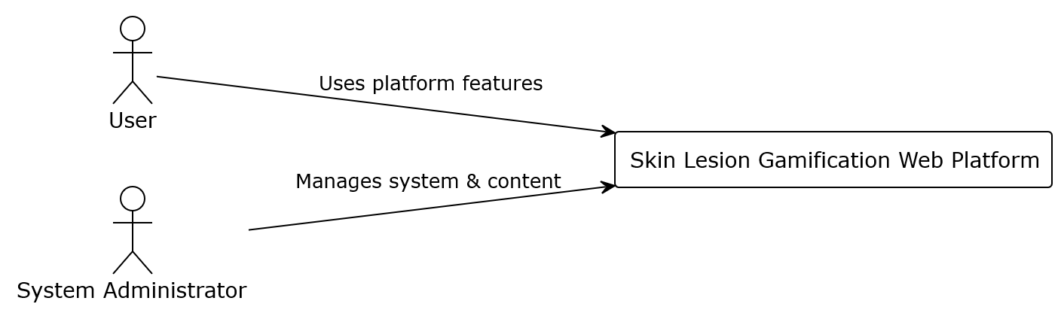

    - General Overview
The following diagram represents the high-level conceptual view of the platform, illustrating how both actors interact with the main functional modules of the system.

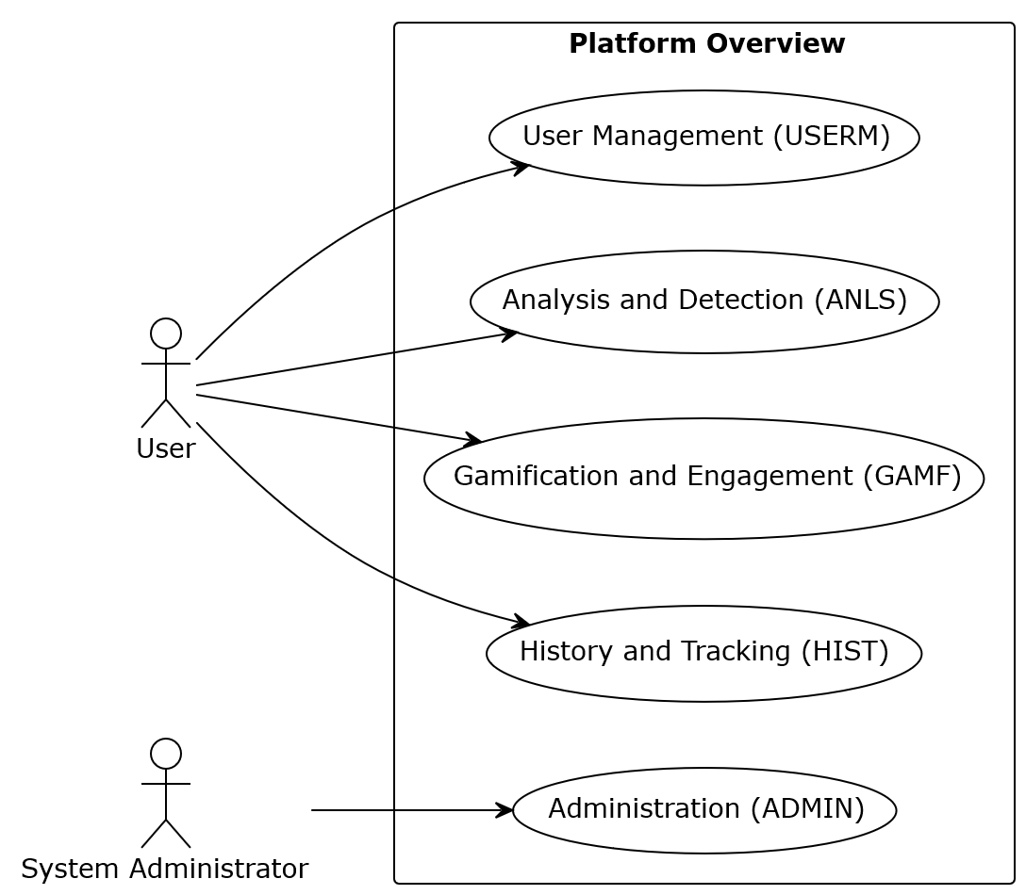

    - USERM Module (User Management)
This diagram details the use case related to user registration, authentication, and profile customization.
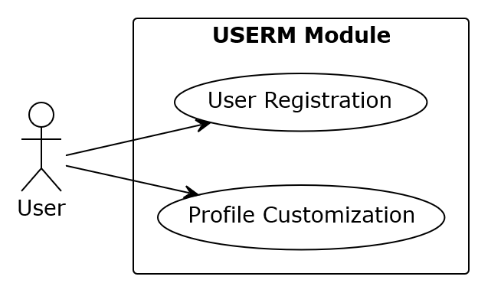

    - ADMIN Module (Administration and Management)
This diagram outlines the backoffice functionalities available exclusively to the System Administrator for content and user management.

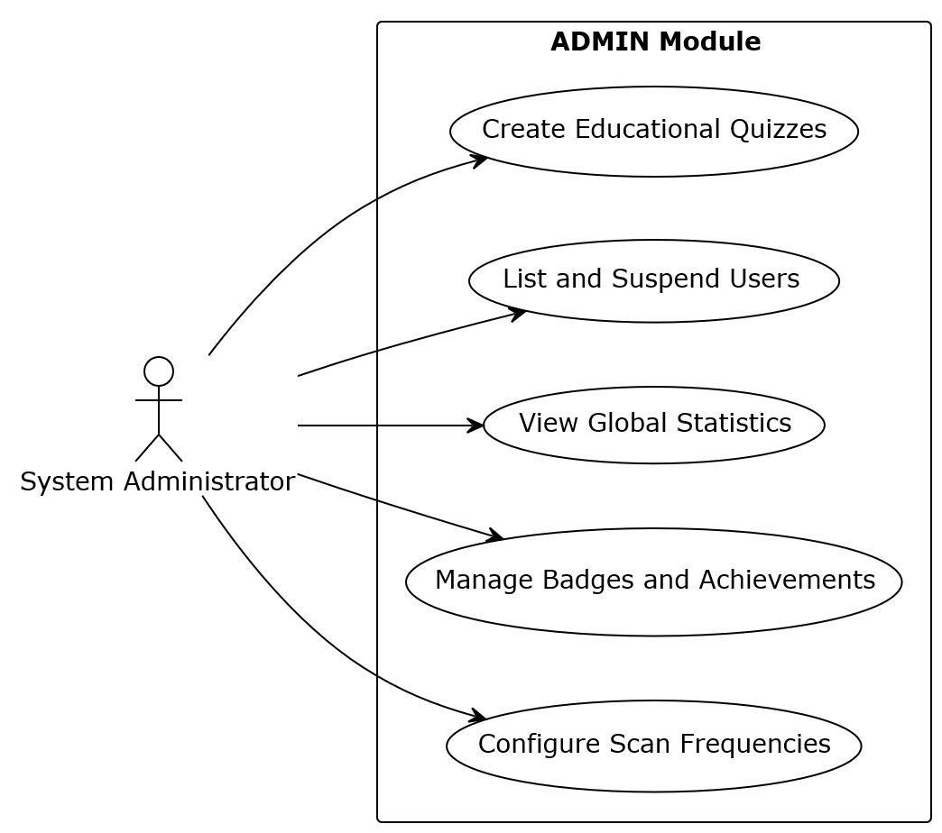

    - ANLS Module (Analysis and Detection)
This diagram represents the core interactions where the user submits lesion images for offline AI evaluation and receives results.
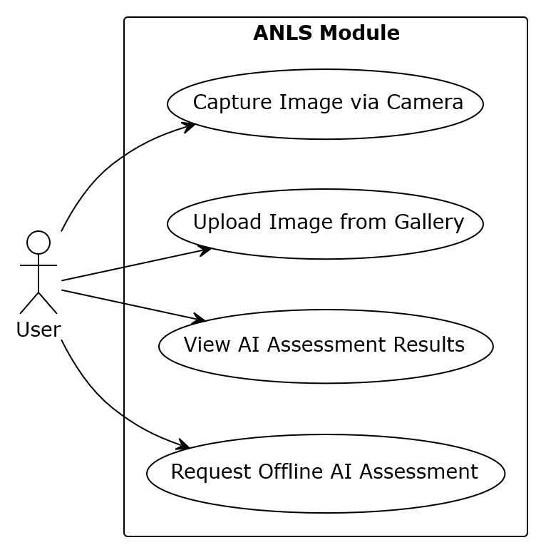

    - GAMF Module (Gamification and Engagement)
This diagram illustrates the gamification mechanics designed to motivate the user, including age-adaptive streaks and educational challenges.
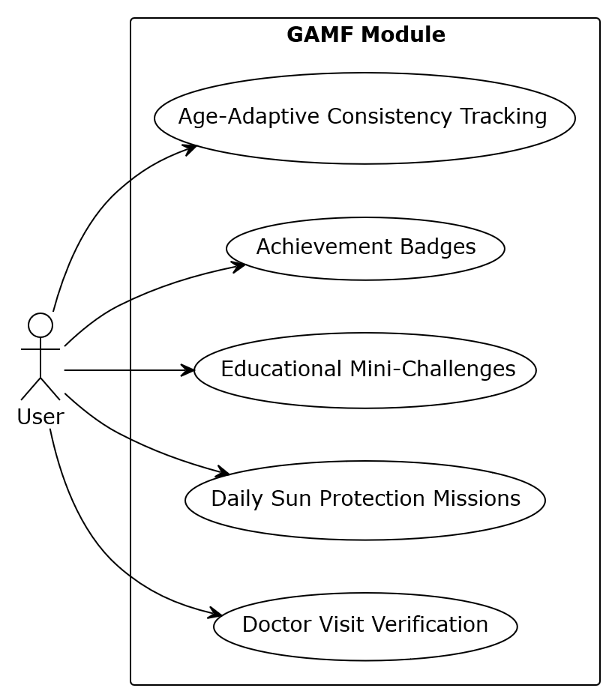

    - HIST Module (History and Tracking)
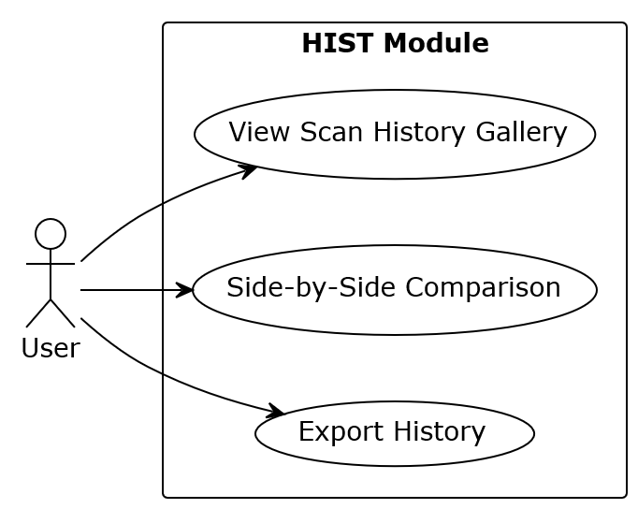
This diagram shows how users interact with their historical scan data to track the evaluation of skin lesions over time

- User Interface Prototypes
The user interface prototypes (mockups) represent the various possible screens of the application to provide a visual foundation for the functional requirements.

User Registration and Login (USERM-UI-1.1)
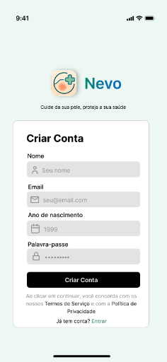
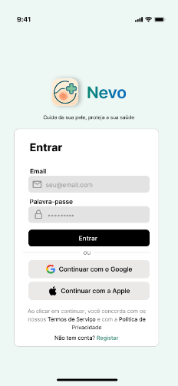

  - Main Dashboard and Gamification (GAMF-UI-1.1)
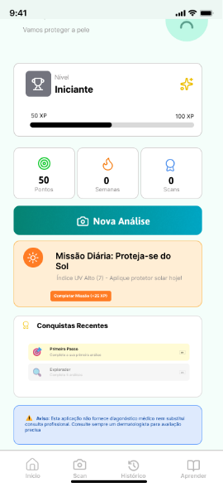
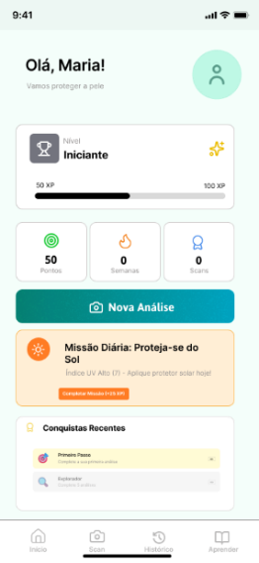

  - Image Capture and Analysis (ANLS-UI-1.1)
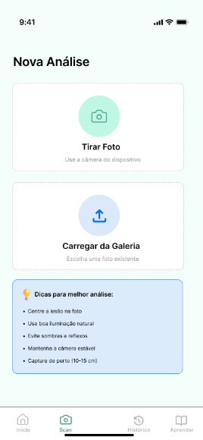

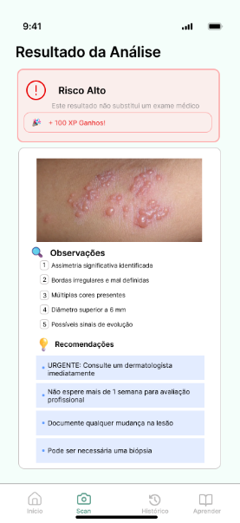
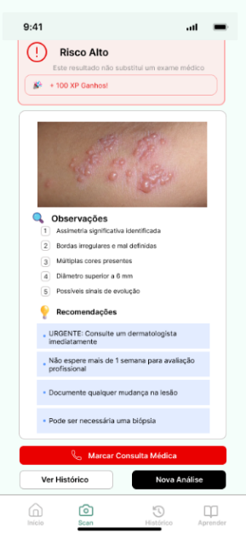
  - AI Assessment Results (ANLS-UI-1.3)

  - History Gallery (HIST-UI-1.1)
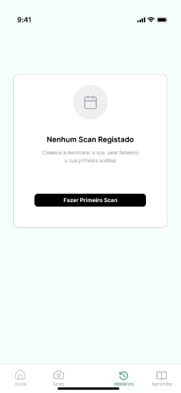
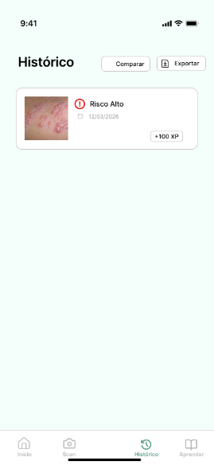

  - Educational Mini-Challenges (GAMF-UI-1.3)
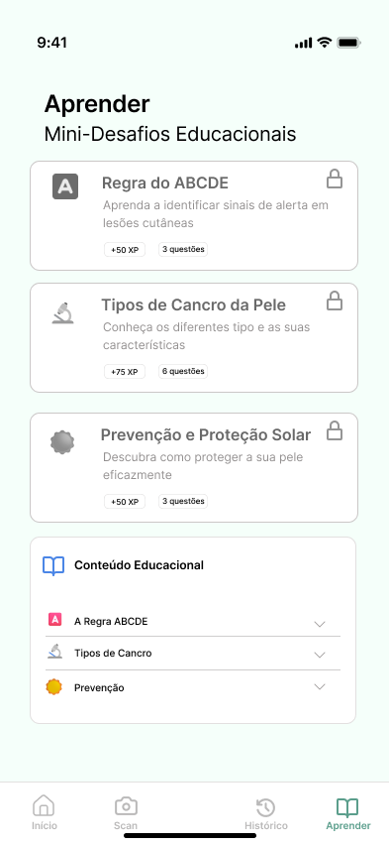

Notes:
Note on Interface Language: Although this Software Requirements Specification is written in English, the User Interface (UI) mockups are presented in Portuguese. This is a deliberate design choice, as the primary target audience for the platform's initial deployment is the Portuguese public. Using the native language ensures clear communication, better accessibility, and higher usability.

Note on Administrator Interface: Prototypes for the System Administrator (ADMIN module) are not included in this document. The administrative backoffice will utilise a standard, functional web dashboard layout, prioritising system performance over bespoke visual design.

