Short exercises for
Murach’s HTML and CSS (6th edition)
Each of these short exercises requires you to use just one or two web development skills, and each is designed so it can be done in from 5 to 45 minutes.
Guidelines for doing the short exercises
- Do the exercise steps in sequence. That way, you will work from the most important tasks to the least important.
- Whenever it’s helpful, copy and paste code from the complete web pages and short examples in the book or from exercises that you’ve already done.
- Use your book as a guide to coding.
- If you are doing an exercise in class with a time limit set by your instructor, do as much as you can in the time limit.
- Because each short exercise is independent of the others, most of the links in the starting HTML for the exercises set the href attribute to a hash character (#). That way, if you click the link, you won’t get a “file not found” error. Instead, you’ll just stay on the same page.
Short 3-1 Create an HTML page for a speaker
In this exercise, you’ll create a semantically correct HTML page that looks like the one below. Estimated time: 20-30 minutes.
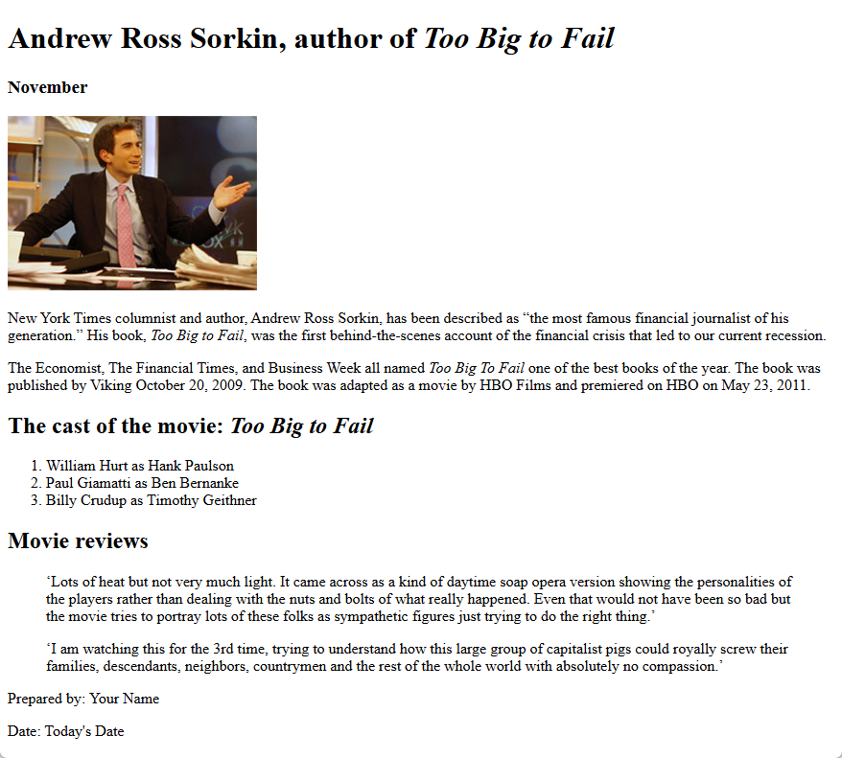
- Open this HTML file:

short_exercises\ch03\index.html
Note that it contains a head section and the text for the body of the page. However, the HTML elements haven’t been applied to the text for the body.
- Add HTML elements so the text looks like the page above.
- Code the last two lines within a <footer> element and all other elements within a <main> element.
- Add an HTML element that displays the image for the speaker. This image is named sorkin_desk260.jpg and is 260 pixels wide.
- Use inline elements to add italics to this page.
- Use inline elements to add double quotation marks to the first paragraph.
- Use character entities to add single quotation marks to the movie reviews.

