MODEL 1
model_glm_reg1 <- train(
Survived ~ Pclass + Age + Fare + Embarked + Title + Family + CabinL

Deviance Residuals:
Min 1Q Median 3Q Max
-2.5937 -0.5319 0.4002 0.5409 2.4444

Coefficients:
Estimate Std. Error z value Pr(>|z|)
(Intercept) 0.729722 0.758854 0.962 0.336245
Pclass2 0.356142 0.204776 1.739 0.082004 .
Pclass3 0.862868 0.254811 3.386 0.000708 ***
Age 0.436242 0.149282 2.922 0.003475 **
Fare -0.116116 0.165557 -0.701 0.483077
EmbarkedQ 0.086707 0.124099 0.699 0.484746
EmbarkedS 0.153425 0.127186 1.206 0.227701
TitleMiss 0.253407 0.220525 1.149 0.250512
TitleMr 1.684119 0.300658 5.601 2.13e-08 ***
TitleMrs -0.201711 0.221155 -0.912 0.361725
TitleRare 0.489442 0.136502 3.586 0.000336 ***
Family 0.765079 0.149527 5.117 3.11e-07 ***
CabinLB 0.007661 0.173989 0.044 0.964881
CabinLC 0.205169 0.181562 1.130 0.258469
CabinLD -0.004466 0.150066 -0.030 0.976260
CabinLE -0.082148 0.156278 -0.526 0.599132
CabinLF -0.010903 0.150282 -0.073 0.942165
CabinLG 0.053319 0.094980 0.561 0.574547
CabinLT 0.502359 20.051320 0.025 0.980012
CabinLZ 0.405309 0.303329 1.336 0.181483
---
Signif. codes: 0 ‘***’ 0.001 ‘**’ 0.01 ‘*’ 0.05 ‘.’ 0.1 ‘ ’ 1

(Dispersion parameter for binomial family taken to be 1)

Null deviance: 943.01 on 712 degrees of freedom
Residual deviance: 576.82 on 693 degrees of freedom
AIC: 616.82

Number of Fisher Scoring iterations: 12
MODEL 2 (= model 1 con Fare y no LogFare)
model_glm_reg1 <- train(
Survived ~ Pclass + Age + Fare + Embarked + Title + Family + CabinL

Deviance Residuals:
Min 1Q Median 3Q Max
-2.5269 -0.5355 0.3958 0.5329 2.3897

Coefficients:
Estimate Std. Error z value Pr(>|z|)
(Intercept) 7.275e-01 7.588e-01 0.959 0.337647
Pclass2 2.608e-01 2.143e-01 1.217 0.223652
Pclass3 6.738e-01 2.835e-01 2.376 0.017487 *
Age 4.351e-01 1.491e-01 2.918 0.003526 **
LogFare -3.421e-01 2.007e-01 -1.704 0.088301 .
EmbarkedQ 6.770e-02 1.248e-01 0.542 0.587553
EmbarkedS 1.292e-01 1.284e-01 1.007 0.314078
TitleMiss 2.525e-01 2.205e-01 1.145 0.252096
TitleMr 1.677e+00 3.006e-01 5.581 2.39e-08 ***
TitleMrs -1.859e-01 2.215e-01 -0.839 0.401456
TitleRare 4.844e-01 1.372e-01 3.531 0.000415 ***
Family 8.799e-01 1.677e-01 5.248 1.53e-07 ***
CabinLB 8.998e-03 1.736e-01 0.052 0.958668
CabinLC 2.344e-01 1.832e-01 1.279 0.200763
CabinLD 1.790e-02 1.519e-01 0.118 0.906199
CabinLE -6.685e-02 1.579e-01 -0.423 0.672068
CabinLF 8.564e-06 1.517e-01 0.000 0.999955
CabinLG 5.853e-02 9.530e-02 0.614 0.539112
CabinLT 5.068e-01 2.005e+01 0.025 0.979837
CabinLZ 4.315e-01 3.081e-01 1.401 0.161300
---
Signif. codes: 0 ‘***’ 0.001 ‘**’ 0.01 ‘*’ 0.05 ‘.’ 0.1 ‘ ’ 1

(Dispersion parameter for binomial family taken to be 1)

Null deviance: 943.01 on 712 degrees of freedom
Residual deviance: 574.20 on 693 degrees of freedom
AIC: 614.2

MODEL 3 (igual modelo 2 pero con sex y title, mejor title)

model_glm_reg1 <- train(
Survived ~ Pclass + Age + Sex + Fare + Embarked + Title + Family ,

Call:
NULL

Deviance Residuals:
Min 1Q Median 3Q Max
-2.5912 -0.5439 0.4051 0.5501 2.3904

Coefficients:
Estimate Std. Error z value Pr(>|z|)
(Intercept) 0.68814 1.73386 0.397 0.691454
Pclass2 0.55056 0.15021 3.665 0.000247 ***
Pclass3 1.14353 0.18301 6.249 4.14e-10 ***
Age 0.40773 0.14640 2.785 0.005353 **
Sexmale 7.08967 292.02605 0.024 0.980631
Fare -0.09744 0.14882 -0.655 0.512614
EmbarkedQ 0.08678 0.12356 0.702 0.482446
EmbarkedS 0.14848 0.12486 1.189 0.234348
TitleMiss 6.18032 243.22812 0.025 0.979728
TitleMr 1.73181 0.29407 5.889 3.88e-09 ***
TitleMrs 5.08510 216.15386 0.024 0.981231
TitleRare 0.57506 0.13858 4.150 3.33e-05 ***
Family 0.76104 0.14730 5.167 2.38e-07 ***
---
Signif. codes: 0 ‘***’ 0.001 ‘**’ 0.01 ‘*’ 0.05 ‘.’ 0.1 ‘ ’ 1

(Dispersion parameter for binomial family taken to be 1)

Null deviance: 943.01 on 712 degrees of freedom
Residual deviance: 583.96 on 700 degrees of freedom
AIC: 609.96

Number of Fisher Scoring iterations: 13

MODEL 4( mas sencilla sin sex,fare,embarked) → ME DA UN SCORE DE 0.758
Call:
model_glm_reg1 <- train(
Survived ~ Pclass + Age + Title + Family ,

Call:
NULL

Deviance Residuals:
Min 1Q Median 3Q Max
-2.5858 -0.5733 0.3992 0.5215 2.4159

Coefficients:
Estimate Std. Error z value Pr(>|z|)
(Intercept) 0.7308 0.1073 6.808 9.91e-12 ***
Pclass2 0.6530 0.1322 4.940 7.80e-07 ***
Pclass3 1.2653 0.1510 8.377 < 2e-16 ***
Age 0.4435 0.1450 3.059 0.00222 **
TitleMiss 0.2532 0.2102 1.205 0.22839
TitleMr 1.6999 0.2876 5.911 3.40e-09 ***
TitleMrs -0.1940 0.2124 -0.913 0.36113
TitleRare 0.5145 0.1308 3.935 8.33e-05 ***
Family 0.7384 0.1387 5.324 1.01e-07 ***
---
Signif. codes: 0 ‘***’ 0.001 ‘**’ 0.01 ‘*’ 0.05 ‘.’ 0.1 ‘ ’ 1

(Dispersion parameter for binomial family taken to be 1)

Null deviance: 943.01 on 712 degrees of freedom
Residual deviance: 589.54 on 704 degrees of freedom
AIC: 607.54

Number of Fisher Scoring iterations: 5

Area under the curve: 0.8847

MODEL 5( añadir logfare al model 4) → ME DA UN SCORE DE 0.75598

Call:Call:
NULL

Deviance Residuals:
Min 1Q Median 3Q Max
-2.5356 -0.5595 0.4005 0.5281 2.3978

Coefficients:
Estimate Std. Error z value Pr(>|z|)
(Intercept) 0.71873 0.10762 6.678 2.42e-11 ***
Pclass2 0.46500 0.16135 2.882 0.00395 **
Pclass3 0.96406 0.22071 4.368 1.25e-05 ***
Age 0.40890 0.14566 2.807 0.00500 **
TitleMiss 0.27322 0.21431 1.275 0.20235
TitleMr 1.72631 0.29383 5.875 4.22e-09 ***
TitleMrs -0.15070 0.21615 -0.697 0.48569
TitleRare 0.51575 0.13223 3.900 9.60e-05 ***
Family 0.86959 0.16537 5.258 1.45e-07 ***
EmbarkedQ 0.07635 0.12355 0.618 0.53662
EmbarkedS 0.13217 0.12459 1.061 0.28877
LogFare -0.31544 0.19608 -1.609 0.10767
---
Signif. codes: 0 ‘***’ 0.001 ‘**’ 0.01 ‘*’ 0.05 ‘.’ 0.1 ‘ ’ 1

(Dispersion parameter for binomial family taken to be 1)

Null deviance: 943.01 on 712 degrees of freedom
Residual deviance: 584.90 on 701 degrees of freedom
AIC: 608.9

Number of Fisher Scoring iterations: 5

Generalized Linear Model

713 samples
6 predictor
2 classes: 'Si', 'No'

Pre-processing: centered (11), scaled (11)
Resampling: Cross-Validated (10 fold)
Summary of sample sizes: 641, 642, 642, 642, 643, 641, ...
Resampling results:

ROC Sens Spec
0.8646769 0.7306268 0.8809091

Area under the curve: 0.8901

MODEL DECISSION TREE
Using cp 0.005, minbucket 15, depth 3
Area under the curve: 0.8239

score = 0.76555

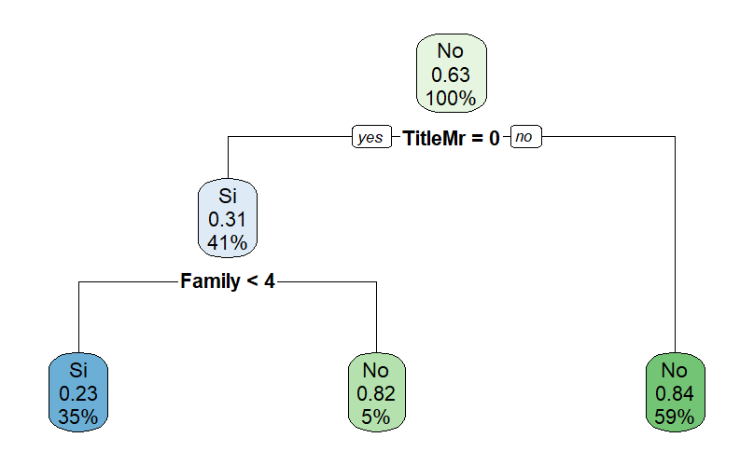

sing cp 0.005, minbucket 15, depth 4
Area under the curve: 0.8507
score= 0.72727

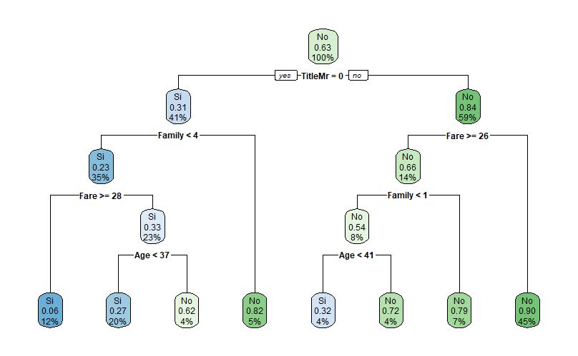

RANDOM FOREST
Survived ~ Pclass + Age + Title + Family + Embarked + LogFare ,
data = df_train2,
MTRY 4
Area under the curve: 0.8898

score = 0.76315
BAGGING MODEL

Survived ~ Pclass + Age + Title + Family + Embarked + Fare ,
NUM BAG 500
Area under the curve: 0.8917

score =0.74401

GRADIENT BOOSTING
Survived ~ Pclass + Age + Title + Family + Embarked + Fare ,

n.trees = 150,
interaction.depth = 6,
shrinkage = 0.1,
n.minobsinnode = 20
Area under the curve: 0.8813
score0.75837

