# **Domaine Model**

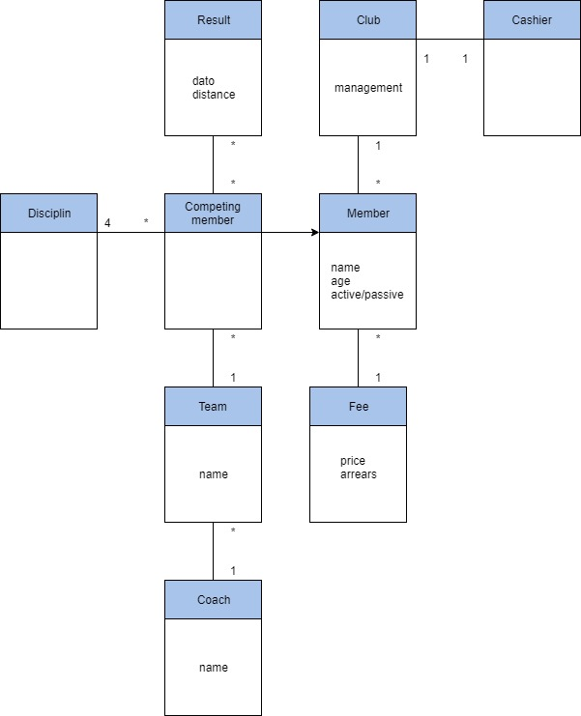

# **Use Case Diagram – for the system**

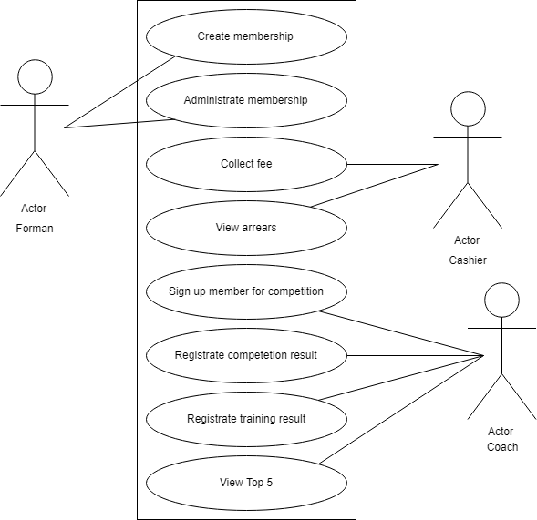

# **Use Case Diagram – expected completion**

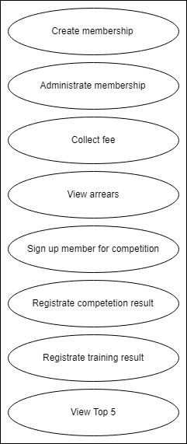

# **Mock Ups**