XML
JSON
MySqL
HDF5
Webscraping
Reading from APIs: Facebook, Google, Twitter, Github...
Foreign package: loads data from Minitab, S, SAS, SPSS, Stata, Systat
Reading images: jpeg, readbitmap, png, EBImage
Reading GIS data: rdgal, rgeos, raster
Reading music data: tuneR, seewave
What do data scientists do?

Define the question
* Types of DSc questions
1. Descriptive: decribe a set of data
2. Exploratory: find relationships you didn't about
3. Inferential: use a relatively small sample of data to say something about a bigger population
4. Predictive: use the data on some objects to predict values for another object
5. Causal: to find out what happens to one variable when you make another variable change.
6. Mechanistic: understand the exact changes in variables that lead to changes in other variables for individual objects.

Define the ideal data set
* What data analysis is called for your data type?
- Biostatistics for medical data
- Data Science for data from web analytics
- Machine learning for data in computer science/computer vision
- Natural language processing for data from texts
- Signal processing for data from electrical signals
- Business analytics for data on customers
- Econometrics for economic data
- Statistical process control for data about industrial processes.

Determine what data you can access

Raw data → Processing script → tidy data → data analysis → data communication

Obtain the data

Clean the data
Tidy Data
1. The raw data.
2. A tidy dataset.
- Each variable you measure should be in one column.
- Each different observation of that variable should be in a different row.
- There should be one table for each “kind” of variable.
- Linked tables

3. A code book describing each variable and its values in the tidy data set.
- Information about the variables (including units) in the data set not contained in the tidy data.
- Information about the summary choices you made.
- Information about the experimental study design you used. (thorough description of how you collected the data)

4. An explicit and exact recipe you used to go from 1 → 2 , 3

- Computer script.
- Input is the raw data.
- Output is the processed, tidy data.
- No parameters to the script.
- When it will not be possible to script every step, you should provide detailed instructions.

Exploratory data analysis
* Analytic graphics
1. Show comparisons
Evidence for a hypothesis is always relative to another competing hypothesis
Always ask “Compared to what?”
2. Show causality, mechanism, explanation
What is your causal framework for thinking about a question?
3. Show multivariate data
4. Integrate multiple modes of evidence
Completely integrate words, numbers, images, diagrams
Data graphics should make use of many modes of data presentation
Don't let the tool drive the analysis

5. Describe and document the evidence with appropriate labels, scales, sources, etc.
A data graphic should tell a complete story that is credible
6. Content is king.
Analytical presentations ultimately stand or fall depending on the quality, relevance and integrity of their content.

Statistical prediction/modeling

Interpret results

Challenge results

Synthesize/write up results

Create reproducible code

* Data analysis files
1. Data
- Raw data
- Processed data
2. Figures
- Exploratory figures
- Final figures
3. R code
- Raw scripts
- Final scripts
- R Markdown files
4. Text
- Readme files
- Text of analysis

Distribute results to other people

1. R packages
- devtools
- roxygen
- testthat
2. rCharts
3. Slidify
4. Shiny

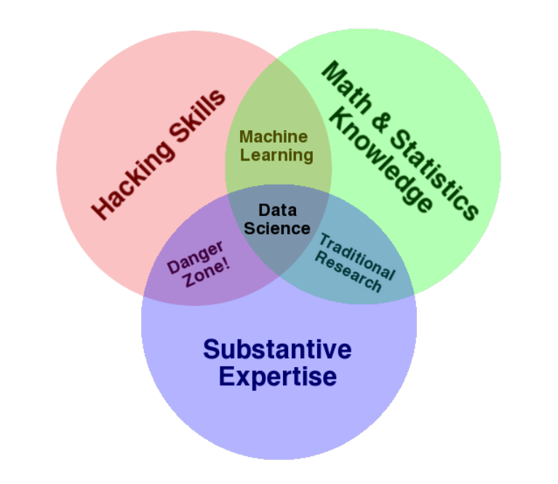

- “Data are values of qualitative or quantitative variables, belonging to a set of items”

- The most important thing in DataSc is the question.
- The second most important is the data.

