**Maria Eduarda Rodrigues Brito – SEMÁFORO, TINKERCAD** 

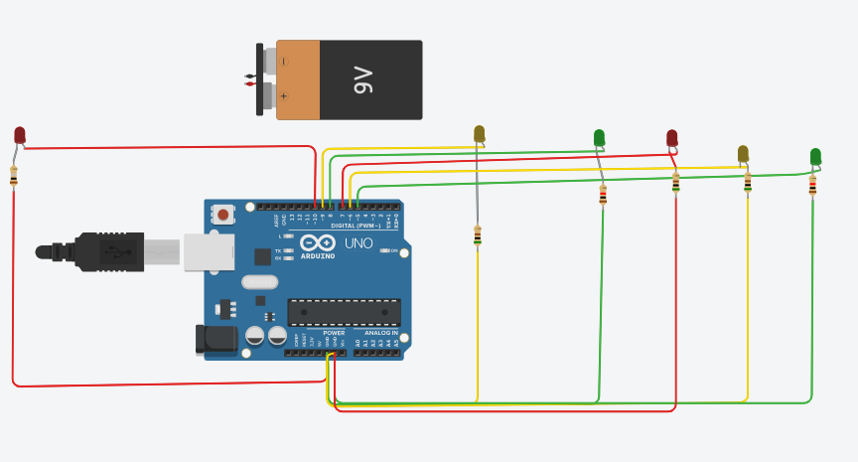

// C++ code

//

void setup()

{

pinMode(10, OUTPUT);//verm1

pinMode(9, OUTPUT);//amar1

pinMode(8, OUTPUT);//verd1

pinMode(7, OUTPUT);//verm2

pinMode(6, OUTPUT);//amar2

pinMode(5, OUTPUT);//verd2

}

void loop()

{

digitalWrite(10, HIGH);

digitalWrite(9, LOW);

digitalWrite(8, LOW);

delay(1000); // Wait for 1000 millisecond(s)

digitalWrite(10, LOW);

digitalWrite(9, LOW);

digitalWrite(8, HIGH);

delay(1000); // Wait for 1000 millisecond(s)

digitalWrite(10, LOW);

digitalWrite(9, HIGH);

digitalWrite(8, LOW);

delay(1000); // Wait for 1000 millisecond(s)

digitalWrite(7, HIGH);

digitalWrite(6, LOW);

digitalWrite(5, LOW);

delay(1000); // Wait for 1000 millisecond(s)

digitalWrite(7, LOW);

digitalWrite(6, LOW);

digitalWrite(5, HIGH);

delay(1000); // Wait for 1000 millisecond(s)

digitalWrite(7, LOW);

digitalWrite(6, HIGH);

digitalWrite(5, LOW);

delay(1000); // Wait for 1000 millisecond(s)

}