Whether you want to achieve ambitions for yourself, teams or business – we rarely accomplish anything in isolation.

Yes. I don’t talk much to my colleagues. They don’t talk to me either. I don’t connect with anyone.

Focus, learning, implementing.

Challenging. Tedious. Interesting.

Useful. Creative.

**ROLES**

**CONNECTION**

How you position yourself in relation to others, how you connect to those around you shapes what is possible.

Understanding your own role, your value & responsibilities shapes what you can create, offer & helps identify what you may need.

They don’t talk to me about anything related with work.

I need more creativity but for that also I need a lot of time to study new technologies and putting in practice the learning. I need to focus and not to lose time.

All the software produced could be impacted by my ambitions so everyone will be impacted.

How you engage with resources you have at your disposal are as much a part of your ability to succeed as the clarity & confidence you have in your ambitions.

Who are the key other players /

dependants / stakeholders that are

impacted by your ambitions?

What responsibilities are critical to your

ability to achieve your ambitions?

For each of these, how supportive &

aligned to your ambitions are they?

Is there any change needed here?

Are there aspects of your role that are

neglected or need reappraising?

How do you define your role currently?

In what way does your role need to

change?

# RESOURCES

Rarely do we accomplish anything without tapping in to resources. Be they tangible, physical, mental, emotional or social. How we engage, connect & utilise the resources we have available to us, will make a significant impact on what we can achieve.

Our relationship to resources & how we perceive the value exchange, can unlock huge potential when we identify & reach for them.

Now consider & identify the different types of resources you have at your disposal, we have given some suggestions to start you off: -

Anarchy.

Greta Tumberg.

I would like to go to a Woman in Tech conferences to see if I can connect with other female in tech but there is no budget.

I do not interact much with anyone that does the same job as me. I think is because they are all man and I nobody considers me much honestly.

I do not have any role model. I have very different life style from others. Also I see myself very different so I cannot compare to anyone. What I do is admiring some skills other have.

I do not interact much with my team

I do not work in a very stressful environment which for me is ideal. It’s the best thing for me.

The product is very interesting and more the integrations and what we can do with the data.

I got access to many courses and I work directly with hight skilled developers

I got the best IDE and good resources to do my job.

Value this offers to you

**TECHNOLOGY**

**KNOWLEDGE**

**BANKS**

**TEAMS**

**OPERATIONAL**

**PROCESSES**

**PRODUCT**

**ROLE MODELS**

**PEERS**

**NETWORKS**

**ADVOCATES**

**BRAND**

# ENGAGEMENT

Now explore how you are currently engaging with these resources. What more is there to consider? If you are confident, values aligned & excited about your future, what role will these resources play in bringing it to life?

|  |  |  |
| --- | --- | --- |
| Value exchange | Untapped potential / opportunity | 1 brave ask/action you could take |
| Use social media to connect other women in tech.  I work 100% tech |  | Participate in woman development competitions |
| I work with high skilled sw developers | Accept more responsibility in terms of accepting I need to force me to be more technical |  |
| Most of developers I follow are man | Do my own tutorials to make sure I understand concepts | Do my own tutorials to make sure I understand concepts |
| Participate in woman development competitions | Use social media to connect other women in tech. | Participate in woman development competitions |
| I do not have any special person I follow. I like a war journalist she is very brave.  Greta Tumberg cause. |  |  |

**TECHNOLOGY**

**KNOWLEDGE**

**BANKS**

**ROLE MODELS**

**PEERS**

**NETWORKS**

**ADVOCATES**

**BRAND**

# EMOTIONS

We do not control our emotions, but we do control our responses to them. Our emotions contain data and signposts which enable us to make better decisions & values aligned choices. Essential to enable us to choose courageous actions.

How does appraising emotions in this way enable you to manage your

responses towards engaging with other people’s emotions?

How we connect to our own emotions, and those of the people around us is a choice. Emotions are data not, directives. Signals not certainties.

Listen to them, learn what they point to, leverage the message.

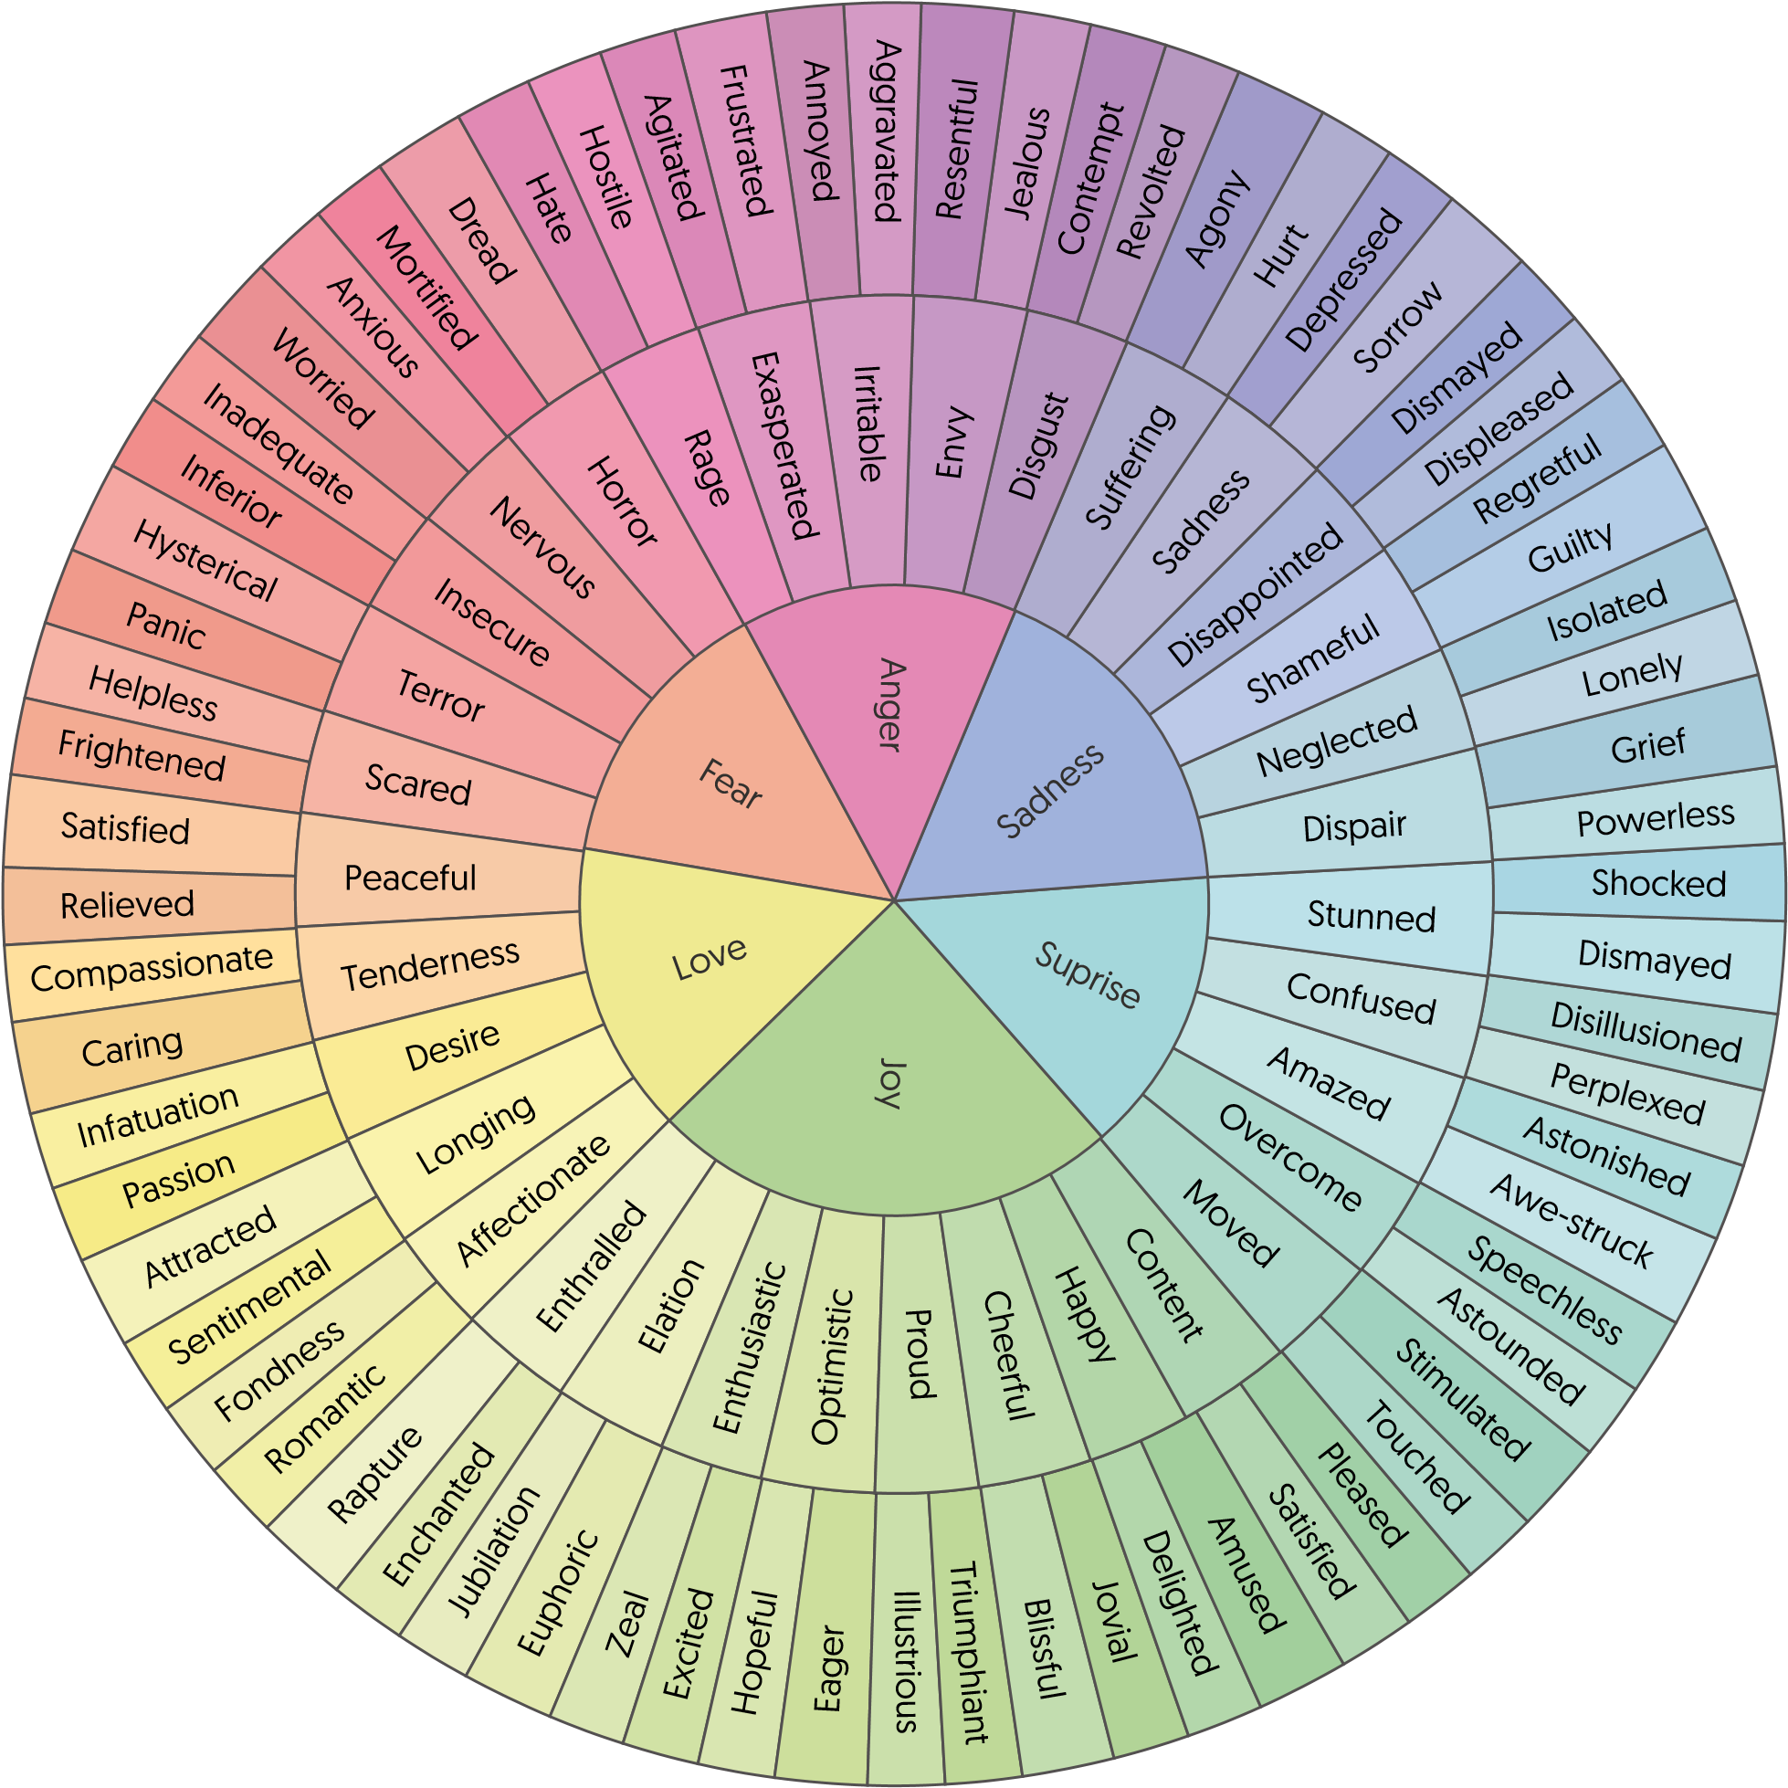

# EMOTIONS

Consider below an emotion that challenges you then in the ‘Today’ column answer the questions as you find them.

In the Be Braver column, consider the ways you might reframe these leaning on your values for & the emotions wheel for insight. Contempt

**TODAY BE BRAVER**

I want to socialise again.

I do not want to see anybody I stay at home and don’t wanna talk anyone.

Do something I like to focus in happiness.

Confusion.

Being grateful for the good things.

I feel angry and sad and confused.

Being more empathic.

Frustration

Loneliness

Feeling uncomprehend.

**WHAT ARE THE**

**TRIGGERS?**

sad

**HOW DO THESE**

**IMPACT YOUR**

**BEHAVIOUR?**

**WHAT THOUGHTS/**

**MIND CHATTER IS**

**HAPPENING/**

**ASSOCIATED?**

**WHAT IS THE**

**EMOTION**

**SIGNPOSTING?**

**Reflection & insights to treasure forever**

