Overview
GTGATracker is a .NET service or .NET Application which works as a windows service. It’s created as a Microsoft Visual Studio project without any user interface to manage it. Running on a windows session, it starts, stops and restarts with the command console on Windows. The goal of the application is tracking a google analytics account, and displays the http responses on a ticker. It should be able to send some requests to google account profiles in a period of time, showing the responses on a ticker will be displayed on a screen.
Architecture
This project is built following the same arquitecture used in Gt projects. Contains four layers displayed below.

How does it work, Google Analytics?
This report walks through the steps required to access Google Analytics account, query the Analytics APIs, handle API responses, and output the results.
There are two important API’s to access, query and handle the Google Analytics applications registered into user accounts. These are called and used as it is related below.
- Management API: With the Management API you can query for an user's account, web properties, and profiles, determine what account segments the user has configured, even retrieve information about the goals in a configured profile.
- Core Reporting API: Google Analytics provides a simple and powerful API to retrieve tabular reports from Google Analytics. With the reporting API, you can save time by automating complex reporting tasks.
Management API.
With the Management API you can:
- List all the Accounts, Web Properties and Profiles information for an user account.
- Retrieve a Profile ID to use with the Core Reporting API.
- Determine which goals are active and access their configured names.
- Retrieve an user's Custom Segments to apply them to Core Reporting API queries.

The Management API exposes 5 Google Analytics configuration entities. Most are organized hierarchically.

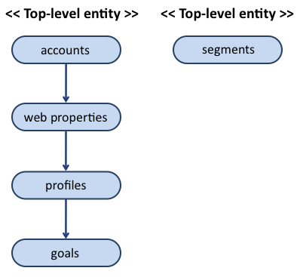
Figura 1.1 The 5 entities configurations of Google Analytics.
As we know to request data for an user, your application must identify the user and specify a profile for wich to retrieve the data.
- In this case, it exists two different users:
- Login: sis-desarrollo@gtmotive.com
This user contains 3 accounts:
- GtGlobal Arval Dev Enviroment
- GtMotive GTI Testeo
- Production Server
- Login: infra@gtmotive.com
In each account there are some web properties and profiles we’ll use to identify the table we’d like to make the request. You can visit the site http://www.google.com/intl/es/analytics/, login in it as one of both users, and check the account there.

Version 3.0 of the Management API exposes each of the entities as a Resource. A list of Resources of a particular kind make up a Collection. The API exposes each Collection at an URI that can be queried to return the list of entities in it. In this project we can underline two of them:
Accounts collection (Management.Account List): Lists all accounts to which the user has access.
The URI used to make the HttpRequest to retrieve the accounts list is:
GET https://www.googleapis.com/analytics/v3/management/accounts
In addition to the standard parameters, this method supports the parameters listed in the next request, (maxResults, startIndex, fields).
GET https://www.googleapis.com/analytics/v3/management/accounts?max-results=2&start-index=1&key={YOUR_API_KEY}
Also we can notice, this request requires authorization to retrieve the data.
After authorization, if successful, this method returns a response body with the following structure.
200 OK
- Show headers -
{
"kind": "analytics#accounts",
"username": "deandresherrero@gmail.com",
"totalResults": 1,
"startIndex": 1,
"itemsPerPage": 2,
"items": [
{
"id": "32564305",
"kind": "analytics#account",
"selfLink": "https://www.googleapis.com/analytics/v3/management/accounts/32564305",
"name": "maria",
"created": "2012-06-11T14:32:22.776Z",
"updated": "2012-06-11T14:32:22.776Z",
"childLink": {
"type": "analytics#webproperties",
"href": "https://www.googleapis.com/analytics/v3/management/accounts/32564305/webproperties"
}
}
]
}

To get full quota, you must register your application in the Google APIs Console and provide an OAuth 2.0 token with each request. You can provide an OAuth 2.0 token with any request in one of two ways:
- Using the access_token query parameter like this: ?access_token=oauth2-token
- Using the HTTP Authorization header like this: Authorization: Bearer oauth2-token,

How it works the Authorization?
Before users can view their account information on the Google Analytics web site, they must first log in with a Google Account. Authorization in the API works using tokens.
After doing the authorization steps described below, the application can make queries to both the Core Reporting API for report data and the Management API for configuration data.

Authorizing requests with OAuth 2.0

All requests to the Google Analytics API must be authorized by an authenticated user.

The details of the authorization process, or "flow," for OAuth 2.0 vary somewhat depending on what kind of application you're writing. The following general process applies to all application types:

When you create your application, you register it with Google. Google then provides information you'll need later, such as a client ID and a client secret.

Activate the Google Analytics API in the Services pane of the Google APIs Console. (If it isn't listed in the Console, then skip this step.)

When your application needs access to user data, it asks Google for a particular scope of access.

Google displays an OAuth dialog to the user, asking them to authorize your application to request some of their data.

If the user approves, then Google gives your application a short-lived access token.

Your application requests user data, attaching the access token to the request.

If Google determines that your request and the token are valid, it returns the requested data.

Here's the OAuth 2.0 scope information for the Google Analytics API: https://www.googleapis.com/auth/analytics.readonly To request access using OAuth 2.0, your application needs the scope information, as well as information that Google supplies during application registration (such as the client ID and/or the client secret).

Basic Steps for Authentification
- Register application.
- Obtain an access token from the google authorization server.
- Send access token to an API.
- Refresh the access token.(optional).

Scenario

This sequence begins with the creation of a Service Account. You may create a Service Account in the Google APIs Console, or if you are using Google App Engine, one is created automatically for your Google App Engine application. During the creation of a Service Account in the Google APIis Console you will be prompted to download a private key. Be sure to save this private key in a secure location. After the Service Account has been created, you will also have access to the client ID associated with the private key. You will need both when coding your application.

After obtaining the client ID and private key from the Google APIs Console, create a JWT and sign it with the private key, and construct an access token request in the appropriate format. Your application then sends the token request to the Google OAuth 2.0 Authorization Server and an access token will be returned. The application can access the API only after receiving the access token. When the access token expires, the application repeats the process.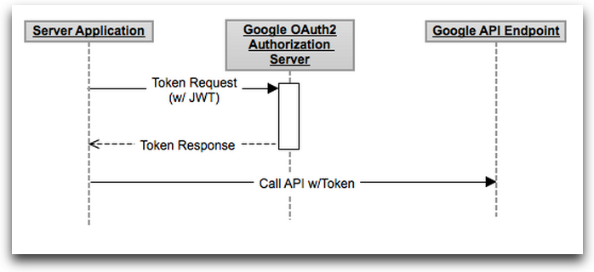

Pasos a seguir en el proceso:

- Descargar la librería adecuada: Client Library: Google APIs Client Library for .NET = google-api-dotnet-client

- Crear ficheros para el tutorial.→esto no es estrictamente necesario.

- Registrar mi aplicación en la Google API’s console.

- Autorizar acceso a la API.

- Crear un Analytic Service Object

- Obtener un object service inicializado.

- Obtener el profile ID del usuario.

- Hacer una query sobre Core Reporting API o Management API (diferencia una trabaja con la v2.3 y la otra con la v3.0.)

- Manejar las respuestas de la API

Devolver los resultados.

GTGATracker is an installed application which is running in a background for long periods of time wihtout any direct interaction with the user. This flow requires that the application has an access to the system browser or the ability to embed a browser control in the application.
When registering the application, you specify that the application is an installed application.This is results in a different value for the redirect Uri,
The client-id and the client-secret are embebed into the source code.
The authorization code can be returned to your application in the title of the browser or to an http://localhost port.
The sequence starts by redirecting a browser (system or embebed) to a Google URL,
With a set of params that indicate the type of Google API.
Scrum.-> Planificación
Offset en el periodo entre queries.

Issues.

What happened with v2.3 API?

