SunsY

Fodor Maria-Gabriela

affiliation:Faculty of Automatic control and Computer Engineering, Iasi,

email: [maria-gabriela.fodor@student.tuiasi.ro](mailto:maria-gabriela.fodor@student.tuiasi.ro)

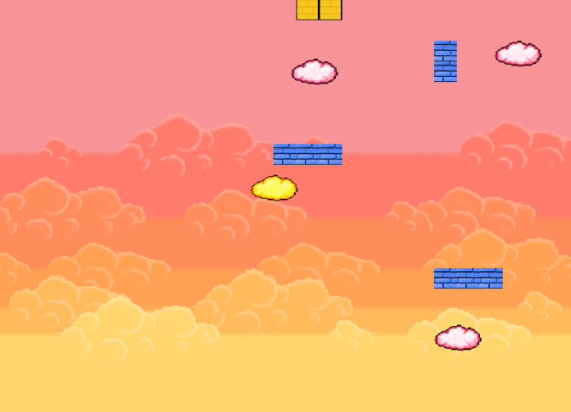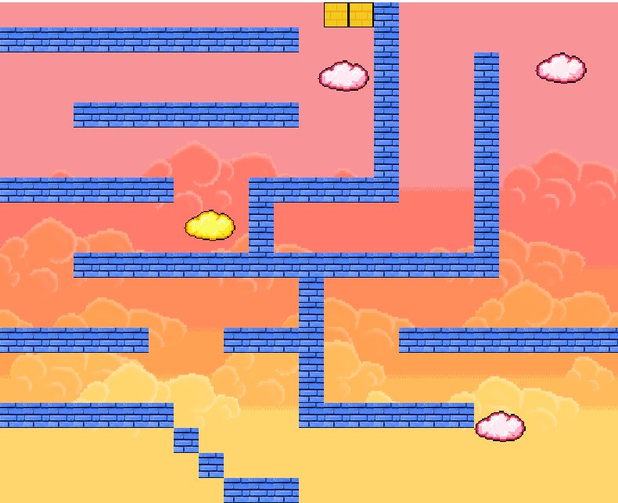

* **Game modes:** the game has two play options: **single player** and **multiplayer.** This makes it a great game for playing whith your friends or alone.
* **Characters:**
  + **Yellow** (the yellow cloud), is the player-charcater of the single-player adventure and the its misson is to get to ***the golden bricks*** (the finish line). It must avoid all the „sunset clouds” (**pink** clouds) which will kill him. The „**sky walls”** are forming an invissible maze that will be reveald once the player (**yellow**) or one of the enemyes (**pink**) hits one of the walls.
  + **Pink** (the pink cloud) is the antagonis-character in the single-player and a player-character in the multiplayer. His mission is to kill **yellow**, and he can do that by simply catching him before he gets to the finish line.
* **Mechanics:**
* **Yellow** moves with <arrows> (4 directions+diagonals)
* **Pink** moves with <WASD> (4 directions+diagonals) –in multiplayer
* **Gameplay:**
* **Single-player:** if **yellow** gets to the finish line, the game is won; if it gets caught by **pink**, the game is lost
* **Multiplayer:** the game can end in only two ways: **yellow** gets safely to the finish line and wins, **or pink** „eats” yellow and wins

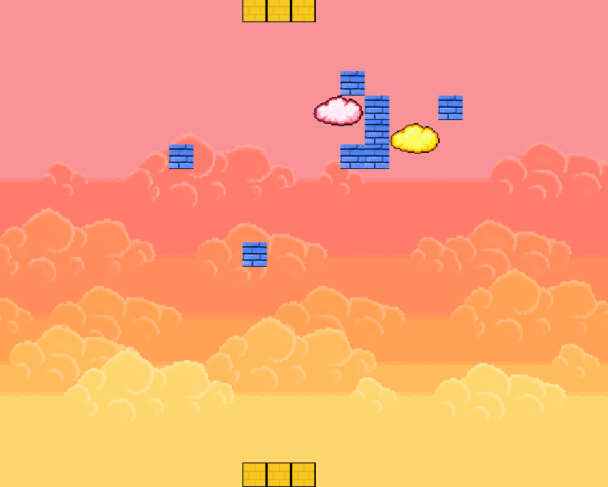Link github :

<https://github.com/MariaFodor/SunsY>

Multyplayer game scene