**ASSESSMENT JAVA**

*María del Carmen González Carranza*

*Jackie Ye*

**SPRING BOOT**

CREATE METHOD

GET ALL METHOD

DELETE METHOD

UPDATE METHOD

SPRING RUNNING (localhost:8080)

REACT RUNNING (localhost:3000)

FORM ON LOAD WITH SAMPLE TABLE. (left)

FORM FILLED OUT. (right)

CONSOLE LOG

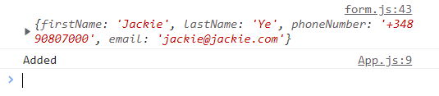

ADD USER 2

UPDATED TABLE

