#### Angular脱坑记

##### 之内存溢出

问题描述

IntelliJ IDEA 2019.1.3

Angular 6.1.5

随着页面数的增多，项目文件体积也随之增加。在编译项目的过程中（dev），Node引擎频繁出现内存溢出问题

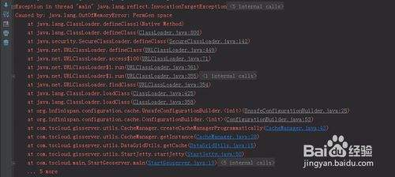

解决

v8本身有一个默认配置:Currently, by default v8 has a memory limit of 512mb on 32-bit systems, and 1gb on 64-bit systems. The limit can be raised by setting –max-old-space-size to a maximum of ~1gb (32-bit) and ~1.7gb (64-bit), but it is recommended that you split your single process into several workers if you are hitting memory limits.

所以我们需要配置一下运行内存

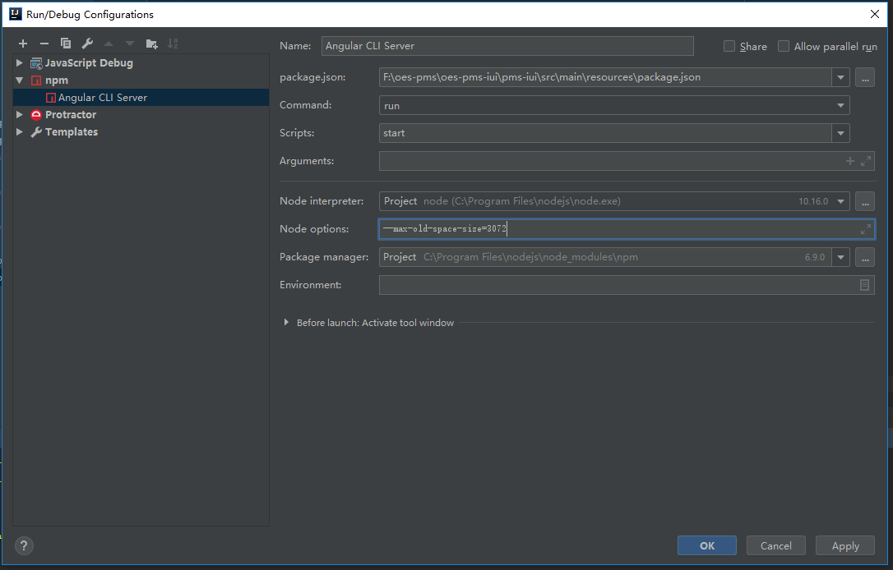

引用

[1] node内存配，https://blog.csdn.net/qq_20881087/article/details/62428774?utm_source=blogxgwz8