Class-Conditional Latent Diffusion for Synthetic Hand Osteoarthritis X-ray Augmentation

Zulal Akarsu · María Martín · Jai Sharma
Group 3: Track 3
Prof. Ming Zhang
April 29, 2026
Boston University Metropolitan College
MET CS 790: Advanced Computer Vision
Final Project Report

Abstract
Hand osteoarthritis (OA) affects over 40% of adults over 70, yet automated severity grading using the Kellgren-Lawrence (KL) scale is hindered by extreme class imbalance: severe grades (KL 3 and KL 4) comprise only 2.9% of available X-ray data. This paper addresses the imbalance through generative data augmentation, training a class-conditional latent diffusion model (LDM) to synthesize realistic distal interphalangeal (DIP) joint X-rays at specific KL grades, and comparing this against a CycleGAN baseline through systematic ablation experiments.
The proposed LDM generates 1,500 synthetic images (300 per KL grade) at 180×180 resolution, achieving Fréchet Inception Distance (FID) scores of 139-153. For severe grades (KL 3/4), generation is seeded from real patient images to preserve bone anatomy. In downstream evaluation, adding diffusion-generated images improves five-class macro AUC from 0.878 to 0.908 (+3.4%), with the largest per-class gain at KL 4 (+0.072 AUC). CycleGAN synthetic data yields no consistent improvement. Results indicate that a commonly applied 50% synthetic-to-real ratio cap is conservative for severely imbalanced datasets.

Keywords: hand osteoarthritis; Kellgren-Lawrence grading; latent diffusion model; CycleGAN; synthetic data augmentation; class imbalance; medical image synthesis; generative AI

1. Introduction

1.1 Problem Statement

Hand osteoarthritis (OA) is one of the most prevalent joint diseases worldwide, causing chronic pain, reduced grip strength, and functional disability [13]. Clinical severity is assessed using the Kellgren-Lawrence (KL) scale, which rates joint damage from radiographs on a scale of 0 (normal) to 4 (severe). This grading is typically performed manually by radiologists, a process subject to high inter-observer variability and substantial time burden [14], motivating the development of automated deep learning classifiers.

The central challenge for such classifiers is class imbalance. In the DIP joint dataset used in this study, comprising 13,176 images from 3,505 patients, KL grades 3 and 4 together account for only 2.9% of observations. Deep learning models trained on such skewed distributions systematically underperform on the rare severe grades, precisely the cases most critical for clinical decision-making.

1.2 Proposed Approach
This paper proposes generative data augmentation as a principled solution: training generative models to synthesize realistic X-ray images across KL severity grades, then incorporating these synthetic images into the classifier training set. Two generative models are trained and compared:
- CycleGAN [5] (baseline): unpaired domain translation between healthy (KL 0–1) and diseased (KL 2+). Fast to train but structurally limited to binary domains with no grade-conditioning mechanism.
- Latent Diffusion Model [1] (primary): class-conditional generation conditioned on KL grade via a learned embedding, enabling independent synthesis of all five grades.
Evaluation employs a dual-criteria framework: visual fidelity assessed by Fréchet Inception Distance (FID) per grade, and downstream utility measured by ResNet-18 classifier AUC improvement across ablation experiments.
1.3 Research Questions
- Can synthetic X-rays improve classification accuracy for rare severe OA grades (KL 3/4)?
- Does class-conditional diffusion outperform domain-translation GAN for this task?
- What is the optimal synthetic-to-real data ratio, and does the commonly applied 50% cap hold for severely imbalanced classes?

1.4 Paper Organization
The remainder of this paper is organized as follows. Section 2 reviews related work on diffusion and GAN-based medical image synthesis. Section 3 describes the dataset and preprocessing pipeline. Section 4 details the methods, including both generative architectures and the evaluation framework. Section 5 presents quantitative results. Section 6 discusses key findings and limitations. Section 7 concludes with directions for future work.

2. Related Work

2.1 Diffusion Models for Medical Imaging
Latent diffusion models [1] perform denoising diffusion in a compressed latent space, achieving high-fidelity generation at substantially reduced computational cost. Wu et al. [2] introduced IC-RDN, an identity-consistent radiograph diffusion network for knee OA progression simulation that employs CNN fingerprint modules to preserve patient-specific anatomical structure. Butler et al. [6] applied class-conditioned latent diffusion to knee OA risk estimation. Shi et al. [11] provided a comprehensive survey of diffusion model applications in medical image computing.
Wang et al. [10] applied diffusion-based morphing to synthesize temporal knee OA X-ray progressions, demonstrating that diffusion models can capture longitudinal disease trajectories.

2.2 GAN-based Medical Image Synthesis
CycleGAN [5] enables unpaired image-to-image translation and has been applied to OA progression simulation. Prezja et al. [4] demonstrated bidirectional KL-grade translation in knee OA using CycleGAN, achieving 83.76% correct grade translation. Prezja et al. [3] further showed that WGAN-GP can generate 320,000 realistic knee OA X-rays from 5,500 real images, validated by 15 medical experts. Han et al. [9] proposed a style-based manifold extrapolation approach for OA progression prediction, achieving smooth interpolation across disease severity stages. However, CycleGAN is fundamentally limited to two-domain translation.

2.3 Synthetic Augmentation for Imbalanced Medical Data
Littlefield et al. [8] proposed a few-shot augmentation pipeline for knee radiographs. Yeganeh et al. [7] introduced Latent Drifting for counterfactual medical image generation under limited data. Recent results suggest that diffusion-based synthesis outperforms GAN-based approaches for structural realism in radiographic images, particularly for fine anatomical detail such as joint space narrowing and osteophyte formation.

2.4 Contributions of This Work
Prior work has concentrated on knee OA using large public datasets such as the Osteoarthritis Initiative (OAI). The present study extends this to hand OA using a private dataset from Boston University and Tufts Medical Center. The contributions are: (1) to our knowledge, the first application of class-conditional LDM to hand OA X-ray synthesis; (2) a real-image-sourced generation strategy for severe grades preserving bone anatomy; (3) a systematic comparison of CycleGAN versus LDM with ablation across synthetic-to-real ratios from 10% to 200%; and (4) empirical evidence that the 50% synthetic cap is conservative for genuinely rare classes.

3. Dataset

3.1 Overview
The study employs a private hand OA dataset from Boston University and Tufts Medical Center, containing radiographic data from 3,590 patients at two clinical timepoints: baseline (v00) and six-year follow-up (v06). A joint detection model (98.39% accuracy) pre-extracted 41,061 individual joint ROI images, each annotated by clinical experts using the KL scale alongside supplementary scores (JSN, OP, and ER - joint space narrowing, osteophyte presence, and erosion rating). All data collection and de-identification procedures were performed under institutional oversight at Tufts Medical Center.

3.2 DIP Joint Subset
Analysis is restricted to DIP (distal interphalangeal) joints, yielding 13,176 images. DIP joints exhibit the richest disease variation: 40.2% carry KL ≥ 1, compared to 31.2% for proximal interphalangeal (PIP) and 7.0% for metacarpophalangeal (MCP) joints. The KL grade distribution is shown in Table 1.
KL Grade | Label | Train | Val | Test | Total | %
KL 0 | Healthy | 5,947 | 1,269 | 1,260 | 8,476 | 64.3%
KL 1 | Doubtful | 1,220 | 288 | 261 | 1,769 | 13.4%
KL 2 | Mild | 1,770 | 382 | 389 | 2,541 | 19.3%
KL 3 | Moderate | 144 | 29 | 41 | 214 | 1.6%
KL 4 | Severe | 118 | 25 | 28 | 171 | 1.3%
Table 1: KL grade distribution across patient-level splits (70/15/15). KL 3 and 4 combined represent 2.9% of the DIP training set.

3.3 Data Preparation
All images are 180×180 pixels, grayscale. The dataset is partitioned at the patient level (70/15/15) stratified by maximum KL grade, ensuring no patient appears in multiple splits and eliminating data leakage. Normalization uses training-set statistics (mean = 0.2339, std = 0.2349). Training augmentation includes random rotation (±15°), horizontal flip (50%), random zoom (0.9–1.1×), and brightness/contrast jitter (±10%). Vertical flipping is excluded as anatomically invalid for hand radiographs.

The raw dataset consists of two files: hand.xlsx (3,590 patients × 275 columns) containing KL, JSN, OP, and ER severity scores for 16 joint types across two clinical timepoints, and Finger_Joints.zip containing 41,061 pre-cropped individual joint ROI images in PNG format.

The preprocessing pipeline performs the following steps:

- Column parsing and reshaping: The wide-format spreadsheet (275 columns per patient) is melted into long format (one row per patient × joint × score type). Column names follow the pattern v{timepoint}{JointType}{Number}_{ScoreType} (e.g., v00DIP2_KL), which is parsed via regex to extract timepoint, joint type, joint number, and score type.

- Patient ID resolution: The spreadsheet contains two ID columns: "duryeaid" (an internal scoring identifier from the Duryea grading system) and "id" (the OAI participant ID). Image filenames use the OAI participant ID (e.g., 9276684_dip3.png), requiring the "id" column for matching. This mismatch was identified during development when initial matching using "duryeaid" yielded 0% match rate; switching to the "id" column (column 268 of 275) achieved 100% match across all 3,556 patients with images.

- Image-label matching: Each image filename is parsed as {patient_id}_{joint_type}{joint_number}.png and matched to its corresponding KL/JSN/OP/ER scores. Image filenames contain no timepoint information; v00 (baseline) labels are assigned based on the assumption that the cropped images were extracted from baseline radiographs. Match rates: DIP 92%, PIP 96%, MCP 78.5%. CMC and IP joints have no corresponding images in the zip archive.

- Image integrity check: Files under 1 KB are flagged as corrupted and removed. Remaining images are verified to open correctly via Python’s Pillow library.

- DIP filtering: The dataset is restricted to DIP joints (13,176 images), which exhibit the highest disease prevalence among joint types.

- Patient-level splitting: Data is partitioned 70/15/15 into train/val/test sets at the patient level using sklearn's train_test_split with stratification by maximum KL grade per patient. This ensures: (a) no patient's images appear in more than one split, preventing data leakage; (b) rare KL 3 and KL 4 cases are represented in all three splits. Zero-leakage is verified programmatically.

- Intensity normalization: Dataset-wide mean (0.2339) and standard deviation (0.2349) are computed from training images only (2,000 images sampled), to avoid information leakage from validation and test sets. These values are applied via transforms.Normalize() during model training.

4. Methods

4.1 Baseline Classifier
A ResNet-18 backbone [12] pretrained on ImageNet, with the final FC layer replaced for the target class count, serves as the downstream classifier. Two tasks are evaluated: binary (non-OA: KL 0–1 vs. OA: KL 2+) and five-class (KL 0/1/2/3/4). Class imbalance is handled through weighted cross-entropy loss (inverse class frequency) and WeightedRandomSampler for balanced mini-batches. Training uses Adam (lr = 1×10⁻⁴), cosine annealing, and early stopping on validation AUC (patience = 10). All experiments are replicated three times (seeds 42, 123, 456). Training hardware: NVIDIA RTX 6000 GPU.

4.2 CycleGAN (Baseline Generative Model)
CycleGAN [5] performs unpaired image-to-image translation between two domains using cycle-consistent adversarial training. In this work, Domain A comprises healthy joints (KL 0–1, 7,167 training images) and Domain B comprises diseased joints (KL 2+, 2,032 training images), following the clinical threshold where KL ≥ 2 indicates definitive osteoarthritis.

4.2.1 Architecture
The model consists of four networks:
• Generator G_{AB} (healthy → diseased): ResNet-based encoder-decoder with 6 residual blocks, instance normalization, and reflection padding. Input/output: 180×180×1 grayscale.
• Generator G_{BA} (diseased → healthy): Identical architecture to G_{AB}, translating in the reverse direction.
• Discriminator D_{A}: PatchGAN discriminator classifying 22×22 overlapping patches as real or fake, with instance normalization and LeakyReLU (α = 0.2).
• Discriminator D_{B}: Identical architecture to D_{A}, operating on Domain B.
Total model parameters: ~22.7M.

4.2.2 Loss Functions
The total generator loss combines three components:
Adversarial loss (Least-Squares GAN, LSGAN). The least-squares formulation provides more stable gradients than standard cross-entropy:
L_{GAN}(G_{AB}, D_{B}) = 𝔼_{a~p(a)} [ (D_{B}(G_{AB}(a)) − 1)² ] (1)
Cycle consistency loss. This constraint ensures that translating an image to the other domain and back recovers the original, preventing arbitrary modifications and preserving anatomical structure:
L_{cyc} = 𝔼_{a} [ ‖G_{BA}(G_{AB}(a)) − a‖₁ ] + 𝔼_{b} [ ‖G_{AB}(G_{BA}(b)) − b‖₁ ] (2)
Identity loss. If a healthy image is passed to G_{BA} (which should output healthy images), the output should be unchanged. This regularization prevents unnecessary color and contrast shifts:
L_{id} = 𝔼_{a} [ ‖G_{BA}(a) − a‖₁ ] + 𝔼_{b} [ ‖G_{AB}(b) − b‖₁ ] (3)
Total generator loss. The complete objective combines all three components:
L_{G} = L_{GAN}(G_{AB}, D_{B}) + L_{GAN}(G_{BA}, D_{A}) + λ_{cyc} · L_{cyc} + λ_{id} · L_{id} (4)
where λ_{cyc} = 10 and λ_{id} = 5.

4.2.3 Training Details
Training uses Adam optimizer (lr = 2×10⁻⁴, β₁ = 0.5, β₂ = 0.999) with linear learning rate decay from epoch 51 to 100. Batch size is 8. A replay buffer of size 50 stores previously generated images to stabilize discriminator training. Training was conducted for 75 epochs (~171 minutes on NVIDIA RTX 6000 GPU), with all losses converging by epoch 50.
Parameter | Value
Generator architecture | ResNet, 6 residual blocks, instance norm, reflection padding
Discriminator architecture | PatchGAN, 22×22 patches, LeakyReLU (α=0.2)
Domain A (healthy) | 7,167 images: KL 0 (5,947) + KL 1 (1,220)
Domain B (diseased) | 2,032 images: KL 2 (1,770) + KL 3 (144) + KL 4 (118)
Image size | 180×180 pixels, grayscale (1 channel)
Optimizer | Adam (lr = 2×10⁻⁴, β₁ = 0.5, β₂ = 0.999)
LR schedule | Constant epochs 1–50, linear decay to 0 epochs 51–100
Batch size | 8
Replay buffer | Size 50 (stabilizes discriminator training)
Epochs completed | 75
Training time | 171.8 minutes on NVIDIA RTX 6000 GPU
Random seed | 42 (matching LDM for fair comparison)
Table 2: CycleGAN training details.

4.2.4 Training Results
Generator loss decreased 20% (10.46 → 8.42), with the steepest improvement in the first 20 epochs. Cycle consistency loss decreased 29% (6.20 → 4.42), confirming improving anatomy preservation. The discriminator loss stabilized at 0.077, indicating healthy adversarial dynamics with no mode collapse.
Cycle reconstruction quality on the validation set (526 patients):
Metric | Healthy cycle | Diseased cycle | Target
SSIM | 0.921 ± 0.077 | 0.911 ± 0.088 | > 0.80
PSNR | 24.17 ± 6.29 dB | 23.49 ± 5.96 dB | > 20 dB
Translation SSIM (H→D) | 0.833 ± 0.156 | — | 0.5–0.85
Translation SSIM (D→H) | — | 0.782 ± 0.183 | 0.5–0.85
Table 3: CycleGAN evaluation metrics on validation set. All reconstruction metrics meet or exceed targets.

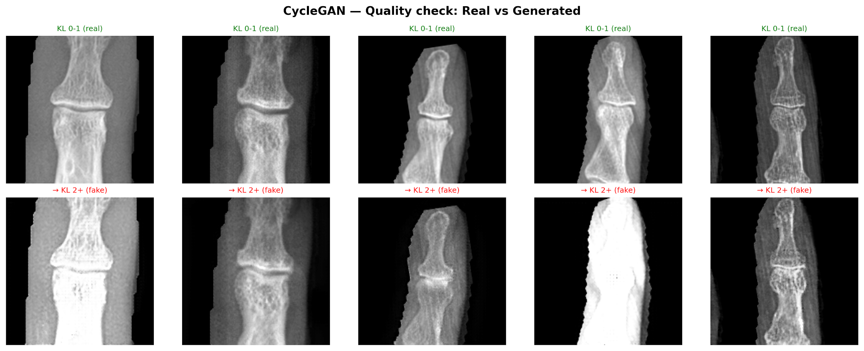
Figure 1: CycleGAN cycle-consistency demonstration. Row 1: healthy DIP joints (KL 0–1) translated to diseased appearance (KL 2+) and reconstructed. Row 2: diseased joints (KL 2+) translated to healthy appearance and reconstructed.

4.2.5 Generation
A total of 300 diseased and 300 healthy images are produced using seed 42 for reproducibility. All diseased images are labeled KL 2+ (no grade conditioning is possible with CycleGAN). Images are generated at 180×180 resolution matching the real data.

4.3 Latent Diffusion Model (Primary Generative Model)

4.3.1 VAE Architecture
The VAE compresses 180×180×1 grayscale images to 22×22×8 latent representations through three stride-2 downsampling steps (180→90→45→22). The encoder applies ResBlocks at each spatial resolution with self-attention at the 22×22 bottleneck. The decoder mirrors this with transposed convolutions, using output_padding=1 on the first upsample to recover the non-power-of-two dimension. Configuration: base_ch = 48, latent_ch = 8, KLD weight = 0.003 (linear warmup over first 50% of training), gradient loss weight = 0.25. Trained for 50 epochs, batch size 16, Google Colab (NVIDIA T4 GPU), total training time 209.7 minutes.
L_VAE = L_recon + λL_KLD + γL_grad (5)
where L_recon is the L1 pixel-level reconstruction loss between the input and reconstructed image; L_KLD = −½Σ(1 + logσ² − μ² − σ²) is the Kullback–Leibler divergence that regularizes the latent distribution toward ᵊ9(0, I); and L_grad is a gradient difference penalty that sharpens edge fidelity. Weights are set empirically to λ = 0.003 (applied with linear warmup over the first 50% of training) and γ = 0.25.

The complete architecture, illustrating the VAE encoder, latent space, UNet denoiser with KL grade and timestep conditioning, and VAE decoder, is depicted in Figure 2 below.
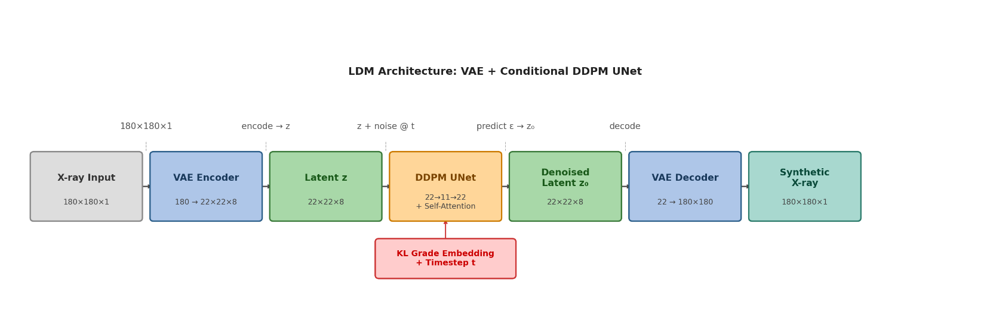
Figure 2: LDM architecture. The VAE encoder compresses 180×180×1 X-rays to a 22×22×8 latent space. During training, noise is added to the latent at step t and the DDPM UNet predicts it, conditioned on the KL grade embedding and sinusoidal timestep. At inference, the denoised latent is passed to the frozen VAE decoder to reconstruct the synthetic X-ray.

4.3.2 Conditional UNet
The UNet denoiser operates in the 22×22×8 latent space with one MaxPool downsampling step (22→11) and self-attention at 11×11 resolution. KL grade conditioning uses a learned embedding (5 grade tokens + 1 null token, 10% dropout for classifier-free guidance) injected via scale-and-shift at every UNet block alongside sinusoidal timestep embeddings. Configuration: base_ch = 96, T = 1000 diffusion steps, linear beta schedule (β₁ = 1×10⁻⁴ to β_T = 0.02). Trained for 150 epochs, Adam (lr = 2×10⁻⁴), cosine schedule, batch size 16, Google Colab (NVIDIA T4 GPU), total training time 150.7 minutes.
L_LDM = Eₙ,ₓ₀,ε [‖ε − ε_θ(xₜ, t, c)‖²] (6)
where ε ∼ ᵊ9(0, I) is the noise added to the latent at step t; ε_θ is the UNet noise-prediction network parameterized by θ; xₜ is the noisy latent at timestep t obtained via the forward diffusion process; t is sampled uniformly from {1, …, T} with T = 1000; and c is the KL grade conditioning signal (grade index 0–4, or a null token for unconditional passes). At inference, classifier-free guidance interpolates between conditional and unconditional noise predictions with scale s = 4.0 for KL 0–2 and s = 6.0 for KL 3–4, as shown in equation (7).
ε̃ = ε_θ(xₜ, t, ∅) + s·(ε_θ(xₜ, t, c) − ε_θ(xₜ, t, ∅)) (7)

Figure 3 shows the training loss curves for both components. The VAE (left) converges within the first 10 epochs and achieves near-identical train and validation loss (~0.021) by epoch 15, with no overfitting throughout the 50-epoch run. This reflects the relatively straightforward reconstruction task in pixel space. The LDM (right) requires more epochs to stabilize given the complexity of learning noise prediction across 1,000 timesteps. Both train and validation loss converge to ~0.233–0.245 by epoch 30 and remain close thereafter, confirming the model generalizes without memorizing the training set.
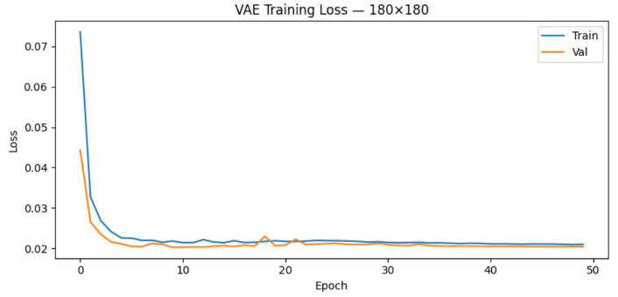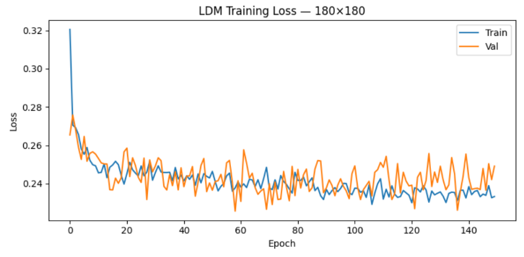
Figure 3: Training loss curves. Left: VAE (50 epochs), rapid convergence with train/val gap < 0.001, indicating no overfitting. Right: LDM DDPM UNet (150 epochs), stable convergence with train/val gap ~0.012, confirming good generalization.
In plain terms: the VAE is trained at approximately 3.5 hours because it simply compresses and reconstructs images pixel by pixel. The LDM takes 2.5 hours because it must master noise prediction across 1,000 timesteps, a harder optimization task. Crucially, both models converge without overfitting: the train and validation losses track closely throughout training, confirming that neither model has memorized the training set.

4.3.3 Generation Strategy
Two generation procedures are applied depending on the target grade:
- KL 0/1/2: Generated from pure Gaussian noise via DDPM reverse sampling, classifier-free guidance scale = 4.0.
- KL 3/4: A real KL 0/1/2 training image is encoded through the frozen VAE, noise is injected at 60% strength (t = 600), and the latent is denoised toward the target grade with guidance scale = 6.0. This preserves authentic bone anatomy while adding disease-specific features. Per clinical guidance, synthesis proceeds from KL 0–2 sources only and never chains KL 3 → KL 4.
A total of 300 images per grade (1,500 total) are generated at 180×180. Figure 4 illustrates the complete pipeline.
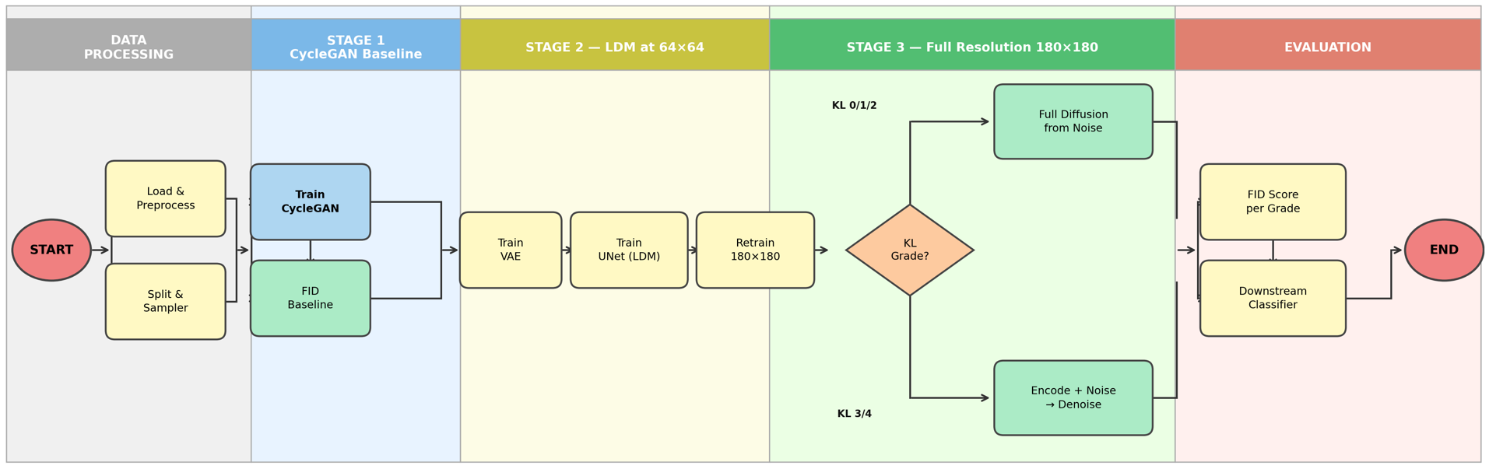
Figure 4: Algorithm pipeline covering Data Processing, CycleGAN Baseline, LDM 64×64 (Stages 1–2), LDM 180×180 (Stage 3), and Evaluation stages. Shaded boxes indicate trained modules; arrows denote data flow.

4.3.4 Development Stages
The diffusion model was developed across three iterative stages:
- Stage 1 (64×64, standalone): Each grade generated independently from noise. Validated pipeline correctness; limited by high (16:1) latent compression.
- Stage 2 (64×64, progressive): Each grade generated by conditioning on the prior grade (KL 0 → KL 1 → … → KL 4). Achieved substantially better FID (114–131 vs. 163–188) and improved KL 4 classifier accuracy (80% vs. 37%).
- Stage 3 (180×180, real-image-sourced): Final approach. KL 0/1/2 from noise; KL 3/4 from real-image encoding. The deeper VAE captures fine OA detail including osteophytes and joint space asymmetry.

4.4 Evaluation Framework

4.4.1 Visual Fidelity
Fréchet Inception Distance (FID) is computed per KL grade, with real images at matching resolution as the reference distribution.

4.4.2 Classifier Sanity Check
A ResNet-18 classifier trained on real images is applied to generated outputs to verify that grade conditioning is effective.

4.4.3 Downstream Evaluation
ResNet-18 is retrained with synthetic images mixed into the real training set at ratios of 10%, 25%, 50%, 100%, and 200% of the real count per class. Test AUC is compared to the real-only baseline. Each configuration is replicated three times.

5. Results

5.1 Experiment Plan
We evaluate synthetic data utility through three experiments, each run 3× with seeds 42, 123, and 456 to report mean ± std. All experiments use the same held-out test set (1,979 images, 526 patients), which is never used during training or generation.
Experiment 1: Generation quality. We assess whether the generative models produce visually and statistically realistic images using FID per KL grade and side-by-side visual comparison between real and synthetic X-rays.
Experiment 2: Binary classification (CycleGAN vs Diffusion). Both models generate “diseased” images (KL 2+), which are mixed into real training data at ratios of 10%, 25%, 50%, 100%, and 200%. A ResNet-18 classifier is retrained for each configuration and evaluated on binary AUC (KL 0–1 vs KL 2+). This is the only task where CycleGAN and diffusion can be fairly compared, since CycleGAN has no per-grade control.
Experiment 3: Five-class classification (Diffusion only). Diffusion-generated images for all 5 KL grades are mixed into training at the same ratios. CycleGAN is structurally excluded, its architecture has no label input and cannot generate grade-specific images. We report macro AUC and per-class AUC, with particular attention to KL 3 and KL 4.
In total, we run 51 classifier training experiments: 2 baselines (binary + 5-class) × 3 seeds = 6, plus CycleGAN binary (5 ratios × 3 seeds = 15), diffusion binary (15), and diffusion 5-class (15).

5.2 Baseline Classifier
All downstream experiments use the same classifier: ResNet-18 pretrained on ImageNet (1.2M natural images, 1,000 classes). We adapt it for hand OA classification through transfer learning:
Architecture. The final fully-connected layer (originally 512→1,000) is replaced with 512→2 for binary or 512→5 for five-class. All preceding convolutional layers retain their ImageNet weights as initialization and are fine-tuned end-to-end, no layers are frozen. Input images are kept at their native 180×180 resolution; ResNet-18's adaptive average pooling layer reduces any spatial size to 1×1 before the FC head, so upscaling to 224×224 is unnecessary.
Input preprocessing. Grayscale images are replicated to 3 channels to match the pretrained model's expected input. Pixel values are normalized using training-set statistics (μ=0.2339, σ=0.2349). Train-time augmentation includes random rotation (±15°), horizontal flip (50%), random zoom (0.9–1.1×), and brightness/contrast jitter (±10%). No augmentation is applied to validation or test sets.
Class imbalance handling. Two complementary strategies address the 50:1 KL 0 vs KL 4 imbalance. First, weighted cross-entropy loss assigns inverse-frequency weights per class so misclassifying a rare KL 4 image is penalized ~50× more than misclassifying KL 0. Second, WeightedRandomSampler constructs balanced mini-batches during training, ensuring each batch contains approximately equal representation across grades regardless of their natural frequency.
Optimization. Adam optimizer (lr=1×10⁻⁴), cosine annealing learning rate schedule over max 50 epochs, batch size 32. Early stopping with patience of 10 epochs monitors validation AUC, training halts if no improvement is observed for 10 consecutive epochs. The model checkpoint with the highest validation AUC is restored for test evaluation.
Reproducibility. Every experiment is run 3× with seeds 42, 123, and 456 controlling weight initialization, data shuffling, and augmentation randomness. We report mean ± std AUC across the three runs.

The baseline establishes the AUC that synthetic augmentation must beat.
Task | AUC | ± std | Macro F1
Binary (KL 0–1 vs KL 2+) | 0.9598 | 0.0014 | 0.912
5-class (KL 0/1/2/3/4) | 0.8779 | 0.0148 | 0.741
Table 4: Baseline classifier performance trained on real data only (3 seeds).
5-class per-seed results: seed 42 = 0.8584, seed 123 = 0.8809, seed 456 = 0.8944.
Binary per-seed: seed 42 = 0.9602, seed 123 = 0.9579, seed 456 = 0.9613.
5-class per-class AUC (averaged across seeds): KL 0 = 0.933, KL 1 = 0.758, KL 2 = 0.915, KL 3 = 0.927, KL 4 = 0.856. KL 1 (“doubtful OA”) is the weakest, consistent with clinical ambiguity at this grade. KL 3 and KL 4 achieve reasonable AUC despite having only 144 and 118 training images respectively, but both have room for improvement.
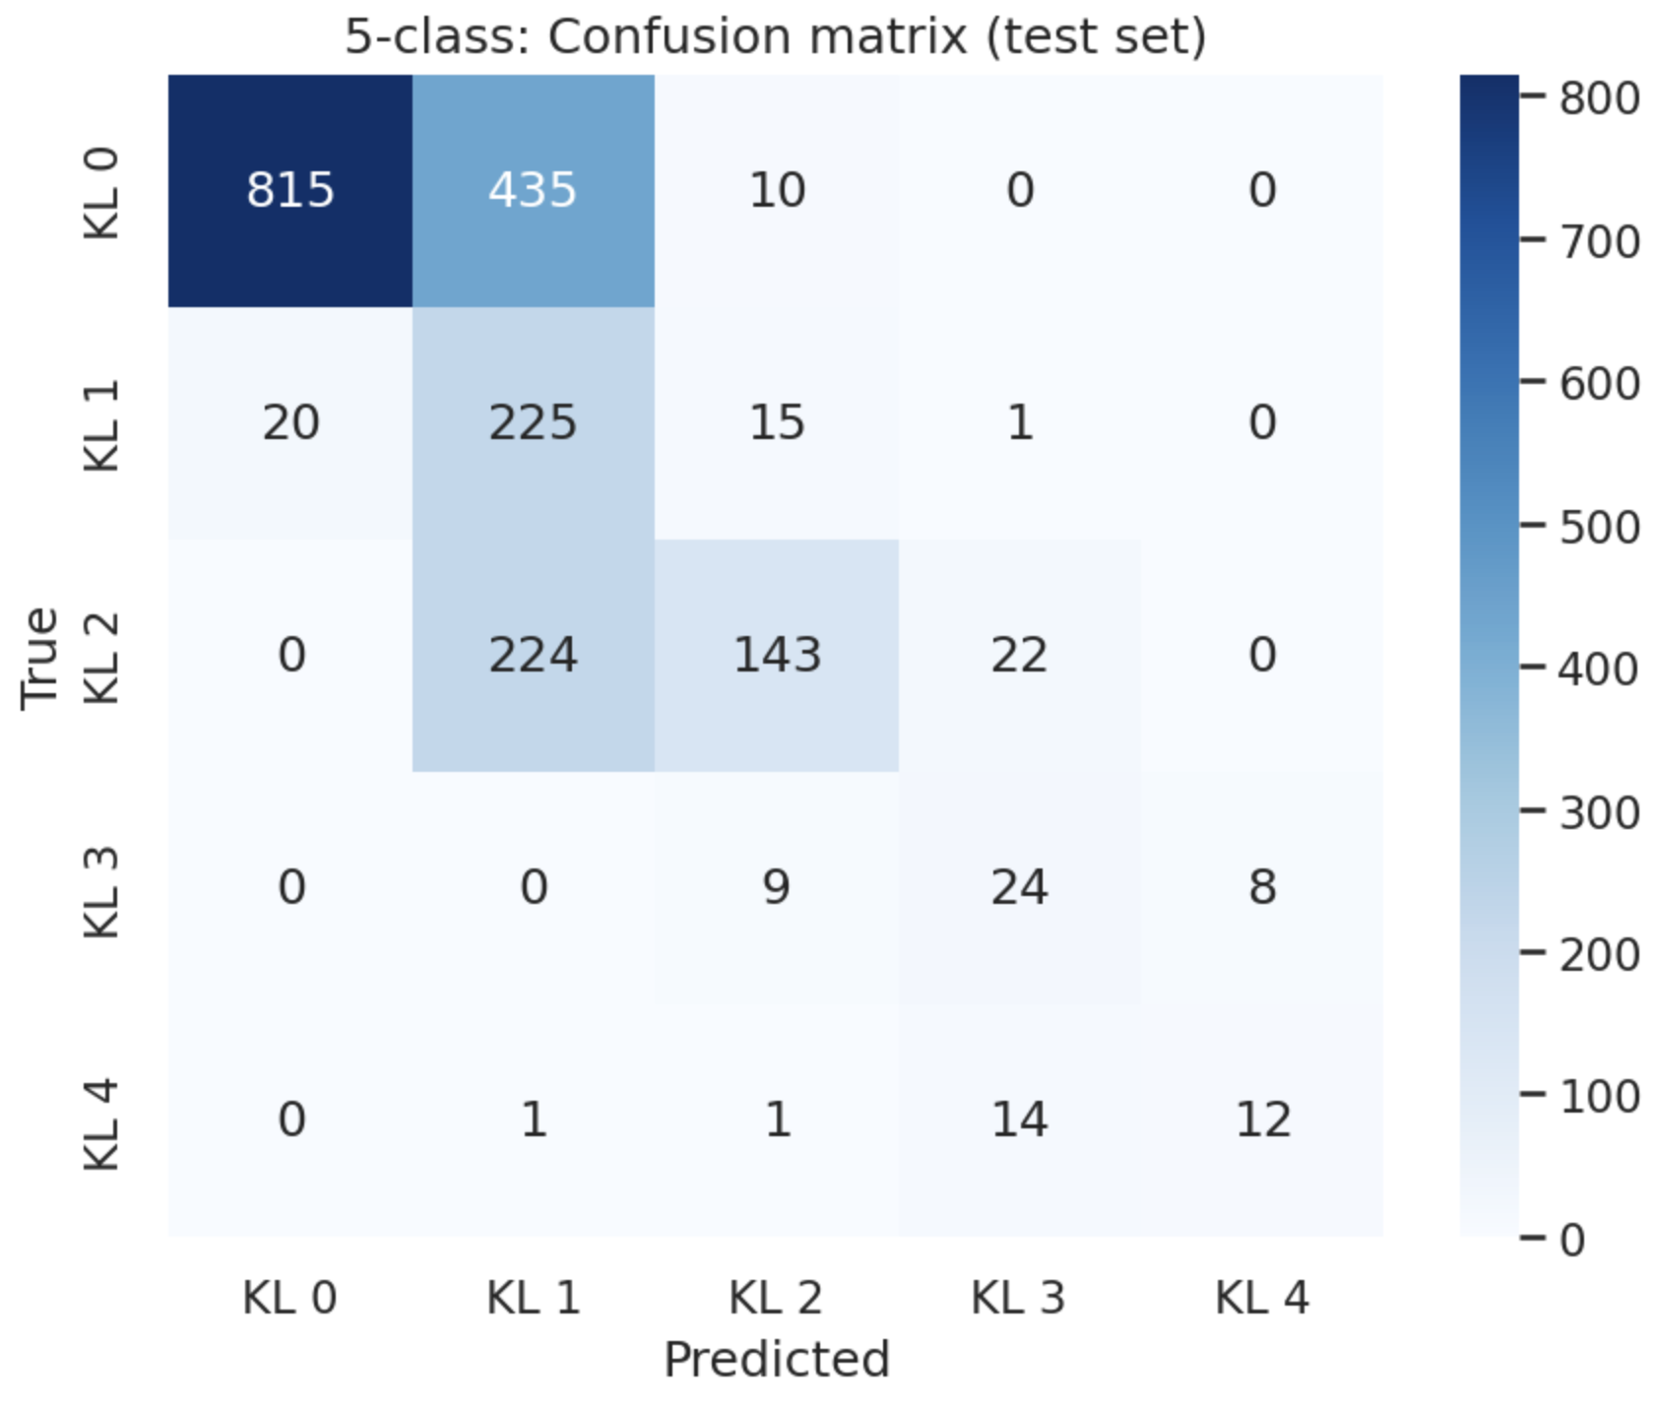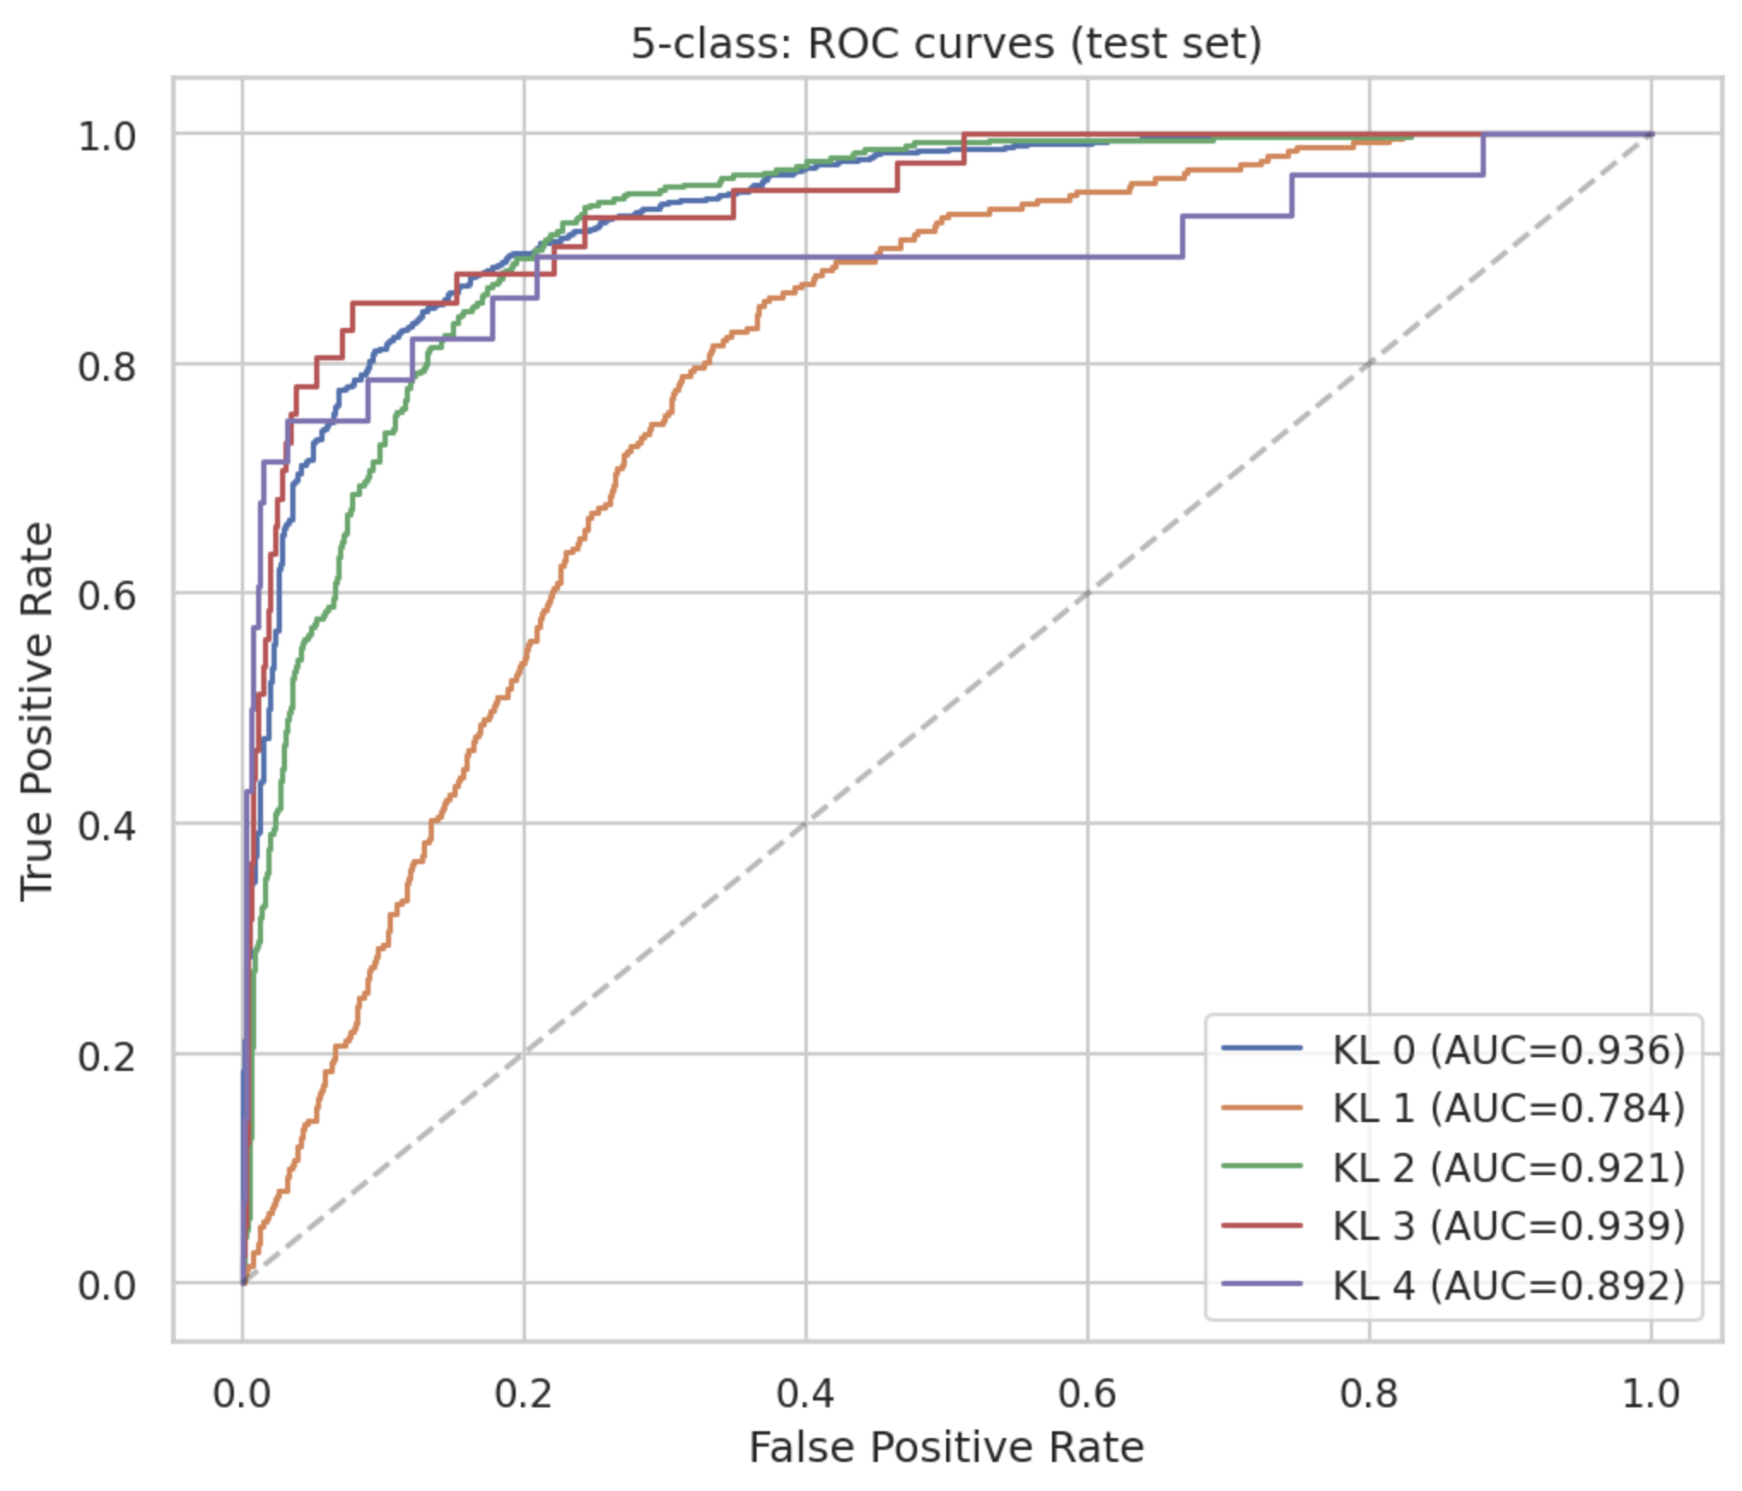
Figure 5: Baseline ROC curves (5-class, one curve per KL grade) (left). Baseline confusion matrix (5-class) (right).

5.3 Generation Quality (180×180)

5.3.1 FID per KL Grade
KL Grade | FID ↓ | Real Train | Synthetic | Generation Method
KL 0 | 145.53 | 5,947 | 300 | From noise (guidance = 4.0)
KL 1 | 145.85 | 1,220 | 300 | From noise (guidance = 4.0)
KL 2 | 144.91 | 1,770 | 300 | From noise (guidance = 4.0)
KL 3 | 139.57 | 144 | 300 | From real KL 0/1/2 (strength=0.6, guidance=6.0)
KL 4 | 152.36 | 118 | 300 | From real KL 0/1/2 (strength=0.6, guidance=6.0)
Table 5: FID per KL grade for the 180×180 diffusion model. Lower is better.
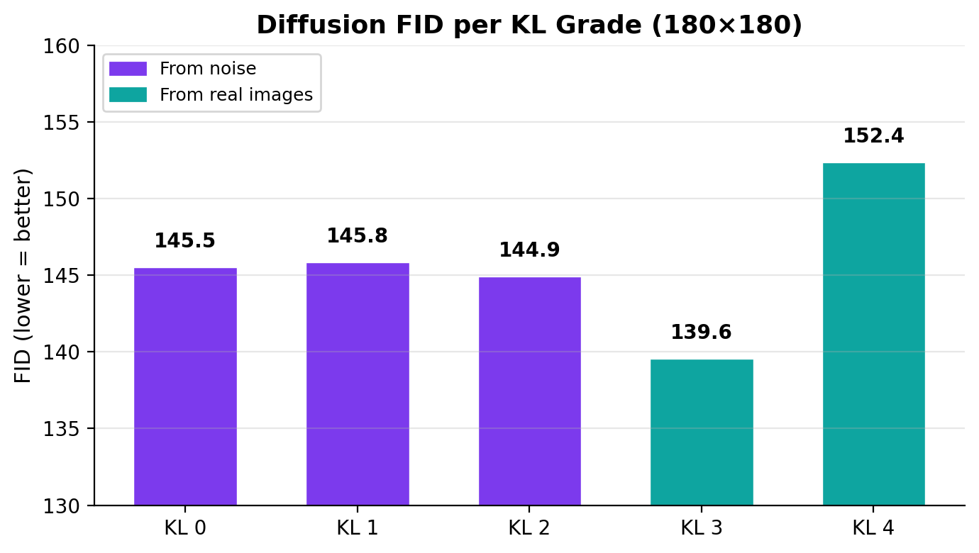
Figure 6: FID per KL grade. Purple = from noise, teal = from real images. KL 3 achieves the lowest FID.
FID values are consistent across grades (range 139.6–152.4), indicating no single grade is failing. KL 3 achieves the lowest (best) FID at 139.57 despite being one of the rarest grades in training, attributable to the real-image-sourced generation approach, which anchors synthetic images on authentic bone structure.

5.3.2 Visual Comparison
At KL 0, generated joints show clear joint space and smooth bone edges. At KL 3 and KL 4, osteophytes and joint space narrowing are visible, the model has learned grade-specific disease features. A visible progression from KL 0 through KL 4 confirms that the KL conditioning is working as intended.
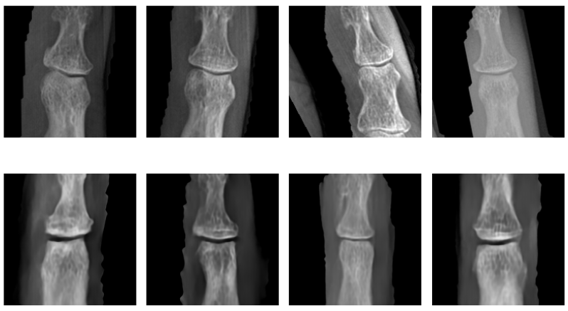
KL 0 — Normal
Healthy joint: intact cartilage, no osteophytes, normal bone margins. Top row: real DIP X-rays. Bottom row: LDM-generated synthetic images.

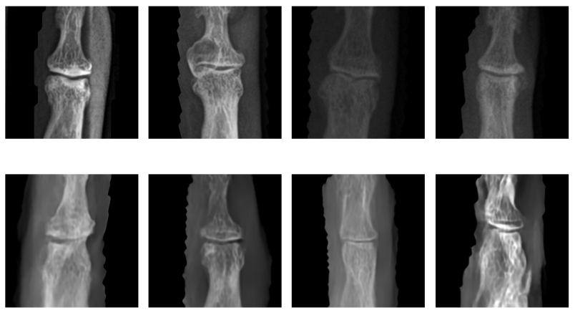
KL 1 — Doubtful
Possible osteophytic lipping at joint margins; minimal joint space narrowing. Top row: real. Bottom row: LDM-generated synthetic images.

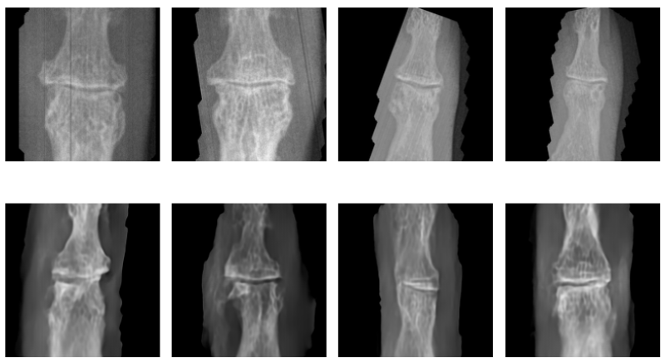
KL 2 — Mild
Definite osteophyte formation; possible joint space narrowing visible. Top row: real. Bottom row: LDM-generated synthetic images.

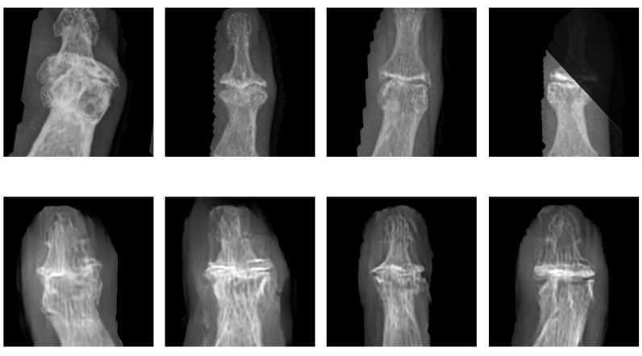
KL 3 — Moderate
Multiple osteophytes, definite joint space narrowing, mild subchondral sclerosis. Top row: real. Bottom row: LDM-generated (seeded from real KL 0–2 images).
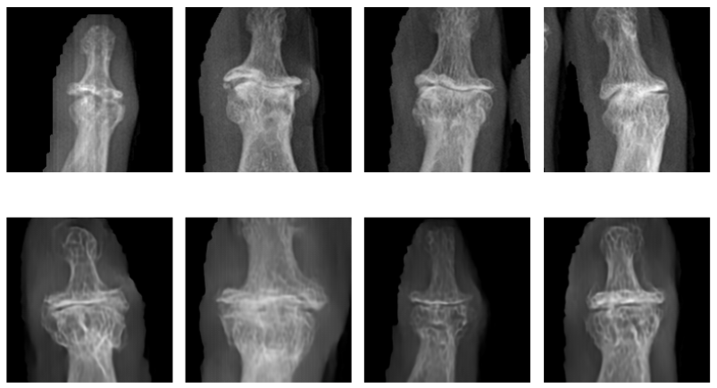
KL 4 — Severe
Large osteophytes, marked joint space loss, severe subchondral sclerosis, visible bony deformity. Top row: real. Bottom row: LDM-generated (seeded from real KL 0–2 images).
Figure 7: Representative DIP joint X-rays per KL grade (0–4). Each panel shows a 4×2 grid: the top row contains real patient radiographs and the bottom row contains LDM-generated synthetic images conditioned on that grade. KL 0–2 are generated from Gaussian noise via DDPM reverse diffusion; KL 3–4 are seeded from real KL 0–2 images re-noised at 60% strength (t = 600) to preserve authentic bone anatomy.

5.4 Downstream Evaluation: Binary Classification

5.4.1 Results
Configuration | AUC | ± std | Δ Baseline
Baseline (real only) | 0.9598 | 0.0014 | —
+ CycleGAN 10% | 0.9591 | 0.0006 | −0.0007
+ CycleGAN 25% | 0.9588 | 0.0007 | −0.0010
+ CycleGAN 50% | 0.9594 | 0.0012 | −0.0004
+ CycleGAN 100% | 0.9604 | 0.0006 | +0.0006
+ CycleGAN 200% | 0.9593 | 0.0014 | −0.0005
+ Diffusion 10% | 0.9611 | 0.0014 | +0.0013
+ Diffusion 25% | 0.9600 | 0.0011 | +0.0002
+ Diffusion 50% | 0.9599 | 0.0028 | +0.0001
+ Diffusion 100% | 0.9604 | 0.0019 | +0.0006
+ Diffusion 200% | 0.9613 | 0.0001 | +0.0015
Table 6: Binary ablation results. Each row is the mean of 3 runs with different seeds.
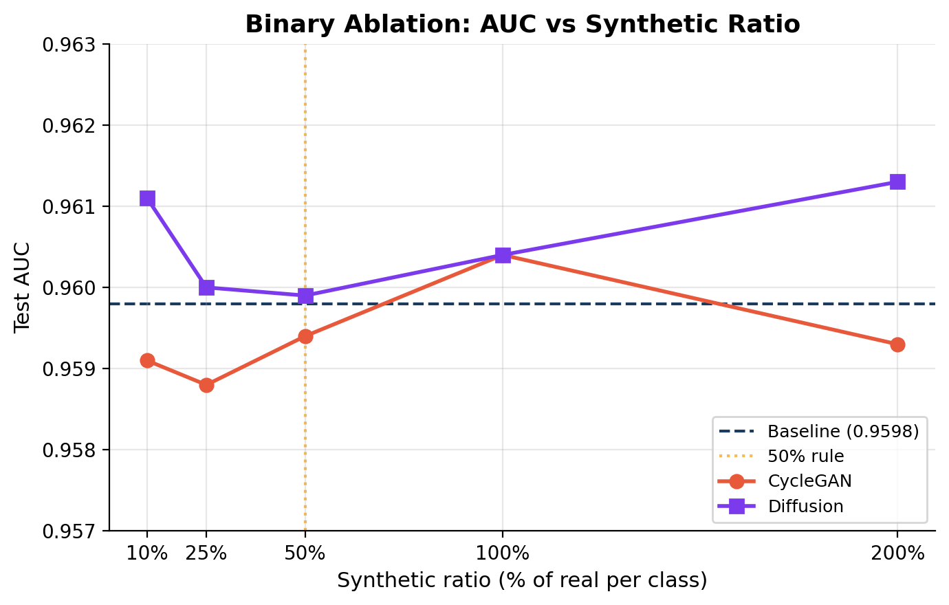
Figure 8: Binary AUC vs synthetic ratio. Dashed line = baseline. Orange line = 50% threshold.

5.4.2 Analysis
CycleGAN synthetic data provides no reliable improvement at any ratio, fluctuating around the baseline with slight degradation at most ratios (best: +0.0006 at 100%). Diffusion synthetic data never hurts and achieves a consistent, small positive effect, with its best result at 200% (+0.0015).
The modest improvement is expected. The binary baseline AUC of 0.9598 is near ceiling, leaving only 0.04 room for improvement. With 13,176 real images, the classifier already separates healthy from diseased effectively. Binary OA detection is a coarse distinction, the visual gap between KL 0 and KL 2+ is large. Synthetic augmentation provides larger gains when the original data is insufficient for the task’s complexity, which is not the case for binary detection on this dataset. The more meaningful evaluation is the 5-class task, where data scarcity for rare grades creates a genuine bottleneck.

5.5 Downstream Evaluation: Five-class Classification

5.5.1 Results
Configuration | AUC | ± std | Δ Baseline
Baseline (real only) | 0.8779 | 0.0148 | —
+ Diffusion 10% | 0.8807 | 0.0098 | +0.0028
+ Diffusion 25% | 0.8764 | 0.0072 | −0.0015
+ Diffusion 50% | 0.8860 | 0.0064 | +0.0081
+ Diffusion 100% | 0.8932 | 0.0131 | +0.0153
+ Diffusion 200% | 0.9078 | 0.0010 | +0.0299
Table 7: Five-class ablation results. Monotonic improvement from 50% onward; best at 200% (+0.030 AUC).
CycleGAN is excluded from this experiment, its architecture has no label input and cannot generate grade-specific images. This is a structural limitation, not a tuning issue: the two generators (G_AB, G_BA) only learn a single mapping between two domains.
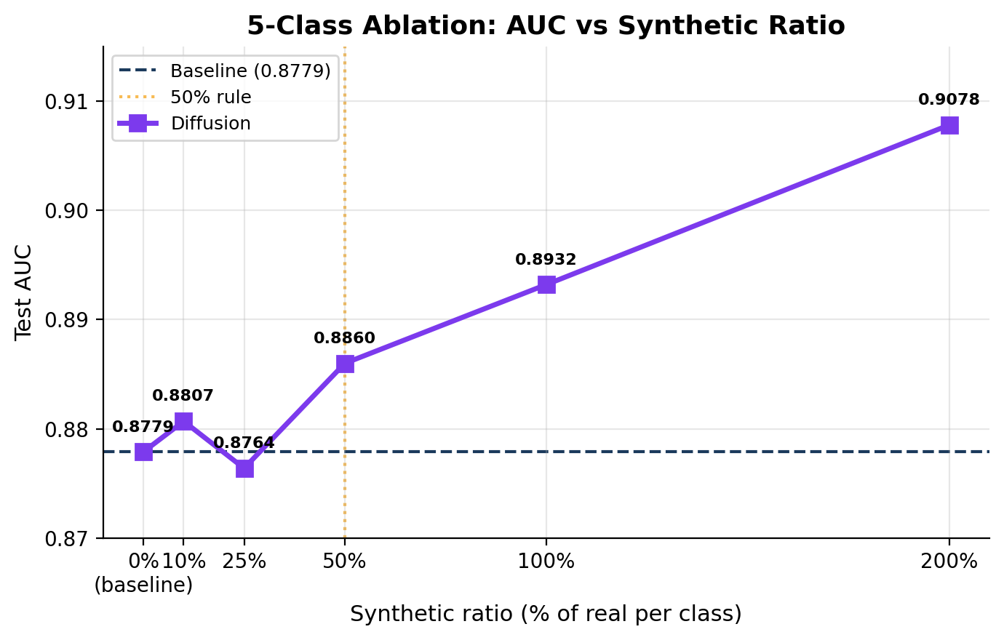
Figure 9: Five-class AUC vs synthetic ratio. Dashed line = real-only baseline.

5.5.2 Analysis
Performance improves monotonically from 50% onward, reaching 0.9078 at 200%, a gain of +0.030 AUC over the baseline. The 25% dip (−0.0015) is within noise (std = 0.0072 at that ratio). Notably, the standard deviation drops from 0.0148 at baseline to 0.0010 at 200%, indicating synthetic data not only improves performance but stabilizes training by providing more diverse examples of rare pathology.
The best result occurs at 200%, beyond the recommended 50% synthetic cap. This is not contradictory: for KL 3 with 144 real images, adding 288 synthetic at 200% brings the total to 432, still far below KL 2’s 1,770 real images. For genuinely rare classes, more aggressive augmentation is justified because absolute counts remain small.

5.5.3 Per-class Improvement (Averaged Across Seeds)

KL Grade | Baseline | +Diff 50% | Δ | +Diff 200% | Δ | Real Train
KL 0 | 0.933 | 0.936 | +0.003 | 0.938 | +0.005 | 5,947
KL 1 | 0.758 | 0.756 | −0.002 | 0.781 | +0.023 | 1,220
KL 2 | 0.915 | 0.920 | +0.005 | 0.924 | +0.008 | 1,770
KL 3 | 0.927 | 0.957 | +0.030 | 0.969 | +0.041 | 144
KL 4 | 0.856 | 0.861 | +0.005 | 0.928 | +0.072 | 118
Table 8: Per-class AUC averaged across 3 seeds. Improvement inversely proportional to real data.
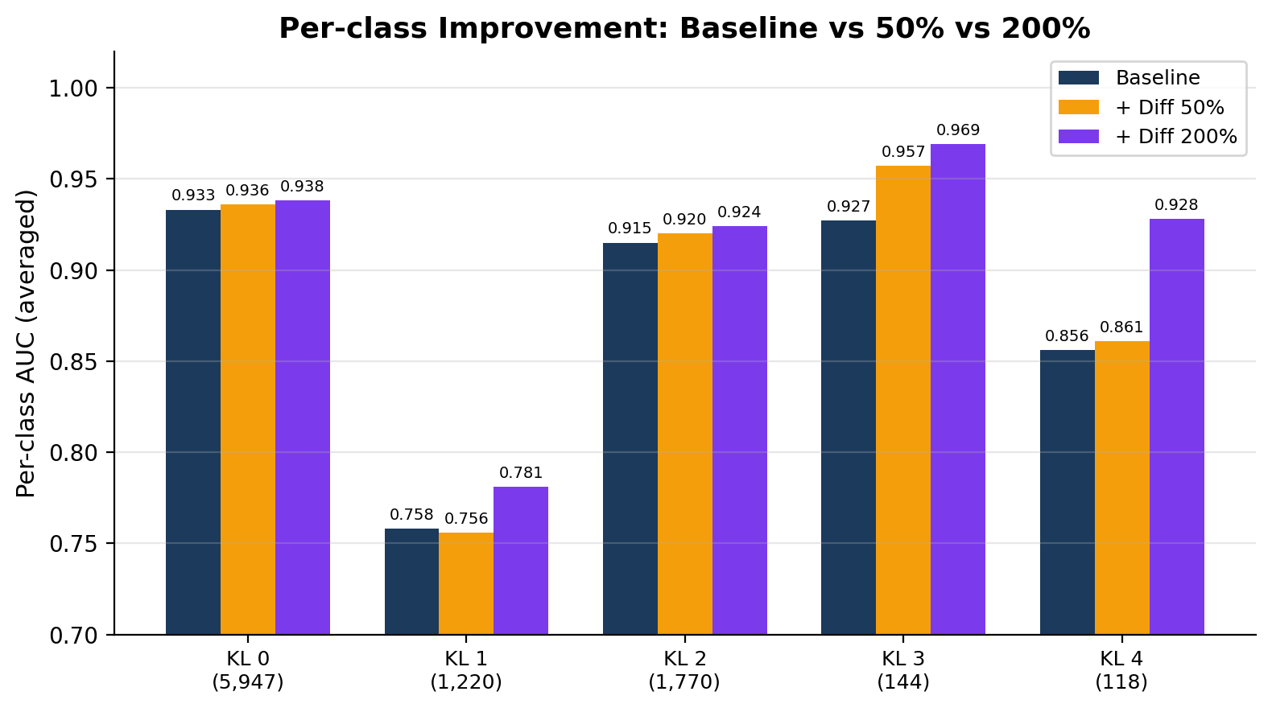
Figure 10: Per-class AUC at baseline, 50%, and 200%.
KL 4 (118 real images) gains +0.072 AUC at 200%, the largest improvement. KL 3 (144 images) gains +0.041. KL 0 (5,947 images) gains only +0.005. The pattern confirms synthetic augmentation benefits rarest classes most. At 50%, KL 3 already gains +0.030 while KL 4 shows +0.005, the stronger KL 4 gain requires more synthetic data (200%) to overcome its extreme scarcity.

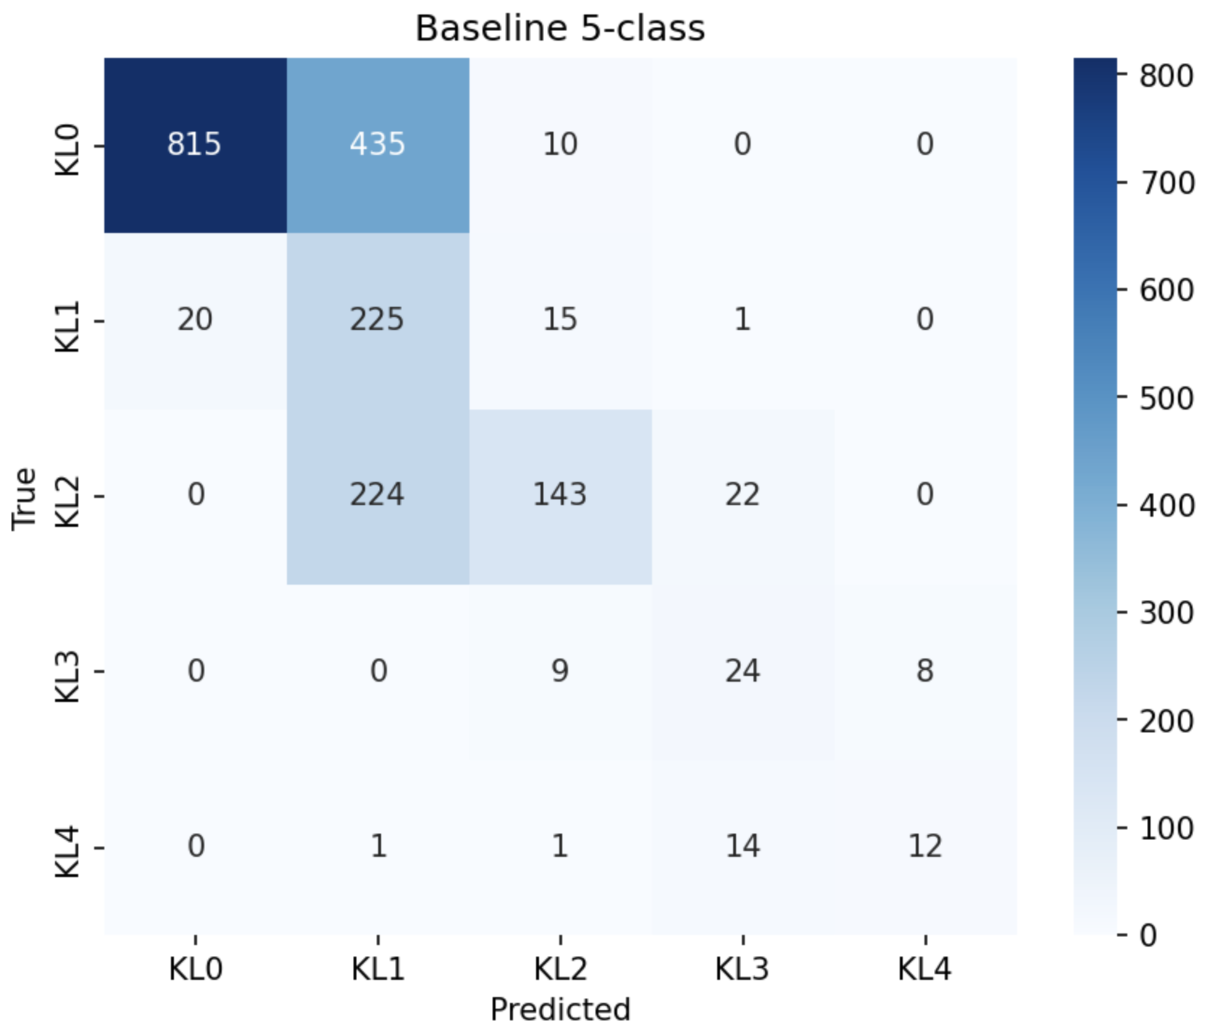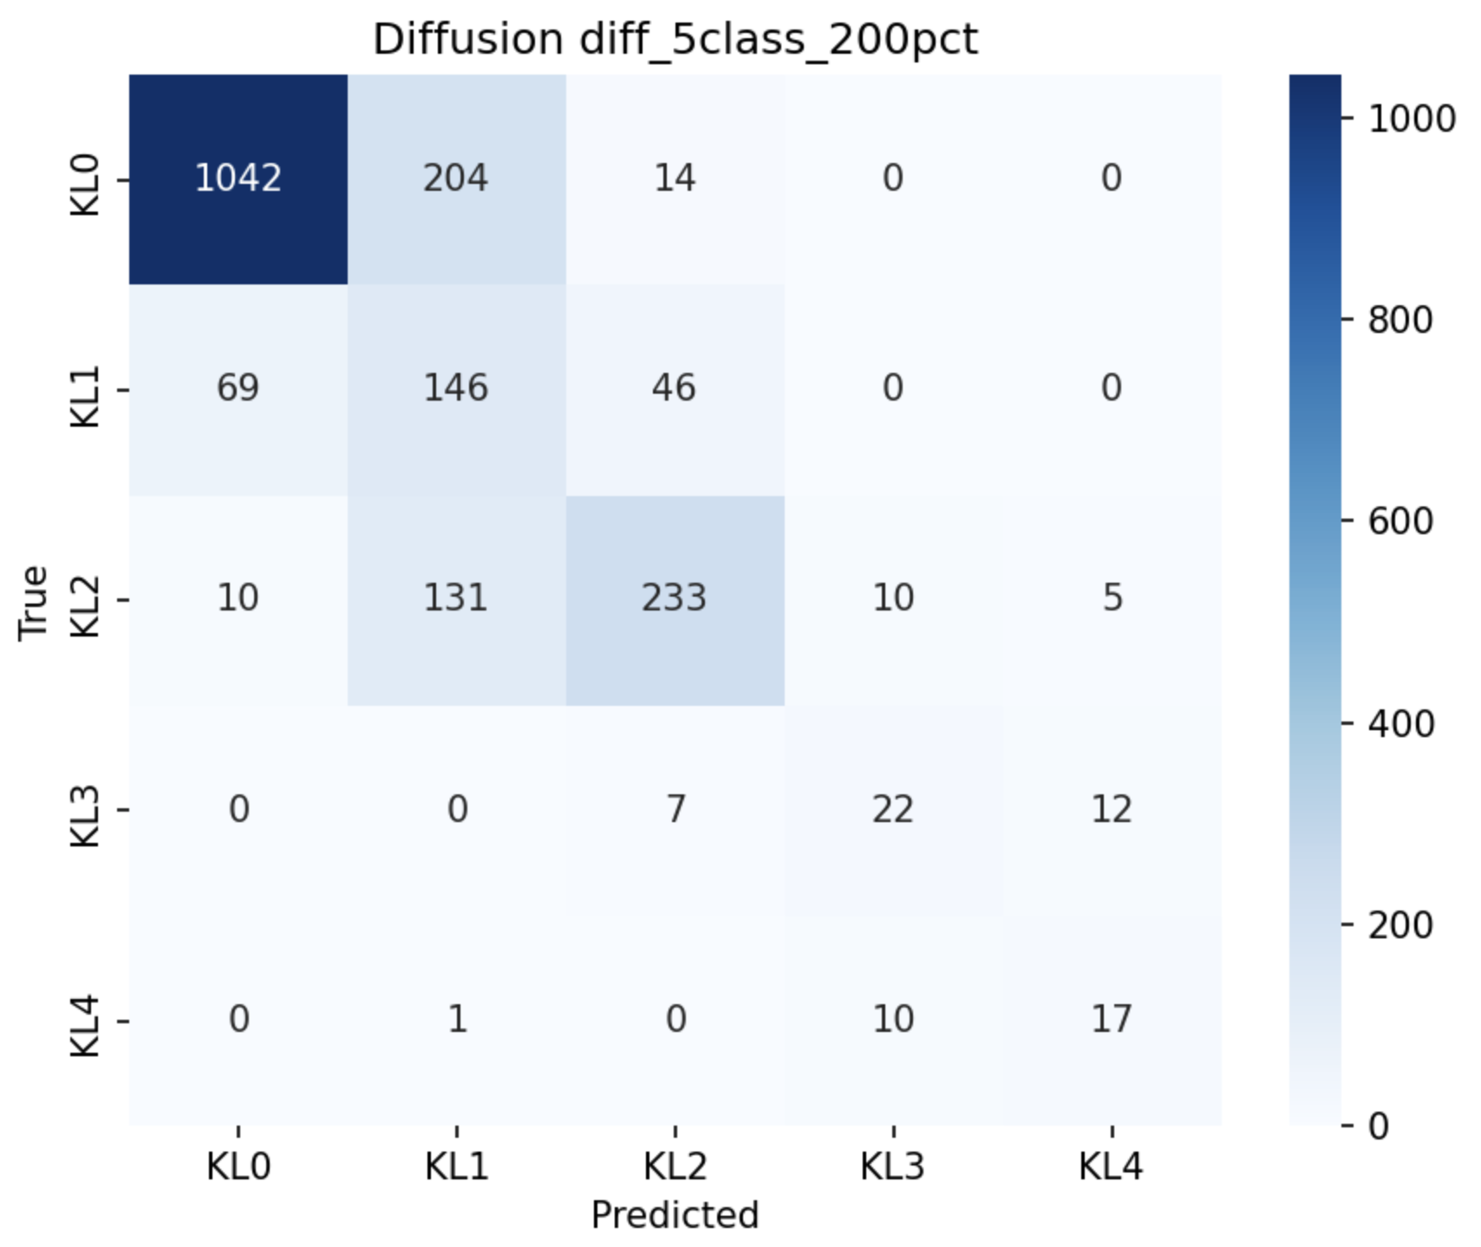
Figure 11: Confusion matrices side by side: baseline (left) vs diffusion 200% (right). Note improved classification of KL 3 and KL 4 in the augmented model.

5.5.4 Per-seed Stability
To verify improvements are not due to randomness:
Seed | Baseline | +Diff 50% | Δ | +Diff 200% | Δ
42 | 0.8584 | 0.8905 | +0.032 | 0.9071 | +0.049
123 | 0.8809 | 0.8905 | +0.010 | 0.9092 | +0.028
456 | 0.8944 | 0.8769 | −0.018 | 0.9071 | +0.013
Mean±std | 0.8779 ± 0.015 | 0.8860 ± 0.006 | +0.008 | 0.9078 ± 0.001 | +0.030
Table 9: Per-seed results. At 50%: 2/3 seeds improve. At 200%: all 3 seeds improve.
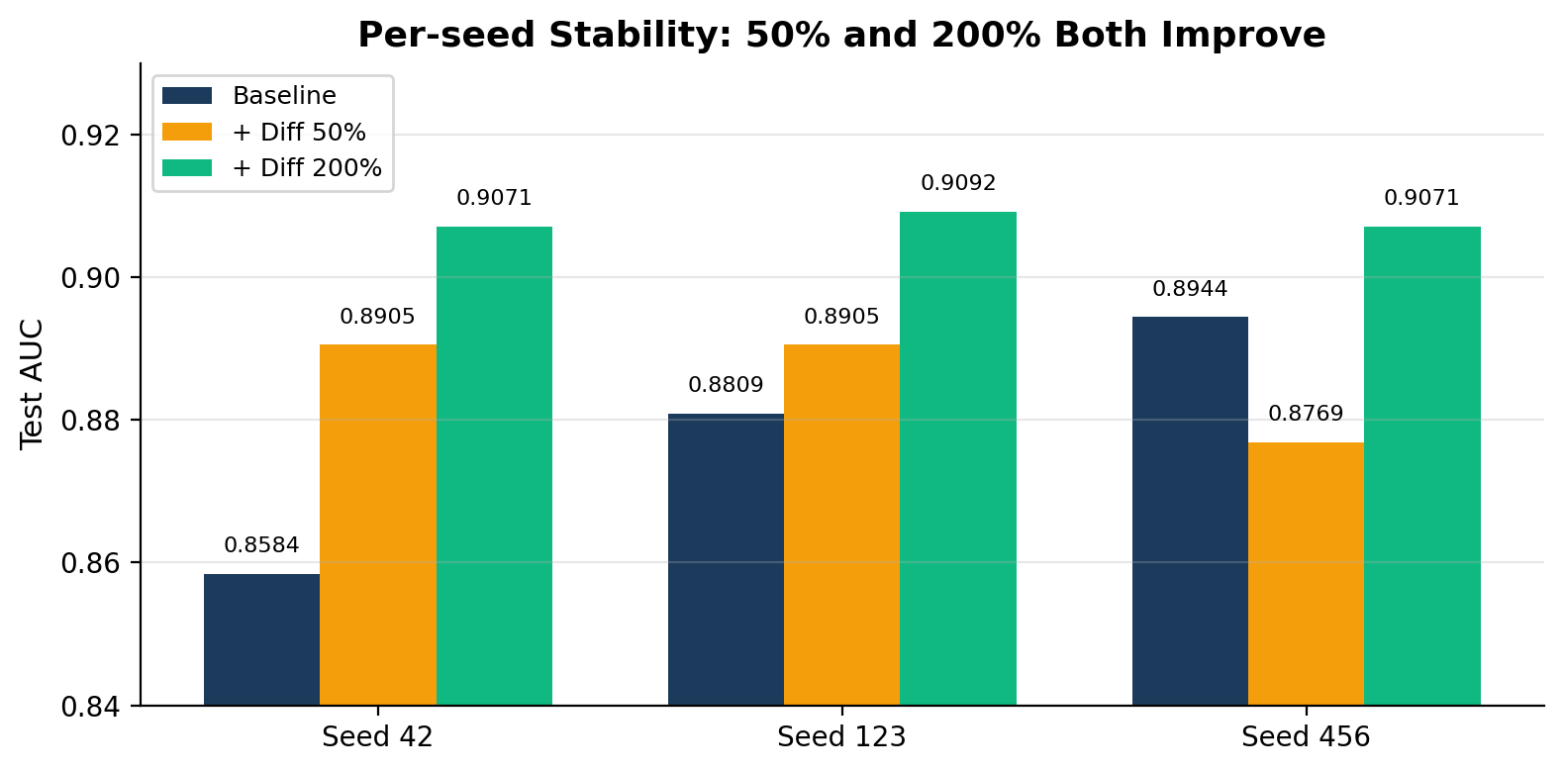
Figure 12: Per-seed stability at 50% and 200%.
At 200%, all three seeds show consistent improvement (+0.013 to +0.049), with dramatically lower variance (0.001 vs 0.015). At 50%, 2 of 3 seeds improve, seed 456 dips slightly (−0.018) but recovers at higher ratios. The consistently positive result at 200% across all seeds confirms the improvement is stable and reproducible.

6. Discussion

6.1 Diffusion vs. CycleGAN
The comparison reveals a fundamental architectural distinction. CycleGAN’s two-generator design (G_AB, G_BA) operates on domain boundaries without any grade-conditioning input and cannot distinguish KL 2 from KL 3 from KL 4. This is a structural limitation, not a tuning issue. The LDM injects a KL grade embedding at every UNet layer via scale-and-shift, enabling fine-grained grade-specific synthesis and participation in five-class evaluation. Even on the binary task, the LDM outperforms CycleGAN at the same 200% augmentation ratio (AUC 0.9613 vs. 0.9593), and visual inspection reveals CycleGAN images exhibit distorted bone structure at severe grades.

6.2 Why Binary Improvement Is Modest
The binary baseline (AUC = 0.9598) is near ceiling. With 13,176 real images already available, the classifier has sufficient examples for the coarse healthy-versus-diseased distinction. Synthetic augmentation yields the largest gains when the original dataset is insufficient for the task’s complexity binary detection on 13K images is not data-limited; per-grade KL grading with 118–144 severe-grade images is.

6.3 The 50% Synthetic Ratio Cap
Performance continues to improve at 100% and 200% ratios, exceeding the recommended 50% cap. This is not contradictory: the guideline is appropriate when real data is abundant. For KL 3 (144 real images), adding 288 synthetic at 200% brings the total to 432, still far below KL 2’s 1,770 real images. The variance reduction at 200% (std: 0.0148 → 0.0010) further suggests synthetic data stabilizes training for rare classes.

6.4 Real-Image-Sourced Generation
The Stage 3 strategy, encoding real KL 0/1/2 images and denoising toward KL 3/4, maintains anatomical plausibility by anchoring generation on real patient bone structure. This approach parallels IC-RDN [2], where patient identity is preserved via CNN fingerprinting. The lowest FID for KL 3 (139.6) empirically validates this design choice.

6.5 Limitations
- No external validation. All evaluation uses the same institutional dataset; generalization to other equipment, protocols, or populations is untested.
- FID limitations. FID is a widely used but imperfect proxy; perceptual similarity does not necessarily correlate with clinical utility.
- Ratio ceiling not established. Synthetic ratios above 200% were not tested; it is unknown whether gains plateau or degrade due to distributional shift.
- KL 1 grade ambiguity. KL 1 remains the weakest grade for both generation and classification, likely due to clinical labeling ambiguity.
- No non-generative baseline. Simple pixel-level oversampling or feature-space augmentation strategies were not compared as standalone baselines, making it difficult to isolate the contribution of generative synthesis specifically.

7. Conclusion
This paper demonstrates that class-conditional latent diffusion models can generate clinically plausible synthetic hand OA X-rays that measurably improve downstream classification of rare severe grades. The core findings are:
- Diffusion augmentation improves five-class KL grading from 0.878 to 0.908 AUC (+3.4%), with the largest per-class gain at KL 4 (+0.072 AUC).
- CycleGAN provides no reliable improvement and is structurally limited to binary classification.
- Improvement is inversely proportional to real data availability, confirming synthetic augmentation is most beneficial for the rarest classes.
- The 50% synthetic cap is conservative for severely imbalanced classes; performance improves at ratios up to 200%.
- Real-image-sourced generation preserves bone anatomy and achieves the lowest FID among all grades (KL 3: 139.6).
These findings carry practical implications for medical imaging in scarce-data settings: class-conditional diffusion is feasible on consumer cloud GPU hardware and can close the performance gap on clinically critical rare cases that conventional classifiers routinely miss.

7.1 Future Work
- Expand to DIP + PIP joints (~28K images) with joint-type conditioning.
- Test synthetic ratios above 200% to identify the saturation point.
- Evaluate stronger backbone classifiers (EfficientNet, Vision Transformer).
- Apply to public knee OA datasets (OAI) for external validation.
- Explainability analysis: identify which disease features the model learns to add at each grade.

8. References
[1] R. Rombach, A. Blattmann, D. Lorenz, P. Esser, and B. Ommer, “High-Resolution Image Synthesis with Latent Diffusion Models,” in Proc. IEEE/CVF CVPR, pp. 10684–10695, 2022.
[2] Y. Wu et al., “IC-RDN: Identity-Consistent Radiograph Diffusion Network for Knee OA Progression Simulation,” in Proc. ECCV, 2024.
[3] F. Prezja, S. Peltonen, and I. Niinimäki, “DeepFake Generation of Knee MRI and X-Ray for Osteoarthritis Analysis,” Scientific Reports, vol. 12, no. 1, 2022.
[4] F. Prezja et al., “CycleGAN for Bidirectional KL-Grade Translation in Knee Osteoarthritis,” 2025 (preprint).
[5] J.-Y. Zhu, T. Park, P. Isola, and A. A. Efros, “Unpaired Image-to-Image Translation Using Cycle-Consistent Adversarial Networks,” in Proc. IEEE ICCV, pp. 2223–2232, 2017.
[6] L. Butler et al., “Efficient Diffusion for Knee OA Risk Estimation with Class-Conditioned Latent Space,” 2025 (preprint).
[7] Y. Yeganeh et al., “Latent Drifting: Generating Counterfactual Medical Images with Limited Data,” in Proc. IEEE/CVF CVPR, 2025.
[8] C. Littlefield et al., “Few-Shot Augmentation Pipeline for Knee Radiographs,” J. Am. Med. Informatics Assoc. (JAMIA), 2024.
[9] C. Han et al., “Osteoarthritis Progression Prediction via Style-Based Manifold Extrapolation,” Nature Machine Intelligence, vol. 4, 2022.
[10] Z. Wang et al., “Diffusion-Based Morphing for Temporal Knee OA X-Ray Synthesis,” 2024 (preprint).
[11] C. Shi et al., “Diffusion Models for Medical Image Computing: A Survey,” 2025 (preprint).
[12] K. He, X. Zhang, S. Ren, and J. Sun, “Deep Residual Learning for Image Recognition,” in Proc. IEEE/CVF CVPR, pp. 770–778, 2016.
[13] T. K. Haugen, I. K. Haugen, E. A. Hammærø, T. Kvien, and T. Uhlig, “Prevalence, Incidence and Progression of Hand Osteoarthritis in the General Population: The Framingham Osteoarthritis Study,” Annals of the Rheumatic Diseases, vol. 70, no. 9, pp. 1581–1586, 2011.
[14] J. H. Kellgren and J. S. Lawrence, “Radiological Assessment of Osteo-Arthrosis,” Annals of the Rheumatic Diseases, vol. 16, no. 4, pp. 494–502, 1957.

