MET CS 790: Advanced Computer Vision
Project Proposal
Group 3
Track 3: Generative AI for Hand OA Disease Simulation
Team: Zulal Akarsu | Jai Sharma | Maria Martin
Team Leader: Zulal Akarsu
Date: March 28, 2026

1. Project Goal
Train a generative model to synthesize realistic hand X-ray images that simulate the progression of osteoarthritis (OA), conditioned on disease severity (KL grade). Given a healthy joint image (KL 0), the model should produce what that joint would look like at higher severity levels (KL 2, 3, or 4). We will evaluate success through both visual fidelity (do generated images look realistic?) and downstream utility (do synthetic images improve a classifier’s performance on rare severe cases?).

2. Preliminary Data Analysis

2.1 Dataset Summary
This report presents the statistical analysis of the Hand Osteoarthritis (HOA) dataset, a private collection developed in collaboration with Tufts Medical Center. The dataset contains 3,590 patients with hand X-rays captured at two timepoints over a 6-year period. A joint detection model (98.39% accuracy) has pre-extracted 41,061 individual joint ROI images from these X-rays.
Key data constraint: KL 3+4 represent only 2.5% of observations (1,056 out of 43,036). This class scarcity for severe OA is precisely what motivates the generative approach, synthetic data augmentation could address this imbalance.
Category | Detail | Value
Image Database | Total ROI images | 41,061
 | Image dimensions (median) | 180 × 180 px
 | Total size on disk | ~686 MB zipped
 | File size per image (median) | ~18 KB
 | Joints per hand | 12 (DIP 2-5, PIP 2-5, MCP 2-5)
 | Working subset | DIP joints only (~14K images)
Clinical Data | Patients | 3,590
 | Columns (wide format) | 275
 | Long format records | 86,075
 | Timepoints | v00 (baseline) + v06 (6-year)
 | Patients with both timepoints | 3,588 (99.9%)
 | Scoring systems | KL, JSN, OP, ER, PW, ME, CY
 | Missing values | 51,290 (5.2% overall)

2.2 Clinical Scoring Systems
Each joint has been manually evaluated by clinical experts using multiple scoring systems. The four primary scores are:
Score | Range | Description
Kellgren-Lawrence (KL) | 0–4 | Overall OA severity. Primary classification target. Grade 0 = normal, Grade 4 = severe with large osteophytes and marked joint space narrowing.
Joint Space Narrowing (JSN) | 0–3 | Degree of narrowing between adjacent bones. The key quantitative indicator of cartilage loss and disease progression.
Osteophyte (OP) | 0–3 | Presence and size of bone spurs. The most balanced score in the dataset (52.6% grade 0 vs 41.1% grade 1).
Erosion (ER) | 0–1 | Presence of bone erosion. Extremely rare: 98.9% grade 0. Not useful as a target variable.

2.3 KL Grade Distribution (All 12 Joints, v00 Baseline)
Aggregating KL grades across all 12 joints (n = 43,036 observations) at baseline reveals a heavily right-skewed distribution. Nearly three-quarters of all joint observations are healthy:
KL 0 — Normal | KL 1 — Doubtful | KL 2 — Mild | KL 3 — Moderate | KL 4 — Severe
31,794 | 4,641 | 5,545 | 815 | 241
73.9% | 10.8% | 12.9% | 1.9% | 0.6%

Critical finding: KL grades 3 and 4 together account for only 2.5% of all joint observations (1,056 out of 43,036). This severe class imbalance is the central challenge for classification projects.
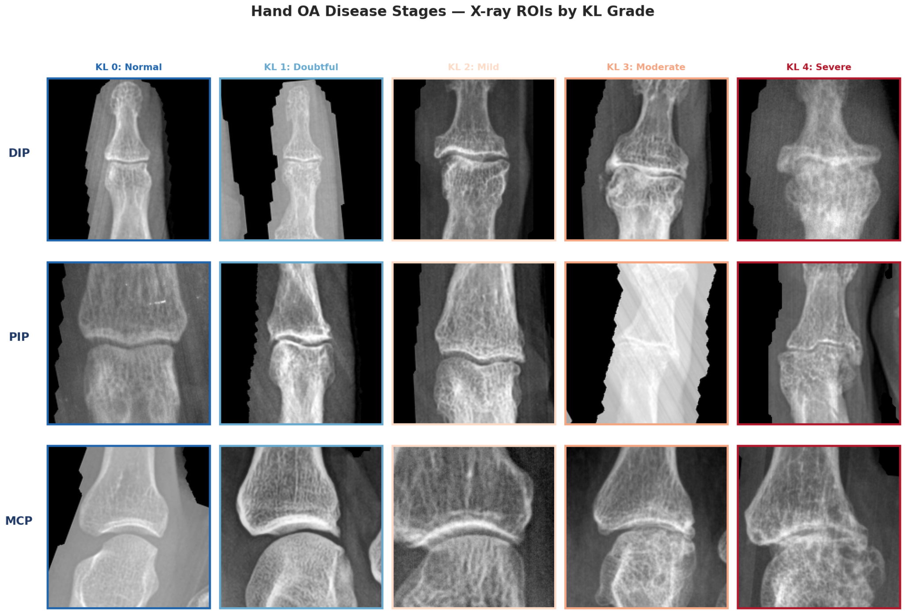

2.4 Distribution by Joint Type
OA severity varies dramatically across joint locations. DIP joints (fingertips) carry most disease burden, while MCP joints (knuckles) are overwhelmingly healthy:
Joint | Mean KL | KL 0 | KL 1 | KL 2 | KL 3 | KL 4 | n
DIP (2-5) | 0.74 | 59.8% | 12.7% | 22.1% | 4.2% | 1.2% | 14,334
PIP (2-5) | 0.49 | 68.8% | 15.7% | 14.0% | 1.2% | 0.3% | 14,344
MCP (2-5) | 0.11 | 93.0% | 3.9% | 2.6% | 0.3% | 0.1% | 14,358

- DIP joints are the most informative for modeling — 40.2% of DIP observations have KL ≥ 1, providing the richest variation across severity grades.
- MCP joints (especially MCP4 and MCP5 with mean KL of 0.03 and 0.02) are almost entirely grade 0 and contribute minimal discriminative signal.
- Implication: Projects may benefit from focusing on DIP and PIP joints, or training joint-type-specific models.
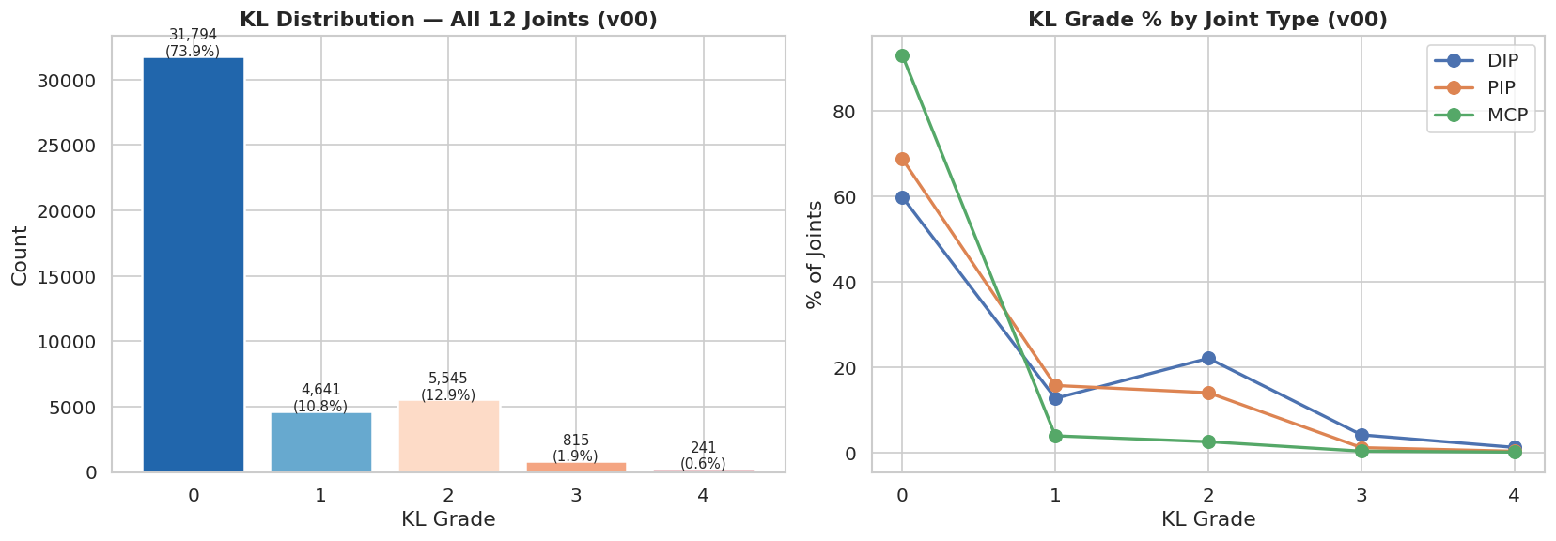

2.5 Score Correlations
All four scores are positively correlated, as expected since they measure related aspects of the same disease. The strongest correlation is between KL and OP (r = 0.74), followed by KL and JSN (r = 0.70):
- KL–OP (0.74) and KL–JSN (0.70): Strong correlations confirm KL grade captures both osteophyte formation and joint space narrowing.
- Multi-label potential: The moderate inter-score correlations (0.37–0.74) suggest a multi-label classification approach could leverage shared features while capturing distinct aspects.
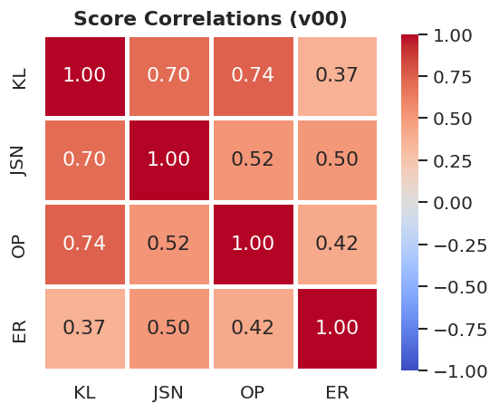

3. Methodology

3.1 Literature Review
We will survey recent work to inform our architecture and evaluation approach:
- Generative architectures for medical image synthesis (DDPM, latent diffusion, CycleGAN, WGAN-GP)
- OA-specific progression models that simulate disease severity changes in X-rays
- Synthetic data augmentation strategies for improving classification on imbalanced medical datasets
- Evaluation methods for generated medical images (FID, downstream task improvement)
Key papers to review:
- Han et al. — OA progression prediction via style-based manifold extrapolation (Nature Machine Intelligence, 2022)
- Wu et al. — IC-RDN: identity-consistent diffusion for KOA progression (ECCV 2024)
- Prezja et al. — Synthetic knee OA X-rays via WGAN-GP with augmentation validation (Scientific Reports, 2022)
- Rombach et al. — Latent diffusion models for high-resolution image synthesis (CVPR 2022)
- Prezja et al. — CycleGAN for bidirectional KL-grade translation (2025)
- Butler et al. — Efficient diffusion for KOA risk estimation, class-conditioned latent space (2025)
- Wang et al. — Diffusion-based morphing for temporal KOA X-ray synthesis (2024)
- Littlefield et al. — Few-shot augmentation pipeline for knee radiographs + KL grading (JAMIA, 2024)
- Enhancing KOA severity classification using diffusion augmented images (2023)
- Yeganeh et al. — Latent Drifting for counterfactual medical images (CVPR 2025)
- Kidder — DreamBooth fine-tuning for medical X-ray synthesis + FID evaluation (2024)
- Shi et al. — Diffusion models for medical image computing survey (2025)
- Osuala et al. — GenAI for synthetic medical data, systematic review (2025)

3.2 Model Selection
Based on the literature review, we will evaluate candidate generative architectures and select the most suitable approach for our dataset size and compute budget. Approaches we are currently considering:
- Conditional DDPM — Diffusion models conditioned on target KL grade; high fidelity, stable training, but compute-heavy
- Latent Diffusion — Runs diffusion in compressed latent space for faster training; used in recent medical image synthesis work
- CycleGAN — Unpaired image-to-image translation between KL grades; fast and well-documented but prone to structural distortion
- WGAN-GP — Demonstrated ability to generate 320K realistic knee OA X-rays from limited real data
- VAE-based approaches — Simpler architecture, faster to train, but typically lower image fidelity
Final architecture selection will be made by April 3 after completing the literature review and consulting with the professor.

3.3 Data Preparation & Augmentation
The dataset contains 41,061 joint ROI images across three joint types (DIP, PIP, MCP) with KL severity grades 0–4. Our preliminary statistical analysis revealed significant differences in disease distribution across joint types:
Joint Type | Images | KL 0 (healthy) | KL 2+ (OA present) | Mean KL
DIP (2-5) | ~14K | 59.8% | 27.5% | 0.74
PIP (2-5) | ~14K | 68.8% | 15.5% | 0.49
MCP (2-5) | ~14K | 93.0% | 3.0% | 0.11
For a generative model to learn meaningful disease transformations, it needs sufficient examples across severity levels. MCP joints are almost entirely healthy, offering little for the model to learn about OA appearance. DIP joints have the richest variation, while PIP joints fall in between.
Rather than committing to a single subset upfront, we plan to experiment with three configurations and compare generation quality:
- DIP-only (~14K images): Best class balance, clearest OA signal, but smallest dataset
- DIP + PIP (~28K images): More training data, still reasonable OA variation, requires joint-type awareness
- All joints with joint-type conditioning (~41K images): Maximum data, but model must handle the 93% healthy MCP distribution without being overwhelmed by KL 0
We will start with DIP-only as a baseline (fastest to train, easiest to evaluate), then expand to DIP+PIP if results are promising and time allows.
Data approach — unpaired, class-conditional: Based on professor guidance, we will not use paired v00→v06 longitudinal data for training, as the number of DIP joints that actually changed KL grade over the 6-year follow-up period is too limited to train a reliable model. Instead, we will treat all images as an unpaired pool grouped by KL grade, regardless of timepoint. Both v00 and v06 images contribute to the training set, effectively doubling our data — a DIP joint at KL 2 from v00 and a different DIP joint at KL 2 from v06 are both valid examples of what KL 2 looks like. The model learns the visual characteristics of each grade from this pooled set rather than learning patient-specific progression trajectories.
Preparation steps:
- Pool all images across both timepoints (v00 + v06) into a single dataset, labeled by KL grade
- Patient-level train/val/test split (70/15/15) — stratified by max KL to ensure rare severe grades appear in all splits and no patient's images leak across splits
- Standard augmentation — rotation, flipping, contrast/brightness jitter to increase effective training set size
- Intensity normalization — standardize pixel values across all images for consistent model input

3.4 Conditioning Strategy
The generative model will use a class-conditional, unpaired approach. Rather than learning to translate a specific patient's joint from one grade to another, the model learns what each KL grade looks like and generates new images conditioned on a target grade. The core paradigm is: given a target KL grade, generate a realistic joint X-ray at that severity level.
If we expand beyond DIP-only, we will add joint type (DIP/PIP/MCP) as an additional conditioning signal so the model can account for anatomical differences between joint locations. We may also explore conditioning on JSN and OP scores, which are strongly correlated with KL (r = 0.70 and r = 0.74 respectively) and capture distinct aspects of disease appearance.

3.5 Model Training
- Environment: Google Colab Pro (A100/T4 GPU), dataset hosted on Google Drive or BU SCC
- Architecture: Selected generative model (to be finalized after literature review by April 3) trained on hand OA joint images, conditioned on target KL grade. A simpler generative approach (e.g., CycleGAN or WGAN-GP) will serve as a baseline for comparison.
- Experimentation plan: We will follow a progressive approach, building from simple to complex and validating at each stage before moving forward:
  - Stage 1 — Baseline generation (Week 3) Train a CycleGAN or WGAN-GP on DIP joints as our baseline model. This gives us a fast first result to visually inspect and establishes a benchmark for FID and downstream utility. If baseline results already show realistic generation, it validates the approach and sets a clear bar for the primary model to beat.
  - Stage 2 — Primary model at low resolution (Week 3–4) Train the selected diffusion architecture (LDM or DDPM) at 64×64 resolution on DIP joints. Lower resolution allows faster iteration on hyperparameters, conditioning strategy, and loss functions before committing GPU hours to full-resolution training. Evaluate visual quality and compare against baseline.
  - Stage 3 — Scale to full resolution (Week 4) Once the model produces coherent outputs at 64×64, scale to full 180×180 px and retrain. Compare generation quality at both resolutions to confirm scaling works.
  - Stage 4 — Expand dataset scope (Week 4, if time allows) If DIP-only results are strong, retrain on DIP+PIP (~28K images) with joint-type conditioning and evaluate whether more data improves generation quality or introduces noise from mixing anatomically different joints.
- Checkpointing: Regular saves to Google Drive every N epochs. Track loss curves, FID scores, and visual sample grids (generated vs real at each KL grade) throughout training to catch issues early.

3.6 Evaluation
Evaluation follows a dual-criteria framework as specified in the project briefing:
Criterion | Method | Success Metric
Visual fidelity | FID score between real and generated images; qualitative side-by-side comparison | FID comparable to literature baselines; generated images visually indistinguishable
Downstream utility | Train ResNet classifier on real-only vs real+synthetic data; compare AUC on KL 3/4 | Measurable AUC improvement on severe grades when synthetic data is added
Ablation | Vary number of synthetic samples added; compare DDPM vs CycleGAN outputs | Quantify marginal value of synthetic data; identify which model produces more useful augmentation

4. Team Roles
Lead Member | Primary Role | Responsibilities
Jai Sharma | Data + Baseline | Data pipeline, preprocessing, CycleGAN baseline, integration
Maria Martin | Generative Model | Primary generative architecture implementation and training
Zulal Akarsu | Evaluation + Report | Downstream classifier, FID evaluation, report lead, presentation

All members contribute to the literature review, final report, and presentation.

5. Timeline
Week | Phase | Deliverables
1 (Mar 25-31) | Research & align | Literature review, data exploration, proposal draft, team meeting (Mar 28)
2 (Apr 1-7) | Decide & prepare | Professor meeting, lock architecture (Apr 3), finalize data pipeline, submit proposal
3 (Apr 8-14) | Build | Train CycleGAN baseline + begin diffusion model training, set up evaluation framework
4 (Apr 15-21) | Train & evaluate | Complete model training, run evaluations (FID + downstream AUC), draft report
5 (Apr 22-28) | Deliver | Finalize report, clean code repo, poster, rehearse, present (Apr 28)

6. Risks & Mitigations
Risk | Impact | Mitigation
Limited KL 3/4 samples (2.5%) | Model may not learn severe features | Focus on DIP joints; augment rare classes; use paired v00/v06 data
Diffusion model too slow to train on Colab | Incomplete training by deadline | Start at 64×64, scale up; CycleGAN as fallback deliverable
Generated images lack anatomical realism | Poor visual fidelity scores | Iterative visual QC; identity-preserving loss terms
Synthetic data doesn’t help classifier | No downstream improvement | Negative result is still publishable; ablation analysis shows what works

7. Tools & Infrastructure
Category | Tools
Compute | Google Colab Pro (GPU: T4/A100) & BU SCC
Framework | PyTorch, torchvision, diffusers (Hugging Face)
Data | Hugging Face Datasets (private repo), Google Drive (backup)
Code | GitHub (shared repo), Google Colab notebooks
Evaluation | pytorch-fid, scikit-learn (AUC/ROC), matplotlib
Collaboration | Google Drive (shared folder structure), weekly meeting minutes

