Econometrics

Exam #1

Prof. Ben Zweig

Take the following model: Yi = β0 + β1Xi + εi.

Describe in detail how the method of Ordinary Least Squares works in returning estimates of β0 and β1.

Refer to this example for the following four questions:

In order to study the effect of teacher incentives on student performance, you gather the average standardized test scores of a classroom (on a scale from 1 to 100) along with the teacher’s annual earnings (measured in $1000) of that classroom. You gather observations (randomly, of course) from 300 public school classroom. You run the following regression Yi = β0 + β1Xi + εi where Y is the student’s performance and X is the teacher’s salary. (Average scores are about 60 and Average salaries are about $55,000). You get the following results:



How do you interpret the coefficient on TeacherEarnings?

How do you interpret the standard error on TeacherEarnings?

Is this coefficient statistically significant? How do you know?

How do you interpret the R2? What does it tell you in the context if this particular study?

If a teacher were paid $100,000 per year, what is your estimate of average student’s scores in his/her classroom?

Refer to the two graphs below in the next three questions:

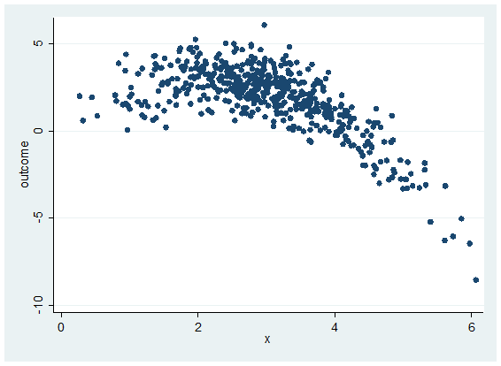

How would you specify the data in the graph on the left in order to get a good fit?

1. Yi = β0 + β1Xi + εi
2. ln(Yi)= β0 + β1Xi + εi
3. Yi = β0 + β1ln(Xi)+ εi
4. ln(Yi)= β0 + β1ln(Xi)+ εi
5. Yi = β0 + β1Xi + β2(X2)+ εi

How would you interpret β1?

How would you specify the data in the graph on the right in order to get a good fit?

1. Yi = β0 + β1Xi + εi
2. ln(Yi)= β0 + β1Xi + εi
3. Yi = β0 + β1ln(Xi)+ εi
4. ln(Yi)= β0 + β1ln(Xi)+ εi
5. Yi = β0 + β1Xi + β2(X2)+ εi

You would like to see if the death penalty affects the number of murders committed in a state – i.e., if execution would deter criminals from committing homicides. You decide to regress the homicide rate in a state on the execution rate in that state:

Yi = β0 + β1Xi + εi

Where Yi = homicide rate in state i ; Xi = execution rate in state i

What is the expected sign (positive or negative) of B1 and how would you interpret its meaning?

The probability of getting cancer for non-smokers is 6%. The probability of getting cancer for smokers is 11%. Let Y = {1 if cancer; 0 if no cancer}, X = {1 if smoker; 0 if non-smoker}. You run the following regression: Yi = β0 + β1Xi + εi. What would your estimates of β0 and β1 be?