**IMPACT OF TECHNOLOGY IN HEALTH SECTOR AND PSYCHOINFORMATICS**

**Dr. Esther Sunanda Bandaru *1, Elisha Maria K N M O*2, Gubbala Teja Sree*3, Gudla Yamini*4**

Department of Computer Science and Systems Engineering, Andhra University College of Engineering for Women, Andhra Pradesh, India.

**ABSTRACT**

With the advent of the novel coronavirus, every country now places considerable emphasis on healthcare. The technological advent in smart sensing devices and the Internet has provided practical solutions in various sectors of networking, public and private sector industries, and government organisations worldwide. Similarly, psychoinformatics is an emerging subject that uses tools and techniques from the computer and information sciences to improve the acquisition, organisation, synthesis of the human psychological data which thereby is utilised during various treatment procedures. There is brief introduction to Machine Learning and IoT concepts as they have been popularly applied on different health care sectors; Different algorithms provide easy computation on dataset and variable sensors provide flexibility on developing models. The fundamentals prove the extensive usage of different softwares and hardwares to provide accurate and efficient results. The main objective of this paper is to demonstrate the versatility of applying technology in the health care sector for the improvement of better treatment.

**Keywords:** Health Care sector, Psychoinformatics, Internet of Things, Machine Learning, Arduino.

1. **INTRODUCTION**

**1.1 About Psychoinformatics and health care:** Data derived from regularly used devices such as smartphones, online social networking sites, laptops, tabs etc.  provides information about psychological traits including personality and mood. As mental health incorporates the overall health of an individual, a device can be designed to monitor general health conditions for better treatment. Through the health monitor system we will be able to acquire sufficient data about the general health condition of the individual for instance stress levels can be derived based on the heart rates and oxygen levels. Patients, doctors, nurses, hospital managers, insurance companies, and health information technologists all have electronic access to medical records thanks to healthcare informatics efforts. With the recent occurrence of covid, there was a problem in accessing the patient’s manual health measurements due to lack of staff and severity of the infectious disease. On placing a health monitor system linked to the web server, not only the hospital staff but also the patient's family members can monitor the health conditions using other tools. The use of on-screen reminders for physicians resulted in slight to modest gains in process adherence, prescription ordering, vaccination, laboratory ordering, and clinical outcomes, according to a Cochrane comprehensive review. Bar code medication administration systems are computerised systems that integrate electronic drug administration data with bar code technology. These systems are designed to avoid medication errors by ensuring that the correct patient receives the correct drug at the appropriate time. Additionally, existing barcode systems differ in their sophistication. New challenges await psychologists considering the results of "Big Data" sets from the classic psychological methods which will only be able to analyse the data, derived from the ever present mobile devices as well as other everyday technologies and social networking sites. Consequently, psychologists must enrich scientific processes through the inclusion of methods from Health informatics. Furthermore, we also emphasise on  combining data derived from Psychoinformatics and Health informatics in such a way, that provides well processed and cleaned data for the human neuroscience department.

**1.2 Discussing security concerns in using this approach :** Technology drives healthcare more than any other force, and it will continue to advance in significant ways in the future. While we might hypothesise and debate the specifics of future healthcare trends, we must first understand the drivers in order to align with them and work toward the best outcomes for society as a whole. Technology drives healthcare more than any other force, and it will continue to advance in significant ways in the future. While we might hypothesise and debate the specifics of future healthcare trends, we must first understand the drivers in order to align with them and work toward the best outcomes for society as a whole. Patient safety is a subset of healthcare that entails the prevention, mitigation, and avoidance of undesirable outcomes or injuries as a result of medical procedures. The Institute of Medicine's (IOM) report "To Err is Human" in 1999 called for the development and testing of new technologies to reduce medical error, and the subsequent 2001 report "crossing the quality chiasm" called for the use of information technology as a key first step in transforming and changing the healthcare environment to achieve better and safer care.

**1.3 Connecting the health sector with technology:** Clinical decision support provides health-care workers with knowledge and patient-specific information. This data is intelligently vetted and presented to healthcare professionals at the appropriate times to assist them in making better judgments. Healthcare decision support is a set of tools aimed at improving clinical workflow and decision-making. Notifications, alerts, and reminders to care providers and patients, clinical guidelines, condition-specific order sets, patient-specific clinical summaries, documentation templates, investigation and diagnostic support, and so on are examples of these tools. For example, some software generates alerts when sound-alike or look-alike medications might be confused. Others may assist with documentation and provide clinical recommendations for certain drugs when scanned (namely, recording drug administration in the eMAR and other relevant clinical details). Hospitals, pharmaceuticals and other health care centres make up the chain of facilities that team up to provide efficient care to patients. Each facility in this chain must be able to communicate with all the other facilities. They must be able to share data accurately, securely and quickly. The health care workers, nurses, and doctors have to combine their expertise, training, and experience not only to provide the correct care to each patient but also to improve their techniques and processes. Health informatics and psychoinformatics personnel study the communication and the efficiency of all of the facilities in the care chain. Their efforts are the driving force behind process improvement and the maintenance of utmost care.  A patient portal is a secure online application that provides patients access to their personal health information and 2-way electronic communication with their care provider using a computer or a mobile device. Numerous studies have shown that patient portals improve outcomes of preventive care and disease awareness and self-management. However, there is no evidence that they improve patient safety outcomes. Electronic incident reporting systems are web-based systems that allow healthcare providers who are involved in safety events to voluntarily report such incidents. Such systems can be integrated with the electronic health record (EHR) to enable abstraction of data and automated detection of adverse events through trigger tools. Electronic incident reporting systems potentially have the following advantages; standardise reporting structure, standardise incident action workflow, rapid identification of serious incidents and trigger events, while automating data entry and analysis. Published research shows that healthcare organisations that have moved to an electronic reporting system have experienced a significant increase in reporting frequency. Incident reporting systems may improve clinical processes, but there is little evidence that electronic reporting systems ultimately reduce medical errors.

1. **PROPOSED METHODOLOGY**

A patient portal is a secure online programme that allows patients to access their personal health information and communicate with their healthcare providers in a two-way electronic format via a computer or mobile device. Patient portals have been shown in numerous studies to increase preventative care, disease awareness, and self-management results. There is, however, little proof that they improve patient safety. EIRS are web-based platforms that allow healthcare professionals involved in safety incidents to report them voluntarily. These systems can be linked to an electronic health record (EHR) to allow for data abstraction and automatic identification of bad events using trigger tools. Electronic incident reporting systems potentially have the following advantages; standardise reporting structure, standardise incident action workflow, rapid identification of serious incidents and trigger events, while automating data entry and analysis. Published research shows that healthcare organisations that have moved to an electronic reporting system have experienced a significant increase in reporting frequency. Although incident reporting systems may improve clinical processes, there is limited evidence that they reduce medical errors in the long run.

The versatility of the concept extends upto both software and hardware applications, this denotes the efficiency and reliability of the concept in discussion. Under software basis it is stretched across various algorithms in Machine Learning which uses dataset of the healthcare centre and computes for an efficient result. Similarly, under hardware platforms it is extended to real time applications which are mostly applied to solve existent issues or to optimise functionality. The two categories are clearly elucidated below;

**2.1 IOT based approach in Health Care Sector:** IoT’s evolution has increased nowadays with smart devices' tremendous ability to share information between them. The importance of IoT in the healthcare sector for remote monitoring of patients' criticality levels has grown as a result of its use in numerous applications. This technical advancement has impacted several aspects of human safety, health, and well-being. IoT is advantageous in computation, processing, and storage utilising cloud-based solutions also useful for processing and storing geographic data on a cloud platform, which can then be shared among devices for various purposes. The existing Internet of Things-based human health monitoring system has some drawbacks, such as an increase in users and uploaded databases, no assurance for users, inadequate real-time performance, and low data utilisation. This paper proposes a human health monitoring system based on the Internet of Things. Heart rate, blood pressure, pulse, body temperature, physiological information, and other vital sign parameters may be monitored continuously and accurately by the system. This work uses wireless sensors to retain the information for health monitoring. To enable real-time monitoring, the data is integrated utilising the Internet of Things for processing, linking, and computing. The proposed system demonstrated relatively accurate and stable test ability improving deficiencies in the existing health monitoring platform.

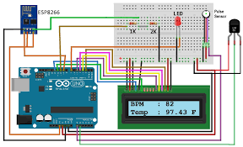

Fig. 1: It is a schematic presentation of a health care monitoring model

**2.2 Machine Learning-Based Approach in Psychological Informatics:** Sentiment Analysis is a machine learning tool that analyses the polarity of texts  from positive to negative. By training machine learning tools with emotional examples  in the text, machines automatically learn how to recognize emotions without human intervention. Simply put, machine learning allows computers to learn new tasks without being explicitly programmed to perform them. There are many techniques and complex algorithms used to command and train machines to perform sentiment analysis. Each has its strengths and weaknesses. But when used together, it gives exceptional results. The following are some of the most commonly used algorithms.

* **Naive Bayes:** Naive Bayes is a fairly simple group of probabilistic algorithms that assign the probabilities that a particular word or phrase is considered positive or negative for the classification of sentiment analysis..
* **Linear Regression**: Linear regression is a statistical algorithm used to predict the Y value given X features. Machine learning is used to examine the dataset's connections. The relationships are then placed along the X / Y axis, and straight lines pass through them, predicting further relationships.
* **Support Vector Machine (SVM):** A support vector machine is another supervised machine learning model that is similar to linear regression but more advanced. SVM uses algorithms to train and categorise text in emotional polarity models, going one step beyond X / Y prediction.

There are depression analysis applications that use sentiment analysis to capture datasets collected from users and provide output using various algorithms. The results obtained so far have proven to be accurate and reliable. Evidence provides sufficient evidence for healthcare  to rely on such models to provide better treatment.

**2.3 Best Selected Approach :** Out of all the methods, a proposition can be made that utilising Machine Learning algorithms and IoT based models, a much better and practical functionality of operations can be achieved as Health care requires accuracy and promising results. With the advancement of technology comes updates in all technical sectors, using the above approaches makes it easy for developers to maintain their models as updates on the systems and softwares are not required, they can be done by simply augmenting codes or additional sensors. For instance, Machine Learning algorithms like Naive Bayes, Linear Regression and SVM only require a collection of data in the form of a structured dataset and few logical codes for successful implementation to provide quick and reliable findings. Machine Learning is chosen among other software applications like file system and database management systems as they require manual assessment which is time taking and cumbersome. In the same way, IOT models require just hardware  like sensors and appropriate Arduino codes for the proper functioning of the model to produce efficient working. IOT is preferred under hardware platforms as the development boards are designed in such a way that they can operate on a wireless basis along with the simplicity of formation and debugging of programmable cod

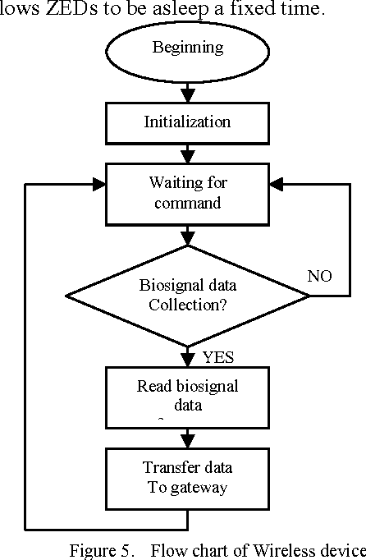

Fig. 2: Flow chart describing the general process

From the above flowchart (fig. 2), It shows a detailed generic process of how any model in software or hardware would have to run to implement the designed models. To begin with we collect data and propose a structure to design an appropriate model according to the requirements. Develop the device using various hardware components and software programs. Run to check for several test cases and debug for any errors if occurred. On receiving promising results the model is deployed into the market for real time use.

1. **APPLICATION ANALYSIS**

**3.1 Implementation of IOT model in hospitals:** With the severity of the pandemic the past few months, many patients could not be monitored on time as the staff were less and there was lack of equipment. The health care monitor system will help in monitoring the patients in real time by sending all readings to the hospital staff through the web server. With the inclusion of a warning buzzer incase of abnormal readings, quick treatment can be given to the patients. The benefits of using an automated Iot device in the health sector is that it is versatile in nature and can be modified depending upon the severity and health condition of the patient. For Instance, a person suffering from diabetes and heart issues can have a device modified to monitor all such parameters related to sugar and heart rate by using various sensors. The benefit of using an ESP32 development board in the project is that it has over 48 pins and can be connected to the wifi. Considering these features we can add many sensors and monitor readings from a distance.

**3.2 IOT Device benefitted by old age bedridden patients:** There persists a common problem in monitoring the health conditions of old aged people as the nurses appointed may not be reliable and patient enough to take care or it might be difficult to get a doctor to check every once in a while if the person is bedridden at home. To battle this inconvenience, an automated health monitor system can be used to check for regular vitals and send them to the concerned person. In addition, with the help of saline detector the caretaker can be intimated whenever the saline is empty in the saline bag. There are some serious consequences if the saline bag is left unattended as it will pass dry air into the blood vessels causing the person to suffer from paralysis. With the presence of a database, all the past recordings can be maintained to check the progress of the patient. Incase of an emergency, immediate warning signals are sent to the hospital and family members. As a person enters old age, it becomes increasingly vital for them to undergo standard medical health checkups. Since it may be time-consuming and difficult for most people to get regular health checkup appointments, IoT-based arrangements can be beneficial to individuals for routine health checkups [4, 5]. IoT technology has developed into an imperative innovation with applications in numerous areas. Specifically, it refers to any system of physical devices that obtain and exchange information over wireless systems without human mediation.

**3.3 A single application of a wearable IOT device:** Through the above discussion a conclusion can be derived that IOT devices are very useful and effective in the health care sector. Seeing how portable and cost effective the devices are, a huge number of users can benefit from the effective results from the IOT devices. Making the device automated saves time and provides accurate readings at ease. These statements prove that the device is very versatile, that is any number of sensors can be added anytime despite updating any software i.e. depending on the illness of the patients the device can be modified accordingly for better treatment. The application of Machine Learning concepts in the health care sector produces efficient and instant results. The collected data being huge, it can be difficult to study one by one whereas utilising machine learning algorithms on the dataset, a quick and reliable conclusion can be made just by filtering the dataset and then applying appropriate logic. Results of the study can be obtained within seconds depending on the speed of the working device. To highlight on the discussion in matter, let us consider the results obtained through a wearable Iot device smart watch(Fig 3);

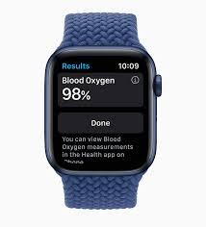

Fig 3: Smart Watch displaying the user’s blood oxygen levels

**3.4 Depression and mood monitoring model**: Another sort of data that has traditionally been difficult to collect constantly is information about depressive symptoms and patients' general mood. Healthcare practitioners could ask patients how they were feeling on a regular basis, but they couldn't predict unexpected mood swings. Patients frequently do not appropriately report their feelings. “Mood-aware” IoT devices can help with these issues. Devices can infer information about a patient's mental state by collecting and analysing data such as heart rate and blood pressure. Advanced IoT devices for mood monitoring can even track data like a patient's eye movement. The main problem is that measurements like these can't accurately anticipate depression symptoms or other indications for concern. A typical in-person mental examination, on the other hand, cannot. Fig. 4 presents a general classification of working of the depression and mood monitoring model. It is a device which would require the user to enter data on a regular basis. The collected data would help the practitioner to diagnose accordingly.

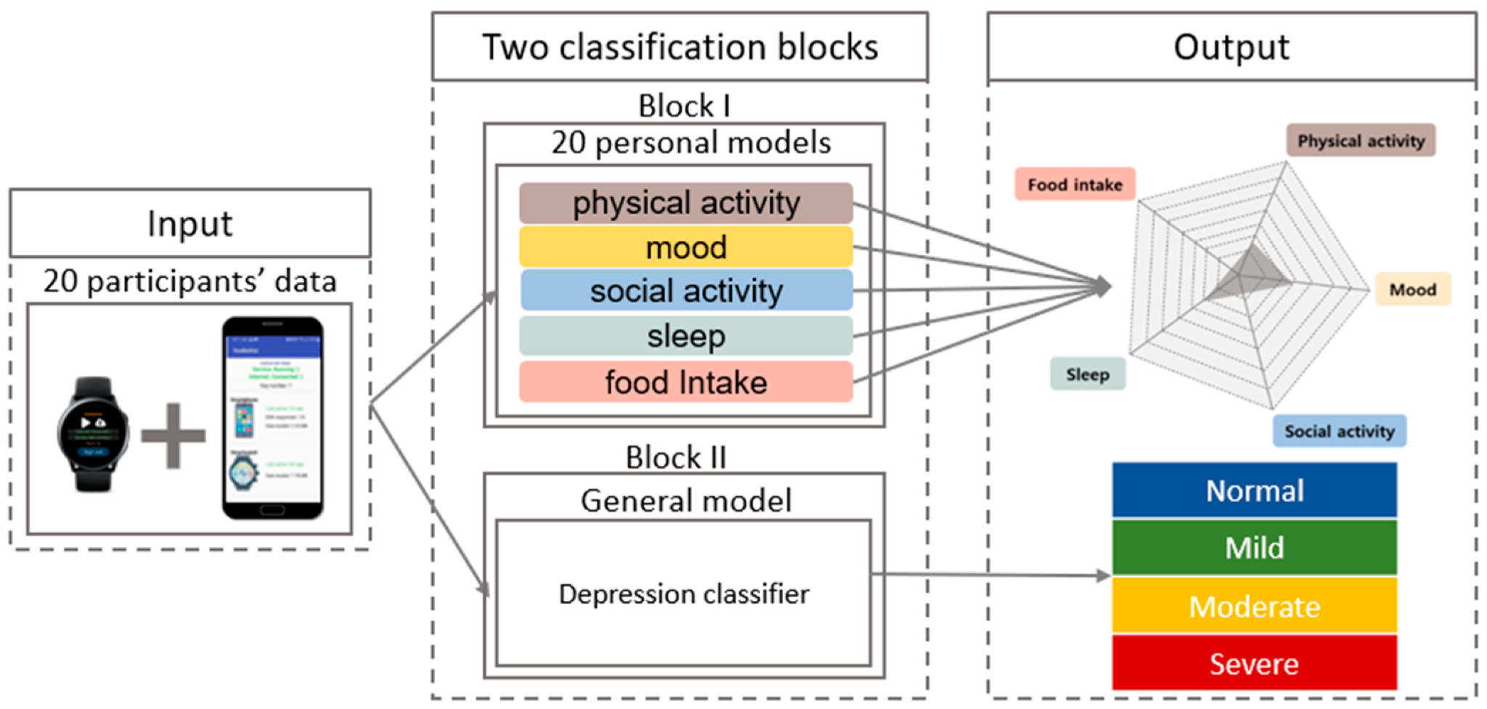 Fig. 4: Classification of working of the model

1. **CONCLUSION**

With the advent of the novel coronavirus an observation can be made that Healthcare being the main concern of every individual, it can be exposed to technology for better progress in treatment quality. The advancements of technology under smart devices and the internet has received much importance from the general public and it has become an essential concept in the development of the healthcare industry. The new emerging concept behind psychoinformatics uses techniques and softwares from the computer for the processing and acquisition of the large volume of data retrieved from various social networking sites and mobile applications that studies and monitors user’s mental health. The ever growing information technology in combination with the healthcare industry brings out phenomenal results. We propose using Machine learning techniques and IOT models, it proves to be the best effective approach towards the ever-growing health care sector. In conclusion, until the end of the human race, there exists the need of healthcare which requires constant evolution and adaptation, syncing with the advancements of technology to make each operation simple and optimal.

1. **REFERENCES**

[1]          Shwetha Singh. Psychoinformatics

[2]         Deepthi Pandey, Raghu Prasad.  “Psychoinformatics: a theoretical approach on information science and              psychology”

[3]     Lei Ru, Bin Zhang, Jing Duan, Guo Ru, Ashutosh Sharma, Gaurav Dhiman, Gurjot Singh Gaba, Emad Sami Jaha, and Mehedi Masud.  “A Detailed Research on Human Health Monitoring System Based on the Internet of Things”.

[4]         Nor Shahanim Mohamad Hadis,, Muhammad Nazri Amirnazarullah , Muhammad Mahdi Jafri and Samihah Abdullah. IoT Based Patient Monitoring System using Sensors to Detect, Analyse and Monitor Two Primary Vital Signs

[5]      [Narongrit Senajit](https://pubmed.ncbi.nlm.nih.gov/?term=Senajit+N&cauthor_id=34866803) , [Piya Prasongchan](https://pubmed.ncbi.nlm.nih.gov/?term=Prasongchan+P&cauthor_id=34866803). Contactless Body Temperature Monitoring of In-Patient Department (IPD) Using 2.4 GHz Microwave Frequency via the Internet of Things (IoT) Network [Wasana Boonsong](https://pubmed.ncbi.nlm.nih.gov/?term=Boonsong+W&cauthor_id=34866803).