**REAL TIME FACE MASK DETECTION AND ACCURACY PREDICTION**

**Vyshnavi Balabhadruni *1, K. Yamini Sai Priya*2, V. Sruthi*3**

*123 Student, Department of CSSE, Andhra University College of Engineering for Women, Andhra Pradesh, India.

**ABSTRACT**

Wearing a face mask appears to be important to both the person and other people to restrict the spread of a virulent disease that can be communicated via sputtering in the context of a virulent sickness which can be transmitted via sputtering. During the COVID-19 pandemic, people all around the world were required to wear masks to limit the danger of virus transmission. According to research, properly wearing a face mask can effectively reduce transmission and save lives. The identification of face masks has made significant progress in the domains of image processing and computer vision since the start of the Covid-19 pandemic. Face recognition models have been built using a number of algorithms and methodologies.

This is a deep learning model design using Python, TensorFlow, Keras, MobileNet, and openCV in this project. The main goal is to utilise a trained AI model and a collection of masked and unmasked photos to determine whether or not someone is wearing a mask during a webcam Livestream. Because it is relatively resource efficient to deploy, this model can be employed for safety considerations.

1. **INTRODUCTION**

The COVID-19 outbreak has startled the world since the year began, and the year 2020 has thrown mankind a mind-boggling series of catastrophes, the most life-changing of which is the COVID-19 pandemic. COVID-19 has urged for strict measures to be taken to prevent the spread of disease, which has an impact on many people's health and life. People are doing everything they can to safeguard themselves and society, from basic grooming to medical treatments; face masks are one type of personal protective equipment. Face masks are worn when people leave their houses, and officials make it a point to ensure that people wear them in groups and public places. To guarantee that citizens follow this essential safety principle, a policy should be developed. A technology that detects face masks can be used to verify this. Face mask detection is the process of recognising whether or not someone is wearing a mask. To detect the existence of a mask on a face, the first step is to detect the face, which divides the technique into two parts: detecting faces and detecting masks on those faces. Face detection is a type of object detection that can be useful in a variety of scenarios, including defence, biometrics, and law enforcement. Several detector systems have been created and are currently in use around the world. However, much of this research still has to be improved; a better, more precise detector is required because the world cannot afford any more corona cases. The goal of this project is to develop a face mask detector that can distinguish between those who are wearing masks and those who aren't. Facenet is used for face detection, and a neural network is used to detect the presence of a face mask in this study's proposed methodology. Using the adam optimizer, the programme processes pictures, videos, and live video streams.

1. **METHODOLOGY**

**SYSTEM REQUIREMENTS**

1. **Hardware Requirements**

* Processor 4.0GHz
* RAM 2 GB
* Hard Disk 30 GB
* Keyboard 104 Keys
* Display VGA

1. **Software Requirements**

* Operating Systems Windows/Linux
* Language Python
* Editor Spyder
* Interpreter Python Interpreter

The flowchart above depicts the many steps in the system.

The project is developed in 2 phases:

* Phase 1: training the Face mask detector
* Phase 2: Applying the face mask detector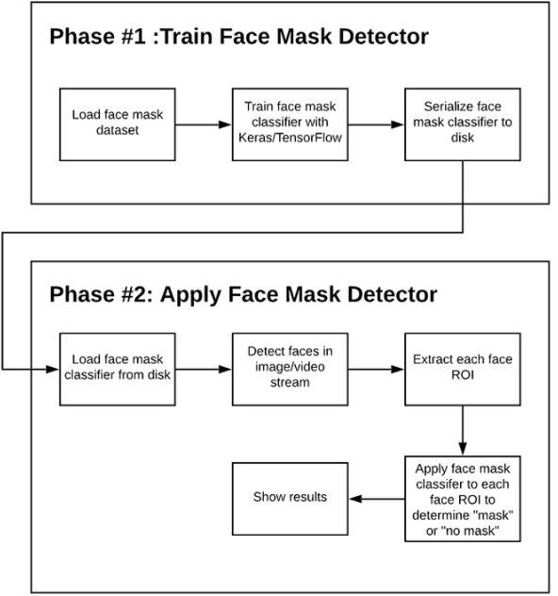

FIGURE 1 : Block Diagram

**Under Phase 1:**

Under this phase various steps like creation of data set , pre-processing of data, training the model are included.

1. **DATASET**

This model was trained on a data set that included two types of images: with mask and without mask. Images were gathered from a variety of sources, including Kaggle, Google Images, and a few open source image libraries, to build this data set.

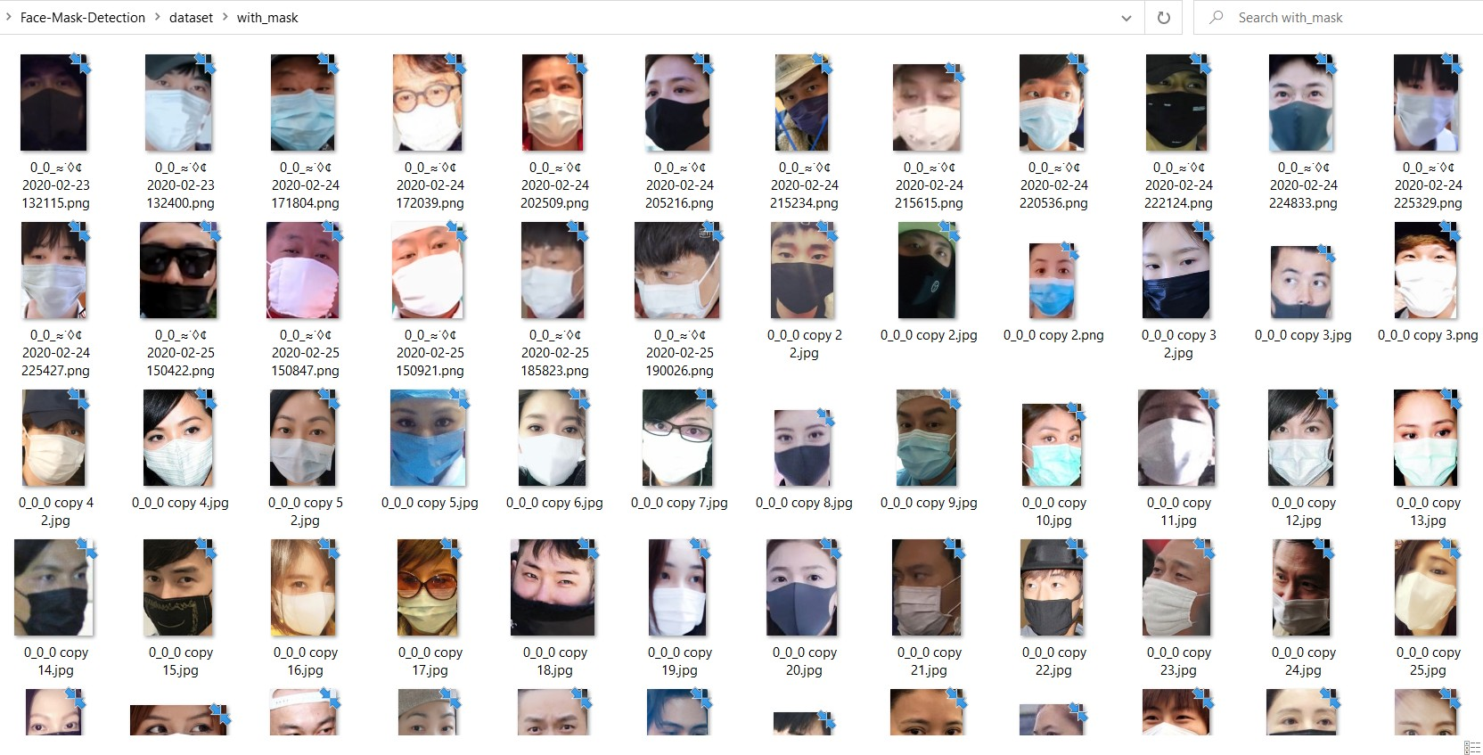 FIGURE 2 : Dataset with mask

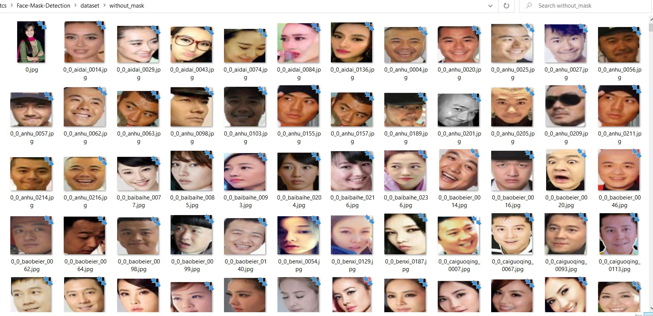

FIGURE 3 : Dataset without mask

1. **DATA PRE-PROCESSING**

The data pre-processing is one of the major steps of this project. The steps as mentioned below was applied to all the raw input images to convert them into clean versions, which could be fed to a neural network machine learning model.

* Converting all the images in the data set to (224 x 224) pixels using the load image function of keras.
* The images are then converted into Numpy arrays using image to array function of keras.
* The images are appended to label list and then convert them into arrays as deep learning model work with arrays.
* The data set is then split into training and testing set.Here it is in the ratio 80:20.

1. **TRAINING**

* The training image generator for data augmentation is constructed, by which mul- tiple images can be created using a single image by adding properties such as flip,rotate thus increasing the dataset.
* To train the model CNN with a little modification has been used. In our model, once the input image is processed into an array, it is being sent into MobileNet instead of convolution layer,followed by pooling.
* It is then flattened and the output is given as masked or unmasked.MobileNet is being used in this model as it is very fast in processing compared to Cnn and it uses lesser parameters.
* The initial weights of the imagenet model are going to be changed for yielding better results and accuracy.The pooling is done with a poolsize(7,7) and then is flattened.A dense layer with 12.8 neurons is added.Dropout is used to avoid non linear use cases.
* The optimizer being used in the model is Adam optimizer which is a goto for image datasets.
* After training of the model,a classification report is generated and saved using the predict method and the graph is plotted between training loss and accuracy using matplotlib.
* The trained model is saved and applied on the face detection model in next phase.

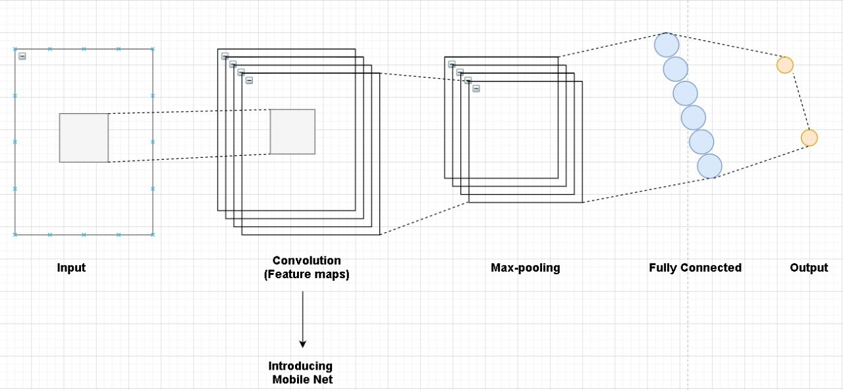

FIGURE 4: Training model using Mobilenet

**Under Phase 2:**

Under this phase the mask detector model that is generated in phase1 is applied on the facenet model to detect mask during livestream.

1. **APPLYING THE MODEL IN LIVESTREAM**

* To apply the model in the camera i.e livestream, firstly the face should be de- tected using readnet function of dnn module in open CV library and the previously trained model must be loaded.
* Every frame in the video is resized to 400 pixels.The model detects the face and predicts if the person is wearing a mask or not and mentions it using the color green for mask and red for no mask with the help of color=(b,g,r) of opencv.
* An additional function of percentage of prediction of the position of the mask is also added to the model.
* Thus the model returns prediction and location.

1. **RESULTS AND DISCUSSION**

Based on the implementation, the output of the module is expected to distinguish peo- ple wearing masks properly and those who are not wearing masks. After training and testing the model is implemented to check whether the people are wearing face masks accurately in the real time video. By making slight changes in the weights while train- ing the efficacy and relevance of the result have improved. This model has been further tested using live video streams and it has shown highly accurate results. The model is built with the MobileNetV2 architecture, which is computationally efficient and lightweight, making it easier to deploy in embedded devices .The dataset is partitioned into training and testing sets by retaining a rational proportion of different classes. The dataset contains 3833 samples in total, with 80 percent of them being used in the training process and 20percent in the testing phase. There are 3066 and 767 images in the training and research datasets, respectively. The built architecture is trained for 40 epochs. The file which was given as an input for validation was successfully analyzed and the results obtained were ac- curate.The output shows how accurately the people in the live video stream is wearing their face mask.

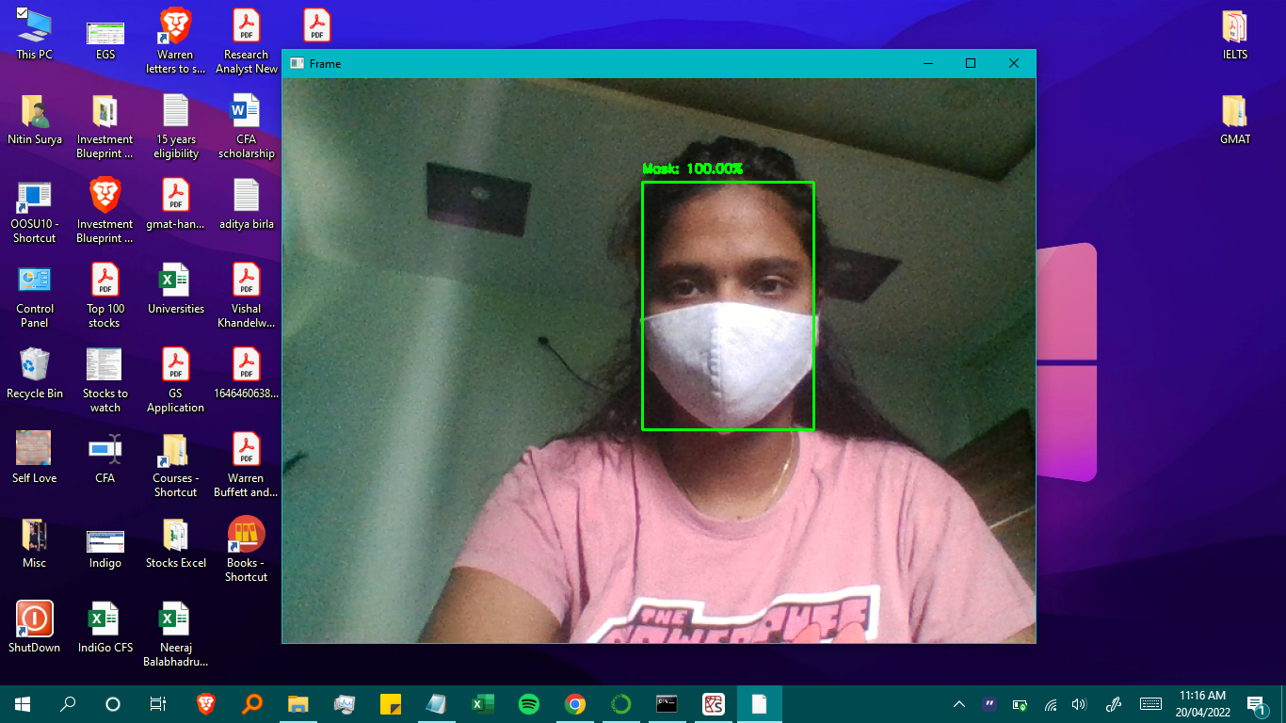

FIGURE 5: Output with mask

The figure above shows a person wearing mask properly.

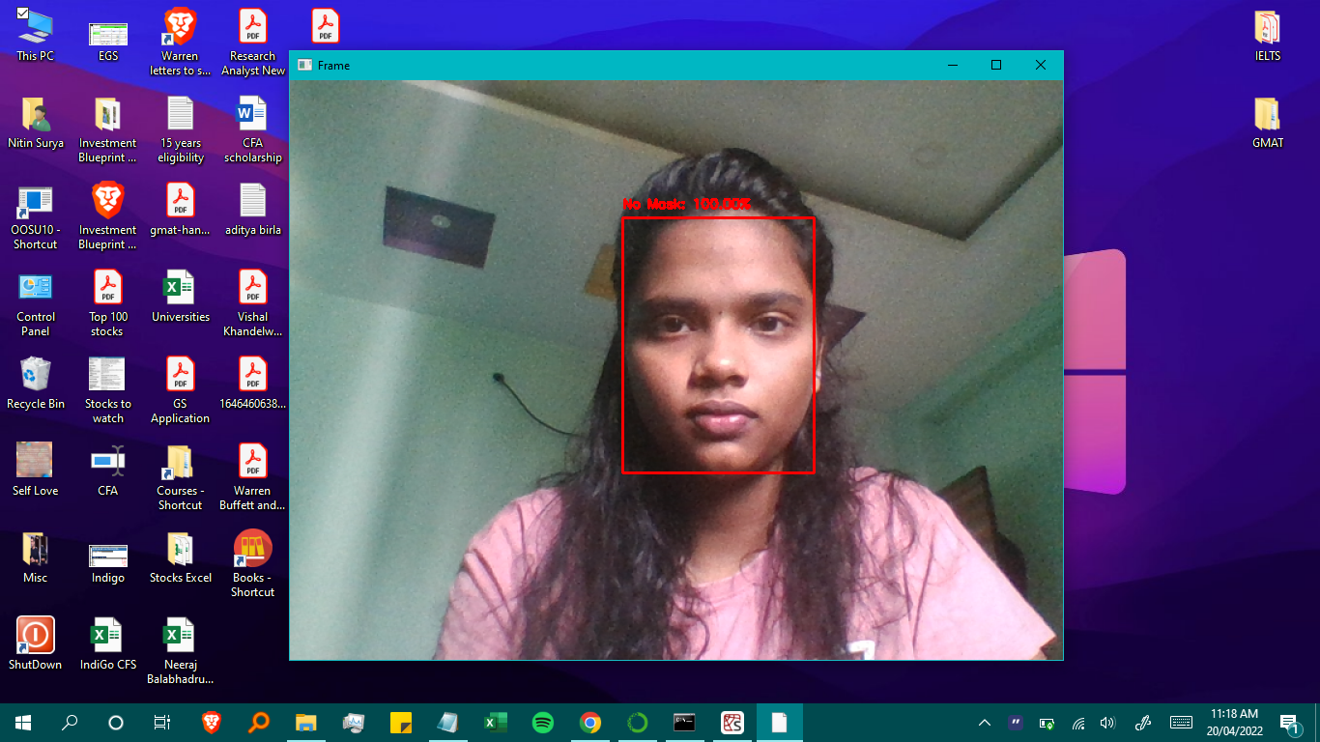

FIGURE 6: Output with mask

The figure above shows a person wearing no mask.

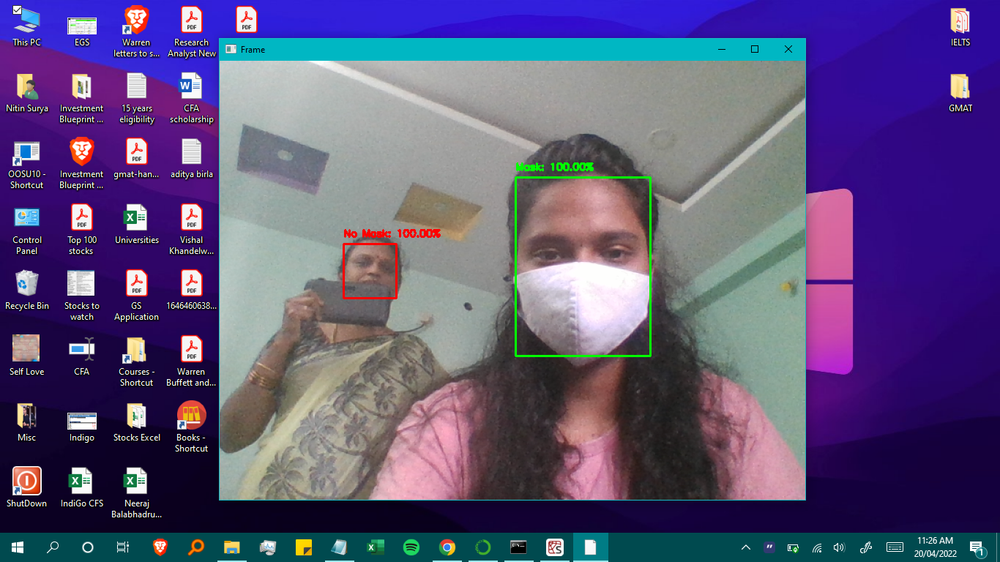

FIGURE 7: Obstacle differentiation

The figure above shows a person putting phone in place of mask.

1. **CONCLUSION**

Based on the implementation, the output of the module is expected to distinguish peo- ple wearing masks properly and those who are not wearing masks. After training and testing the model is implemented to check whether the people are wearing face masks accurately in the real time video. By making slight changes in the weights while train- ing the efficacy and relevance of the result have improved. This model has been further tested using live video streams and it has shown highly accurate results. The model is built with the MobileNetV2 architecture, which is computationally efficient and lightweight, making it easier to deploy in embedded devices .The dataset is partitioned into training and testing sets by retaining a rational proportion of different classes. The dataset contains 3833 samples in total, with 80 percent of them being used in the training process and 20percent in the testing phase. There are 3066 and 767 images in the training and research datasets, respectively. The built architecture is trained for 40 epochs. The file which was given as an input for validation was successfully analyzed and the results obtained were ac- curate.The output shows how accurately the people in the live video stream is wearing their face mask.



FIGURE 5: Output with mask

The figure above shows a person wearing mask properly.



FIGURE 6: Output with mask

The figure above shows a person wearing no mask.



FIGURE 7: Obstacle differentiation

The figure above shows a person putting phone in place of mask.

1. **REFERENCES**

[1] A. Rota, M. S. Oberste, S. S. Monroe, W. A. Nix, R. Campagnoli, J. P. Icenogle, S. Penaranda, B. Bankamp,K. Maher, M.-h. Chenet al., “Characterization of a novel coronavirus associated with severe acute respiratory syndrome,”science, vol. 300, no. 5624, pp. 1394–1399, 2003.

[2] Vinitha, V., Velantina, V. (2020). Covid-19 Facemask Detection With Deep Learning and Computer Vision. Int. Res. J. Eng. Technol, 7(8), 3127-3132.

[3] Z. A. Memish, A. I. Zumla, R. F. Al-Hakeem, A. A. AlRabeeah, and G.

M. Stephens, “Family cluster of middleeast respiratory syndrome coronavirus infections,”New England Journal of Medicine, vol. 368, no. 26, pp.2487–2494, 2013.

[4] C. Li, Y. Diao, H. Ma and Y. Li., 2008. “A Statis- tical PCA Method for Face Recognition”, Available from: https://ieeexplore.ieee.org/abstract/document/4740022/citationscitations

[5] Y. Liu, A. A. Gayle, A. Wilder-Smith, and J. Rocklo¨v, “The reproductive number of covid-19 is higher comparedto sars coronavirus,”Journal of travel medicine, 2020.

[6]Melissa P. Johnston. 2014. “Secondary Data Analysis: A Method of which the time Has Come” Available from: http://www.qqml- journal.net/index.php/qqml/article/view/169/170