**REQUIREMENT SPECIFICATION**

**HARDWARE REQUIREMENTS:**

The system consists of two parts: the equipment and the mobile application. Both parts are fundamental to the system. The health monitoring system can measure oxygen saturation, pulse rate, and human body temperature,humidity. This multifunction system requires several components to be implemented. Implementation is achieved by performing activities portrayed in a work arrangement. For making the system successful, design implementation plays an important role. The components required to execute this system are briefly described below. Here is the list of required hardware components

* ESP32 Board
* MAX 30100 Pulse Oximeter sensor
* DS 18B20 body temperature sensor
* DHT11 Humidity and Temperature sensor
* LM358 comparator-saline indication
* Jumper wires
* Breadboard
* Resistors

**ESP32 Webserver**:

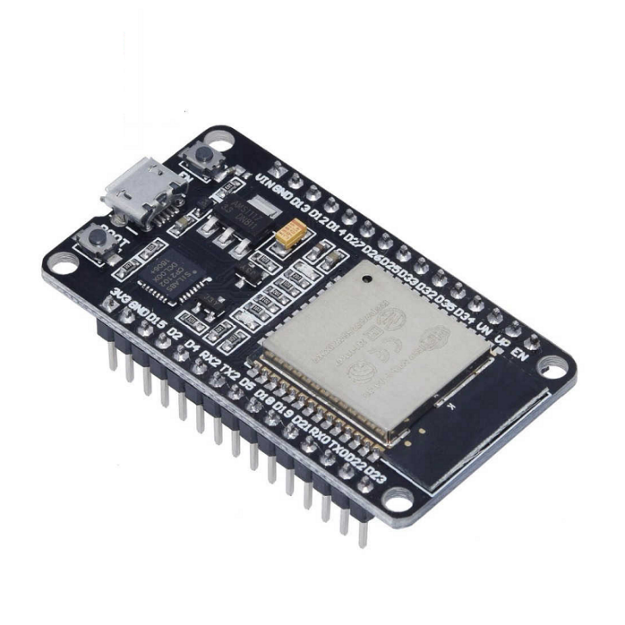

**MAX 30100 Pulse Oximeter sensor:**

MAX30100 is a sensor that can measure blood oxygen saturation level and pulse rate. Saturation of peripheral oxygen (SpO2) is a calculation of blood vessel oxygen saturation, which refers to the amount of oxygenated hemoglobin in the blood. In a human body, ordinary SpO2 values range from 90to 100%. In this system, a MAX 30100 pulse oximeter was suitable. It is a coordinated beat oximeter and heart rate sensor arrangement, which provides precise values. This sensor combines two LEDs, a photo detector, optimized optics, and low-noise analog flag handling to identify beat oximetry and heart rate signals; hence, it is suitable for this system.

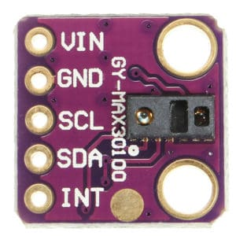

**DS 18B20 body temperature sensor:**

DS18B20 sensor that works with the technique for 1-wire correspondence. It requires only the information pin related to the microcontroller with a draw-up resistor, and the other two pins are utilized to control. The pull-up resistor is used to keep the line in a high state when transport is not being operated. This sensor is used for the precise measurement of temperature. The temperature measured by the sensor will be absent in a 2-byte register inside the sensor. These data can be examined through the 1-wire procedure by sending them in an arrangement of data. There are two types of commands to be sent to examine the values: one could be a ROM command, and the other may be a workin

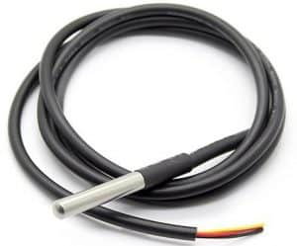

**DHT11 Humidity and Temperature sensor:**

The **DHT11** is a basic, ultra low-cost digital temperature and humidity sensor. It uses a capacitive **humidity sensor** and a **thermistor** to measure the surrounding air, and spits out a digital signal on the data pin (no analog input pins needed). It’s fairly simple to use, but requires careful timing to grab data. The only real downside of this sensor is you can only get new data from it once every 2 seconds, so when using the library, sensor readings can be up to 2 seconds old.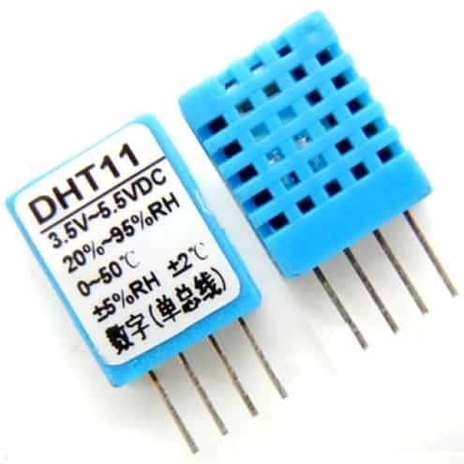

**Jumper wires:**

Jumper wires are simply wires that have connector pins at each end, allowing them to be used to connect two points to each other without soldering. Jumper wires are typically used with [breadboards](https://blog.sparkfuneducation.com/what-is-a-breadboard) and other prototyping tools in order to make it easy to change a circuit as needed. Fairly simple. In fact, it doesn’t get much more basic than jumper wires.

Jumper wires typically come in three versions: male-to-male, male-to-female and female-to-female. The difference between each is in the end point of the wire. Male ends have a pin protruding and can plug into things, while female ends do not and are used to plug things into. Male-to-male jumper wires are the most common and what you likely will use most often. When connecting two ports on a breadboard, a male-to-male wire is what you’ll need.

Though jumper wires come in a variety of colors, the colors don’t actually mean anything. This means that a red jumper wire is technically the same as a black one. But the colors can be used to your advantage in order to differentiate between types of connections, such as ground or power.

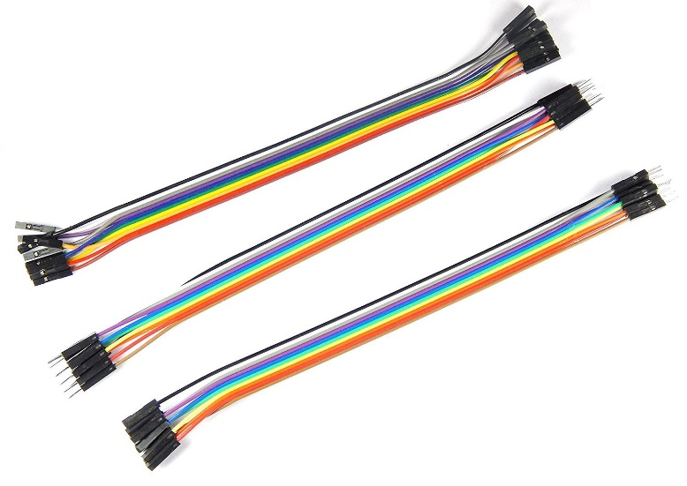

**Brearboard:**

Breadboards are temporary work boards for [electronic circuits](https://www.sciencedirect.com/topics/engineering/networks-circuits). Compatible with most breadboards, 24-gauge wire is used to connect circuits; solid wire, not stranded. Sometimes, kits may be available with various colors of fixed lengths to specifically fit breadboards. These are a nice convenience.

 The horizontal rows are connected throughout the row and may make a complete row with the addition of a simple jumper at the center point. These rows are noted with red and blue or black markings

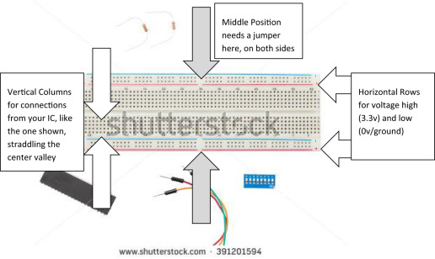

Similarly, the vertical columns are connected vertically down half the width of the board. A jumper may be inserted at the middle location to connect the full width of the breadboard. The horizontal rows are typically used for power and ground, and, with the middle NOT connected, one can apply more than one power level, such as 12 V, 3.3 V, and ground.

**Resistors:**

Resistors are electronic components, which offer resistance against the current flow, or speaking at a deeper level, against the electrons' flow. Resistors, denoted by *R*, are passive components, which means that they don't generate any electricity at all, but rather reduce voltage and current by dissipating power in the form of heat.

The unit of resistance is ohms (Ω) and resistors are usually built using carbon or metal wire. You will also find the resistors being color-coded in order to help convey the value of resistance they offer.

This is what a resistor looks like:

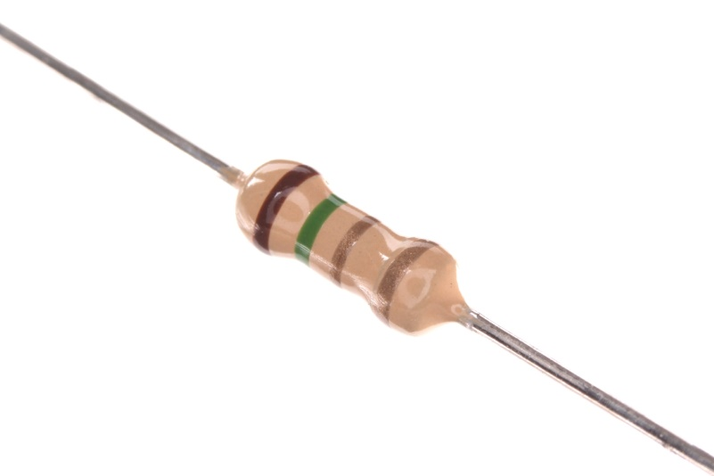

**Software requirement:**

* Arduino IDE

**Arduino IDE(Integrated development environment):**

* **Arduino IDE** is an open-source software, designed by Arduino.cc and mainly used for writing, compiling & uploading code to almost all Arduino Modules.
* It is an official Arduino software, making code compilation too easy that even a common person with no prior technical knowledge can get their feet wet with the learning process.
* It is available for all operating systems i.e. MAC, Windows, Linux and runs on the Java Platform that comes with inbuilt functions and commands that play a vital role in debugging, editing and compiling the code.
* A range of Arduino modules available including Arduino Uno, Arduino Mega, Arduino Leonardo, [Arduino Micro](https://www.theengineeringprojects.com/2018/09/introduction-to-arduino-micro.html) and many more.
* Each of them contains a microcontroller on the board that is actually programmed and accepts the information in the form of code.
* The main code, also known as a sketch, created on the IDE platform will ultimately generate a Hex File which is then transferred and uploaded in the controller on the board.
* The IDE environment mainly contains two basic parts: Editor and Compiler where former is used for writing the required code and later is used for compiling and uploading the code into the given Arduino Module.
* This environment supports both C and C++ languages