# Project: Ontoterminology visualization

Purpose:

Generate a graphic representation from an ontoterminology.

Specifications:

1. The program reads an xml file, for example: “Dress.ote”
2. The program detects the languages used in the file and the user has to choose in which language the graph will be generated.
3. If no terms have been defined for a concept, the name of the concept will be displayed on the node.
4. Right now only the relationship “is a” is recognized by the program.
5. A file “graph.html” will be generated in the same directory of the program

Requirement:

The program is an executable jar and required a Java Virtual Machine to run:

<http://java.com/download>

Usage:

1. Execute the program TediViewer:

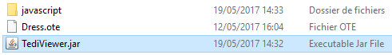

1. Choose an ote file, for example you can choose: “Dress.ote”
2. If no errors happen, you will get this window:

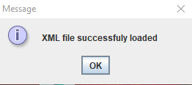

1. Then choose a language, the graph will be generated in the language chosen by the user.
2. Finally, you will get this message box:

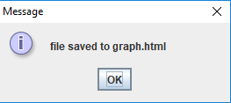

1. As you can see, a new html file appears:

You can run this file “graph.html” in a web browser.

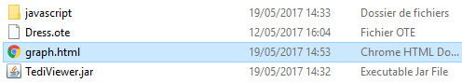

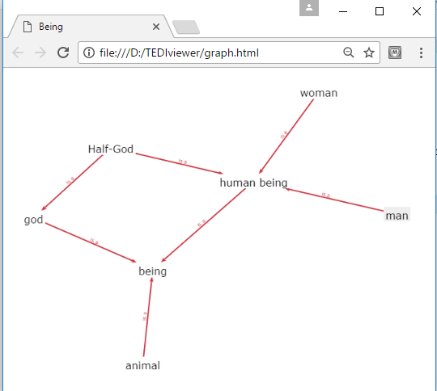

Publish:

You want to publish your graph?

All you need are the following files:



The directory javascript contains the library springyjs used to draw the graph in javascript. These files have to keep together.

You can put these files on a webserver and the graph can be shown online in a web browser.