SECONDARY STRUCUTRES ARE MORE RPESERVED THNA LOOPS, BUT WHEN USING A BLOSSUM MATRIX, THIS DOESN’T Care about specific substitutions. If I have info about the subs in each position in the seq, would it be much better? Yes.
How do we want to create one matrix that has this specificity? We need an MSA of many homologs, I’m getting the substitutions from each position. Now this substitution matrix is called Position Specific Matrix, in which I need an MSA to get it. Then I need BLAST to find these homologues.
I’m going to run my query seq, against a DB using BLOSSUM, obtaining a MSA_1→ Position Substitution Matrix (PSSM) and with this + my query protein + DB → MSA_2 → PSSM → run again, and so on and so forth, at some point that there will be no seq, and the program stops. What happens if it never ends? Some people use at max 5 iterations, and some 10. That depends on how far is the ancestor between these homologs. We have seen that some proteins have more than one homolog, for instance, 2 homologs that have two domains, the third one do not have the second domain but share the first one, and the fourth one only has the second domain and the first domain is different. So by doing a MSA for this seq, I’m introducing a vias. We do not have to let the program run to convergence, because convergence is too far away.

GOAL → We have a seq and we want to know what is the fold, like TIM barrel, globin, etc.

- EMBL is a dataset that contains seq of proteins, even the ones that don’t exist.
- Uniprot is a dataset to know the function of a specific seq, but for known protein, so lower amount of protein seq.
- PDB (Protein Data Bank) 3D protein structures.
If I want to know th structure, with blast I will use PDB
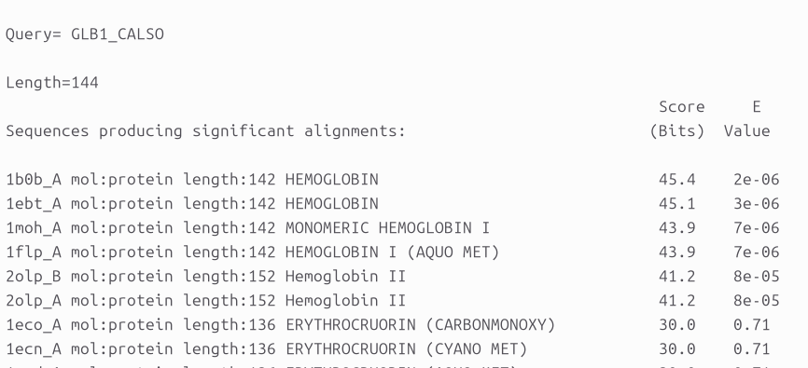
Our query protein is hemoglobin. The e-value is not that bad, only 6 proteins have a good e-value, but the other ones are terrible. The reason is that it has many substitutions (as long as its hydrophobic core is conserved), the problem is that we don’t know the position of the hydrophobic core and the surface. To know this we should do an MSA, do iterations.
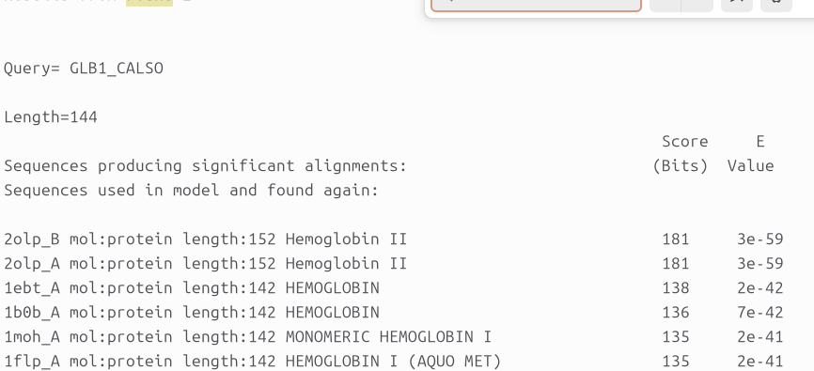
Now the e-value is much better. So now the more rounds, the more seq found, and the e-value gets better. But this raises a problem: the database "pdb_seq" contains only sequences with known structure. Then, the result is biased towards those families with higher number of known structures (i.e. that have been crystallized or studied by NMR) instead of incorporation the evolutionary information about substitutions, deletions and/or insertions. In PDB only cristalyzed proteins, not evolution → VIAS IN THE DATASET, do not explain the evolutionary substitutions. We first obtain PSSM in UNirpot and then use PDB.
PDB is biased:
- only proteins with known structures
- overrepresentation of certain folds
Unirpot:
- Better reflects evolutionary substitutions
- Produces stronger, more meaningful scores

- Why are the e-values different in target_pdb.out than in the fifth iteration in target_pdb_5.out?
  - IN the 5th iteration, the PSSM is built from a larger and more diverse MSA, and this matrix now captures position-specific conservation and knows which position tolerate substitutions (surface) and which do not (core). The e-values differ because PSI-BLAST is using a different position-specific substitution matrix and a different statistical model at each iteration.
By the 5th iteration, the PSSM is more informative, so homologs score better and their e-values improve—even when searching the same PDB database.

- Why do we need to run blastpgb with unipro_sprot.fasta before searching in pdb_seq?
  - We run blastpgp against UniProt/Swiss-Prot first to build a PSSM that captures true evolutionary substitution patterns, avoiding the strong structural bias of PDB, and only then search pdb_seq to reliably identify structural homologs and protein folds.
- When obtaining the file target_pdb_sprot5.out why we didn’t run 5 iterations as before?
  - 5 iterations were for UniProt search, to collect many evolutionary homologs and build a stable, informative PSSM. Early rounds fins close homologs, later rounds refine position-specific substitutions patterns. When searching to pdb, we use the already trained-PSSM. We did not run 5 iterations when generating target_pdb_sprot5.out because the PSSM was already built using UniProt/Swiss-Prot; further iterations on PDB would bias the matrix toward structurally over
- Search in the SCOP database with the PDB code of the best match of the target sequence. Do all the files target_pdb_specific.out, target_pdb_sprot5.out, target_pdb_5.out and target_pdb.out produce the same result?
  - Yes, they should converge to the same SCOP fold, but no, they do not necessarily return the same PDB hit or same e-values.
- Can you use the file target_sprot5.out to obtain the name of the fold in SCOP? Why?
  - SCOP assiangs folds based on 3D structure, nt just sequence similarity, and this file contains only sequence-based results

6. What are the folds of the following sequences?
- problem1 → PLP-dependent transferases
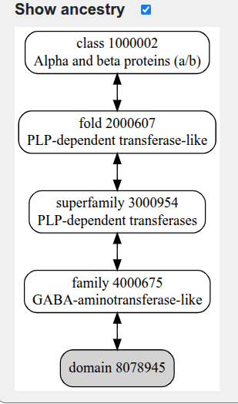
- problem 2 → Left-handed parallel coiled–coil
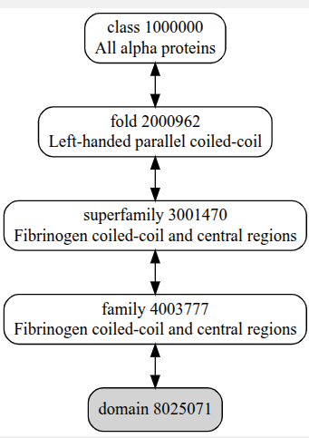
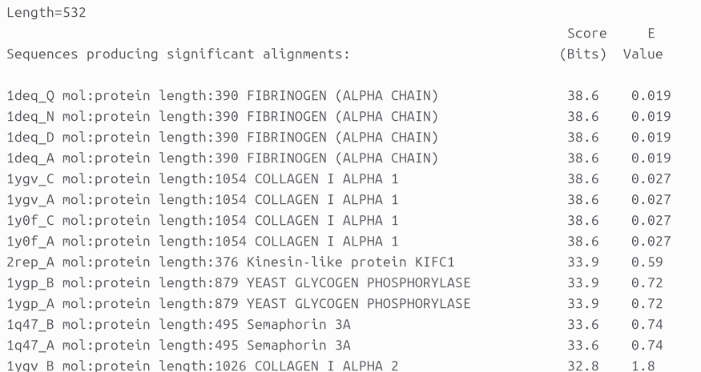

But here at the end we obtain bad e-values.

- problem 3 → alpha/beta -hydrolases
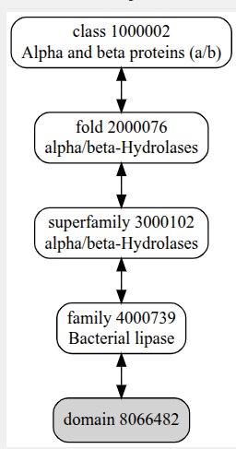 (2hih)
- problem 4 → Double Clp-N motif
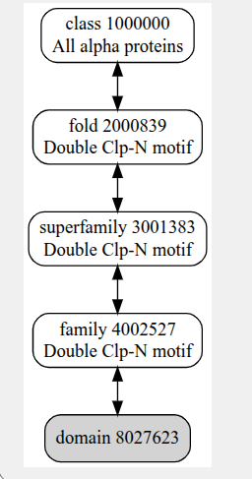
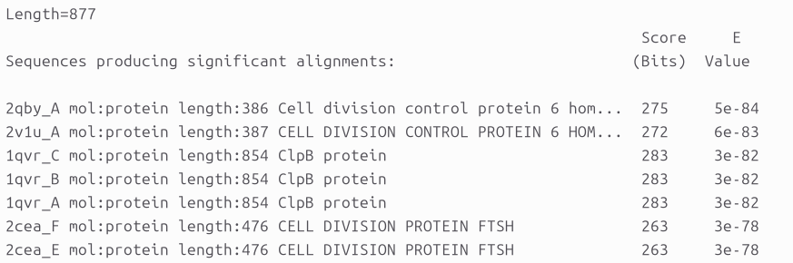
(it was used 1qvr)

HMMER
LAst class we wanted to find seq from known structures and homologues. LAst time we used PSSM and was not very robust. INstead of producing the PSSM, we have a db of PSSM and then search, will get the same result as my neighbour. Now this db of PSSM does not exist, but there’s a db of other thing that is called HMM and it’s much more powerful than PSSM. What will do today is learn about this other method and how to construct such a db.
I will have a machine that will spill letters. This has the probability to produce one of each letters, so the probability to have this seq: P=Pa * Pc * Pt * Ph (seq= ACTH). In biology it’s a bit difficult, because we have to take into account subst, indels, etc. To deal with it, there will be another machine for insertions, so to go from the initial machina to this one, we add in the previous equation the probability of the change of the machine:
P=Pa * Pc * Pt * Ph * tmi * Ps’ * Pf’
If we have deletion, move to a different machine for deletions, so in the equation add this change:
P=Pa * Pc * Pt * Ph * tmi * Ps’ * Pf’ * tid
Also he have transitions to go back, so we can move to one machine to another. It is not called machines, they are called STATES! When observe a seq, we don’t see this diagram, we only see the seqs, so why not producing the same seq, but first the insertion, the main state to the deletion state. But this probability is different from the first one. So the resulting seq will depend on the machine used, so the P = sum of all different path by which you can produce teh same seq.
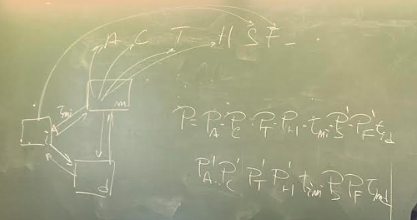
The diagram is hidden for us, so they use a feature in which the present step depends on the previous step, and this is what HMM model consist about. To generate this we need a MSA, to strong the probabilities of a certain residue.

Now will create a HMM for a sets of globins:
hmmbuild globins4.hmm globins4.sto

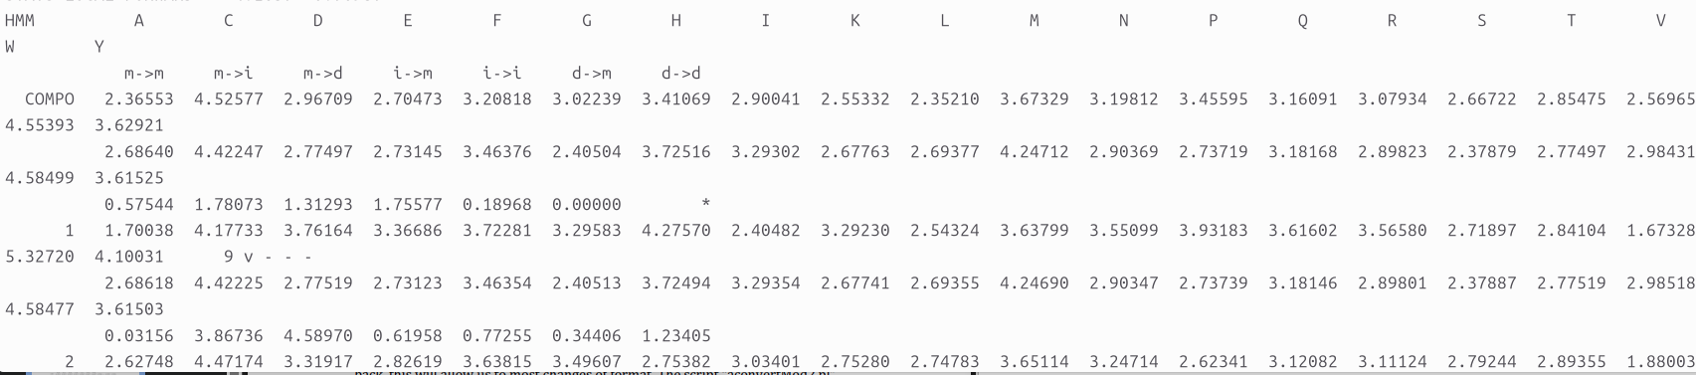
the transitions m→m, moves to the right, and m → i moves up
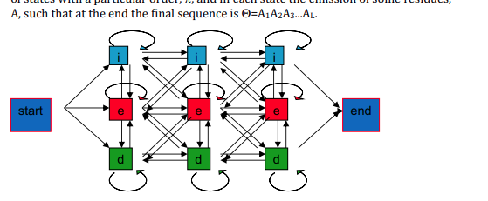
when having a MSA we have indels. the models decides whether to start with inserts, main state or deletions at position 1 in the alignment, and for position two we also hae the 3 states and between them there are transitions, and so on and so forth till the end of the alignment. So for each position, I can get the probability to get one A, for instance if all is an A, the portability is A, never 0. It builds different combinations to build that seq, and the final probability is the sum of this diff combinations. Another thing is how to use it: We have a query, a db, pdb and want a list of the best homologs (closest), with blast we know how to do it, but with HMM, first I sarch in a db, like PFAMa, and run hmmscan and with this I get HMM model that corresponds to…. then hmmfethc to download this HMM model and then I run whic hmmsearch to get the distantseq (the homologs). So, what happen if the protein has two domains? DO THE EXERCISES!
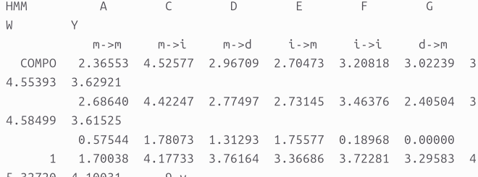
This is state 1, so 1.700 A in the main state has this value, C has a value of 4.177…
The probability of transition, is the third line, not the residues. SO we have 7 columns referring to transitions, s the first transitions has a value of 0.0315. Letters refre only on rows 1 and 2, the first is the main state and the second is the insertion state.
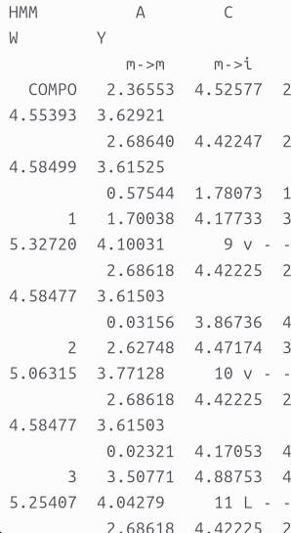

Now I have to decide which is going to be the ebay of the matches, teh ihhest the score, the better. So I will run:
hmmsearch globins4.hmm /mnt/NFS_UPF/soft/databases/blastdat/pdb_seq > globins4_pdb.out
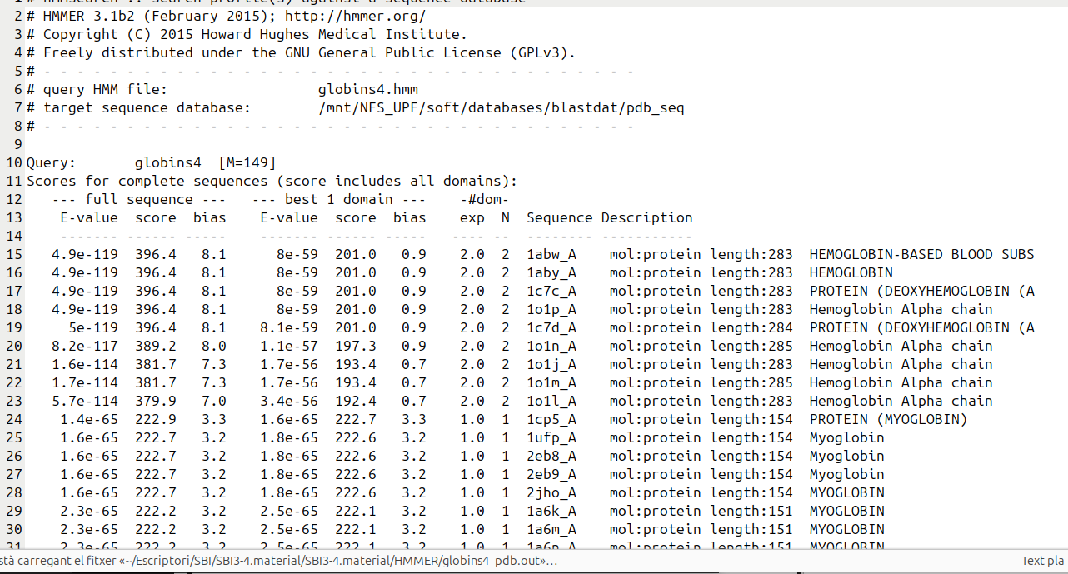
The best match has been for 1abw_A. This corresponds to seq of PDB that matches this HMM. SO we have used a HMM to look for sequences. HMM is constructed with some MSA and this corresponds to a particular domain, and protein seq have more than one domain, so for instance, in this dataset, I have fn3, which is a domain of fibonectin. So I will build one and then I will check this domain against a drosophila seq. Once we check with HMM, we should get all this matches.
hmmbuild fn3.hmm fn3.sto
hmmsearch fn3.hmm 7LES_DROME > fn3.out
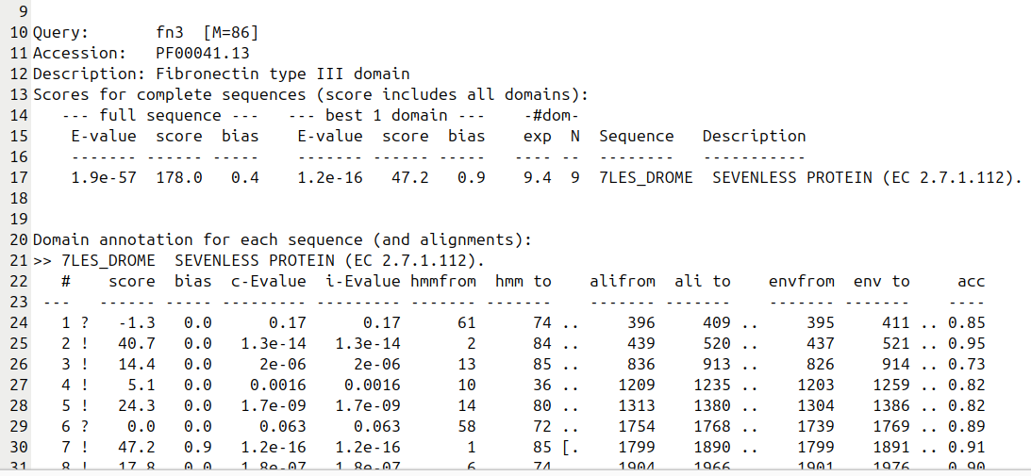
It has found 9 times this domain (N=9). 1.3e-14 as the e value are trustful. This seq has many times this domain. Now the original questoiun was, if I have a seq I want to check the PSSM, what are the HMM.
- Construct a db
- 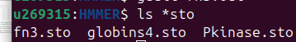
- hmmbuild pkinase.hmm Pkinase.sto
- cat *hmm > minifam
At this point it looks like kind a db, but it is not, because we need indexes, so that we can go directly to the file we want. For that we will use:
- hmmpress minifam
- Run, so how many domains I have? Something else?
- hmmscan minifam 7LES_DROME > 7LES_DROME_minifam.out

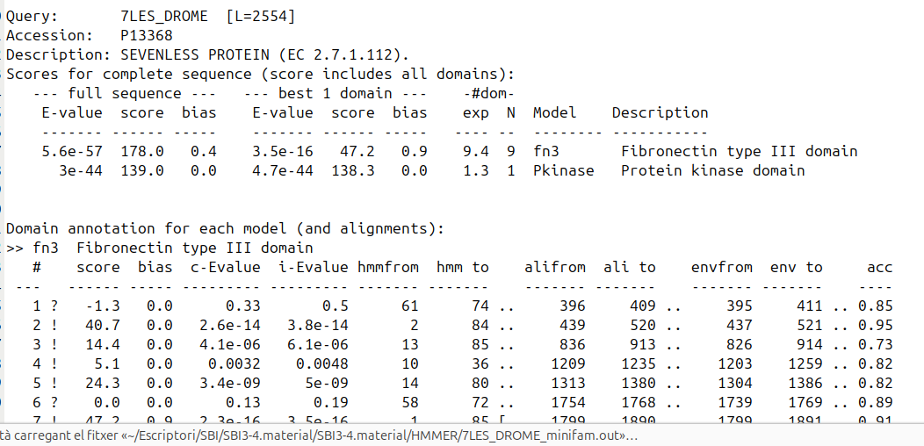
not only there’s firbonectin domain, but also protein kinase domain. So if I have a seq can we search in a db and find the HMM of my seq? Yessss

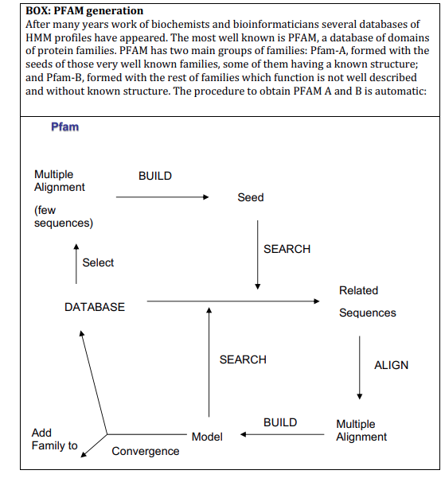
AT THE END WE HAVE TEH WHOLE db called PFAMa, and when there are no more seq from which we know the alignment, it stops. and PFAMb is for see from unknown structures and functions.
I want to fins seq homologous for my target, and dont know the target so build a PSSM of the target… so for instead a PSSM, build a HMM model. Find the PFAm that corresponds to it.
hmmscan /mnt/NFS_UPF/soft/databases/pfam-3/Pfam-A.hmm target.fa > target_Pfam.out

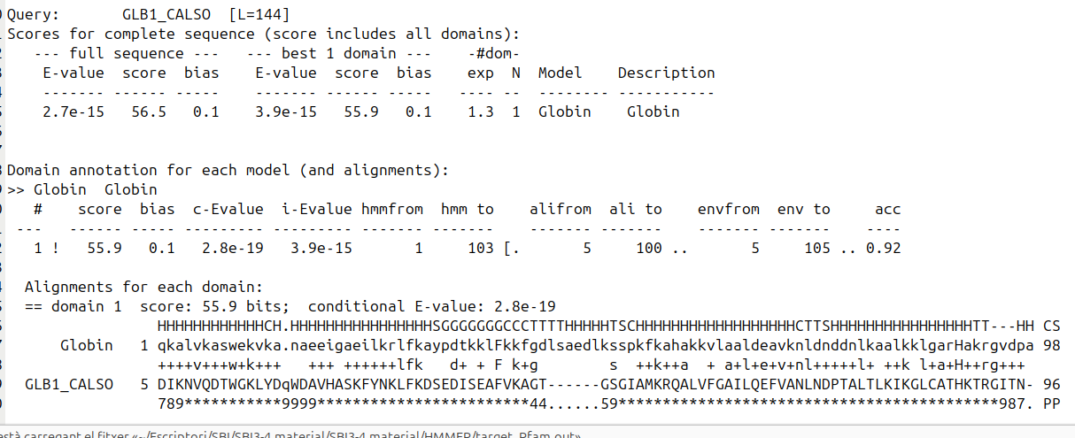
SO the fam is globin.
hmmfetch /mnt/NFS_UPF/soft/databases/pfam-3/Pfam-A.hmm Globin > Globin.hmm
HMM profile that correpsonds to my target. To fetch (take) the fam
hmmsearch Globin.hmm /mnt/NFS_UPF/soft/databases/blastdat/pdb_seq > Globin_pdb.out
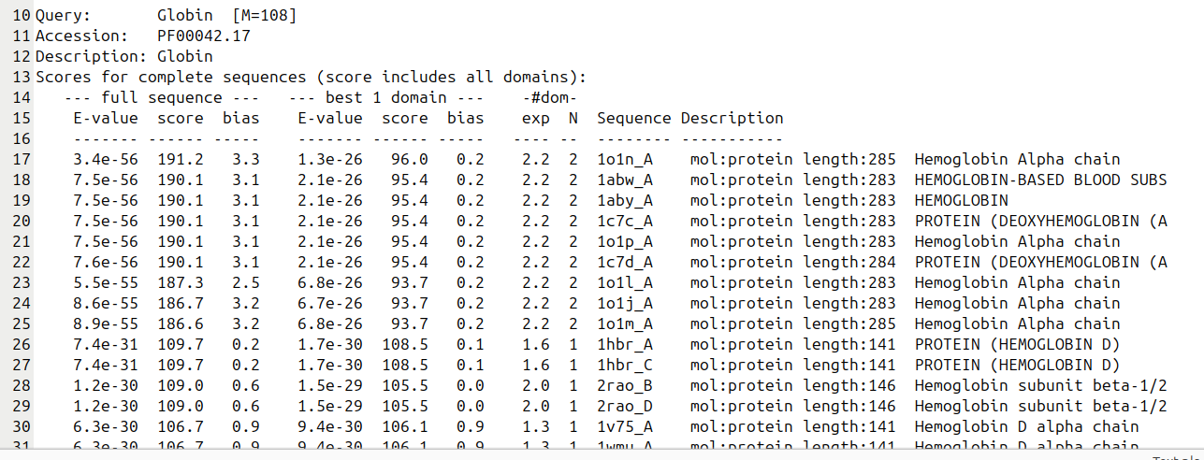
to get the list of homologs with HMM:
like blast, jackhmmer creates HMM at each iteration. Align the 45 seq of globin:
hmmalign globins4.hmm globins45.fa > globins45.hmmalign
aconvertMod2.pl -in h -out c < globins45.hmmalign > globins45.clu

-in is to say the format → h for HMM
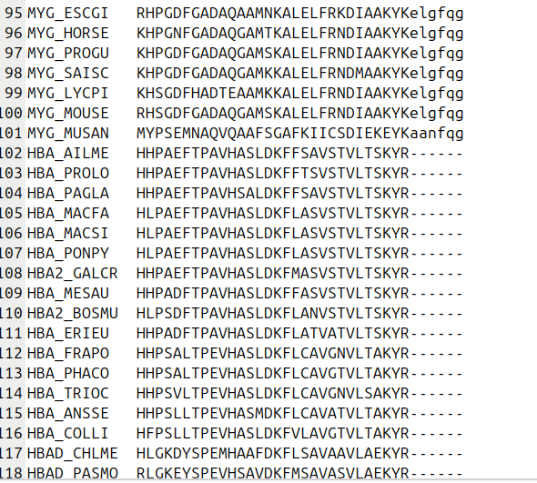
the small caps are negligible, don’t care, it is not an alignment. For the alignment of seq, we use clustalw:
clustalw globins630.fa
clustalw compares all the eq and gets the ones that are closer and builds a tree of the full alignment. For this it has to be compared all seq between each one. Soo much time, but with HMM a second:
hmmalign Globin.hmm globins630.fa > globins630.hmmalign
Each seq is compared to a profile, while CLUSTL is one vs al, then the other one.
we have seen to how to generate a HMM profile, but if we wan to make an alignment with clustal T-coffeee, and whant to mae a HMM of this, so it’s a format problem, so how to transform it?
aconvert does nt have a way to trnasofrm, so the intermediate format is a fasta format:
aconvertMod2.pl -in c -out f < globins45.clu > globins45.clu.fasta
fasta2sto.pl globins45.clu.fasta > globins45.sto

UESTIONS FROM THE TUTORIAL
1) Compare the results of phmmer, jackhmmer with the results of hmmsearch
using “domain_hbb.hmm” (see hbb_pdb_by_HMM.out) when searching
homologs in pdb_seq for hbb_human. Note: "domain_hbb" is not a real
name, this is the name you give after running hmmfetch with the HMM
model of the family found after running hmmscan (check the tutorial).
- phmmer:
phmmer hbb_human /mnt/NFS_UPF/soft/databases/blastdat/pdb_seq > hbb_human.phmmer
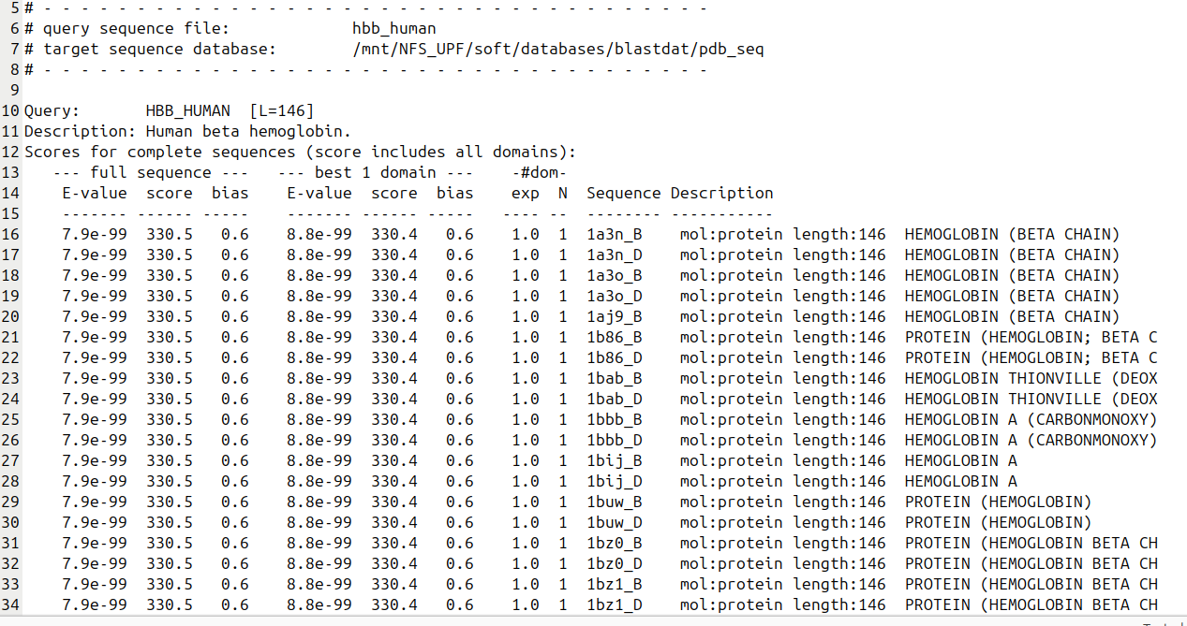
- jackhmmer:
jackhmmer -N 5 hbb_human /mnt/NFS_UPF/soft/databases/blastdat/pdb_seq > hbb_human_.jack

hmmscan /mnt/NFS_UPF/soft/databases/pfam-3/Pfam-A.hmm hhb_human > hbb_human_pfam.scan

- phmmer → “What sequences are similar to this one sequence?”
  - input: single protein seq
  - output: returns fewer closer homologs
- jackhmmer → “What else can I find if I keep learning from my hits?”
- hmmsearch → “Where does this sequence family (profile) occur?”
  - input: a profile HMM
  - output: finds more hits, especifically waj or distant ones, because the profile captures position-speciic conservation

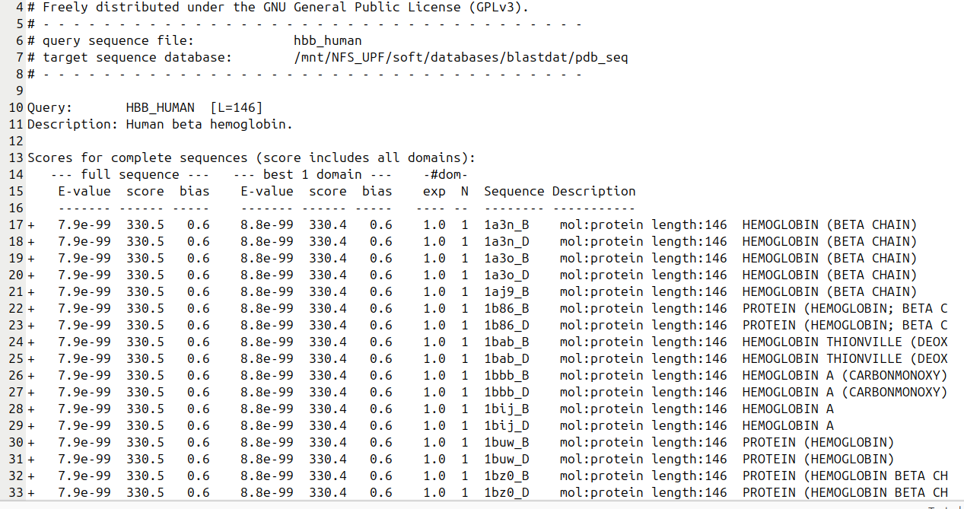

TEACHER: the results coming from hmmsearch are different form the other two
2) If a protein sequence has more than one domain in PFAM, do you think the
result of using hmmsearch and jackhmmer will be the same? Why? Test the
example with 7LES_DROME in SwissProt.
same answer than first exercise
So for multi-domain proteins like 7LESS_DROME, the results will differ because hmmsearch focuses on domain-level matches (multiple hits per sequence), while jackhmmer produces a profile of the whole protein, which does not directly or reliably separate the domains. This is a consequence of the algorithmic design for each tool

3) In practice 2.1 we used PSI-BLAST to fish sequences in the database
uniprot_sprot.fasta and generate a PSSM profile which was used for
searching homologs in PDB. Check the manual of HMMER3.0 and create
your own protocol in which you use the program jackhmmer in a similar
approach: use SwissProt database to generate the HMM profile and perform
the search in pdb_seq.

jackhmmer -N 5 --chkhmm target_hmm target.fa /mnt/NFS_UPF/soft/databases/blastdat/uniprot_sprot.fasta > target_uniprot.jack (this is he output of seq in unirpot)

run a search with this HMM:

hmmsearch target_hmm-2.hmm /mnt/NFS_UPF/soft/databases/blastdat/pdb_seq > targe_hmm-2.pdb.out

when we have two domain, we cannot select each one, so the best way is to construct a HMM which will contain both domains inside.
4)
Use hmmscan to search the best model(s) for 7LES_DROME in PFAM and
search the homologs in PDB with this/these model(s). Compare the results
of this search with the results of your protocol search in question 3. What
are the differences? Why?

5) Use your protocol described in question 3 to search homologs of
7LES_DROME in PDB and compare with the results of the protocol described
in practice 2.1 when using PSI-BLAST.
6) Use the sequence target.fa from practice 2.1. Apply phmmer, jackhmmer and
the protocols of questions 3 and 4 to find homologs in PDB. What’s the fold
of this sequence? Compare the result with the homologs found in practice
2.1
7) Use hmmalign and FetchFasta.pl to align the sequence of target.fa and its
homologs of PDB
8) If you have to align the sequence 7LES_DROME and its homologs of PDB
what’s the best model to use? Produce the alignment with the models from
question 4 and your protocol in question 3 to show your answer.
9) What are the folds of the following sequences?
a. problem1/serc_myctu.fa
b. problem2/p72_mycmy.fa
c. problem3/lip_staau.fa
d. problem4/orc1_human.fa

