Lecture 15. DB

Create a data model for a [AirBnb.com](http://airbnb.com/) system.

Your model should give ability to store information about:

* the users
* the rooms
* the reservations
* the reviews

You should have two types of users:

* Hosts
* Guests

Hosts

Host should be able to create rooms with different attributes:

* amount of residents
* price
* A/C
* refrigerator

Guest

Guest should be able to make a

* Check availability of any rooms
* Make Reservation for a room.

Primary Key and Foreign Keys

For each table you should describe what is the primary key and what are the foreign keys (if any).

Result

Result of the work might be description in a table. You can create tables in text file with description of each field. You also can you any graphic tool that you might use to create data model. I usually use [DRAW.io](http://draw.io/) for such thing, but might choose another tool.

(Optional)

Add this possibilities for a guest

* Pay for reservation
* Review for the host.

List of this tool:

<https://www.holistics.io/blog/top-5-free-database-diagram-design-tools/>

Example

Example of data model that you should provide as a result of your work:

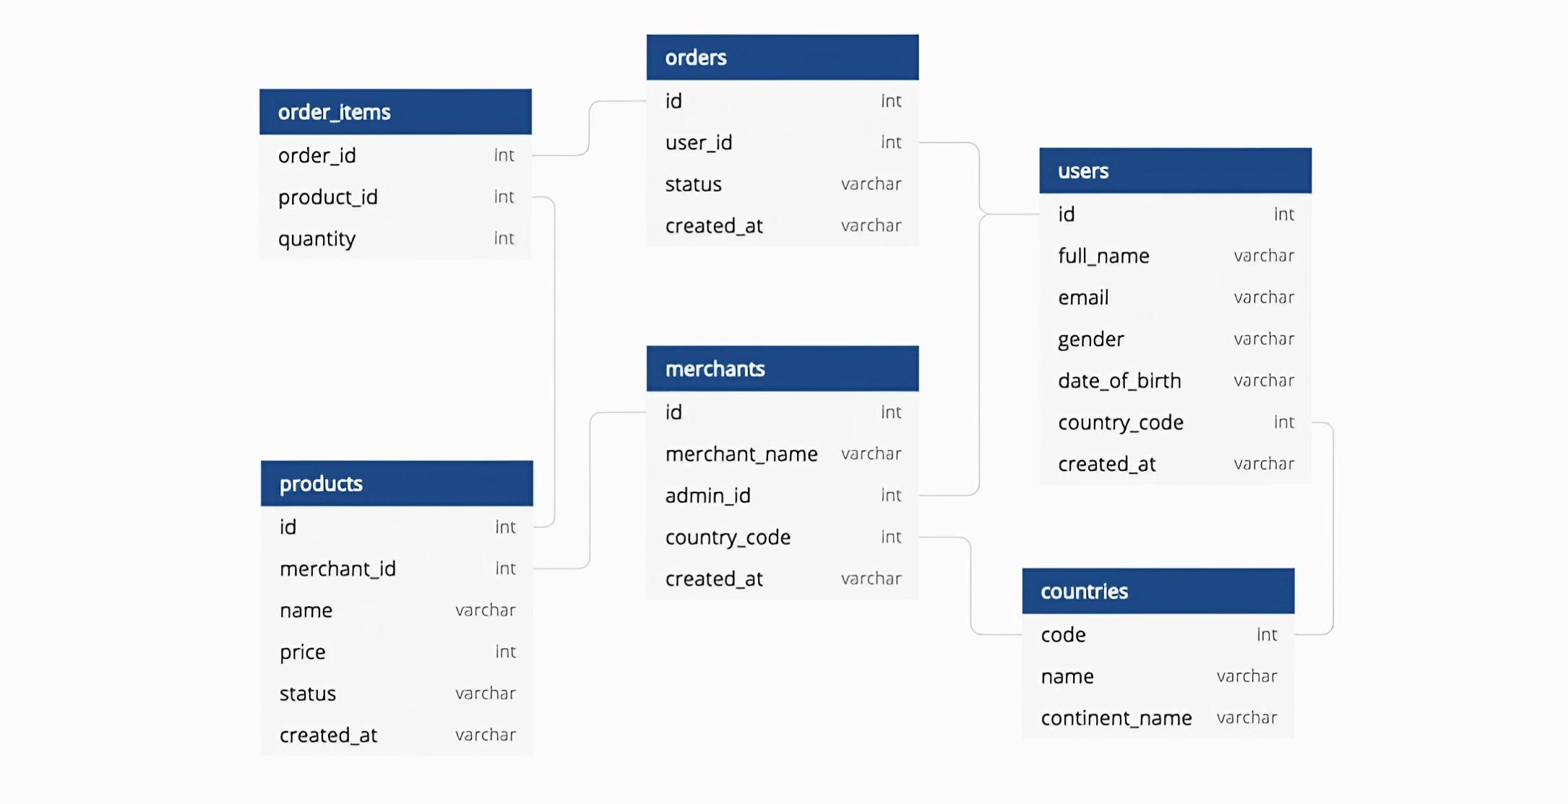

Result

Hosts:

|  |  |  |
| --- | --- | --- |
| host_id | int | Primary Key, Unique Identifier |
| host_name | varchar | Name of the host |

Guests:

|  |  |  |
| --- | --- | --- |
| guest_id | int | Primary Key, Unique Identifier |
| guest_name | varchar | Name of the guest |

Rooms:

|  |  |  |
| --- | --- | --- |
| room_id | int | Primary Key, Unique Identifier |
| host_id | int | Foreign Key to Hosts table (host_id) |
| price | decimal | Price per night |
| capacity | int | Maximum number of residents |
| ac | boolean | Availability of air conditioning |
| refrigerator | boolean | Availability of refrigerator |
| wifi | boolean | Availability of WiFi |
| private_bathroom | boolean | Availability of private bathroom |
| pet_friendly | boolean | Pet-friendly accommodation |

Reservations Table:

|  |  |  |
| --- | --- | --- |
| reservation_id | int | Primary Key, Unique Identifier |
| guest_id | int | Foreign Key to Guests table (guest_id) |
| room_id | int | Foreign Key to Rooms table (room_id) |
| check_in_date | date | Date of check-in |
| check_out_date | date | Date of check-out |
| total_price | decimal | Total price of reservation |

Payments Table:

|  |  |  |
| --- | --- | --- |
| payment_id | int | Primary Key, Unique Identifier |
| guest_id | int | Foreign Key to Guests table (guest_id) |
| reservation_id | int | Foreign Key to Reservations table (reservation_id) |
| amount | decimal | Amount paid for reservation |
| payment_date | date | Date of payment |

Reviews Table:

|  |  |  |
| --- | --- | --- |
| review_id | int | Primary Key, Unique Identifier |
| host_id | int | Foreign Key to Hosts table (host_id) |
| room_id | int | Foreign Key to Rooms table (room_id) |
| guest_id | int | Foreign Key to Guests table (guest_id) |
| rating | int | Rating given by guest |
| comment | text | Review comment |

Data Model

